1. **Write a program to implement k-mediods clustering algorithm**

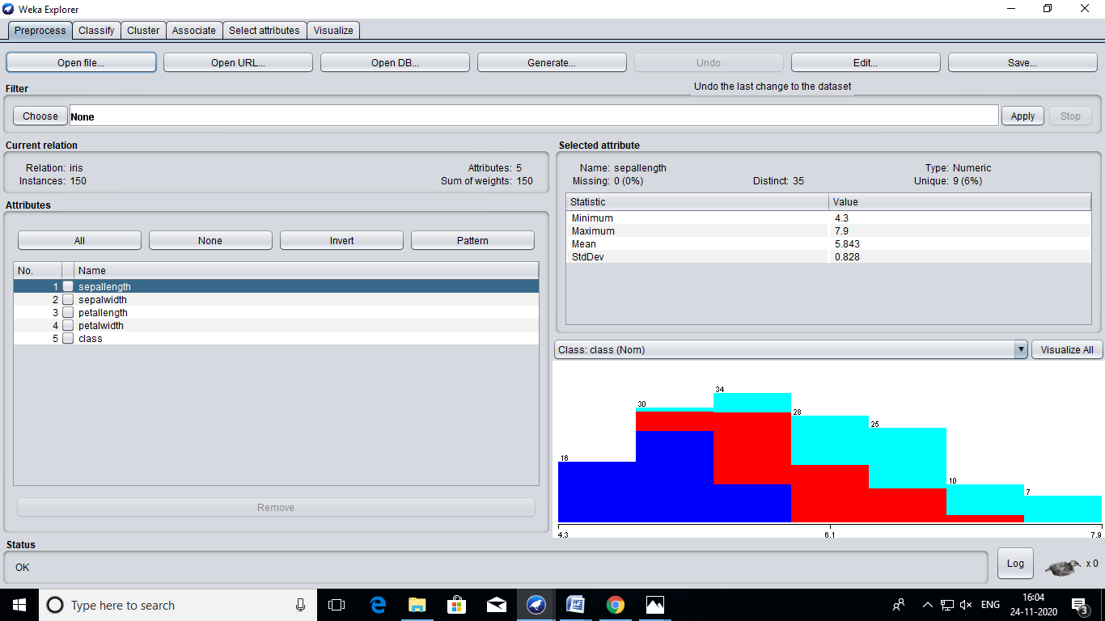

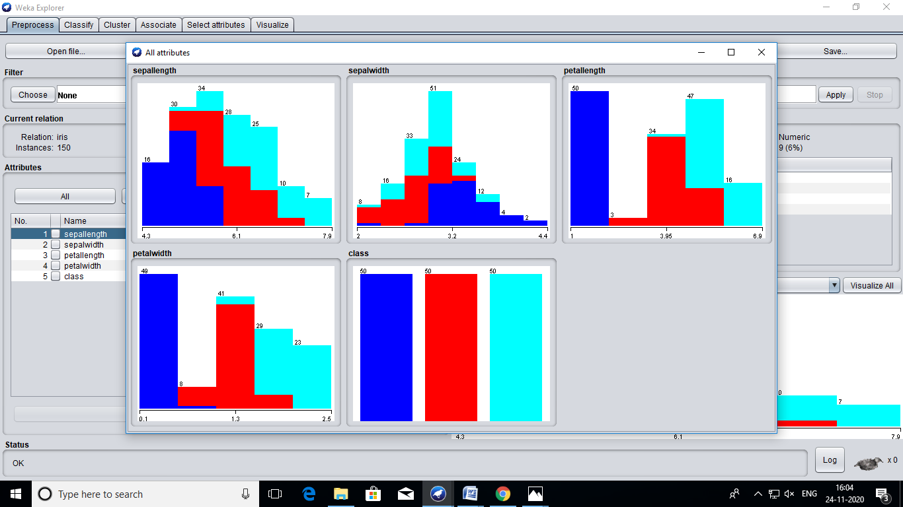

**=== Run information ===**

**Scheme: weka.clusterers.SimpleKMeans -init 0 -max-candidates 100 -periodic-pruning 10000 -min-density 2.0 -t1 -1.25 -t2 -1.0 -N 2 -A "weka.core.EuclideanDistance -R first-last" -I 500 -num-slots 1 -S 10**

**Relation: iris**

**Instances: 150**

**Attributes: 5**

**sepallength**

**sepalwidth**

**petallength**

**petalwidth**

**class**

**Test mode: evaluate on training data**

**=== Clustering model (full training set) ===**

**kMeans**

**======**

**Number of iterations: 7**

**Within cluster sum of squared errors: 62.1436882815797**

**Initial starting points (random):**

**Cluster 0: 6.1,2.9,4.7,1.4,Iris-versicolor**

**Cluster 1: 6.2,2.9,4.3,1.3,Iris-versicolor**

**Missing values globally replaced with mean/mode**

**Final cluster centroids:**

**Cluster#**

**Attribute Full Data 0 1**

**(150.0) (100.0) (50.0)**

**==================================================================**

**sepallength 5.8433 6.262 5.006**

**sepalwidth 3.054 2.872 3.418**

**petallength 3.7587 4.906 1.464**

**petalwidth 1.1987 1.676 0.244**

**class Iris-setosa Iris-versicolor Iris-setosa**

**Time taken to build model (full training data) : 0.02 seconds**

**=== Model and evaluation on training set ===**

**Clustered Instances**

**0 100 ( 67%)**

**1 50 ( 33%)**