Program No:1.1
Develop a C++ Program to Find Factorial of a Given Number Using Recurssion.
Aim: To develop a program to find the factorial of a given number using recursion.
Description: Recursion is a process in which a function calls itself to solve smaller sub-problems of a bigger problem.
It is commonly used in tasks that can be divided into similar sub-tasks — like Factorial, Fibonacci, Tree Traversals, Backtracking, etc.
Syntax:
return_type function_name(parameters)
{
if (base_case_condition)
{
// base case: stop recursion
return some_value;
}
else
{
// recursive case: function calls itself
return function_name(modified_parameters);
}
}
Program:
#include <iostream>
using namespace std;
int fact(int n);
int main()
{
int n;
cout << "Roll No: 25B61AI002" << endl;
cout << "Enter n value: ";
cin >> n;
int result = fact(n);
if (result == -1)
cout << "Factorial is not defined" << endl;
else
cout << "Factorial: " << result << endl;
return 0;
}

int fact(int n)
{
if (n < 0)
return -1;
else if (n == 0 || n == 1)
return 1;
else
return n * fact(n - 1);
}

Output:
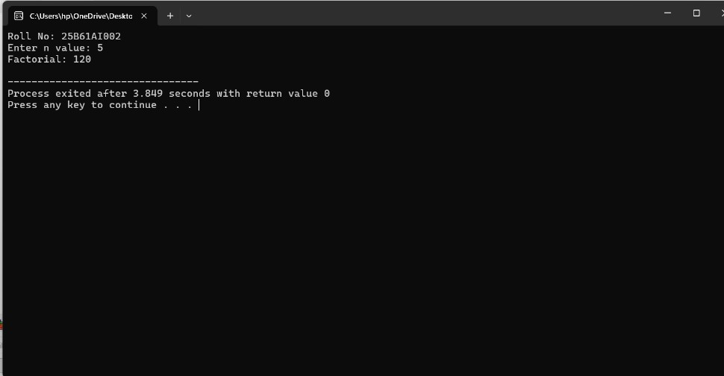

CO Mapped: CO1
POs Mapped: PO1, PO2, PO3, PO4, PO5, PO9, PO11
PSOs Mapped: PSO1

Program No :1.2
Develop a C ++ to Demonstrate Call by value and Call by Reference .
Aim: To develop a C ++ to Demonstrate Call by value and Call by Reference .
Description :
Call by Value: A copy of the actual argument is passed to the function. Changes made inside the function don’t affect the original variable.
Syntax :
void modify(int x)
{
x = x + 10;
}
Call by Reference: The address of the actual argument is passed. Changes inside the function directly affect the original variable.
Syntax:
void modify(int &x) {
x = x + 10;
}
Program :
#include <iostream>
using namespace std;
// Function to swap two values using references
void swapValues(int &first, int &second)
{
int temp = first;
first = second;
second = temp;
}
int main()
{
cout << "Roll No: 25B61AI002" << endl;
int a, b;
cout << "Enter two numbers (a and b): ";
cin >> a >> b;
cout << "\nBefore Swapping:\n";
cout << "a = " << a << endl;
cout << "b = " << b << endl;
swapValues(a, b); // Swapping the values
cout << "\nAfter Swapping:\n";
cout << "a = " << a << endl;
cout << "b = " << b << endl;
return 0;
}
Output :
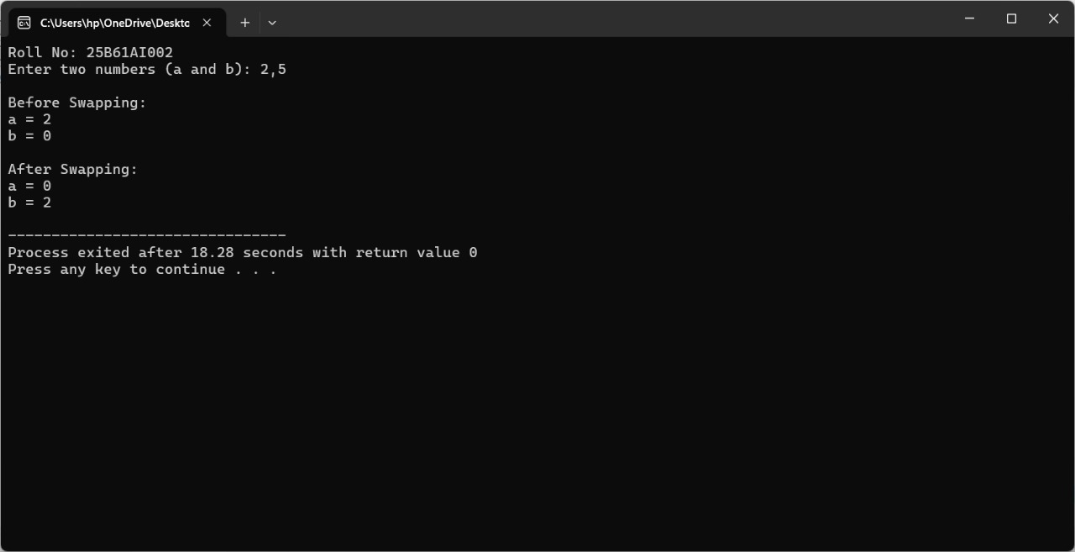
CO Mapped: CO1
POs Mapped: PO1, PO2, PO3, PO4, PO5, PO9, PO11
PSOs Mapped: PSO1

Program No :2.1
Develop a C++ program that demonstrates the use of the scope resolution operator and namespaces
Aim : To develop a C++ program that demonstrates the use of the scope resolution operator and namespaces.
Description :
a)Global and Local Variables :
Variables declared outside all functions are global and accessible throughout the program. Variables declared inside a function or block are local and only accessible within that scope .
Syntax :
int globalVar = 10; // Global
void fun() {
int localVar = 5; // Local
}
b)Scope Resolution Operator (::) :
The :: operator is used to access global variables when there’s a local variable with the same name, or to access members from a specific scope like a namespace.
Syntax :
int x = 50; // Global
void fun() {
int x = 10;
cout << ::x; // Refers to global x
}
c)Namespaces :
Namespaces help avoid name conflicts by encapsulating identifiers . Members of a namespace can be accessed using the scope resolution operator.
Syntax:
namespace MyNamespace {
int value = 100;
}
cout << MyNamespace::value; // Accessing namespace variable
Program :
#include <iostream>
using namespace std;
// Global variable
int b = 200;
// Namespace declarations
namespace N1
{
int a = 500;
}
namespace N2
{
int a = 1000;
}
// Function to demonstrate local, global, and namespace scope
void fun()
{
int a = 100; // Local variable inside fun
cout << "Fun A : " << a << " " << ::b << endl; // local a, global b
}

int main()
{
// Display Roll Number in output
cout << "Roll No: 25B61AI002" << endl;

{
int a = 100; // Inner block variable
cout << "Inner A : " << a << endl;
}

cout << "Outer B : " << b << endl;

fun(); // Call to function fun()

// Using fully qualified names
cout << "Name space 1 : " << N1::a << endl;
cout << "Name space 2 : " << N2::a << endl;

return 0;
}
Output :
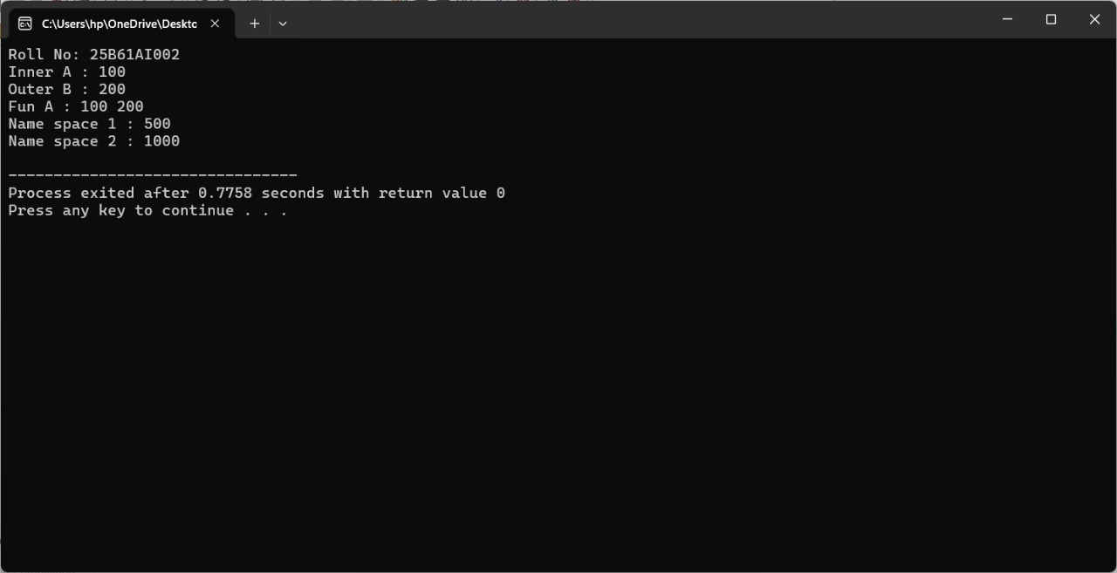
CO Mapped: CO1
POs Mapped: PO1, PO2, PO3, PO4, PO5, PO9, PO11
PSOs Mapped: PSO1

Program No :2.2
C++ program that illustrates the use of inline functions .
Aim : To write C++ program that illustrates the use of inline functions .
Description : An inline function is a function where the compiler replaces the function call with the actual code of the function (to reduce function call overhead).
Syntax :
inline return_type function_name(parameter_list) {
// function body
return value;
}
Program :
#include <iostream>
using namespace std;
inline int square(int x)
{
return x * x;
}
int main()
{
cout << "Roll No: 25B61AI002" << endl;
int num = 4;
cout << "Square of " << num << " is " << square(num) << endl;
return 0;
}
Output :
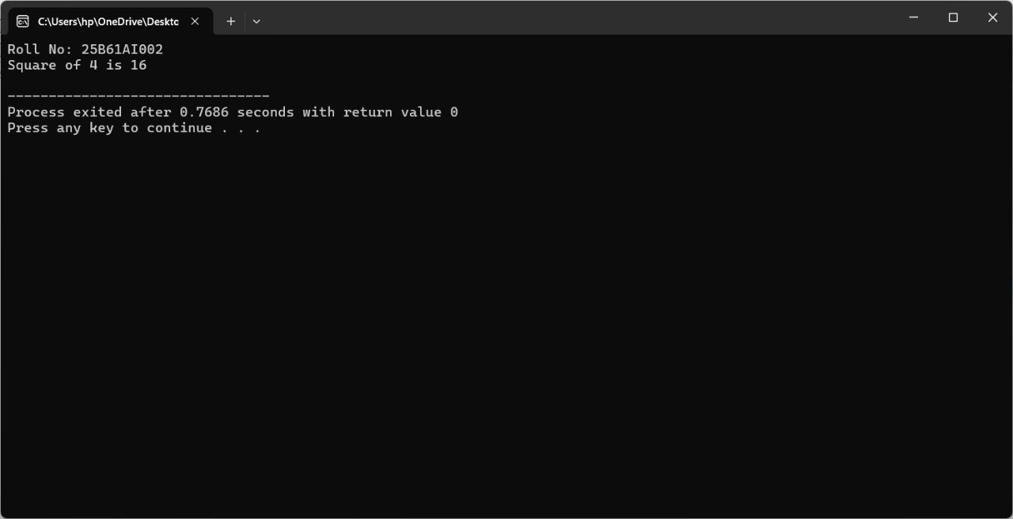
CO Mapped: CO1
POs Mapped: PO1, PO2, PO3, PO4, PO5, PO9, PO11
PSOs Mapped: PSO1

Program No :3.1
C++ program that models a Bank Account using a class. The class include data member account number, name, balance and member functions deposit, withdraw, display balance.
Aim: To C++ program that models a Bank Account using a class. The class include data member account number, name, balance and member functions deposit, withdraw, display balance.
Description :
a)Classes :
A class is a user – defined data type that groups data members and function into a single unit to represent real-world entities.
Syntax :
Class className{
//data members and member functions
};
b)Objects :
An object is an instance of a class that holds actual data and access to the class’s functions
Syntax :
ClassName object;
c)Data Members && Member Functions :
Data Members store object attributes ; member functions define behaviours that operate on these attributes.
Syntax :
class Bank {
private:
int accNumber; // data member
public:
void deposit(double); // member function
};
d)Encapsulation :
Encapsulation hides data by declaring members private and exposes through public functions , ensuring data integrity.
Syntax :
Class Bank{
Private:
double balance;
Public :
double getBalance();
};
Program :
#include<iostream>
#include<string>
using namespace std;
class Bank
{
private:
int accNumber;
string name;
double balance;

public:
Bank(int accno,string accname,double bal)
{
accNumber=accno;
name=accname;
balance=bal;
}
void withdraw(double amount)
{
if(amount < 0)
{
cout<<"Withdrraw Not Allowed";
}
else if(balance < amount)
{
cout<<"Insufficient Balance";
}
else
{
balance -=amount;
cout<<"Amount withdraw:"<<balance;
}
}
void deposit(double amount)
{
if(amount > 0)
{
balance += amount;
cout<< "Amount is Deposited:"<<balance<<endl;
}
else
{
cout<<"Not allowed to deposite"<<balance<<endl;
}
}
void displayBalance()
{
cout<<"Acc num:"<<accNumber<<endl;
cout<<"Acc Name:"<<name<<endl;
cout<<"Balance:"<<balance<<endl;
}
};
int main()
{
Bank bank(1234,"Priya",5000.00);
bank.displayBalance();
bank.deposit(50000.00);
bank.withdraw(14500.00);
return 0;
}
Output :
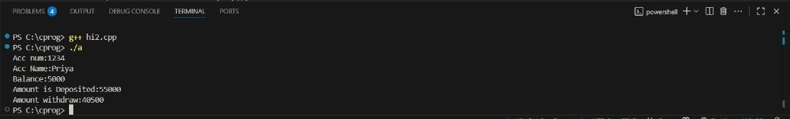

CO Mapped: CO2
POs Mapped: PO1, PO2, PO3, PO4, PO5, PO9, PO11
PSOs Mapped: PSO1

Program No:3.2
Program that illustrates the difference between the public and private access specifiers
Aim : To write a program that illustrates the difference between the public and private access specifiers
Description : Access specifiers control visibility of class members.
- private: Accessible only inside the class.
- public: Accessible from outside the class.
They support data hiding and encapsulation
Syntax:
class ClassName {
private:
int a; // private
public:
int b; // public
};
Program :
#include <iostream>
#include <string>
class Student {
private:
std::string name;
int age;

public:
void setDetails(const std::string& studentName, int studentAge)
{
name = studentName;
age = studentAge;
}
void displayDetails() const
{
std::cout << "Roll No: 25B61AI002" << std::endl;
std::cout << "Student Name: " << name << std::endl;
std::cout << "Student Age: " << age << std::endl;
}
};
int main()
{
Student student;
student.setDetails("Hari Priya ", 18);
student.displayDetails();
return 0;
}
Output :
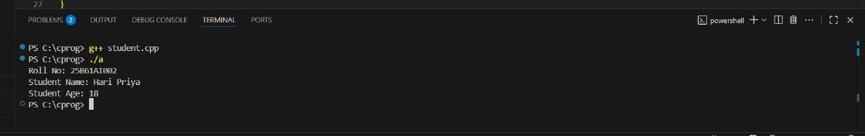

CO Mapped: CO2
POs Mapped: PO1, PO2, PO3, PO4, PO5, PO9, PO11
PSOs Mapped: PSO1

Program No:3.3
Develop a C++ program that uses the this pointer to refer to the current object
Aim : To Develop a C++ program that uses the this pointer to refer to the current object
Description :
This is an implicit pointer that refers to the current object.
Used to resolve naming conflicts between class members and parameters.
Also helps in returning the object itself for chaining.
Syntax :
class Sample {
int x;
public:
void setX(int x) {
this->x = x;
}
};
Program :
#include <iostream>
using namespace std;
class Student
{
private:
int rollNo;
string name;

public:

void setData(int rollNo, string name)
{
this->rollNo = rollNo;
this->name = name;
}

void display() {
cout << "Roll No: " << rollNo << endl;
cout << "Name: " << name << endl;
}
};

int main()
{
Student s1;

s1.setData(002, "Hari Priya");
s1.display();

return 0;
}
Output :
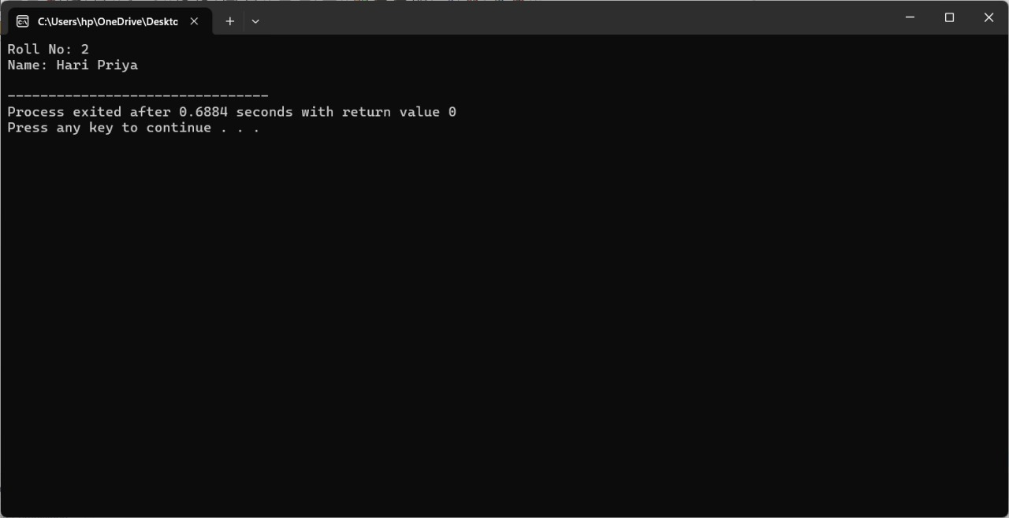
CO Mapped: CO2
POs Mapped: PO1, PO2, PO3, PO4, PO5, PO9, PO11
PSOs Mapped: PSO1

Program No:4.1
Create a C++ program that demonstrates function overloading by defining multiple functions with the same name but different parameter types or counts
Aim: To create a C++ program that demonstrates function overloading by defining multiple functions with the same name but different parameter types or counts
Description :
Function overloading allows multiple functions with the same name but different parameter types or counts. It improves code readability and reusability by using the same name for similar operations.
Program:
#include<iostream>
using namespace std;
class DispDemo
{
public:
void display()
{
cout<<"Nothing to say"<<endl;
}
void display(string msg)
{
cout<<"I have something to say :"<<msg<<endl;
}
void display(int age)
{
cout<<"Age: "<<age<<endl;
}
void display(string msg,int age)
{
cout<<"Hi "<<msg<<endl;
cout<<"Age :"<<age<<endl;
}
int display(int age, int grace)
{
return (age+grace);
}
};
int main()
{
DispDemo dd;
dd.display(25);
dd.display();
dd.display("Welcome to c++ progrmming");
dd.display("Hari Priya",19);
cout<<"result:"<<dd.display(19,1);
return 0;
}
Output:
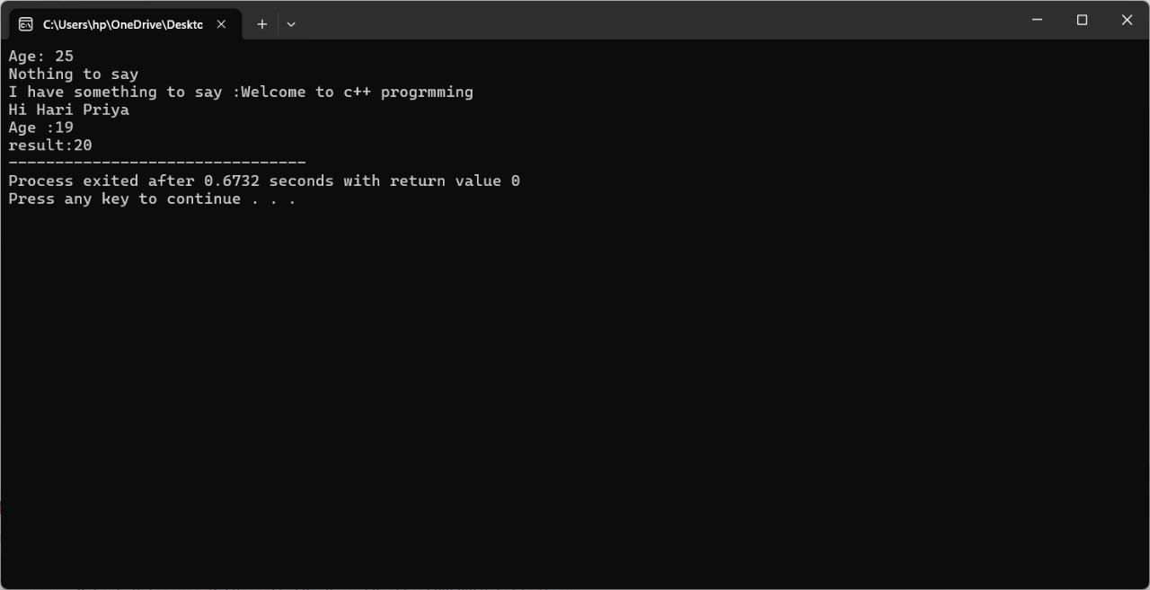
CO Mapped: CO2
POs Mapped: PO1, PO2, PO3, PO4, PO5, PO9, PO11
PSOs Mapped: PSO1

Program No :4.2
Develop a C++ program that illustrates the use of default arguments in functions
Aim: To Develop a C++ program that illustrates the use of default arguments in functions.
Description :
Default arguments let you assign default values to parameters in function declarations. If no value is provided during the call, the default is used. Defaults must be assigned from right to left.
Program :
#include<iostream>
using namespace std;
class DispDemo
{
public:
void display()
{
cout << "Nothing to display" << endl;
}
void display(string msg)
{
cout << "I am having something to display:" << msg << endl;
}
void display(int age)
{
cout << "Age:" <<age << endl;
}
void display(string msg,int age)
{
cout << "Hello" << msg <<"Age:" <<age << endl;
}
int display(int age, int grace)
{
return (age+grace);
}
void show(int c,int a = 10,int b = 20)
{
cout << "A:" << a <<" B:" <<b << " C:" << c<< endl;
}
};
int main()
{
DispDemo dd;
dd.display(30);
dd.display();
dd.display("Welcome to C++ programming");
dd.display("Hari Priya",19);
cout << " Result:" << dd.display(30, 5) << endl;
//dd.show();
dd.show(50);
dd.show(100, 200);
return 0;
}
Output:
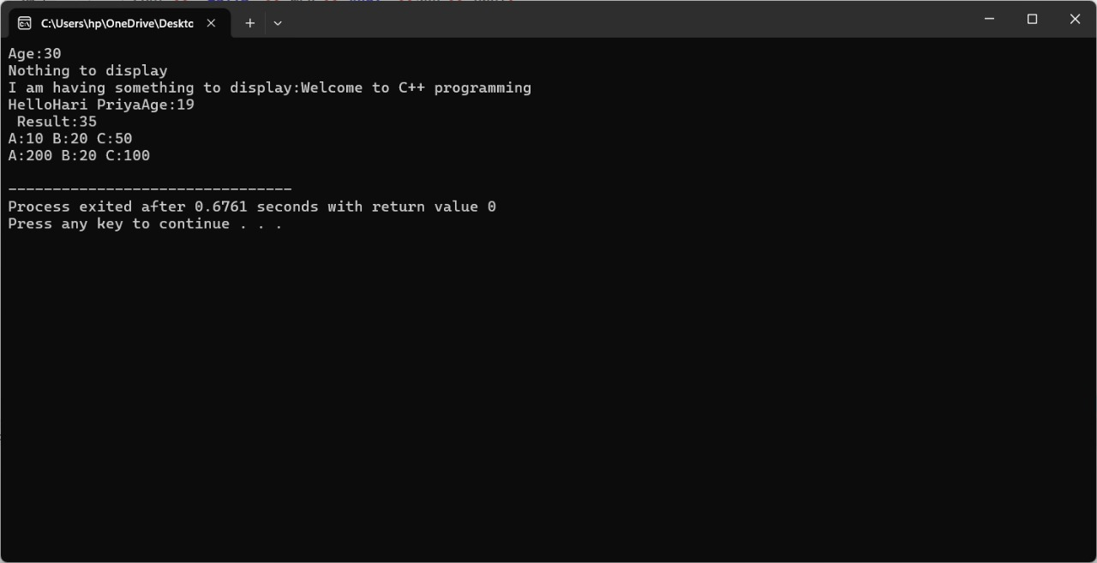
CO Mapped: CO2
POs Mapped: PO1, PO2, PO3, PO4, PO5, PO9, PO11
PSOs Mapped: PSO1

Program No:4.3
Create a C++ program that uses a friend function to access the private data of a class
Aim: To Create a C++ program that uses a friend function to access the private data of a class.
Description :
A friend function is declared using the friend keyword and can access private and protected members of a class. It's not a member of the class but has special access privileges.
Program :
#include<iostream>
using namespace std;
class B;
class A
{
private:
int a;
friend int sum(A,B);
/*A(int a)
{
this.a = a;
}*/
public:
A() : a(10) { }
};
class B
{
private:
int b;
friend int sum(A,B);
/*A(int a)
{
this.a = a;
}*/
public:
B() : b(20) { }
};
int sum(A aobj,B bobj)
{
return(aobj.a + bobj.b);
}
int main()
{
A aobj;
B bobj;
cout << "a value: " << sum(aobj,bobj)<<endl;
cout<<"25B61AI002";
return 0;
}
Output:
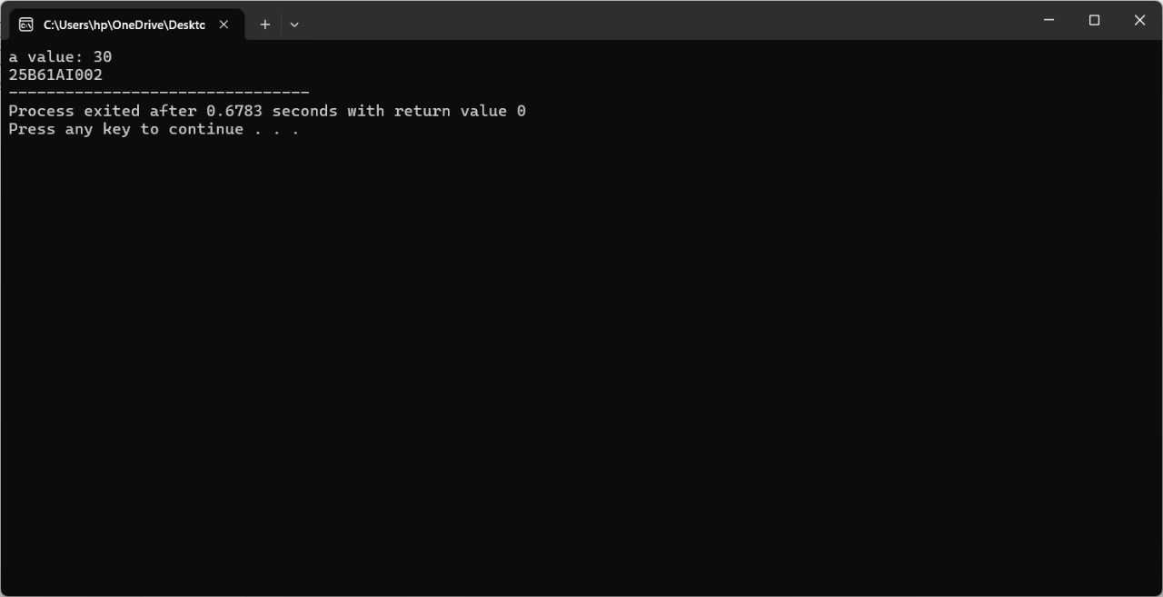
CO Mapped: CO2
POs Mapped: PO1, PO2, PO3, PO4, PO5, PO9, PO11
PSOs Mapped: PSO1

Program No : 5.1
Create a C++ program that demonstrates the use of constructors and destructors in a class.
Aim : To create a C++ program that demonstrates the use of constructors and destructors in a class.
Description :
Constructors and destructors in C++ are special member functions that manage the lifecycle of objects. A constructor is automatically called when an object is created to initialize its data, while a destructor is invoked when the object is destroyed to release resources and perform cleanup
Program :
#include <iostream>
using namespace std;
class Student {
private:
string name;
int age;
public:
Student(string n, int a) {
name = n;
age = a;
cout << "Constructor called for " << name << endl;
}
~Student() {
cout << "Destructor called for " << name << endl;
}
void display() {
cout << "Name: " << name << ", Age: " << age << endl;
}
};
int main() {
string n;
int a;
cout << "Enter student name: ";
getline(cin, n);
cout << "Enter student age: ";
cin >> a;
Student s1(n, a);
s1.display();
cout << "End of program.\n";
return 0;
}

Output :

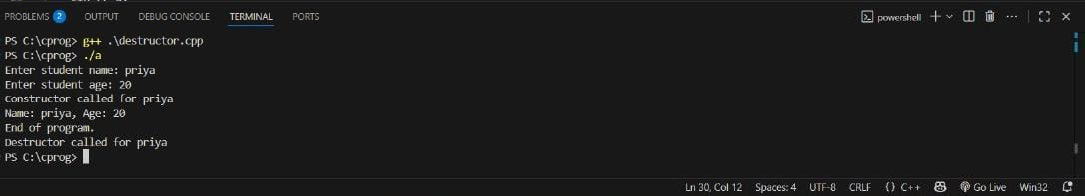
CO Mapped: CO2
POs Mapped: PO1, PO2, PO3, PO4, PO5, PO9, PO11
PSOs Mapped: PSO1

Program No : 5.2
Develop a C++ program that illustrates constructor overloading.
Aim : To develop a C++ program that illustrates constructor overloading.
Description :
Constructor overloading in C++ allows a class to have multiple constructors with different parameter lists. This enables objects to be initialized in various ways, applying the same principle as function overloading but specifically for constructors.
Program :
#include <iostream>
using namespace std;

class Rectangle {
private:

int length;
int width;

public:
Rectangle() {
length = 0;
width = 0;
cout << "Default constructor called!" << endl;
}

Rectangle(int side) {
length = side;
width = side;
cout << "Square constructor called!" << endl;
}

Rectangle(int l, int w) {
length = l;
width = w;
cout << "Rectangle constructor called!" << endl;
}

void display() {
cout << "Length: " << length << ", Width: " << width << endl;
}
};

int main() {
int choice;
cout << "Choose how to create the rectangle:\n";
cout << "1. Default (0x0)\n";
cout << "2. Square (one side)\n";
cout << "3. Rectangle (length & width)\n";
cout << "Enter choice: ";
cin >> choice;

if (choice == 1) {
Rectangle r1;
r1.display();
}
else if (choice == 2) {
int side;
cout << "Enter side length: ";
cin >> side;
Rectangle r2(side);
r2.display();
}
else if (choice == 3) {
int l, w;
cout << "Enter length: ";
cin >> l;
cout << "Enter width: ";
cin >> w;
Rectangle r3(l, w);
r3.display();
}
else {
cout << "Invalid choice!\n";
}

return 0;
}
Output:
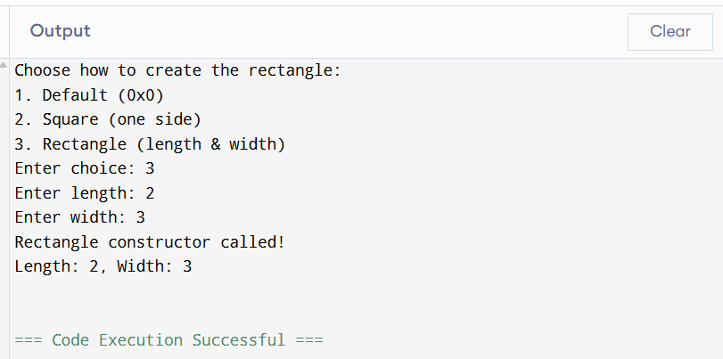

CO Mapped: CO2
POs Mapped: PO1, PO2, PO3, PO4, PO5, PO9, PO11
PSOs Mapped: PSO1

Program No : 5.3
Write a C++ program that illustrates the use of a copy constructor
Aim : Write a C++ program that illustrates the use of a copy constructor .
Description :
A copy constructor in C++ is a special constructor used to create a new object as a copy of an existing one. It is invoked when objects are passed by value, returned from functions, or explicitly initialized with another object of the same class.
Program :
#include <iostream>
using namespace std;
class Rectangle {
private:
int length;
int width;
public:
Rectangle(int l, int w) {
length = l;
width = w;
}
Rectangle(const Rectangle &r) {
length = r.length;
width = r.width;
cout << "Copy constructor called!" << endl;
}
void setLength(int l) {
length = l;
}
void display() {
cout << "Length: " << length << ", Width: " << width << endl;
}
};
int main() {
int l, w;
cout << "Enter length and width: ";
cin >> l >> w;

Rectangle rect1(l, w);
cout << "\nOriginal Rectangle (rect1):" << endl;

rect1.display();

Rectangle rect2 = rect1;
cout << "\nCopied Rectangle (rect2):" << endl;
rect2.display();

rect1.setLength(l + 10);
cout << "\nAfter changing rect1's length:" << endl;
cout << "rect1: ";
rect1.display();
cout << "rect2: ";
rect2.display();

return 0;
}

Output:
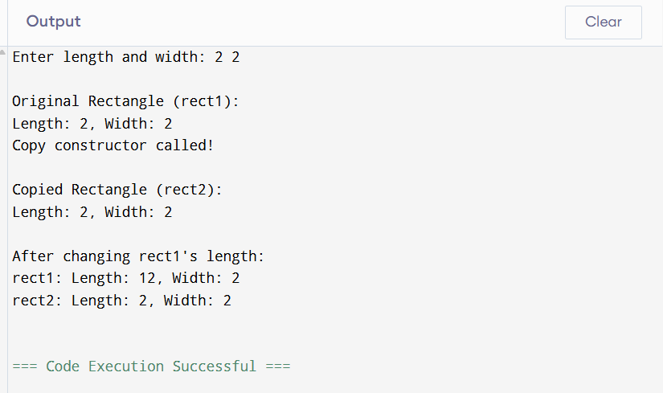
CO Mapped: CO2
POs Mapped: PO1, PO2, PO3, PO4, PO5, PO9, PO11
PSOs Mapped: PSO1

Program No : 6.1
Develop a C++ program that demonstrates how to overload both unary and binary operators using member functions.
Aim: Develop a C++ program that demonstrates how to overload both unary and binary operators using member functions.
Description :
Operator overloading using member functions allows us to redefine unary and binary operators inside a class so that they work with user-defined objects, ensuring proper return types and supporting chaining of operations.
Program:
#include<iostream>
using namespace std;
class complex
{
private:
int real;
int imaj;
public:
complex(int r,int i) : real(r) , imaj(i) { }
complex operator-()
{
return complex(-real,-imaj);
}
complex operator+(complex& obj)
{
return complex(real+obj.real,imaj+obj.imaj);
}
string display()
{
return std::to_string(real)+"+"+std::to_string(imaj)+"i\n";
}
};
int main()
{
cout<<"25B61AI002"<<endl;
complex c1(10,20);
cout<<"complex number c1:"<<c1.display();
complex c2(30,50);
cout<<"complex number c2:"<<c2.display();
complex c3 = -c1;
cout<<"complex number c3:"<<c3.display();
complex c4 = c1+c2;
cout<<"complex number c4:"<<c4.display();
return 0;
}
Output:
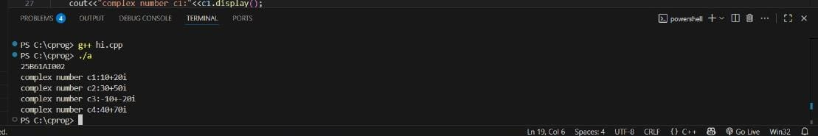
CO Mapped: CO3
POs Mapped: PO1, PO2, PO3, PO4, PO5, PO9, PO11
PSOs Mapped: PSO1

Program No:6.2
Create a C++ program to demonstrate operator overloading for unary and binary operators using friend functions
Aim: Create a C++ program to demonstrate operator overloading for unary and binary operators using friend functions
Description :
Operator overloading using friend functions lets us define operators outside the class while still accessing private members, useful for cases where the left operand is not an object of the class.
Program:
#include<iostream>
using namespace std;
class complex
{
private:
int real;
int imaj;
public:
complex(int r,int i) : real(r) , imaj(i) { }
friend complex operator-(complex& obj);
friend complex operator+(complex& obj1,complex& obj2);
string display()
{
return std::to_string(real)+"+"+std::to_string(imaj)+"i\n";
}
};
complex operator-(complex& obj)
{
return complex(-obj.real,-obj.imaj);
}
complex operator+(complex& obj1,complex& obj2)
{
return complex(obj1.real+obj2.real,obj1.imaj+obj2.imaj);
}
int main()
{
cout<<"25B61AI002"<<endl;
complex c1(10,20);
cout<<"complex number c1:"<<c1.display();
complex c2(30,50);
cout<<"complex number c2:"<<c2.display();
complex c3 = -c1;
cout<<"complex number c3:"<<c3.display();
complex c4 = c1+c2;
cout<<"complex number c4:"<<c4.display();
return 0;
}
Output:
CO Mapped: CO3
POs Mapped: PO1, PO2, PO3, PO4, PO5, PO9, PO11
PSOs Mapped: PSO1

Program No : 7.1
Develop C++ programs to demonstrate different forms of inheritance
Aim : To develop C++ programs to demonstrate different forms of inheritance
Description :
1. Single Inheritance :
In this type, a child class derives properties and methods from only one parent class.
It is the simplest form of inheritance and avoids ambiguity.
2. Multiple Inheritance :
A child class inherits from two or more parent classes.
This allows the child class to combine features of multiple classes.
However, it can sometimes lead to conflicts (for example, if two parent classes have the same method name).
3. Multilevel Inheritance :
Here, a class inherits from another class, which itself is derived from another class.
It forms a chain-like structure (grandparent → parent → child).
This shows the concept of transitive inheritance, where the child indirectly inherits features from the grandparent class.
4. Hierarchical Inheritance :
In this form, multiple child classes inherit from a single parent class.
Each child has access to the parent’s features, but they can also define their own.
This is useful when different classes share common characteristics.
5. Hybrid Inheritance :
A combination of two or more types of inheritance.
For example, a class may use both multiple and multilevel inheritance at the same time.
It is powerful but can create ambiguity, which is resolved differently in different programming languages (e.g., Method Resolution Order in Python).

Program :
//1. Single Inheritance:
#include <iostream>
using namespace std;
class Parent
{
public:
void display() {
cout << "This is Parent class" << endl;
}
};
class Child :
public Parent
{
public:
void show() {
cout << "This is Child class" << endl;
}
};
int main() {
cout<<"25B61AI002"<<endl;
Child obj;
obj.display();
obj.show();
return 0;
}
//2 .Multiple Inheritance :
#include <iostream>
using namespace std;
class Father {
public:
void quality() {
cout << "Quality from Father" << endl;
}
};
class Mother {
public:
void skill() {
cout << "Skill from Mother" << endl;
}
};
class Child : public Father, public Mother {
public:
void own() {
cout << "Own feature of Child" << endl;
}
};
int main() {
cout<<"25B61AI002"<<endl;
Child obj;
obj.quality();
obj.skill();
obj.own();
return 0;
}
//3. Multilevel Inheritance :
#include <iostream>
using namespace std;
class Grandparent {
public:
void heritage() {
cout << "This is Grandparent heritage" << endl;
}
};
class Parent : public Grandparent {
public:
void property() {
cout << "This is Parent property" << endl;
}
};
class Child : public Parent {
public:
void own() {
cout << "This is Child's own feature"<<endl;
}
};
int main() {
cout<<"25B61AI200"<<endl;
Child obj;
obj.heritage();
obj.property();
obj.own();
return 0;
}
//4. Hierarchical Inheritance :
#include <iostream>
using namespace std;
class Parent {
public:
void commonFeature() {
cout << "Common feature from Parent" << endl;
}
};
class Child1 : public Parent {
public:
void feature1() {
cout << "Feature of Child1" << endl;
}
};
class Child2 : public Parent {
public:
void feature2() {
cout << "Feature of Child2" << endl;
}
};
int main() {
cout<<"25B61AI002"<<endl;
Child1 c1;
c1.commonFeature();
c1.feature1();
Child2 c2;
c2.commonFeature();
c2.feature2();
return 0;
}
//5. Hybrid Inheritance:
#include <iostream>
using namespace std;
class A {
public:
void showA() {
cout << "Class A feature" << endl;
}
};
class B : public A {
public:
void showB() {
cout << "Class B feature" << endl;
}
};
class C : public A {
public:
void showC() {
cout << "Class C feature" << endl;
}
};
class D : public B, public C {
public:
void showD() {
cout << "Class D feature" << endl;
}
};
int main() {
cout<<"25B61AI002"<<endl;
D obj;
obj.showB();
obj.showC();
obj.showD();
return 0;
}

OUTPUT :
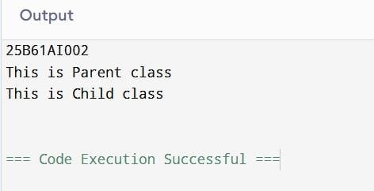

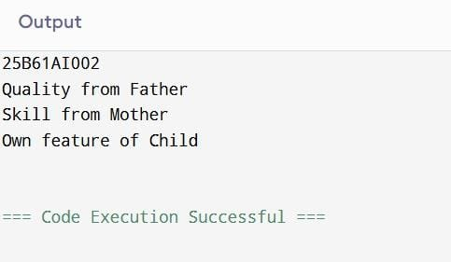

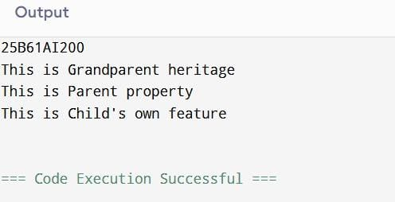
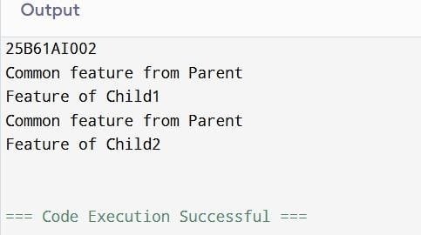
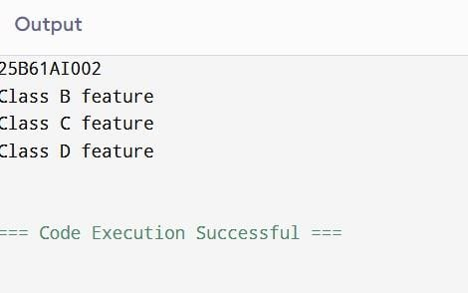

CO Mapped: CO3
POs Mapped: PO1, PO2, PO3, PO4, PO5, PO11
PSOs Mapped: PSO1

Program No : 7.2
Develop a C++ program that illustrates the order of execution for constructors and destructors in the context of inheritance.
AIM : To develop a C++ program that illustrates the order of execution for constructors and destructors in the context of inheritance.
Description :
Constructors
• When an object of a derived class is created, constructors are executed in the following order:
o First, the base class constructor is called.
o Then, constructors of intermediate derived classes (if any).
o Finally, the most derived class constructor.
• This ensures that base parts of the object are properly initialized before the derived parts.
Destructors
• When the object goes out of scope or is deleted, destructors are executed in the reverse order:
o First, the most derived class destructor. o Then, destructors of intermediate classes.
o Finally, the base class destructor.
• This ensures that derived parts are cleaned up before the base class.
Program :
#include <iostream>
using namespace std;
class Base {
public:
Base() {
cout << "Base Constructor called" << endl;
}
~Base() {
cout << "Base Destructor called" << endl;
}
};
class Derived1 : public Base {
public:
Derived1() {
cout << "Derived1 Constructor called" << endl;
}
~Derived1() {
cout << "Derived1 Destructor called" << endl;
}
};
class Derived2 : public Derived1 {
public:
Derived2() {
cout << "Derived2 Constructor called" << endl;
}
~Derived2() {
cout << "Derived2 Destructor called" << endl;
}
};
int main() {
cout << "25B61AI002" << endl;
cout << "Creating object of Derived2..." << endl;
Derived2 obj; // Constructors will run in order
cout << "Exiting main..." << endl;
return 0;
}

OUTPUT :
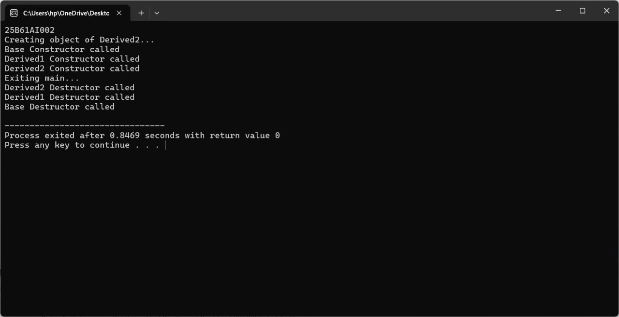
CO Mapped: CO3
POs Mapped: PO1, PO2, PO3, PO4, PO5, PO11
PSOs Mapped: PSO1

Program No : 8.1
Develop a C++ program that demonstrates how to use pointers to access and manipulate objects of a class.
AIM : To develop a C++ program that demonstrates how to use pointers to access and manipulate objects of a class.
Description :
This program illustrates the use of pointers to objects in C++ by creating objects both on the stack and dynamically on the heap. It demonstrates dereferencing and member access using the -> operator, modifying object data through member functions, and applying proper memory management with new and delete.
Program :
#include <iostream>
#include <string>
using namespace std;
class student
{
private:
string name;
int age;
public:
student(string n = "no name", int a = 0)
{
name = n;
age = a;
}
void setplayer(string n)
{
name = n;
}
void dispInfo()
{
cout << "Name: " << name << " Age: " << age << endl;
}
};
int main()
{
student s("Hari", 17);\
student* sp;
sp = &s;
sp->dispInfo();
sp->setplayer("Priya");
sp->dispInfo();
student* sp1 = new student("Hari Priya", 18);
sp1->dispInfo();
delete sp1;
return 0;
}
OUTPUT :
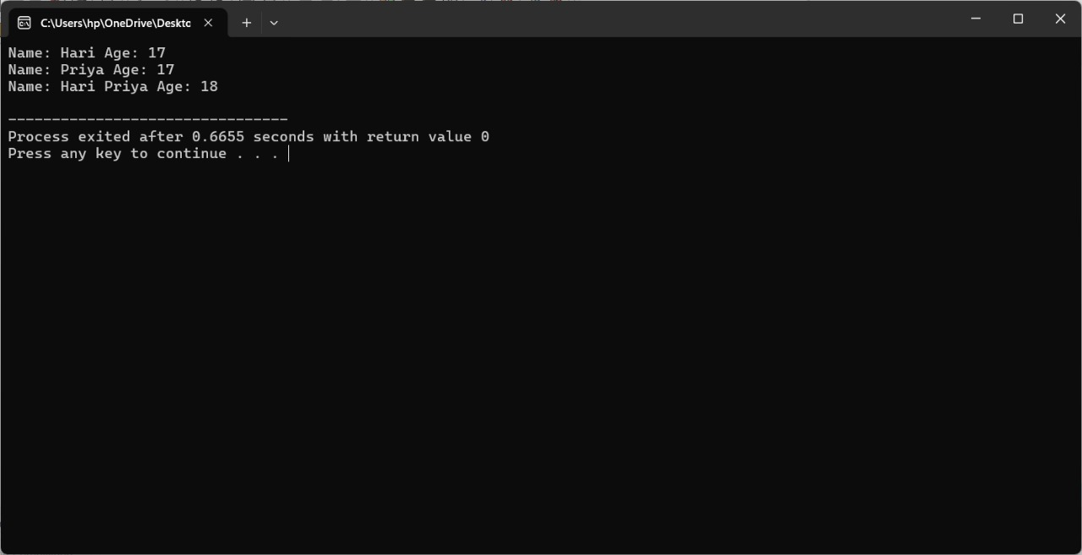
CO Mapped: CO3
POs Mapped: PO1, PO2, PO3, PO4, PO5, PO9, PO11
PSOs Mapped: PSO1

Program No : 8.2
Develop a C++ program to demonstrate the concept of virtual base classes in the context of multiple inheritance, which resolves ambiguity in the inheritance hierarchy
AIM : To develop a C++ program to demonstrate the concept of virtual base classes in the context of multiple inheritance, which resolves ambiguity in the inheritance hierarchy
Description :
This program demonstrates the diamond problem in multiple inheritance and how it is resolved using virtual base classes in C++. It also illustrates the order of constructor and destructor calls, showing how virtual inheritance ensures that the common base class is initialized only once, avoiding ambiguity in the inheritance hierarchy.
Program :
#include <iostream>
#include <string>
using namespace std;

class person
{
protected:
string name;

public:
void setName(string n)
{
name = n;
}

void displayPerson()
{
cout << "Name: " << name << endl;
}
};

class student : virtual public person
{
protected:
string course;

public:
void setcourse(string c)
{
course = c;
}

void displayPerson()
{
cout << "Course: " << course << endl;
}
};

class Employee : virtual public person
{
protected:
string company;

public:
void setcompany(string c)
{
company = c;
}

void displayPerson()
{
cout << "Company: " << company << endl;
}
};

class Workingstudent : public student, public Employee
{
public:
void displayInfo()
{
person::displayPerson();
student::displayPerson();
Employee::displayPerson();
}
};

int main()
{
cout<<"25B61AI002"<<endl;
Workingstudent ws;
ws.setName("Hari Priya");
ws.setcourse("C++");
ws.setcompany("ADITYA");

ws.displayInfo();
return 0;
}

OUTPUT :
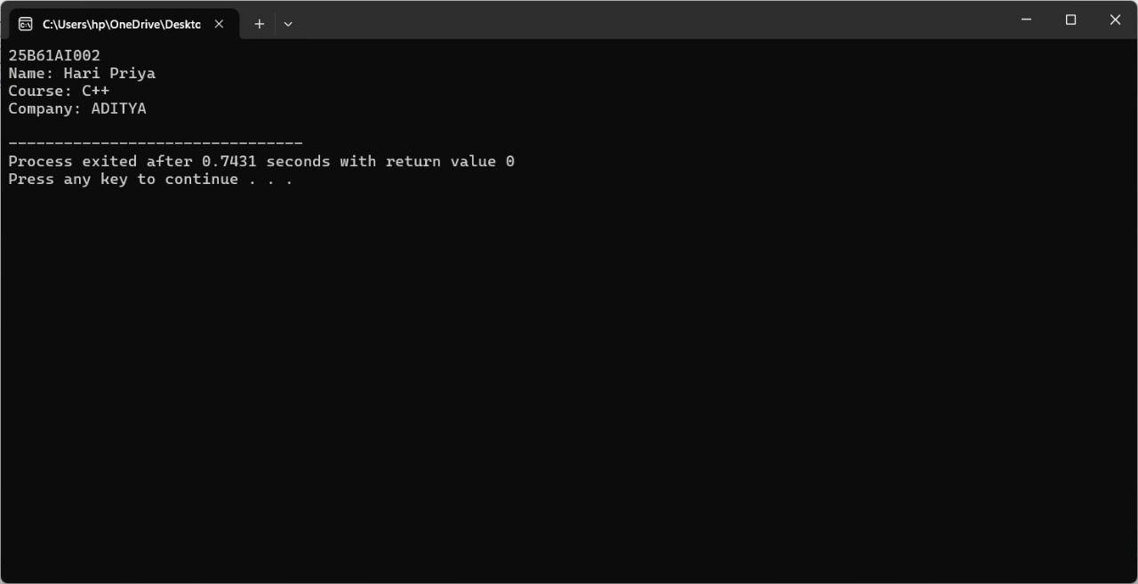

CO Mapped: CO3
POs Mapped: PO1, PO2, PO3, PO4, PO5, PO9, PO11
PSOs Mapped: PSO1

