Program No.:9a
Virtual functions, Function overriding, Dynamic binding
Aim:
To develop a C++ program that demonstrates constructor overloading by creating multiple constructors with different parameter lists.
Description:
Constructor overloading allows a class to have more than one constructor with different parameters to initialize objects in various ways.
Syntax:
class ClassName {
public:
ClassName(); // default constructor
ClassName(parameter_list); // parameterized constructor
};

Program Code:
#include <iostream>
using namespace std;
class Student {
string name;
int age;
public:
Student() {
name = "G.Hari Priya";
age = 19;
}
Student(string n, int a) {
name = n;
age = a;
}
void display() {
cout << "Name: " << name << endl;
cout << "Age : " << age << endl;
}
};
int main() {
Student s1;
Student s2("Priya", 20);
cout << "Default Constructor Output:\n";
s1.display();
cout << "\nParameterized Constructor Output:\n";
s2.display();
return 0;
}
Sample Output:
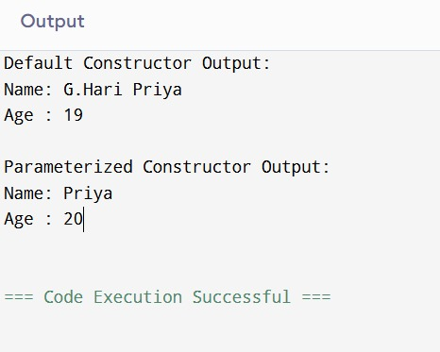
CO Mapped: CO3
POs Mapped: PO1 , PO2 , PO3 , PO4 , PO5 , PO9 , PO11
PSOs Mapped: PSO1

Program No.:9b
Runtime polymorphism, Base class pointer/reference, Overriding methods
Aim:
To develop a C++ program that illustrates the use of a copy constructor.
Description:
A copy constructor initializes a new object as a copy of an existing object.
Syntax:
class ClassName {
public:
ClassName(parameter_list); // parameterized constructor
ClassName(const ClassName &object); // copy constructor
};

Program Code:
#include <iostream>
using namespace std;
class Student {
string name;
int age;
public:
Student(string n, int a) {
name = n;
age = a;
}
Student(const Student &s) {
name = s.name;
age = s.age;
}
void display() {
cout << "Name: " << name << endl;
cout << "Age : " << age << endl;
}
};
int main() {
Student s1("G.Hari Priya", 19);
Student s2 = s1;
cout << "Original Object:\n";
s1.display();
cout << "\nCopied Object:\n";
s2.display();
return 0;
}
Sample Output:

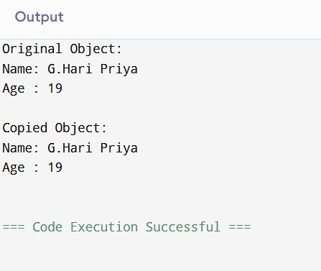
CO Mapped: CO3
POs Mapped: PO1 , PO2 , PO3 , PO4 , PO5 , PO9 , PO11
PSOs Mapped: PSO1

Program No.:10a
Function template, Template argument deduction
Aim:
To develop a C++ program to overload unary and binary operators using member functions.
Description:
Operator overloading enables defining custom behavior for operators for user-defined types.
Syntax :
class ClassName {
data_members;
public:
ClassName operator + (const ClassName &obj);
};

Program Code:
#include <iostream>
using namespace std;
class Complex {
int real, imag;
public:
Complex(int r=0, int i=0) {
real = r;
imag = i;
}
Complex operator + (const Complex &c) {
Complex temp;
temp.real = real + c.real;
temp.imag = imag + c.imag;
return temp;
}
void display() {
cout << real << " + " << imag << "i" << endl;
}
};
int main() {
Complex c1(3, 4), c2(5, 6);
Complex c3 = c1 + c2;
cout << "Result of Addition: ";
c3.display();
cout<<”G.Hari Priya”<<endl;
cout<<”25B61AI002”<<endl;
return 0;
}
Sample Output:
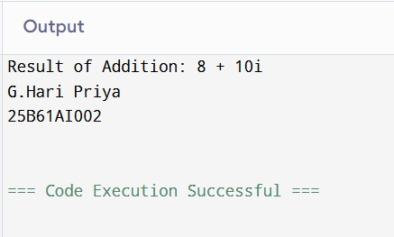

CO Mapped: CO4
POs Mapped: PO1 , PO2 , PO3 , PO4 , PO5 , PO9 , PO11
PSOs Mapped: PSO1

Program No.:10b
Template class ,Code reusability
Aim:
To develop a C++ program to overload unary and binary operators using friend functions.
Description:
Friend functions can access private members and allow operator overloading outside the class scope.
Syntax (Binary Operator):
class ClassName {
data_members;
public:
friend ClassName operator - (const ClassName &obj1,
const ClassName &obj2);
};
Program Code:
#include <iostream>
using namespace std;
class Complex {
int real, imag;
public:
Complex(int r=0, int i=0) {
real = r;
imag = i;
}
friend Complex operator - (const Complex &c1, const Complex &c2);
void display() {
cout << real << " + " << imag << "i" << endl;
}
};
Complex operator - (const Complex &c1, const Complex &c2) {
return Complex(c1.real - c2.real, c1.imag - c2.imag);
}
int main() {
Complex c1(8, 10), c2(5, 6);
Complex c3 = c1 - c2;
cout << "Result of Subtraction: ";
c3.display();
cout<<”Hari Priya”<<endl;
cout<<”25B61AI002”<<endl;
return 0;
}
Sample Output:
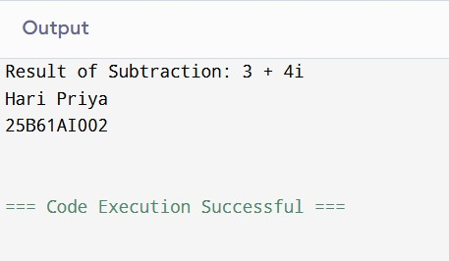

CO Mapped: CO4
POs Mapped: PO1 , PO2 , PO3 , PO4 , PO5 , PO9 , PO11
PSOs Mapped: PSO1

