Experiment 1
Program No.:1
Aim: Convert kilograms to pounds.
Software used: Collab (or) Jupiter note book.
Description:
This program converts a user-entered weight from kilograms to pounds. The program multiplies the weight in kilograms by 2.20462 (the standard conversion factor from kg to lbs). It prints the converted weight in pounds, formatted to two decimal places. If the user enters a non numeric value, a Value Error is caught, and a friendly error message is displayed.

SOURCE CODE:
def kg_to_pounds():
"""
Converts a weight entered in kilograms to pounds.
"""
try:
kilograms = float(input("Enter the weight in kilograms: "))
pounds = kilograms * 2.20462
print(f"The weight in pounds is: {pounds:.2f}")
except ValueError:
print("Invalid input. Please enter a numerical value for weight.")
# Call the function directly to run the conversion
kg_to_pounds()

PROCEDURE:
1. Prompt the user to enter weight in kilograms.
2. Convert the input to float and multiply by 2.20462 to get pounds.

3. Print the result rounded to two decimal places.
4. If input is invalid, display an error message.

INPUT:
Enter the weight in kilograms: 12

EXPECTED OUTPUT:
The weight in pounds is: 26.46

ACTUAL OUTPUT:
The weight in pounds is: 26.46

Experiment 2
Program No.:1.2
Aim: Write a program that uses a for loop and while loop to print the numbers 8,11,14,…,89.
Software used: Collab (or) Jupiter note book.
Description:
This simple program uses a for loop and while loop to print a sequence of numbers starting from 8 up to (but not including) 90, incrementing by 3 each time. Range (8, 90, 3) generates numbers starting from 8 and increases by 3 each time. The loop continues until the number reaches or exceeds 90 (but does not include 90). The while loop continues as long as num_while is less than or equal to 89. Prints each number in the sequence on a new line.

SOURCE CODE:
FOR LOOP
print("Using a for loop:")
for num in range(8, 90, 3):
print(num)
WHILE LOOP
print("Using a while loop:")
num_while = 8
while num_while <= 89:
print(num_while)
num_while += 3

PROCEDURE:
1. Print a heading: "Using a for loop or a while loop".
2. Use a for loop to iterate from 8 to 89, increasing by 3 each time.
3. Print each number in the sequence.

EXPECTED OUTPUT:
Using a while loop / For loop:
8
11
14
17
20
23
26
29
32
35
38
41
44
47
50
53
56
59
62
65
68
71
74
77
80
83
86
89
ACTUAL OUTPUT:
Using a while loop / For loop:
8
11
14
17
20
23
26
29
32
35
38
41
44
47
50
53
56
59
62
65
68
71
74
77
80
83
86
89

Experiment 3
Program No.:1.3
Aim: Write a program to split a string into array of characters.
Software used: Collab (or) Jupyter Notebook
Description:
This simple Python program takes a string and converts it into a list of its individual characters. The string is stored in the variable my_string, and the list() function is used to split it into characters.
SOURCE CODE:
my_string = "venky"
char_list = list(my_string)
print(char_list)
PROCEDURE:
1. Store the string "python" in a variable.
2.Convert the string into a list of characters using list().
3. Print the resulting list.

EXPECTED OUTPUT:
[ 'v', 'e', 'n', 'k', 'y']
ACTUAL OUTPUT:
[ 'v', 'e', 'n', 'k', 'y']

Experiment 4

Program 1.4
Aim:Write a Python program to calculate the nth Fibonacci number using a function.
Software used: Collab (or) Jupyter Notebook
Description:
This program computes the nth Fibonacci number using recursion. The user enters a positive integer n, and the program returns the nth Fibonacci number. If the user enters an invalid number, an error message is displayed.

SOURCE CODE:
def fibonacci(n):
if n <= 0:
return "Input must be a positive integer"
elif n == 1:
return 0
elif n == 2:
return 1
else:
return fibonacci(n-1) + fibonacci(n-2)

n = 10
print(f"The {n}th Fibonacci number is: {fibonacci(n)}")
PROCEDURE:
- Define a recursive function fibonacci(n).
- Check if the input is valid.
- Return base values for n = 1 or n = 2.
- Use recursion for larger values.
- Print the result.

INPUT:
n = 10

EXPECTED OUTPUT:
The 10th Fibonacci number is: 34

ACTUAL OUTPUT:
The 10th Fibonacci number is: 34

Experiment 5
Program 1.5
Aim: Write a Python program to get the largest number from a list.
Software used: Collab (or) Jupyter Notebook
Description:
This program finds the largest number in a list by comparing each element. It starts with the first element as the largest and iterates through the list to update the maximum value.
SOURCE CODE:
def get_largest_number(numbers):
if not numbers:
return None
largest = numbers[0]
for num in numbers[1:]:
if num > largest:
largest = num
return largest

my_list = [10, 45, 2, 99, 67, 88]
largest_number = get_largest_number(my_list)
print("The largest number is:", largest_number)

PROCEDURE:
- Define a function get_largest_number(numbers).
- Initialize the first element as the largest.
- Compare each element with the current largest.
- Update if a larger value is found.
- Return and print the largest number.

INPUT:
my_list = [10, 45, 2, 99, 67, 88]

EXPECTED OUTPUT:
The largest number is: 99

ACTUAL OUTPUT:
The largest number is: 99

EXPRIMENT 6
Program : 2.1

Aim: Write a Python program that defines a Car class with attributes like make, model, and year, and methods like start() to start the car and stop() to stop it.
Software used: Colab (or) Jupyter Notebook
Description:
This program defines a Car class with attributes such as make, model, and year. It provides methods to start and stop the car while keeping track of whether the car is currently running or not.

SOURCE CODE:
class Car:
def __init__(self, make, model, year):
self.make = make
self.model = model
self.year = year
self.is_started = False

def start(self):
if not self.is_started:
print(f"The {self.year} {self.make} {self.model} is starting.")
self.is_started = True
else:
print(f"The {self.year} {self.make} {self.model} is already running.")

def stop(self):
if self.is_started:
print(f"The {self.year} {self.make} {self.model} is stopping.")
self.is_started = False
else:
print(f"The {self.year} {self.make} {self.model} is already stopped.")

# Demonstrating the Car class
print("--- Car Class Demonstration ---")
my_car = Car("Toyota", "Camry", 2022)
print(f"My car: {my_car.make} {my_car.model} ({my_car.year})")

my_car.start()
my_car.start()
my_car.stop()
my_car.stop()

PROCEDURE:
- Define a class Car with attributes make, model, year, and state (running or stopped).
- Implement the method start() to start the car.
- Implement the method stop() to stop the car.
- Create an object of the Car class and demonstrate its methods.

INPUT:
Car("Toyota", "Camry", 2022)

EXPECTED OUTPUT:
--- Car Class Demonstration ---
My car: Toyota Camry (2022)
The 2022 Toyota Camry is starting.
The 2022 Toyota Camry is already running.
The 2022 Toyota Camry is stopping.
The 2022 Toyota Camry is already stopped.

ACTUAL OUTPUT:
--- Car Class Demonstration ---
My car: Toyota Camry (2022)
The 2022 Toyota Camry is starting.
The 2022 Toyota Camry is already running.
The 2022 Toyota Camry is stopping.
The 2022 Toyota Camry is already stopped.

Experiment 7
Program 2.2 :
Aim: Write a Python program that demonstrates inheritance by creating a base class Animal and derived classes like Dog and Cat with specific behaviors.
Software used: Colab (or) Jupyter Notebook
Description:
This program demonstrates inheritance in Python. A base class Animal is created with common behaviors (eat, sleep). Derived classes Dog and Cat extend the base class and include their own specific methods (bark, meow).

SOURCE CODE:
class Animal:
def __init__(self, name):
self.name = name

def eat(self):
print(f"{self.name} is eating.")

def sleep(self):
print(f"{self.name} is sleeping.")

class Dog(Animal):
def bark(self):
print(f"{self.name} says Woof!")

class Cat(Animal):
def meow(self):
print(f"{self.name} says Meow!")

dog1 = Dog("Buddy")
cat1 = Cat("Whiskers")

dog1.eat()
dog1.sleep()
cat1.eat()
cat1.sleep()

dog1.bark()
cat1.meow()
PROCEDURE:
- Define base class Animal with methods eat() and sleep().
- Define derived class Dog with method bark().
- Define derived class Cat with method meow().
- Create objects and demonstrate inheritance.
INPUT:
Dog("Buddy"), Cat("Whiskers")

EXPECTED OUTPUT:
Buddy is eating.
Buddy is sleeping.
Whiskers is eating.
Whiskers is sleeping.
Buddy says Woof!
Whiskers says Meow!
ACTUAL OUTPUT:
Buddy is eating.
Buddy is sleeping.
Whiskers is eating.
Whiskers is sleeping.
Buddy says Woof!
Whiskers says Meow!
Experiment 8
Program 2.3
Aim: Write a Python program that demonstrates error handling using the try-except block to handle division by zero.
Software used: Colab (or) Jupyter Notebook
Description:
This program demonstrates exception handling in Python. It performs division safely by catching errors like division by zero and invalid data types using try-except blocks.

SOURCE CODE:
def safe_divide(numerator, denominator):
try:
result = numerator / denominator
print(f"The result of {numerator} / {denominator} is: {result}")
except ZeroDivisionError:
print(f"Error: Cannot divide by zero! Attempted {numerator} / {denominator}")
except TypeError:
print("Error: Invalid input types. Please provide numbers.")

print("--- Error Handling Demonstration ---")
safe_divide(10, 2)
safe_divide(10, 0)
safe_divide(5, "abc")
PROCEDURE:
- Define a function safe_divide() with try-except.
- Attempt to divide two numbers.
- Catch ZeroDivisionError if denominator is zero.
- Catch TypeError if inputs are invalid.
- Print results or error messages.

INPUT:
safe_divide(10, 2)
safe_divide(10, 0)
safe_divide(5, "abc")

EXPECTED OUTPUT:
The result of 10 / 2 is: 5.0
Error: Cannot divide by zero! Attempted 10 / 0
Error: Invalid input types. Please provide numbers.

ACTUAL OUTPUT:
The result of 10 / 2 is: 5.0
Error: Cannot divide by zero! Attempted 10 / 0
Error: Invalid input types. Please provide numbers.

Experiment 8
Program 2.4
Aim:
Write a Python program that defines a base class Animal with a method make_sound() and derived classes Dog, Cat, and Bird that override the method to produce different sounds. Demonstrate polymorphism.
Software used:
Colab (or) Jupyter Notebook
Description:
This program demonstrates polymorphism in Python. A base class Animal defines a method make_sound(). The derived classes override the method to provide their own sounds. The same method is called on different objects, showing polymorphism.
SOURCE CODE:
class Animal:
def make_sound(self):
raise NotImplementedError("Subclass must implement abstract method 'make_sound'")

class Dog(Animal):
def make_sound(self):
return "Woof! Woof!"

class Cat(Animal):
def make_sound(self):
return "Meow!"

class Bird(Animal):
def make_sound(self):

return "Chirp! Chirp!"

print("--- Polymorphism Demonstration ---")
animals = [Dog(), Cat(), Bird()]

for animal in animals:
print(f"An animal makes sound: {animal.make_sound()}")
PROCEDURE:
- Define base class Animal with method make_sound().
- Define derived classes Dog, Cat, Bird that override the method.
- Create a list of animal objects.
- Call make_sound() for each object to demonstrate polymorphism.
INPUT:
animals = [Dog(), Cat(), Bird()]
EXPECTED OUTPUT:
--- Polymorphism Demonstration ---
An animal makes sound: Woof! Woof!
An animal makes sound: Meow!
An animal makes sound: Chirp! Chirp!
ACTUAL OUTPUT:
--- Polymorphism Demonstration ---
An animal makes sound: Woof! Woof!
An animal makes sound: Meow!
An animal makes sound: Chirp! Chirp!

Experiment 9
Program 3.1
Aim: Write a NumPy program using methods info, add, array, all, greater, greater_equal, less and less_equal,equal, allclose, zeros, ones, linspace, tolist.
a. To get help on the add function
b. To test whether none of the elements of a given array is zero.
c. To create an element-wise comparison (greater, greater_equal, less and less_equal, equal, equal within a tolerance) of two given arrays.
Software used:
Colab (or) Jupyter Notebook
Description:
This NumPy program demonstrates the use of functions like info, add, array, all, and various comparison methods. It gets help on a function, checks if an array has no zero elements, and performs element-wise comparisons between two arrays. The program also shows how to create arrays and convert them into lists efficiently.
SOURCE CODE:
import numpy as np
# a. Help on the add function
help(np.add)
# b. Test whether none of the elements of a given array is zero
import numpy as np
arr1 = np.array([1, 2, 3, 4])
print("None of the elements is zero:", np.all(arr1 != 0))
# c. Element-wise comparison of two arrays
import numpy as np
arr2 = np.array([2, 2, 3, 5])
print("Greater:", np.greater(arr1, arr2))
print("Greater Equal:", np.greater_equal(arr1, arr2))
print("Less:", np.less(arr1, arr2))
print("Less Equal:", np.less_equal(arr1, arr2))
print("Equal:", np.equal(arr1, arr2))
print("Equal within tolerance:", np.allclose(arr1, arr2, atol=1))
# Convert to list
print("Array to list:", arr1.tolist())
PROCEDURE:
- Import the NumPy library using import numpy as np.
- Get help on the add function using help(np.add) to understand its usage.
- Create arrays using methods like np.array(), np.zeros(), np.ones(), and np.linspace().
- Check if none of the elements of a given array is zero using the np.all() function.
- Perform element-wise comparisons between two arrays using np.greater(), np.greater_equal(), np.less(), np.less_equal(), and np.equal().
- Compare arrays within a tolerance using the np.allclose() function.
- Convert the NumPy array to a Python list using the tolist() method.
- Display results of all operations using the print() function.

EXPECTED OUTPUT :
None of the elements is zero: True
Greater: [False False False False]
Greater Equal: [False True True False]
Less: [ True False False True]
Less Equal: [ True True True True]
Equal: [False True True False]
Equal within tolerance: True
Array to list: [1, 2, 3, 4]
ACTUAL OUTPUT :
None of the elements is zero: True
Greater: [False False False False]
Greater Equal: [False True True False]
Less: [ True False False True]
Less Equal: [ True True True True]
Equal: [False True True False]
Equal within tolerance: True
Array to list: [1, 2, 3, 4]

Experiment 10
Program 3.2
Aim: Write a NumPy program using NumPy methods - max, min, argmax, argmin, argmax, repr, count, bincount, unique.
a. To extract all numbers from a given array which are less and greater than a specified number.
b. To find the indices of the maximum and minimum numbers along the given axis of an array
Software used:
Colab (or) Jupyter Notebook
Description:
This NumPy program demonstrates the use of methods like max, min, argmax, argmin, repr, count, bincount, and unique. It extracts elements from an array that are either less than or greater than a specified value. The program also finds the indices of maximum and minimum elements along a given axis. These operations help analyze and manipulate numerical data efficiently.
SOURCE CODE:
# Sample array
arr = np.array([[10, 20, 5], [30, 15, 25]])
# a. Extract numbers less than and greater than a specified number
specified_number = 18
less_than = arr[arr < specified_number]
greater_than = arr[arr > specified_number]
print("Less than 18:", less_than)
print("Greater than 18:", greater_than)
# b. Indices of max and min along axis
import numpy as np
# Create a sample 2D NumPy array
arr = np.array([[10, 20, 5],
[15, 3, 25],
[30, 8, 12]])

print("Original array:")
print(arr)

# Find the indices of the maximum values along each row (axis=1)
max_indices = np.argmax(arr, axis=1)

# Find the indices of the minimum values along each row (axis=1)
min_indices = np.argmin(arr, axis=1)

print("\nIndices of the maximum values along each row:", max_indices)
print("Indices of the minimum values along each row:", min_indices)

# To verify, you can use these indices to get the actual max and min values
max_values = arr[np.arange(len(arr)), max_indices]
min_values = arr[np.arange(len(arr)), min_indices]

print("\nMaximum values:", max_values)
print("Minimum values:", min_values)
PROCEDURE:
- Import the NumPy library using import numpy as np.
- Create an array using the np.array() function with a set of numerical values.
- (For Q-a)
  - Define a specified number for comparison.
  - Use conditional expressions (arr < number, arr > number) to extract all numbers less and greater than the specified number.
  - Display the results using the print() function.
- (For Q-b)
  - Use np.max() and np.min() to find the maximum and minimum values in the array.
  - Use np.argmax() and np.argmin() to find the indices of the maximum and minimum values.
  - If needed, specify the axis parameter to find indices along a specific dimension.
- Use np.unique() to find unique elements in the array.
- Use np.bincount() and np.count_nonzero() to count occurrences of numbers.
- Use repr() to display the array representation in string form.
- Print all results clearly for observation

EXPECTED OUTPUT :
Less than 18: [10 5 15]
Greater than 18: [20 30 25]
Original array:
[[10 20 5]
[15 3 25]
[30 8 12]]
Indices of the maximum values along each row: [1 2 0]
Indices of the minimum values along each row: [2 1 1]
Maximum values: [20 25 30]
Minimum values: [5 3 8]
ACTUAL OUTPUT :
Less than 18: [10 5 15]
Greater than 18: [20 30 25]
Original array:
[[10 20 5]
[15 3 25]
[30 8 12]]
Indices of the maximum values along each row: [1 2 0]
Indices of the minimum values along each row: [2 1 1]
Maximum values: [20 25 30]
Minimum values: [5 3 8]
Experiment 11
Program 4.1
Aim: i)Write a Pandas program to create and display a one-dimensional array-like object containing an array of data using Pandas module.
ii)Write a Pandas program to convert a Panda module Series to Python list and it's type.
Software used:
Colab (or) Jupyter Notebook
Description:
This Pandas program demonstrates how to create and display a one-dimensional Series containing an array of data. It also shows how to convert a Pandas Series into a Python list and check its type. These operations are useful for data manipulation and for integrating Pandas data structures with standard Python data types.
SOURCE CODE:
import pandas as pd
import numpy as np

# Create a Pandas Series from a list of data
data_list = pd.Series([10, 20, 30, 40, 50])

# Display the Series
print("Pandas Series created from a list:")
print(data_list)
# Convert the Series to a Python list
data_list = data_list.tolist()

# Display the list
print(data_list)

# Display the type of the new object
print("Type of the converted object:", type(data_list))
PROCEDURE:
- Import the Pandas module using import pandas as pd.
- (For Q-i)
  - Create a Pandas Series using the pd.Series() function with a list or NumPy array of data.
  - Display the created Series using the print() statement to show its data and index.
- (For Q-ii)
  - Convert the Pandas Series to a Python list using the tolist() method.
  - Use the built-in type() function to check the type of the converted object.
- Display both the original Series and the converted Python list with appropriate labels.
- Ensure the output clearly shows the Series structure and list type confirmation.

EXPECTED OUTPUT :
Pandas Series created from a list:
0 10
1 20
2 30
3 40
4 50
dtype: int64
[10, 20, 30, 40, 50]
Type of the converted object: <class 'list'>
ACTUAL OUTPUT :
Pandas Series created from a list:
0 10
1 20
2 30
3 40
4 50
dtype: int64
[10, 20, 30, 40, 50]
Type of the converted object: <class 'list'>

Experiment 12
Program 4.2
Aim: Consider Sample Python dictionary data and list labels: exam_data = {'name': ['Anastasia', 'Dima', 'Katherine', 'James', 'Emily','Michael', 'Matthew', 'Laura', 'Kevin', 'Jonas'],
'score': [12.5, 9, 16.5, np.nan, 9, 20, 14.5, np.nan, 8, 19],
'attempts': [1, 3, 2, 3, 2, 3, 1, 1, 2, 1],
'qualify': ['yes', 'no', 'yes', 'no', 'no', 'yes', 'yes', 'no', 'no', 'yes']} labels = ['a', 'b', 'c', 'd', 'e', 'f', 'g', 'h', 'i', 'j']
i)Write a Pandas program to create and display a DataFrame from a specified dictionary data which has the index labels
ii)Write a Pandas program to change the name 'James' to 'Suresh' in name column of the DataFrame. iii)Write a Pandas program to insert a new column in existing DataFrame.
iv)Write a Pandas program to get list from DataFrame column headers.
v)Write a Pandas program to get list from DataFrame column headers
Software used:
Colab (or) Jupyter Notebook
Description:
SOURCE CODE:
import pandas as pd
import numpy as np

# Sample Python dictionary data and list labels
exam_data = {'name': ['Anastasia', 'Dima', 'Katherine', 'James', 'Emily', 'Michael', 'Matthew', 'Laura', 'Kevin', 'Jonas'],
'score': [12.5, 9, 16.5, np.nan, 9, 20, 14.5, np.nan, 8, 19],
'attempts': [1, 3, 2, 3, 1, 1, 2, 1, 1, 2],
'qualify': ['yes', 'no', 'yes', 'no', 'no', 'yes', 'yes', 'no', 'yes', 'yes']}
labels = ['a', 'b', 'c', 'd', 'e', 'f', 'g', 'h', 'i', 'j']

# Create the DataFrame with the specified data and index labels
df = pd.DataFrame(exam_data, index=labels)

# Display the DataFrame
print("DataFrame created from the dictionary:")
print(df)

# Change the name 'James' to 'Suresh' in the 'name' column
df.loc['d', 'name'] = 'Suresh'

# Display the updated DataFrame
print(df)

# Create a list of salaries
salaries = [50000, 60000, 75000, 45000, 55000, 80000, 70000, 48000, 62000, 78000]

# Insert the new column 'salary'
df['salary'] = salaries

# Display the DataFrame with the new column
print(df)

# Get the list of column headers
column_headers = df.columns.tolist()

# Display the list of headers
print(column_headers)
PROCEDURE:
- Import the Pandas module using import pandas as pd.
- Create a DataFrame using the pd.DataFrame() function with data and column names.
- (For Q-ii)
  - Use the replace() function or direct indexing to change the value 'James' to 'Suresh' in the 'name' column.
  - Display the updated DataFrame using print().
- (For Q-iii)
  - Insert a new column into the existing DataFrame using df['new_column_name'] = [values].
  - Verify the insertion by printing the DataFrame.
- (For Q-iv)
  - Retrieve a list of column headers from the DataFrame using df.columns.tolist().
  - Print the list of column names.
- (For Q-v)
  - (Same as Q-iv) Use the columns attribute and convert it to a list using list(df.columns) to get column headers.
- Display all outputs clearly to show the modifications and results for each operation.

EXPECTED OUTPUT :
DataFrame created from the dictionary:
name score attempts qualify
a Anastasia 12.5 1 yes
b Dima 9.0 3 no
c Katherine 16.5 2 yes
d James NaN 3 no
e Emily 9.0 1 no
f Michael 20.0 1 yes
g Matthew 14.5 2 yes
h Laura NaN 1 no
i Kevin 8.0 1 yes
j Jonas 19.0 2 yes
name score attempts qualify
a Anastasia 12.5 1 yes
b Dima 9.0 3 no
c Katherine 16.5 2 yes
d Suresh NaN 3 no
e Emily 9.0 1 no
f Michael 20.0 1 yes
g Matthew 14.5 2 yes
h Laura NaN 1 no
i Kevin 8.0 1 yes
j Jonas 19.0 2 yes
name score attempts qualify salary
a Anastasia 12.5 1 yes 50000
b Dima 9.0 3 no 60000
c Katherine 16.5 2 yes 75000
d Suresh NaN 3 no 45000
e Emily 9.0 1 no 55000
f Michael 20.0 1 yes 80000
g Matthew 14.5 2 yes 70000
h Laura NaN 1 no 48000
i Kevin 8.0 1 yes 62000
j Jonas 19.0 2 yes 78000
['name', 'score', 'attempts', 'qualify', 'salary']
ACTUAL OUTPUT :
DataFrame created from the dictionary:
name score attempts qualify
a Anastasia 12.5 1 yes
b Dima 9.0 3 no
c Katherine 16.5 2 yes
d James NaN 3 no
e Emily 9.0 1 no
f Michael 20.0 1 yes
g Matthew 14.5 2 yes
h Laura NaN 1 no
i Kevin 8.0 1 yes
j Jonas 19.0 2 yes
name score attempts qualify
a Anastasia 12.5 1 yes
b Dima 9.0 3 no
c Katherine 16.5 2 yes
d Suresh NaN 3 no
e Emily 9.0 1 no
f Michael 20.0 1 yes
g Matthew 14.5 2 yes
h Laura NaN 1 no
i Kevin 8.0 1 yes
j Jonas 19.0 2 yes
name score attempts qualify salary
a Anastasia 12.5 1 yes 50000
b Dima 9.0 3 no 60000
c Katherine 16.5 2 yes 75000
d Suresh NaN 3 no 45000
e Emily 9.0 1 no 55000
f Michael 20.0 1 yes 80000
g Matthew 14.5 2 yes 70000
h Laura NaN 1 no 48000
i Kevin 8.0 1 yes 62000
j Jonas 19.0 2 yes 78000
['name', 'score', 'attempts', 'qualify', 'salary']

Experiment 13
Program 5.1
Aim: Create a series of plots to analyze a given dataset.
Software used:
Colab (or) Jupyter Notebook
Description:
This program demonstrates how to analyze a dataset using multiple plots in Matplotlib. It covers creating line and scatter plots to explore trends and relationships in the data. Customizations like titles, labels, and colors enhance readability and interpretation.
SOURCE CODE:
import matplotlib.pyplot as plt
import numpy as np

# Sample data
x = np.linspace(0, 2 * np.pi, 100)
y = np.sin(x)
y2 = np.cos(x)
y3 = np.sin(x) * np.cos(x)

# Create a figure with a series of plots
plt.figure(figsize=(12, 4))

plt.subplot(1, 3, 1)
plt.plot(x, y, color='blue')
plt.title('Sine Wave')
plt.xlabel('X-axis')
plt.ylabel('Y-axis')

plt.subplot(1, 3, 2)
plt.plot(x, y2, color='green')
plt.title('Cosine Wave')
plt.xlabel('X-axis')
plt.ylabel('Y-axis')

plt.subplot(1, 3, 3)
plt.plot(x, y3, color='red')
plt.title('Product of Sine and Cosine')
plt.xlabel('X-axis')
plt.ylabel('Y-axis')

plt.tight_layout() # Adjusts subplot params for a tight layout
plt.show()
PROCEDURE:
Create a series of plots to analyze a given dataset
- Import the required libraries using import matplotlib.pyplot as plt, import numpy as np, and import pandas as pd.
- Load or create a dataset using Pandas or NumPy.
- Use different plotting functions such as plt.plot() for line plots, plt.scatter() for scatter plots, and plt.bar() for bar charts.
- Add labels, titles, and legends using plt.xlabel(), plt.ylabel(), and plt.title().
- Display all the plots using plt.show().

EXPECTED OUTPUT :
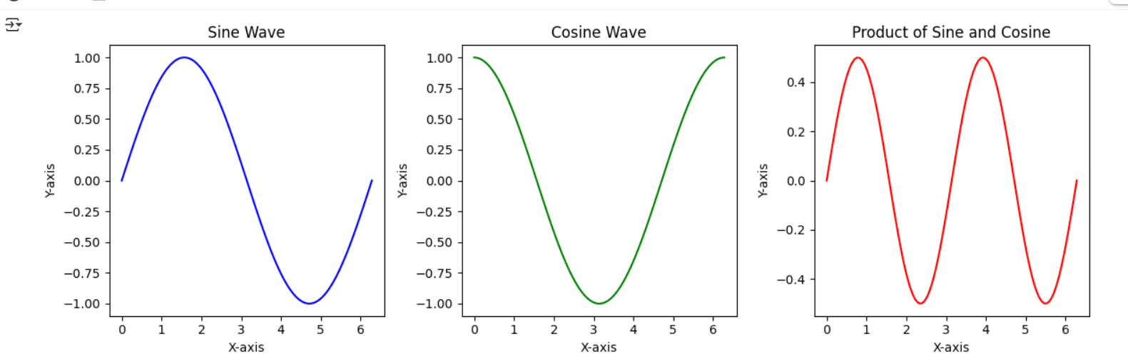

ACTUAL OUTPUT :

Experiment 14
Program 5.2
Aim: Generate a subplot layout with various plot types (scatter, line, bar).
Software used:
Colab (or) Jupyter Notebook
Description:
This program shows how to create subplot layouts combining different plot types in a single figure. It includes line, scatter, and bar plots to compare multiple aspects of a dataset side by side. Subplots help visualize complex data efficiently in one view.
SOURCE CODE:
import matplotlib.pyplot as plt
import numpy as np
import pandas as pd

# Sample data
data = {'Category': ['A', 'B', 'C', 'D'],
'Value1': [10, 25, 15, 30],
'Value2': [15, 20, 25, 10]}
df = pd.DataFrame(data)

x_scatter = np.random.rand(50)
y_scatter = np.random.rand(50)
x_line = np.arange(10)
y_line = np.random.randint(1, 10, size=10)

fig, axes = plt.subplots(2, 2, figsize=(10, 8))

# Scatter Plot
axes[0, 0].scatter(x_scatter, y_scatter)
axes[0, 0].set_title('Scatter Plot')
axes[0, 0].set_xlabel('X-axis')
axes[0, 0].set_ylabel('Y-axis')

# Line Plot
axes[0, 1].plot(x_line, y_line, marker='o')
axes[0, 1].set_title('Line Plot')
axes[0, 1].set_xlabel('X-axis')
axes[0, 1].set_ylabel('Y-axis')

# Bar Chart
axes[1, 0].bar(df['Category'], df['Value1'])
axes[1, 0].set_title('Bar Chart')
axes[1, 0].set_xlabel('Category')
axes[1, 0].set_ylabel('Value1')

# This subplot is intentionally left empty to match the assignment's implied 2x2 grid
axes[1, 1].set_visible(False)

plt.tight_layout()
plt.show()
PROCEDURE:
Generate a subplot layout with various plot types (scatter, line, bar)
- Import Matplotlib and NumPy libraries.
- Create sample data arrays using np.arange() or np.random() functions.
- Use the plt.subplots() function to create multiple subplots in one figure.
- Plot different types of graphs in each subplot — line plot, scatter plot, and bar plot.
- Add titles, axis labels, and customize the layout using plt.tight_layout().
- Display all subplots using plt.show().
EXPECTED OUTPUT :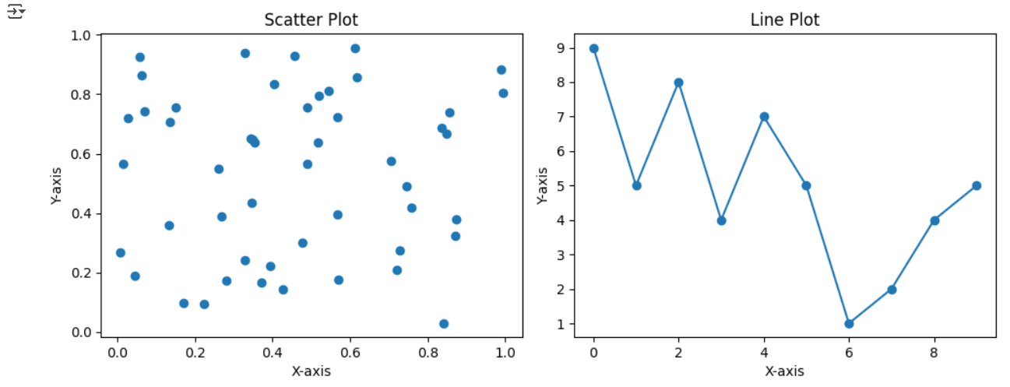 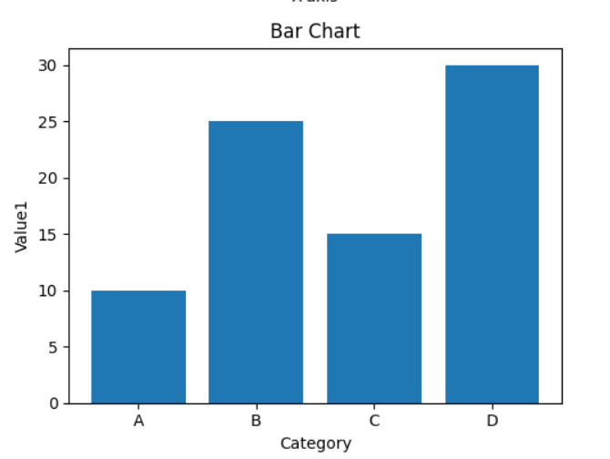

ACTUAL OUTPUT :

Experiment 15
Program 5.3
Aim: Visualize time-series data and customize axis labels and date formats.
Software used:
Colab (or) Jupyter Notebook
Description:
This program focuses on time-series data visualization using Matplotlib. It demonstrates how to plot data over time, customize axis labels, and format dates for clarity. These features make temporal trends easier to analyze and interpret.
SOURCE CODE:
import matplotlib.pyplot as plt
import pandas as pd
import numpy as np

# Sample time-series data
dates = pd.to_datetime(pd.date_range(start='2024-01-01', periods=100, freq='D'))
sales_data = np.random.randint(100, 500, size=100) + np.sin(np.arange(100) * 0.2) * 50
df = pd.DataFrame({'Date': dates, 'Sales': sales_data})
df = df.set_index('Date')

plt.figure(figsize=(12, 6))
plt.plot(df.index, df['Sales'])

# Customize axis labels and date formats
plt.xlabel('Date')
plt.ylabel('Sales')
plt.title('Daily Sales Over Time')

# Use pandas' built-in plotting for automatic date formatting
# This is a good practice for clean time-series plots
df.plot(y='Sales', figsize=(12, 6), title='Daily Sales Over Time')
plt.show()
PROCEDURE:
Visualize time-series data and customize axis labels and date formats
- Import Matplotlib and Pandas libraries.
- Create time-series data using pd.date_range() and corresponding values using NumPy.
- Use plt.plot() to plot the date on the x-axis and data on the y-axis.
- Customize the date format and axis labels using plt.xlabel(), plt.ylabel(), and plt.gcf().autofmt_xdate().
- Add a title and grid lines for better visualization.
- Display the plot using plt.show().
EXPECTED OUTPUT :
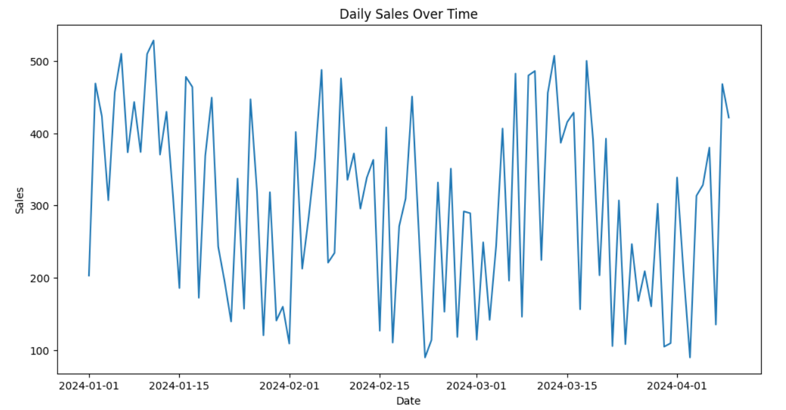
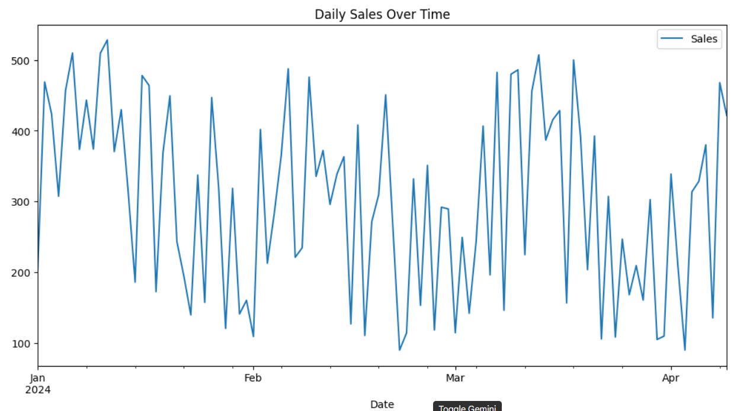

ACTUAL OUTPUT :

Experiment 16
Program 5.4
Aim: Create a 3D plot.
Software used:
Colab (or) Jupyter Notebook
Description:
This program illustrates how to create 3D plots using Matplotlib’s mpl_toolkits.mplot3d. It shows plotting data in three dimensions to reveal patterns not visible in 2D plots. Customizations like labels, colors, and viewing angles enhance the 3D visualization.

SOURCE CODE:
import matplotlib.pyplot as plt
import numpy as np
from mpl_toolkits.mplot3d import Axes3D

# Sample 3D data
np.random.seed(42)
x = np.random.rand(50)
y = np.random.rand(50)
z = np.random.rand(50)

# Create a 3D figure
fig = plt.figure(figsize=(8, 6))
ax = fig.add_subplot(111, projection='3d')

# Plot the 3D data
ax.scatter(x, y, z)

# Set labels for the axes
ax.set_xlabel('X-axis')
ax.set_ylabel('Y-axis')
ax.set_zlabel('Z-axis')
ax.set_title('3D Scatter Plot')
Procedure:
- Import the required libraries:
- import matplotlib.pyplot as plt
- from mpl_toolkits.mplot3d import Axes3D
- import numpy as np
- Create some data points using NumPy.
- Create a 3D figure and axes using projection='3d'.
- Plot the 3D data using ax.plot3D() or ax.scatter3D().
- Add title and labels for X, Y, and Z axes.
- Display the plot using plt.show().

EXPECTED OUTPUT :
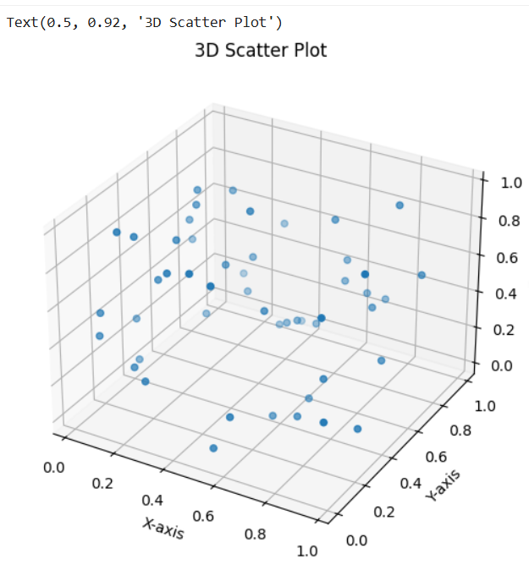

ACTUAL OUTPUT :

