1. We can see all the 4 tables are created into Redshift cluster database

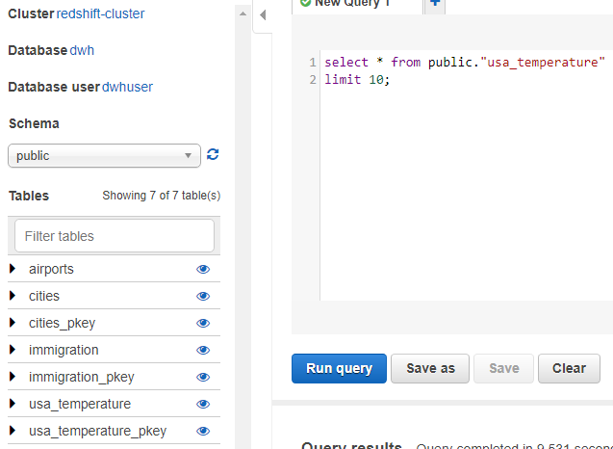

1. Immigration is the fact table and cities, airport and usa_temperature are dimensional tables
2. Performing Data quality check of the data loaded

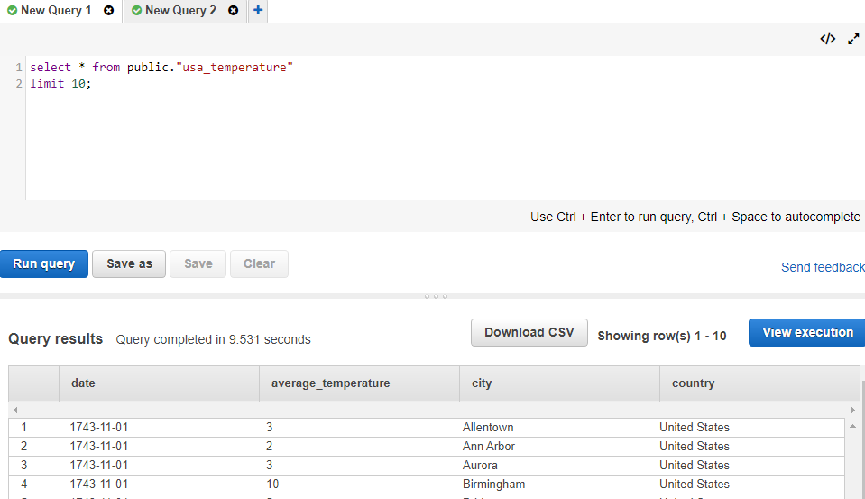

1. Data from airports table

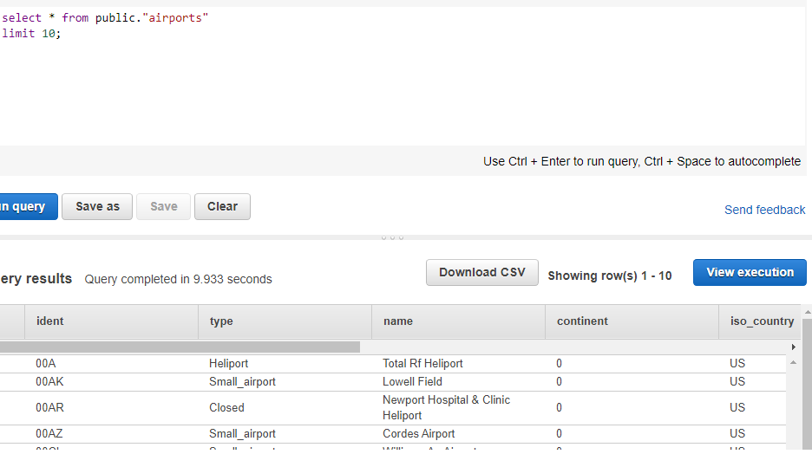

1. Data from immigration table

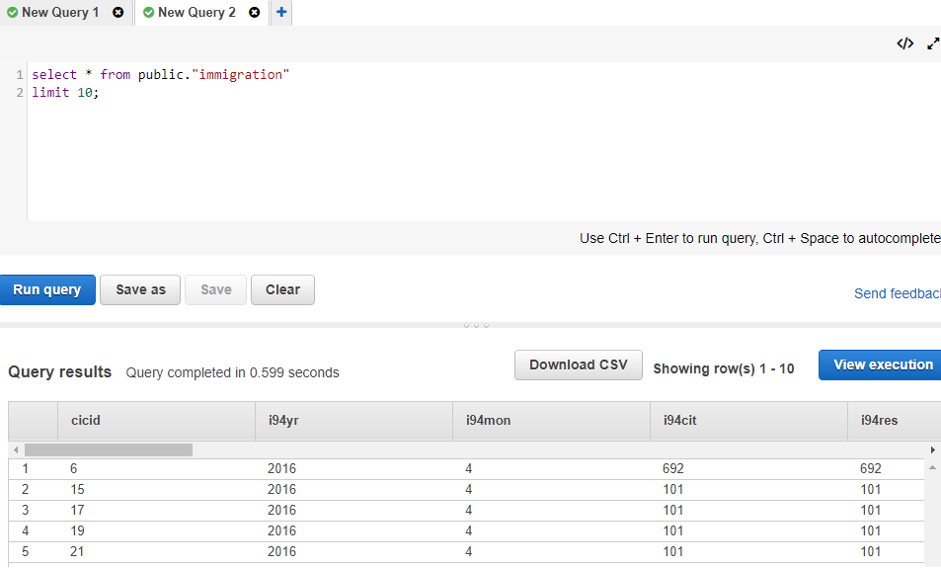

1. Data from cities table

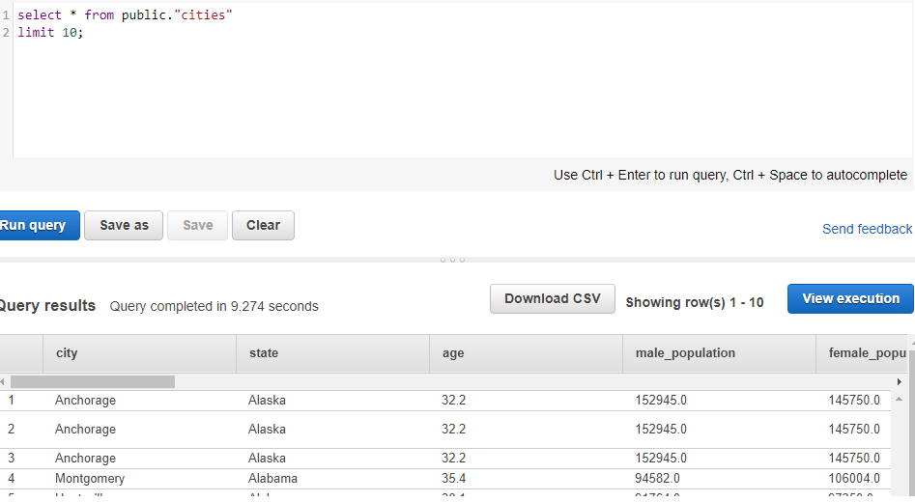

1. Selecting the visatype which is mostly used by immigrants

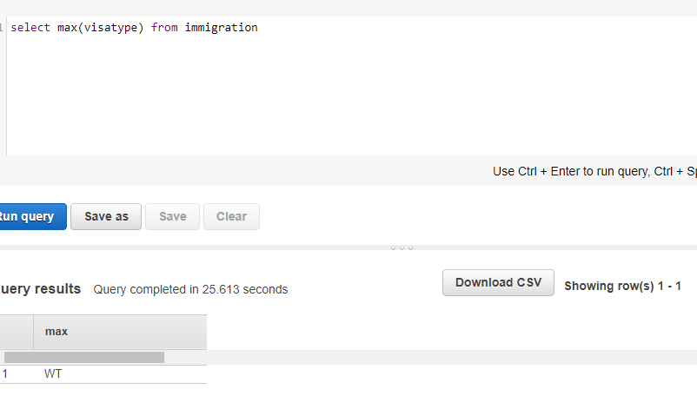

1. Selecting the city to which most number of migrants are settled
2. City where Most population are living and its temperature

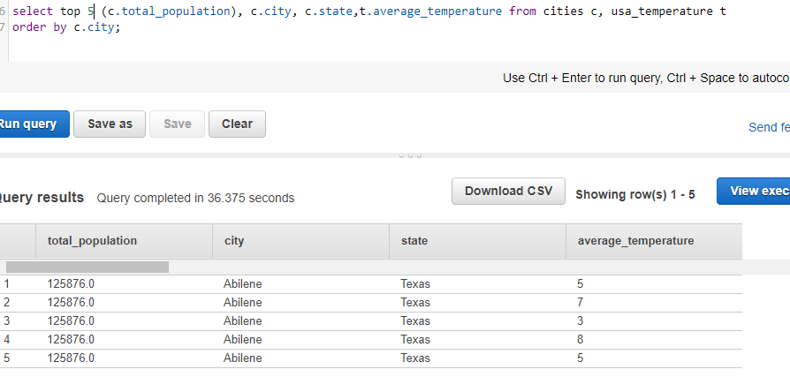

1. Top 5 airports name and its type mostly used by immigrants

