## **Brand Name: DBSmart Consulting**

**Mission Statement:**

By using University of Maryland course rankings, the DBMS project aims to help students make well-informed selections while choosing courses and to analyze the rankings to build insights for courses through years.

**Mission Objectives:**

* To fetch all the programs available at RH Smith business school which made top 10 list during a period of last 5 years.
* To analyze how the course rankings of a particular program evolved over the years.
* To fetch all the programs instructed by the smith school online.
* To find the programs which are not ranked by any sources

**Business terms and facts:**

* Each Program is described by a unique ID, name of the program, head of the program duration of the program, Contact Information, program Instruction Mode..
* Each Ranking is described by a unique Id, rank and scope of the rank(e.g.: Global rankings, Business school rankings).
* Each program has many rankings from different scopes but one rank is given to only one program.
* Each source is identified by a unique source Id with source name e.g. (U.S. News, Grad school Hub) and source URL.
* Each rank is derived from only one source based on scope of the rank e.g. ( Scope - U.S. News can rank MSIS in top 10 for public school rankings but it can be in top 50 for overall rankings)
* Each year is identified by unique year id and year term for that particular year
* Each year a program has multiple rankings.

**ER schema:**

## Entities, Attributes and Primary Keys

Program (**prgId**, prgName, prgHead, prgDuration, prgContact{1..2}, prgInstructionMode)

Ranking (**rankId,** rank, rankType)

Source (**sourceId**, sourceName, sourceUrl )

Year ( **yearId,** year, yearTerm)

## Relationships, Attributes, Degrees, Participating Entities and Constraints

Ranks: binary relationship

1 program to 0 or more rankings

1 ranking to 1 program

Corresponds: binary relationship

1 ranking to 1 or more years

1 year to 0 or more rankings

Derived: binary relationship

1 ranking to 1 source

1 source to 1 or many rankings

**ER-Diagram:**

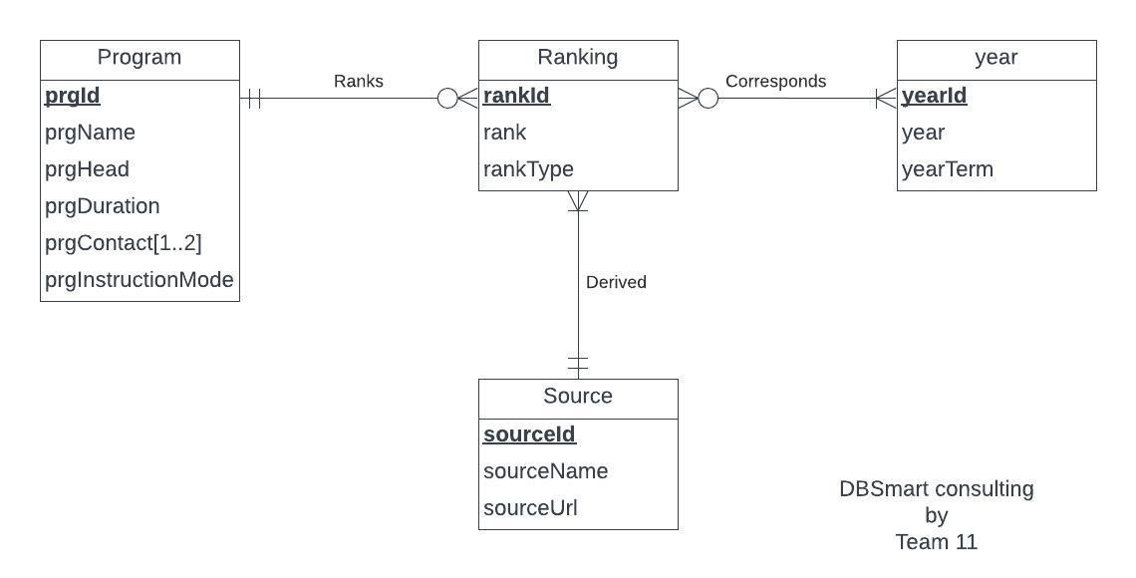

**Relations**:

Program (**prgId**, prgName, prgHead, prgDuration, prgInstructionMode)

ProgramContact (***prgId*,** **prgContact**)

Ranking (**rankId,** rank, rankType, *prgId,sourceId*)

Source (**sourceId**, sourceName, sourceUrl )

Year (**yearId,** year, yearTerm)

corresponds( ***rankId,yearId*)**

**Functional Dependency**:

prgId → prgName, prgHead, prgDuration, prgInstructionMode

prgContact , prgId→

rankId → rank, rankType, prgId, sourceId

sourceId → sourceName, sourceUrl

yearId → year, yearTerm

yearId,rankId→

**Business Rules**:

1. When Program information is deleted or changed in the database, all Program Contact information of the Program should be deleted or changed accordingly.
2. When a Program is removed from Smith School of Business, its ranking information should also be deleted.
3. When a Program information is updated in Smith School of Business, its ranking information should not be changed.
4. When a source information is deleted, its respective Source information should also be deleted.
5. When a source information is updated for a particular program, its source information should not be changed.
6. When there is a rank information for a particular year, its corresponding rank and the year cannot be changed or deleted .

## **Referential Integrity:**

|  |  |  |  |  |  |  |  |
| --- | --- | --- | --- | --- | --- | --- | --- |
| Relation | Foreign Key | Base Relation | Primary Key | Business Rule | Constraint: ON DELETE | Business Rule | Constraint: ON UPDATE |
| ProgramContact | *prgId* | Program | prgId | R1 | CASCADE | R1 | CASCADE |
| Ranking | *prgId* | Program | prgId | R2 | CASCADE | R3 | NO ACTION |
| Ranking | *sourceId* | Source | sourceId | R4 | CASCADE | R5 | NO ACTION |
| corresponds | *rankId* | Ranking | rankId | R6 | NO ACTION | R6 | NO ACTION |
| corresponds | *yearId* | year | yearId | R6 | NO ACTION | R6 | NO ACTION |

**Sample Data:**

Program:

|  |  |  |  |  |
| --- | --- | --- | --- | --- |
| prgId | prgName | prgHead | prgDuration | prgInstructionMode |
| 001 | Master of Science in Information Systems | Tej Anand | 1.5 | In-class |
| 002 | Master of Business Administration | Jack Daniels | 2 | In-class |
| 003 | Master of Science in Business Analytics | Suresh Acharya | 1.5 | In-class |
| 004 | Master of Finance |  | 1.5 | In-Class |

ProgramContact:

|  |  |
| --- | --- |
| prgId | prgContact |
| 001 | 301 405 8855 |
| 001 | tejanand@umd.edu |
| 002 | 301-405-2559 |
| 002 | smithmasters@umd.edu |
| 003 | 301 405 8654 |
| 003 | suresh12@umd.edu |
| 004 | 301 405 2333 |
| 004 | mcichell@umd.edu |

Ranking:

|  |  |  |  |  |
| --- | --- | --- | --- | --- |
| rankId | rank | rankType | prgId | sourceId |
| 01 | 6 | Public schools | 001 | 0001 |
| 02 | 8 | Overall | 001 | 0001 |
| 14 | 25 | world universities ranking | 003 | 0002 |
| 15 | 31 | world universities ranking | 003 | 0002 |
| 16 | 38 | world universities ranking | 003 | 0002 |
| 17 | 41 | world universities ranking | 004 | 0002 |
| 18 | 44 | world universities ranking | 004 | 0002 |
| 19 | 44 | world universities ranking | 004 | 0002 |

Source:

|  |  |  |
| --- | --- | --- |
| sourceId | sourceName | sourceUrl |
| 0001 | US News | [University of Maryland, College Park Overall Rankings | US News Best Colleges](https://www.usnews.com/best-colleges/university-of-maryland-2103/overall-rankings#:~:text=University%20of%20Maryland%2C%20College%20Park%20is%20ranked%20%2346%20out%20of,about%20how%20we%20rank%20schools.) |
| 0002 | QS Top universities | https://www.topuniversities.com/universities/university-maryland-college-park/university-maryland-robert-h-smith-school-business |
| 0003 | EDUniversal ranking | https://www.best-masters.com/ranking-master-accounting-in-north-america.html |

Year:

|  |  |  |
| --- | --- | --- |
| yearId | year | yearTerm |
| 1 | 2018 | Fall |
| 2 | 2018 | Spring |
| 3 | 2019 | Fall |
| 4 | 2019 | Spring |
| 5 | 2020 | Fall |

Corresponds:

|  |  |
| --- | --- |
| rankId | YearId |
| 01 | 11 |
| 02 | 11 |
| 03 | 11 |
| 04 | 11 |
| 05 | 11 |