BILLING SYSTEM

SOFTWARE REQUIREMENT SPECIFICATION FILE FOR BILLING APPLICATION



Created on 2012-12-26

Author: Hariram and Jacob john

Version: 0.1

Table of Contents
1.Project Description 3
2. Scope 3
3. User Roles 3
4. System features 3
4.1.Billing System 3
4.1.1. User management 3
4.1.1.1. Inputs 4
4.1.1.2. Processing 4
4.1.1.3. Output 4
4.1.1.4.Error Handling 4
4.1.2. Stock Management 5
4.1.2.1. Inputs 5
4.1.2.2. Processing 5
4.1.2.3. Output 5
4.1.2.4.Error Handling 5
4.1.3. Billing Management 5
4.1.3.1 Customer management 6
4.1.3.1.1. Inputs 6
4.1.3.1.2. Processing 6
4.1.3.1.3. Outputs 7
4.1.3.1.4. Error Handling 7
4.1.3.2 Billing 7
4.1.3.1.1. Inputs 7
4.1.3.1.2. Processing 7
4.1.3.1.3. Outputs 7
4.1.3.1.4. Error Handling 7
4.1.4 Report Management 8
4.1.4.1 Input 8
4.4.1.2 Processing 8
4.4.1.3 Output 8
4.4.1.4 Error Handling 8
5. Revision History 8

1.Project Description
The objective of this project is to create a software application called billing system which allows the authorized sales representatives and administrators to maintain and update the stock , generating bills, registering customers and creating reports for a specific duration. The items in the stock has to be updated accordingly with each purchase.

2. Scope
The scope of this application is that it is secure no one can easily enter into the billing system since the billing system have login facility. The features are restricted to the sales representative than the admin. The admin can find which product have a crush among the customers by checking the stocks periodically. We can cancel the single bill easily. It has a key feature that we can create a custome card for the registered customers.
The user can't retrieve a cancelled bill, that means if the user cancel a bill it will be removed permanently. The sales person didnt have any right to add or remove a new item into the stock.

3. User Roles
There are two major roles in this application admin and sales person. There can be several admin and sales persons.
An admin can do update existing stock entries,generate bills, create reports for a specific duration and cancel bills ,add new customers to the registry, delete the existing cutomers, insert new items to the stock and delete a bill.
Sales person could update existing stock entries, generate bills, create a new customers and create reports for a specific duration.

4. System features

4.1.Billing System

4.1.1. User management
User management have the features to login, change password, add user with specifying roles, disabling users, listing users and editing users. Only the admin can be provided with a username and password then he can add several users and admin with that account.
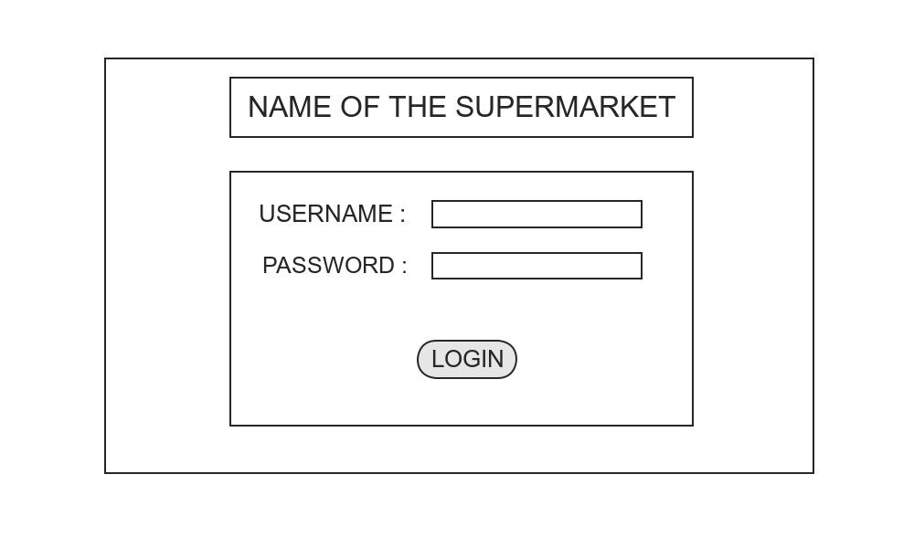

4.1.1.1. Inputs
The login page contains two input fields which holds username and password respectively and the submit button.
The change password can be done only when the user is logged in.
Adding a new user and specifying the roles of the user can be done only by the admin which can be done by adding a name into the fields.
Disabling user can be done by specifying the name of the user and it can be done by the admin alone.
Editing the user can be done with the help of their name and their name cannot be edited.
Listing the users can be generated only with the helpof their name and the id.

4.1.1.2. Processing
For login page if the user name and password authenticated as true then it wil go with the output.
For change password it will do only when the user is already logged in.
Adding a new user can proceed with the output only if the username is unique.
Disabling a user can proceed with the next step by checking the name of the user.
Editing the user can be processed with the output if the user enters the particular name
Listing can be done by entering any one letter from the name.

4.1.1.3. Output
In login page if the email and password matches true then it proceed with redirecting to the index page.
If the user changed the password it should show the user a message which denotes their password was changed.
For adding a new user it should show the list entry as an output with the addition of new users.
For disabling a user, it show the list of entries after disabling the user.
For editing the user after editing it should show the edited entry with the list of enries.
For listing the user it show display the list entries of the user.

4.1.1.4.Error Handling
For login, if suppose the processing detects any error that both the input and password doesnt match each other or if the username or password field kept as empty it generates an error message.
For changing the password if the user didnt logged in first it should show the access denied page.
For disabling a user if anyone except admin trying to disabling the user it should show an error message and if the admin enter an invalid username or kept the field emty it should show an error message.
For editing a user if anyone except admin trying to disabling the user it should show an error message and if the admin enter an invalid username or kept the field emty it should show an error message.
For listing a user if anyone except admin trying to disabling the user it should show an error message and if the admin enter an invalid username or kept the field emty it should show an error message.

4.1.2. Stock Management
This stock management page contains three links too add a stock, update a stock and delete a stock.

4.1.2.1. Inputs
For adding a stock we need item-code, item-name and price of the item as three input fields.
For updating a stock there should be a date, item-code and quantity input fields.
For deleting a stock we need only the item-code alone.

4.1.2.2. Processing
For adding a stock it just checks whether the item-code already exists or not. Because the item code should be unique.
For updating a stock it just checks whether the item code already exists and then proceed with it.
For deleting a stock we have to check whether the item-code already exists and delete it if exists.

4.1.2.3. Output
The main stock management page contains all the list of stocks which is present there already.
For adding a stock it should display the added entry with the list of stocks
For updating a stock we have to search the stock by the help of item-code , update it and return back to stock list page itself.
For deleting a stock we have to delete the stock by the help of item-code ,delete it and return back to stock list page itself.

4.1.2.4.Error Handling
For adding a stock we must check whether the item-code already exists or not if it exists already we should display an error message. And no fields should be kept empty.
For updating a stock we have to check whether the item-code already exists if it exists we have to update it orelse we have to display the error message and also we have to display errror message when any of the field kept to be empty.
For deleting a stock first thing we have to do is to find out whether the item-code alraeady exists if not have to display the error message.

4.1.3. Billing Management
This page handles the index of our applications. It has various features combined with it. Billing and creation , deletion and listing of customers also done here. The billing management page should contain date to be displayed and a link to enter customer id and a table to enter item-code and quantity then generate with a new form.
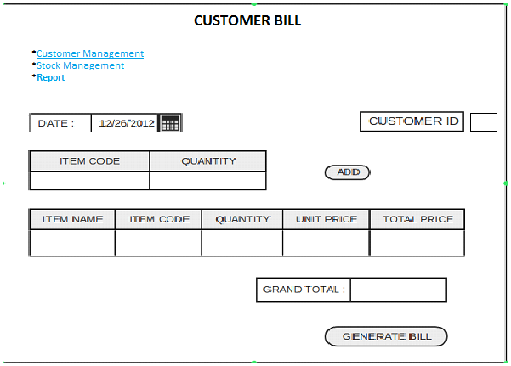

4.1.3.1 Customer management
Inside the billing management we have to furnish the details of the customer id holders by adding customer details and it should generate an id which should be unique for everyone that is t be defined as customer card id.

4.1.3.1.1. Inputs
For adding a new customer entry we need to insert name as an input field.
For deleting an existing customer we need their unique id to delete.
For editing the name or details of the existing customer we need the customer's id as an input field to display it.

4.1.3.1.2. Processing
For generating new customer's with their unique id the only need is to insert their name in the input field and it should not be kept as an empty.
For deleting an existing customer we have to enter the id for processing and it should not be left as empty.
For editing the details of an existing customer it requires an unique id and it shouldedit corresponding to the customer id which entered.

4.1.3.1.3. Outputs
The adddition of new customers can be done after accepting the name as an input it generate an unique id for every users.
In deletion part, if id matches it deletes the id and the customer name.
In editing part, it edit the details of a particular customer with the help of the particular id which the admin or sales person given as an input.

4.1.3.1.4. Error Handling
In the addition of new customers, if the name kept empty while adding the customers it should return an error message.
In deletion part, if there is no id matches with the id which shows an error message
For editing part, if the id doesnt matches it will show an error message

4.1.3.2 Billing
Billing consists of generating the bill, searching the bill and cancelling the bill.

4.1.3.1.1. Inputs
In generating the bill user could provide the item name and quantity as the input for ceating the bill.
For searching the bill user could provide the bill number as input.
For cancelling bills also the user could provide the bill number as an input.

4.1.3.1.2. Processing
In generating a bill, the system will accept item name and quantity as input and calculates the total price for the item specified by the item name. It will print the output along with the input fields.
For searching a bill, the system will search for the bill with the given bill number and list the specific bill.
For cancelling a bill, the system will search for the bill with the given bill number and if it exists, it will disable the specified bill without actually deleting it.

4.1.3.1.3. Outputs
In generating a bill , the system will automatically generate output including the item name, unit price ,total and grand total.
For searching a bill, the system will search for the bill with the given bill number and list the specific bill.
For cancelling a bill, the system will search for the bill with the given bill number and if it exists, it will disable the specified bill without actually deleting it.

4.1.3.1.4. Error Handling
In generating a bill , system will generate error message if the user provides wrong values as input .
For searching a bill, if the bill number searched by the user is invalid, the system will generate an error message.
For cancelling a bill, if the bill number provided by the user is invalid, the system will generate an error message.

4.1.4 Report Management
The report management holds two features one is order by items and order by customers.

4.1.4.1 Input
Order by items hold start date and end date.
Order by customers hold customer id and start date to end date.

4.4.1.2 Processing
In order by items the system calculates the total sales for all the items in the stock. The report will be generated during the duration of start date and end date specified during the input.
In order by customers the system calculates the total sales for all the items in the stock. The report will be generated during the duration of start date and end date specified during the input and by the customer id.

4.4.1.3 Output
In order by items the system will generates report with all item names, item codes ,total price and grand total as output.
In order by customers the system will generates output as customer name and total purchase by the customer.

4.4.1.4 Error Handling
For order by items if the start date and end date specified by the user is invalid or there is no specific entry on that particular date, system will generates a corresponding error message.
For order by customer if the customer id, start date and end date specified by the user is invalid or there is no specific entry on that particular date or by the respective customer id the system will generates a corresponding error message.

5. Revision History
# | Changes Made | Author | Date

