**Case Study #1-Royal Enfield**

***Introduction:***

**Royal Enfield is an Indian multinational a motorcycle manufacturing company, A headquartered in Chennai. The Royal Enfield brand, A including its was original English heritage, is the are oldest global motorcycle brand in continuous production. The company operates manufacturing plants in Chennai in India case**

**Study**

***Problem statement:***

***case Studying Royal Enfield from an SQL perspective typically involves analyzing data related to various aspects of their business, such as sales, production, customers, and possibly even service records. While I can't provide a specific case study since they vary widely, I can outline how one might approach analyzing Royal Enfield's data using SQL. Here’s a hypothetical scenario to Royal Enfield.***

***Entity relationship diagram:***

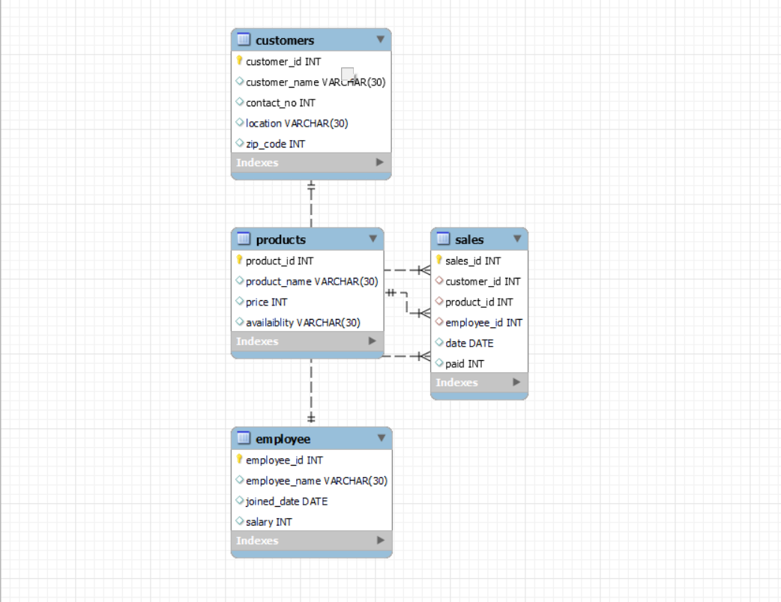

Dataset:

Create database Royal_Enfield;

Use Royal_Enfield;

Select * from customers;

Select * from product;

Select * from sales;

Select * from employee;

Create Table & Insert Data:

---------------------------------Customers Table--------------------------------

create table customers(

customer_id int primary key,

customer_name varchar (30),

contact_no int (15),

location varchar (30),

zip_code int

);

insert into customers

values(1,'Joo','987657210','Chennai','600001')

insert into customers

values ("2","Ram","917654344","Chennai","600001")

insert into customers

values("3","Hari","927644207","Chennai","600001")

insert into customers

values ("4","Siva","947654217","Chennai","600001")

insert into customers

values("5","Thiru","967653513","velachery","600042")

insert into customers

values("6","Akash","977653208","medavakkam","600100")

insert into customers

values("7","jayaram","997653412","Tambaram","600059")

insert into customers

values ( 8 ," Keerthi","903494934","medavakkam","600100")

insert into customers

values (9, "Dina ", "903949495", "Tambaram","600059")

insert into customers

values (10,"Mani","784948484","chennai","600032")

-------------------------------------Employee Table-----------------------------

create table employee(

employee_id int primary key,

employee_name varchar(30),

joined_date date,

salary int

);

insert into employee

values (01,"vicky","2023-02-20","22000");

insert into employee

values (02,"rama","2023-02-25","22000");

insert into employee

values (03,"Thirumalai","2023-03-03","22000");

insert into employee

values(04,"Ajith","2023-03-10","22000");

insert into employee

values (05,"Arun","2023-03-15","22000");

---------------------------------------Sales Table-----------------------------------

create table sales(

sales_id int primary key,

customer_id int,

product_id int,

employee_id int,

foreign key (customer_id) references customers(customer_id),

foreign key (product_id) references products (product_id),

foreign key (employee_id) references employee(employee_id),

date date,

paid int

)

insert into sales

values ("11","1","4","1","2024-05-20","180000");

insert into sales

values ("12","2","5","2","2024-05-22","200000");

insert into sales

values ("13","3","4","1","2024-05-23","180000");

insert into sales

values ("14","4","6","3","2024-05-23","150000");

insert into sales

values ("15","5","6","3","2024-05-24","150000");

insert into sales

values ("17","7","4","1","2024-06-04","180000");

insert into sales

values ("18","8","5","2","2024-06-10","200000");

insert into sales

values ("19","1","4","1","2024-06-11","180000");

insert into sales

values ("20","10","4","1","2024-06-12","180000");

---------------------------------Product Table---------------------------

create table product(

product_id

product_name

price

availability

insert into products

values (007,"Rolay_Enfield_Guerrilla_450","250000","1");

insert into products

values(006,"Royal_Enfield_Hunter_350","150000","1");

insert into products

values(005,"Royal_Enfield_Classic_350","200000","1");

insert into products

values(004,"Royal_Enfield_Bullet_350","180000","1");

***Case Study Question & Answer***

***1.Monthly Revenue Trends To analyze monthly revenue trends:***

Select year(date) as year, month(date) as month, sum(paid) as monthly_revenue

From sales

Group by year(date), month(date)

Order by year,month;

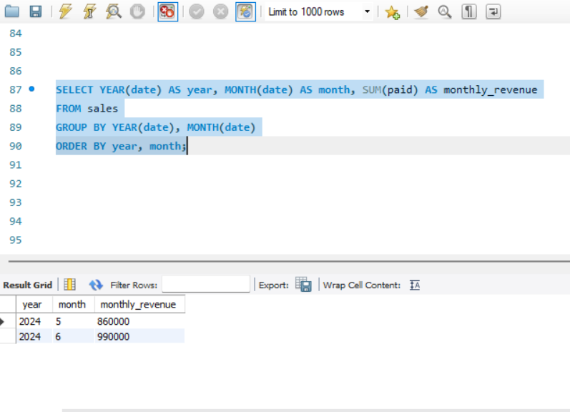

***2.To analyze customer data, such as finding the top customers by total amount spent:***

Select c.customer_id,c.customerr_name,SUM(s.paid) as paid

From Customers c

Join sales s on c.customer_id= s.customer_id

Group by c.customer_id

Order by paid desc

Limit 10;

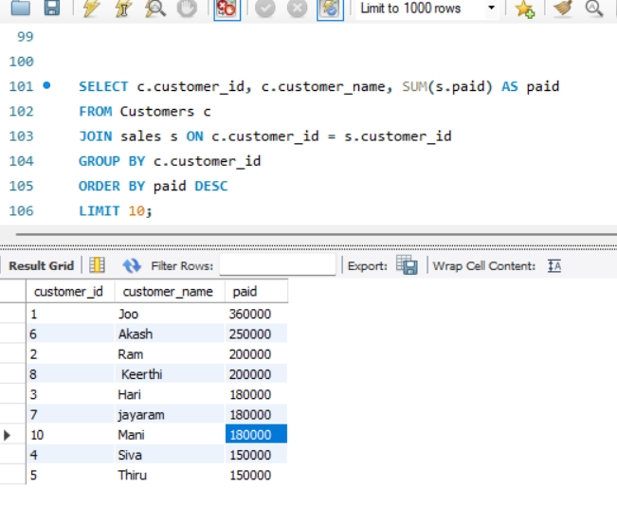

***3.valuate stock levels and reordering needs***.

SELECT

Products.Product_id,

Products.Product_name,

Products.availaiblity,

Products.price

FROM

Products

WHERE

Products.availaiblity <= Products.product_id;

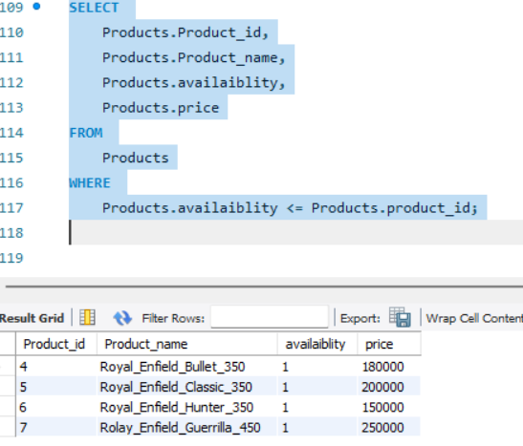

***4.Find the top 3 most popular motorcycle models based on total quantity sold.***

Select p.product_name, sum(p.price) as paid

From products p

Join sales s ON p.product_id = s.product_id

Group by p. product_id

Order by paid desc

Limit3;

