User Story 1

A Maze (as defined in Maze1.txt consists of walls 'X', Empty spaces ' ', one and only one Start point 'S' and one and only one exit 'F'

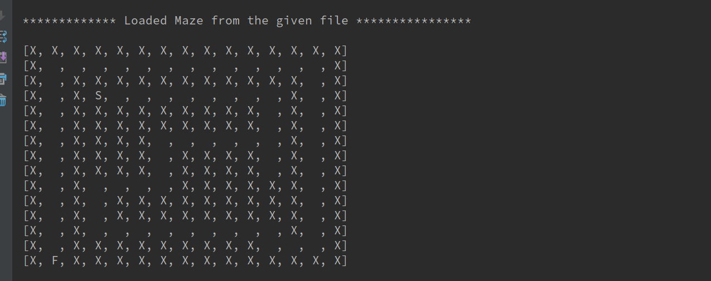
After a maze has been created the number of walls and empty spaces should be available to me

After a maze has been created I should be able to put in a co ordinate and know what exists at that point

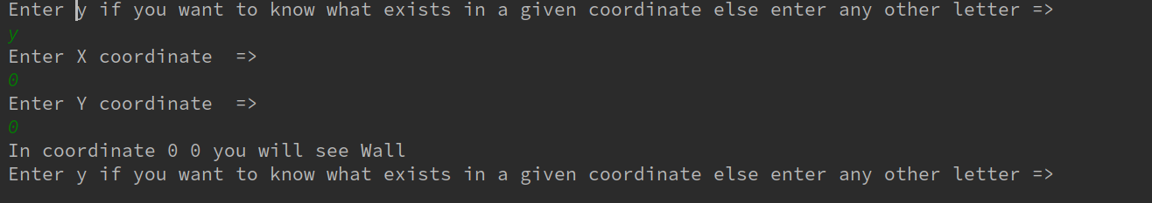
User Story 2

Given a maze the explorer should be able to drop in to the Start point

An explorer on a maze must be able to move forward

An explorer on a maze must be able to turn left and right (changing direction the explorer is facing)
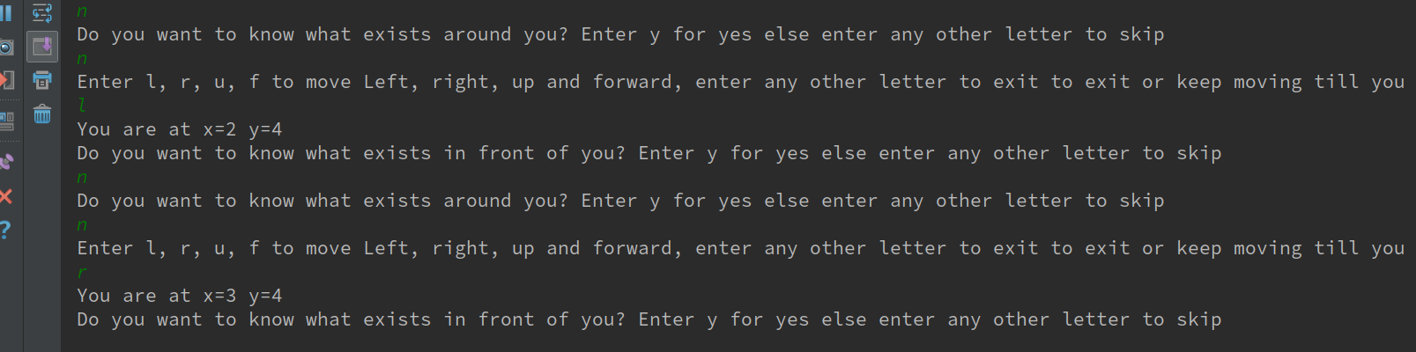

An explorer on a maze must be able to declare what is in front of them
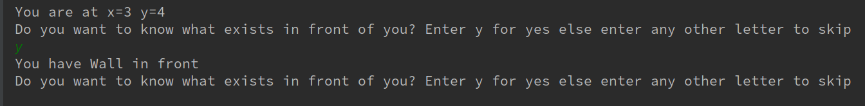
An explorer on a maze must be able to declare all movement options from their given location
An explorer on a maze must be able to report a record of where they have been in an understandable fashion

