**Comprehensive Feature Overview**

unikrew.com

Confidential © 2023

Unikrew Solutions Pvt. Ltd.

Table of Contents

Cascade™ Loan Lifecycle Management Platform 4

Intuitive and Business-Oriented UI/UX 4

API Configuration 4

Channels 5

Captures the Complete Customer Journey 6

Cascade™ e-KYC and Originations 7

Prospecting and Lead Generation 7

Data Capturing 7

Field Definition and Validation 7

Dynamic forms 8

Credit Initiation And Decision-Making 8

Profile Checks 9

Bureau Check And Exposure 10

Limit management 10

Policy engine 10

Scoring engine 13

Peer benchmarking 13

Security-wise LGD 14

Pricing 14

Approvals And Recommendations 15

Application Routing And Approval Hierarchy 15

Escalations 17

Disbursement And Client Documentation 17

Documentation 17

Disbursement And Funds Movement 18

Document Management 18

Cascade™ Collections – Optional Module Offered 23

Data Ingestion 23

Strategy And Queues 25

Strategy 25

Queues 26

Allocations 26

Actions 27

Performance Management 28

# Cascade™ Loan Lifecycle Management Platform

## Intuitive and Business-Oriented UI/UX

While developing UI/UX for Cascade suite we followed the design methodology which included several aspects leading to a human centered design which eventually contributes to a UI/UX that users can relate to in terms of productivity in their daily operations. We did design research which can be done as either primary, secondary, exploratory, or evaluative research. We used a combination of exploratory research and primary research techniques to define the problem accurately. This was done by interviewing participants to explore different design concepts and think outside the box.

## API Configuration

Below is how a group of APIs for disbursement has been configured as a set of APIs for effecting disbursements. This entailed usage of two APIs called in a specific sequence.

*Configuration screen, where the user setup the flow of APIs*

*Configuration detail screen, where user can set & view the details of APIs*

*This is the list of disbursements hits with their status.*

*This is the screen where the user can see the disbursement process through a diagram & status.*

## Channels

The entire digital banking journey is available on all channels with a uniform customer targeting user interface.

The channels covered include mobile app, tablet app, web interface. Each front-end journey component can be viewed (based on security settings) by the bank team at the back office.

Integration with SMS, email, and WhatsApp banking platforms allow notifications to be configured at any stage.

A journey that begins on one channel can be continued on any other channel.

## Captures the Complete Customer Journey

CascadeTM covers the entire journey from customer prospecting to digital onboarding, to loan origination, to loan management, and ending on collections and recoveries.

# Cascade™ e-KYC and Originations

The product consists of an end-to-end loan origination system that covers all aspects of the origination journey. These aspects are mentioned in detail in the following sections.

## Prospecting and Lead Generation

The system has the ability to cover the lead generation process where prospective customers can be considered by prescreening them for a potential loan offer and conversion. This involves capturing data of future customers and applying specific rules, and pre-checking them before passing them on to the next stage for exposure management and further processing. Lead generation is accompanied by reports that specify prospective customers' conversion rates into converted loans.

Using the above-mentioned Lead Generation, Workflow Enquiry & Filters, an end-to-end Lead Management can be carried out using the system.

## Data Capturing

This module covers the data capturing process throughout the application’s lifecycle during all stages of the application processing and approvals. This module governs all the data entry-related operations, including field validations, interdependencies, and associated calculations.

### Field Definition and Validation

Fields can be defined dynamically as part of this module and their associated details, including name, code, description, nature (required or optional), grouping, etc. New fields can be added without any development, and existing ones can be modified using the same methodology.

Similarly, all field validations that must be applied to a given field to ensure data quality and accuracy can be defined using the user interface. These validations may include basic ones like required/optional, minimum/maximum length, and advanced ones like regular expressions and interdependent calculations like age, years in business, etc.

### Dynamic forms

This module has the functionality of dynamic forms, enabling the organization to add new fields, stages, and validations to the data capturing form without needing development. The module automatically adjusts fields on the form and draws it on a web and mobile-based interface using the pre-defined configuration in the production factory. This removes the need for development in the event of changes in the data capturing fields because of a regulation or internal need.

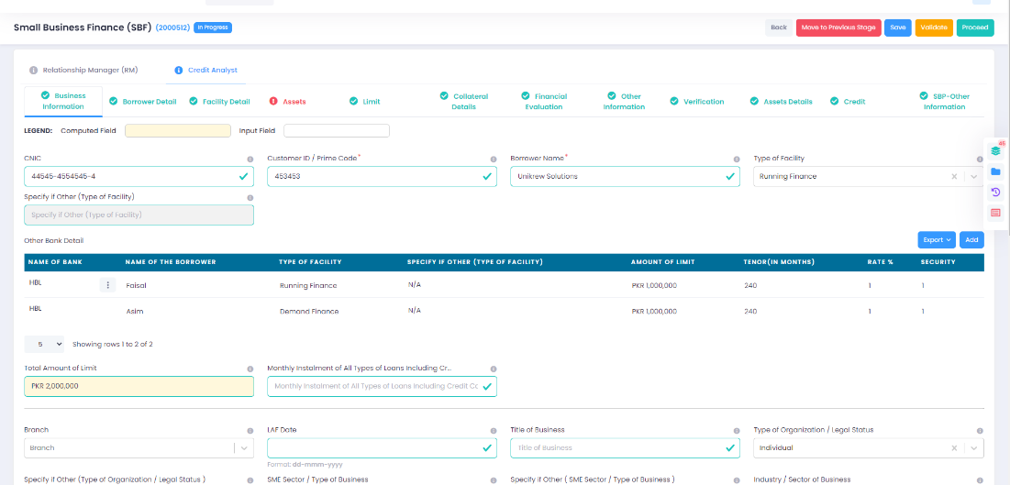

## Credit Initiation And Decision-Making

This module covers the process which involves credit initiation and decision-making of the loan application captured using the data capturing module. It covers all the aspects, including approvals, exposure, and bureau checks.

### Profile Checks

This sub-module is responsible for checking the customer’s profile against lists and checks, which include the following.

1. Fraud
2. Anti-money laundering
3. Political exposure
4. Anti-terrorism list
5. Deduping – checking known associates of the customer against previously disbursed loans
6. NADRA Verisys using API
7. Defaulters list

Except for deduping and defaulters list (built-in), these checks require integrating relevant providers and lists. These lists and subscriptions can be separately acquired by relevant authorities. These checks ensure that only such customer which qualify for specific criteria go through the next stage.

If a match is found, the system can automatically reject the case or park it in a bucket for review and approval as per the defined process, in cases where co-borrowers and multiple shareholders in the company, these checks are performed for all individuals.

### Bureau Check And Exposure

This sub-module is responsible for performing bureau checks and automatically generating the exposure sheet according to the defined criteria and product family mapping built in the system. Integration with Data Check ensures that the system automatically fetches the bureau and credit history of the customer and generates an exposure sheet using the product family configuration. The generated exposure sheet contains the following.

1. Secured exposure
2. Unsecured exposure
3. Details of previous loans
   1. Product
   2. Outstanding amount
   3. EMI (if applicable)
   4. Limit (if applicable)
   5. Delinquency
   6. Maturity (if appliable)

Using the exposure and information received from the bureau, DBR and DSR are calculated considering the income entered or calculated in the data capturing module.

### Limit management

This sub-module governs the assignment of limits based on exposure, policies, and scorecard. Limits can be manually or automatically assigned based on pre-defined criteria. While setting limits, previously assigned limits and sanctioned loans also assist decision-making. These limits can be assigned multiple heads and products per the customer’s need.

### Policy engine

This sub-module is responsible for executing predefined policies automatically during the entire life cycle of the loan application. These policies include prudential SECP and State Bank regulations and those defined by the financial institution’s internal risk management and compliance. The policies can be defined using the visual condition builder on any data element (entered or computed). The module also allows time-based policies to help financial institutions offer time-bound relaxation and waivers. This module's dynamic and flexible nature enables financial institutions to define policies on the fly without any complex development.

Policies have two types, mainly error and warning. The policies with type errors will prevent the application from being approved until a decision is made on the policy violation. At the same time, the ones with type waning don’t need any approval; however, they are tagged with the application and reported in relevant reports.

For all such policies with type error, a deviation is tagged, which needs to be acted upon and approved before the case can proceed any further. In case of a policy violation, relevant deviations are automatically created and assigned to approval authorities.

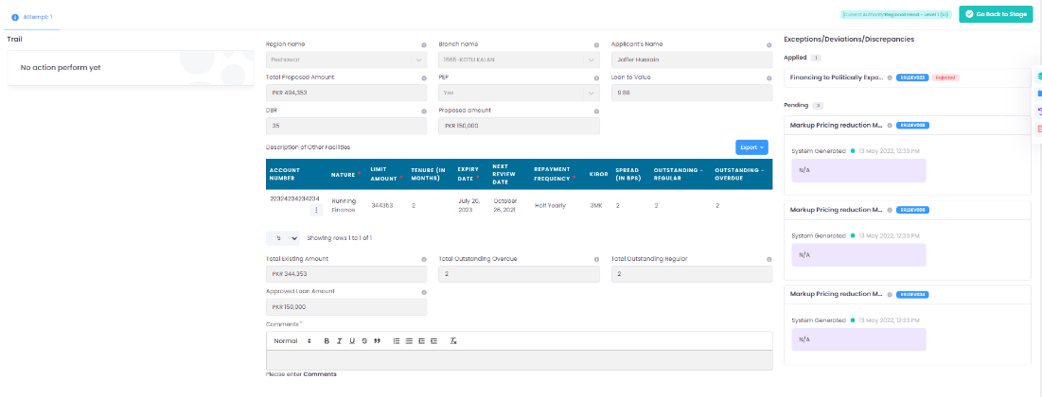

### Graphical user interface, application Description automatically generatedScoring engine

This sub-module is responsible for automatically generating the scorecard using the pre-defined conditions that execute on the data elements (either entered or computed). Cut-offs and labels can be assigned for decision-making purposes based on the calculated scorecard. Cases are automatically categorized as per the scoring result. Scoring can either be done using a predefined static scorecard or a machine learning-based scorecard trained on historical data of loan origination and delinquencies.

The module also allows for time-based scoring criteria to help financial institutions offer time-bound relaxation and waivers and experiment with a few tweaked parameters.

### Peer benchmarking

As part of the scoring process, the module can generate peer benchmarks and percentiles for evaluating the customer with respect to others in the same sector. Data needs to be fed into the system, which can be arranged separately by the financial institution via different data agencies.

### Security-wise LGD

This module can compute variables to arrive at security-wise LGD (loss given default). These variables are calculated using earlier parameters during the scoring and data capturing phase. Currently, the following variables are calculated:

1. Haircut percentage
2. Pre haircut collateral coverage
3. Secured portion.
4. Unsecured portion
5. Weighted average

### Pricing

This module is responsible for managing pricing and fees for the loan approved using the process and stages mentioned earlier. It includes the computation of the following elements. More can be added if needed:

1. Markup
2. KIBOR
3. Spread
4. Processing fees
5. FED

The module also allows for time and condition-based markup and processing, which can help financial institutions offer time-bound offers and relaxations. It will enable conditions, special markup rates, and processing fees for specific segments based on any data elements captured during the lifecycle.

The module can have fixed or variable rates, which can be helpful while designing products for the end customer. Similarly, FED is defined based on the province to which the loan application belongs.

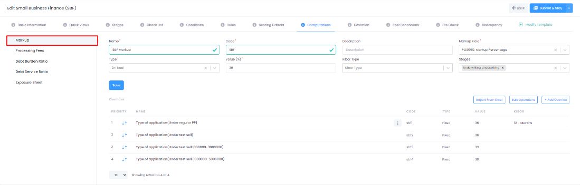

## Approvals And Recommendations

This module governs the process of approvals and recommendations that a loan application goes through during its lifecycle. This includes automatic application routing, approval hierarchy, and escalation levels.

### Application Routing And Approval Hierarchy

This sub-module manages the application routing for approval and processing purposes during the lifecycle of the loan application. It automatically routes the application to a relevant user or group of users for approval and recommendation based on certain conditions and parameters predefined in the production factory. It also considers the deviations and limits on top of other parameters from the data capturing stage. Condition builder and product factory can define complex routing hierarchies and levels.

A given approval level has the following decisions based on its application assessment, including its data, exposure, limits, etc. Detailed comments can be mentioned during the approval process for later reference and action.

1. Recommend
2. Approve
3. Reject
4. Review

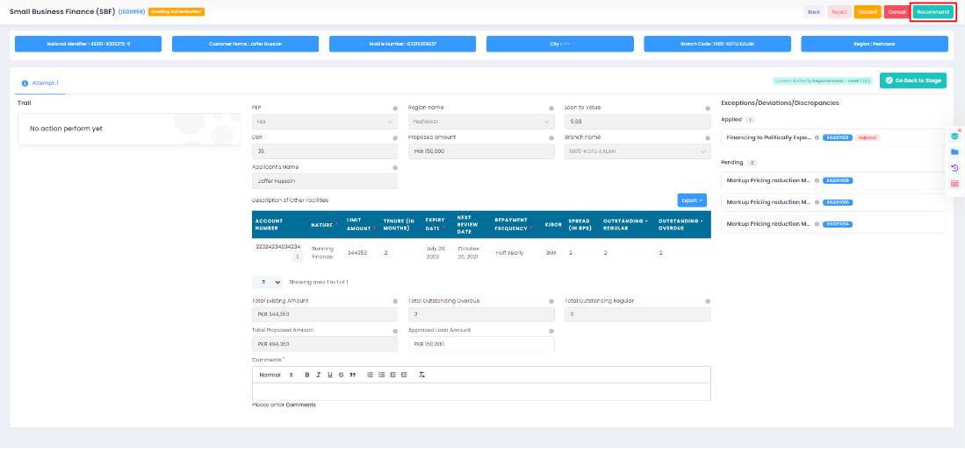

Based on these actions, the application is routed to the relevant authority. Additionally, the administrative user can bypass the application or assign it to a temporary approval authority if the primary authority is absent.

During this phase, the module allows for a synopsis window. The approval authority can provide approvals and recommendations with specific changes in limits, tenure, and other data elements related to the customer’s offer. It generates an end-to-end trail and modifications made by each approval level during the lifecycle. This trail contains details that can serve both internal and external audit requirements.

### Escalations

This sub-module handles the escalations and related matrix, which may be followed during the approval and application processing. A detailed escalation matrix can be configured with a hierarchy and groups handling the escalations. When an escalation occurs, a notification is sent to the higher authority along with relevant details. Similarly, the entire application can also be moved to the bucket of pertinent users or groups to handle the escalation.

## Disbursement And Client Documentation

This module covers the process that manages the disbursement-related activities, including financial and documentation-related activities, including the movement of funds, and getting legal documentation.

### Documentation

This sub-module allows the financial institution to automatically generate all kinds of documents from the system with predefined templates, including offer letters, agreements, sanction-related documents, and other necessary documentation as defined by the internal process. It also allows the users to get the documents signed and upload signed and stamped copies for later referencing and compliance requirements. These documents can also be emailed to the customer for reference if configured. The steps at which the documents get generated along with the relevant stakeholders can be configured as per the business process of the financial institution.

### Disbursement And Funds Movement

This sub-module makes the actual transaction of funds movement or limit creation once the loan is approved using the steps mentioned above based on the approved limits during the approval phase. Based on the nature of the approved loan, either movement of funds can take place, or a limit can be assigned which can be utilized later. In both cases, communication with relevant systems is done using APIs or other integration methods to perform the task.

In disbursement, there are two steps involved in the process.

1. Creation of a loan – A new loan is created in the core banking or accounting system using the predefined GL codes and account heads. It ensures that relevant bookkeeping is done before the movement of actual funds. This also includes creating a repayment account using which repayments would be handled at a later stage.
2. Movement of funds – Once a new loan account is created, funds are moved to the customer's account using the integration with the internal core banking system or other financial institutions using REST APIs or a similar integration channel. SAF (store and forward) mechanism ensures robustness at this stage.

In case of limit creation, relevant entries are passed in the core banking or accounting system, along with creating a running finance account used to withdraw and move funds based on the assigned limit. The actual movement of funds is on-demand when the user utilizes the limit assigned to them.

## Document Management

This module covers the complete functionality of document management in Cascade suite. It includes end to end management of document, along with its lifecycle, storage archiving and retrieval using indexing. Due to flexible nature of the module, it can be enabled using configuration at any stage of the loan application lifecycle. This module has the following features which enable users to utilize complete functionality while working on Cascade suite.

1. Document upload using file upload or browser extension.
2. Document versioning and retrieval
3. Document tagging with respect to the type.
4. Document preview with rotate, zoom and search.
5. Document thumbnail and search for easy access
6. Association of documents with checklist and discrepancy resolution



*Toggle for uploading file via extension or browser*

*Document Upload File Selection*

*Document Upload Via Extension*

*Document Upload via browser*

*Documents List in Grid View*

*Documents List in Thumbnail Preview Mode*



*Version of file and actions (view, version upload, download, delete) against a file*

*Individual Document Preview Mode*

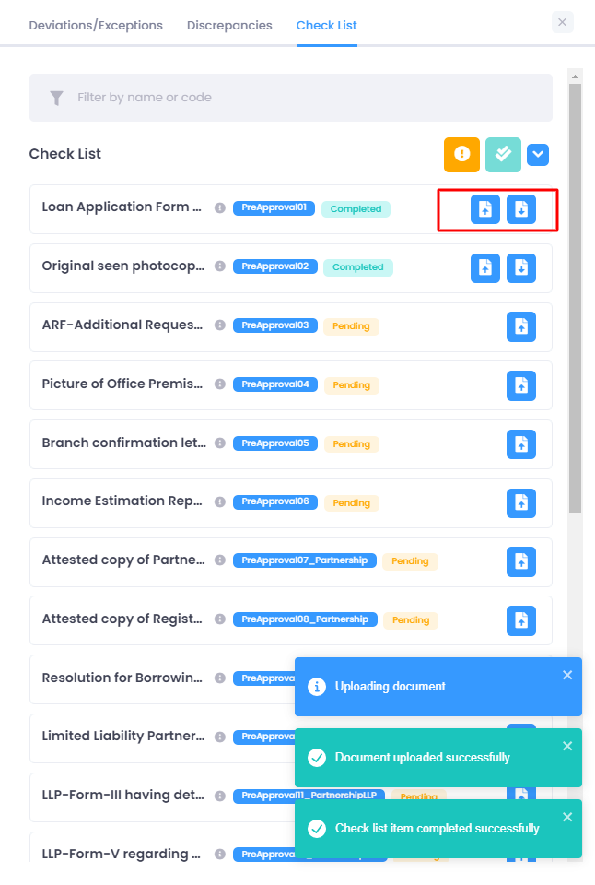

*Documents can be uploaded against a checklist item*

*Document based Discrepancy can be created*

*Discrepancy with document example*

# Cascade™ Collections – Optional Module Offered

The product consists of an end-to-end loan collections system that covers all aspects of the collection-related processes and procedures. These aspects are mentioned in detail in the following sections.

## Data Ingestion

This module governs the process which feeds the data from the Core Banking System or Cascade Asset Management module, whichever the case may be. In the case of Core Banking System, ETL is used to ingest the data, whereas, for Cascade Management, data can natively travel to the collection module for onward processing.

The data is fed for individual loan types to provide the flexibility of defining separate processing rules and conditions as per the product. The data includes particulars of each loan account that is active in the loan management system with respect to the following attributes:

1. Basic product information
2. Customer details
3. Contact details
4. Limits and collaterals
5. Installments (in case of term finance)
6. Withdrawals (in case of running finance)
7. Repayments

This data is extracted, transformed, and loaded in a staging area where the computations regarding DPD (days past due) and delinquency are performed and further used in subsequent stages of the collection process. At the same time, other CASA relationships of the customer are also fetched from the core banking system for the presentation of the customer’s 360-degree view on the collector’s screen. Only linkages with other relationships are drawn at this stage; the account balance is fetched in real-time at the collector’s request.

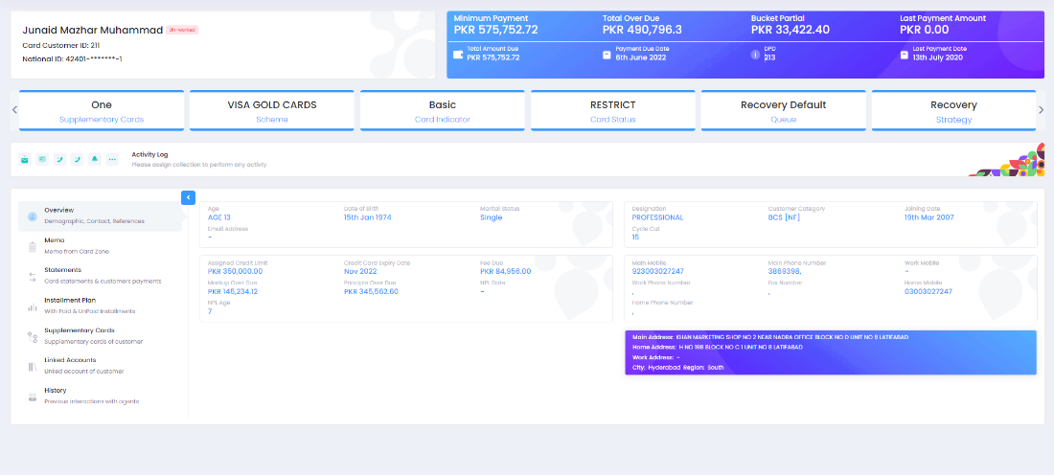

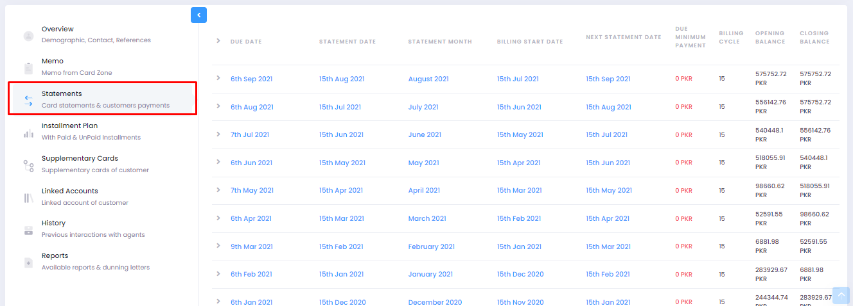

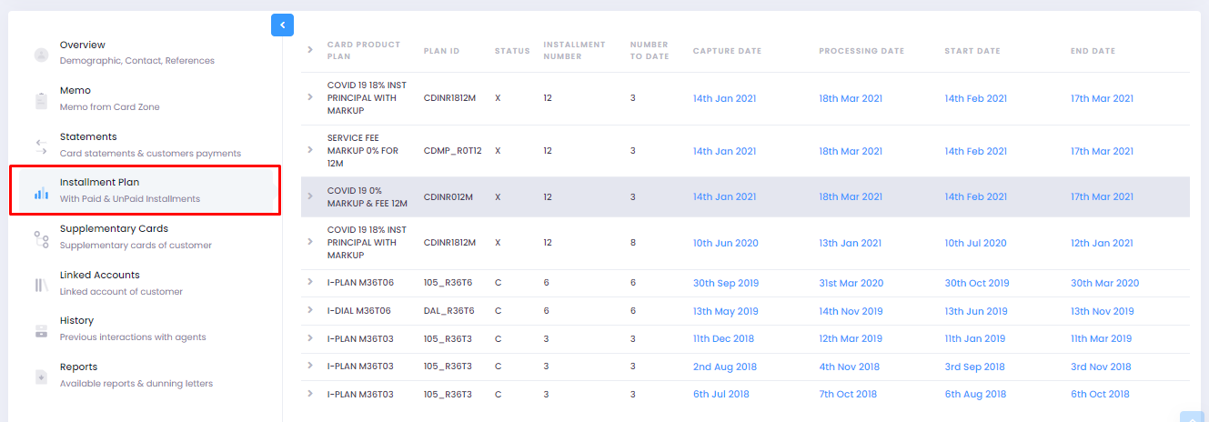

## Strategy And Queues

This sub-module manages the assignment of strategies and queues to the incoming accounts via the data feeding module. Further actions and allocations of the loan accounts are done based on the assigned strategies and queues.

### Strategy

Strategy is a way of categorizing loan accounts using the DPD primarily along with other parameters. It governs what kind of action a collector takes on such accounts and how such a customer will be dealt with during the collection process. This also determines the options given to the customer, such as a promise to pay for a partial amount. These can be configured using the product factory using any data element ingested or calculated by the data feeding module. Generally, the following strategies are used in the industry based on DPD:

1. Preemptive
2. Frontend
3. Mid-range
4. Hardcore
5. Recovery

### Queues

Queues are the second level of categorization after strategies, and it mainly assists in assigning loan accounts to the relevant collector with a specific skill set and experience. They are generally made using characteristics that a charge may possess, such as geographical hierarchy, tags (deceased, skip, legal, and others), past payment behavior, etc. A queue can span across multiple strategies, which allows the financial institution to use collectors effectively based on their core competency. A few examples of queues can be:

1. Low balance
2. Skip
3. Deceased
4. Fraud
5. Legal
6. Nonstarter

The queue configuration can also be found in the product factory, using which queues can be flexibly developed without the need to develop.

## Allocations

This sub-module handles the allocations and assignment of the loan accounts to collectors and their reassignment and escalations. It has the functionality to provision manual and automated allocation as per the need of the financial institution. Each strategy has a TAT which this module tracks. In case of escalation, a notification is sent to the supervisor, and if configured, the loan account is automatically assigned to the supervisor.

The allocation amongst collectors can be done in any manner based on the configuration for that product.

1. Manual allocation by the supervisor – In this mode, all loan accounts are parked in a staging area from where a supervisor can assign them to collectors manually in bulk.
2. Round robin allocation – In this model, the system assigns loan accounts to the pool of collectors, ensuring a consistent workload amongst all collectors in a round-robin fashion.
3. Shared pool allocation – In this model, the system parks relevant accounts to a shared pool of collectors from where accounts can be picked, assigned, and worked upon



*Example of manual allocation*



*Example of manual reassignment*

## Actions

This sub-module enables collectors to perform actions and record reactions against the loan accounts assigned to them for collection and recovery purposes. The actions available to the collector are governed by the given strategy and its associated configuration in the production factory. All actions performed are recorded in the activity log, which can be viewed and exported for audit purposes. Every time an action is performed, an associated reaction must be recorded along with remarks (if applicable). Generally, the following actions are available, and more can be added if required:

1. Outgoing call
2. Incoming call
3. Customer visit

Based on these actions, the following reactions can be configured, and more can be added if required:

1. Promise to pay –the customer promises to make a full or partial payment based on the dues. The system automatically tracks if the customer paid on the promised date and marks it as kept or broken
2. Phone not responding – in this case, a counter is marked against the customer
3. Talked to a relative – in this case, a counter is marked against the customer, and information is logged in the digital diary
4. Special conditions (Deceased, skip, fraud, etc.) – in this case, a tag is marked against the loan account, and it is assigned to the relevant collector for further action

The actions and reactions marked against the account generate counters that eventually determine the customer's historical responses, showing their behavior.





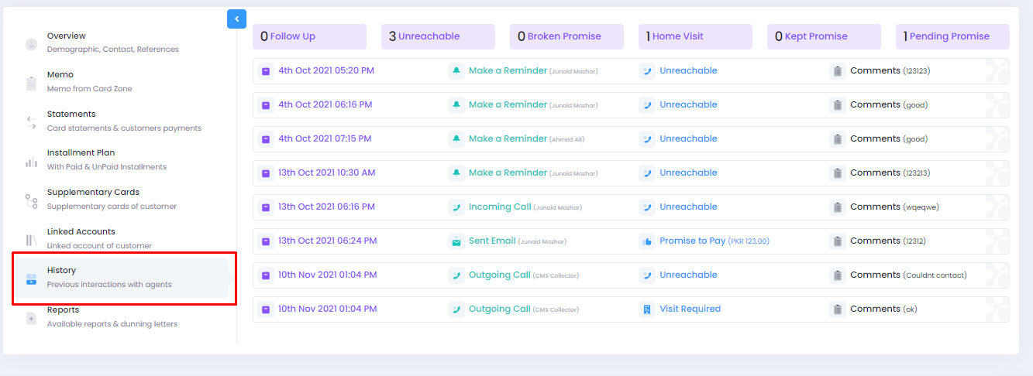

## Performance Management

This sub-module manages collectors’ performance as they perform actions and record reactions. The system determines the repayments and recoveries that the customers have done according to the actions performed by the collectors and promises taken by them. Every action of the collector is logged, and pre- and post-analysis are done based on which the performance and effectiveness of the collector are determined.

Based on this data, commission structure can also be configured, using which the commission and payouts of the collectors can be determined monthly. The performance and commission of supervisors and heads will be that of collectors with a particular factor who are working under their supervision and leadership.