User Creation Guide

U N I K R E W S O L U T I O N S

Contents

Groups 3

Users 10

Deleting a User 19

# Groups

Maker

1. Login Page. Log in with your credentials to proceed.

2. Click on the ‘identity’ tab then on ‘Groups’.

**Note**: Modules and tabs may vary according to the rights assigned to the user.

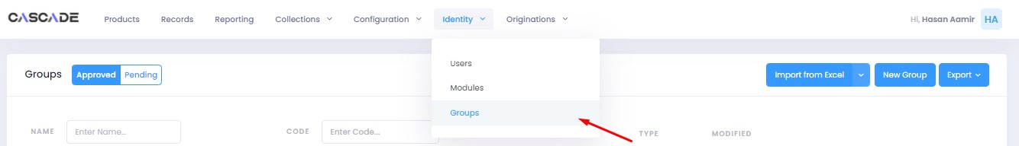

3. Click on ‘new group’ to create a new group.

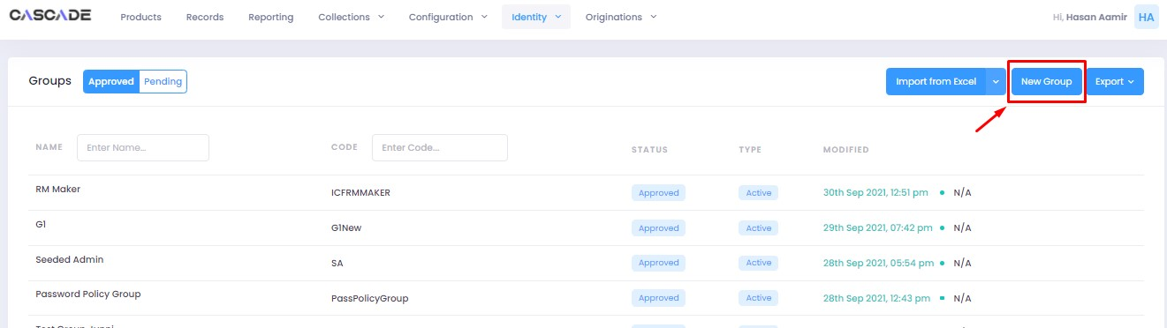

4. Fill all the required fields, then click on the ‘add modules’ button to select modules from a drop-down menu. 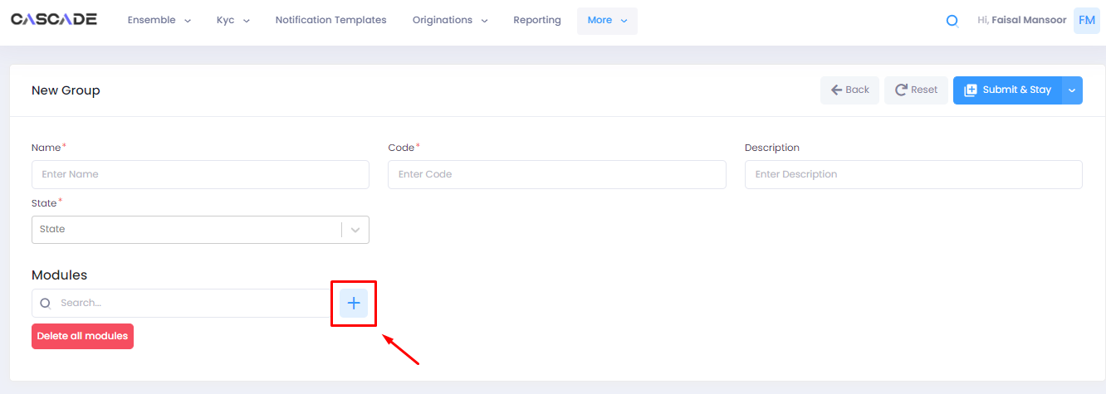

5. After you select a module, you will further be able to select the rights to assign relevant to the selected module. 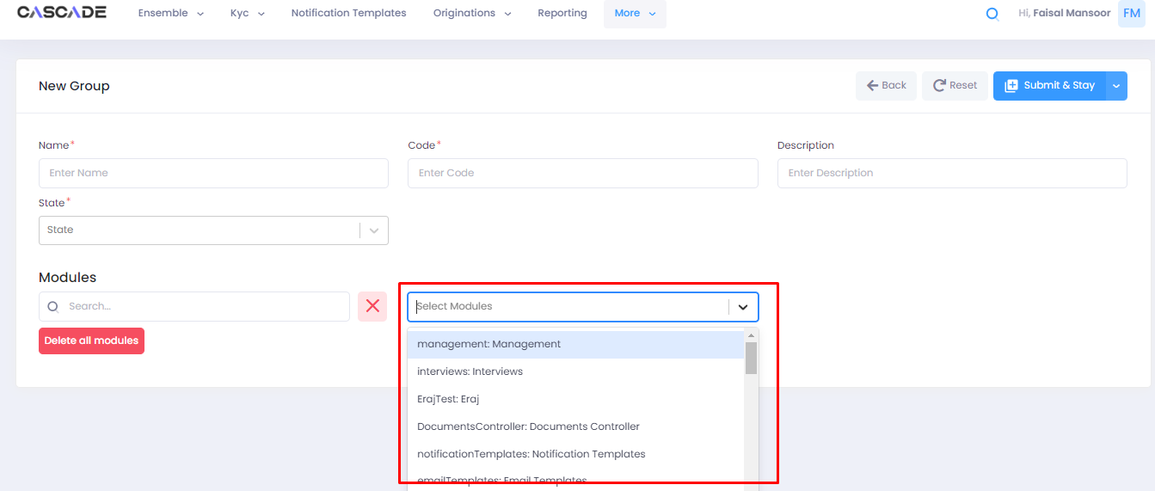

6. After you have selected a module, you can add more modules by following the same procedure. Once done, click on ‘submit & stay’ to save and stay on the page, or click on ‘submit’ to submit and leave the page.

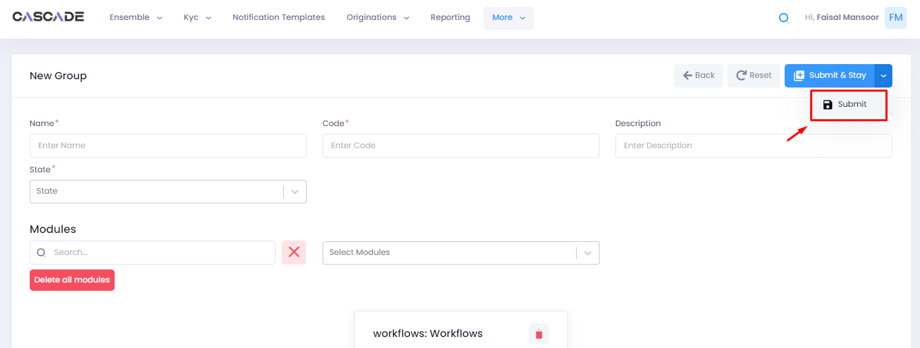

7. Your newly created group will now show under the ‘pending’ tab.

8. If you want to make any changes to the group, you can click on ‘edit’ to do so. You can also duplicate the group by clicking on ‘clone item’ or delete it by clicking on ‘delete item’.

9. After you are done with making all changes, select the group by ticking the check box then click on the ‘maker checker action’ button.

10. Leave comments then click on ‘send for approval’.

Checker

1. From the checker account, click on the ‘identity’ tab then on ‘Groups’.

**Note**: Modules and tabs may vary according to the rights assigned to the user.

2. Then click on ‘pending’. Here you will see the groups that require approval including the one that was just created.

3. Select a group by ticking the check box, then click on the ‘maker checker action’ button.

4. Leave a comment, then click on ‘approve’ to approve the group. You can also click on ‘reject’ to reject the group or click on ‘send for review’ to send it to a third person for further reviewal.

5. The newly created group will now show as approved under the ‘approved’ tab.

# Users

Maker

1. Login Page. Log in with your credentials to proceed.

2. Click on the ‘identity’ tab then on ‘Users’.

**Note**: Modules and tabs may vary according to the rights assigned to the user.

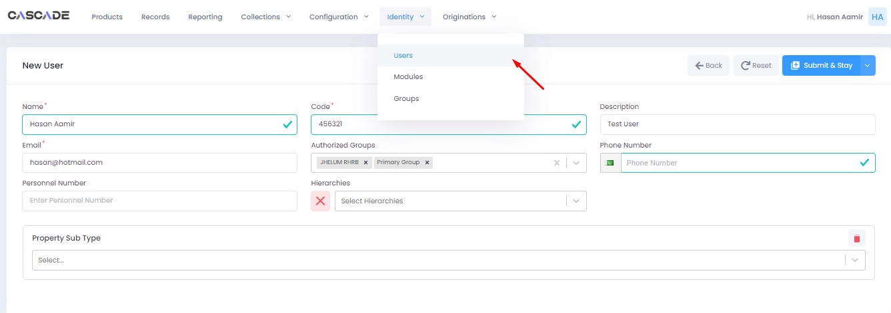

3. Click on ‘new user’ to create a new user.

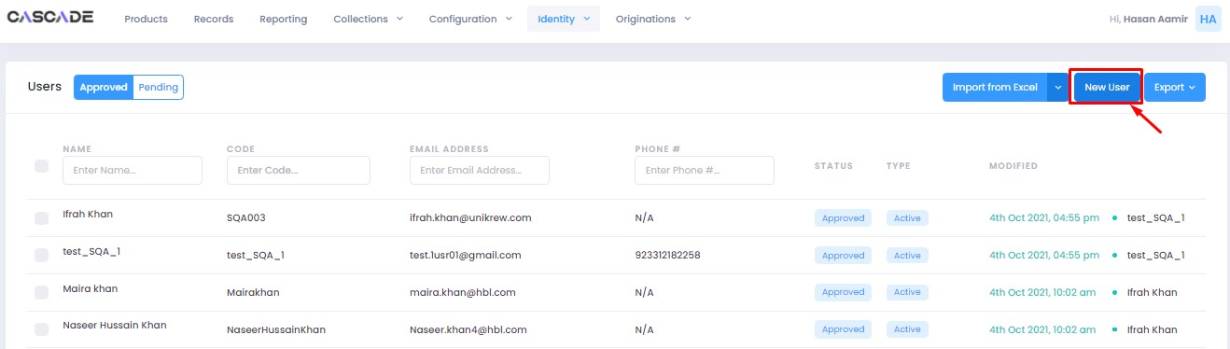

4. Fill all the required fields such as name, code, email, etc.

5. You can also add details such as branch code, department, designation and enable two-factor authentication.

6. After filling in all the details, select groups under ‘authorized groups’ from a drop-down menu.

**Note**: With authorized groups you can assign different rights to a user which can include modules, tabs, etc.

7. Then select ‘hierarchies’ by clicking on the ‘add hierarchies’ button.

**Note**: Hierarchies allow you to assign certain constraints, such as regions to a user

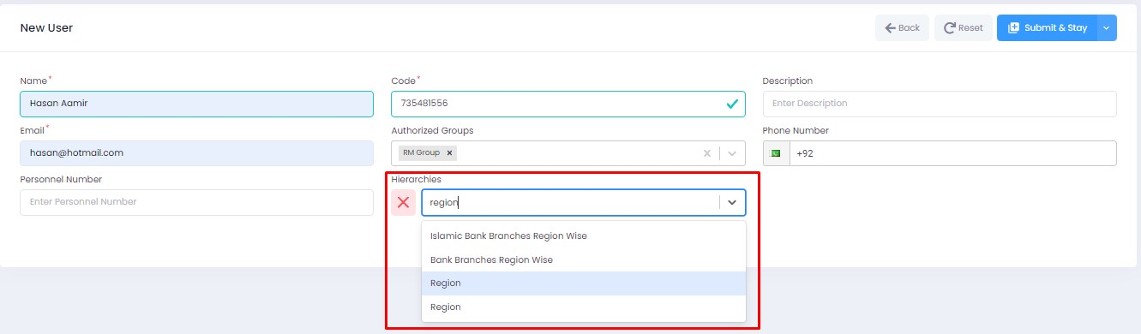

8. After selecting a hierarchy, you can select options from a drop-down menu pertaining to the hierarchy selected.

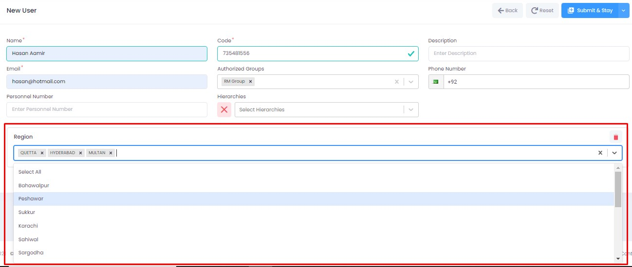

9. Once you have filled all the fields, click on ‘submit & stay’ to save and stay on the page, or click on ‘submit’ to submit and leave the page.

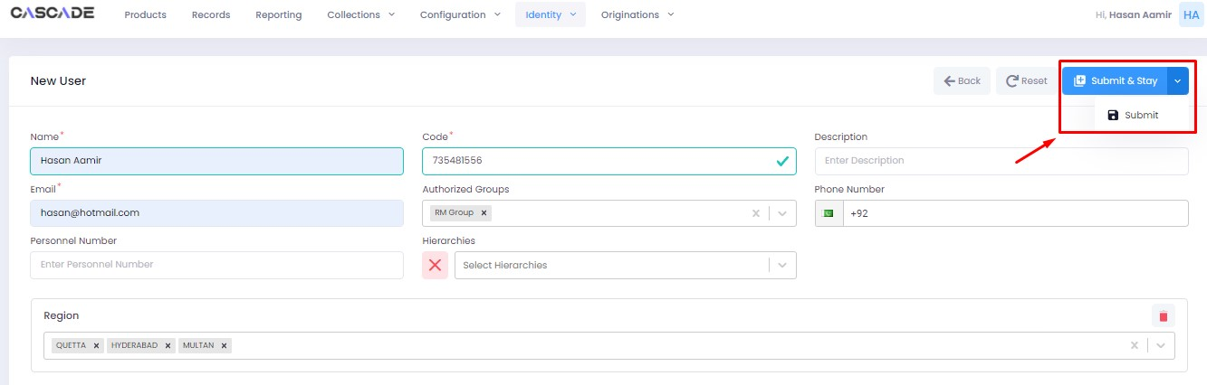

10. Your newly created user will now show under the ‘pending’ tab.

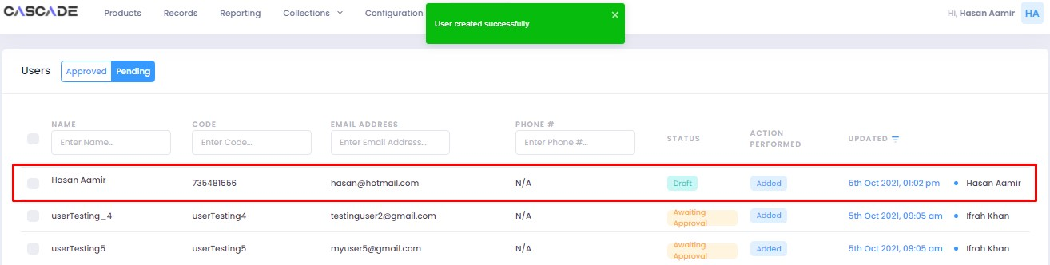

11. If you want to make any changes to the user, you can click on ‘edit’ to do so. You can also duplicate the user by clicking on ‘clone item’ or delete it by clicking on ‘delete item’.

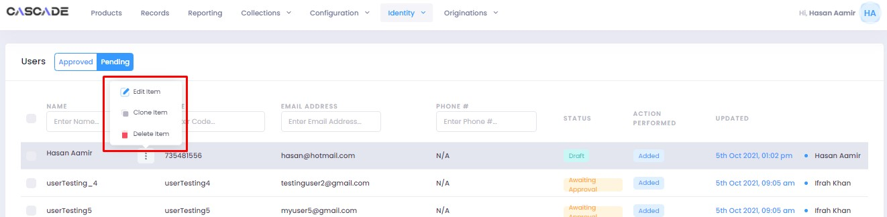

12. After you are done with making all changes, select the user by ticking the check box then click on the ‘maker checker action’ button.

13. Leave comments then click on ‘send for approval’.

Checker

1. From the checker account, click on the ‘identity’ tab then on ‘Users’.

**Note**: Modules and tabs may vary according to the rights assigned to the user.

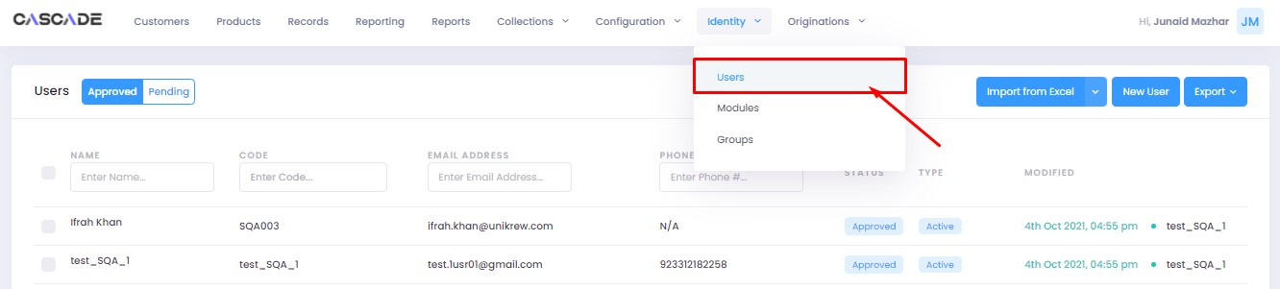

2. Then click on ‘pending’. Here you will see the users that require approval including the one that was just created.

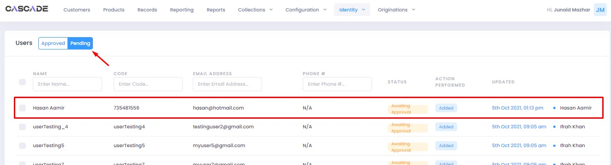

3. Select a user by ticking the check box, then click on the ‘maker checker action’ button.

4. Leave a comment, then click on ‘approve’ to approve the user. You can also click on ‘reject’ to reject the user or click on ‘send for review’ to send it to a third person for further reviewal.

5. The newly created user will now show as approved under the ‘approved’ tab.

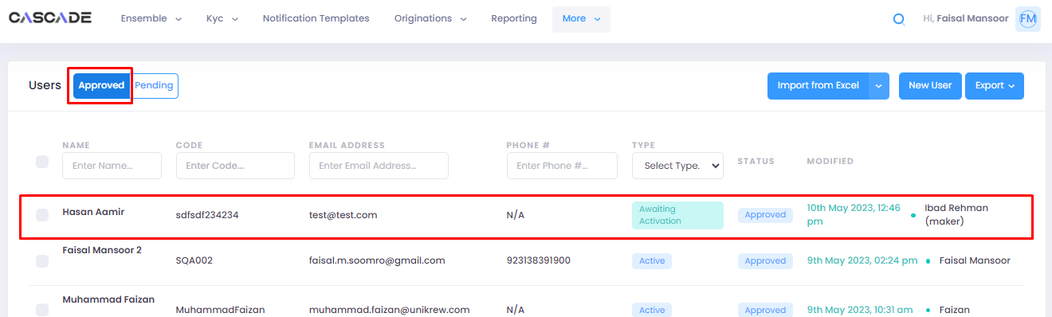

6. The account will now require activation. The activation instructions will be received on the email address entered during the user creation process.

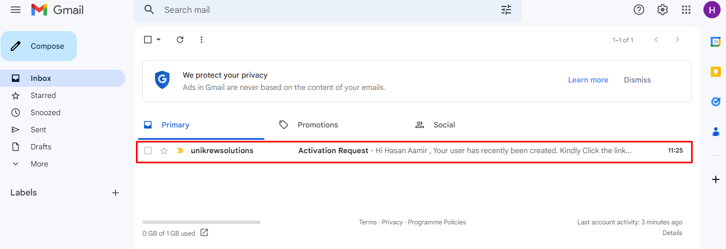

7. Click on the link to activate the account and set a password.

8. Enter the password you want to set then click on ‘submit’.

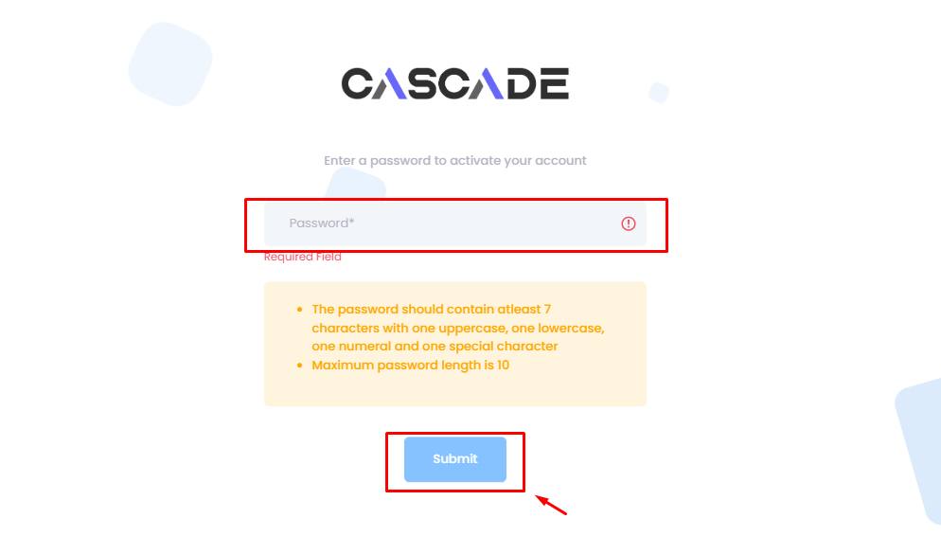

# Deleting a User

1. To delete a user, select the user you want to delete then click on the ‘delete’ button.

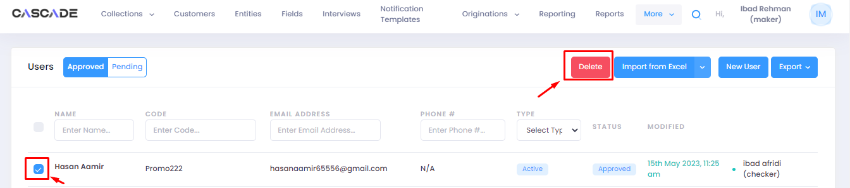

1. The user will then be moved under the ‘pending’ tab which will require a maker checker approval.

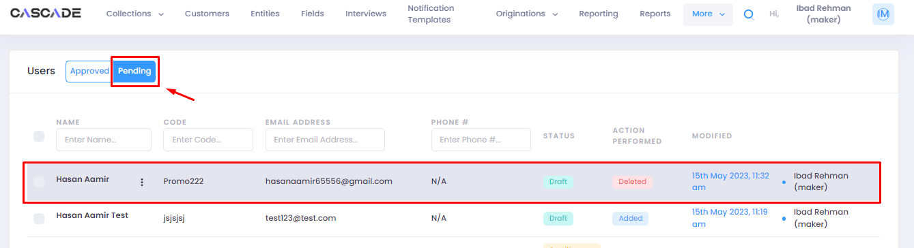

1. Select the deleted user then click on the ‘maker checker’ button.

1. Leave comments then click on ‘send for approval’.

Checker

1. The user will be moved to the bucket of the checker under the pending tab.

1. Leave comments then click on ‘approved’.

1. The user will now show as ‘deleted’.

