**Technical Task**

**Title:**

Convert 2D Image into a 3D Model using any tool

**Objectives:**

* Capture image from your mobile phone and camera.
* Convert the 2D image to 3D model.
* Calculate the dimensions from the 3D model as well as the real object and discuss the accuracy of results. For instance, you have capture or that of a book, laptop0 or apple.

**Deliverable:**

* GitHub project link
  + https://github.com/haris-iqbal-h/2d-to-3d-model
* Demo video
* Screenshots of Results

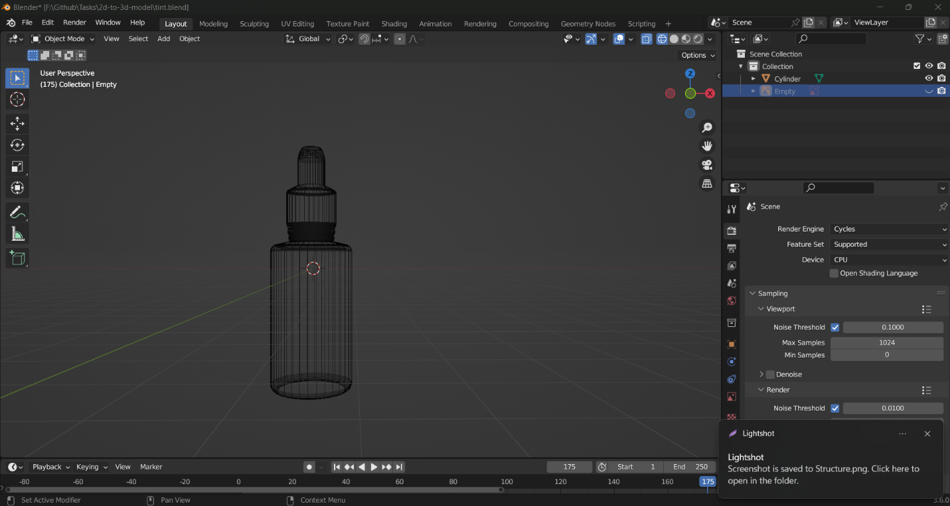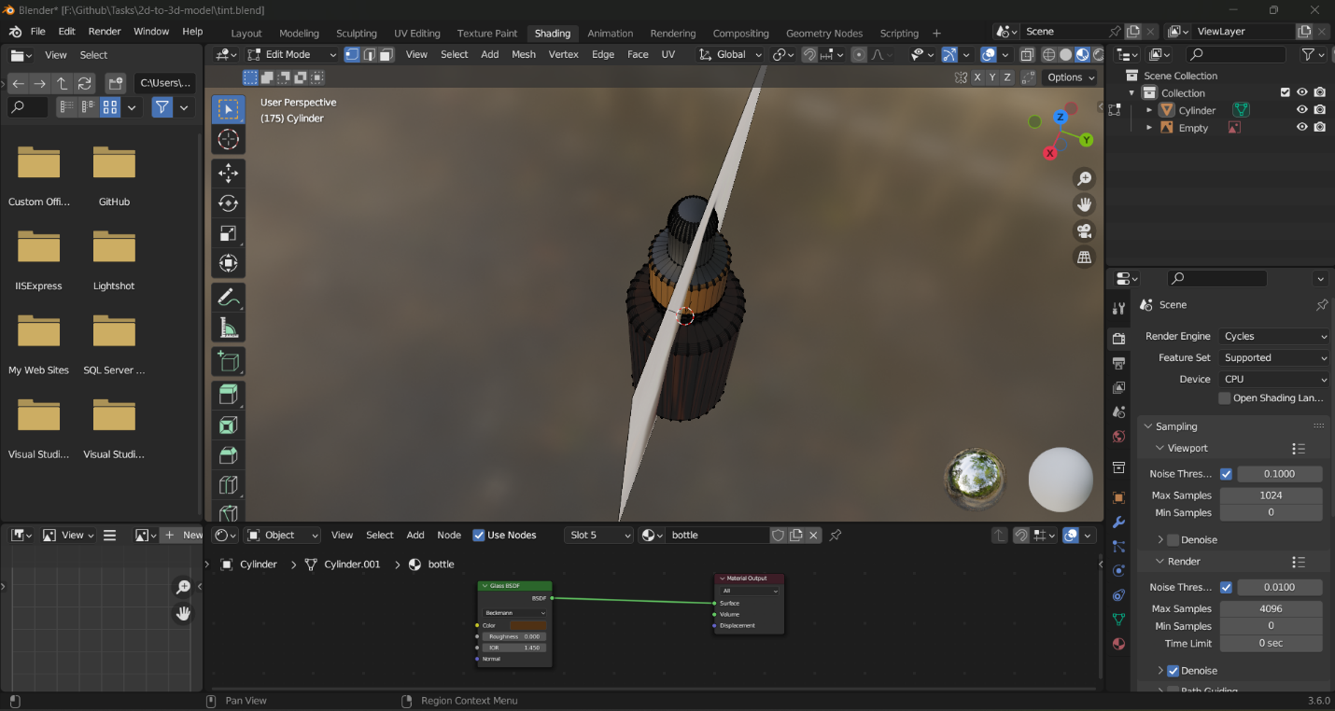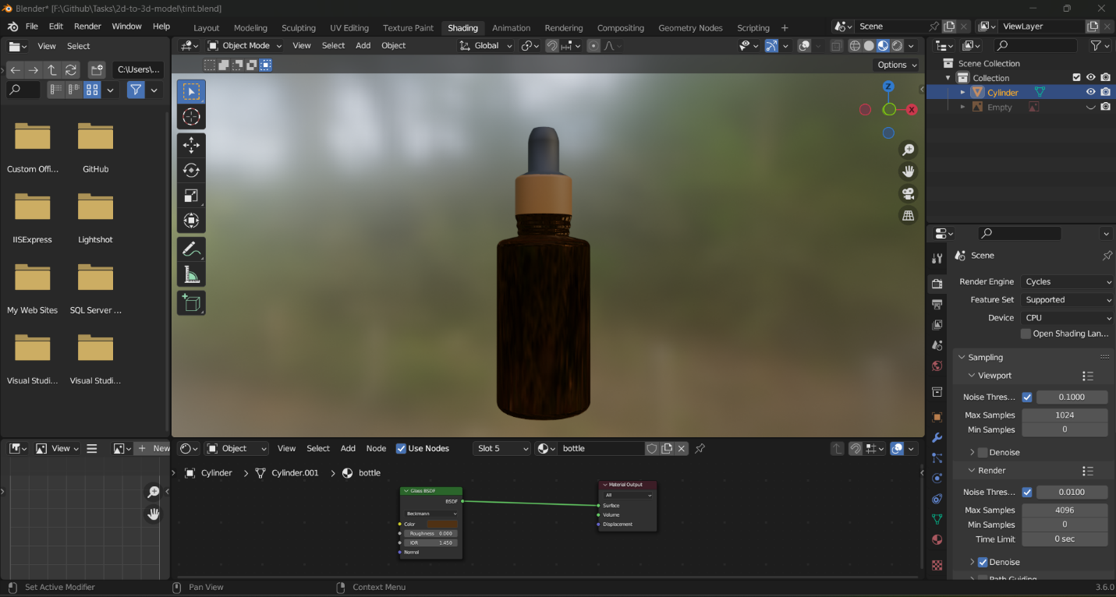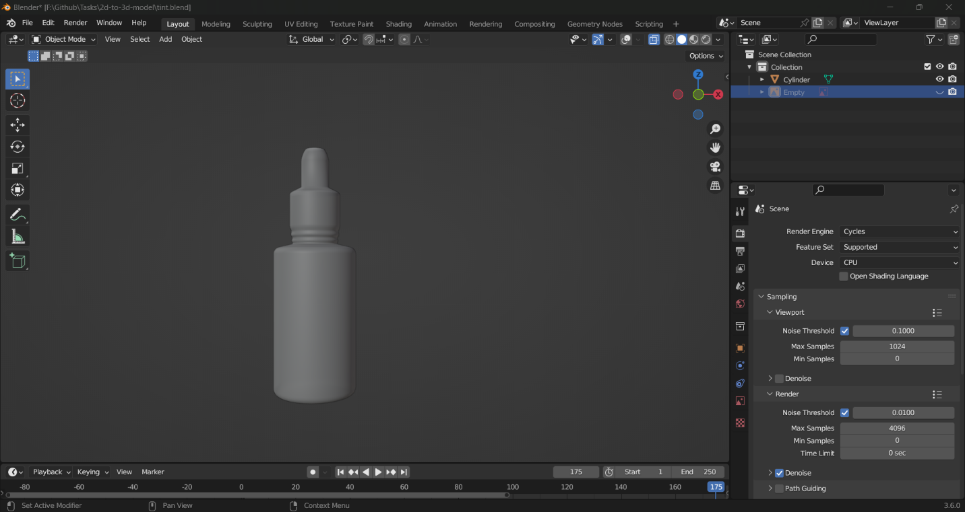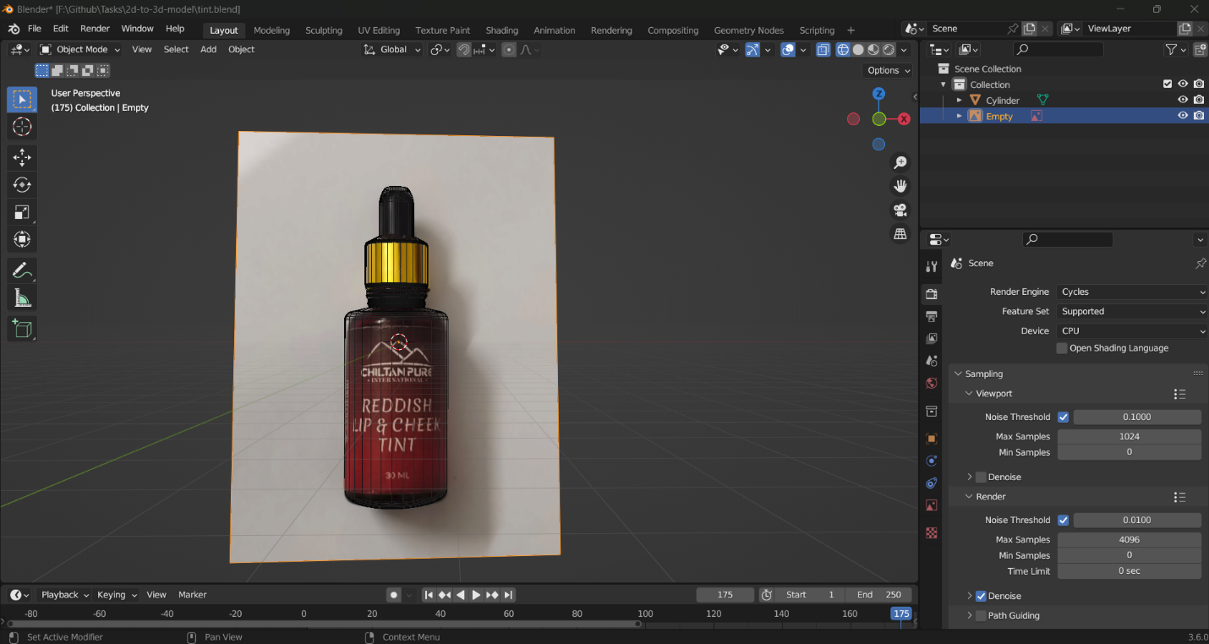

* Technical Manual of Project illustration development choices used
  + Blender is a powerful, open-source 3D computer graphics software used for creating animated films, visual effects, video games, and various other 3D modeling applications. It offers a comprehensive set of tools and features that enable artists, designers, and animators to create stunning and realistic 3D models and animations.
  + Also it is possible to calculate the dimensions from 3D model as well as fr5om the real object itself; however, the accuracy of the results depends on several factors.
  + I had used the factor or accuracy of dimensions is Reference object as shown in the figures the use of reference object.

**References:**

* YouTube:
  + <https://www.youtube.com/watch?v=hUfPvHPdgR4&ab_channel=ArtisansofVaul>
  + <https://www.youtube.com/watch?v=JHFi_zo6VSM&t=620s&ab_channel=LukasArvell>
  + <https://www.youtube.com/watch?v=dU6MSBjxUdU&ab_channel=Blender3DTutorials>
  + https://www.youtube.com/watch?v=cKi5rF9LSQA&ab_channel=saivfx
* Open-Source
  + https://www.blender.org/
  + <https://cgian.com/2023/02/blender-gold>
  + ChatGPT OpenAI tool
  + <https://docs.blender.org/manual/en/latest/render/shader_nodes/shader/glass.html>
  + https://artisticrender.com/how-to-create-a-glass-shader-in-eevee-and-cycles/