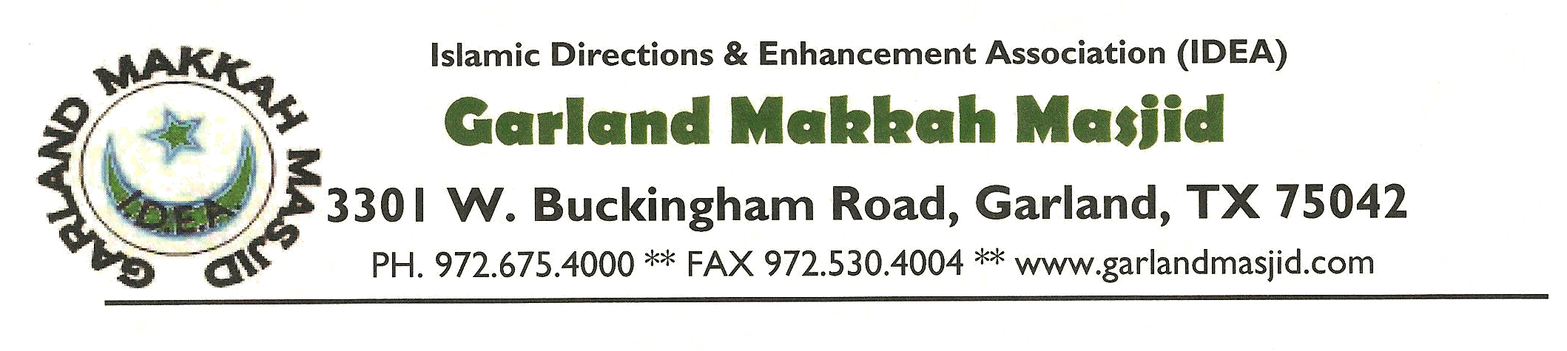

July 16th, 2021

To Whom It May Concern:

Muslims observe the holy month of Hajj in which we celebrate Eid ul Adha in the memory of Prophet Abraham. This festival of sacrifice is observed on the 9th and 10th day of the month of Hajj. This year the Eid ul Adha celebration will fall on Tuesday July 20th, 2021 and on Wednesday , July 21st, 2021.

Therefore on these dates we ask you to please excuse _______________________________ from being absent from school/work __________________________________ , so that he/she may join in fulfilling the religious obligations and enjoy the festivities of these holidays with other family members and friends.

Your understanding and cooperation is greatly appreciated. If you have any further questions, please do not hesitate to contact us.

Sincerely,

Ghulam Jangda
President, Board of Directors

