PRJ – Customer Success Team
Please use the link to open Power Point Presentation
View in Power BI
Tools Used : Advanced Excel, Power BI
Dataset : Sample-Google-sheet-Plum.
Developed: Dashboard based on the groups in the dataset for the end user visibility
Description:
Data Cleaning:
Step 1 : Download the excel sheet and save in the path.
Step 2 : created a parameter for the path to avoid data source error’s while opening the file for the end user.
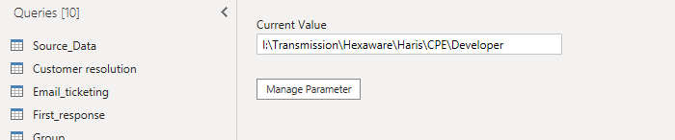
Step 3: If the end user has their own path it can be in the parameter and hence data source or end-user won’t affect while visualizing the data.
Step 4 : Based on the source data normalizing the data as I required for modeling the data by grouping various Tables and framed a model.
Step 5 : Created a Rolling calendar for the future updating for days , weeks, Months.
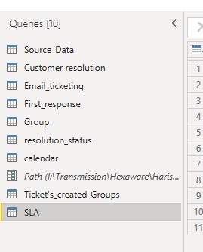

Data Modeling & Normalizing
Step 6 : used Star-schema to connect all the data from a source data using one to many model with the filter context of single

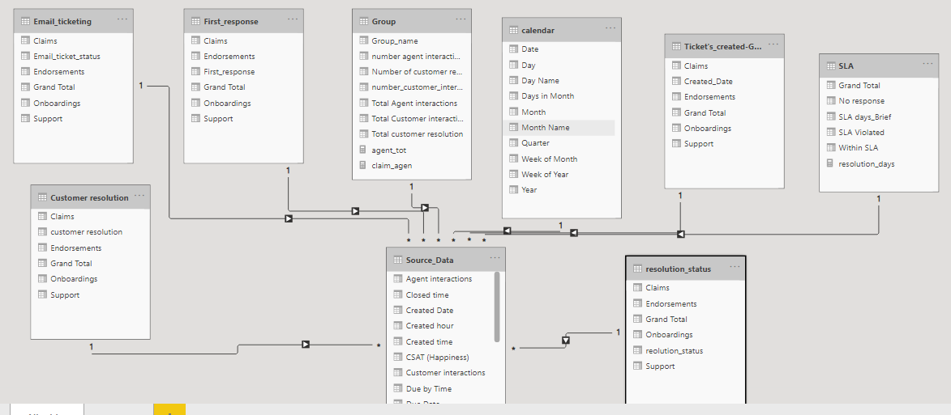
Created and connected model Successfully.
Reports.
Step 7: Used Power bi theme colors and imported as Json file for dark background.
Step 8 : Created Navigation for the better user experience for all groups and overall dashboard in all the pages
Step 9 : It can be visualize using the View/ Selection Pane and group the panes, visuals for the better user experience.
Step 10 : Created Book-marks for the visuals based on the insights.
Note 1: Based on the Report Navigation of page will be hover over to green and yellow color.
Note 2: If the Navigation is open visuals in the report won’t work or hovered or selected.

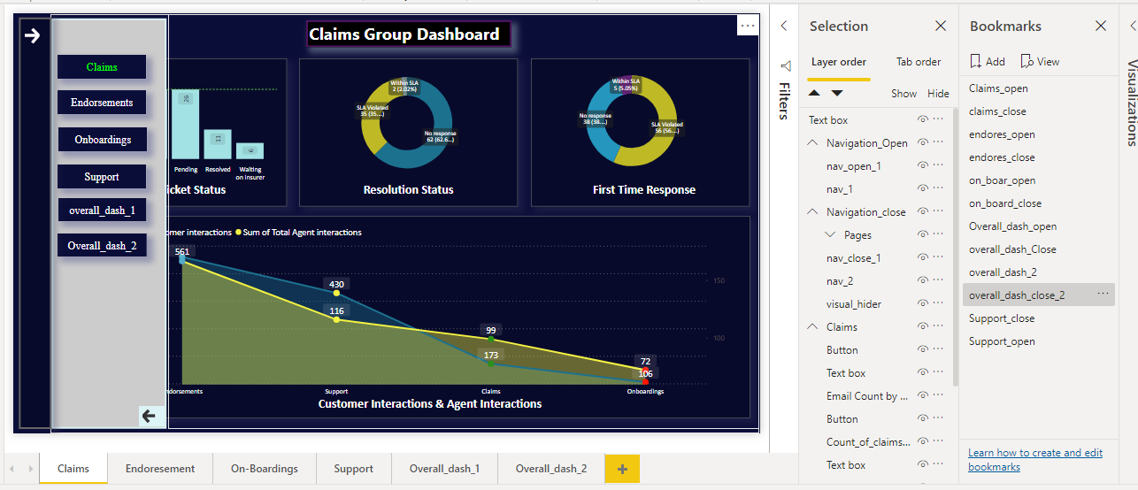
Details based on Dashboard:
Dashboard 1: Claims-Group

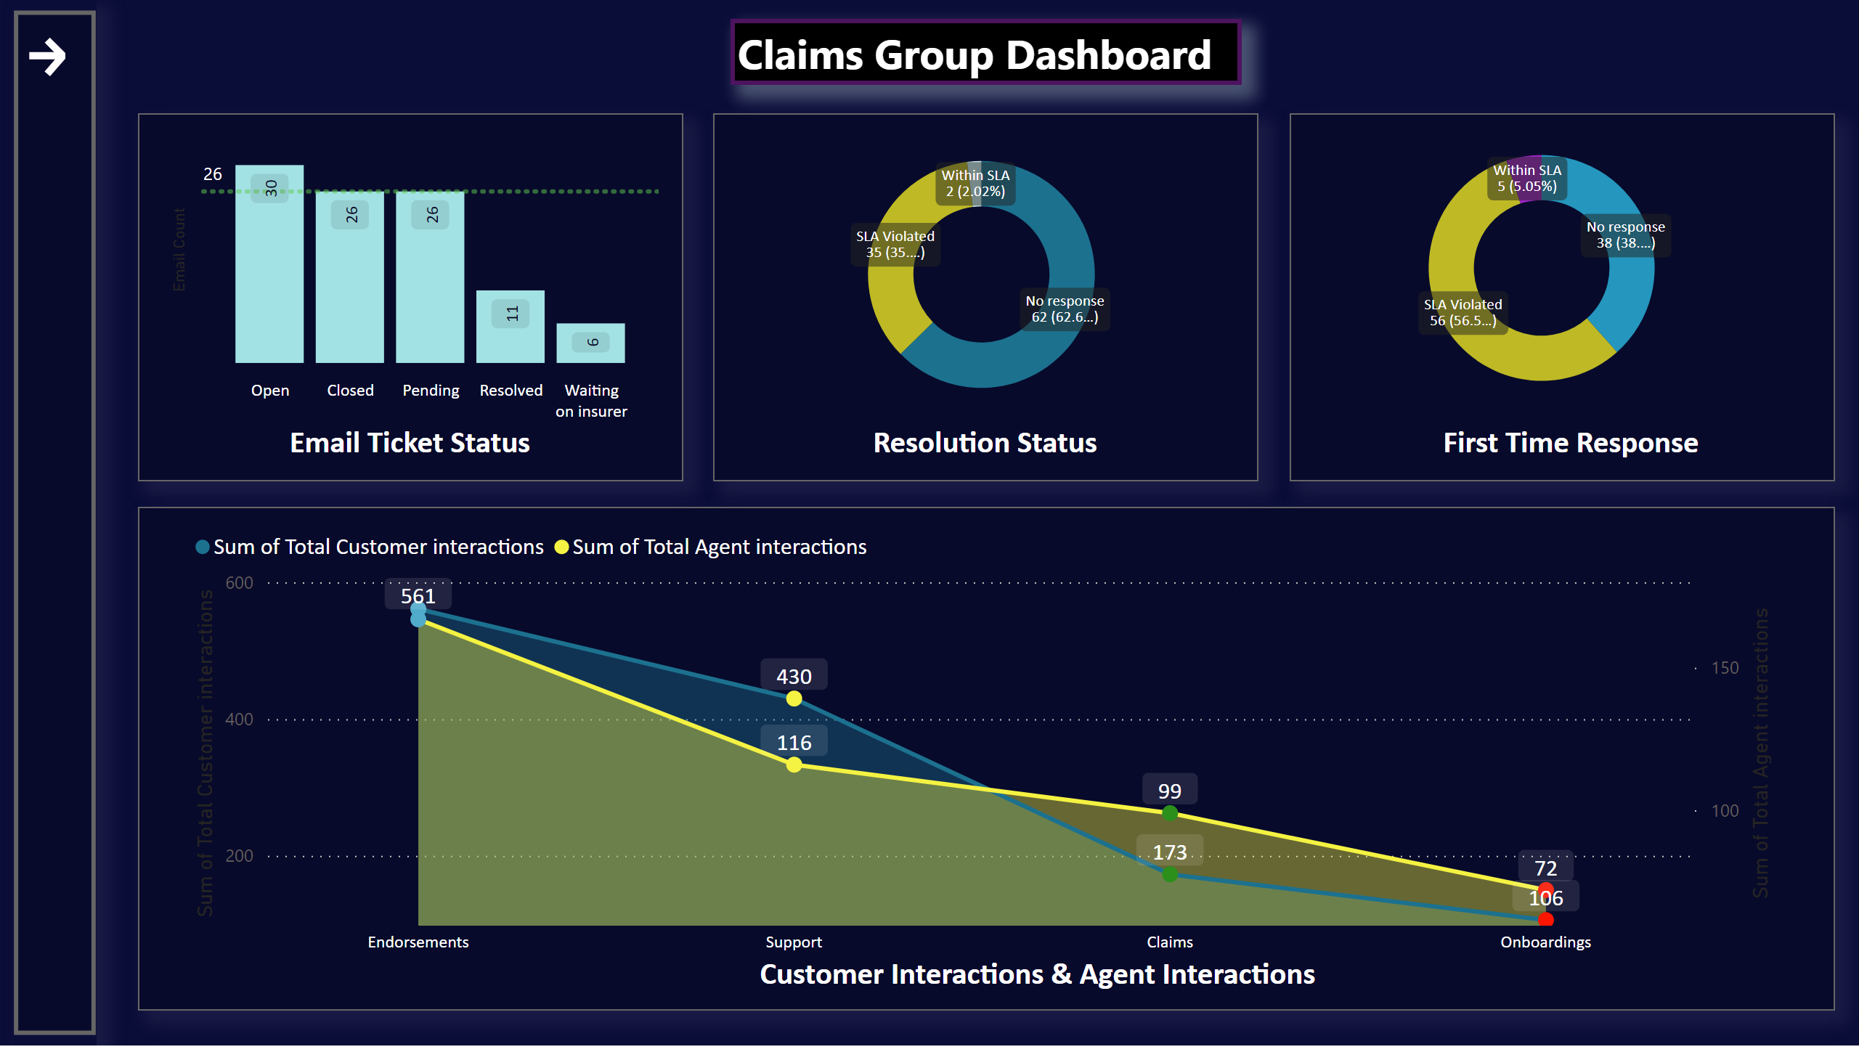

Details :
VS1: Email Ticket Status:
Gives the information of the emails handled by the team claim and status.
Vs2: Resolutions Status:
Gives the information of the resolution based on the team on SLA-Priority bases.
Vs3: First Time Response Status:
Gives the information of the FTR based on the team on SLA-Priority bases.
Vs4: Customer & Agent Interactions
Gives the overall information of group interactions to customer and agents.
Formula:
DAX measures is used like calculate, All, Filter, sum, sum x, if blank, VAR, INT.
Dashboard 2: Endorsement-Group
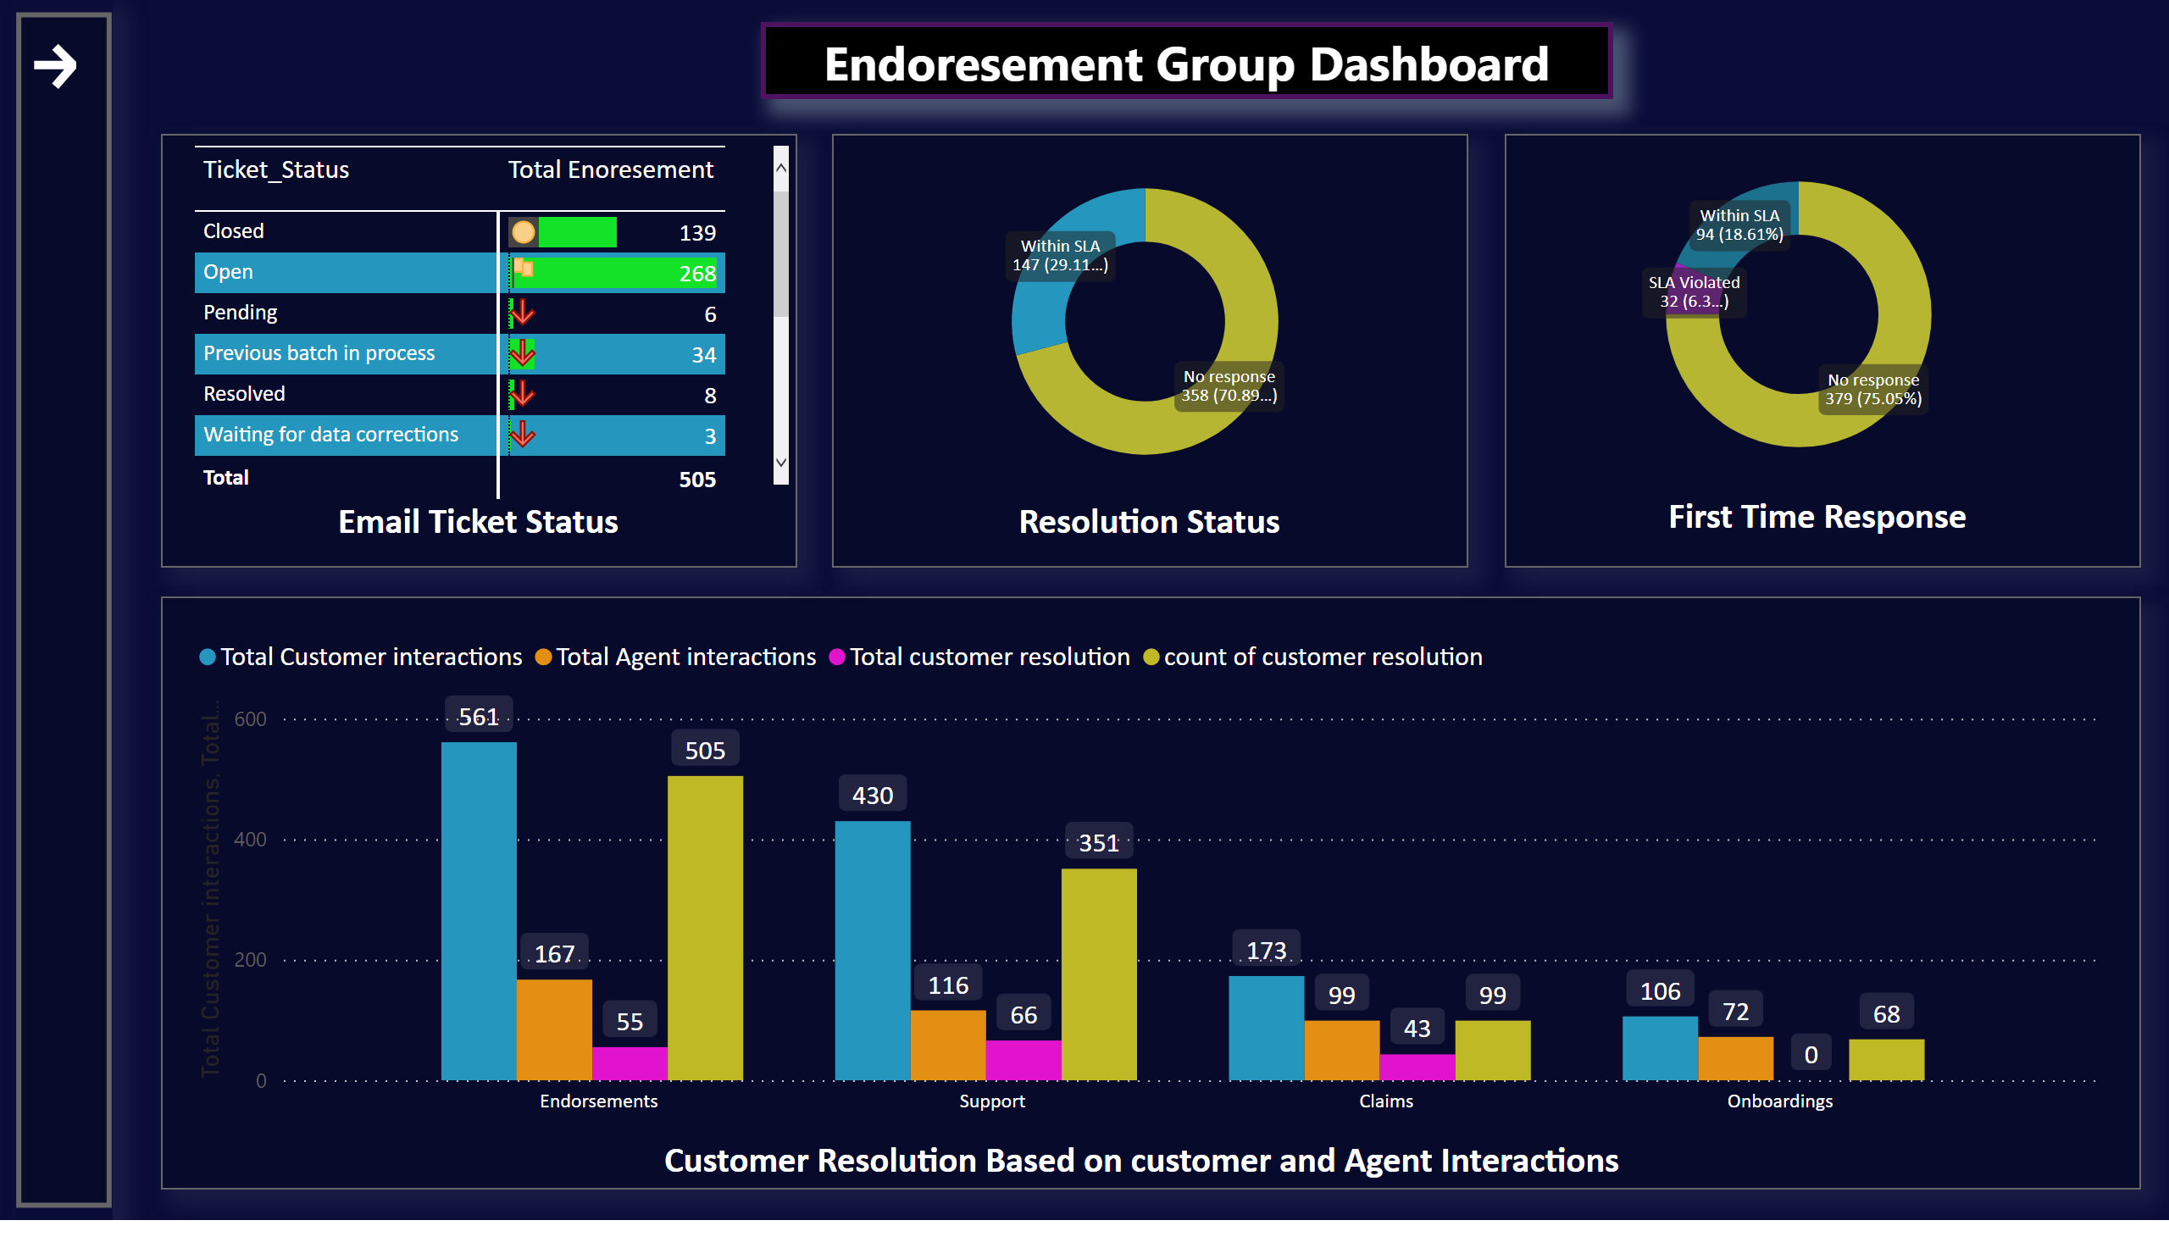
Details :
VS1: Email Ticket Status:
Gives the information of the emails handled by the team Endorsement and status.
Vs2: Resolutions Status:
Gives the information of the resolution based on the team on SLA-Priority bases.
Vs3: First Time Response Status:
Gives the information of the FTR based on the team on SLA-Priority bases.
Vs4: Performance based on customer and their resolutions
Gives the overall information of group interactions to customer, agents, resolution.
Formula:
DAX measures is used like calculate, All, Filter, sum, sum x, if blank, VAR, INT.

Dashboard 3: Onboarding-Group

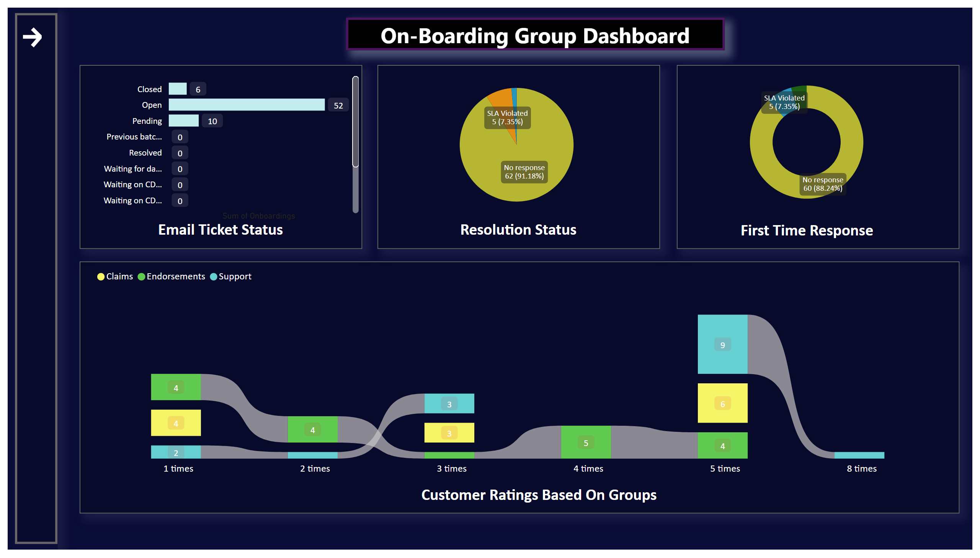

Details :
VS1: Email Ticket Status:
Gives the information of the emails handled by the team On-boarding and status.
Vs2: Resolutions Status:
Gives the information of the resolution based on the team on SLA-Priority bases.
Vs3: First Time Response Status:
Gives the information of the FTR based on the team on SLA-Priority bases.
Vs4: Performance based on customer Ratings and number of times reviews and their resolutions
Formula:
DAX measures is used like calculate, All, Filter, sum, sum x, if blank, VAR, INT.

Dashboard 4: Support-Group
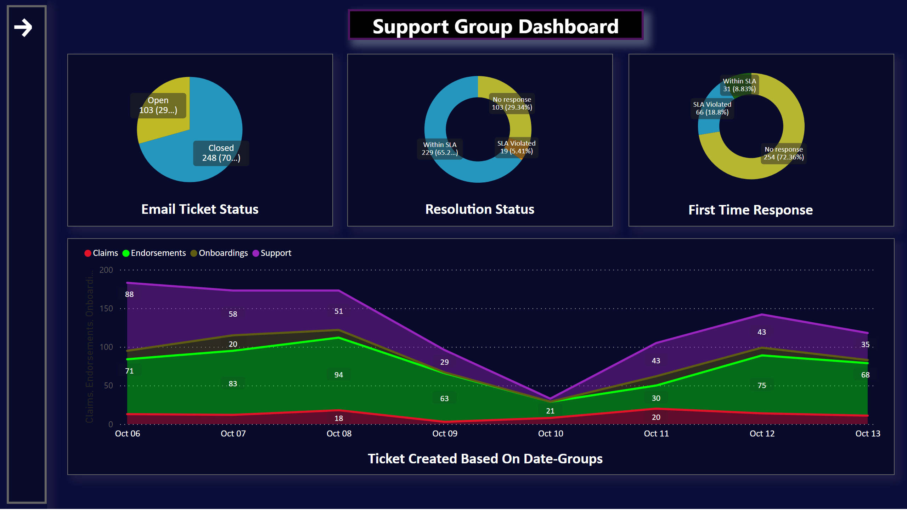

Details :
VS1: Email Ticket Status:
Gives the information of the emails handled by the team and status.
Vs2: Resolutions Status:
Gives the information of the resolution based on the team on SLA-Priority bases.
Vs3: First Time Response Status:
Gives the information of the FTR based on the team on SLA-Priority bases.
Vs4: Tickets Created Based on Date-Groups
Based on the group created date how much work has been handled
Formula:
DAX measures is used like calculate, All, Filter, sum, sum x, if blank, VAR, INT.
Dashboard 5: Over-all-Dashboard-1
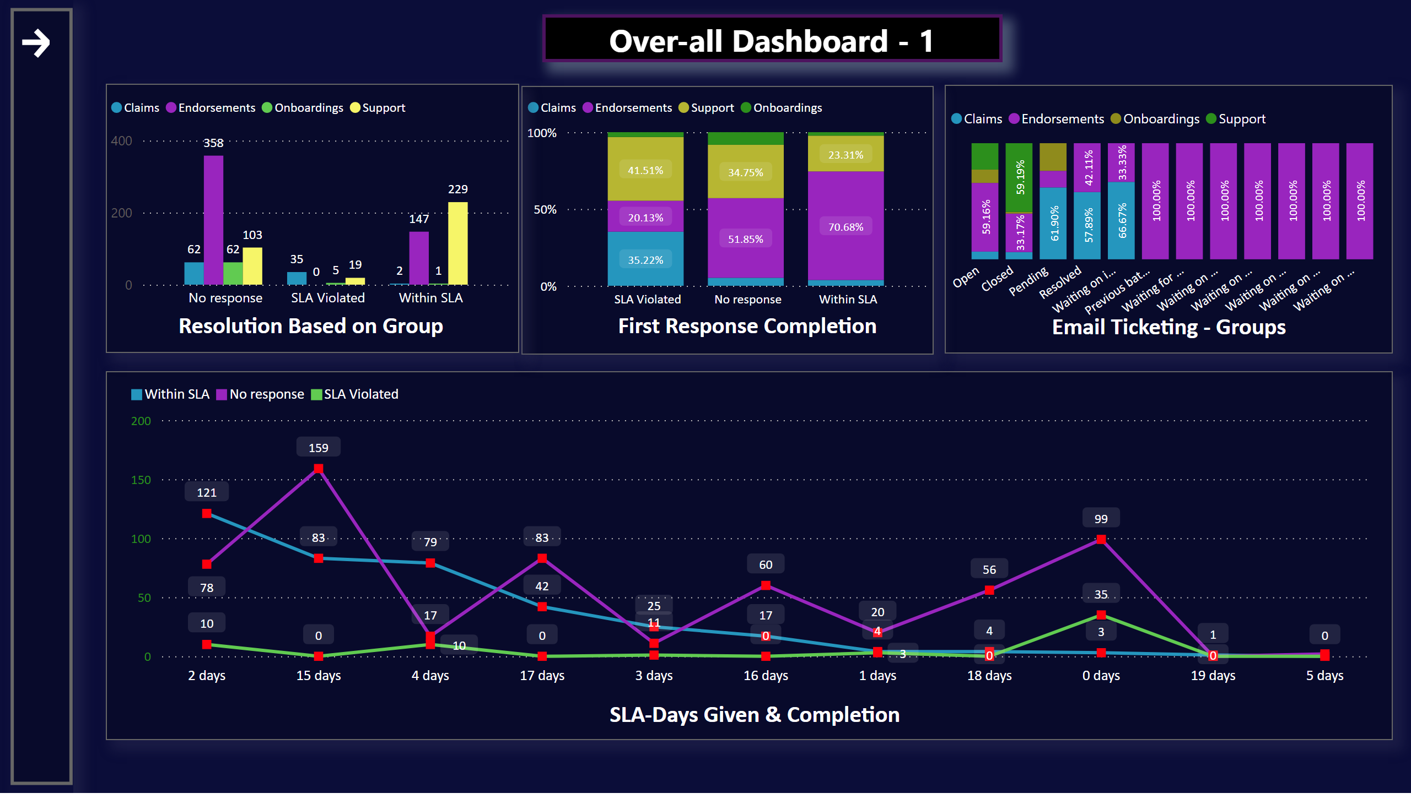
Vs1: Resolutions Status:
Gives the information of the resolution based on the total team on SLA-Priority bases.
Vs2: First Time Response Status:
Gives the information of the FTR based on the total team on SLA-Priority bases.
VS3: Email Ticket Status:
Gives the information of the emails handled by the total team and status.
Vs4: Total number of orders handled based on the SLA Days given
Formula:
DAX measures is used like calculate, All, Filter, sum, sum x, if blank, VAR, INT
Dashboard 6: Over-all-Dashboard-2
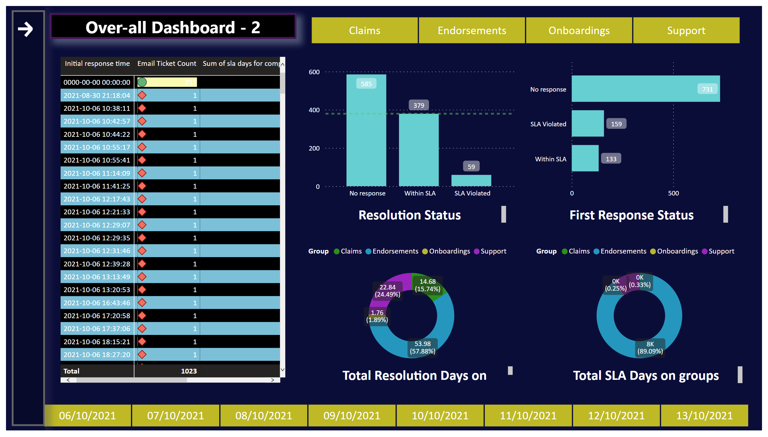
Vs1: Slicer based on groups:
Given Slicer to interact all the visuals at time.
Vs2: Matrix table.
To get more insights about columns and rows based on created basis, emails, mins, hrs.
Vs3: Resolutions Status:
Gives the information of the resolution based on the total team on SLA-Priority bases.
Vs4: First Time Response Status:
Gives the information of the FTR based on the total team on SLA-Priority bases.
VS5: Total Resolution based on groups
Gives the information of the resolution handled by the total team and status.
VS6: Total SLA based on groups
Gives the information of the SLA handled by the total team and status.
VS7: Slicer based on created date.
Formula:
DAX measures is used like calculate, All, Filter, sum, sum x, if blank, VAR, INT

Conclusion:
I hereby assure that the given records are prepared by me for any changes please let me know.
Developed by:
Haris Shanmugam – Software Engineer
Hexaware Technologies
Microsoft Certified Data Analyst Associate

