Software Architecture Document
Development of Scenario Generator with DRS
Architecture reference — RFQ Milestone 1

Document type | Software Architecture Document (SAD)
System | Development of Scenario Generator with DRS (referred to herein as EWTSS)
Version | 1.0
Date | 30 June 2026
Status | Issued for RFQ Milestone 1 (Software Architecture for SG)
Prepared by | Architecture team
Classification | Commercial-in-Confidence — issued under RFQ Milestone 1
This document describes the EWTSS software architecture for the development phase. Capabilities already validated in the current codebase are distinguished from those planned for the build.

Contents
Contents 2
Figures 3
1. Introduction 4
1.1 Purpose 4
1.2 Scope 4
1.3 Intended audience 4
1.4 How to read this document 4
1.5 Terminology 4
2. System overview and context 5
2.1 What EWTSS is 5
2.2 System context and boundaries 5
2.3 External interfaces 7
2.4 Operating modes 7
3. Architectural drivers 7
3.1 Key functional requirements and quantitative scope 7
3.2 Quality attributes 8
3.3 Constraints 8
3.4 RFQ traceability 9
4. Architecture overview 9
4.1 Component structure 9
4.2 Layered model 11
4.3 Component responsibilities 13
5. Key architectural decisions 13
6. Workflow and behaviour 14
6.1 Operator workflow (end to end) 14
6.2 Telemetry data flow 16
6.3 Control flow 18
6.4 Scenario compute lifecycle 20
6.5 Exercise execution (Integrated + Scenario) 20
7. Deployment and runtime view 22
7.1 What runs where 24
7.2 Hardware and software 24
7.3 Network and ports 24
7.4 Critical setup considerations 24
8. Delivery approach and scope boundaries 24
8.1 Delivery approach 24
8.2 Out of scope 25

Figures
Figure 1. EWTSS system context — personas, the WS1+WS2 system boundary, and external interfaces. 6
Figure 2. Component / deployment-component overview. 10
Figure 3. Seven-layer system model with the L3 split point and cross-LAN rules. 12
Figure 4. End-to-end operator workflow / operational cycle. 15
Figure 5. Telemetry data flow and the batched-write hot path. 17
Figure 6. Control / command propagation across WS1, the Kafka control plane, WS2, and entity controllers. 19
Figure 7. Scenario compute lifecycle and the three-transaction write-back. 20
Figure 8. Integrated + Scenario exercise execution sequence. 21
Figure 9. Deployment / runtime view — nodes, artifacts, ports, and licences. 23

1. Introduction

1.1 Purpose
This Software Architecture Document (SAD) is the architecture reference for the Development of Scenario Generator with DRS (the RFQ project title), referred to throughout this document by the short name EWTSS. It is prepared as the RFQ Milestone-1 "Software Architecture for SG" deliverable. The system is engineered to meet the required telemetry throughput and concurrency at scale. This document describes the architecture, the decisions behind it, the major workflows it supports, the deployment and runtime view, and the phased path to delivery.

1.2 Scope
The document covers the system context and boundaries, architectural drivers, the component and layered architecture, the key architectural decisions (ADRs), the major operator and runtime workflows, the deployment/runtime view, and the delivery scope. It covers the two workstations inside the development scope (WS1 — Scenario Generator; WS2 — DRS) and treats the client-owned Control Center and per-variant Entity Controller Applications as external integration boundaries. Implementation-level UI gestures and exhaustive alternatives analysis are out of scope for this document.

1.3 Intended audience
- Architects & technical reviewers — the architecture and the decision record.
- Engineering staff — component responsibilities and how the system fits together.
- Customer architects & design-review participants — feasibility assessment and RFQ alignment.
- Ops / integration engineers — the deployment and runtime view.

1.4 How to read this document
This document describes the target architecture for the development phase. A capability already validated in the current codebase is identified as Established; a capability scheduled for the build is marked Planned; an integration point with a client-owned system is marked External.
Marker | Meaning
Established | Validated in the current codebase.
Planned | Scheduled for the development phase.
External | Boundary with a client-owned / third-party system; EWTSS exposes an interface but does not own the consumer.

Table 1. Capability markers used in this document.

1.5 Terminology
- EWTSS — the short name used throughout this document for the system delivered under the RFQ title 'Development of Scenario Generator with DRS' (expands as Electronic Warfare Training Software System).
- DRS = Device Replacement Software — software that replaces real EW hardware in test scenarios (per the RFQ). It is NOT 'Data Recording Subsystem' or 'Digital Receiver System' — both are incorrect for this system.
- WS1 (SG) — Scenario Generator workstation: the only STK-bearing host.
- WS2 (DRS) — hosts the drs-server / drs-bridge services, Kafka, and TimescaleDB; serves the DRS Engineer webapp.
- SG Operator / DRS Engineer — the two operator personas in scope (WS1 and WS2 respectively).
- Scenario Generator application — the Sg.App C# WPF desktop application on WS1 with STK 12 embedded in-process; the SG Operator's primary surface.
- Operating modes — two independent dimensions: deployment scope (Standalone | Integrated) and data source (Random | Scenario). Distinct from any application packaging.

2. System overview and context

2.1 What EWTSS is
EWTSS supports authoring, computation, telemetry capture, and analysis of GNSS / DRS hardware test scenarios. It is a Windows-based defence simulation system run on isolated workstations or a LAN-connected workstation pair. Operators author scenarios in STK terms (vehicles, sensors, transmitters, coverage definitions, figures of merit), run pre-computed STK link analysis, and capture live telemetry from up to ~100 DRS instances during exercise execution. Scenario computation is a pre-computed batch (not real-time); the computed link analysis is replayed tick-by-tick during execution.

2.2 System context and boundaries
Figure 1 shows the system boundary and its external interfaces. The two operator personas drive the two workstations inside scope; STK 12 is a third-party engine embedded in-process on WS1; the Control Center, the per-variant Entity Controller Applications, and the DRS hardware devices are external. The whole deployment runs on an air-gapped LAN with no runtime internet.
Figure 1. EWTSS system context — personas, the WS1+WS2 system boundary, and external interfaces.
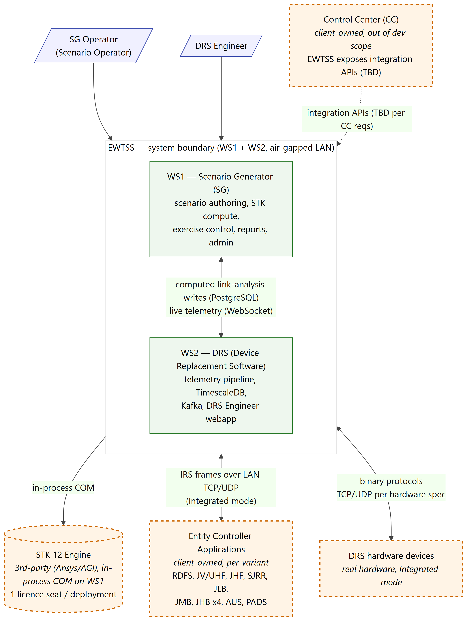

2.3 External interfaces
- STK 12 Engine (external, third-party) — Ansys/AGI engine accessed via in-process COM on WS1; one licence seat per deployment. Governed by the AGI COM interface contract.
- Control Center (CC) (external, client-owned) — EWTSS exposes integration APIs from SG and/or DRS; the specific surface (endpoints, topics, schemas) is Open and defined once CC integration requirements arrive. Anticipated touchpoints: mission-guidelines delivery, exercise-lifecycle events, aggregate health push, CC-initiated queries.
- Entity Controller Applications (external, client-owned, per-variant) — drs-bridge exchanges IRS-compliant frames over LAN TCP/UDP in Integrated mode.
- DRS hardware devices (external) — real hardware speaking per-variant binary protocols over TCP/UDP.

2.4 Operating modes
The system runs in one of four mode combinations along two independent axes. All four reuse the same components; only the active topics, the data source, and the presence of entity controllers change.
Mode | Deployment | Entity controllers | DRS data source | STK at runtime
Standalone + Random | WS1 + WS2 only | None | C++ random generator | No
Standalone + Scenario | WS1 + WS2 only | None | computed link-analysis (STK pre-computed) | Pre-compute only
Integrated + Random | + entity workstations | Yes | C++ random generator | No
Integrated + Scenario | + entity workstations | Yes | computed link-analysis | Pre-compute only

Table 2. The four operating-mode combinations.

3. Architectural drivers

3.1 Key functional requirements and quantitative scope
- Author scenarios against STK 12 and run pre-computed link analysis (range, azimuth, elevation, Doppler, signal strength, signal offsets, channel attenuation) per (sensor, emitter) pair across the exercise window.
- Capture and persist live telemetry from up to ~100 DRS instances; display it live with filter/search/sort.
- Support 12+ hardware variants through one configuration system: a new variant is one YAML profile + one C++ parser, not a refactor.
- Two operator surfaces by persona: SG-side scenario authoring/exercise control (WS1) and a DRS-side hardware health/monitor/config webapp (WS2).
- Full RBAC + JWT auth, template-based PDF reports, scenario library lifecycle, and time synchronisation (SG as Time Server) are in scope for the build.
Dimension | Value
Hardware variants in scope | 12+ (RDFS, JV/UHF, JHF, SJRR, JLB, JMB, JHB×4, AUS, PADS)
Concurrent DRS instances | Up to 100
Per-instance message rate | ~10–20 Hz
Sustained throughput target | ~2,000 msg/s, indefinite duration
Deployment | Air-gapped LAN, two Windows workstations (WS1 + WS2)
Delivery | DVD with vendored dependencies + source code
Build phase | Phased build with integration-test checkpoints

Table 3. Quantitative scope of the delivered system.

3.2 Quality attributes
Performance and scalability are the dominant drivers. EWTSS is engineered to sustain the required telemetry load profile indefinitely; the design achieves this structurally rather than by tuning. Table 4 lists the targets and the design approach behind each.
Dimension | Target | Design approach
Concurrent DRS instances | 100+ | asyncio single event loop; one shared producer per bridge
Hardware variants | 12+ (linear in files) | One YAML profile + one C++ parser per variant
Sustained throughput | 2,000+ msg/s, indefinite | Batched writes (100 msg / 500 ms); async SQLAlchemy + asyncpg
Query latency | Near-constant under growth | TimescaleDB chunk exclusion + composite index
Concurrent UI operators | Sustained without degradation | All handlers async; WebSocket fan-out replaces polling
Cost of a new DRS type | One YAML + one C++ file | Generic bridge supervisor + ICD codegen

Table 4. Quality-attribute targets and the design approach behind each.
- Reliability — Kafka durability for replay; manual offset commit only after a successful DB write (no message loss across restart). Telemetry services run as Windows Services.
- Security — air-gapped LAN, no runtime internet; RBAC + JWT issued by drs-server; PostgreSQL inbound restricted to WS1. A security baseline (threat model, data classification, auth lifecycle) is defined, with security review and penetration testing performed during the build.
- Maintainability — adding a hardware variant is one YAML profile + one C++ parser, with no Python, server, or UI changes (accelerated by the ICD codegen tool); a new typed STK entity is localised, additive work (a deliberate choice over a metadata-driven editor, ADR-007).
- Usability — STK-Insight-grade desktop fidelity (smooth pan/zoom, native drag-handle editing). Load-bearing rule: STK COM event subscriptions are made on-demand (only while placing or editing), never permanently, to preserve interaction latency (ADR-013).
- Latency budget — tens of milliseconds end-to-end; explicitly NOT sub-millisecond / hardware-in-the-loop. The cross-LAN scenario-publisher path carries a p99 ≤ 30 ms target, validated during integration testing.

3.3 Constraints
Constraint | Rationale
Air-gapped LAN, no runtime internet; all dependencies vendored | Target deployment environment
DVD delivery with vendored deps + pre-built parser .dlls | Offline installation on the secure segment
Windows-only | Forced by in-process single-threaded-STA STK COM
One STK Engine seat per deployment, on WS1 only; WS2 has zero STK | Per-process STK licensing (ADR-005 / ADR-012)
STK one-process invariant (single AgSTKXApplication lifecycle) | STK COM constraint; one engine lifecycle per process
STK version pinned per deployment | STK COM behaviour is version-specific; no forward-compat promise
Two-workstation topology (WS1 + WS2) | RFQ deployment shape
Pre-computed (not real-time) link analysis | Author → compute → execute workflow
Single-user per workstation (no multi-user concurrency) | Out of scope
Cloud / multi-tenant out of scope | Air-gapped LAN is load-bearing

Table 5. Constraints the architecture must honour.

3.4 RFQ traceability
Functional scope traces to RFQ Annexure A.1 (Scope of Development) and A.2 (deliverables and milestones). A full requirement-by-requirement traceability matrix — every numbered RFQ requirement mapped to where it is satisfied in EWTSS — accompanies the SRS deliverable; this document satisfies the Milestone-1 "Software Architecture for SG" deliverable.

4. Architecture overview

4.1 Component structure
EWTSS is a partial service-oriented architecture (ADR-002). Figure 2 is the canonical high-level diagram: WS1 — the Scenario Generator — runs the Sg.App desktop application (C# WPF) with STK 12 embedded in-process; WS2 hosts drs-bridge, drs-server, Kafka, TimescaleDB, and the DRS Engineer webapp. Solid edges are present in every deployment; dashed orange boxes are out-of-scope, client-owned external systems.
Figure 2. Component / deployment-component overview.
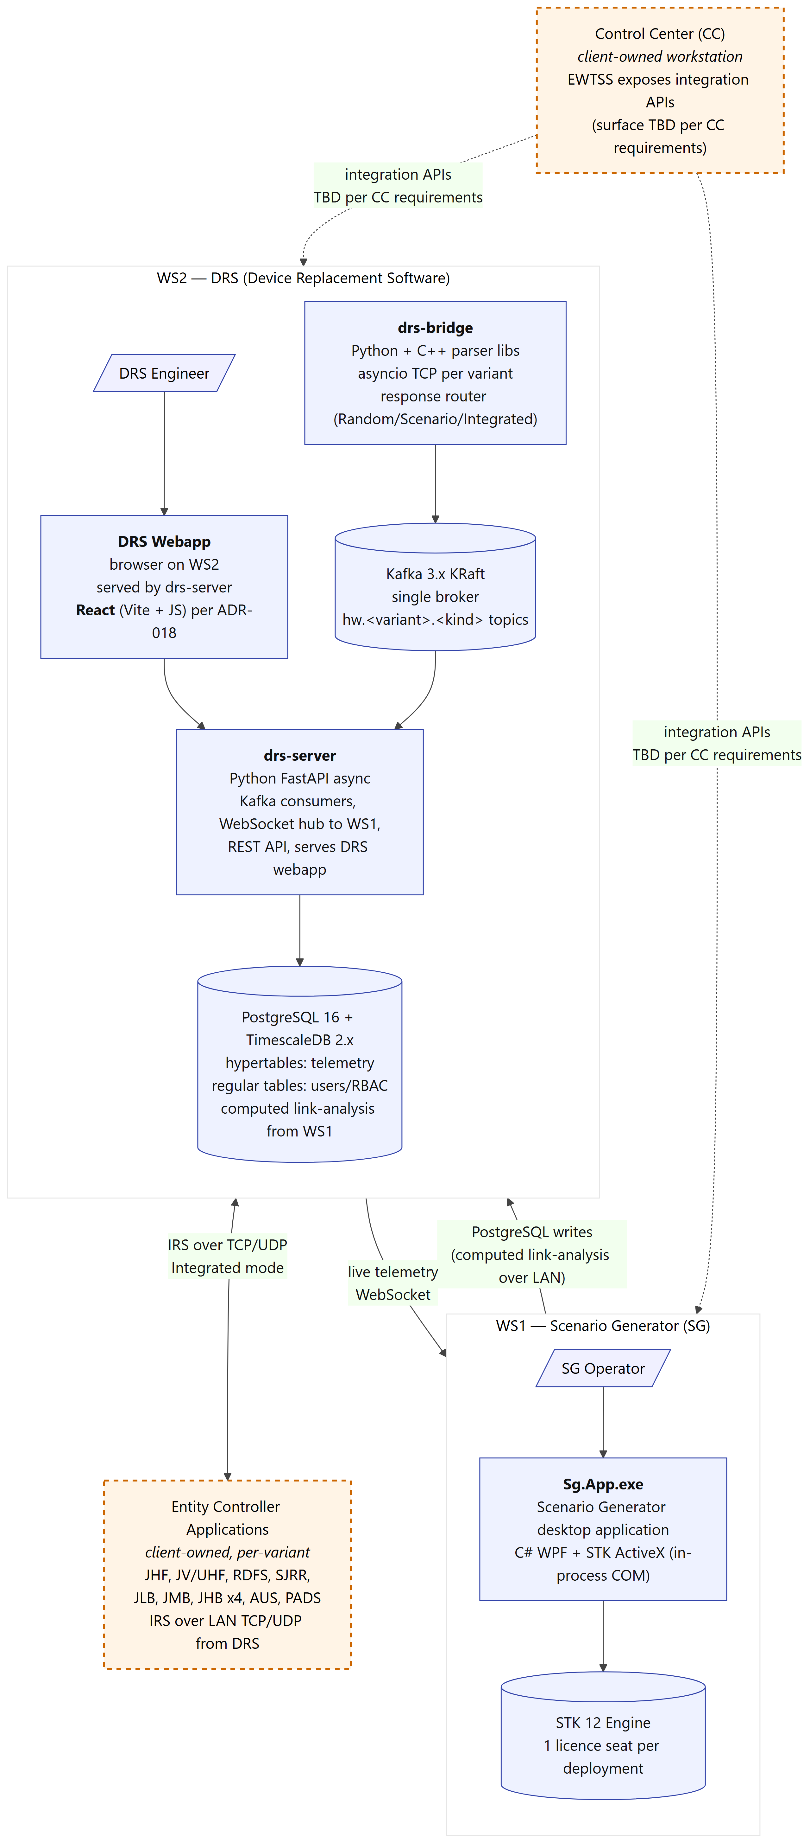

4.2 Layered model
The same components factor into seven horizontal layers (Figure 3). Each layer talks only to its immediate neighbour; no layer skips levels. The split point is L3 (Kafka + DB on WS2): L4–L6 live on WS1, L0–L3 on WS2. The only cross-LAN traffic is L4(WS1)↔L3(WS2) (computed link-analysis writes) and L5(WS2)↔L6(WS1) (drs-server REST/WebSocket). These layer rules are load-bearing: violations of them — a layer reaching past its neighbour or calling synchronously across services — are the class of issue that degrades a system of this kind under sustained load.
Figure 3. Seven-layer system model with the L3 split point and cross-LAN rules.
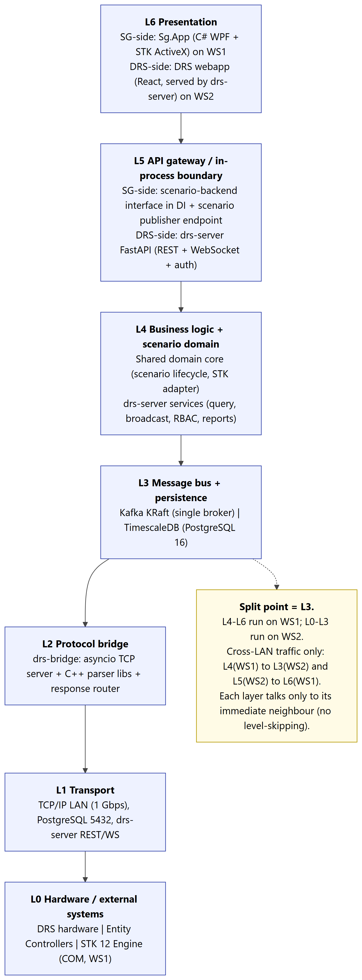

4.3 Component responsibilities
- Shared domain core — DTO records, the scenario-backend interface (the single boundary to STK), the STK COM adapter, view-models, and the interaction (placement/edit) controller. No COM types leak into the data contracts, enforced by a build-time check. Established.
- Sg.App (the Scenario Generator desktop application) — C# WPF host over the shared domain core: DI wiring, STK ActiveX hosting via WindowsFormsHost, object tree, property panel, keyboard finalize routing, file dialogs, splash. Established.
- drs-server — Python 3.12 FastAPI: Kafka consumers, TimescaleDB batched writes, WebSocket hub to WS1, REST reports/queries, RBAC + JWT, and serves the DRS webapp. Planned.
- drs-bridge — Python asyncio TCP servers + per-variant C++ parser .dlls + a response router. One YAML profile and one C++ parser per variant. A reference parser template is established; per-variant parsers are Planned.
- TimescaleDB — PostgreSQL 16 + Timescale 2.x: hypertables for telemetry; regular tables for users/RBAC, scenarios, library, computed link-analysis. Planned.
- Kafka KRaft — single-broker 3.x (no ZooKeeper); hw.<variant>.<kind> topics + control-plane topics. Single-broker infrastructure established; per-variant data-plane topics added with each variant interface.
- DRS webapp — React (Vite + JS) DRS Engineer surface on WS2: dashboard, per-variant monitor-scan, IP/network config, message logs, per-variant control, consumer-lag health. Planned.

5. Key architectural decisions
Table 6 summarises the architectural decisions that govern the delivered Scenario Generator and telemetry system, each stating what was chosen and the rationale. Status convention: Accepted = current canon; revisions are noted where a decision superseded earlier guidance.
ADR | Decision | Rationale (short) | Status
001 | Frontend: C# WPF desktop with in-process STK | STK-Insight-grade fidelity for power users on Windows; validated during design validation | Accepted
002 | Telemetry stack: three-service partial SOA | drs-server + drs-bridge (Python/C++); scenario authoring + STK in C# | Accepted
003 | Database: TimescaleDB (PostgreSQL 16 + Timescale 2.x) | Hypertables for telemetry; regular tables for RBAC/scenarios | Accepted
004 | Message bus: Kafka KRaft single-node | Replay + persistence; KRaft drops ZooKeeper | Accepted
005 | STK access: C# COM in-process | STK API is C#-first: native typing, microsecond method-call latency | Accepted
006 | STK contract boundary: a backend interface + DTOs | Single boundary; no COM types in the data contracts; JSON round-trip safe | Accepted
007 | Typed entities, not metadata-driven editor | Small fixed catalogue favours compile-time safety over a generic framework | Accepted
008 | Desktop GUI: WPF + WindowsFormsHost | Hosts the STK ActiveX control with validated interaction performance | Accepted
011 | Scenario file format: STK native (.sc/.vdf) | Round-trip with STK Desktop/Insight is a customer requirement | Accepted
012 | STK licensing: one Engine seat per deployment | Per-process licensing; only WS1 hosts STK, so the count is unambiguous (1) | Accepted
013 | STK COM events: on-demand only, never permanent | Permanent COM event subscriptions degrade interaction latency; subscribe only while placing/editing | Accepted (load-bearing)
014 | Facility position via direct geodetic assignment | Direct geodetic assignment is the reliable position-write path on the target STK build | Accepted
015 | Drag-edit changes committed explicitly on release | A user drag updates the visual only; an explicit commit persists the change | Accepted
016 | Placement/edit UX: match STK Desktop where possible | Principle load-bearing; specific keystrokes open for revision | Accepted; revised
017 | STK Mock: test-only, never runtime fallback | Fail-fast at startup; runtime mocks drift and hide bugs | Accepted
018 | WS2 DRS webapp, served by drs-server (React) | RFQ-required DRS Engineer surface; React + JavaScript (Vite) | Accepted

Table 6. Architectural decisions governing the delivered system.
Dependency notes: ADR-001 drives ADR-005/006/008/012; ADR-013/014/015 are implementation invariants that must hold for ADR-008 to deliver its performance/correctness goals (each was validated during design validation); ADR-018 is the second-persona (DRS Engineer) commitment and is independent of the Scenario Generator application.

6. Workflow and behaviour
This section illustrates the major workflows with diagrams. The figures below capture the load-bearing workflows; additional sequence detail (authentication, library operations, every execution mode, DRS Engineer flows, error/recovery, and external integration) is carried in the accompanying interface and test specifications.

6.1 Operator workflow (end to end)
Figure 4 traces a complete operational cycle: the SG Operator logs in, checks time sync, manages the EW library, authors a scenario on the GIS map, saves it (edits to compute-inputs flip it to STALE), computes link analysis when needed, selects an exercise mode, executes and monitors live, controls playback, and generates a report. The DRS Engineer works in parallel on WS2. Green nodes are established in the current codebase; amber nodes are planned for the build.
Figure 4. End-to-end operator workflow / operational cycle.
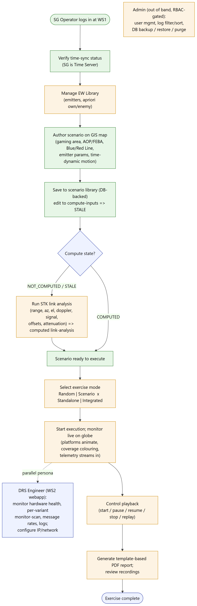

6.2 Telemetry data flow
Figure 5 shows how telemetry moves through the system — the hot path the design is built to keep stable. Hardware (or the C++ random generator) feeds drs-bridge, which parses to JSON and publishes to Kafka; drs-server consumes, writes to TimescaleDB in batches (100 msg / 500 ms) committing the Kafka offset only after the DB write, and fans out over WebSocket to the Sg.App panels and the DRS webapp. The low-volume computed link-analysis write from WS1 is the only other cross-LAN data path.

Figure 5. Telemetry data flow and the batched-write hot path.
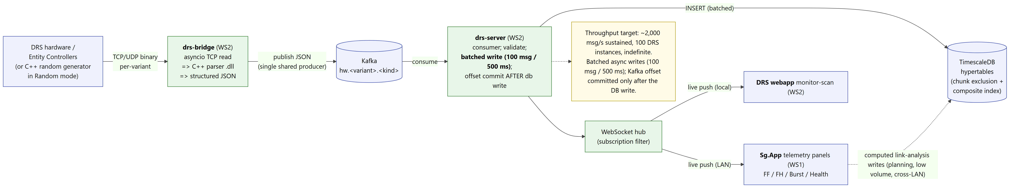

6.3 Control flow
Figure 6 shows how commands propagate. The SG Operator's exercise control (start/pause/resume/stop) is published to Kafka control topics and consumed by drs-bridge's response router; in Scenario mode the bridge pulls pre-computed values from Sg.App's scenario-publisher endpoint per tick and emits IRS frames to the entity controllers. The DRS Engineer's config/control actions flow through drs-server to Kafka control topics. A SYNC_LOST time-sync event auto-pauses a running exercise.

Figure 6. Control / command propagation across WS1, the Kafka control plane, WS2, and entity controllers.
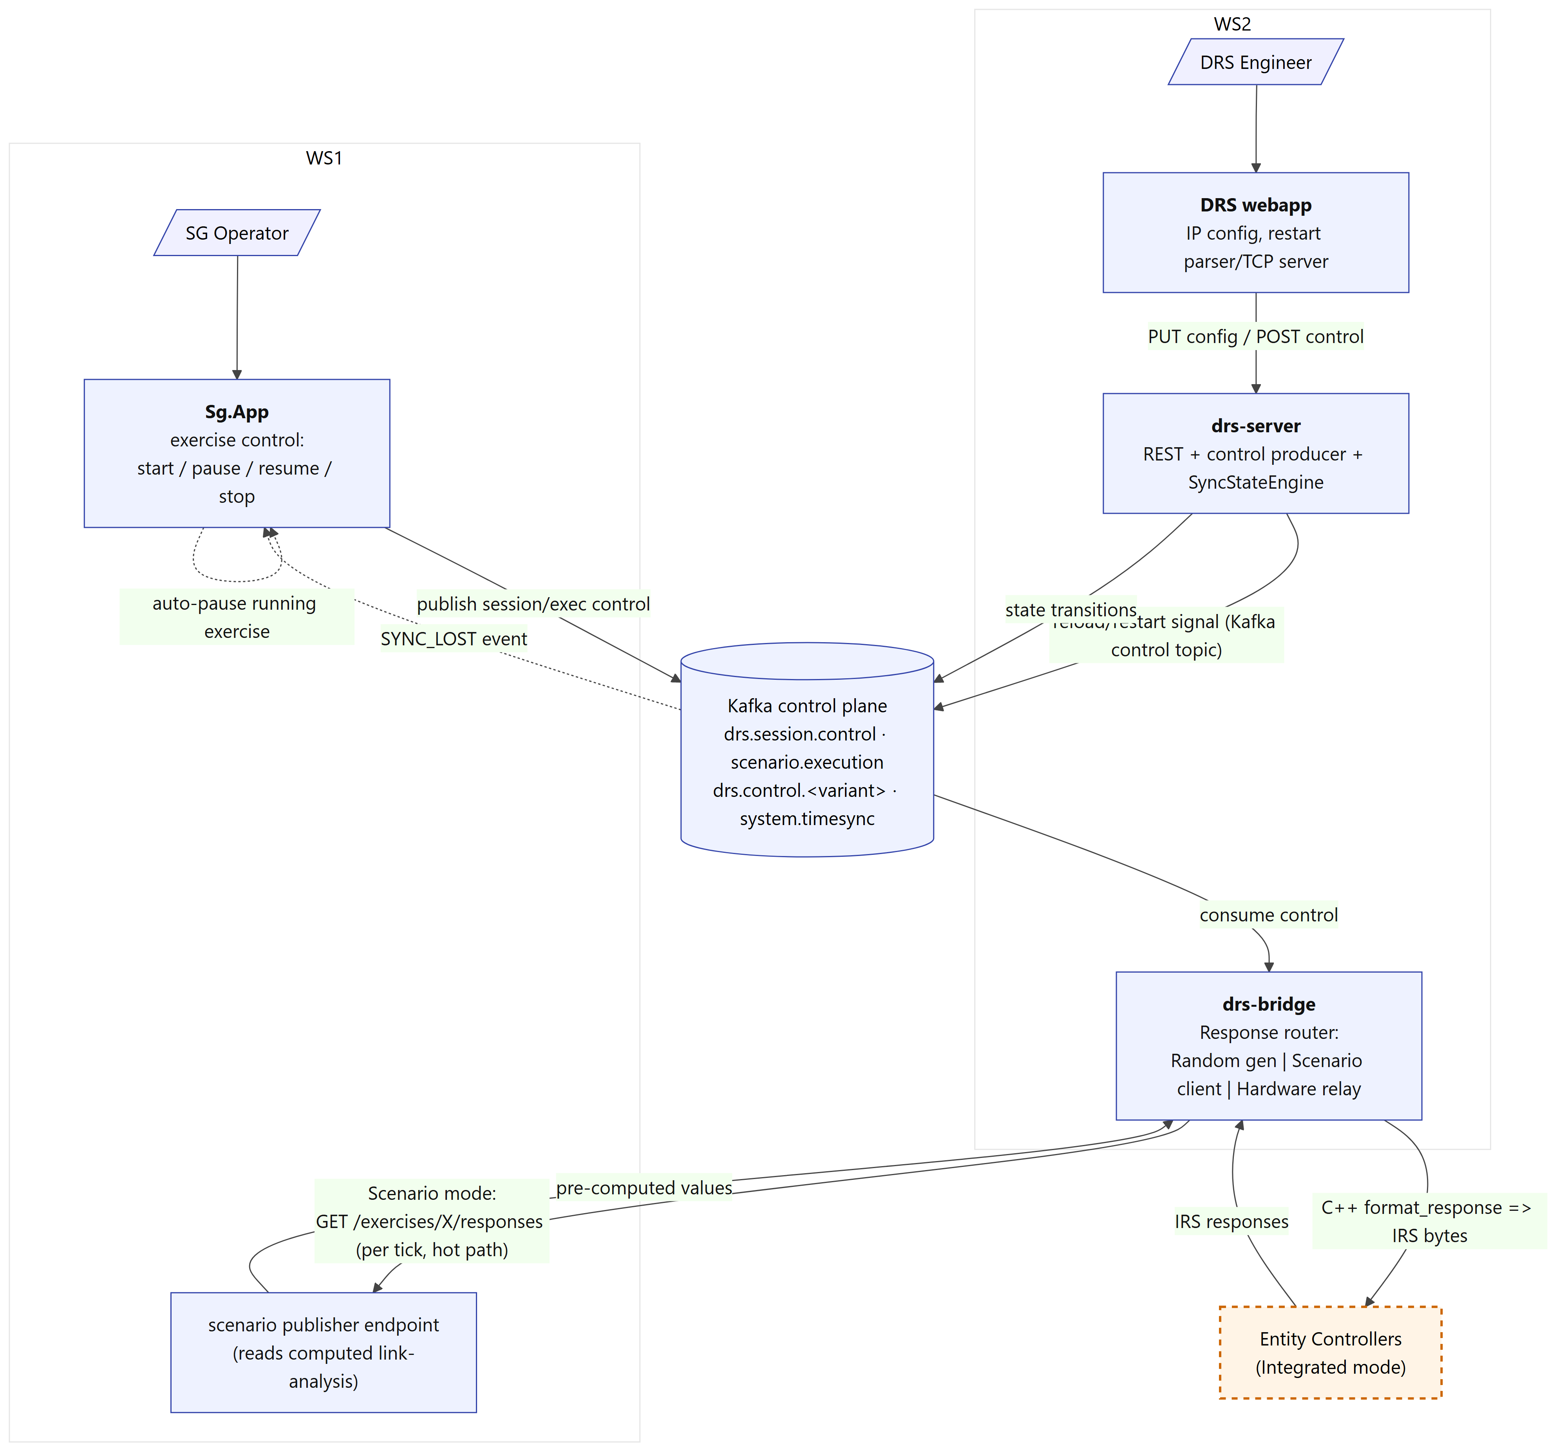

6.4 Scenario compute lifecycle
Figure 7 is the scenario compute state machine. A scenario is NOT_COMPUTED on creation/import/duplicate, becomes COMPUTED after a successful compute, and flips to STALE when an edit changes compute-inputs (which invalidates the prior computed link-analysis on save). Compute runs as three transactions so the multi-minute STK loop never holds the cross-LAN write lock, and is idempotent at every failure point.
Figure 7. Scenario compute lifecycle and the three-transaction write-back.
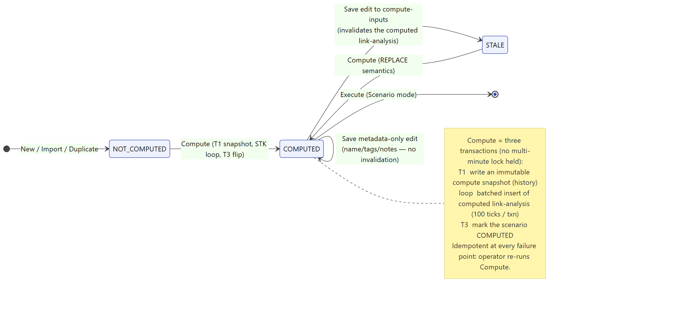

6.5 Exercise execution (Integrated + Scenario)
Figure 8 is the runtime sequence for the primary mission-execution mode. Each tick: Sg.App publishes the tick, drs-bridge fetches the pre-computed response from Sg.App, formats IRS bytes to the entity controllers, captures their responses, and mirrors both entity-response and telemetry traffic through Kafka into TimescaleDB and back to the operator UI over WebSocket.

Figure 8. Integrated + Scenario exercise execution sequence.
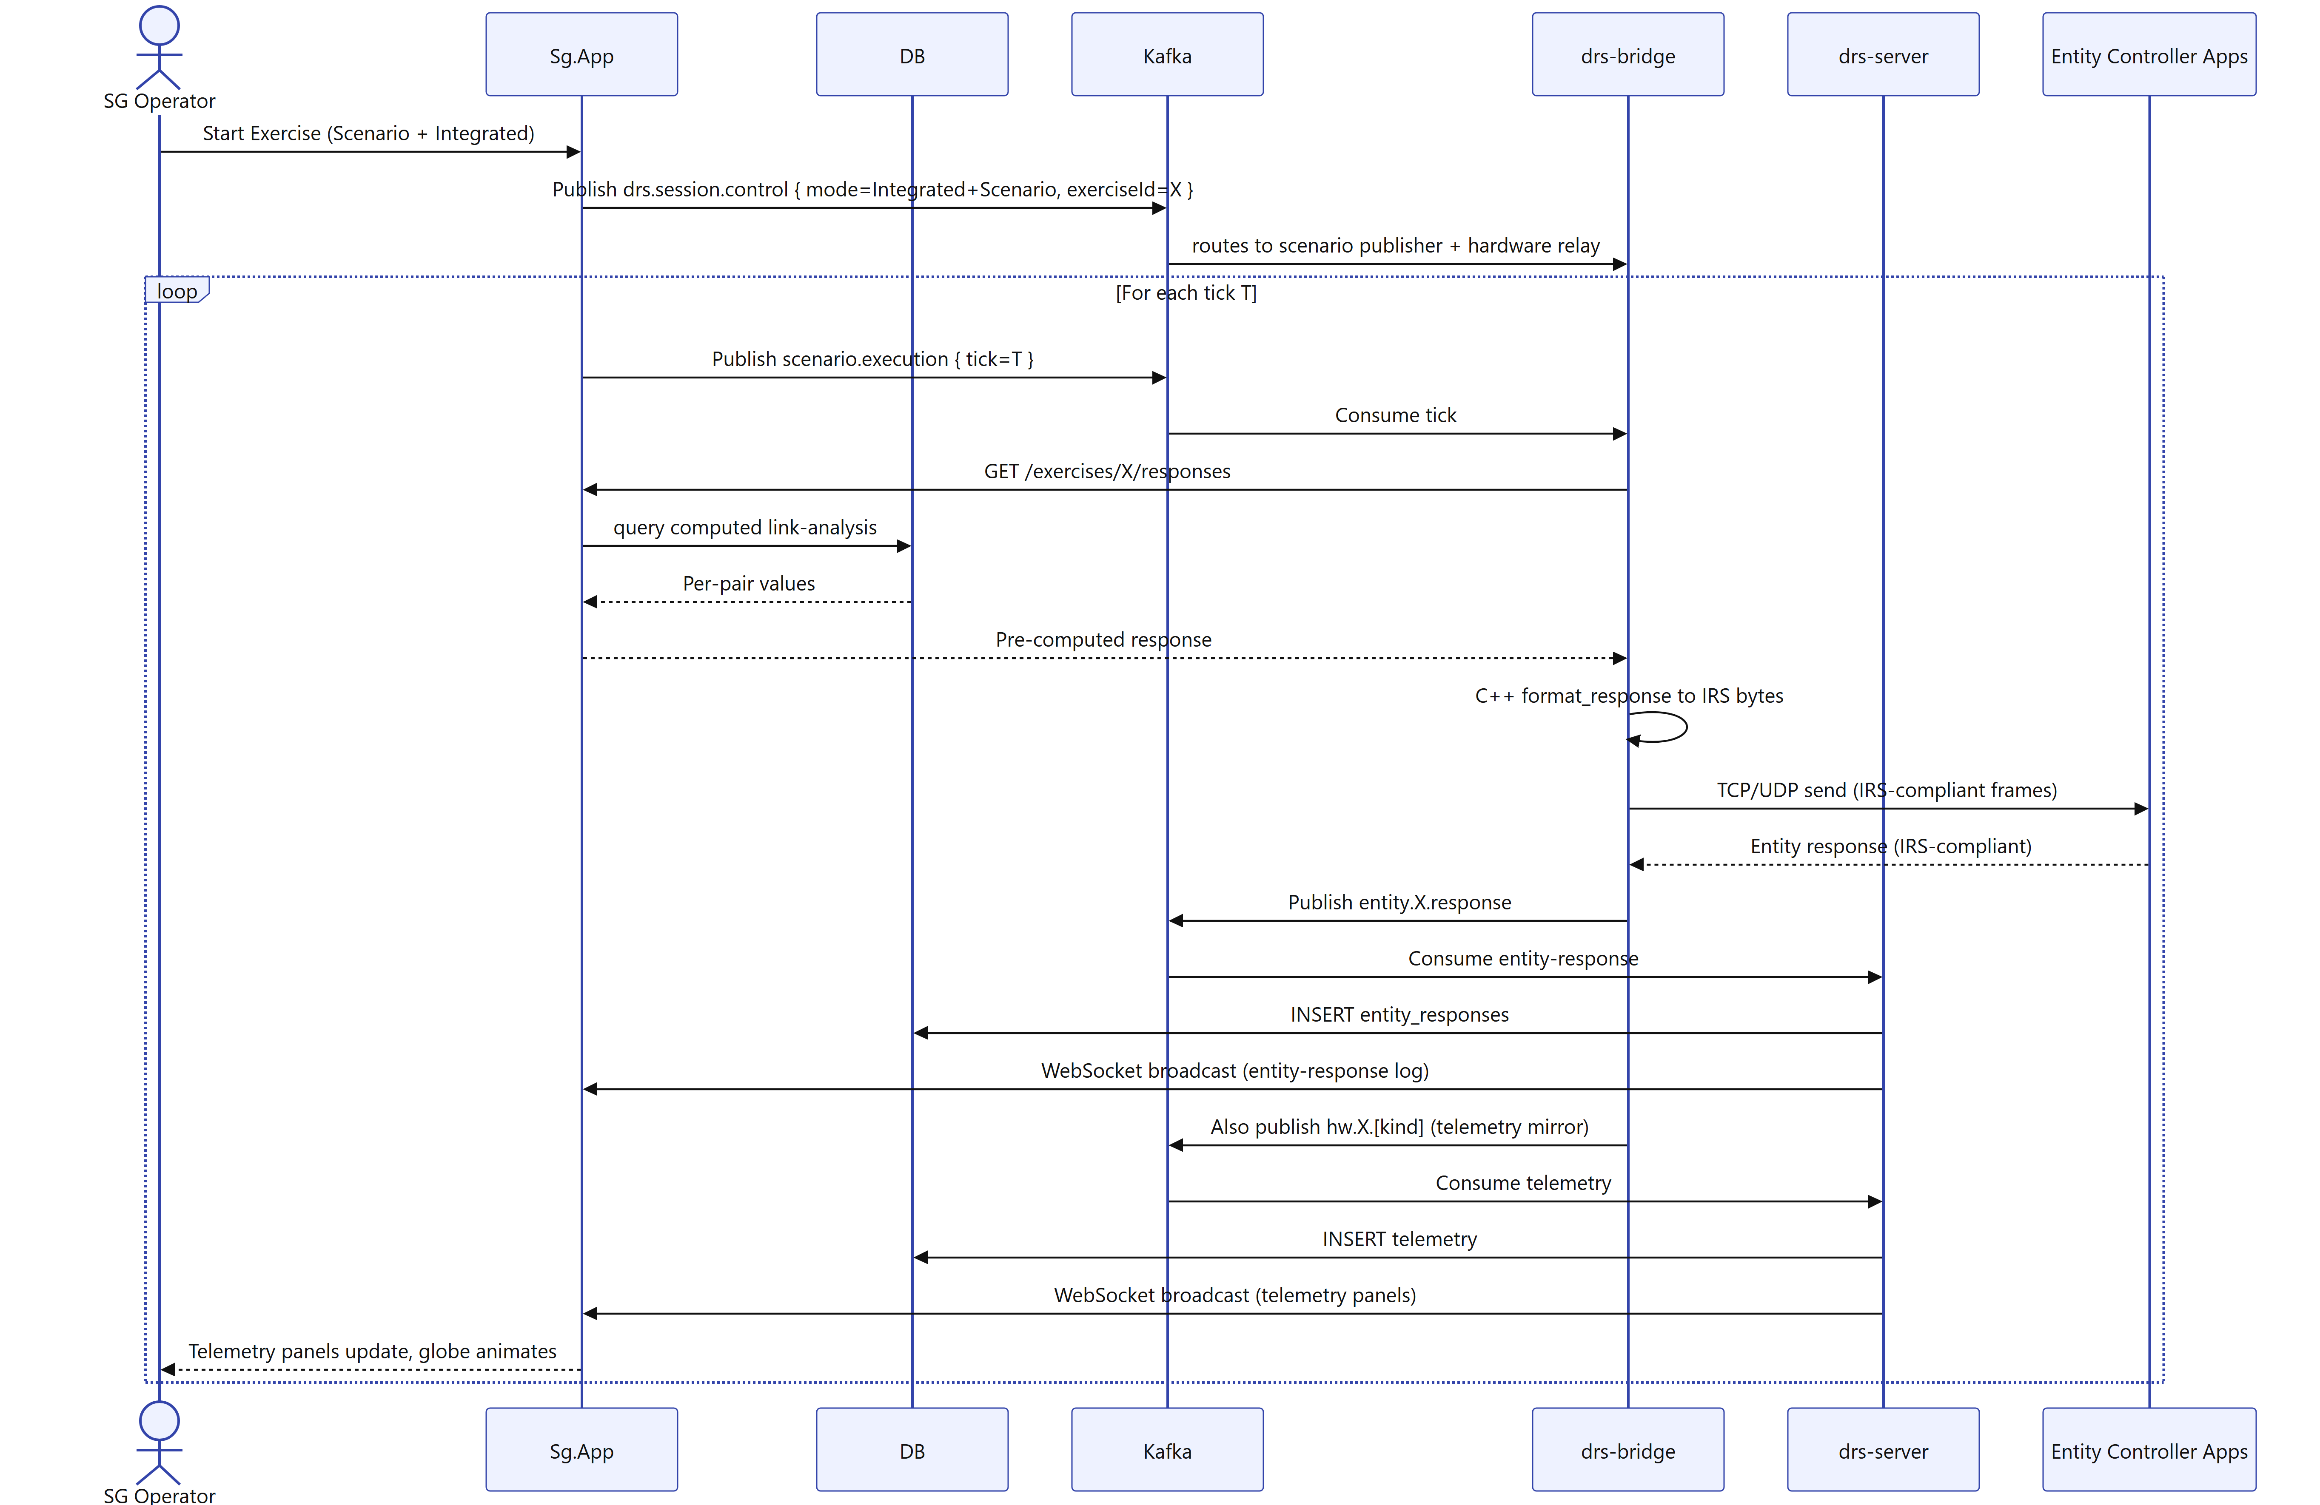

7. Deployment and runtime view
Figure 9 is the deployment view: two Windows nodes on an air-gapped LAN with their deployed artifacts, the labelled ports between them, and the external client-owned nodes.

Figure 9. Deployment / runtime view — nodes, artifacts, ports, and licences.
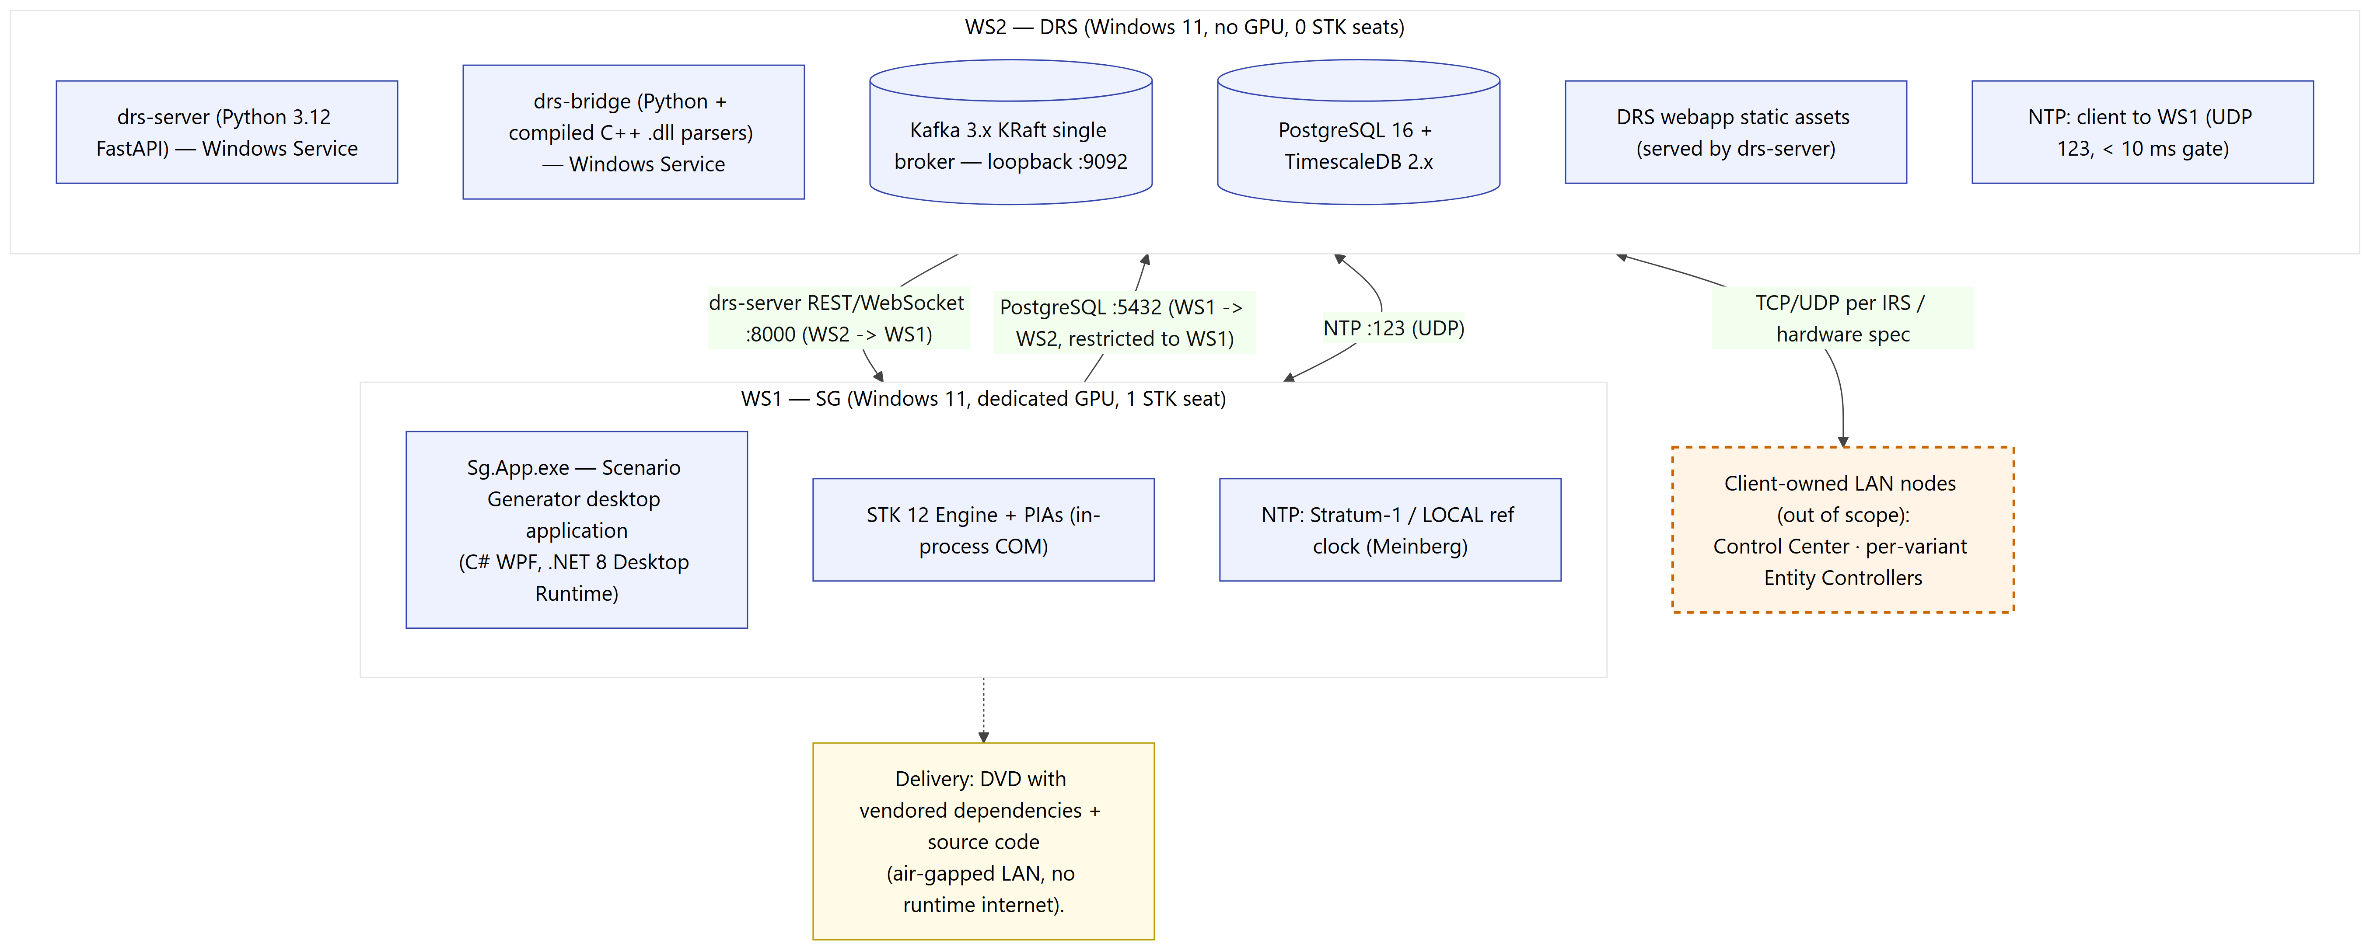

7.1 What runs where
 | WS1 — Scenario Generator | WS2 — DRS
Role | Scenario authoring, STK compute, exercise control, reports, admin | Telemetry pipeline, TimescaleDB, Kafka, DRS Engineer webapp
Artifacts | Sg.App.exe (WPF, .NET 8 Desktop Runtime) + STK 12 + PIAs | drs-server + drs-bridge (+ C++ .dlls) + Kafka + PostgreSQL/Timescale
STK seats | 1 (Engine) | 0
GPU | Dedicated strongly recommended | Not required

Table 7. Topology — what runs where.

7.2 Hardware and software
Resource | WS1 | WS2
OS | Windows 11 | Windows 11
CPU | x64, 4 cores min / 8 rec | 8 cores min / 16 rec
RAM | 16 GB min / 32 GB (>50 entities) | 32 GB min / 64 GB for 100-DRS load
GPU | GTX 1650 / RTX 3050+ recommended | Not required
Disk | SSD; ~5 GB STK + app + scenarios | SSD; ~1 TB recommended (retention)
Key software | STK 12, .NET 8 Desktop Runtime, VC++ redist | Python 3.12, PostgreSQL 16 + Timescale 2.x, Kafka 3.x KRaft, NSSM

Table 8. Hardware and software requirements.

7.3 Network and ports
- PostgreSQL 5432 — WS1 → WS2 (computed link-analysis writes); inbound restricted to WS1.
- drs-server REST/WebSocket 8000 — WS2 → WS1 (telemetry reads).
- Kafka 9092 — loopback on WS2.
- NTP UDP 123 — WS2 → WS1 (WS1 is Stratum-1 time server; < 10 ms offset gate).
- DRS hardware / entity controllers — TCP/UDP per protocol / IRS spec.

7.4 Critical setup considerations
- GPU preference (critical) — Sg.App.exe must be set to High Performance on dual-GPU machines or globe interaction is sluggish regardless of code quality.
- Windows Time Service must be Disabled on WS2 — Meinberg NTP owns the clock; a GPO can re-enable it and break the sync smoke test.
- DVD ships pre-built parser .dlls — the C++ toolchain is only needed if rebuilding on-site.

8. Delivery approach and scope boundaries

8.1 Delivery approach
The architecture in this document is the target end-state for the delivered system. It is delivered through a phased build with integration-test checkpoints, so that the telemetry pipeline, the Scenario Generator capabilities, and the DRS Engineer webapp are each exercised against acceptance criteria as they come together. Capabilities already validated in the current codebase (the scenario-authoring core and its STK integration, the time-synchronisation service, the message-bus infrastructure, and the reference hardware-parser template) are marked Established in this document; the remainder are Planned for the build.

8.2 Out of scope
- Multi-user authoring concurrency; real-time (mid-execution) scenario compute; and cloud / multi-tenant deployment — out of scope (the air-gapped, single-site LAN is load-bearing for the architecture).
- Cross-deployment scenario portability — out of scope (single-site delivery; the STK .sc/.vdf export exists for STK Desktop interoperability and backup, not for moving scenarios between deployments).

