**IOT BASED AUTOMATIC ELECTRICITY BILL & MAINTENANCE ALARM GENERATING SYSTEM**



**B.S. (SE) SRE Presentation Report**

**Submitted by:**

**Name: M.ABDULLAH WASEEM Student ID: SP17-BSSE-0060**

**Name: HARIS KHALID Student ID: SP17-BSSE-0046**

**Name: ZAUFISHAN HASSAN Student ID: FA16-BSSE-0028**

**Section: AM**

**Submitted to:** **Ms. Nazish Nouman**

**Date: 24 May, 2019**

**Department of Computer Science**

##### Muhammad Ali Jinnah University

**22-E Block 6, PECHS, Karachi-Pakistan**

Table of Contents

Table of Contents 2

1.1 The Product Vision: 5

1.2 Product Description: 5

1.3 Project Scope: 6

1.3.1 In-scope: 6

1.3.2 Out-scope: 6

1.4 Project Objectives: 6

1.5 Targeted Audience: 6

1.6 Business Requirements 6

1.6.1 Background of the Project: 6

1.7 Business Opportunities: 7

1.8 Business Objectives: 7

1.9 Business Risks: 7

1.10 Success Metrics: 7

1.11 Identifying Stake Holders: 8

2 Overall Description 8

2.1 Product Feature: 8

2.2 List of Deliverables: 8

2.3 Identifying User Classes: 9

2.4 Project Assumptions: 9

2.5 Project Constraints: 9

2.6 Design and Implementation Constraints: 9

3. External Interface Requirements 10

3.1 User Interfaces: 10

3.2 Hardware Interfaces: 10

3.3 Software interfaces: 10

3.4 Communication Interfaces: 10

4. System Features 11

4.1 Assumptions and Dependencies: 11

4.2 Add feature Tree: 11

4.3 Functional Requirements: 11

5. Use Case Diagram 13

5.1 Use case: Register Complaint 14

5.2 Use case: Generate Maintenance Alarm 14

5.3 Use case: Identify Defaulters 15

5.4 Use case: Pay Bill 16

5.5 Use case: Track Complaint Status 16

5.6 Use case: Block Users 17

5.7 Use case: Change Rates 17

5.8 Use case: Generate Bill 18

6. Nonfunctional Requirements 19

6.1 Accounting Requirements 19

6.2 Usability Requirements: 19

6.3 Security Requirements 19

6.4 External Requirements 19

6.5 Performance Requirements 19

6.6 Organizational Requirements 19

6.7 Operational Requirements 19

6.8 Development Requirements 20

6.9 Ethical Requirements 20

6.10 Regulatory Requirements 20

6.11 Testability: 20

6.12 Availability: 20

6.13 Installability: 20

6.13 Integrity: 20

7. System Features 21

7.1 System Feature 1 21

7.2 Description and Priority 21

7.3 Stimulus/Response Sequences 22

Appendix A: Project Gantt chart 23

23

Appendix B: Analysis Models / Design Models: 25

ER Diagram 25

Activity Diagram: 26

Login 26

Register Complaint 27

Generate Maintenance Alarm 28

Identify Defaulters 29

Pay Bill 30

UML Class Diagram: 31

Context Diagram: 31

Test Cases: 32

Appendix C: Screenshots of Prototypes: 38

References: 43

**1. INTRODUCTION**

## 1.1 The Product Vision:

**For** the Electric company and its users who want to connect each other through a better median. **The** IOT Based Automatic Electricity Bill &amp; Maintenance Alarm Generation System **is a** mobile application **that** allows the user to check their electricity consuming amount at anytime and anywhere. **Unlike** the other system which provides the amount of consuming electricity at the end of the month. **Our Product** will create a bridge between the user and the company so that they both communicate each other without any hesitation.

## 1.2 Product Description:

The software **“IOT Based Automatic Electricity Bill & Maintenance Alarm Generation System”**, is used for multiple purposes, It provides services to both, the employees of the Organization using it; Here its electricity company and the end users who are the staff of organization or consumers as well. Where we are monitoring the electric meter continuously and generate the bill based on consumption of electricity. Also this will require no additional time to generate the bill. Moreover bill will be more accurate and will be given to the appropriate customer. Automatic Meter Reading (AMR) is a technology using which automated electric bill generation process was done. It was developed in 1962, but was not successful. Then another project was implemented where meter reading was taken using camera and image processing. The camera will rotate and take reading of the meter. The drawback was if the dust get over camera screen the pure image will not be taken due to which the bill will not be generated. The employees of Electricity Company are benefited in a way that, from the office if someone has not paid the bill, they can terminate their electricity, or in case of a meter breakdown, instead of the user notifying them about the problem, they can automatically detect the problem and its location as an alarm will start buzzing in that mobile and the location will be traced easily, so they can send a maintenance man ASAP. For the consumers, they can pay the bills without having to go to the bank; they can monitor their electricity consumption and can register complaint whether it is about excessive bill amount or electricity shortfall.

## 1.3 Project Scope:

### 1.3.1 In-scope:

The employees of Electricity Company are benefited in a way that, from the office if someone has not paid the bill, they can terminate their electricity, or in case of a meter breakdown, instead of the user notifying them about the problem, they can automatically detect the problem and its location, so they can send a maintenance man ASAP. For the consumers, they can pay the bills without having to go to the bank; they can monitor their electricity consumption and can register complaint whether it is about excessive bill amount or electricity shortfall.

### 1.3.2 Out-scope:

The app will be operated from the network sim rather than Wi-Fi as Internet may not available every time. The communication will become a lot easier through the network communication.

## 1.4 Project Objectives:

* For the consumer they can pay their bills without having to go to banks.
* Customers can monitor their electricity consumption and can register complaint.
* They can review the status of their meter.

## 1.5 Targeted Audience:

This software targets all the audience, especially those with the facility of the internet. Consumers, power house station staff and management staff of organization who owns this software.

## 1.6 Business Requirements

### 1.6.1 Background of the Project:

Now days in each and every sector there are many people consuming electricity. The people are not satisfied with the services provided by power distribution companies, also electricity authority. The software **“IOT Based Automatic Electricity Bill & Maintenance Alarm Generation System”**, is used for multiple purposes, It provides services to both, the employees of the Organization using it; Here its electricity company and the end users who are the staff of organization or consumers as well. Where we are monitoring the electric meter continuously and generate the bill based on consumption of electricity.

## 1.7 Business Opportunities:

For the consumers, they can pay the bills without having to go to the bank; they can monitor their electricity consumption and can register complaint whether it is about excessive bill amount or electricity shortfall. By secure login consumer has no need to worry about privacy concerns. Consumer can track the status of complaint. The employees of Electricity Company are benefited in a way that, from the office if someone has not paid the bill, they can terminate their electricity, or in case of a meter breakdown, instead of the user notifying them about the problem, they can automatically detect the problem and its location as an alarm will start buzzing in that mobile and the location will be traced easily, so they can send a maintenance man ASAP. They can monitor the usage of individuals or whole power feeders. They can keep close eyes on electricity thefts.

## 1.8 Business Objectives:

In a very short span of time the complaint of the user will be registered. There will be no effect on the performance of this application even if all the registered users logged in at the same time. They all can register their complain at the same time. If the customer wants to check their bill or want to check their total units consumed they can do it in seconds.

## 1.9 Business Risks:

If the device that is connected with the meter is damaged, then the person can’t even complain nor can he check his units consumed or bill. If anyone hacks a person’s device so they can change the bill and the units consumed of that person. Maybe the mobile application gets down or for maintenance due to any reason.

## 1.10 Success Metrics:

The features that we are providing through this application, all the users can avail them at the same time. If anyone complains about the electricity break down then they will get the response with in few seconds. Or if he is using any other feature of the application then he will get the output quickly from the system.

## 1.11 Identifying Stake Holders:

The K-Electric Officials, Power House Station Staff, Developing Team & Consumers are the primary stakeholders.

# 2 Overall Description

## 2.1 Product Feature:

**For Customers:**

* They will have the leverage to pay their bills online.
* They can review their electricity consumption.
* They can have access to their usage statistics.
* In case of electricity breakdown, they can easily generate maintenance alarm.
* In case of error in bill generation they can register complaint for correctness of bill.
* Consumer can track the status of complaint.
* By secure login consumer has no need to worry about privacy concerns.

**For Employees:**

* If the bills are not paid, they can cut the power without going to their home.
* They can get notified of the faulty meter.
* They can keep close eyes on electricity thefts.
* They can monitor the usage of individuals or whole power feeders.

## 2.2 List of Deliverables:

The system consist of two parts, one is mobile application other is web portal. The device will be installed to the meter of the user which works as a bridge between company and the user. The device is directly controlled by the K-Electric also the user can easily access it through mobile application. The device provides 24hr meter details to the K-Electric as well as the User.

## 2.3 Identifying User Classes:

There are 2 types of users who will be using this system, one is the **customers** and others are the **employees** of Electricity Company. Customers shall be using mobile application whereas electricity company employees shall be using web portal. Customers can use this application to inspect their electricity. It includes, monitoring their electricity usage, checking the status of their meter, paying electricity bill. Employees can use web portal to manage electricity outage. Who is consuming how much electricity, who has paid the bills and who has not, which customers are having problem with their meter or electricity, who are stealing others electricity, they can fine the culprits.

## 2.4 Project Assumptions:

The device will provide 24hr details to the company and the user if the internet is available. The product will always be used on mobile phones that have enough hardware resource available.

## 2.5 Project Constraints:

Mobile application can face application malfunctions depending on their mobile type, since app requires internet and it may not be available every time.

Web users can also face same problem. Internet downfall can cause my progress to slack. Not all systems are well built; some are of new technology while same our still old, the old systems have slow response time.

## 2.6 Design and Implementation Constraints:

* There can be various constraints for both the mobile applicants and the web users.
* Mobile applicants can face application malfunctions depending on their mobile type, since this app requires internet or Wi-Fi connection, many people might not have this facility, internet is not always or everywhere available, and this might limit its effectiveness.
* Web users might also face the problem. Internet downfall can cause my progress to slack.
* Not all systems are well built, some are of new technology while some are still old, and the old systems have slow response time.

# 3. External Interface Requirements

## 3.1 User Interfaces:

At first the login page will be visible to the consumer and the basic function like generate maintenance alarm, register complaint, check status, pay bill and track complaint status will be presented.

## 3.2 Hardware Interfaces:

Only hardware except from the mobile phones used to run specific application and computer is the electric meters that has the capability to interact with application servers.

## 3.3 Software interfaces:

The mobile application communicates with the application servers in order to get information from the database in order to get the information about the usage. The communication between the database and the web portal consists of operation concerning both reading and modifying the data, while the communication between the database and the mobile application consists of only reading operations.

## 3.4 Communication Interfaces:

The communication between the different parts of the system is important since they depend on each other. However, in what way the communication is achieved is not important for the system and is therefore handled by the underlying operating systems for both the mobile application and the web portal.

# 4. System Features

## 4.1 Assumptions and Dependencies:

IOT bases electric meter is compulsory component to perform all operations as it is the function of electric meter to transfer the data in form of statistics about electricity usage. System is also dependent on ISP’s to work properly, for proper communication between components of system and between systems itself.

Another assumption for consumers is that the product will always be used on mobile phones that have enough performance. If the phone does not have enough hardware resources available for the application, for example the users might have allocated them with other applications, there may be scenarios where the application does not work as intended or even at all.

## 4.2 Add feature Tree:

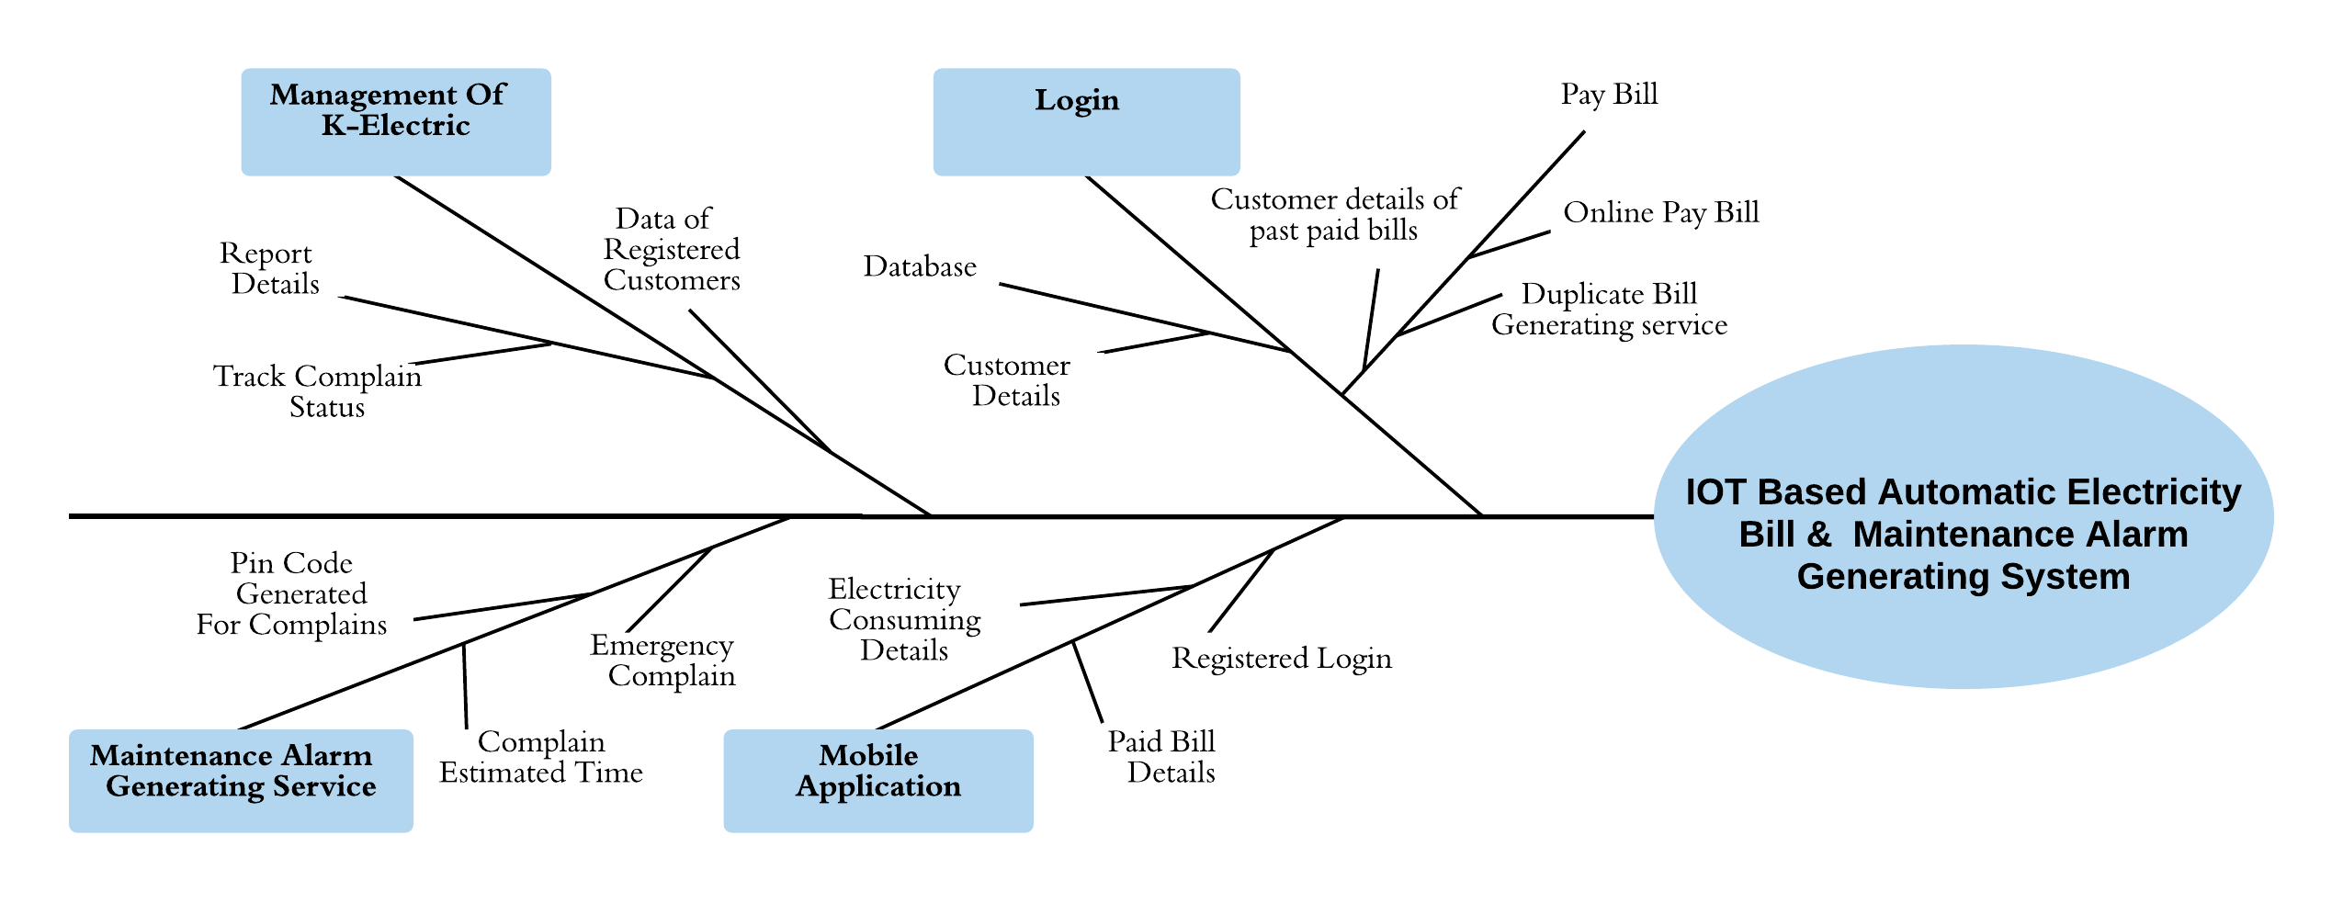

## 4.3 Functional Requirements:

* Enable the user/customer to check the consumption of electricity of his/her home online.
* Facilitate the user to pay bill online rather than going to a physical location (Bank) to pay.
* In an event of an electricity outbreak or shortfall, the consumer will be immediately notified.
* Providing the user, the facility to call maintenance in an event of a meter malfunction.
* To provide secure meter reading, preventing any disruption from external entity.
* To enable K-Electric to have a close check of the sectors under their supervision.
* In an event of a meter malfunction, notify the maintenance man immediately.
* To check for the amount of electricity supplied to the homes.
* To check how much electricity is consumed at residential and industrial level.
* To check if anyone is tampering with the meter.
* Notify if someone has paid or not paid the bill.
* To prevent the stealing of electricity.
* Rather than manually going to a grid station to shut down electricity, the person can cut down power from the department.
* Electricity bill can be sent to consumer online. Provide ease to both, consumer and employee to get the work done efficiently.

# 5. Use Case Diagram

## 5.1 Use case: Register Complaint

|  |  |
| --- | --- |
| Description | Register Complaint either about electricity shortfall or excessive bill amounts by simply selecting options. User can do so by filling and submitting complaint forms in “Register Complaint” section. |
| Pre-Condition | User should be logged in to the system before registering complaint. |
| Data | Consumer credentials and detailed description of complaint. |
| Stimulus | User clicks on register complaint option after having issues with system or supply. |
| Response | Complaint form is provided to the user which is further filled and submitted by user. |
| Flow of Events | * Open “Register Complaint” section in system * Choose either “Register Excessive Bill Amount Complaint” or “Register Electricity Shortfall Complaint” Section * Fill complaint form including complaint details and consumer credentials * Get tracking id against particular complaint |
| Post-Condition | Complaint is registered and sent to concerned operators. User has tracking ID to track complaint status. |
| Comment | The consumer must have valid user name, password and credentials to use the system for complaint registration. |

## 5.2 Use case: Generate Maintenance Alarm

|  |  |
| --- | --- |
| Description | Generate maintenance alarm in case of electricity short fall or other technical problem. |
| Pre-Condition | User should be logged in to the system and should have registered complaint about this particular category. |
| Data | Consumer credentials and complaint tracking id. |
| Stimulus | User clicks on “Generate Maintenance Alarm” option after having issues with supply. |
| Response | Proper complaint statistics and complaint ID is displayed for validation of proper complaint. |
| Flow of Events | * Open “Register Complaint” section in system * Choose “Register Electricity Shortfall Complaint” Section * Verify the validity of alarm and attached complaint id. * Generate the maintenance alarm by click on verify and continue button. * Get the maintenance report |
| Post-Condition | Maintenance alarm is generated and sent to maintenance operator with user complaint and credential details. |
| Comment | The consumer must have valid complaint tracking ID to generate the maintenance alarm. |

## 5.3 Use case: Identify Defaulters

|  |  |
| --- | --- |
| Description | Identify defaulters who have not paid electricity bills so that further action could be performed. |
| Pre-Condition | User should be logged in as Manager to the system before identifying defaulters. |
| Data | Particular amount of remaining bill that distinguish the defaulters from other consumers. |
| Stimulus | User clicks on identify defaulters option in need to identify non payers. |
| Response | List of defaulters is displayed on screen with detail of their billing history and connection address. |
| Flow of Events | * Login is essential * Open “Identify Defaulters” section in system * Write a query with specific bill amount that distinguish the defaulters from other consumers. * Click on particular consumer name. * Get detailed data of default consumers. |
| Post-Condition | List of defaulters that came under the condition of query generated by user is displayed with complete billing history. |
| Comment | The consumer must have already specified the proper query that could differentiate the defaulters from other consumers. |

## **5.4 Use case: Pay Bill**

|  |  |
| --- | --- |
| Description | Bill payments of either existing or new bills by choosing payment methods in the system or paying bills. |
| Pre-Condition | There must be pending bill in billing options. If no bill exist than that means there is no need to pay bills. |
| Data | Bill details with amount and month of bill with valid details of online billing transaction. |
| Stimulus | Either after getting a notification about bill payment or paying bill voluntarily, User clicks on pay bill option and choose payment method. |
| Response | User get copy of his/her bill and system provides the user bill payment methods. |
| Flow of Events | * Open “Pay Bill” section in system * Choose either “Online Bill Paying Option” or “Payment Via Mobile” Section * Verify the validity of bill and bill amount. * Click on Pay Bill option to pay bill and get receipt. |
| Post-Condition | User has receipt of bill which he/she paid and paid amount is deducted from total bill amount. |
| Comment | The remaining payment amount should be greater than zero so that bill for that particular amount could be paid. User must have valid bank account details if he/she is going to pay bill online. |

## 5.5 Use case: Track Complaint Status

|  |  |
| --- | --- |
| Description | Track status of already registered complained to know in which process is complaint now. |
| Pre-Condition | User should must be logged in as consumer and complaint should already be registered and user must have tracking ID of that complaint. |
| Data | Complaint status and tracking ID. |
| Stimulus | User clicks on “Complaint Status” option to let know in which process complaint is. |
| Response | Status of complaint with original complain transcript is displayed before user. |
| Flow of Events | * Open “Check Complaint Status” section in system * Enter Complaint Tracking ID in search form * Click on “GO” button to submit the request * Get the status of complaint with detailed description of complaint |
| Post-Condition | User has complete status of his/her complaint. |
| Comment | It is necessary that a complaint should already be registered and user should have a valid tracking ID to perform this process. |

## **5.6 Use case: Block Users**

|  |  |
| --- | --- |
| Description | Block the particular user and stop electric supply by clicking on block user option and providing details of consumer. |
| Pre-Condition | User should be logged as Manager to the system. |
| Data | Consumer credentials. |
| Stimulus | User clicks on “Block User” option after finding user in this category. |
| Response | Credentials of consumer who needed to be blocked are displayed before user. |
| Flow of Events | * Open “Block User” section in system * Search for the consumer in search option * Click on the Block button provided in front of consumer * Enter the reason of blocking * Refresh the page to validate that consumer is blocked |
| Post-Condition | Consumer is blocked with no more supply of electricity. |
| Comment | The user should be logged in as manager. User should have valid reason for blocking a user that needs to be written in review that appears after clicking on block button. |

## 5.7 Use case: Change Rates

|  |  |
| --- | --- |
| Description | Change rates of electricity per unit for either commercial or general users by processing through change rates option. |
| Pre-Condition | User should be logged in to the system as Manager before changing rates of electricity. |
| Data | Login details and new rates amount. |
| Stimulus | User clicks on “Change Rates” option in case of demand from stakeholders of system. |
| Response | Form that contains previous rates that would be override with new rates. |
| Flow of Events | * Open “Change Rates” section in system * Override the form that contains previous rates |
| Post-Condition | Rates are changed. Every bill generated after this process would be using these new rates. |
| Comment | The consumer must have valid user name, password to login as manager to change the rates per unit. |

## 

## 5.8 Use case: Generate Bill

|  |  |
| --- | --- |
| Description | Generate the bills of all consumers when a bill generating data arrived |
| Pre-Condition | User should be logged in to the system as Manager |
| Data | Login details and usage details of all consumers |
| Stimulus | User clicks on Generate Bill option when last data of month arrived. |
| Response | All customers are displayed on screen and a red generate bill option appears. |
| Flow of Events | * Open “Generate Bill” section in system * View the list of all consumers with a generate bill now option * Click on the generate bill now option * Confirmation Message displayed on screen |
| Post-Condition | Bills are generated and send to consumers accounts for bill paying. |
| Comment | The consumer must have valid user name, password to login as manager to generate the bills of all consumers. |

# 6. Nonfunctional Requirements

## **6.1 Accounting Requirements**

Update the ones who have paid the electricity bills, bills should not be paid after 23:59. Fine will be imposed.

## 6.2 Usability Requirements:

Both the consumers and the employees can use this system to monitor but an employee cannot make changes after work time.

## 6.3 Security Requirements

Login and password of the user is required. The data of consumer is visible only to the user and not to anyone else, in case of data being delivered to an unauthorized user, the consumer will be notified.

## 6.4 External Requirements

Those who have signed in to the system will receive details, any outsider will not be permitted to access the system.

## 6.5 Performance Requirements

System updates every 30 minutes, so any changes or status can be updated efficiently.

## 6.6 Organizational Requirements

The system should follow all of the organizational norms, any functionality other than organizations norm should not be included in the system. The system should authorize specific users with limited access as it will be against organization culture to give access to personal records of employee and customers.

## 6.7 Operational Requirements

System is capable of handling 1000 requests at a time means at one time the system is capable to perform either data entries or retrievals. Requests more than one thousand will be placed in queue so that as soon as one user closes its operation other can continue with his own.

## 6.8 Development Requirements

System and sub systems should be developed using specific development tools and methods. Development methods other than specified ones cannot be used.

## 6.9 Ethical Requirements

The system is well protected, it allows the employees and customers login and password to either see data or to access data. There are certain changes that you cannot make without certain authorizations.

## 6.10 Regulatory Requirements

System obey laws of regulatory bodies and every functionality provided in systems does not exceed the limits and boundaries that are not specified by regulatory bodies.

## 6.11 Testability:

System is easy to test it can also be divided in different modules so that it is easier for testing.

## 6.12 Availability:

The system shall be available 97% in a year and will be shut down for at least 4 hours on Sunday morning from 6 am to 9 am twice a year.

## 6.13 Installability:

The system shall be taken minimum 3 minutes on installation while the time is totally dependent on how fast the device will work. The maximum time taken would be 5 minutes for any amateur user.

## 6.13 Integrity:

The Bridge of information between the k-electric, users and the device which is planted on user’s meter is totally based on encryption so that no other person can over write then.

# 7. System Features

## 7.1 System Feature 1

* Registration.
* Logging in.
* See performance of electricity consumption.
* Status of the meter.
* Pay electricity bill.
* Generating a complaint.
* Feedback.
* Logging out.

## 7.2 Description and Priority

* Registration: When using this application, customers should register themselves, and provide the information of their meter, all its specifications and other details of the customer itself.

Priority: High.

* Logging In: After the customer has registered him/herself, to access the application, hey must be logged in.

Priority: High.

* See performance of electricity consumption: Once logged in, user can see their electricity consumption on their mobile phone.

Priority: Low.

* Status of the meter: Performance of the meter can also be monitored using this app, if its working fine, if its lagging or too heat up or if there is any fault in the meter. It all can be monitored.

Priority: Low.

* Pay Electricity Bill: Electricity bill can be paid from mobile application online.  
  Priority: High.
* Generating Complaint: In case of any problem, user can generate a complaint, e.g. if meter breaks, electrical shortage, miscalculated bill etc.

Priority: Medium.

* Feedback: As all apps have a feedback option, this one too has a feedback option to gain customer feedback, it helps in keeping the app maintained and up to date.  
  Priority: Low.
* Logging out: A customer can log out or keep themselves logged in.

Priority: Low.

## 7.3 Stimulus/Response Sequences

* Registration:

Open the Application on mobile phone. Click register if you are a new user, if you are an old user, you can directly log in. There will be requirements for registration regarding the user and their electricity requirements and their meter. User must fill the requirements and click continue and then finish.

* Logging in:

Once registered, the user must fill the user name gap and then provide them with the password, where user can see all the functionalities of the application. The user can choose any option.

* See performance of electricity consumption:

There will be several buttons to go into different functionalities. Click on the performance evaluation button. A new screen opens, where the performance of the meter will be shown. From there we can monitor our meter.

* + Status of the meter:

Another button is about status of the meter. Clicking on that button. We will go into a new screen. There we will be shown if the meter is performing well, a green light is shown, if there are minor unnoticeable faults a yellow light but if intense faults red light will be show.

* Pay electricity bill:

While logged in. we can click pay bill button. A challan will be displayed on the screen, showing us our consumption. While paying the bill our payment method will be asked. We will choose our payment method.

* Generating Complaint:

On clicking the complaint box. There will be a few options in front of us on what type of complaints we are having. There are abundant options. There is a blank space also where we can make our custom complaint if it is not in the complaint box.

* Feedback:

There is a feedback option, where we can submit our feedback.

* Logging Out:

On clicking logging out button, we can log out from the app. It’s an option to log out.

# Appendix A: Project Gantt chart

# 

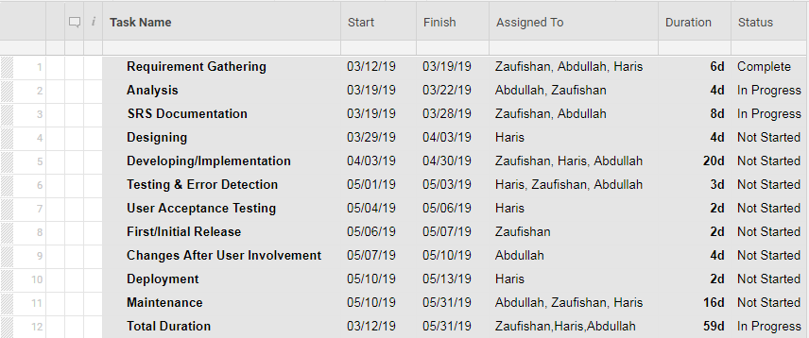

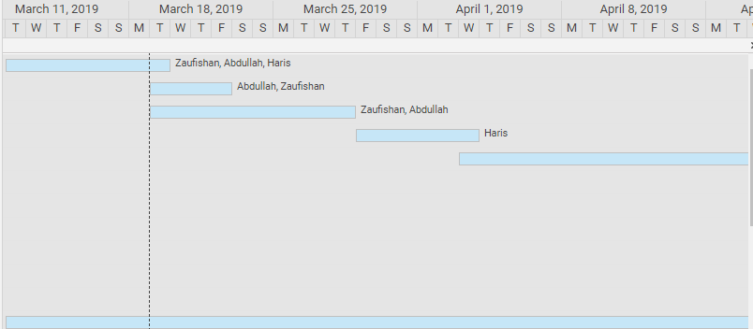

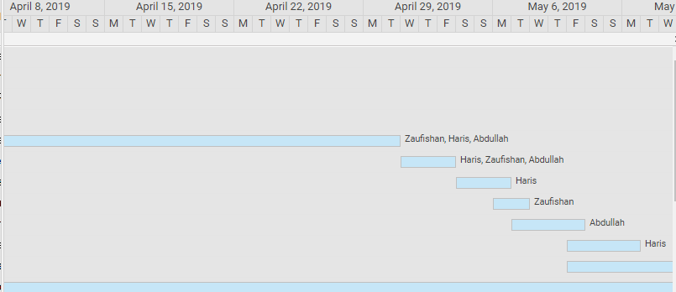

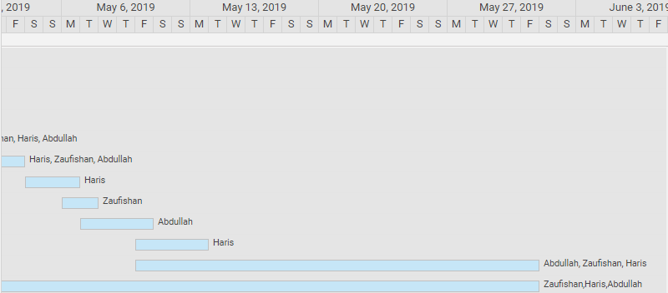

# Appendix B: Analysis Models / Design Models:

## ER Diagram



## Activity Diagram:

### Login



### Register Complaint



### Generate Maintenance Alarm



### Identify Defaulters



### Pay Bill



## UML Class Diagram:

## Context Diagram:

## Test Cases:

|  |  |  |  |
| --- | --- | --- | --- |
| Project Name: IOT BASED ELECTRICITY BILLING AND GENERATING ALARM SYSTEM | | | |
| Test Id | 01 | Test Designed By: | Abdullah |
| Test Title: | Test login functionality | Test Designed Date: | 1st MAY 2019 |
| Description | Test login with invalid details | | |
| S.No | Test Steps | Test Input | Expected Results |
| 1 | Open login | Click login | successful |
| 2 | Enter acc no. | 123456 | valid |
| 3 | Enter consumer name | Abd | invalid |
| 4 | Click submit |  | Login failed |

|  |  |  |  |
| --- | --- | --- | --- |
| Project Name: IOT BASED ELECTRICITY BILLING AND GENERATING ALARM SYSTEM | | | |
| Test Id | 02 | Test Designed By: | Haris |
| Test Title: | Test login functionality | Test Designed Date: | 3rd May 2019 |
| Description | Test login with invalid details | | |
| S.No | Test Steps | Test Input | Expected Results |
| 1 | Open login | Click login | successful |
| 2 | Enter acc no. | 123 | invalid |
| 3 | Enter consumer name | Haris | valid |
| 4 | Click submit |  | Login unsuccessful |

|  |  |  |  |
| --- | --- | --- | --- |
| Project Name: IOT BASED ELECTRICITY BILLING AND GENERATING ALARM SYSTEM | | | |
| Test Id | 03 | Test Designed By: | Haris |
| Test Title: | Test login functionality | Test Designed Date: | 5th May 2019 |
| Description | Test login with valid details | | |
| S.No | Test Steps | Test Input | Expected Results |
| 1 | open login | Click login | successful |
| 2 | Enter acc. no | 123456 | valid |
| 3 | Enter consumer name | Haris | valid |
| 4 | Click submit | - | Login successful |

|  |  |  |  |
| --- | --- | --- | --- |
| Project Name: IOT BASED ELECTRICITY BILLING AND GENERATING ALARM SYSTEM | | | |
| Test Id | 04 | Test Designed By: | Zaufishan |
| Test Title: | Test the register complain Functionality | Test Designed Date: | 9th May 2019 |
| Description | Verify register complain with valid account (Account No. should be of 14 digits). | | |
| S.No | Test Steps | Test Input | Expected Results |
| 1 | Open Register Complain | Click register complain option | Open successfully |
| 2 | Enter Account No. | 12345678234561 | valid |
| 3 | Enter complain | - | Complain registered |
| 4 | Click submit | - | Complain registered successfully |
| Project Name: IOT BASED ELECTRICITY BILLING AND GENERATING ALARM SYSTEM | | | |
| Test Id | 05 | Test Designed By: | Zaufishan |
| Test Title: | Testing register complain functionality | Test Designed Date: | 12th May 2019 |
| Description | Verify register complain with invalid account | | |
| S.No | Test Steps | Test Input | Expected Results |
| 1 | Open Register Complain | Click register complain option | Open successfully |
| 2 | Enter Account No. | 123A | Invalid, Account no. should contain any alphabet. |
| 3 | Enter Complain | - | Registered |
| 4 | Click Submit | - | Complain isn’t registered. |

|  |  |  |  |
| --- | --- | --- | --- |
| Project Name: IOT BASED ELECTRICITY BILLING AND GENERATING ALARM SYSTEM | | | |
| Test Id | 06 | Test Designed By: | Zaufishan |
| Test Title: | Testing pay bill functionality | Test Designed Date: | 14th May 2019 |
| Description | Verify pay bill with valid details | | |
| S.No | Test Steps | Test Input | Expected Results |
| 1 | Open pay bill | Click pay bill option | Opened successfully |
| 2 | Enter acc no | 12345678234567 | Valid user |
| 3 | Enter consumer name | Abdullah | Valid user |
| 4 | Enter address | 123, Gulshan Iqbal Karachi. | Valid user |
| 5 | Phone no. | 021-1234567 | valid |
| 6 | Enter date | 20 may 2019 | valid |
| 7 | Click submit |  | Bill payed successfully |

|  |  |  |  |
| --- | --- | --- | --- |
| Project Name: IOT BASED ELECTRICITY BILLING AND GENERATING ALARM SYSTEM | | | |
| Test Id | 07 | Test Designed By: | Abdullah |
| Test Title: | Test pay bill functionality | Test Designed Date: | 17th May 2019 |
| Description | Verify pay bill with invalid address | | |
| S.No | Test Steps | Test Input | Expected Results |
| 1 | Open pay bill option | Click pay bill option | Opened successfully |
| 2 | Enter account no. | 12356642 | valid |
| 3 | Enter consumer name | Abd | valid |
| 4 | Enter phone no. | 021-1234567 | valid |
| 5 | Enter address | House no 100 near Sakhi Hasan | invalid |
| 6 | Enter date | 20 may 2019 |  |
| 7 | Click submit | - | Bill won’t be payed |

|  |  |  |  |
| --- | --- | --- | --- |
| Project Name: IOT BASED ELECTRICITY BILLING AND GENERATING ALARM SYSTEM | | | |
| Test Id | 08 | Test Designed By: | Abdullah |
| Test Title: | Test pay bill functionality | Test Designed Date: | 20th May 2019 |
| Description | Verify pay bill with invalid phone no.(must be at most 10 digits) | | |
| S.No | Test Steps | Test Input | Expected Results |
| 1 | Open pay bill option | Click pay bill option | successful |
| 2 | Enter acc no. | 12345678234567 | valid |
| 3 | Enter consumer name | Zaufishan | valid |
| 4 | Enter phone number | 021-32432 | invalid |
| 5 | Enter address | House no 100 near Gulshan Iqbal | valid |
| 6 | Enter date | 20th may 2019 | valid |
| 7 | Click submit |  | Bill won’t be payed. |

# Appendix C: Screenshots of Prototypes:

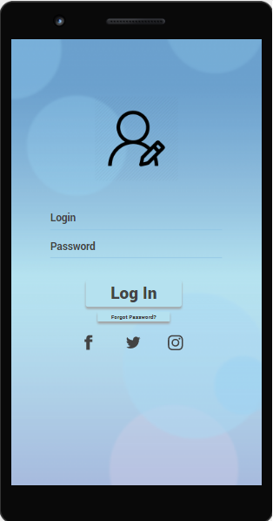 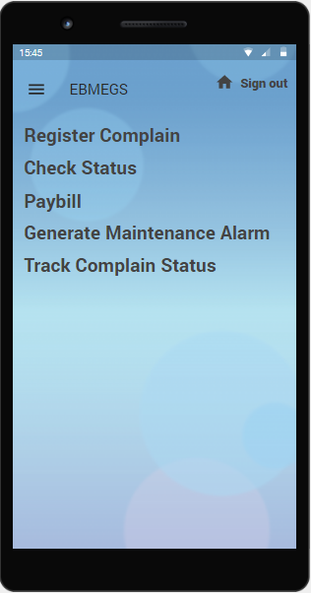

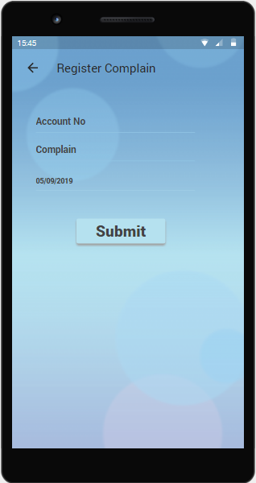 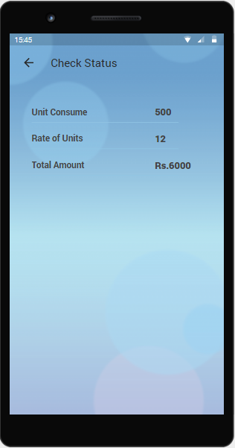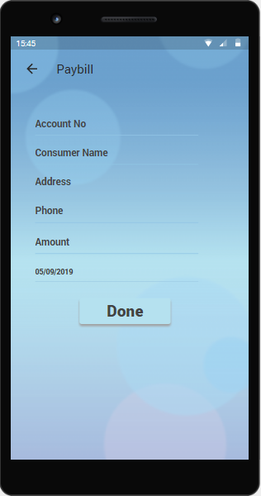 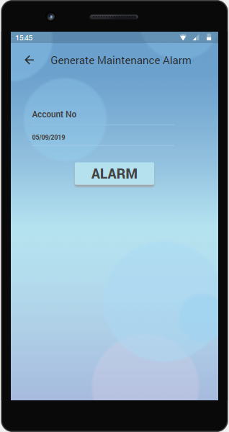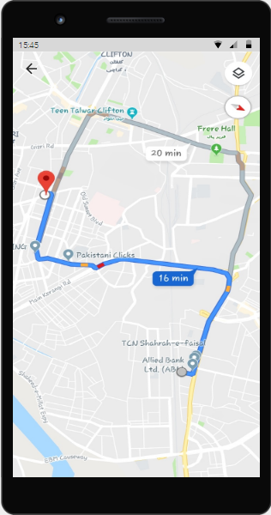 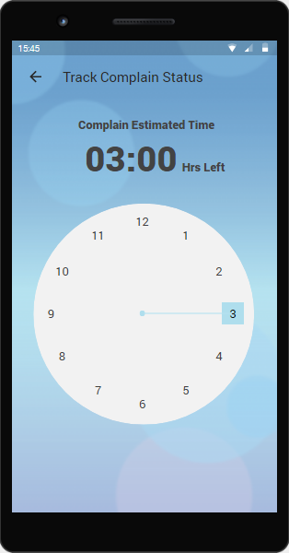

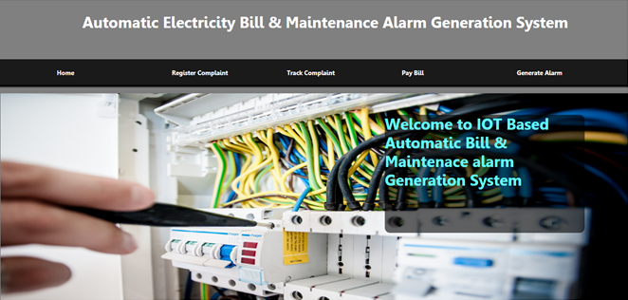

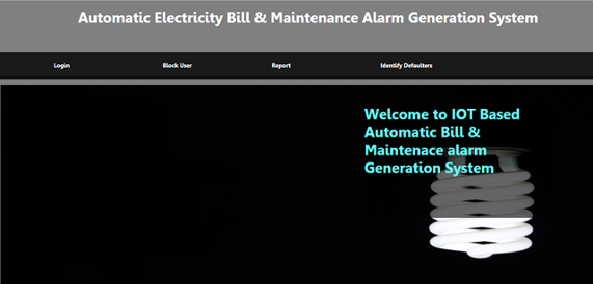

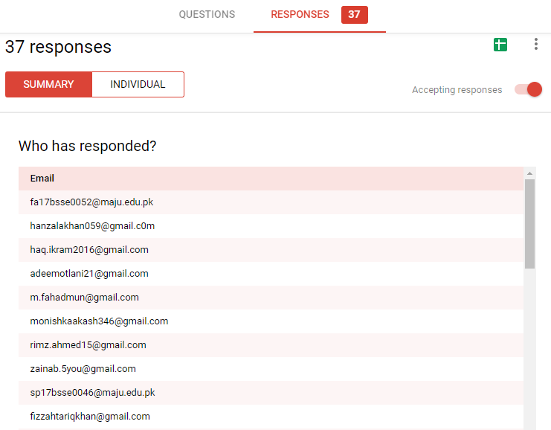

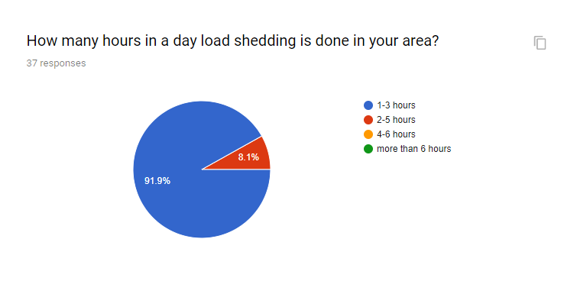

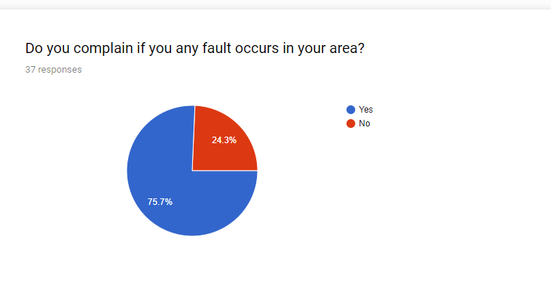

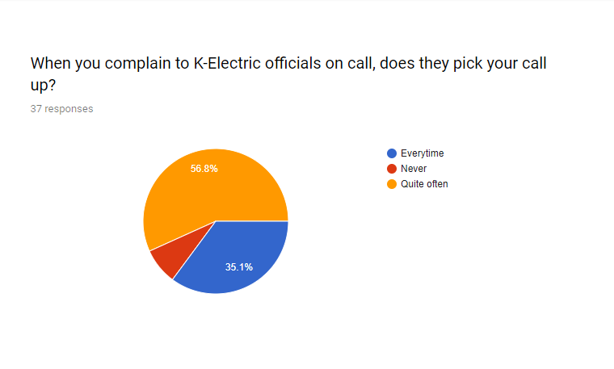

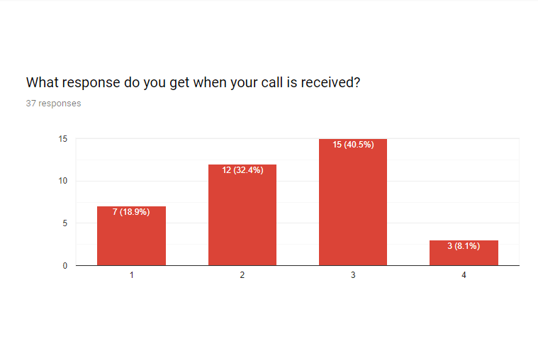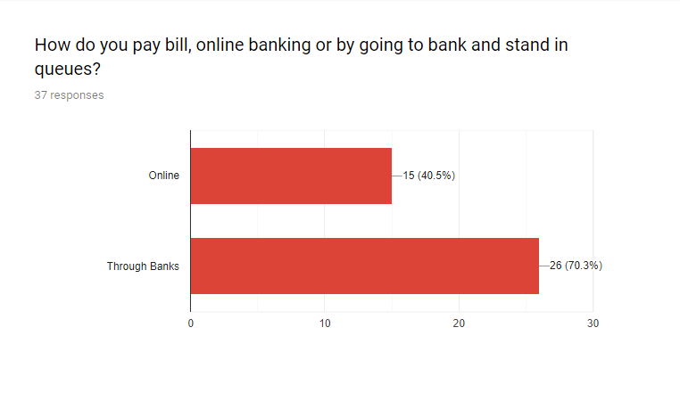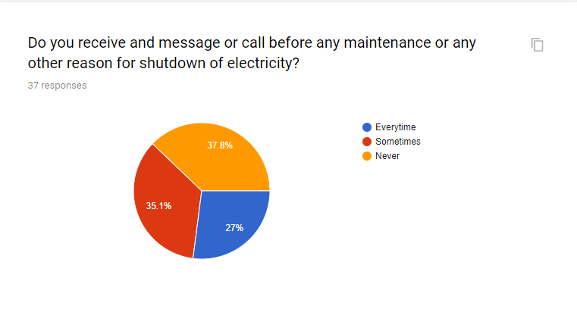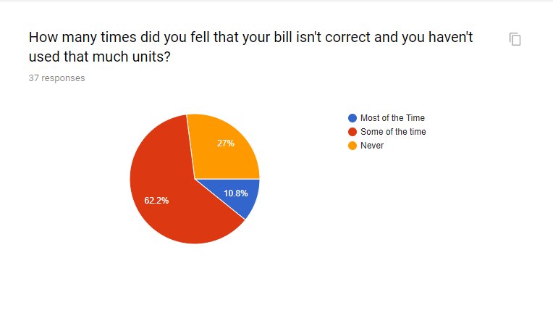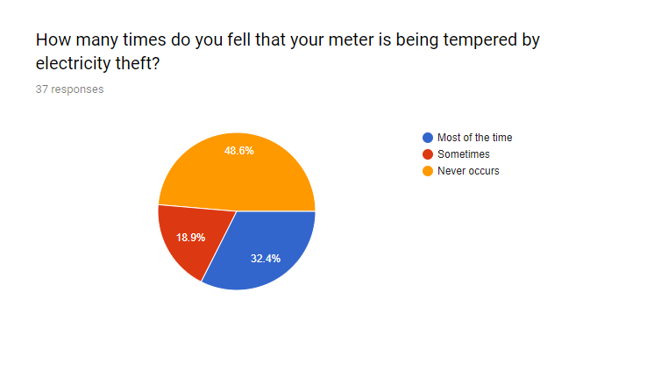

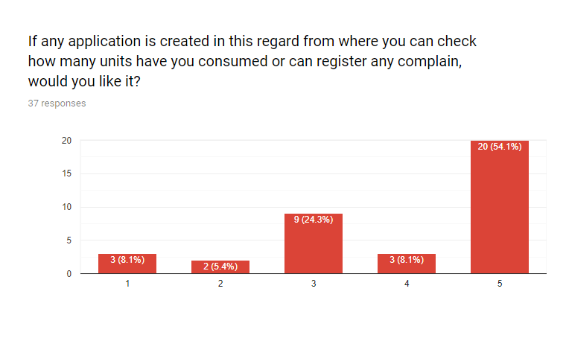

# References:

<https://www.ke.com.pk/>

<https://www.pict.com.pk/en/online-billing>

<https://www.fema.gov/emergency-alert-system>

<https://www.safewise.com/home-security-faq/how-do-security-systems-work/>

<https://www.consumer.ftc.gov/blog>