Software Requirements Specification

for

Learning Management system

Prepared by

|  |  |
| --- | --- |
| Tayyab Mehmood | 8476 |
| Syed Usman Ali | 9017 |
| Haris Ahmed Khan | 9131 |
| Nabeel Rashid | 8495 |  |
| Mohammad Imran Khan | 8763 |  |

|  |  |
| --- | --- |
| Course: | Software Engineering |

**Table of Contents**

1. Introduction

2. The General Description

3. Specific Requirements

4. Supporting Information

**1. Introduction**

**1.1 Purpose**

This document describes the software requirements for the Learning Management System built for the Chinese Railway Ministry (CRM).

**1.2  Scope In**

1. **LMS** (Learning Management System) aims to promote a greater count of students to splurge into the field of Education. It will usher in the immense flexibility and sophistication in the existing learning platform structures, with the perfect blend of synchronous and asynchronous interaction. It provides a means of collaborative learning for the students.
2. The benefits of having LMS is to provide assistance to administration, faculty and students. Administration will be able to maintain staff, student record, student are facilitated via sharing their activities, marks or class schedule. Faculties can evaluate test sheets, schedule test and perform related activities online. The system will provide easy-to-access web based service which can give management an effective means of managing all resources.

**1.3  Scope Out**

The following features will not be the part of this Project:

**1.3 Definitions, Acronyms, and Abbreviations.**

LMS – Learning Management System

PP - Project Plan

SDD - Software Design Description

SRS - Software Requirement Specification

SDS – Software Design Specification

SPMP - Software Project Management Plan

GUI – Graphical User Interface

QAM – Quality Assurance Manager

PDM – Project Development Manager

PMP – Project Management Professional

TBD – To be determined

UML – Unified Modeling Language

**2. The General Description**

This section describes the general factors that affect the product and its requirements. This section consists of five subsections that follow. This section does not state specific requirements. Each of the subsections makes those requirements easier to understand, it does not specify design or express specific requirements. Such detail is provided in section 3.

**2.1 Product Perspective**

The Automated Railway Reservation System diagram showing the overview of the system’s modules and the relationship of the system to external interfaces is presented in Figure 2.1.

## Figure 2.1 Learning Management System of the ARRS

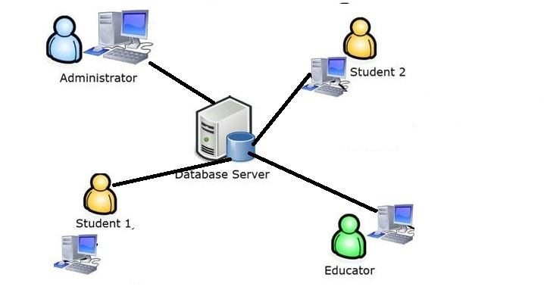

**Functions of System Components:**

Database:

•       Stores data

•       Creates reports

•       Provides access to data

•       Updates information

**External Interfaces:**

Personal Computers

•       Users (Admin, faculty, and student) may use via personal computers.

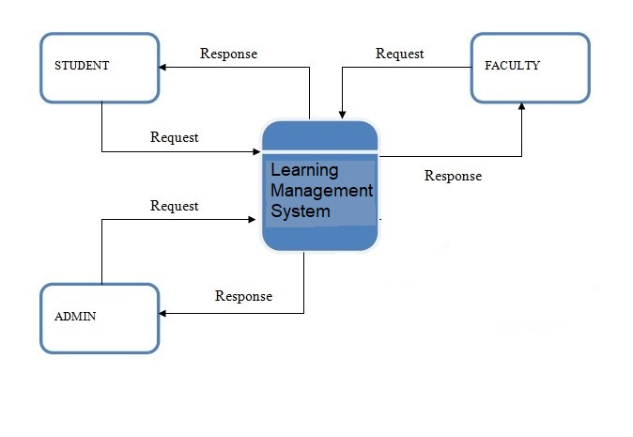

**2.2 Product Functions**

This section provides a summary of the functions that the software will perform.

**2.2.1 Function Relationships**

Figure 2.2 to 2.6 depict the relationships among the functions to be implemented by the system.  
  
Figure 2.2 ARRS General Function Relationship/**Higher Level Usecase** Diagram

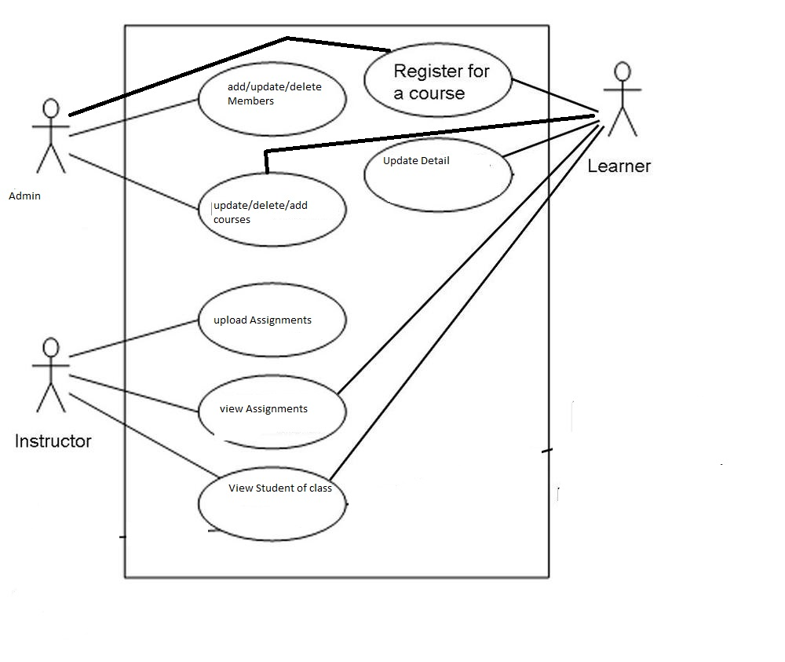

**2.2.2 Function Descriptions (Functional Requirement Listings)**

**2.2.2.1 Log In Function**

***Description:*** This function ensures that only authorized users gain access to the Reservation databases. An authorized user is a user who has an account on the system. Users include Admin, Faculty, and students. The user must type a valid username and password to gain access.

**2.2.2 Module 1:**

**Administrator:**

* **Add:** Admin can add faculty, students.
* **Delete:** Admin can delete faculty, students.
* **Update:** Admin can update faculty, students.
* **Search:** Admin can Search faculty, students
* **View:** Admin view add faculty, students.

**2.2.3 Module 2:**

**Faculty:**

* **Add:** faulty can add task for student.
* **Delete:** faulty can delete task for student.
* **Update:** faulty can update task for student.
* **Search:** faulty can search task for student.
* **View:** faulty can view task for student.
* **View/Upload/Delete notices:** View, upload and delete the notices.
* **View/Upload/Delete files:** View, upload and delete files as per the requirements.
* **Update Profile:** View and update self-profile ( Password, Name, Date of Birth, Address, Email Ids, Contact Numbers etc.).
* **View/Schedule/Update Discussion Time:** View, schedule or update the discussion times provided to the students for their problem solving.
* **View Student Report:** View the progress reports of various students.
* **Search:** can search schedule.

**2.2.4 Module 3:**

**Student:**

* **Add:** student can add queries, personal information.
* **Delete:** student can delete queries.
* **Update:** student can update queries, personal information.
* **Search:** student can search queries.
* **View:** student can view queries.

**2.2.5 Module 4:**

Course Registration:

* **Add:** student can add course.
* **Delete:** student can delete course.
* **Update:** student can update course.
* **Search:** student can search course.
* **View:** student can view course.

**2.2.6 Module5:**

CID Registration

* **Add:** admin can add teacher for course.
* **Delete:** admin can delete teacher for course.
* **Update:** admin can update teacher for course
* **Search:** admin can search teacher for course.
* **View:** admin can view teacher for course.

***Description:*** This function

**2.3 User Characteristics**

The main users of the system will be the admin, the admin can enroll new students, faculty, and course in the system. Student can register courses and student will also be able to add quires. Faculty will be able to assign task to the students. The users are not required to have knowledge in the computer field. The graphical interface provides an easy way of using the LMS with minimum of training.

**3. Specific Requirements**

This section of the SRS contains design requirements for the Learning Management System.

**3.1 Functional Requirements**

**3.1.1 Log In Function**

1. ***Description:*** This function ensures that only authorized users gain access to the Reservation databases. An authorized user is a user who has an account on the system. Users include Students, Admin, faculty members. The user must type a valid username and password to gain access.

1. ***Usage Scenario/ Use case Description/******Specification:***

|  |  |
| --- | --- |
| Description | Allows access to online ARRS |
| Inputs | Username, password |
| Source | 1. User inputs username and password 2. Press Login Button |
| Alternate case |  |
| Outputs | Successful login; unsuccessful login |
| Destination | None |
| Precondition | Authorized User |
| Post Condition | No change to Passenger Accounts Database |
| Side Effects | Failures and successful logins are sent to Reservation Database |

* + 1. **Module 1 complete CRUD Make a Reservation Function**

1. ***Description:*** This function allows the user to [make | drop | view | update] a reservation for a particular train on a particular date for a certain number of tickets. If the user does not already have a reservation, then a new reservation is created. If the user already has a previous reservation, a new reservation is added to the list of current reservations, and the passenger account balance gets updated.
2. ***Usage Scenario/ Use case Description/******Specification:***

|  |  |
| --- | --- |
| Description | [ make | drop | view | update] a reservation to the user’s account |
| Inputs | From city, to city, seat type, travel date, return date and time |
| Source | 1. User inputs from city, to city, seat type, travel date, return date and time 2. Press Button … |
| Alternate Case |  |
| Outputs | Added | Deleted | Viewed | Modified reservation |
| Destination | Computer screen  Reservation database  Passenger Account database |
| Precondition | Valid information; train route and tickets available; user does not have another reservation at the same time |
| Post Condition | Reservation added to passenger account |
| Side Effects | User’s current reservations adjusted  Balance due adjusted |

1. ***Use case Diagram:***



1. ***Use case Realization:***
2. 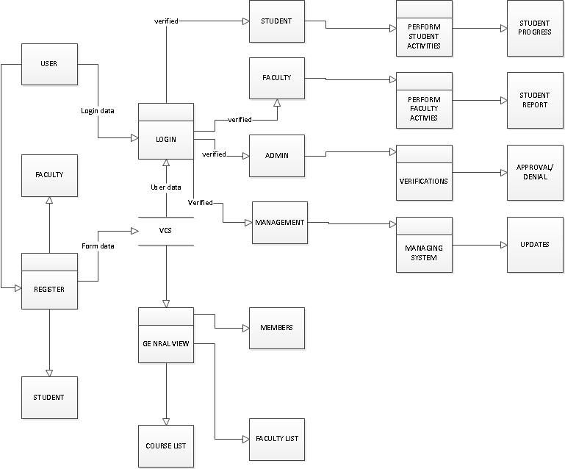***Flow of Event or Data Flow Diagram:***
3. ***Activity Diagram:***

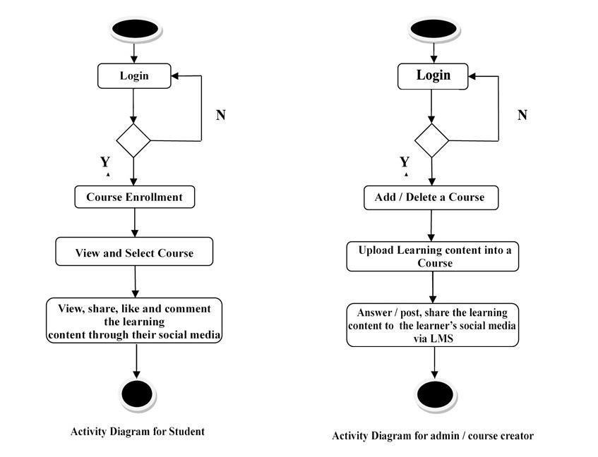

***Class Diagram:***





