1. **PREREQUISITES**

* A good understanding of DS.
* You can add hardware and software requirements as well.

1. **AIMS OF PROJECT**

* Design, develop and test an application for ATM Machine.
* The system will consist of two main subsystems: administration system and user system.
* The administration system provides:
  + Registration of an Account.
  + Provide money to collect by using their ATM Machine
  + Can give you a detail of amount your withdrawal and remaining amount
  + Support for statistics.
* The user system is an application system that take yours details for verification.
  + A person can give their card no which a system can verify with their database.
  + A person can add and withdrawal amount.
  + Can get Account information
  + A person can create account also.

1. **CHALLENGES PRESENTED BY THE PROJECT**

* Specification, design and development of an application with several subsystems using DS approach.
* Techniques for showing transection amount.

1. **METHOLOGY**

* Admin can add money to ATM Machine.
* Admin can create account on basis of CNIC No also check if this CNIC No is already saved or not. If not then create account or if saved then a message shows it already exits.
* Admin can also Update the user Account Info except CNIC No.
* Here admin can reset their ID and Password.
* Display menu can show the Single User Info, All User Info, Transections and Withdrawal records.
* Transection can also be done through user account and also through cash.
* In User Portal, A user can see his/her record of transection and withdraw and also info.
* A User can withdraw amount directly through system desire and also his/her own desire.
* User can only transect amount through his/her own account not by cash.
* While withdrawing amount a slip will also generate.

1. 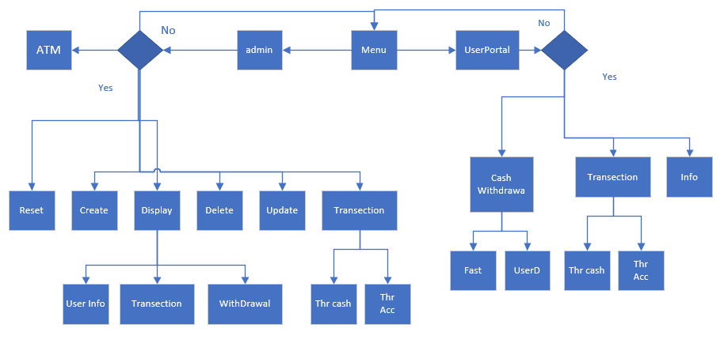**FLOW CHART**
2. **SCREEN SHOT**  
   **Main Menu:**

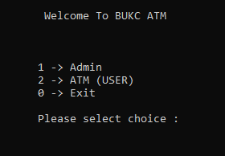

**Admin Menu:**  
After Login Admin Menu will appear.  
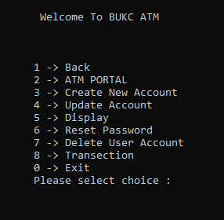

**2 = > ATM Portal:**  
here we can add money to ATM Machine when ATM got empty, here admin can also check the remaining amount of ATM Machine.  
  
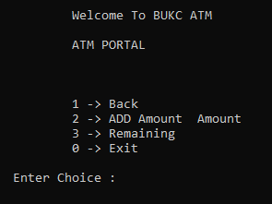

**3 = >Create Account:**here data of a particular person is taken with full validation CNIC No should no be less than 13 digits and should not be already exits, while giving CNIC No a string (a – z) alphabet or any character (+, -, *, /) will not accept even in Pin Code and also in Amount only Numeric data will accept. If a person exceeds more than 3 times the program will return to back.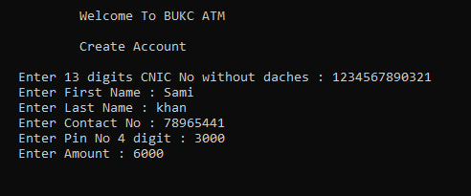

**4 = >Update Account:**here admin can update Pin Code, Name and can add Money to the account by providing CNIC No along with Pin Code.

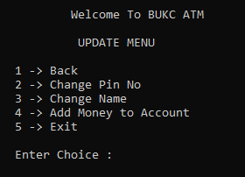

**5 = >Update Account:**here are Display All User Info and even a single record also by giving a CNIC No and Pin Code of a person to check if that person is exits or not.

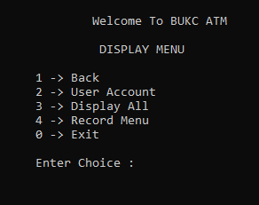

**5.3 = >Update Account - > Display All:**

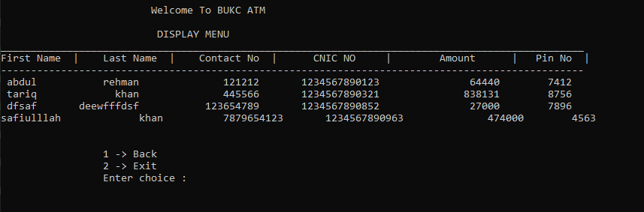

**5.4 = >Update Account - > Record Info:**

Here admin can view Transection and Withdrawal record of a singular and multiple person.

**5.4 = >Update Account - > Record Info -> Withdrawal:**

Here admin can use their own desire.

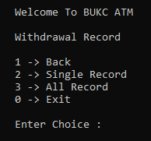

**All Withdrawal Record:**

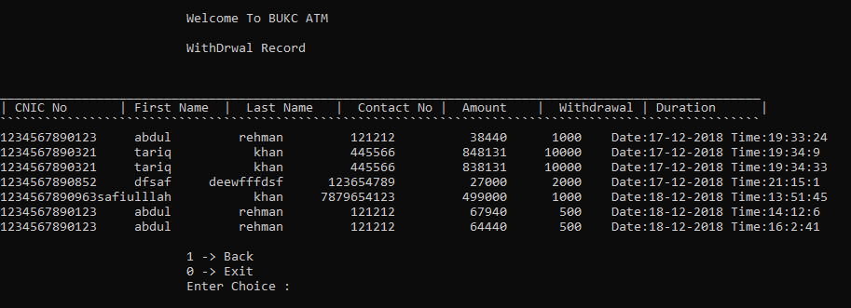

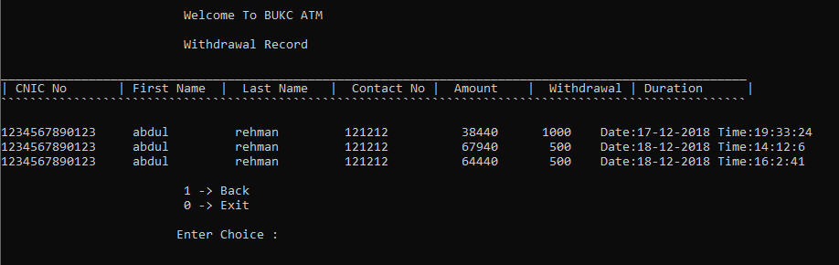**Single Person Withdrawal Record:**

**5.4 = >Update Account - > Record Info -> Transection:**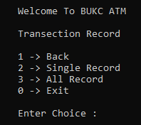

**All Transection Record:**

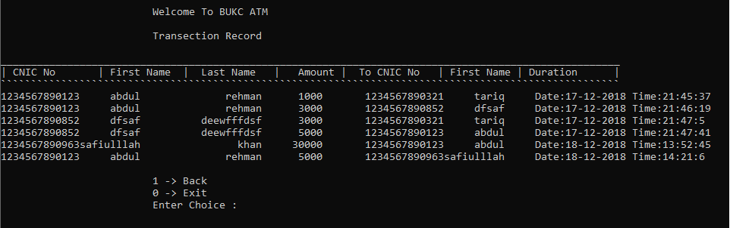

**Single Person Transection Record:**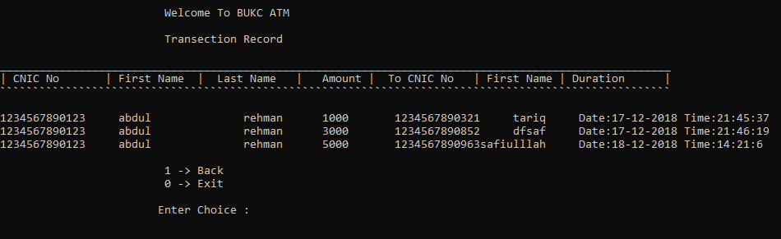

**8 = >Transection Menu**

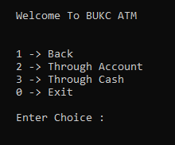

**8 = >Transection Menu - > 3 = Through Account**

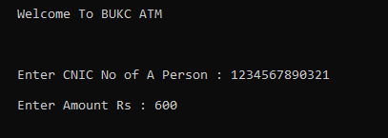

**8 = >Transection Menu - > 3 = Through Cash**

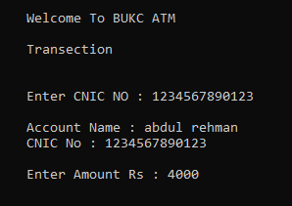

**ATM USER MENU:**after login to specific CNIC No and Pin Code which has been saved in database this menu will appear.

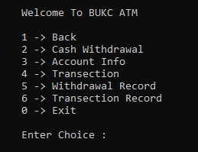

**2 = >Cash Withdrawal**

here user have choice to withdrawal their amount directly or user’s desire.

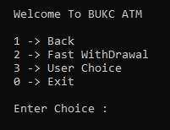

**2 = >Cash Withdrawal 2 -> Fast Withdrawal**

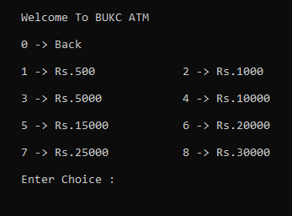

**2 = >Cash Withdrawal = 3 - > User Choice Withdrawal**

Here a 2000 amount is withdrawn with a given slip and time and date also mentioned.

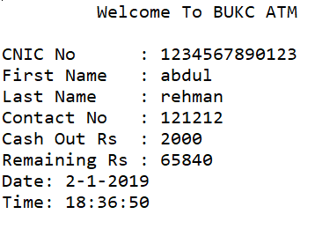

**3 = >Account Info**

Here is the information of the accountant.

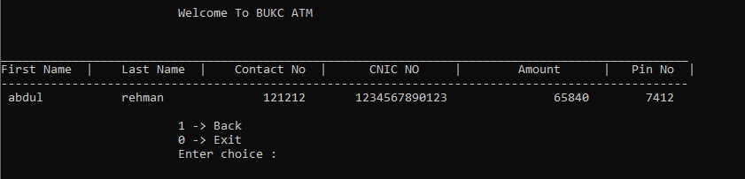

**4 = >Transection**

Here user put the particular CNIC No of that person to whom which he/her want to transect amount through his/her self-account.

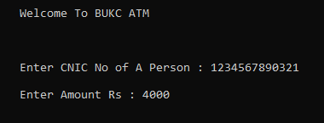

**5 = >Withdrawal Record**

Here all transection record will be displayed.

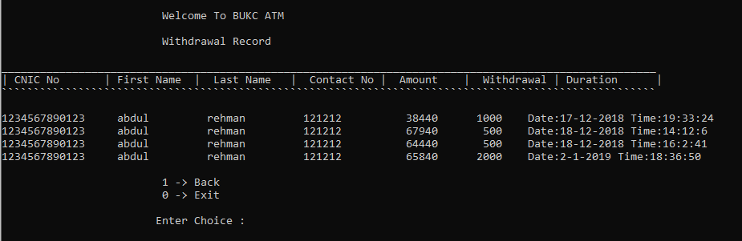

**6 = >Transection Record**

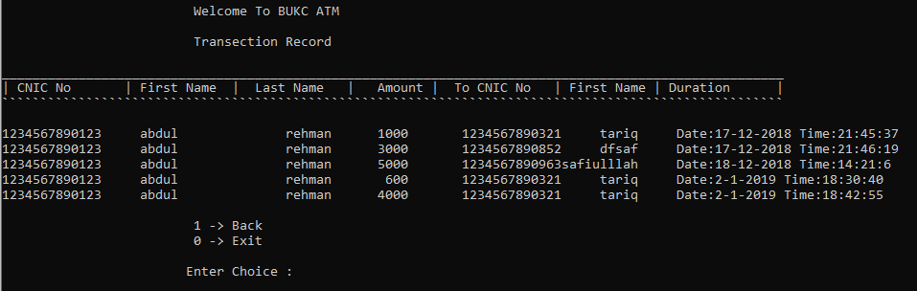

**User Profile Database:**

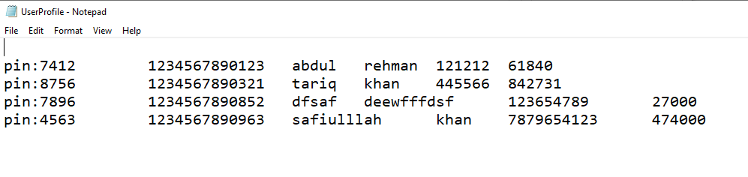

**Withdrawal Database:**

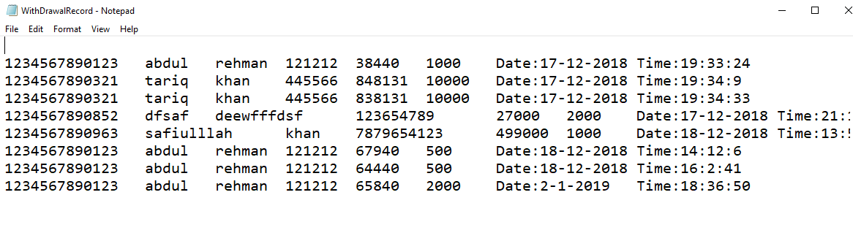

**Transection Database:**

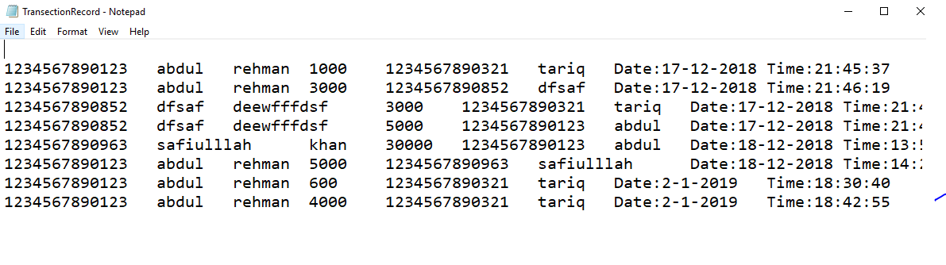

**Printing Slip:**

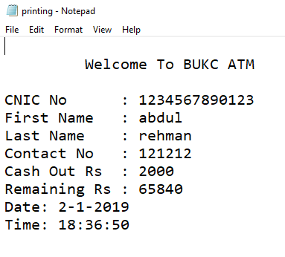

1. **CONCLUTION:**

This ATM Machine and Banking can do very simple work by providing CNIC No and very common data to register their self and can do many of function like transection which can not be possible through other ATM Machine and even not providing a full info. Where as the Admin Menu is far simple and much secure.