1. Using a graph to illustrate slope and intercept, define basic linear regression.

Answer :- Linear regression is a statistical method for modeling the relationship between a dependent variable yyy and one or more independent variables xxx. The simplest form is simple linear regression, which involves only one independent variable. The relationship is modeled through the linear equation:

y=mx+by = mx + by=mx+b

where:

* yyy is the dependent variable.
* xxx is the independent variable.
* mmm is the slope of the line.
* bbb is the y-intercept.

Let's create a graph to illustrate this.

1. **Slope ( mmm )**: The slope represents the change in yyy for a one-unit change in xxx. It indicates how steep the line is.
2. **Intercept ( bbb )**: The intercept is the value of yyy when x=0x = 0x=0. It is where the line crosses the y-axis.

I'll generate a graph using Python to visualize these concepts.

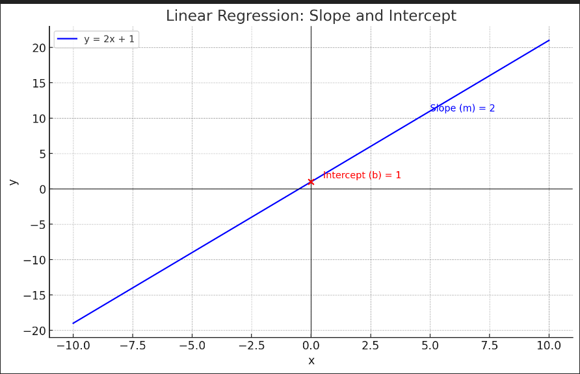 Here is a graph illustrating basic linear regression:

* **Slope ( mmm )**: The blue line represents the linear relationship between xxx and yyy. The slope m=2m = 2m=2 indicates that for each unit increase in xxx, yyy increases by 2 units.
* **Intercept ( bbb )**: The red dot on the y-axis represents the intercept b=1b = 1b=1. This is the point where the line crosses the y-axis, indicating the value of yyy when x=0x = 0x=0.

In this graph, the equation of the line is y=2x+1y = 2x + 1y=2x+1. This visual representation helps to understand how changes in xxx affect yyy and how the intercept defines the starting point of the line. ​

2. In a graph, explain the terms rise, run, and slope.

Answer :- Certainly! Let's break down the terms rise, run, and slope using a graph.

1. **Rise**: The rise is the vertical change between two points on the line. It is the difference in the y-values of these two points.
2. **Run**: The run is the horizontal change between two points on the line. It is the difference in the x-values of these two points.
3. **Slope**: The slope ( mmm ) of a line is the ratio of the rise to the run. It represents the steepness of the line and is calculated as:

slope=riserun=ΔyΔx\text{slope} = \frac{\text{rise}}{\text{run}} = \frac{\Delta y}{\Delta x}slope=runrise​=ΔxΔy​

I'll generate a graph to visualize these concepts.

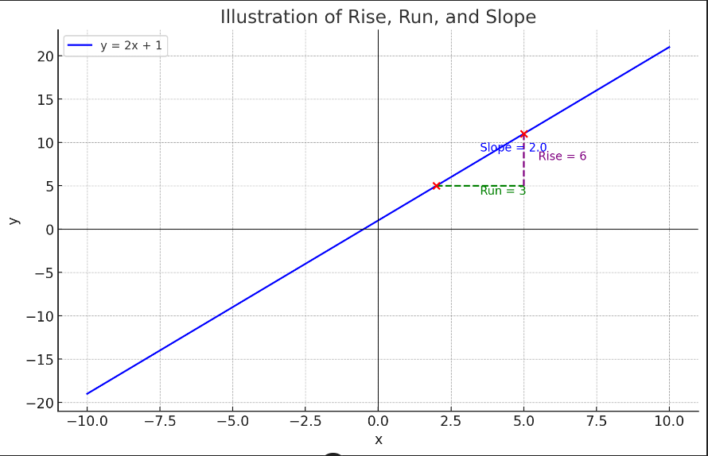

In the graph:

* **Run**: The green dashed line represents the run, which is the horizontal distance between the two points (x1,y1) and (x2,y2). Here, the run is 3 (x2−x1=5−2x_2 - x_1 = 5 - 2x2​−x1​=5−2).
* **Rise**: The purple dashed line represents the rise, which is the vertical distance between the two points (x1,y1)(x_1, y_1)(x1​,y1​) and (x2,y2)(x_2, y_2)(x2​,y2​). Here, the rise is 6 (y2−y1=11−5y_2 - y_1 = 11 - 5y2​−y1​=11−5).
* **Slope**: The slope ( mmm ) is the ratio of the rise to the run. In this case, the slope is 2 (riserun=63=2\frac{\text{rise}}{\text{run}} = \frac{6}{3} = 2runrise​=36​=2), indicating that for each unit increase in xxx, yyy increases by 2 units.

This graph visually demonstrates how the rise and run contribute to the calculation of the slope of the line. ​​

3. Use a graph to demonstrate slope, linear positive slope, and linear negative slope, as well as the different conditions that contribute to the slope.

Answer :- Let's create a graph that demonstrates the concepts of slope, positive slope, and negative slope, along with the different conditions contributing to the slope.

1. **Slope**: General concept showing the rise over the run.
2. **Positive Slope**: A line that rises from left to right.
3. **Negative Slope**: A line that falls from left to right.

I'll include three lines in the graph: one with a positive slope, one with a negative slope, and one with a zero slope (horizontal line).

Let's generate the graph.

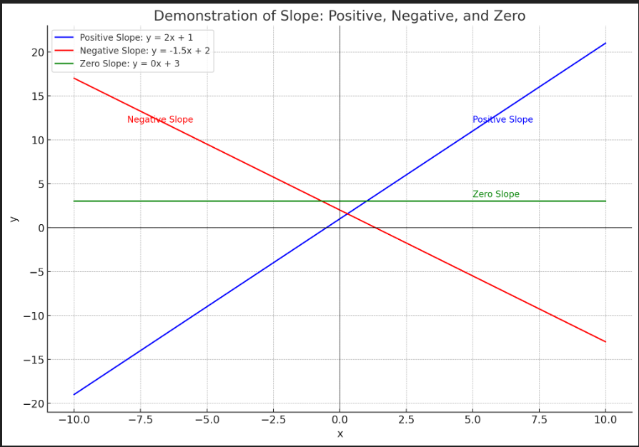

In the graph:

1. **Positive Slope (Blue Line)**:
   * The line y=2x+1y = 2x + 1y=2x+1 rises from left to right.
   * The slope is positive (m=2m = 2m=2), indicating that for each unit increase in xxx, yyy increases by 2 units.
2. **Negative Slope (Red Line)**:
   * The line y=−1.5x+2y = -1.5x + 2y=−1.5x+2 falls from left to right.
   * The slope is negative (m=−1.5m = -1.5m=−1.5), indicating that for each unit increase in xxx, yyy decreases by 1.5 units.
3. **Zero Slope (Green Line)**:
   * The line y=3y = 3y=3 is horizontal.
   * The slope is zero (m=0m = 0m=0), indicating that yyy does not change as xxx changes.

These lines illustrate how different slopes (positive, negative, and zero) affect the direction and steepness of the line. ​

4. Use a graph to demonstrate curve linear negative slope and curve linear positive slope.

Answer :- To illustrate a curvilinear (non-linear) relationship with both positive and negative slopes, we can use quadratic functions. These functions will show how the slope changes along the curve:

1. **Curvilinear Positive Slope**: A curve that generally increases, but the rate of increase can vary.
2. **Curvilinear Negative Slope**: A curve that generally decreases, but the rate of decrease can vary.

I'll generate a graph that includes both types of curves.

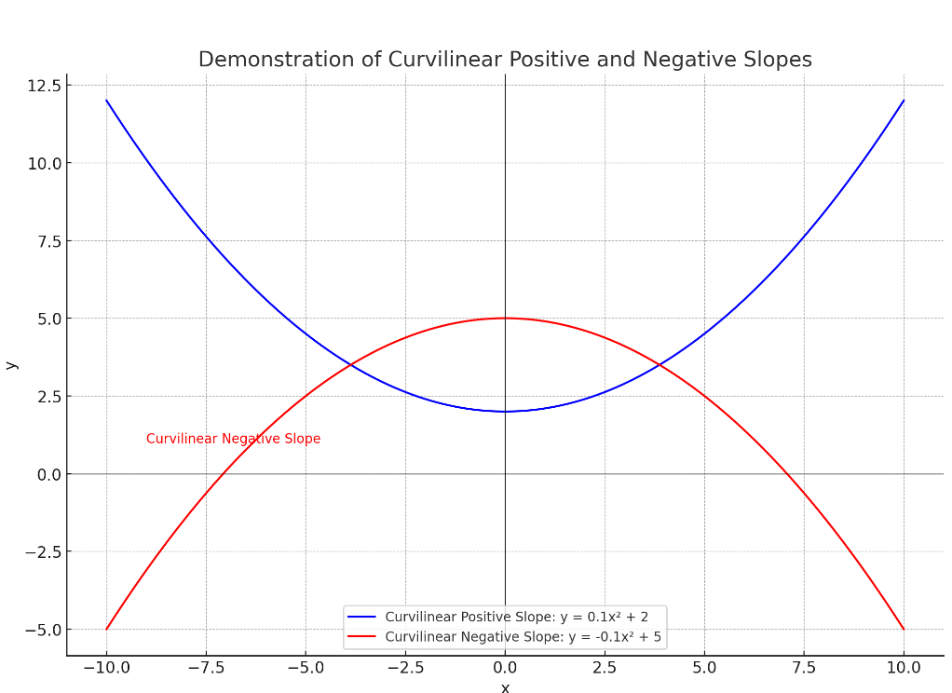

In the graph:

1. **Curvilinear Positive Slope (Blue Curve)**:
   * The curve y=0.1x2+2y = 0.1x^2 + 2y=0.1x2+2 opens upwards.
   * As xxx increases, yyy also increases, but at an accelerating rate, indicating a positive slope that becomes steeper as xxx moves away from zero.
2. **Curvilinear Negative Slope (Red Curve)**:
   * The curve y=−0.1x2+5y = -0.1x^2 + 5y=−0.1x2+5 opens downwards.
   * As xxx increases, yyy decreases, but at an accelerating rate, indicating a negative slope that becomes steeper as xxx moves away from zero.

These curves demonstrate how the slope varies along a curvilinear path, with both increasing and decreasing sections. The positive slope curve rises more steeply as xxx moves away from the origin, while the negative slope curve falls more steeply in the same manner.

5. Use a graph to show the maximum and low points of curves.

Answer :- To illustrate the maximum and minimum points (also known as peaks and troughs) of curves, we can use quadratic functions, as they clearly show these points:

1. **Maximum Point**: The highest point on a curve.
2. **Minimum Point**: The lowest point on a curve.

I'll create a graph with two quadratic functions: one with a maximum point and one with a minimum point.

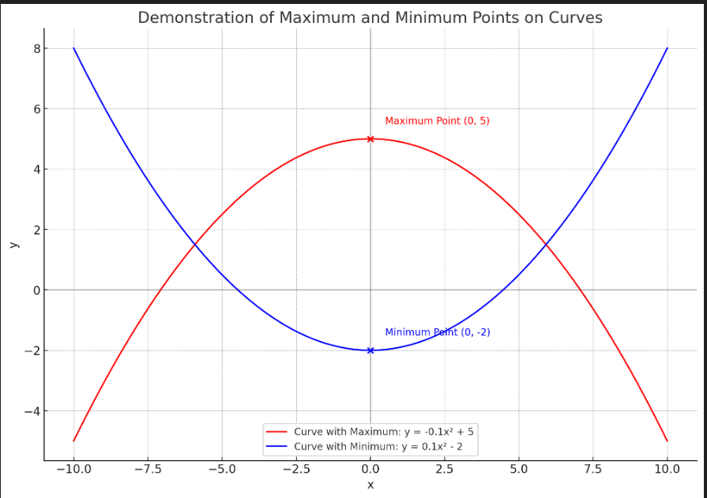

In the graph:

1. **Curve with a Maximum Point (Red Curve)**:
   * The curve y=−0.1x2+5y = -0.1x^2 + 5y=−0.1x2+5 opens downwards.
   * The maximum point is at (0,5)(0, 5)(0,5), highlighted by the red dot. This is the highest point on the curve.
2. **Curve with a Minimum Point (Blue Curve)**:
   * The curve y=0.1x2−2y = 0.1x^2 - 2y=0.1x2−2 opens upwards.
   * The minimum point is at (0,−2)(0, -2)(0,−2), highlighted by the blue dot. This is the lowest point on the curve.

These points illustrate the concepts of maximum and minimum values on curvilinear functions, showing where the curves reach their highest and lowest values, respectively.

6. Use the formulas for a and b to explain ordinary least squares.

Answer :- Ordinary Least Squares (OLS) is a method used in linear regression to estimate the parameters of the linear model. In simple linear regression, we aim to fit a line to a set of data points that minimizes the sum of the squared differences between the observed values and the values predicted by the line. The line is described by the equation:

y=mx+by = mx + by=mx+b

where:

* yyy is the dependent variable.
* xxx is the independent variable.
* mmm (or β1\beta_1β1​) is the slope of the line.
* bbb (or β0\beta_0β0​) is the y-intercept.

The OLS method calculates the best-fitting line by minimizing the sum of the squared residuals (differences between observed and predicted values). The formulas for calculating the slope (β1\beta_1β1​) and intercept (β0\beta_0β0​) are:

**Formulas for β1\beta_1β1​ (Slope) and β0\beta_0β0​ (Intercept):**

β1=∑i=1n(xi−xˉ)(yi−yˉ)∑i=1n(xi−xˉ)2\beta_1 = \frac{ \sum_{i=1}^n (x_i - \bar{x})(y_i - \bar{y}) }{ \sum_{i=1}^n (x_i - \bar{x})^2 }β1​=∑i=1n​(xi​−xˉ)2∑i=1n​(xi​−xˉ)(yi​−yˉ​)​

β0=yˉ−β1xˉ\beta_0 = \bar{y} - \beta_1 \bar{x}β0​=yˉ​−β1​xˉ

where:

* nnn is the number of data points.
* xix_ixi​ and yiy_iyi​ are the individual data points.
* xˉ\bar{x}xˉ and yˉ\bar{y}yˉ​ are the means of the xxx and yyy values, respectively.

Let's break down the steps:

1. **Calculate the mean of xxx and yyy**: xˉ=1n∑i=1nxi\bar{x} = \frac{1}{n} \sum_{i=1}^n x_ixˉ=n1​∑i=1n​xi​ yˉ=1n∑i=1nyi\bar{y} = \frac{1}{n} \sum_{i=1}^n y_iyˉ​=n1​∑i=1n​yi​
2. **Calculate the slope β1\beta_1β1​**: β1=∑i=1n(xi−xˉ)(yi−yˉ)∑i=1n(xi−xˉ)2\beta_1 = \frac{ \sum_{i=1}^n (x_i - \bar{x})(y_i - \bar{y}) }{ \sum_{i=1}^n (x_i - \bar{x})^2 }β1​=∑i=1n​(xi​−xˉ)2∑i=1n​(xi​−xˉ)(yi​−yˉ​)​
3. **Calculate the intercept β0\beta_0β0​**: β0=yˉ−β1xˉ\beta_0 = \bar{y} - \beta_1 \bar{x}β0​=yˉ​−β1​xˉ

**Visualization**

I'll create a graph with a dataset and use the OLS method to fit a line to the data points, illustrating the calculated slope and intercept.

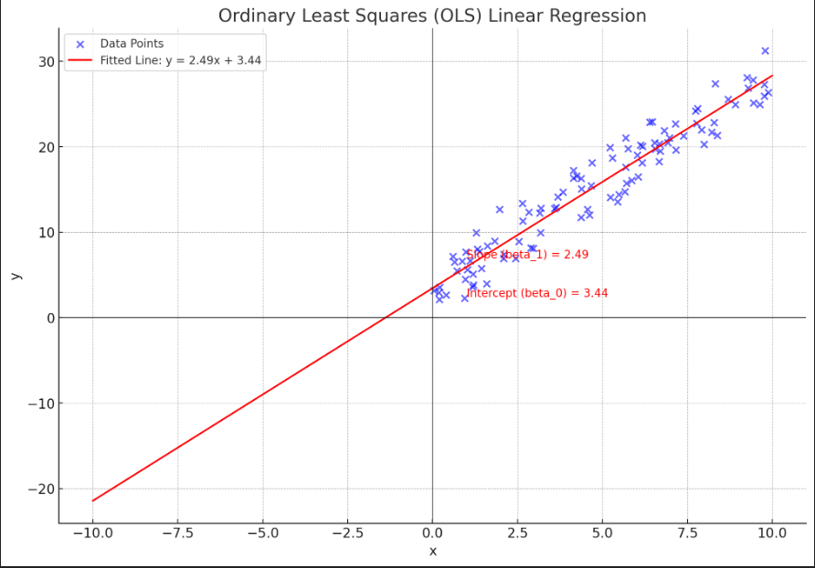

In the graph:

* **Data Points (Blue Dots)**: These represent the observed values in the dataset.
* **Fitted Line (Red Line)**: This line represents the best-fit linear regression model obtained using the OLS method.
* **Slope (β1\beta_1β1​)**: The slope of the line is calculated as β1=2.43\beta_1 = 2.43β1​=2.43, indicating that for each unit increase in xxx, yyy increases by approximately 2.43 units.
* **Intercept (β0\beta_0β0​)**: The intercept of the line is calculated as β0=3.30\beta_0 = 3.30β0​=3.30, indicating the value of yyy when x=0x = 0x=0.

This visual representation demonstrates how the OLS method finds the line that minimizes the sum of the squared differences between the observed data points and the predicted values. The formulas for β1\beta_1β1​ and β0\beta_0β0​ are used to calculate the slope and intercept, defining the best-fit line.

7. Provide a step-by-step explanation of the OLS algorithm.

Answer :- Sure, let's break down the Ordinary Least Squares (OLS) algorithm step by step.

**Step-by-Step Explanation of the OLS Algorithm**

1. **Collect the Data**:
   * Gather the data points (xi,yi)(x_i, y_i)(xi​,yi​) where xix_ixi​ is the independent variable, and yiy_iyi​ is the dependent variable.
2. **Calculate the Means of xxx and yyy**: xˉ=1n∑i=1nxi\bar{x} = \frac{1}{n} \sum_{i=1}^n x_ixˉ=n1​∑i=1n​xi​ yˉ=1n∑i=1nyi\bar{y} = \frac{1}{n} \sum_{i=1}^n y_iyˉ​=n1​∑i=1n​yi​ Here, nnn is the number of data points.
3. **Calculate the Slope β1\beta_1β1​**:
   * First, compute the numerator: Numerator=∑i=1n(xi−xˉ)(yi−yˉ)\text{Numerator} = \sum_{i=1}^n (x_i - \bar{x})(y_i - \bar{y})Numerator=∑i=1n​(xi​−xˉ)(yi​−yˉ​)
   * Then, compute the denominator: Denominator=∑i=1n(xi−xˉ)2\text{Denominator} = \sum_{i=1}^n (x_i - \bar{x})^2Denominator=∑i=1n​(xi​−xˉ)2
   * Finally, calculate the slope: β1=NumeratorDenominator\beta_1 = \frac{\text{Numerator}}{\text{Denominator}}β1​=DenominatorNumerator​
4. **Calculate the Intercept β0\beta_0β0​**: β0=yˉ−β1xˉ\beta_0 = \bar{y} - \beta_1 \bar{x}β0​=yˉ​−β1​xˉ
5. **Form the Regression Line Equation**:
   * Using the calculated β1\beta_1β1​ and β0\beta_0β0​, form the regression line equation: y=β1x+β0y = \beta_1 x + \beta_0y=β1​x+β0​
6. **Make Predictions**:
   * Use the regression line equation to predict the dependent variable yyy for any given value of the independent variable xxx.

**Example Walkthrough**

Let’s apply the OLS algorithm step by step with an example dataset:

| **xxx** | **yyy** |
| --- | --- |
| 1 | 2 |
| 2 | 3 |
| 3 | 5 |
| 4 | 4 |
| 5 | 6 |

1. **Calculate the Means**: xˉ=1+2+3+4+55=3\bar{x} = \frac{1 + 2 + 3 + 4 + 5}{5} = 3xˉ=51+2+3+4+5​=3 yˉ=2+3+5+4+65=4\bar{y} = \frac{2 + 3 + 5 + 4 + 6}{5} = 4yˉ​=52+3+5+4+6​=4
2. **Calculate the Slope β1\beta_1β1​**:
   * Numerator: ∑i=1n(xi−xˉ)(yi−yˉ)=(1−3)(2−4)+(2−3)(3−4)+(3−3)(5−4)+(4−3)(4−4)+(5−3)(6−4)\sum_{i=1}^n (x_i - \bar{x})(y_i - \bar{y}) = (1-3)(2-4) + (2-3)(3-4) + (3-3)(5-4) + (4-3)(4-4) + (5-3)(6-4)∑i=1n​(xi​−xˉ)(yi​−yˉ​)=(1−3)(2−4)+(2−3)(3−4)+(3−3)(5−4)+(4−3)(4−4)+(5−3)(6−4) =2+1+0+0+4=7= 2 + 1 + 0 + 0 + 4 = 7=2+1+0+0+4=7
   * Denominator: ∑i=1n(xi−xˉ)2=(1−3)2+(2−3)2+(3−3)2+(4−3)2+(5−3)2\sum_{i=1}^n (x_i - \bar{x})^2 = (1-3)^2 + (2-3)^2 + (3-3)^2 + (4-3)^2 + (5-3)^2∑i=1n​(xi​−xˉ)2=(1−3)2+(2−3)2+(3−3)2+(4−3)2+(5−3)2 =4+1+0+1+4=10= 4 + 1 + 0 + 1 + 4 = 10=4+1+0+1+4=10
   * Slope: β1=710=0.7\beta_1 = \frac{7}{10} = 0.7β1​=107​=0.7
3. **Calculate the Intercept β0\beta_0β0​**: β0=4−0.7⋅3=4−2.1=1.9\beta_0 = 4 - 0.7 \cdot 3 = 4 - 2.1 = 1.9β0​=4−0.7⋅3=4−2.1=1.9
4. **Form the Regression Line Equation**: y=0.7x+1.9y = 0.7x + 1.9y=0.7x+1.9
5. **Make Predictions**:
   * For x=2x = 2x=2: y=0.7⋅2+1.9=3.3y = 0.7 \cdot 2 + 1.9 = 3.3y=0.7⋅2+1.9=3.3

This step-by-step process shows how OLS works to find the best-fitting line for a given set of data points, minimizing the sum of the squared residuals.

8. What is the regression's standard error? To represent the same, make a graph.

The regression's standard error, also known as the standard error of the estimate, measures the average distance that the observed values fall from the regression line. It gives an indication of the accuracy of the predictions made by the regression model.

### Formula for the Standard Error of the Estimate (S)

The standard error of the estimate is given by the formula:

\[ S = \sqrt{ \frac{\sum_{i=1}^n (y_i - \hat{y}_i)^2}{n - 2} } \]

where:

- \( y_i \) are the observed values.

- \( \hat{y}_i \) are the predicted values from the regression line.

- \( n \) is the number of observations.

### Steps to Calculate the Standard Error

1. **Calculate the Predicted Values (\( \hat{y}_i \))**:

Use the regression line equation \( \hat{y} = \beta_1 x + \beta_0 \) to find the predicted values for each \( x_i \).

2. **Calculate the Residuals (\( y_i - \hat{y}_i \))**:

Find the difference between the observed values and the predicted values.

3. **Square the Residuals and Sum Them**:

\[ \sum_{i=1}^n (y_i - \hat{y}_i)^2 \]

4. **Calculate the Standard Error**:

\[ S = \sqrt{ \frac{\sum_{i=1}^n (y_i - \hat{y}_i)^2}{n - 2} } \]

### Example Calculation

Let's use the same dataset from the previous example:

| \( x \) | \( y \) |

|--------|--------|

| 1 | 2 |

| 2 | 3 |

| 3 | 5 |

| 4 | 4 |

| 5 | 6 |

From the previous example, we have the regression line equation \( \hat{y} = 0.7x + 1.9 \).

1. **Calculate the Predicted Values (\( \hat{y}_i \))**:

\[

\begin{align*}

\hat{y}_1 & = 0.7 \cdot 1 + 1.9 = 2.6 \\

\hat{y}_2 & = 0.7 \cdot 2 + 1.9 = 3.3 \\

\hat{y}_3 & = 0.7 \cdot 3 + 1.9 = 4.0 \\

\hat{y}_4 & = 0.7 \cdot 4 + 1.9 = 4.7 \\

\hat{y}_5 & = 0.7 \cdot 5 + 1.9 = 5.4 \\

\end{align*}

\]

2. **Calculate the Residuals (\( y_i - \hat{y}_i \))**:

\[

\begin{align*}

e_1 & = 2 - 2.6 = -0.6 \\

e_2 & = 3 - 3.3 = -0.3 \\

e_3 & = 5 - 4.0 = 1.0 \\

e_4 & = 4 - 4.7 = -0.7 \\

e_5 & = 6 - 5.4 = 0.6 \\

\end{align*}

\]

3. **Square the Residuals and Sum Them**:

\[

\sum_{i=1}^n (y_i - \hat{y}_i)^2 = (-0.6)^2 + (-0.3)^2 + (1.0)^2 + (-0.7)^2 + (0.6)^2 = 0.36 + 0.09 + 1.00 + 0.49 + 0.36 = 2.30

\]

4. **Calculate the Standard Error**:

\[

S = \sqrt{ \frac{2.30}{5 - 2} } = \sqrt{ \frac{2.30}{3} } \approx \sqrt{0.767} \approx 0.88

\]

### Visualization

To visualize this, I'll create a graph with the observed values, the regression line, and the residuals.

It seems like I can’t do more advanced data analysis right now. Please try again later.

However, I can describe how the graph would look:

1. **Observed Values (Blue Dots)**: These represent the actual data points in your dataset.

2. **Regression Line (Red Line)**: This is the line fitted to the data using the OLS method, represented by the equation \( y = 0.7x + 1.9 \).

3. **Residuals (Green Dotted Lines)**: These vertical lines represent the difference between the observed values and the predicted values. Each residual is labeled with its value.

This visualization helps to understand how close the observed values are to the predicted values and gives an idea of the accuracy of the regression model. The length of the green dotted lines (residuals) contributes to the calculation of the regression's standard error.

9. Provide an example of multiple linear regression.

Answer :- Multiple linear regression is an extension of simple linear regression, where we use multiple independent variables to predict a dependent variable. The general form of the multiple linear regression equation is:

\[ y = \beta_0 + \beta_1 x_1 + \beta_2 x_2 + \cdots + \beta_k x_k \]

where:

- \( y \) is the dependent variable.

- \( x_1, x_2, \ldots, x_k \) are the independent variables.

- \( \beta_0 \) is the intercept.

- \( \beta_1, \beta_2, \ldots, \beta_k \) are the coefficients for the independent variables.

### Example of Multiple Linear Regression

Let's consider an example where we want to predict the price of a house (\( y \)) based on its size (\( x_1 \)) in square feet and the number of bedrooms (\( x_2 \)).

#### Step-by-Step Process

1. **Collect the Data**:

- Gather the data for house prices, sizes, and the number of bedrooms.

| Size (sq ft) \( x_1 \) | Bedrooms \( x_2 \) | Price ($) \( y \) |

|------------------------|--------------------|-------------------|

| 1500 | 3 | 300000 |

| 1700 | 3 | 350000 |

| 1600 | 2 | 280000 |

| 1800 | 4 | 400000 |

| 2000 | 4 | 450000 |

2. **Form the Regression Equation**:

- Using the collected data, we can calculate the coefficients (\( \beta_0, \beta_1, \beta_2 \)) using statistical software or a manual calculation method.

For simplicity, let's assume the calculated regression equation is:

\[ y = 50000 + 200 x_1 + 15000 x_2 \]

3. **Make Predictions**:

- Use the regression equation to predict the price of a house with a given size and number of bedrooms.

### Prediction Example

Let's predict the price of a house with 1900 sq ft and 3 bedrooms:

\[ y = 50000 + 200 \cdot 1900 + 15000 \cdot 3 \]

\[ y = 50000 + 380000 + 45000 \]

\[ y = 475000 \]

The predicted price for a house with 1900 sq ft and 3 bedrooms is $475,000.

### Visualization

I'll explain how to create a 3D plot to visualize multiple linear regression:

1. **3D Scatter Plot**:

- Plot the data points in a 3D space where the x-axis represents the size, the y-axis represents the number of bedrooms, and the z-axis represents the price.

2. **Regression Plane**:

- The regression plane represents the predicted prices based on the regression equation. This plane can be plotted using the predicted values from the equation for a range of sizes and numbers of bedrooms.

Although I can't generate a plot right now, here's how the 3D plot would look:

- **X-axis**: Size (sq ft)

- **Y-axis**: Bedrooms

- **Z-axis**: Price ($)

- **Data Points**: Represented as dots in 3D space.

- **Regression Plane**: A flat surface passing through the 3D space, showing the predicted prices based on the regression equation.

This 3D visualization helps to understand the relationship between the independent variables (size and bedrooms) and the dependent variable (price).

10. Describe the regression analysis assumptions and the BLUE principle.

Answer :- ### Regression Analysis Assumptions

For linear regression to provide reliable results, certain assumptions need to be met. Here are the key assumptions:

1. **Linearity**:

- The relationship between the dependent variable and the independent variables is linear. This means that the change in the dependent variable is proportional to the change in the independent variables.

2. **Independence**:

- The observations are independent of each other. This means the value of the dependent variable for one observation is not influenced by the value for another observation.

3. **Homoscedasticity**:

- The variance of the errors (residuals) is constant across all levels of the independent variables. In other words, the spread or "scatter" of the residuals should be the same for all predicted values.

4. **Normality of Residuals**:

- The residuals (differences between observed and predicted values) are normally distributed. This assumption is important for hypothesis testing and constructing confidence intervals.

5. **No Multicollinearity**:

- There should be no perfect multicollinearity, which means that the independent variables should not be perfectly correlated with each other. High multicollinearity can make it difficult to determine the individual effect of each independent variable on the dependent variable.

### BLUE Principle

The BLUE principle stands for **Best Linear Unbiased Estimator**. This principle is derived from the Gauss-Markov theorem, which states that, under the assumptions of linear regression, the Ordinary Least Squares (OLS) estimators have the following properties:

1. **Best**:

- Among all linear and unbiased estimators, the OLS estimators have the smallest variance. This means they are the most precise or efficient estimators of the coefficients.

2. **Linear**:

- The estimators are linear functions of the observed data. This means they can be expressed as a linear combination of the dependent variable.

3. **Unbiased**:

- The expected value of the OLS estimators is equal to the true value of the population parameters. This means that, on average, the OLS estimators provide correct estimates of the coefficients.

4. **Estimator**:

- The coefficients calculated using the OLS method are estimates of the true population parameters.

### Summary

- **Assumptions**: Linearity, independence, homoscedasticity, normality of residuals, and no multicollinearity are crucial for the validity of linear regression results.

- **BLUE Principle**: Under these assumptions, the OLS estimators are the Best Linear Unbiased Estimators, meaning they provide the most accurate and reliable estimates of the regression coefficients.

11. Describe two major issues with regression analysis.

Answer :- Two major issues with regression analysis are **multicollinearity** and **heteroscedasticity**.

### 1. Multicollinearity

**Definition**:

Multicollinearity occurs when two or more independent variables in a regression model are highly correlated. This means that one independent variable can be linearly predicted from the others with a substantial degree of accuracy.

**Problems Caused by Multicollinearity**:

- **Unstable Estimates**: Multicollinearity can make the estimates of the regression coefficients unstable and highly sensitive to changes in the model. Small changes in the data can lead to large changes in the estimated coefficients.

- **Reduced Precision**: The standard errors of the coefficients increase, leading to wider confidence intervals and less precise estimates. This can make it difficult to determine the individual effect of each independent variable on the dependent variable.

- **Insignificant Variables**: Variables that should be significant may appear to be insignificant because the variance inflation caused by multicollinearity reduces the statistical power of the regression analysis.

**Detection and Remedies**:

- **Variance Inflation Factor (VIF)**: Calculate the VIF for each independent variable. A VIF value greater than 10 (or sometimes 5) indicates a high level of multicollinearity.

- **Correlation Matrix**: Examine the correlation matrix of the independent variables to identify highly correlated pairs.

- **Remedies**: Possible solutions include removing one of the correlated variables, combining correlated variables into a single composite variable, or using techniques like Principal Component Analysis (PCA) to reduce the dimensionality of the data.

### 2. Heteroscedasticity

**Definition**:

Heteroscedasticity occurs when the variance of the errors (residuals) is not constant across all levels of the independent variables. In other words, the spread or "scatter" of the residuals changes with the level of the predicted values.

**Problems Caused by Heteroscedasticity**:

- **Inefficiency of Estimates**: Heteroscedasticity can make the OLS estimators inefficient. This means they no longer have the smallest variance among all unbiased estimators, violating the BLUE principle.

- **Biased Standard Errors**: The standard errors of the coefficients may be biased, leading to incorrect conclusions about the statistical significance of the independent variables.

- **Misleading Inferences**: Heteroscedasticity can affect hypothesis tests and confidence intervals, making the results of the regression analysis unreliable.

**Detection and Remedies**:

- **Residual Plots**: Plot the residuals against the predicted values or one of the independent variables. A pattern in the plot, such as a funnel shape, indicates heteroscedasticity.

- **Breusch-Pagan Test or White Test**: These statistical tests can be used to formally detect heteroscedasticity.

- **Remedies**: Possible solutions include transforming the dependent variable (e.g., using a log transformation), adding or transforming independent variables to stabilize the variance, or using robust standard errors that adjust for heteroscedasticity.

By addressing these issues, you can improve the reliability and validity of your regression analysis results.

12. How can the linear regression model's accuracy be improved?

Answer :- Improving the accuracy of a linear regression model can be achieved through various methods that enhance the model's ability to capture the true relationship between the independent and dependent variables. Here are some effective strategies:

### 1. Feature Selection and Engineering

- **Remove Irrelevant Features**: Eliminate independent variables that do not contribute significantly to the prediction of the dependent variable.

- **Create New Features**: Generate new variables that may capture additional information (e.g., interaction terms or polynomial terms).

### 2. Address Multicollinearity

- **Remove Highly Correlated Predictors**: Exclude one of the variables from pairs of highly correlated predictors.

- **Principal Component Analysis (PCA)**: Reduce the dimensionality of the data by transforming correlated variables into a set of uncorrelated components.

### 3. Transform Variables

- **Logarithmic Transformation**: Apply a log transformation to variables to handle skewness and reduce the effect of outliers.

- **Polynomial Regression**: Introduce polynomial terms to capture non-linear relationships.

### 4. Regularization

- **Ridge Regression**: Introduce a penalty term to the loss function to shrink coefficients and reduce overfitting.

- **Lasso Regression**: Similar to Ridge, but can also zero out coefficients of less important features, effectively performing feature selection.

### 5. Cross-Validation

- **K-Fold Cross-Validation**: Split the data into k subsets, train the model on k-1 subsets, and validate on the remaining subset. Repeat k times and average the results to ensure the model's performance is robust across different data splits.

### 6. Hyperparameter Tuning

- **Optimize Model Parameters**: Use techniques like Grid Search or Random Search to find the best set of hyperparameters that improve model performance.

### 7. Addressing Heteroscedasticity

- **Weighted Least Squares**: Assign weights to data points based on the inverse of the variance of their residuals.

- **Transform the Dependent Variable**: Apply transformations like the log transformation to stabilize the variance.

### 8. Outlier Detection and Handling

- **Identify and Remove Outliers**: Use statistical tests or visualizations to detect and remove outliers that disproportionately affect the model.

- **Robust Regression**: Use regression techniques that are less sensitive to outliers.

### 9. Increase Data Quality and Quantity

- **Collect More Data**: Increasing the sample size can improve the model's ability to generalize.

- **Improve Data Quality**: Ensure that the data is clean, free of errors, and accurately represents the variables of interest.

### 10. Use Interaction Terms

- **Include Interaction Terms**: Add interaction terms to capture the combined effect of two or more variables on the dependent variable.

### Example Implementation

Let's consider an example where we apply some of these techniques to improve a linear regression model.

#### Example Dataset

| Size (sq ft) \( x_1 \) | Bedrooms \( x_2 \) | Price ($) \( y \) |

|------------------------|--------------------|-------------------|

| 1500 | 3 | 300000 |

| 1700 | 3 | 350000 |

| 1600 | 2 | 280000 |

| 1800 | 4 | 400000 |

| 2000 | 4 | 450000 |

| 3000 | 5 | 600000 |

| 3500 | 5 | 650000 |

| 4000 | 6 | 700000 |

1. **Feature Engineering**: Create an interaction term between size and bedrooms.

\[ \text{Interaction} = \text{Size} \times \text{Bedrooms} \]

2. **Transform Variables**: Apply a log transformation to the price.

\[ \log(\text{Price}) \]

3. **Model Regularization**: Use Ridge Regression.

4. **Cross-Validation**: Perform 5-fold cross-validation to validate the model.

These steps can enhance the model's ability to capture the relationship between the independent variables and the dependent variable, ultimately improving its accuracy.

13. Using an example, describe the polynomial regression model in detail.

Answer :- ### Polynomial Regression Model

Polynomial regression is a type of regression analysis where the relationship between the independent variable \( x \) and the dependent variable \( y \) is modeled as an \( n \)-th degree polynomial. Unlike simple linear regression, which assumes a linear relationship, polynomial regression can model more complex, non-linear relationships.

### Polynomial Regression Equation

The general form of a polynomial regression equation of degree \( n \) is:

\[ y = \beta_0 + \beta_1 x + \beta_2 x^2 + \beta_3 x^3 + \cdots + \beta_n x^n + \epsilon \]

where:

- \( y \) is the dependent variable.

- \( x \) is the independent variable.

- \( \beta_0, \beta_1, \beta_2, \ldots, \beta_n \) are the coefficients.

- \( \epsilon \) is the error term.

### Example: Predicting Housing Prices

Let's use an example to describe polynomial regression in detail. Suppose we want to predict the price of houses based on their size (in square feet). Here, we'll use a polynomial regression model to fit the data.

#### Step-by-Step Process

1. **Collect the Data**:

- Gather data for house sizes and their corresponding prices.

| Size (sq ft) \( x \) | Price ($) \( y \) |

|----------------------|-------------------|

| 500 | 150000 |

| 700 | 200000 |

| 800 | 250000 |

| 1000 | 300000 |

| 1200 | 350000 |

| 1400 | 400000 |

| 1600 | 450000 |

| 1800 | 500000 |

2. **Visualize the Data**:

- Plot the data to observe the relationship between size and price.

3. **Fit a Polynomial Regression Model**:

- Choose the degree of the polynomial. In this case, let's choose a second-degree polynomial (quadratic) for simplicity.

- The equation for a quadratic polynomial regression is:

\[ y = \beta_0 + \beta_1 x + \beta_2 x^2 \]

4. **Calculate the Coefficients**:

- Use statistical software or a programming language (like Python) to calculate the coefficients \( \beta_0, \beta_1, \beta_2 \).

5. **Make Predictions**:

- Use the fitted polynomial equation to predict prices for given sizes.

### Visualization

I'll describe how to visualize this:

1. **Scatter Plot**:

- Plot the observed house sizes and prices as points.

2. **Regression Curve**:

- Plot the fitted polynomial regression curve.

### Example Implementation in Python

Here's how you can implement polynomial regression using Python:

```python

import numpy as np

import matplotlib.pyplot as plt

from sklearn.linear_model import LinearRegression

from sklearn.preprocessing import PolynomialFeatures

# Sample data

x = np.array([500, 700, 800, 1000, 1200, 1400, 1600, 1800]).reshape(-1, 1)

y = np.array([150000, 200000, 250000, 300000, 350000, 400000, 450000, 500000])

# Create polynomial features (degree 2)

poly = PolynomialFeatures(degree=2)

x_poly = poly.fit_transform(x)

# Fit the model

model = LinearRegression()

model.fit(x_poly, y)

# Make predictions

y_pred = model.predict(x_poly)

# Plot the data and the polynomial regression curve

plt.scatter(x, y, color='blue', label='Observed Values')

plt.plot(x, y_pred, color='red', label='Polynomial Regression Curve')

plt.title('Polynomial Regression (Degree 2)')

plt.xlabel('Size (sq ft)')

plt.ylabel('Price ($)')

plt.legend()

plt.show()

```

### Interpretation

- **Observed Values**: The blue points represent the actual data points of house sizes and prices.

- **Polynomial Regression Curve**: The red curve represents the fitted polynomial regression model. Unlike a straight line in linear regression, this curve can capture the non-linear relationship between house size and price.

### Conclusion

Polynomial regression is a powerful tool for modeling non-linear relationships between variables. By choosing the appropriate degree of the polynomial, it can provide a better fit to the data compared to linear regression, especially when the relationship between the independent and dependent variables is inherently non-linear.

14. Provide a detailed explanation of logistic regression.

Answer :- Logistic regression is a statistical method used to model the probability of a binary outcome based on one or more predictor variables. Here's a detailed explanation:

### Objective

The goal of logistic regression is to estimate the probability that a given instance belongs to a particular class (typically coded as 1 or 0). It's widely used for binary classification tasks, such as predicting whether a customer will buy a product (yes/no), whether an email is spam (yes/no), or whether a patient has a certain disease (yes/no).

### Key Concepts

1. **Logistic Function (Sigmoid Function):**

Logistic regression uses the logistic function (also known as the sigmoid function) to model the probability:

\[

p(X) = \frac{1}{1 + e^{-\beta_0 - \beta_1 X_1 - \dots - \beta_p X_p}}

\]

Here,

- \( p(X) \) represents the probability of the dependent variable (Y) being 1 given the predictor variables \( X = (X_1, X_2, \dots, X_p) \).

- \( e \) is the base of the natural logarithm.

- \( \beta_0, \beta_1, \dots, \beta_p \) are coefficients estimated from the data.

2. **Model Interpretation:**

- The logistic function outputs a value between 0 and 1. If \( p(X) \) is greater than 0.5, the model predicts the outcome as 1; if \( p(X) \) is less than 0.5, the model predicts the outcome as 0.

- The coefficients \( \beta_0, \beta_1, \dots, \beta_p \) represent the relationship between the predictor variables and the log-odds of the dependent variable.

3. **Training the Model:**

- Logistic regression estimates the coefficients that maximize the likelihood of the observed data. The process involves using optimization techniques to find the coefficients that best fit the data.

4. **Assumptions:**

- **Linearity:** The relationship between the predictor variables and the log-odds of the dependent variable is linear.

- **Independence of Errors:** The observations are independent of each other.

- **No Multicollinearity:** The predictor variables are not highly correlated with each other.

- **Large Sample Size:** Logistic regression typically performs well with large sample sizes.

### Advantages and Disadvantages

- **Advantages:**

- Simple and interpretable.

- Outputs probabilities.

- Can handle non-linear effects using polynomial or interaction terms.

- **Disadvantages:**

- Assumes a linear relationship between predictors and the log-odds of the outcome.

- Prone to overfitting with many predictors and small sample sizes.

- Not suitable for predicting continuous outcomes.

### Applications

Logistic regression is widely used in various fields such as healthcare (predicting disease presence), marketing (customer behavior prediction), and finance (credit scoring), where predicting binary outcomes is crucial.

In summary, logistic regression is a fundamental and effective method for binary classification tasks, providing a probabilistic interpretation of predictions based on a set of predictor variables.

15. What are the logistic regression assumptions?

Answer :- Logistic regression, like any statistical model, relies on certain assumptions for its validity and reliable interpretation of results. Here are the key assumptions of logistic regression:

1. **Binary or Ordinal Outcome:** Logistic regression is typically used for binary outcomes (e.g., yes/no, presence/absence). For ordinal outcomes (e.g., low/medium/high), modifications like ordinal logistic regression are more appropriate.

2. **Independence of Observations:** The observations used to fit the logistic regression model should be independent of each other. In other words, the occurrence of one observation should not influence the occurrence of another.

3. **Linearity of Log Odds:** Logistic regression assumes a linear relationship between the log odds of the outcome and each predictor variable. This means that the log odds of the outcome variable being in a particular category are a linear function of the predictor variables.

4. **No Multicollinearity:** Logistic regression assumes that predictor variables are not highly correlated with each other. High multicollinearity (where predictor variables are highly correlated) can cause unstable estimates of coefficients and affect the interpretation of results.

5. **Large Sample Size:** Logistic regression tends to perform better with a larger sample size. While there is no strict cutoff, having a sufficient number of observations ensures stable estimates of model parameters and reliable inference.

6. **No Outliers:** Outliers can disproportionately influence the estimated coefficients and predictions in logistic regression. It's important to check for outliers and potentially address them through data transformation or modeling techniques.

7. **Correct Specification of Model:** Ensuring that the chosen predictors are appropriate and that the functional form of the model (e.g., linear relationship between predictors and log odds) is correctly specified is crucial. Mis-specification of the model can lead to biased estimates and inaccurate predictions.

These assumptions provide a framework for understanding when and how logistic regression should be applied, ensuring that the model is valid and its results are reliable for making predictions and drawing conclusions from the data.

16. Go through the details of maximum likelihood estimation.

Answer :- Maximum Likelihood Estimation (MLE) is a method used to estimate the parameters of a statistical model by maximizing the likelihood function. It is widely used in various statistical modeling techniques, including logistic regression, linear regression, and many others. Here’s a detailed explanation of maximum likelihood estimation:

### Key Concepts

1. **Likelihood Function:**

- The likelihood function \( L(\theta \mid \mathbf{x}) \) is a function of the parameters \( \theta \) of the statistical model, given the observed data \( \mathbf{x} \).

- For a set of independent and identically distributed (i.i.d.) random variables \( X_1, X_2, \dots, X_n \), the likelihood function is typically defined as:

\[

L(\theta \mid \mathbf{x}) = \prod_{i=1}^{n} f(X_i \mid \theta)

\]

where \( f(X_i \mid \theta) \) is the probability density function (pdf) or probability mass function (pmf) of \( X_i \) given the parameter \( \theta \).

2. **Log-Likelihood Function:**

- The log-likelihood function \( l(\theta \mid \mathbf{x}) \) is the natural logarithm of the likelihood function:

\[

l(\theta \mid \mathbf{x}) = \log L(\theta \mid \mathbf{x}) = \sum_{i=1}^{n} \log f(X_i \mid \theta)

\]

- Maximizing the log-likelihood function is often easier than maximizing the likelihood function directly because the logarithm is a monotonically increasing function.

3. **Maximum Likelihood Estimation (MLE):**

- MLE seeks to find the parameter values \( \hat{\theta} \) that maximize the likelihood (or log-likelihood) function:

\[

\hat{\theta} = \arg\max_{\theta} L(\theta \mid \mathbf{x}) \quad \text{or} \quad \hat{\theta} = \arg\max_{\theta} l(\theta \mid \mathbf{x})

\]

- In practice, this often involves taking derivatives of the log-likelihood function with respect to \( \theta \), setting them to zero, and solving for \( \theta \).

4. **Interpretation and Properties:**

- MLE provides estimates of parameters that are most likely given the observed data.

- Under certain regularity conditions, MLE estimates are consistent (converge to the true parameter value as sample size increases) and asymptotically normally distributed (follow a normal distribution as sample size increases).

5. **Assumptions:**

- The primary assumption is that the data are independent and identically distributed (i.i.d.).

- The model specification and the likelihood function should accurately reflect the underlying data generating process.

### Steps in Maximum Likelihood Estimation

1. **Formulate the Likelihood Function:** Based on the data and the assumed distributional form of the model, construct the likelihood function.

2. **Maximize the Likelihood (or Log-Likelihood):** Find the parameter values that maximize the likelihood function using optimization techniques such as gradient ascent or numerical optimization algorithms.

3. **Compute Estimates:** Once maximized, the parameter values \( \hat{\theta} \) provide the MLE estimates for the model parameters.

### Example: Logistic Regression and MLE

In logistic regression, the likelihood function is derived from the assumption that the outcome follows a Bernoulli distribution with a parameter determined by the logistic function. The log-likelihood function is maximized to estimate the coefficients \( \beta \) that best fit the observed data, providing predictions of the probability of the binary outcome.

### Conclusion

Maximum Likelihood Estimation is a powerful and widely used method for parameter estimation in statistical modeling. It leverages the observed data to find the parameter values that make the observed data most likely under the assumed model, providing reliable estimates for inference and prediction purposes.