**SOFTWARE VERIFICATION, VALIDATION AND TESTING**

TESTING DOCUMENTATION

TESTING GMAIL

Prepared by:

**Anid Ali**

**Haris Alić**

Proposed to:

**Samed Jukić, Assist. Prof. Dr.**

**Aldin Kovačević, Teaching Assistant**

22.1.2023

TABLE OF CONTENTS

Contents

1. Introduction 3

1.1. About the Project 3

1.2. Project Functionalities and Screenshots 3

2. Test Plan 3

2.1. Scope 3

2.2. Testing Environment and Tools 3

3. Test Execution 3

3.1. Register 3

3.2. Log in 4

3.3 All mail navigate 5

3.4 Delete 5

3.5 Archive 6

3.6 Open settings 7

3.7 Change the status 7

3.8 Search 8

3.9 Sign out 9

3.10 send mail 9

9. Conclusion 10

9.1. Testing Summary 10

9.2. Final Thoughts 10

# 1. Introduction

## 1.1. About the Project

We are going to test the official site of gmail.

There is the link to the site: [https://www.google.com/gmail/about/](https://www.rubicon-world.com/)

## 1.2. Project Functionalities and Screenshots

In this project, we are going to test the features of the gmail. We are going to send mails and use the features that are related to mails.

# 2. Test Plan

## 2.1. Scope

We will test the procedure of creating an account, sending mail, login in into the account, archive, delete mail. At the end we are going to log out. We will test almost the whole application.

## 2.2. Testing Environment and Tools

We will use Java and Selenium. It is used on Eclipse.

# 3. Test Execution

## 3.1. Register

|  |  |  |  |  |
| --- | --- | --- | --- | --- |
| **Test Name:** Registration | | | | |
| **Description:**  Creating a new account | | | | |
| **Pre-condition(s):** This test is done until the part where the user have to put the numbers he receives from the Gmail to finally create an account | | | | |
| **Test Steps:**   1. Go to the official page 2. Choose “Create an account” 3. Fill the fields with information 4. Wait until we get the numbers | **Test Data:**  - we used passwords, mails, phone numbers, name and last name that we made up for this test. | **Expected Result:**  We expected to create a whole new account. | **Actual Result:**  At the end we kind of have what we wanted, except of the part where Gmail sends us new code each time we create a new account. | **Status:**  PASS |
|  | | | | |

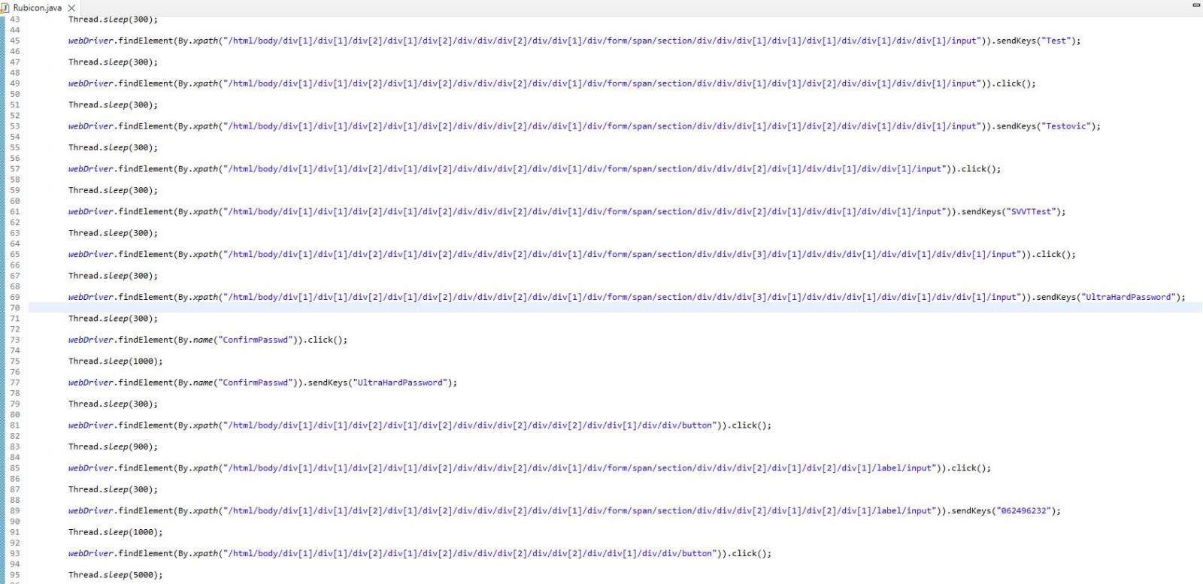

## 3.2. Log in

|  |  |  |  |  |
| --- | --- | --- | --- | --- |
| **Test Name:** Log in | | | | |
| **Description:**  Check if we can log in to an already existed account | | | | |
| **Pre-condition(s): have an account** | | | | |
| **Test Steps:**  1. Go to the official page  2. Choose “Log in”  3. Fill the information  4. Log in | **Test Data:**  **We used real accounts that we are not using** | **Expected Result:**  Login | **Actual Result:**  The test passed | **Status:**  PASS |
| **Notes: We used the account that is not important to us anymore, just for testing** | | | | |

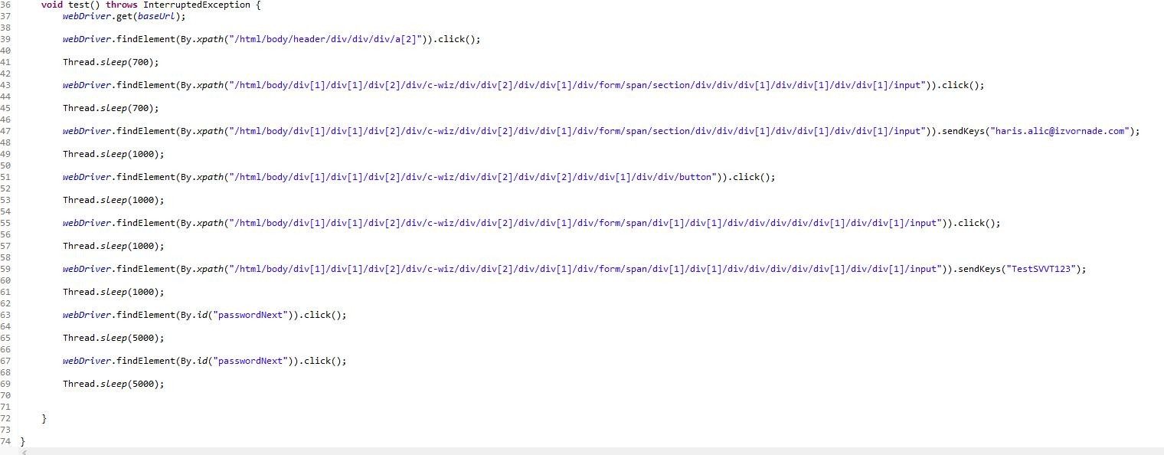

## 3.3 All mail navigate

|  |  |  |  |  |
| --- | --- | --- | --- | --- |
| **Test Name:** All mail navigate | | | | |
| **Description:**  Check if “All Mail” button works and leads to proper page | | | | |
| **Pre-condition(s):** | | | | |
| **Test Steps:**   1. Login to account 2. Go to “More” at the side buttons 3. Click “All Mail” | **Test Data:**  **We used the side buttons and opened all mail that were ever sent** | **Expected Result:**  Open “All Mail” | **Actual Result:**  The test passed | **Status:**  PASS |
| **Notes:** | | | | |

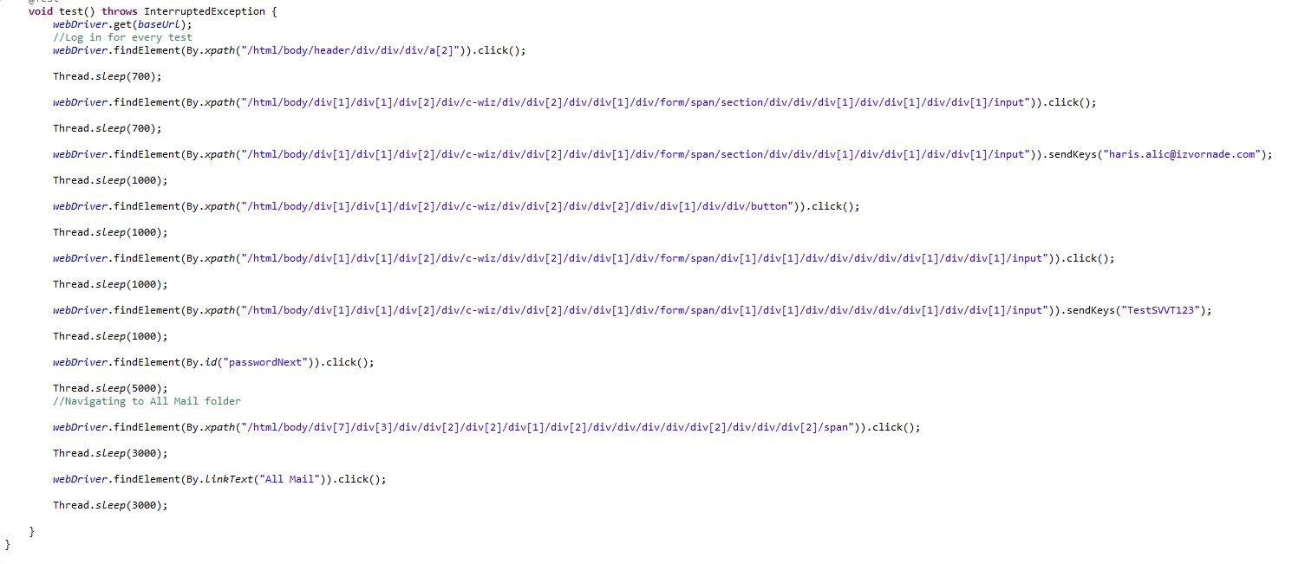

## Delete

|  |  |  |  |  |
| --- | --- | --- | --- | --- |
| **Test Name:** Delete | | | | |
| **Description:**  Delete the mail | | | | |
| **Pre-condition(s):** Have a received mail | | | | |
| **Test Steps:**   1. Login 2. Choose mail 3. Delete | **Test Data:**  Real mails just for delete testing | **Expected Result:**  Delete test | **Actual Result:**  The test passed | **Status:**  PASS |
| **Notes :** | | | | |

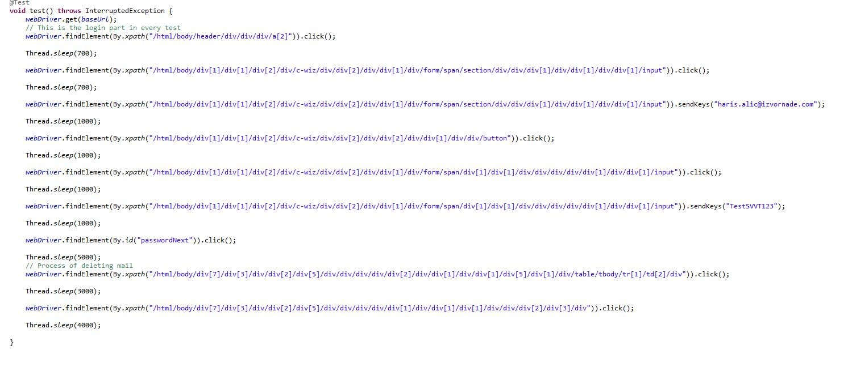

## Archive

|  |  |  |  |  |
| --- | --- | --- | --- | --- |
| **Test Name:** Archive | | | | |
| **Description:**  Archive mail | | | | |
| **Pre-condition(s):** Have a received mail to archive. | | | | |
| **Test Steps:**   1. Login 2. Choose mail 3. Archive | **Test Data:**  - real mails | **Expected Result:**  Archive mail | **Actual Result:**  The test passed | **Status:**  PASS |
| **Notes:** | | | | |

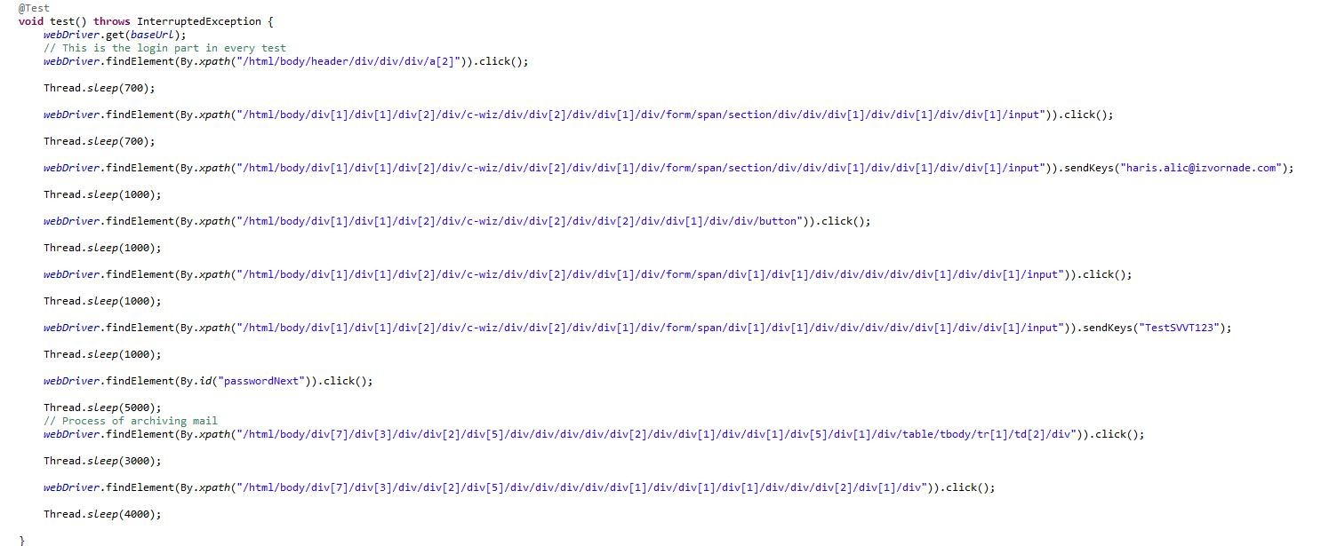

## Open settings

|  |  |  |  |  |
| --- | --- | --- | --- | --- |
| **Test Name:** Settings | | | | |
| **Description:**  Check if the “Settings” button works | | | | |
| **Pre-condition(s):** | | | | |
| **Test Steps:**   1. Login 2. Choose “Settings” button | **Test Data:** | **Expected Result:**  Test the button | **Actual Result:**  The test passed | **Status:**  PASS |
| **Notes :** | | | | |

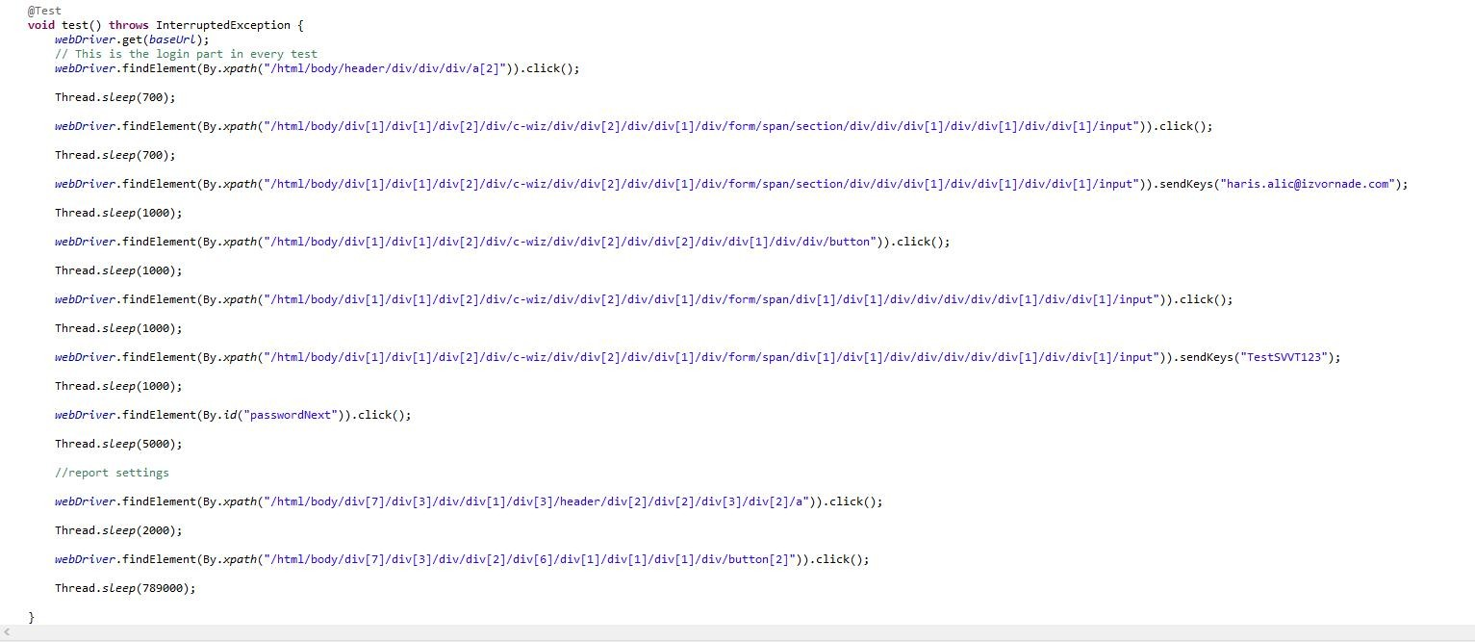

## 3.7 Change the status

|  |  |  |  |  |
| --- | --- | --- | --- | --- |
| **Test Name:** Status change | | | | |
| **Description:**  Check if the status can be changed | | | | |
| **Pre-condition(s): have an option for the status** | | | | |
| **Test Steps:**   1. Login 2. Choose “Status” 3. Change it to “Do not disturb” | **Test Data:** | **Expected Result:**  Change the status | **Actual Result:**  The test passed | **Status:**  PASS |
| **Notes :** | | | | |

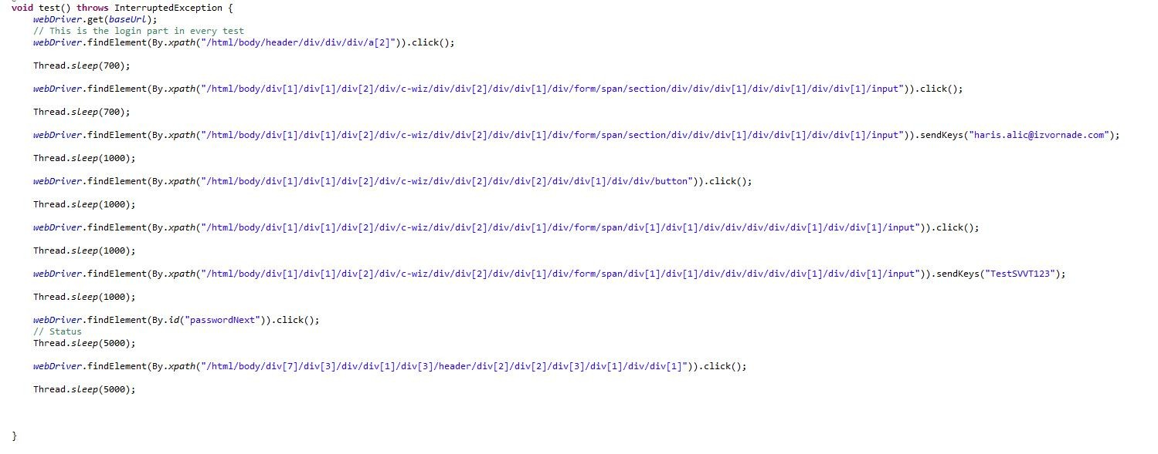

## Search

|  |  |  |  |  |
| --- | --- | --- | --- | --- |
| **Test Name:** Settings | | | | |
| **Description:**  Check if the “Settings” button works | | | | |
| **Pre-condition(s): Have a mail to search for** | | | | |
| **Test Steps:**   1. Login 2. Choose “Search in mail” 3. Fill the fields | **Test Data:**  Real names and mails | **Expected Result:**  Test the button | **Actual Result:**  The test passed | **Status:**  PASS |
| **Notes :** | | | | |

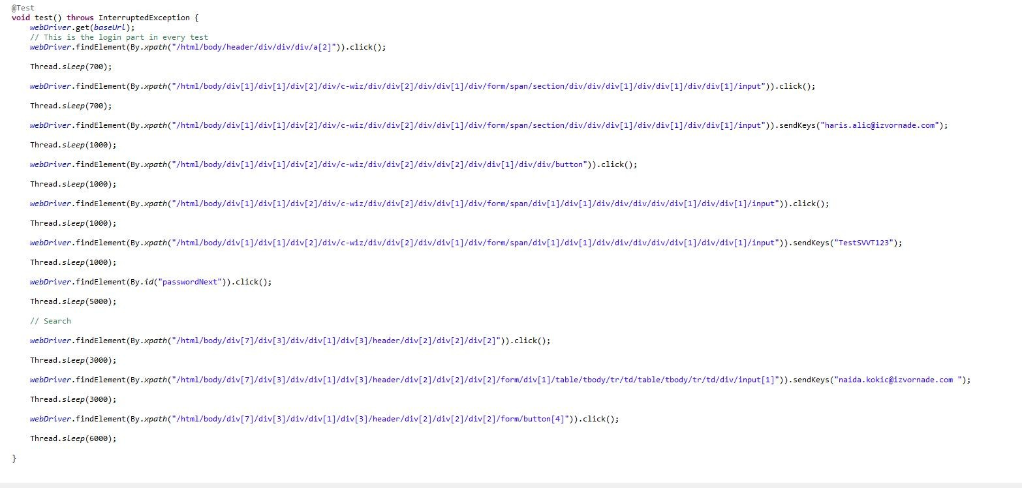

## Sign out

|  |  |  |  |  |
| --- | --- | --- | --- | --- |
| **Test Name:** Sign out | | | | |
| **Description:**  Signing out of the mails | | | | |
| **Pre-condition(s): login to mail** | | | | |
| **Test Steps:**   1. Login 2. Choose button with the picture to the top right corner 3. Choose “Sign out” | **Test Data:** | **Expected Result:**  Test the sign out option | **Actual Result:**  The test failed.  Not enough elements given | **Status:**  FAIL |
| **Notes :** | | | | |

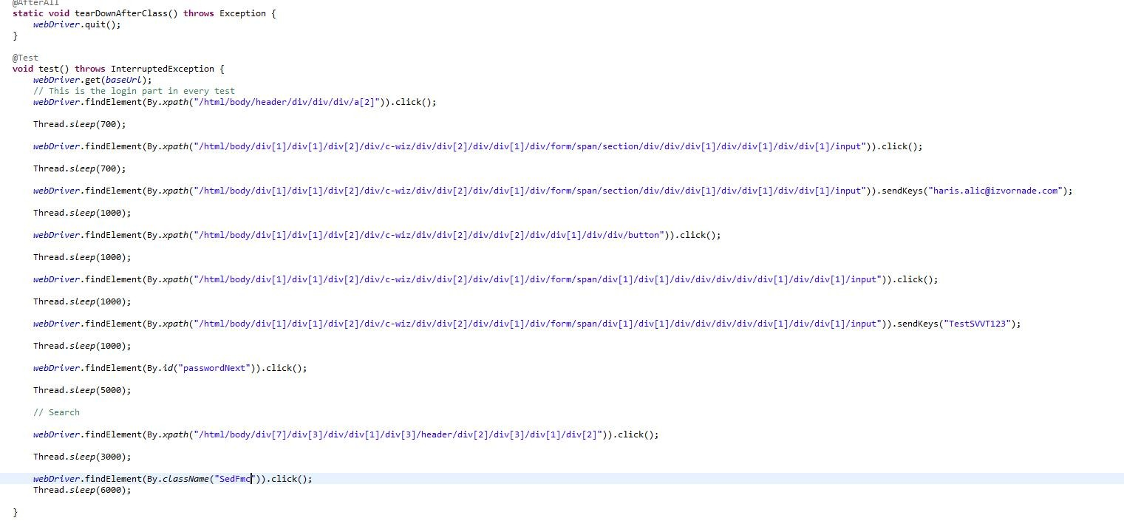

## send mail

|  |  |  |  |  |
| --- | --- | --- | --- | --- |
| **Test Name:** Send mail | | | | |
| **Description:**  sending a real mail to someone else | | | | |
| **Pre-condition(s):** | | | | |
| **Test Steps:**   1. Login 2. Choose “Compose” 3. Fill the fields 4. Send the mail | **Test Data:** | **Expected Result:**  Test if sending mails is possible | **Actual Result:**  The test failed.  Not enough elements given | **Status:**  FAIL |
| **Notes :** | | | | |

# 9. Conclusion

## 9.1. Testing Summary

|  |  |  |  |
| --- | --- | --- | --- |
| **Testing Tool** | **Total Tests** | **Passed Tests** | **Failed Tests** |
| Eclipse.  Java  Selenium | 10 | 8 | 2  1. Sign out  2. Send mail |

## 9.2. Final Thoughts

We tested 10 features and most of the worked properly. The problem was that not all elements were clearly given and made it a bit hard to find and work with them. Most of the time the test crashed out of nowhere, even if the test worked multiple time before that. This was a bit problematic and it may still be, because we have to try it multiple time before the test, actually passed, even if it is working.