Smart contract Deployed at:
0xefE188AD3B9A6c92e0D355B9e3ba15dA23a260eB
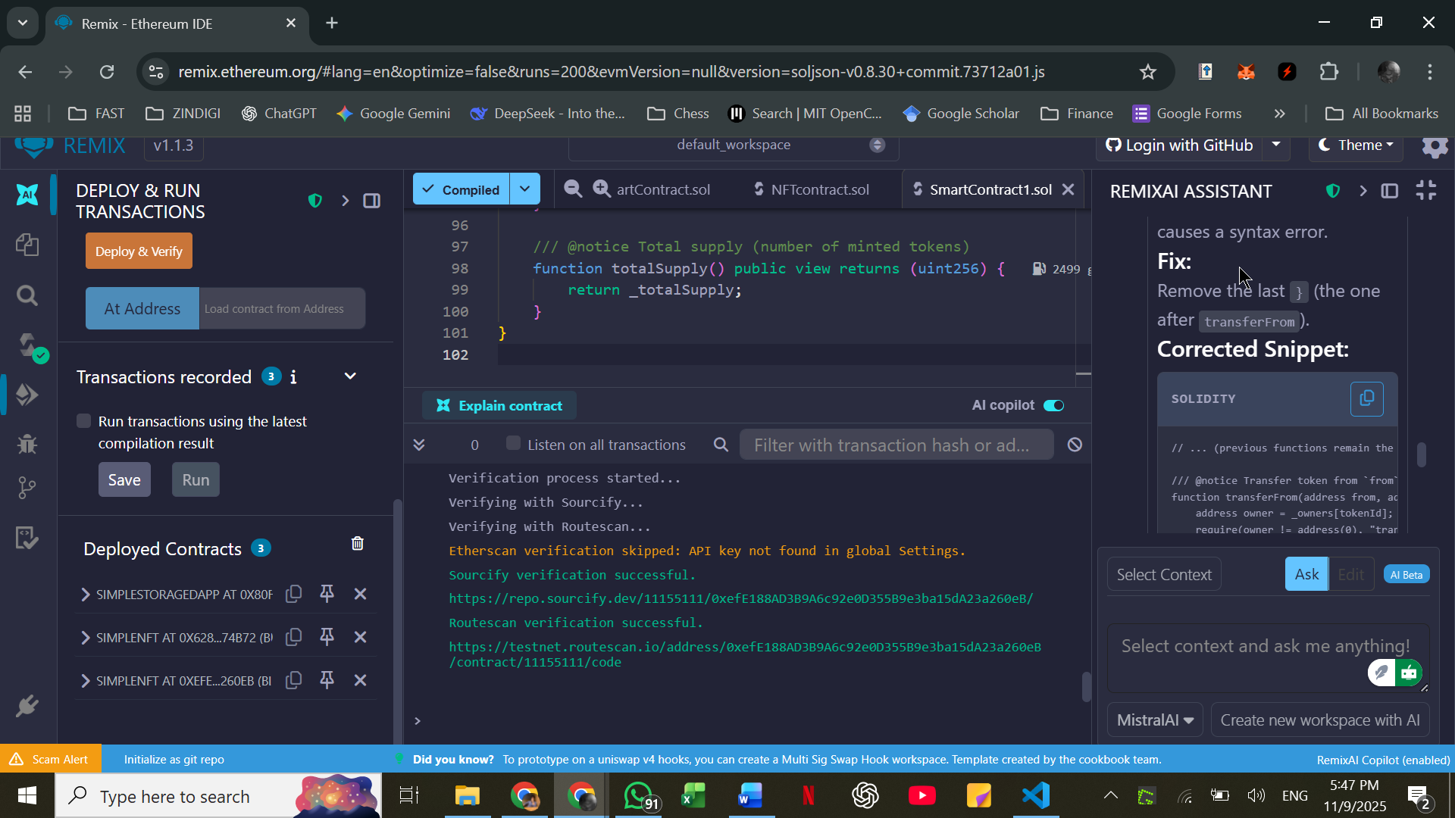
Connected MetaMask to NFT Minter
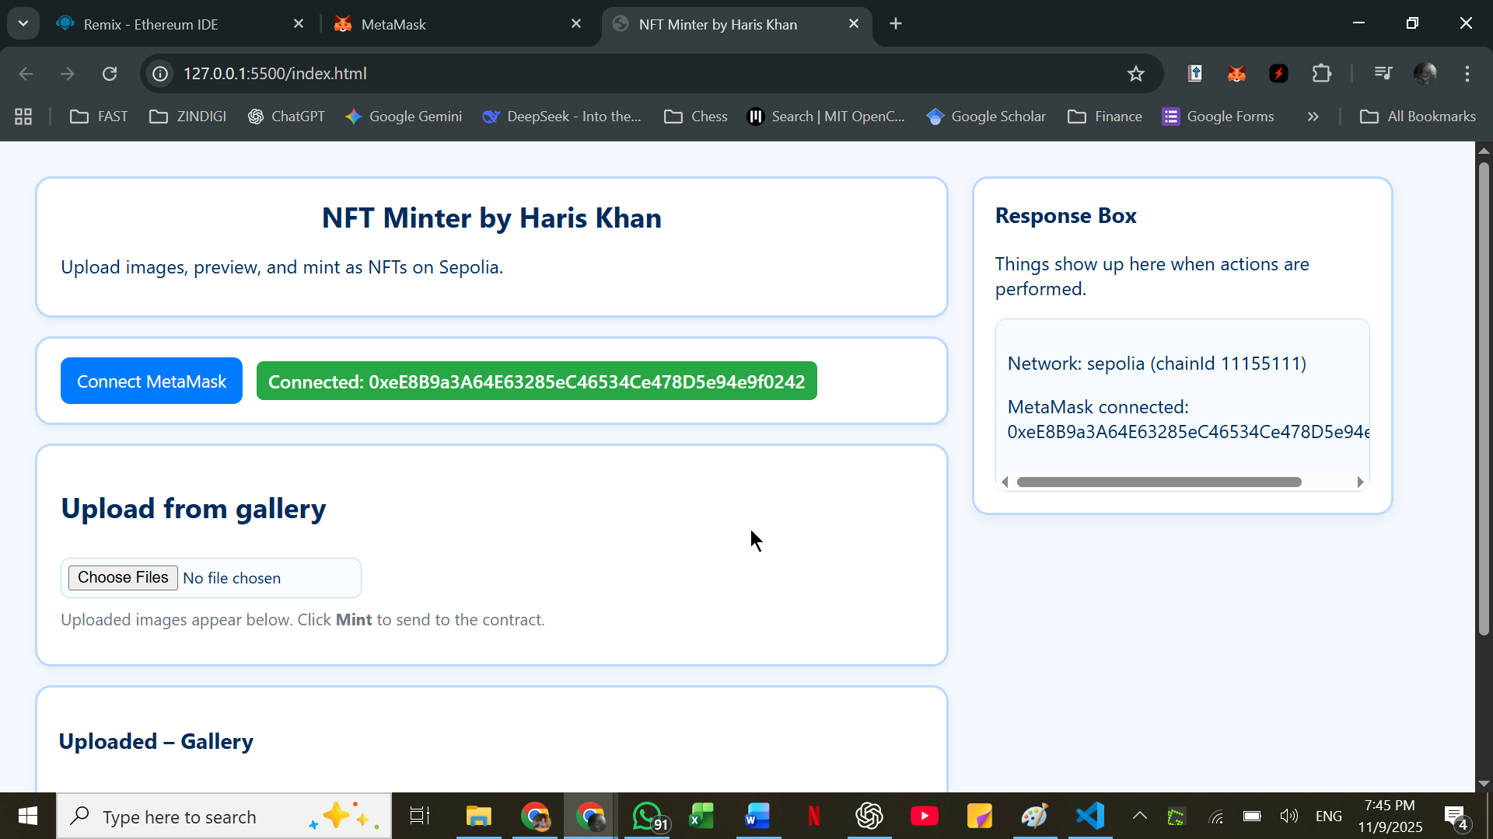
Uploaded Pictures from Gallery:
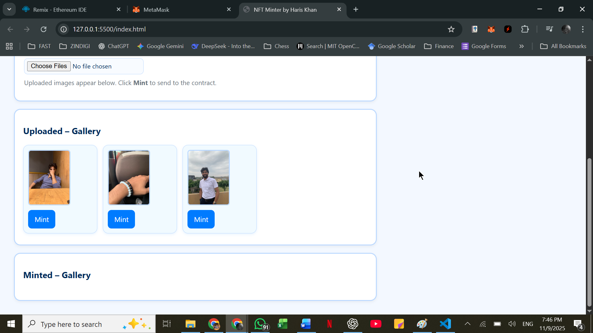
NFT Minted.
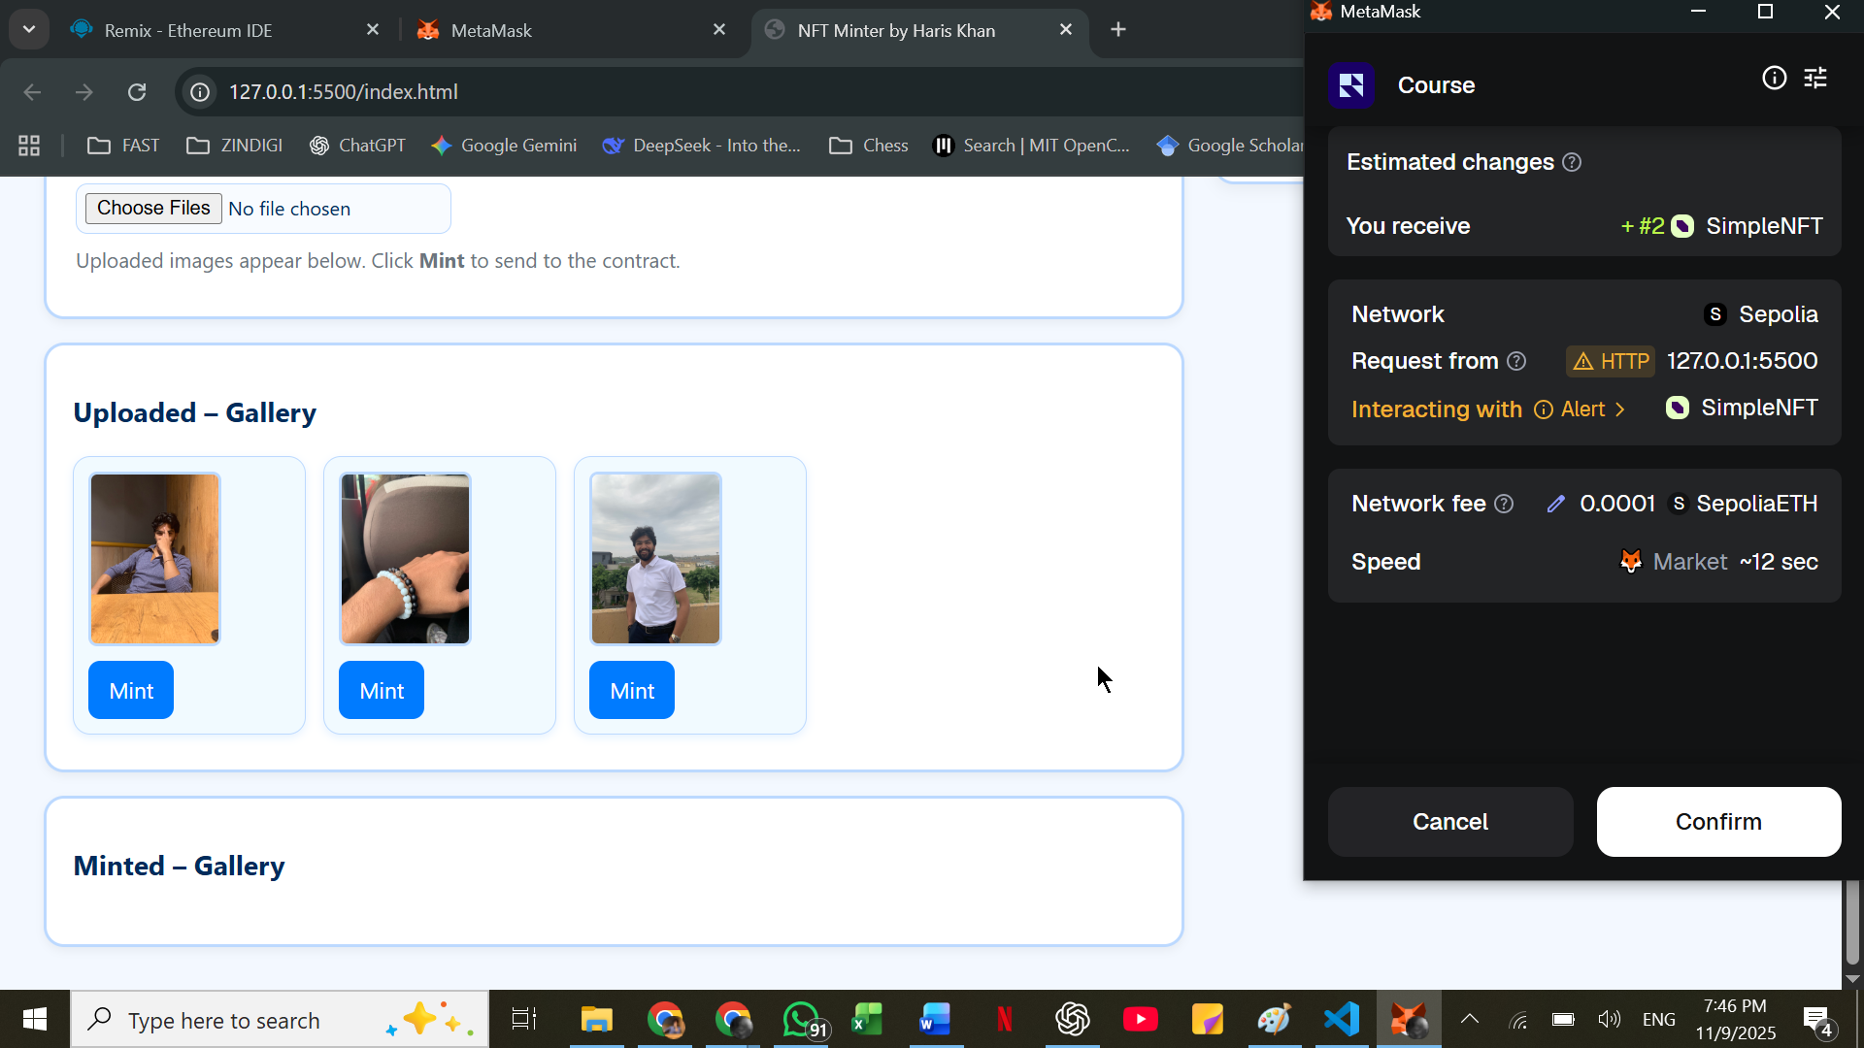
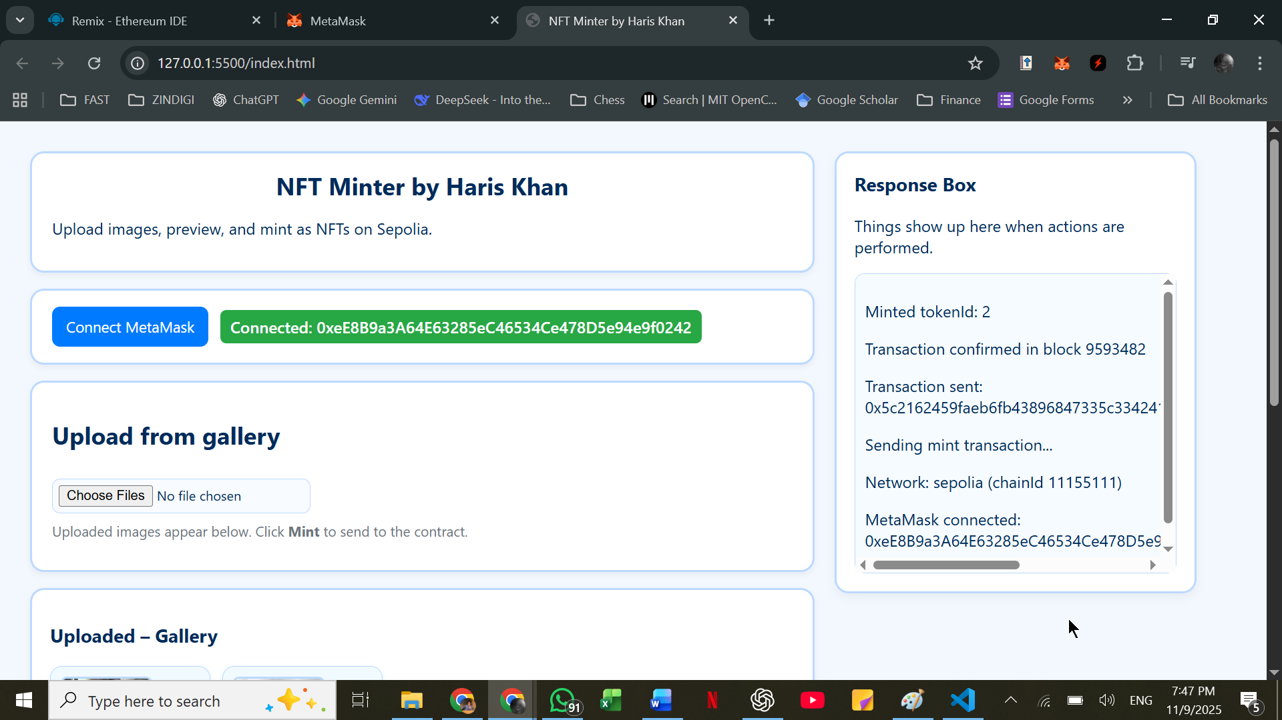
Transaction hash: 0x5c2162459faeb6fb43896847335c334241729fd2f2d6a4cb8e6035aa51c6e62d
NFT Minted and transferred to Minted Gallery
