We have effectively merged the architecture each of our former two groups. In this project we are going to go through a feature driven development for our software to be delivered on December 3rd.

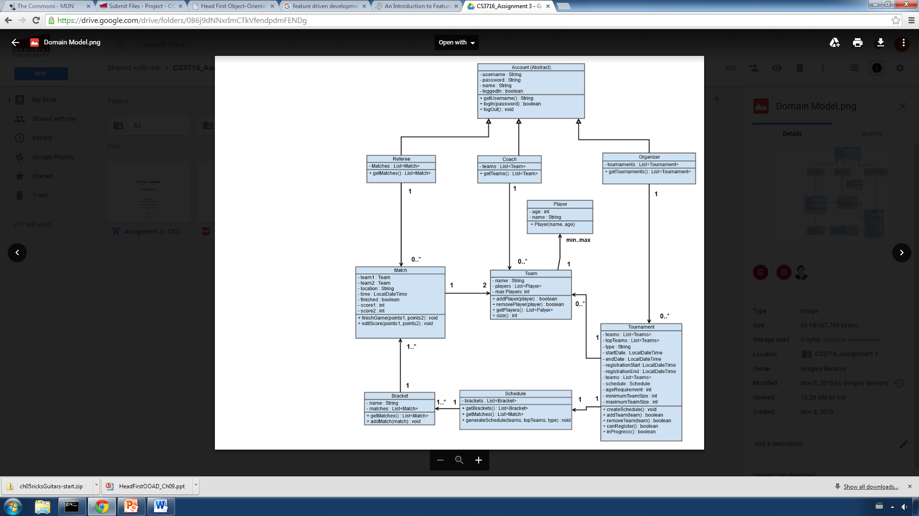**Feature List:**

1. Create a Tournament

2. Add/remove a team

3. Register a team into an existing tournament

4. Register an account for user

5. Add/remove players

6. Create automated bracket

7. Generate schedule

8. Add/edit scores

Our first iteration will be feature #1 which is creating a tournament. Creating a tournament allows the organizer to create a tournament by choosing several criteria such as the format, start date, end date, age requirement etc. In this case we are going to ignore the user limitation of the system and assume that everyone can access everything within the system.

**Domain Model**

**Create a tournament feature – completion list**

* User must be able to select start and end dates for the tournament
* User must be able to set a maximum and minimum amount of teams within the tournament (Depending on format)
* User must be able to create different formats of tournament. In this case we have chosen 2 which are division and single elimination.
* The tournament must also be able to group the teams in their own respective seeds when adding the team.