

**PROJECT LIFE CYCLE**

|  |  |  |
| --- | --- | --- |
|  | **Sarajevo,2019** | **Done by:**  **Haris Čehić** |

**TABLE OF CONTENT**

|  |  |
| --- | --- |
| 1. **Initiation phase** 2. **Planning phase** 3. **Execution phase** 4. **Closing phase** | **2**  **3**  **3**  **4** |

1. **Initiation phase**

The goal of this project is to design a system that will record inspection controls of registered products that are in the system. This project consists of 5 parts that will be essential parts of the system and they are:

1. Track records of products
2. Track records of inspection bodies that will control products
3. Track records of inspection controls
4. Overview of completed inspection controls for specific time period
5. Overview of details of inspection controls

The first 3 parts need to have Create, Edit and Delete option. 4th part of the system needs to have a start date and end date for report of completed inspection controls. One of the requests for the system is to be designed in Web Application form using MVC patterns. The purpose of this project is to have a system that will have a qualitative insight for market and sanitary inspection.

1. **Planning phase**

In this phase I will briefly explain what am I going to do. When it comes to the technologies I have loose hands, the only requirement is to use MVC patterns. I have decided to do this system in Microsoft Visual Studio with ASP.NET and SQL Server. First of all I am going to create a database called Inspekcija that will contain 3 different tables: Proizvod, Kontrola and Tijela. Each of these tables are designed for the first 3 requirements of the system, that will store data, update or delete it, based on what user chooses. Second thing is to create models for these tables. The third thing is to create controllers which will have different functionalities and how to execute what user chooses. The first three controllers have create, edit and delete functions and the functionalities correspond to the options. Forth thing is that I will connect the database to the web application so that the data is stored and can be accessed through the system. Fifth thing is to create Views that will correspond to the models and controllers in the application so that they are connected and communicating between them.

1. **Execution phase**

The implementation phase, as always, is the longest phase in Project Life Cycle. I have created the database with 3 tables in it. I have connected these tables through primary and foreign keys. The database diagram looks like this:

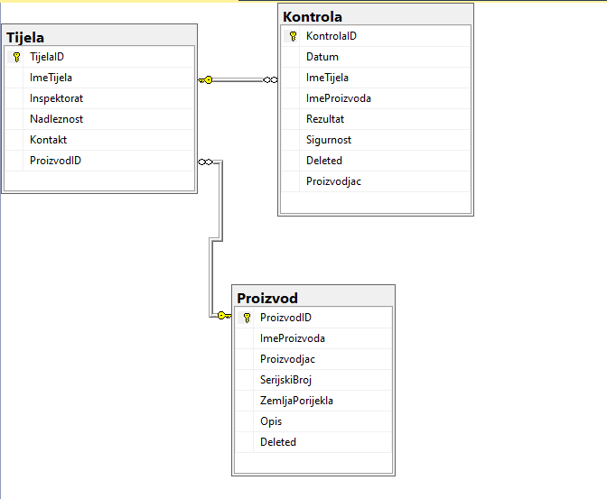

**Picture 3.1**

As we can see in the diagram above I have created relational database and the Kontrola table has a column named ImeTIjela that corresponds to Tijela.ImeTijela table, and ImeProizvoda which corresponds to Proizvod.ImeProizvoda table. When it comes to the MVC patterns, I have 5 models, each of them representing column names from the tables in the database. In the Controller folder I have 5 controllers which represents 5 functions for each part that needs to be developed. The View folder contains 5 subfolder and has Index view and, if needed, a create and edit view. For the Proizvod table I have left SerijskiBroj and Opis as optional and if the user does not enter anything I have decided to insert default values, for SerijskiBroj that would be 0 because it is an integer, and for Opis is “Empty” as a default value for string. The second thing in the inspection bodies I have created a dropdown list for Inspektorat which has 3 options, either FBIH, RS and Brčko Distrikt. And for Nadležnost I have 2 values either Tržišna inspekcija or Zdravstveno – sanitarna. In this way I am trying to control human error and to minimize potential risks. In the third part the user needs to enter Datum, and I have checked in my controller is the Datum up to today’s Date. The ImeTijela and ImeProizvoda that needs to be entered, has to exist in the first and second table, and I have created a function to stop the process until the users enters an existing product and body into the input fields. Also I have made it in our format which is DD/MM/YYYY. The overview of inspection controls needs to have start date and end date to show inspections in selected time period. I have created functions to check if the start date is bigger than today’s date, if the end date is bigger than today’s, if the start date is bigger than the end date, and if there is any date entered in and start date and end date. The fifth overview is detail view of inspection controls done. I have tried to create as many checks as possible to minimize human error and potential risks that could occur when entering data into these fields. At the end I have created a start page that will display 5 options in the system and based on your click it will navigate you to the requested part of the system.

1. **Closing phase**

The project objectives have been met and the potential risk was minimized. In this phase I have tested the application in order to see if there are some bugs that need to be fixed. For now everything is working and requirements have been satisfied. This project has been done in the requested time period.