The ETH Question:

Polkovnikov et al describes eigenstate thermalization as follows:

- Quantum Ergodicity:
In an ergodic (nonintegrable) quantum system, quantum eigenstates are uniformly distributed over an energy shell for large energies:
Follows from Berry Conjecture
- The notion of “Typicality”:
Many particle states, in general, can be described by their 'typicality'.
In this paradigm, the full many body Hamiltonian is decomposed to a 'non-interacting' part (integrable) and an 'interacting part' that makes the full Hamiltonian nonintegrable.
  - A 'typical' state is one that is highly delocalized in the Hilbert space spanned by the eigenstates of the noninteracting Hamiltonian.
  - 'Delocalization' refers to the distribution of its amplitudes in the noninteracting eigenbasis. Their total sum of amplitudes is always unity.
  - If the amplitudes are distributed over only a 'small number' [O(10) or less?] of noninteracting eigenstates, then the state is highly atypical.
  - For instance, say you have a system of size populating a state , and the system has noninteracting eigenstates (and full eigenstates ), then
        - If we have for some m,n, and all other amplitudes 0, then is highly atypical, but
        - If for states to , and all other amplitudes are 0, then the state is much more typical.
  - The ground state and low-lying excitations of ANY many-body Hamiltonian, whether integrable or not, are expected to be atypical.
  - Highly excited eigenstates of nonintegrable Hamiltonians are typical.
  - Experimentally, usually only atypical states can be populated a priori.
  - Typicality can be quantified by the Inverse Participation Ratio, Shannon Entropy or Diagonal entropy.

- Hamiltonian Dynamics of closed quantum systems:
Suppose the state is atypical before the quench and thus was successfully populated in the lab.
  - After a quench, a system evolves as from the atypical state .
  - The atypical state is not an eigenstate, so is not stationary. However, in some limit, it evolves to a stationary state that is typical.
  - The expectation of any operator

  - In order to measure the expectation value we need to perform many measurements unless is an eigenstate of O. Each measurement corresponds to a new atypical wave function due to statistical fluctuations. Thus, we measure
- The thesis of ETH:

Thermalization is built into the structure of the full many body eigenstates and revealed only through observables rather than the density matrices.
  - Dynamics is just dephasing between eigenstates
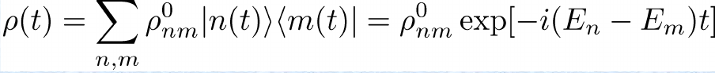

  - In general, energy is extensive and energy fluctuations are sub-extensive. If all eigenstates within a subextensive energy shell are similar, then, for 'typical' states evolving with dephasing after a quench, there exists a state m such that

where

indepenent of initial conditions.

  - Thus, it is a microcanonical ensemble.
  - ETH essentially says that there are no atypical stationary states in nonintegrable systems except for low-lying energy states. In nonintegrable systems, all stationary states of high energy are 'typical', delocalized in the noninteracting Hilbert space, and so are also 'thermal'.

- The Generalized Gibbs Ensemble:
If the system is integrable, then the above is also true, except

where are local integrals of motion viz.

One question:
- In classical dynamics of nonintegrable many body systems, there is a proven link between dynamical chaos and thermalization/ergodicity
- The maximum Lyapunov exponent of a dynamical system in the chaotic regime (via Chirikov's criterion and the KAM theorem). Chirikov links the width of the 'separatrix' torus bordering nonlinear resonances in action-angle phase space with the 'distance' between the resonant tori. If this exceeds unity, then the system is predicted to be chaotic. This criterion may fail under certain conditions. In the thermodynamic limit, the ratio is expected to diverge, meaning always chaos.
- The classical Lyapunov exponent is

where
are two time evolving states in the phase space
are the two initial conditions
is the final time
- This quantity is positive in chaotic regimes once appropriate thresholds are crossed.
- In order to measure thermalization, it is necessary to make thermodynamic predictions and compare the dynamics from the propagation of the equations of motion, with the thermodynamic state.
- Dynamically, a 'spectral entropy' is also defined, which is a quantitiative measure of the difference between the time-averaged dynamical state and the expected thermodynamic state.
- This spectral entropy can be normalized with the expected thermal entropy.
- In classical dynamics, this spectral entropy vanishes when the chaotic threshold for either Lyapunov or Chirikov are attained.
- Quantum analogs for Lyapunov and Chirikov measures are possible by replacing the distance metric with inner products and made Euclidean by suitable canonical transformations.
- Quantum analogs for entropy can be made via ETH as described above.
- So the question is, can this effect be replicated in the quantum many body realm even though no dynamical chaos is possible?
- Specific test cases can be:
Bose Hubbard Model (there in literature), or
A quench of harmonic oscillators with additional . or
Fermi Hubbard in 2D.
- Couple to a tls and measure the transition to eqm by temp as relaxation time.

Another question:

What if we introduce time dependence into one of the parameters of the Hamiltonian that is more than a simple impulse quench? For instance, suppose it was a STIRAP from the interacting ground state, with

where link the ground state to high(er) energy many body states like

In the 3 level case, This would lead to a complete population transfer from state 0 to state m with state d as the 'dark state' at . This also amounts to a 'quench' in the Hamiltonian, as, for large times

In such a case, 'thermalization' will work only if the final populated state 'm' is 'typical', but what if it isn't?? What is it's a low-lying eigenstate? What happens to ETH then???

Furthermore, my past work shows that adding all many body levels to the STIRAP problem above (going beyong the 3-level limit) may cause 'quantum chaos' due to additional avoided crossings in the Floquet eigenspectrum. Can we link this phenomenon to thermalization via ETH? Would that be interesting?

The Rigol lattice problem

Hamiltonian:
The Rigol lattice consists of N hard core Bosons in an M x M lattice (M is always odd) with some of the sites removed. The sites are removed as follows. From the origin, remove all diagonal sites until the middle, then remove all subdiagonal sites till M, keeping the middle site. Below is a diagram of the lattice. The existing sites are filled in black, and the dashed ones are removed.

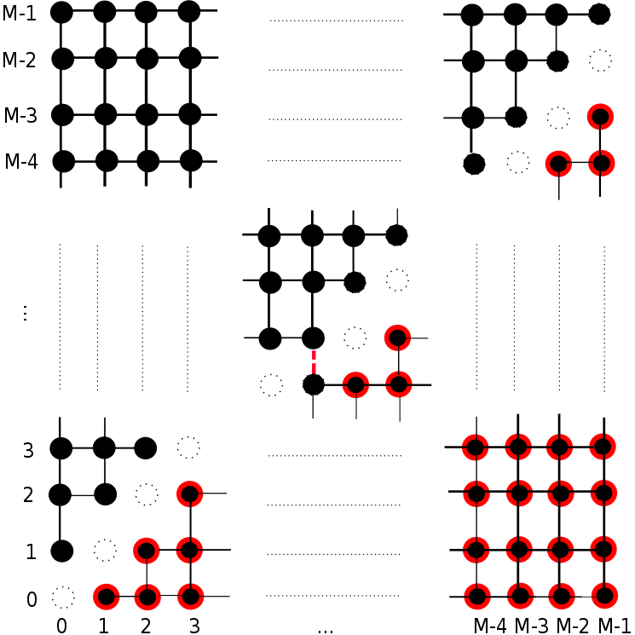

Hamiltonian is

where the sum is over all nearest neighbor pairs of sites that are linked together. These are hard core bosons, and commute off-site but anticommute on site. This system has sites and N hard core bosons, so the total dimensionality is .

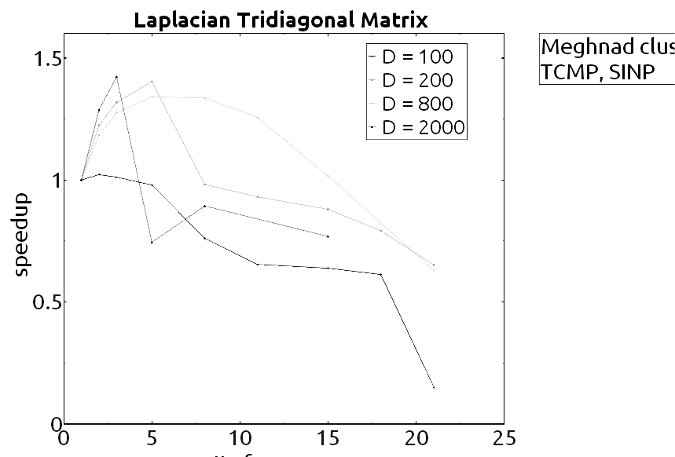

The basic steps towards diagonalizing this Hamiltonian are as follows.
- Create a 'canonical basis' that consists of D – dimensional vectors with N elements as unity and rest 0. In order to do this, create a structure datatype 'gsl_combination' that contains an array of N integers. The integers are the indices of the occupied sites.
- Now, dynamically create an size D array of such gsl_combination objects, and use combination algorithms to take combinations of N integers from a list of the first integers from 0. Remove all basis gsl_combination objects that have indices in the forbidden sites (dashed ones in the figure above). That should leave an array of size D.
- Write a subroutine 'can_sdot' that evaluates the scalar product of 2 of these orthonormal objects. Simply compare them, return 1 when they are the same and 0 if they are not. Also add a provision where can_sdot with a null object returns 0.
- Now to evaluate the matrix elements of H.
- Initiate a DxD matrix with all elements 0. Do this using Slepc in parallel environment.
- Note that basically just does the following to any gsl_combination object: If the site has a unity, it moves the unity to site (unless the site is forbidden or occupied, in which case it returns null) and creates a new gsl_combination object. Write a subroutine, 'bdaggerb', that does this.
- Also, note that acts very simply on a gsl_combination object. If both the sites have unity, then it returns the same gsl_combination object, else it returns null. Write a subroutine, 'nsquared', that does this.
- Now run two indices from 0 to D (or whatever sub-range is locally set on the parallel grid) and build

(can_sdot(gsl_combination , bdaggerb(i,j,gsl_combination )) -
U can_sdot(gsl_combination , nsquared(i,j, gsl_combination )) )
- That's basically it. Now just use Slepc to diagonalize H in parallel. Let the diagonalizing matrix of evecs be 'U'.
- Note that the speedup is rarely more than 1.5, and heavy overheads bring it down for more than 2-3 processors. See figure above for details.

Dynamics:

The lower half of the lattice (red strokes, black filled) is populated with the N atoms at . At , the red dashed link is activated. This is the link between the two halves, and is situated right at the middle of diagonal at coordinates for odd M.

The dynamics is simply

The inner products and can be evaluated using BLAS level 3, and multiplication of each eigenstate with the exponent can be performed using BLAS level 1. The Rigol lattice is said to be nonintegrable and so shows ETH.

Once diagonalized with the algorithm in the previous page,
the basic steps towards setting up the initial conditions and time evolution are as follows
- Initiate an “initial Hamiltonian” of the same size as H, but as an identity matrix.
- Take the basis states from the previous algorithm. Now, write a subroutine 'is_below(basis_state)' that flags those basis state whose constituent particles (in the combination array) all lie in the lower cells marked by red in the Rigol lattice diagram above.
- For flagged states ONLY, rebuild the matrix elements with the same formula as H above.
- Diagonalize this Hamiltonian, take the lowest eigenvalue and its corresponding eigenvector. This is the initial state.
- Multiply it with 'U' to bring it to the diagonal basis.
- Now time evolution is simple. Multiply each component 'n' in the diagonal basis by where is the eigenvalue.
- After a time 't', rotate it with to bring it back to the canonical basis.

TODO: Diagonal ensemble averages for momentum density.

