SOFTWARE ENGINEERING
CineSense
Intelligent Web-Based Movie Recommendation System
DELIVERABLE 4 — Sprint 3 (Final Report)
Module: AI/ML Recommendation Engine Integration & Final System

Group Members
M Haris Fayyaz | 23L-0767
Moeez Ijaz | 23L-0750
Faiqa Waseem | 23L-0633
Section: BCS-6C
Submitted to: Ma'am Ansa Liaqat
Date: May 2026



1. Project Introduction

1.1 Project Title
CineSense — Intelligent Web-Based Movie Recommendation System

1.2 Introduction
CineSense is a full-stack web application that delivers personalized movie recommendations using a hybrid machine learning approach (Content-Based Filtering + Collaborative Filtering). Users can register, log in, search movies from the MovieLens dataset, rate them, build a watchlist, and curate a personal dashboard. Sprint 3 completes the system by integrating the AI/ML recommendation engine that generates ranked, personalized suggestions based on each user's rating history and genre preferences. The stack is React.js (frontend), Node.js/Express (backend APIs), Python/Flask (ML microservice), and Firebase (Auth + Firestore + Storage).

1.3 Sprint Summary
- Sprint 1 — Core User Management: Signup, Login, Logout, Profile, Password Reset (US-01 to US-05)
- Sprint 2 — Core Movie Features: Search, Movie Details, Rating, Manual Dashboard, Trending, Watchlist, Feedback (US-06 to US-15)
- Sprint 3 — AI/ML Integration & Final Product: Hybrid Recommendation Engine, Similar Movies (CBF), Feedback Loop, Performance Polish, BVA Testing (US-10, US-13, US-14, US-16, US-17)

2. Sprint 3 Backlog

2.1 Module: AI/ML Recommendation Engine Integration & Final System
Sprint 3 delivers the core AI/ML recommendation engine — the primary goal of the CineSense project. This sprint also includes similar-movie discovery (content-based), feedback-to-ML re-ranking, performance optimization, and full BVA testing.

2.2 Rework / Leftover Stories
No stories were left over from Sprint 2. All Sprint 2 stories (US-05, US-06 to US-09, US-11, US-12, US-15) were completed by end of Sprint 2. There are no rework items from previous sprints to carry into Sprint 3.

3. User Stories (All Sprints)

3.1 Sprint 1 & 2 — Summary
Full user story details for Sprint 1 (US-01 to US-05) and Sprint 2 (US-06 to US-12, US-15) were submitted in Deliverables 2 and 3 respectively. The table below provides a summary for reference.

ID | Story | Sprint | Hrs | Summary
US-01 | User Registration (Signup) | Sprint 1 | 8 hrs | Signup via Firebase Auth; save profile to Firestore
US-02 | User Login | Sprint 1 | 6 hrs | Firebase auth login; session persistence (LOCAL)
US-03 | User Logout | Sprint 1 | 3 hrs | Firebase signOut(); redirect to login; clear session
US-04 | View and Edit Profile | Sprint 1 | 7 hrs | Fetch/update profile from Firestore; upload profile pic
US-05 | Password Reset | Sprint 1→2 | 4 hrs | Forgot Password email; in-profile re-auth reset
US-06 | Movie Search & Filtering | Sprint 2 | 6 hrs | Keyword search + genre/year/rating filters on Firestore
US-07 | Movie Details Page | Sprint 2 | 5 hrs | Full movie info, cast, overview, similar movies section
US-08 | Rate a Movie | Sprint 2 | 7 hrs | 1–5 star widget; writes to Firestore ratings collection
US-09 | Personalized Dashboard | Sprint 2 | 10 hrs | Manually add/remove movies; stored in Firestore per user
US-11 | Trending Movies Section | Sprint 2 | 4 hrs | Top 10 by avg rating; horizontally scrollable cards
US-12 | Add Movie to Watchlist | Sprint 2 | 5 hrs | Add/remove from Firestore watchlist collection
US-15 | Feedback System | Sprint 2 | 5 hrs | Thumbs up/down stored in Firestore for Sprint 3 ML

3.2 Sprint 3 — Full User Stories

Story ID: US-10 | Story Title: View Similar Movies on Movie Details Page
Priority | Medium | Est. Hours: 5 hrs
User Story | As a registered user, I want to see a list of movies similar to the one I am viewing so that I can discover more movies that match my taste.
Description | The Similar Movies section on the Movie Details page uses Content-Based Filtering (cosine similarity on genre/keyword TF-IDF vectors) to compute the top 5 most similar movies and display them as scrollable movie cards.
Sub User Stories | - As a user, I want to see a 'Similar Movies' section at the bottom of the Movie Details page.  - As a user, I want the similar movies to be computed based on genre and keyword similarity.  - As a user, I want to click on a similar movie card to navigate to its own details page.
Acceptance Criteria | - The Similar Movies section must display a minimum of 5 movie cards.  - Similarity must be computed using cosine similarity on TF-IDF genre/keyword vectors via the ML microservice.  - Each card must show: poster, title, genre(s), and average rating.  - Clicking a similar movie card must navigate to that movie's details page.  - Section must load within 2 seconds under normal network conditions.

Story ID: US-13 | Story Title: Mark Recommendation as Relevant/Not Relevant (ML Loop)
Priority | Medium | Est. Hours: 4 hrs
User Story | As a registered user, I want to mark any recommendation as relevant or not relevant so that the system continuously improves my personalized suggestions.
Description | This story extends the Sprint 2 feedback mechanism (US-15) to feed directly into the ML recommendation engine re-ranking loop. User feedback (thumbs-up/down) is read by the ML microservice during the next recommendation cycle to adjust CBF/CF score weighting.
Sub User Stories | - As a user, I want to mark a recommendation as relevant (thumbs-up) or not relevant (thumbs-down).  - As a user, I want the system to use my feedback to improve the next set of recommendations.  - As a user, I want to be able to update my feedback at any time.
Acceptance Criteria | - Feedback data stored in Firestore must be consumed by the ML microservice during recommendation generation.  - Movies marked as 'not relevant' must be down-ranked or excluded from the next recommendation cycle.  - Movies marked as 'relevant' must be used to seed similar-movie discovery via content-based filtering.  - Feedback changes must take effect in the next dashboard load without requiring a manual refresh.

Story ID: US-14 | Story Title: Receive Personalized AI Recommendations
Priority | High | Est. Hours: 12 hrs
User Story | As a registered user, I want to receive a personalized list of movie recommendations on my dashboard powered by the AI/ML engine so that I can discover movies tailored to my tastes.
Description | This is the core Sprint 3 deliverable. The ML microservice accepts the user's rating history and feedback from Firestore, runs Content-Based Filtering (CBF) and Collaborative Filtering (CF), combines scores using a weighted hybrid, and returns a ranked Top-N list. Results are cached in Firestore.
Sub User Stories | - As a user, I want to see AI-generated movie recommendations on my personalized dashboard.  - As a user, I want my recommendations to update as I rate more movies.  - As a user, I want the dashboard to load quickly even when recommendations are being computed.  - As a user, I want the system to handle my cold-start scenario (fewer than 3 ratings) gracefully.
Acceptance Criteria | - The ML microservice must return a ranked Top-N (minimum 10) list of recommended movies given a user ID.  - Recommendations must use a weighted hybrid of CBF (cosine similarity) and CF (matrix factorization).  - For cold-start users (fewer than 3 ratings), fall back to globally trending movies.  - Recommendations must be cached in the Firestore recommendations collection with a 24-hour TTL.  - The personalized dashboard must display AI recommendations as a distinct 'Recommended For You' section.  - Dashboard must load within 3 seconds using cached recommendations.

Story ID: US-16 | Story Title: Performance Optimization & UI Polish
Priority | Low | Est. Hours: 6 hrs
User Story | As a user, I want the CineSense application to be fast, responsive, and visually consistent across all pages so that I have a smooth and pleasant experience.
Description | This story covers performance improvements and final UI enhancements: lazy loading of movie posters, pagination/infinite scroll on search, consistent color scheme enforcement, and fixing any UI inconsistencies from integration testing.
Sub User Stories | - As a user, I want movie posters to load progressively without blocking page render.  - As a user, I want the search page to support pagination or infinite scroll for large result sets.  - As a user, I want all pages to be visually consistent in terms of fonts, colors, and spacing.
Acceptance Criteria | - All movie poster images must use lazy loading to improve initial page load time.  - The search page must implement pagination (minimum 12 results per page) or infinite scroll.  - All pages must pass a visual consistency check against the defined color palette and typography.  - Lighthouse performance score for the dashboard must be at least 80.

Story ID: US-17 | Story Title: End-to-End Integration Testing & BVA
Priority | Low | Est. Hours: 5 hrs
User Story | As a developer, I want to perform end-to-end integration testing across all modules so that the complete system works correctly as a unified product.
Description | This story covers final integration testing and Boundary Value Analysis (BVA) on the Signup and Login interfaces. Test cases cover the full user journey from registration through recommendation generation.
Sub User Stories | - As a developer, I want to test the complete user journey from signup to receiving recommendations.  - As a developer, I want to perform Boundary Value Analysis on the Signup and Login forms.  - As a developer, I want to verify that all Firestore security rules enforce correct access control.
Acceptance Criteria | - All end-to-end test cases covering the primary user journey must pass.  - BVA test cases for Signup (name, email, password fields) must be documented and executed.  - BVA test cases for Login (email, password fields) must be documented and executed.  - Firestore security rules must prevent unauthorized reads/writes across all collections.

4. Design
All diagrams were created in draw.io. The full system design from Sprint 2 is carried forward; the architecture diagram below reflects the completed Sprint 3 ML integration.

4.1 Architecture Diagram
CineSense adopts a hybrid of two architecture styles: Layered (N-Tier) Architecture — separating Presentation, Business Logic, ML/AI, and Data layers; and Client-Server Architecture — the browser client communicates with Node.js via REST APIs over HTTPS.
Rationale: The Layered style enforces separation of concerns so the ML model can be developed and scaled independently from the frontend. The Client-Server style defines clear communication boundaries, improving testability and maintainability.

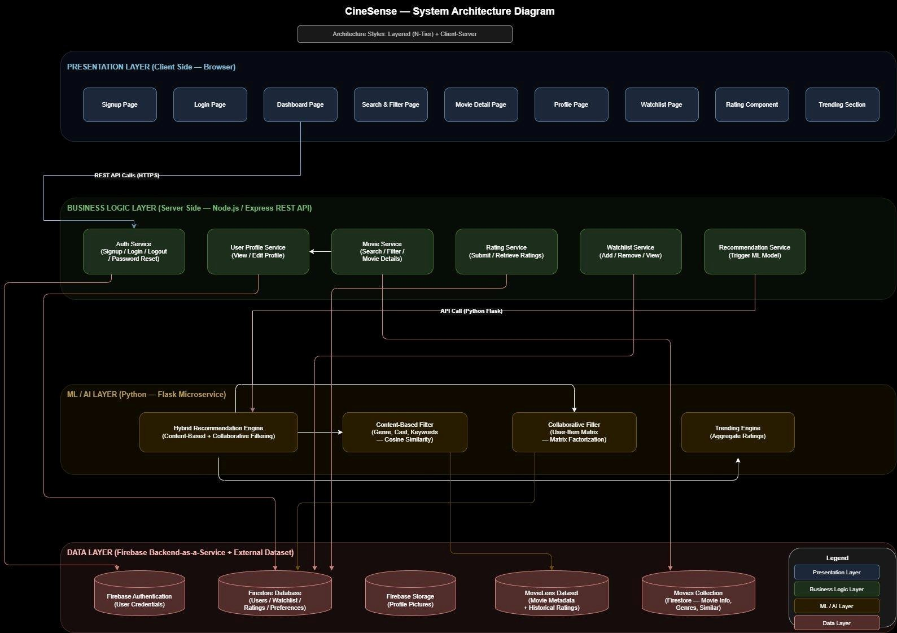
Figure 1: CineSense System Architecture Diagram

4.2 Component Diagram
UML ball-and-socket (lollipop) notation. Four subsystems: Frontend (React.js), Backend (Node.js/Express), ML Microservice (Python/Flask), Firebase BaaS + Dataset.
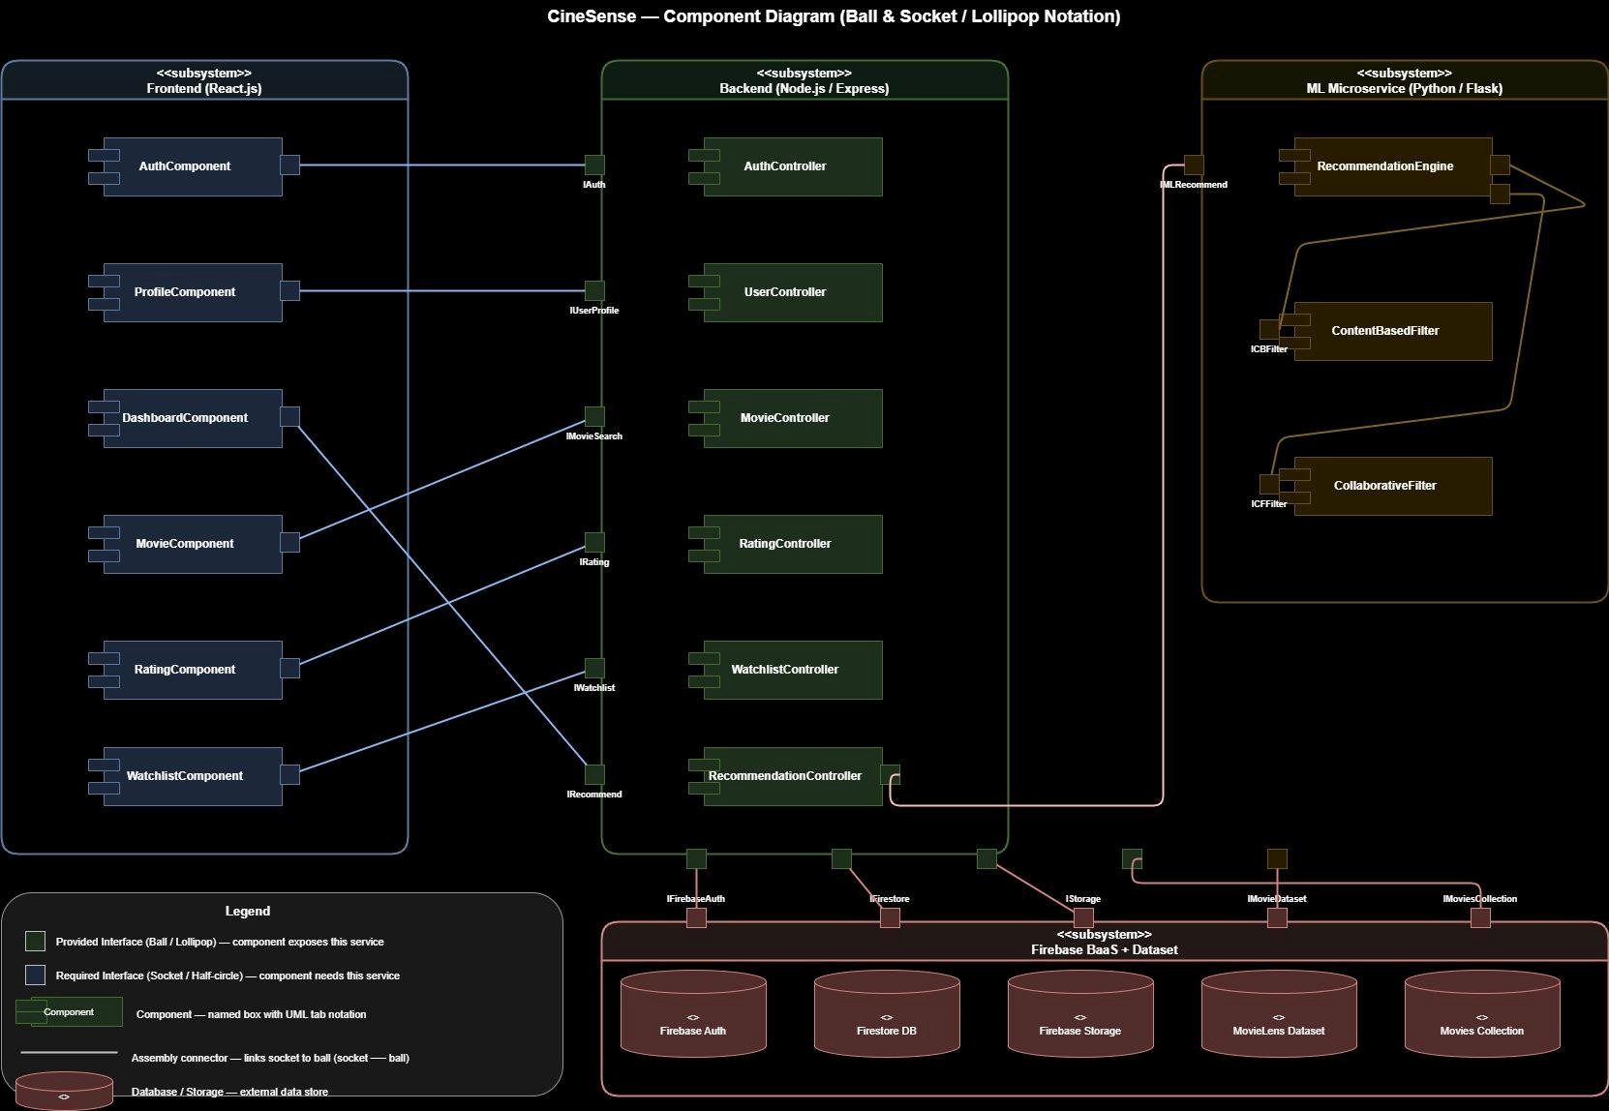
Figure 2: Component Diagram (Ball & Socket)

4.3 Data Flow Diagrams

4.3.1 Level 0 — Context Diagram
CineSense as a single process interacting with four external entities: User, Firebase BaaS, ML Microservice, and MovieLens Dataset.
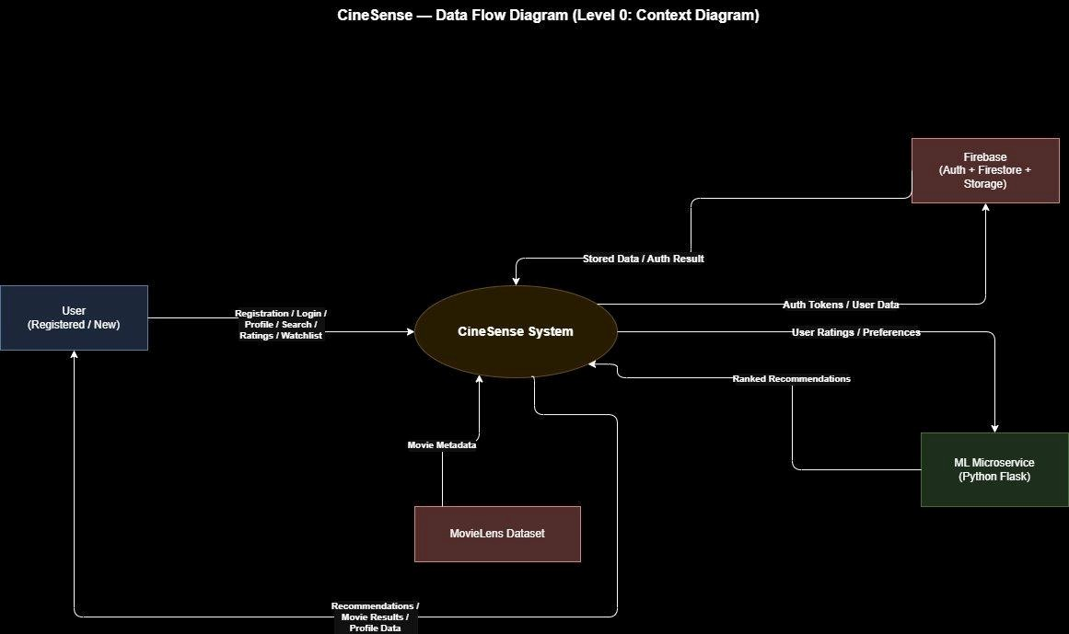
Figure 3: DFD Level 0 — Context Diagram

4.3.2 Level 1 — System Processes
Decomposes CineSense into six processes: P1 User Auth, P2 Profile Management, P3 Movie Search & Filter, P4 Rating & Feedback, P5 Recommendation Generation, P6 Watchlist Management.
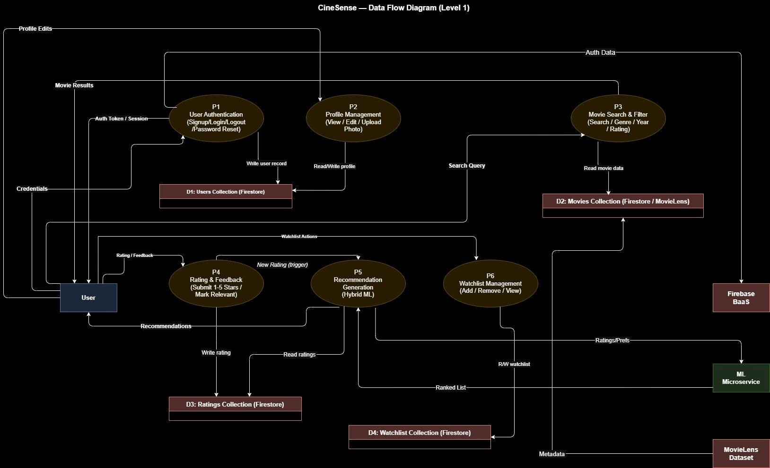
Figure 4: DFD Level 1 — System Processes

4.3.3 Level 2 — Recommendation Generation (P5)
P5 exploded into: P5.1 Fetch Ratings, P5.2 Content-Based Filtering (TF-IDF cosine similarity), P5.3 Collaborative Filtering (matrix factorization), P5.4 Score Aggregation (weighted hybrid), P5.5 Rank & Filter Top-N.

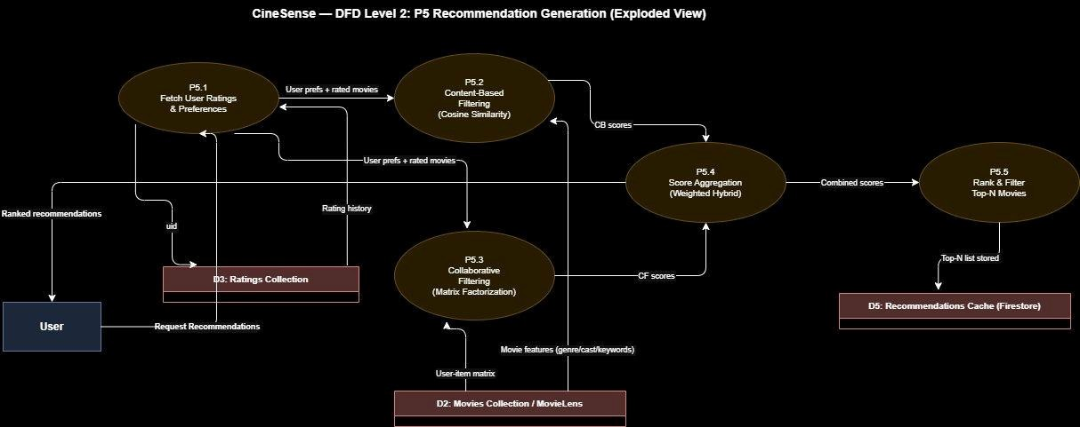
Figure 5: DFD Level 2 — Recommendation Generation (Exploded)

4.4 Activity Diagrams

4.4.1 User Registration (Signup)

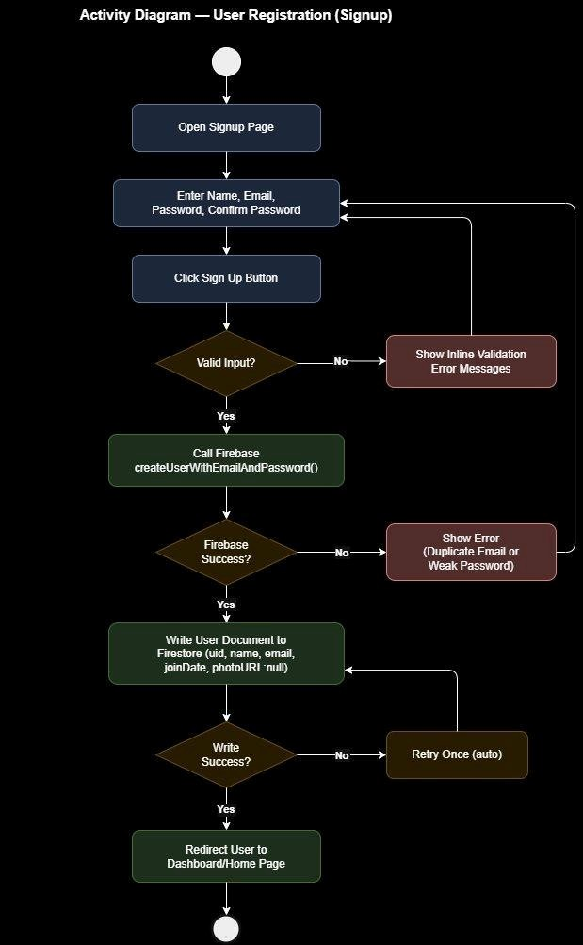
Figure 6: Activity — User Registration

4.4.2 Rate a Movie & Recommendation Trigger

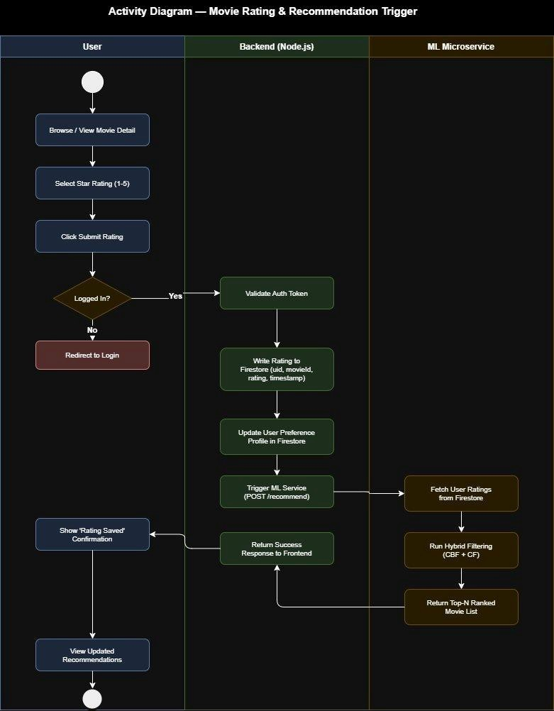
Figure 7: Activity — Movie Rating & Recommendation Trigger (Swimlane)

4.4.3 View Personalized Recommendations (Dashboard)

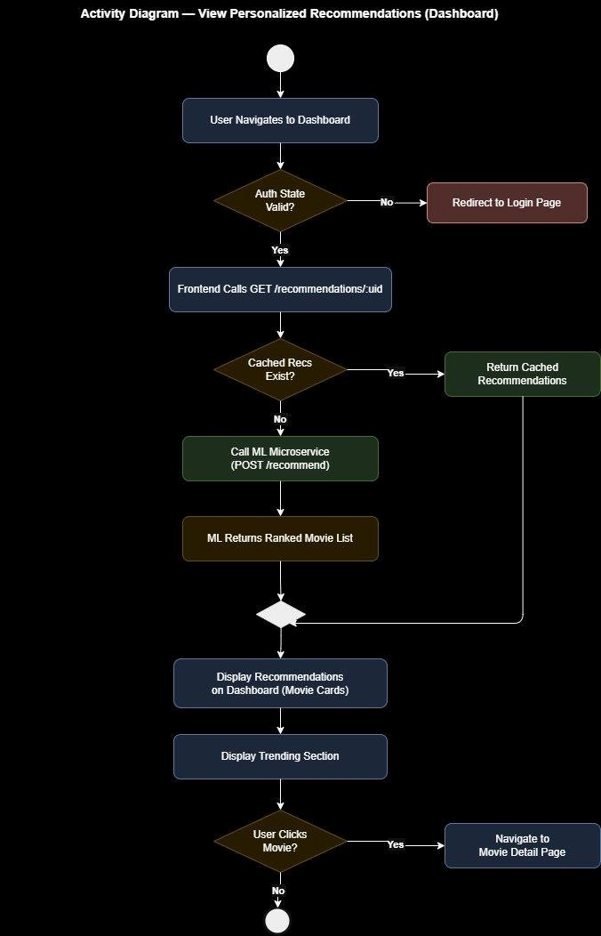
Figure 8: Activity — View Personalized Recommendations

4.5 Use Case Diagram
Actors: Guest User, Registered User (generalization of Guest), ML Microservice, Firebase BaaS. Key relationships: <<include>> (View Recommendations includes Generate Recommendations), <<extend>> (Filter Movies extends Search Movies).

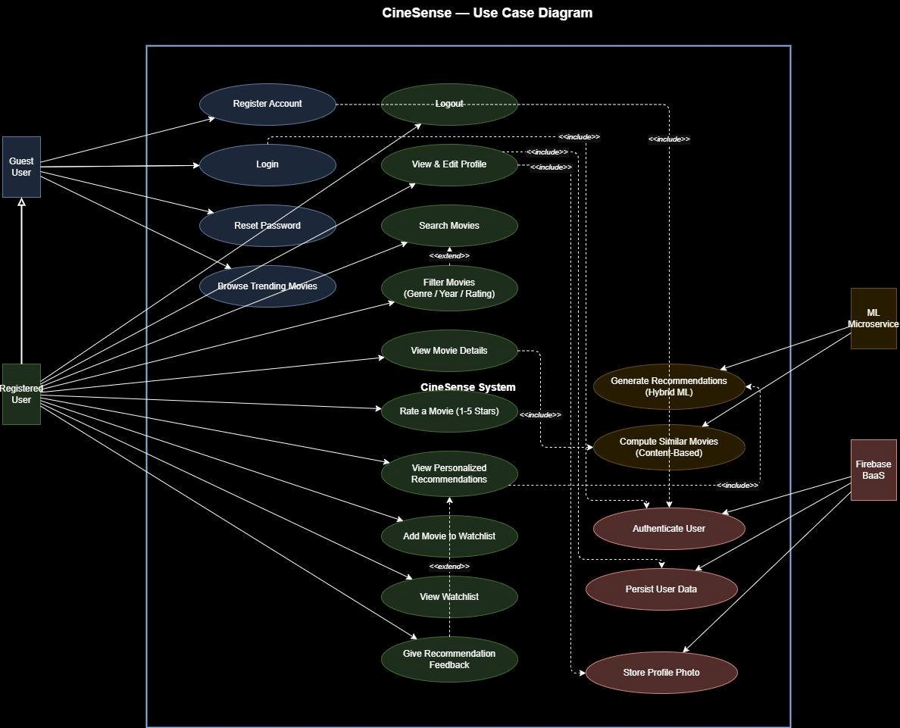
Figure 9: Use Case Diagram

4.6 Sequence Diagrams

4.6.1 User Login

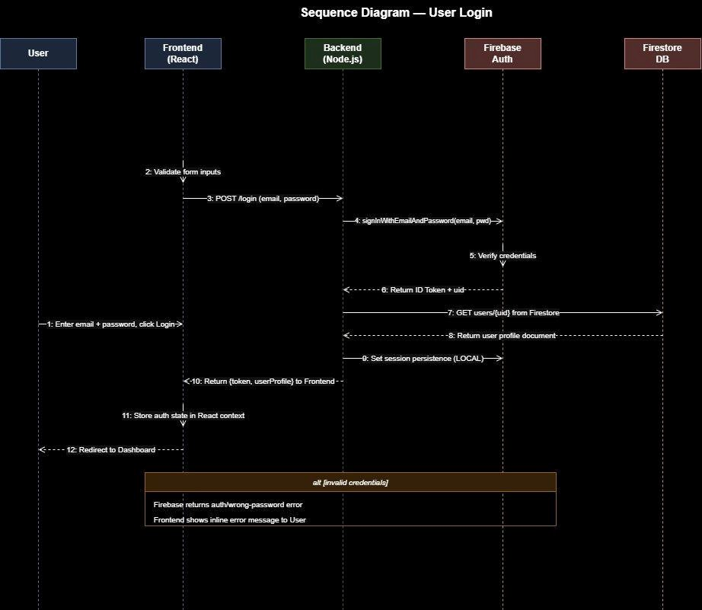
Figure 10: Sequence — User Login

4.6.2 Rate a Movie & Trigger Recommendation Update

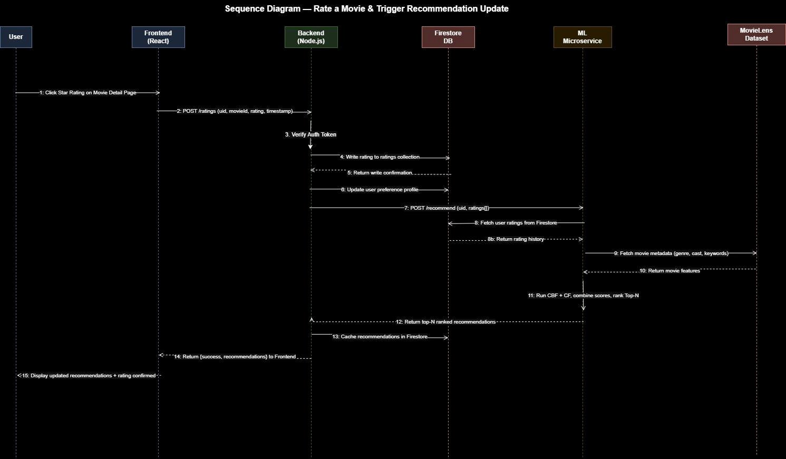
Figure 11: Sequence — Rate a Movie & Recommendation Update

4.6.3 View Personalized Recommendations (Dashboard Load)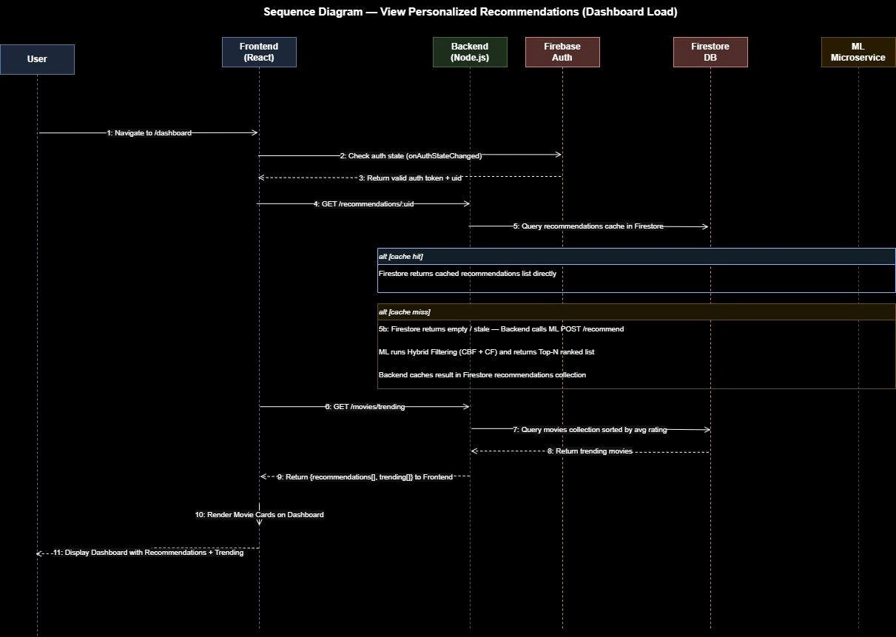
Figure 12: Sequence — Dashboard Load (Recommendations)

4.7 Class Diagram
Eight core classes: User, Movie, Rating, Watchlist, Recommendation, RecommendationEngine, Feedback, AuthService. Relationships: association (User submits Rating), aggregation (Watchlist contains Movies), dependency (Recommendation uses RecommendationEngine).

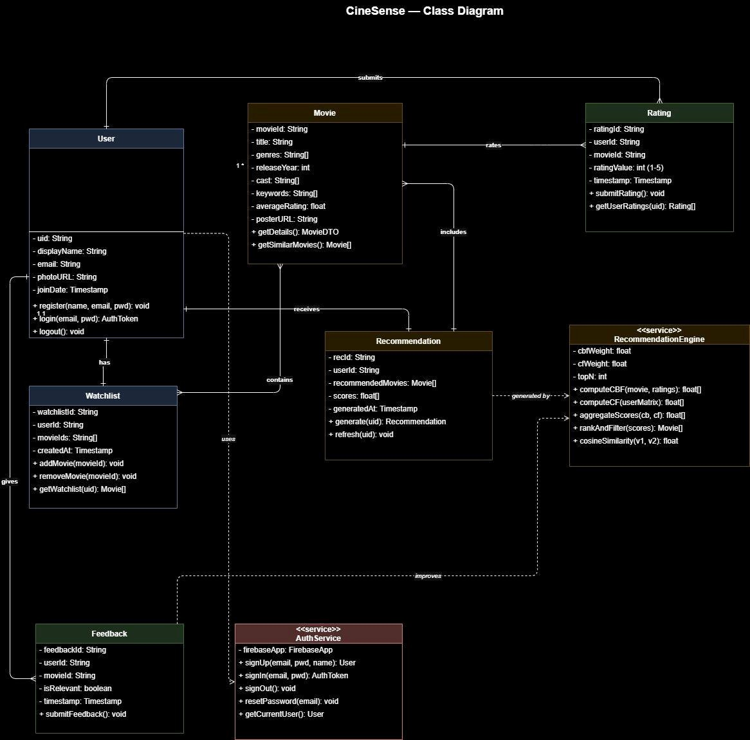
Figure 13: Class Diagram

5. Architecture

5.1 Architecture Pattern
CineSense uses Layered (N-Tier) Architecture as the primary pattern, augmented with Client-Server style. The four layers are:
- Presentation Layer — React.js SPA: UI rendering, React Router, React Context for state management.
- Business Logic Layer — Node.js/Express REST API: auth middleware, request validation, Firestore orchestration, ML microservice triggering.
- ML/AI Layer — Python/Flask microservice: hybrid CBF + CF engine, POST /recommend endpoint, cosine similarity for similar-movie suggestions.
- Data Layer — Firebase BaaS (Auth + Firestore + Storage) and MovieLens dataset loaded into the Firestore movies collection.

5.2 Architecture Diagram (Sprint 3 — Full System)


Figure 14: Full System Architecture (Sprint 3)

5.3 Rationale
The Layered style was chosen because it enforces strict separation of concerns — the ML model can be developed, tested, and scaled independently of the React frontend. Each layer communicates only with the layer directly below it, improving testability and maintainability. The Client-Server style complements this by defining clear communication boundaries via REST APIs over HTTPS, enabling horizontal scaling and easier debugging.

6. Actual Implementation Screenshots

6.1 Authentication — Sprint 1

6.1.1 Login Page
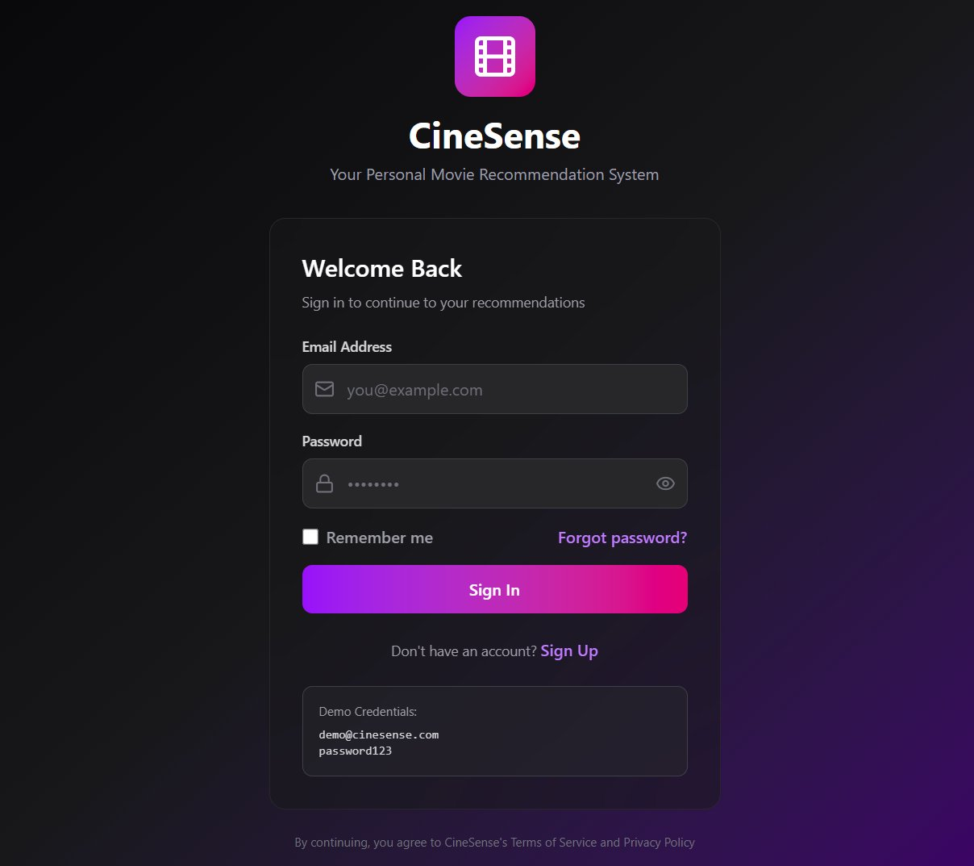

6.1.2 Signup / Registration Page
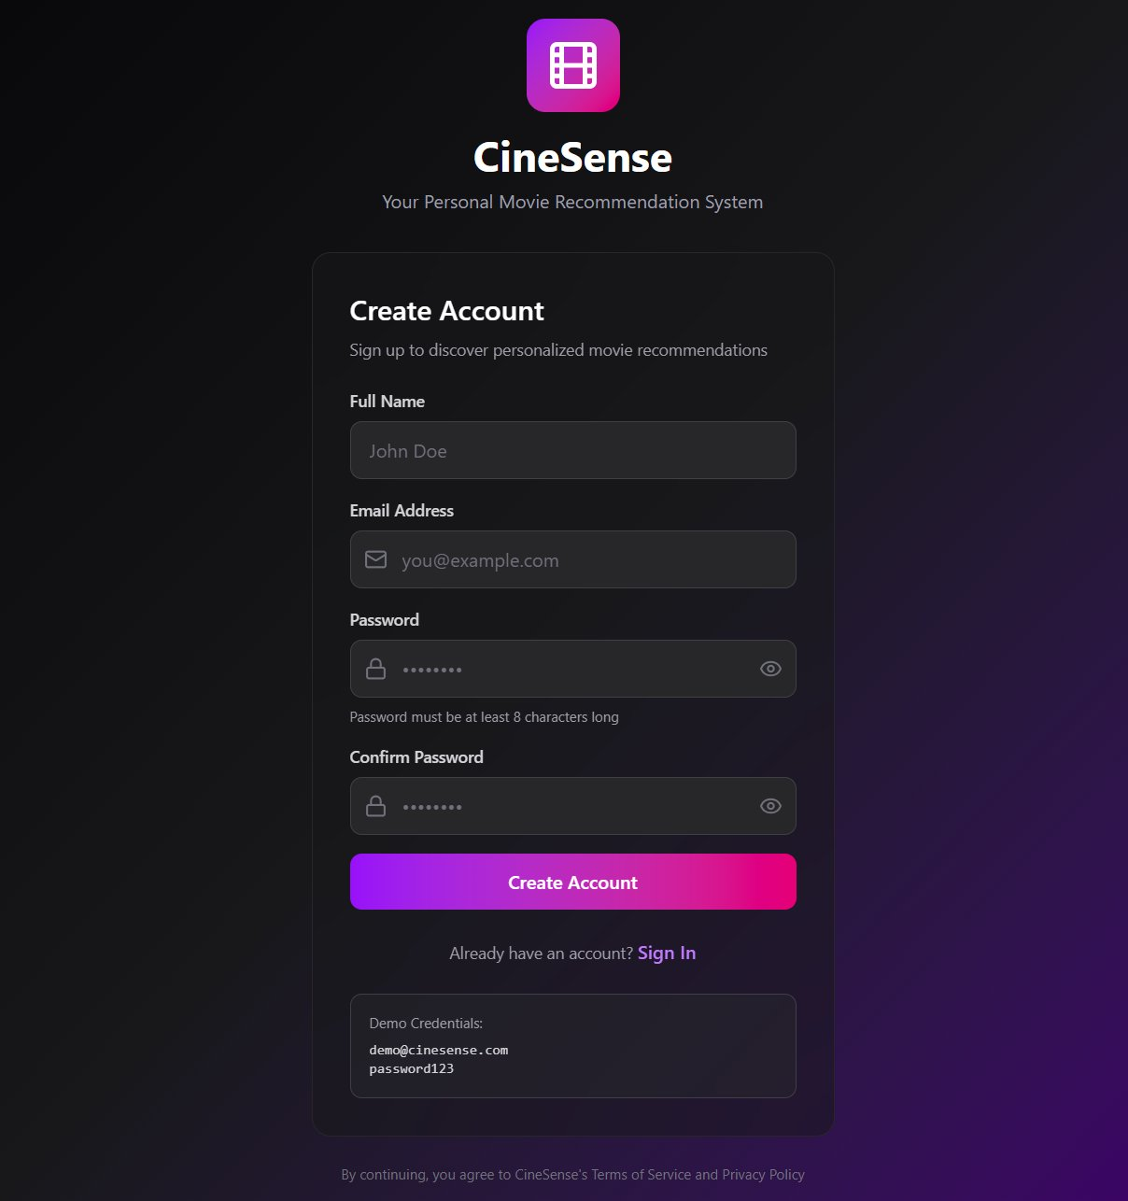

6.1.3 Password Reset
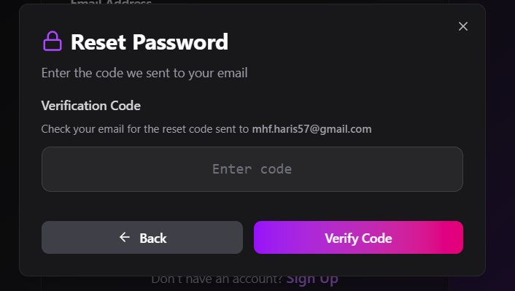
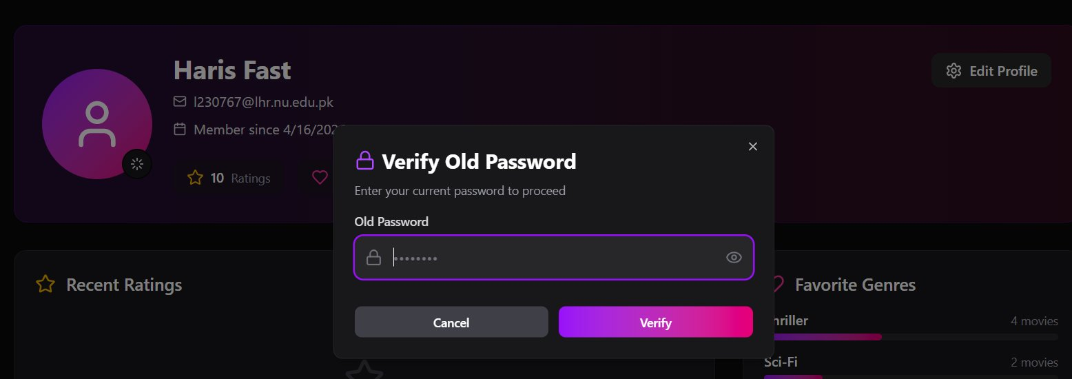
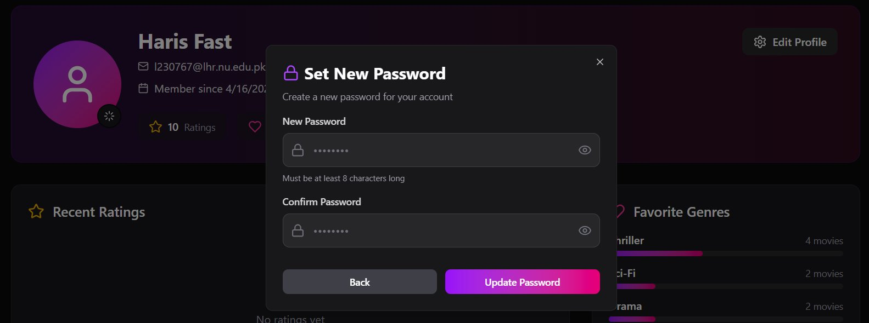

6.1.4 User Profile
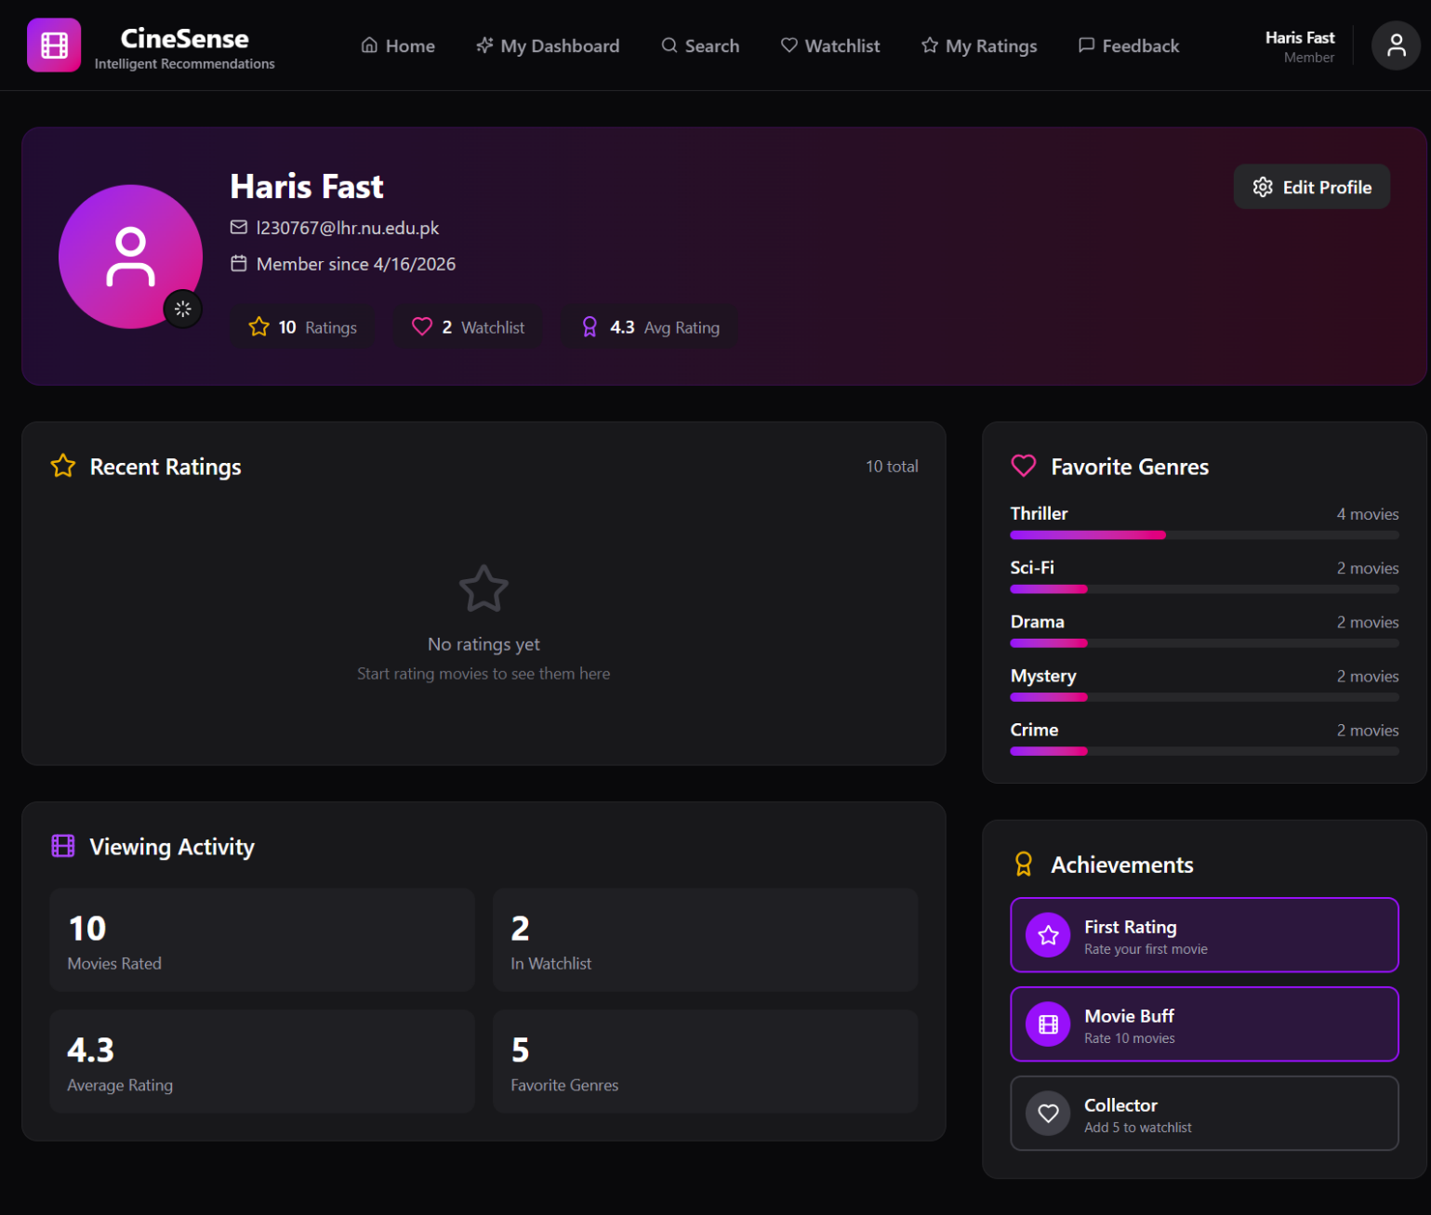

6.2 Core Movie Features — Sprint 2

6.2.1 Home Dashboard
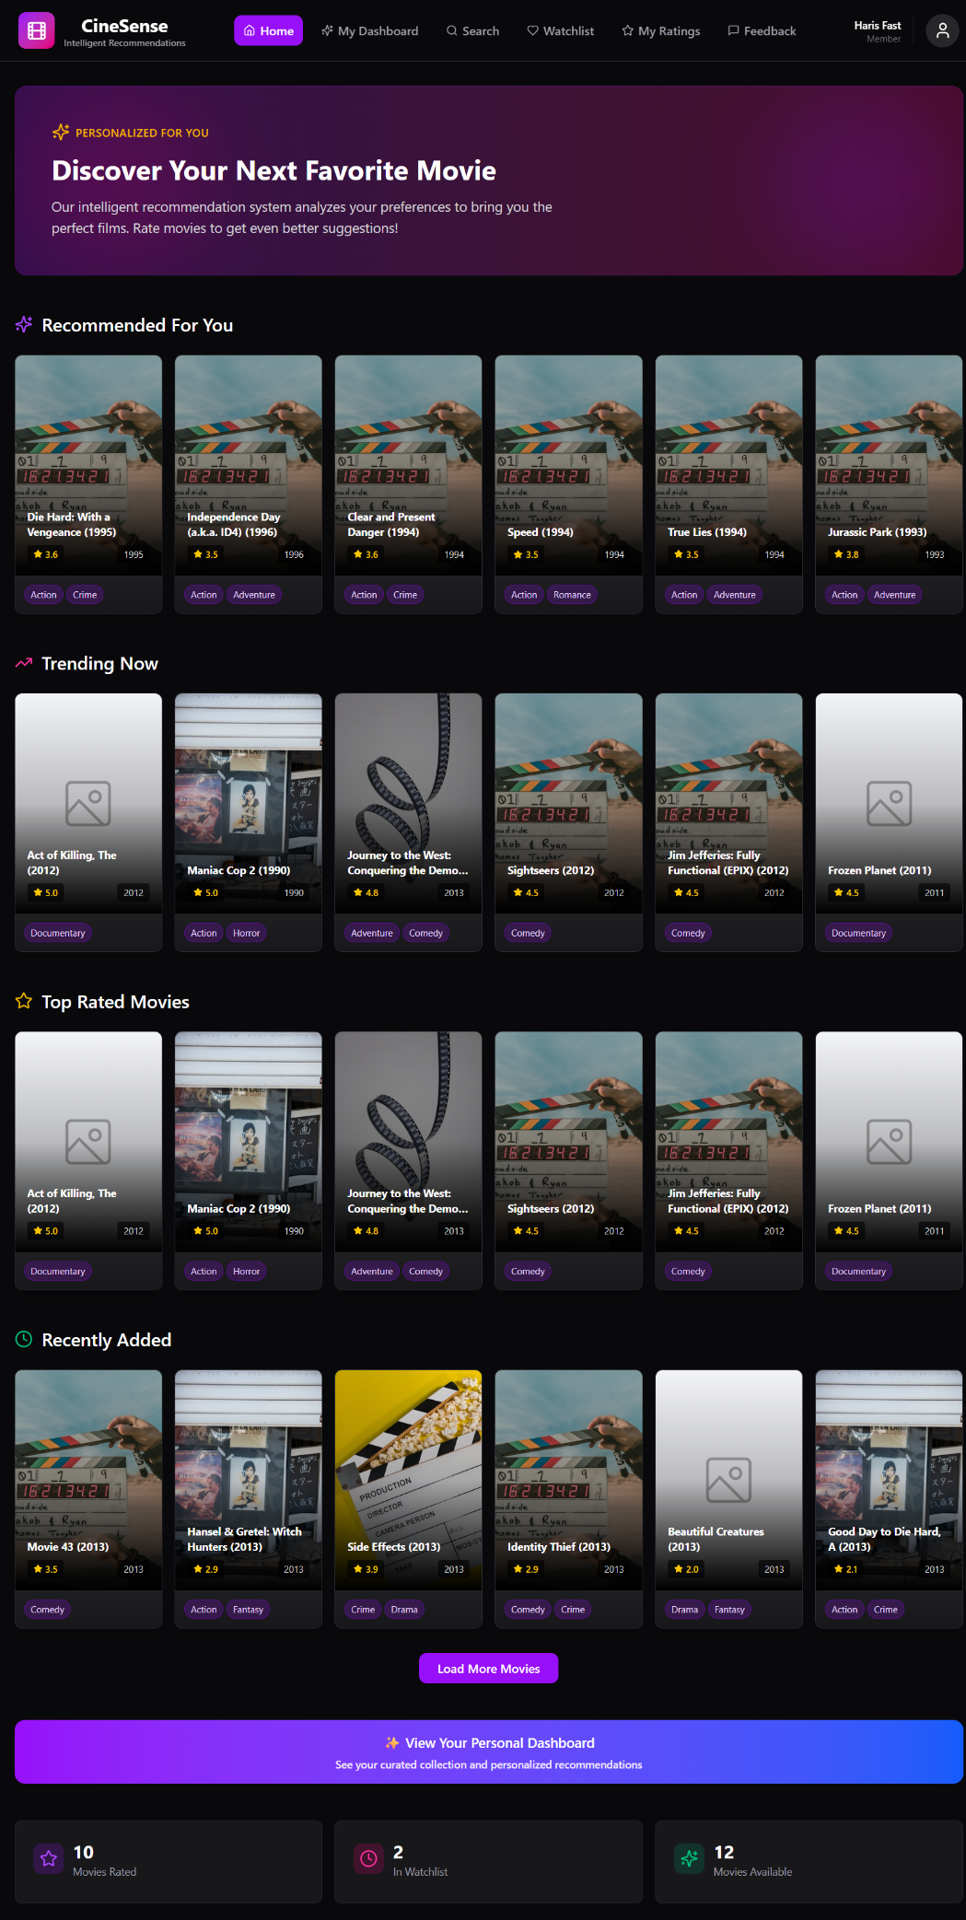

6.2.2 Movie Search & Filtering (US-06)
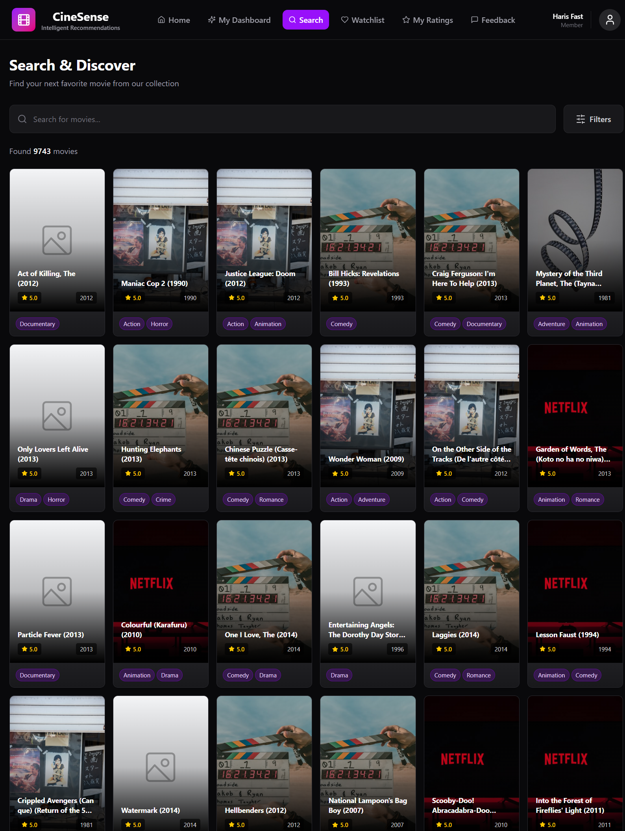
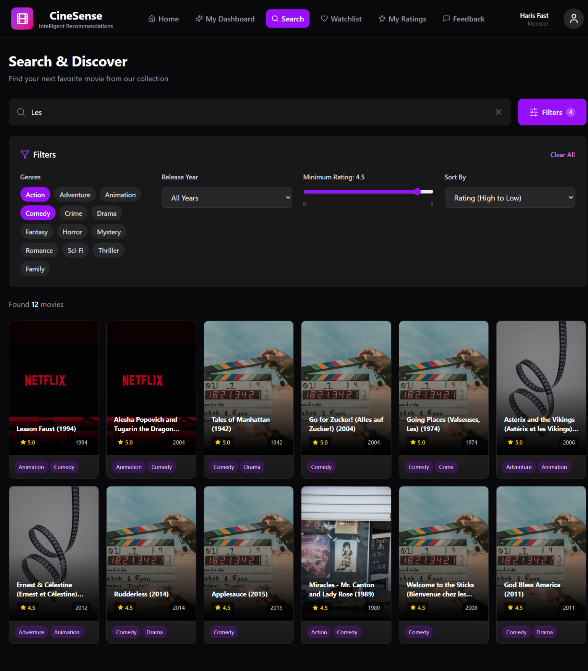

6.2.3 Movie Details Page (US-07)
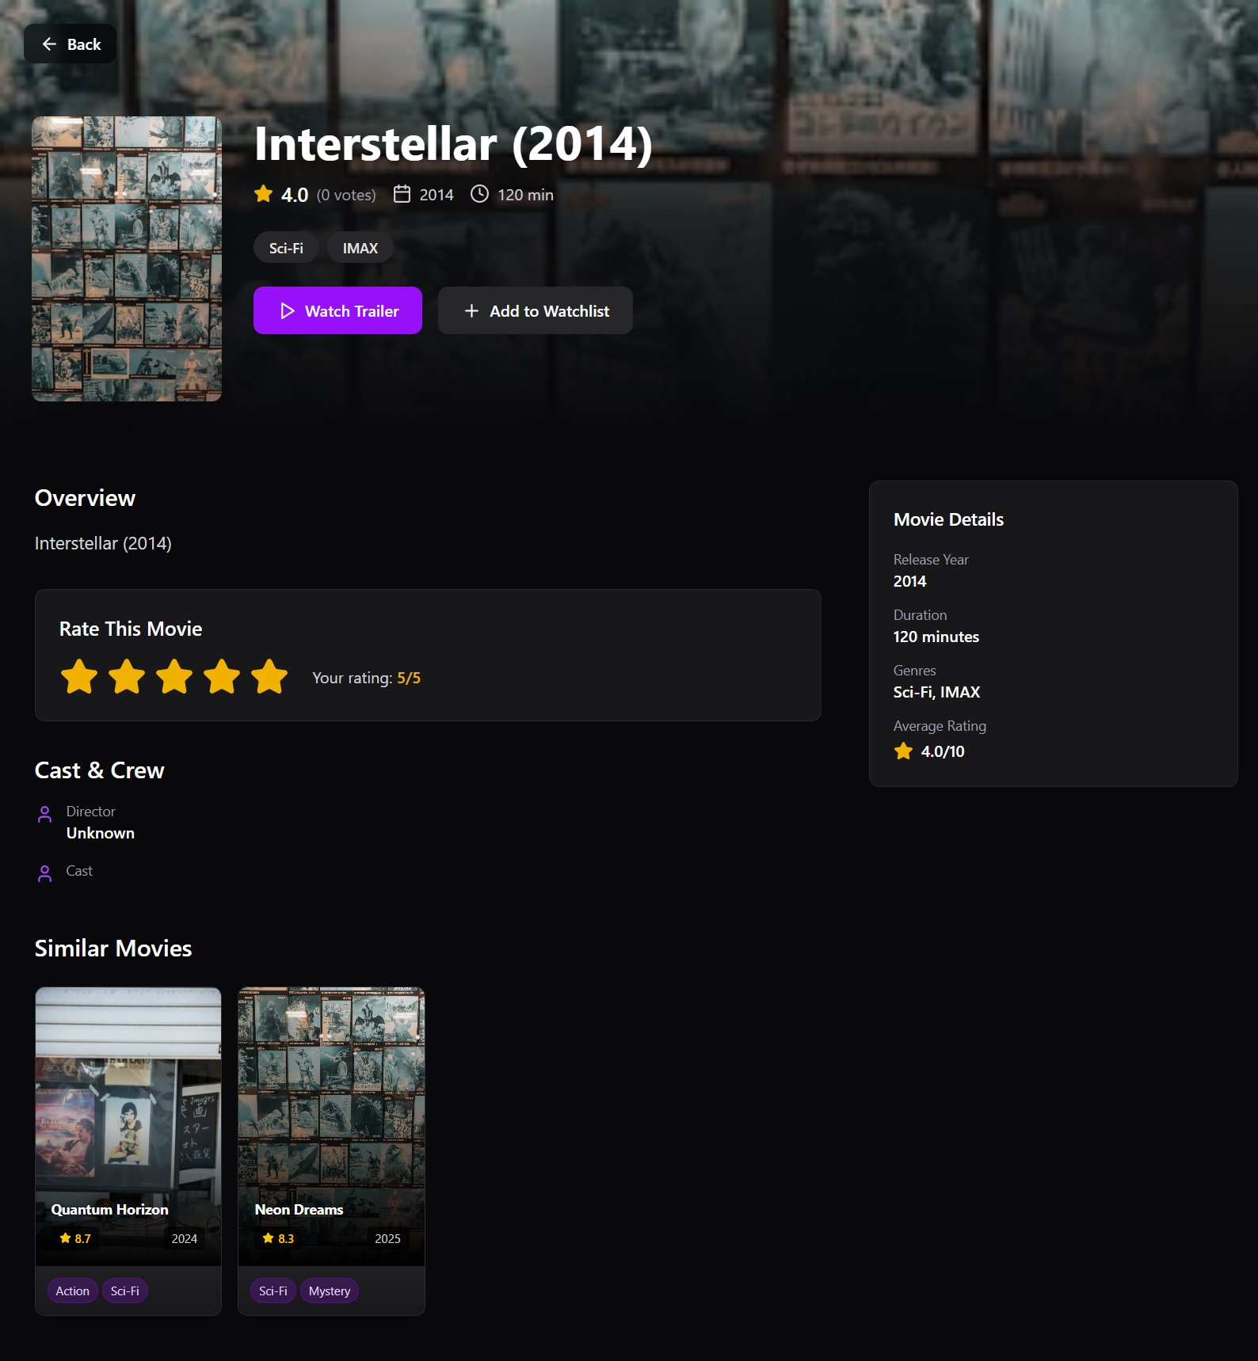

6.2.4 Rate a Movie Widget (US-08)
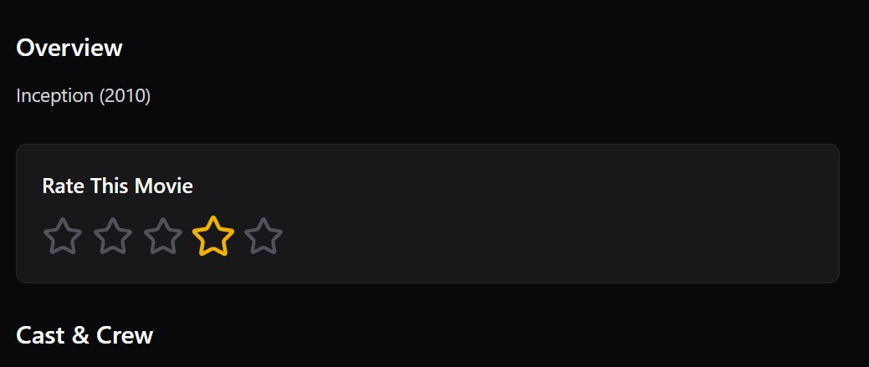

6.2.5 Personalized Dashboard (US-09)
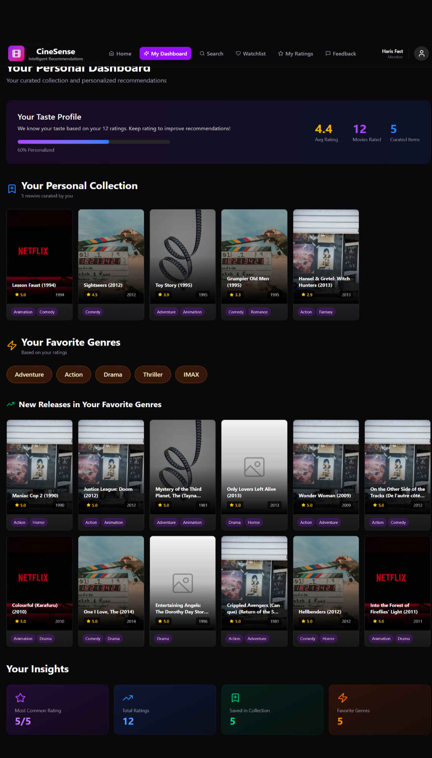

6.2.6 Trending Movies (US-11)
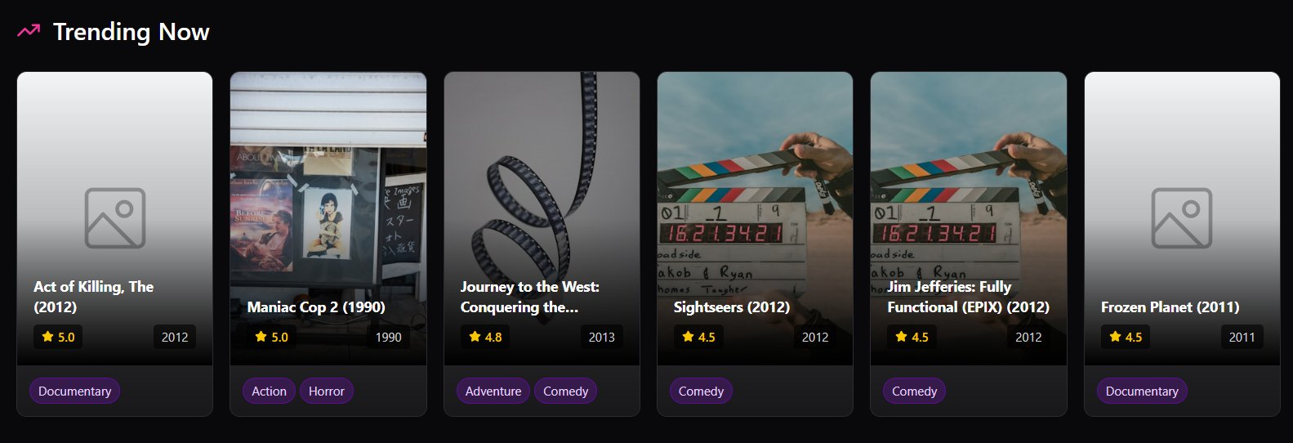

6.2.7 Watchlist Page (US-12)
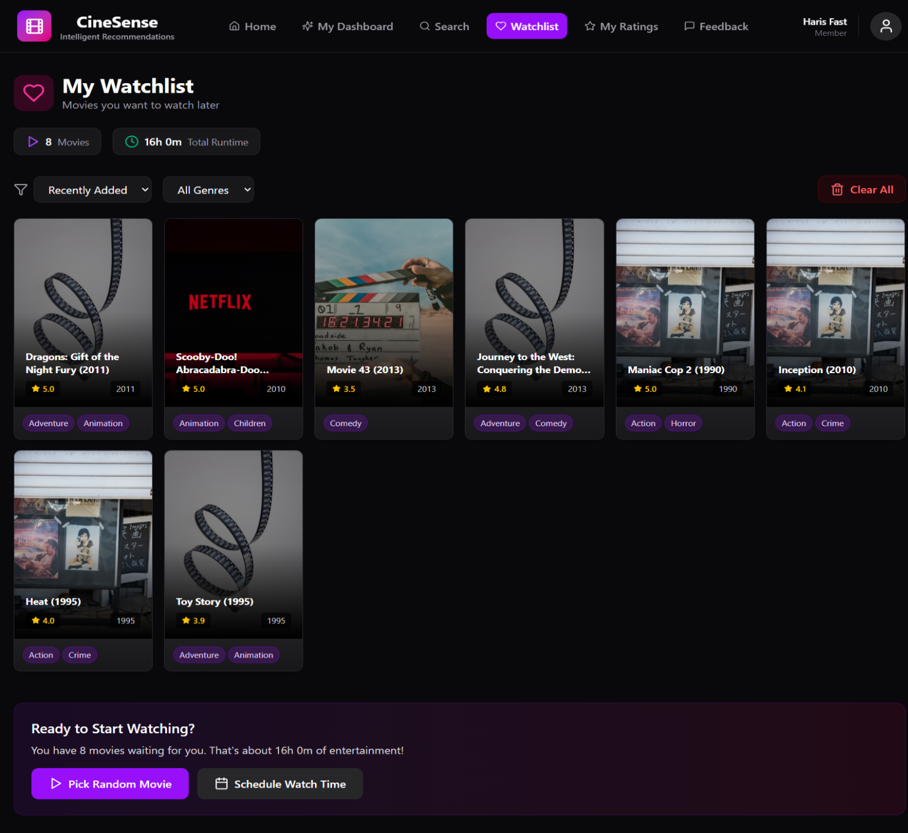

6.2.8 Feedback System (US-15)
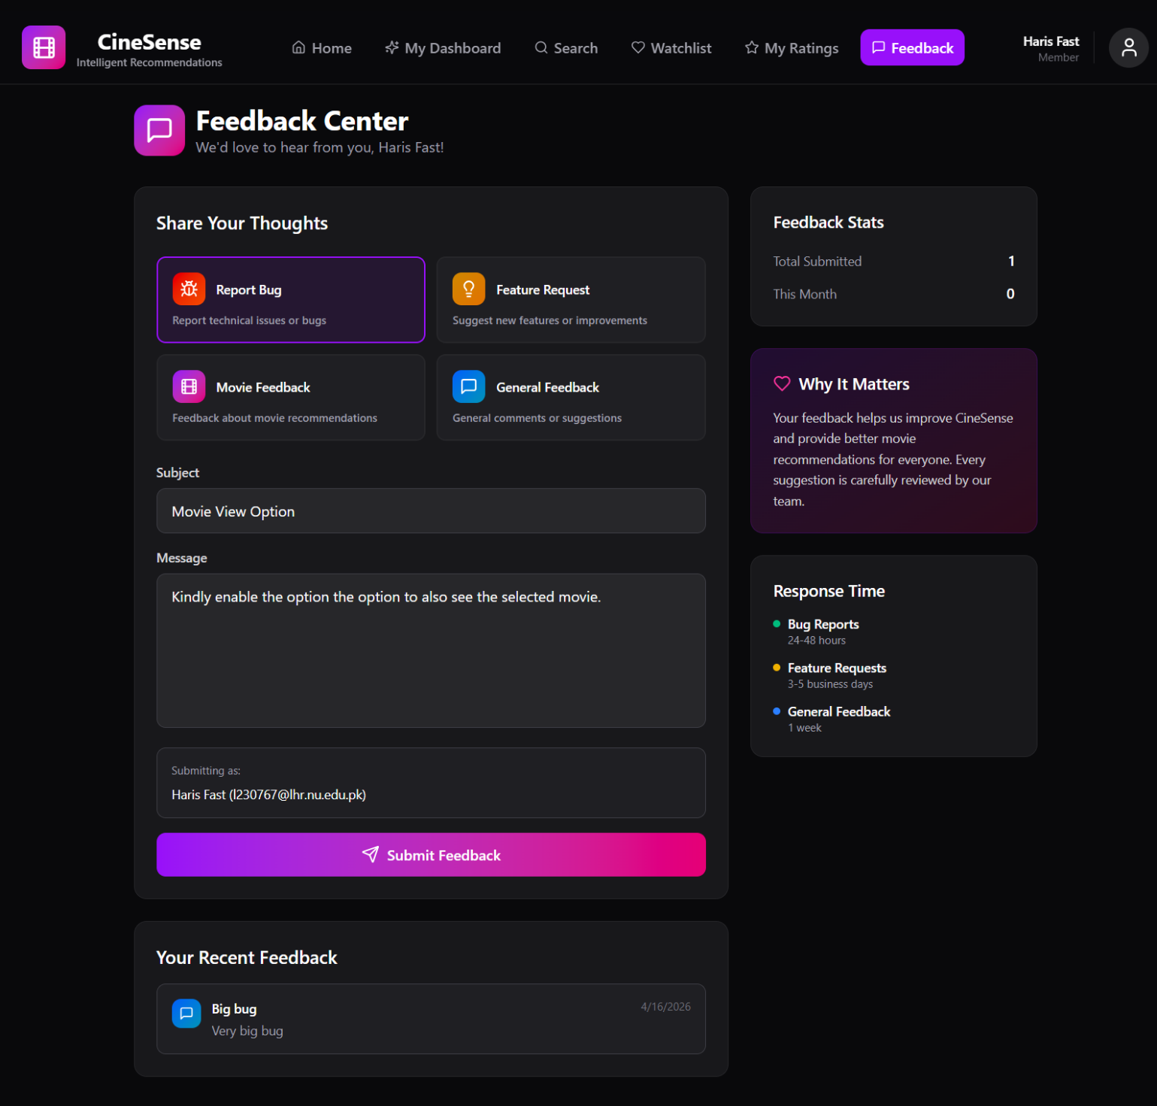

6.3 AI/ML Features — Sprint 3

6.3.1 Personalized AI Recommendations (US-14)
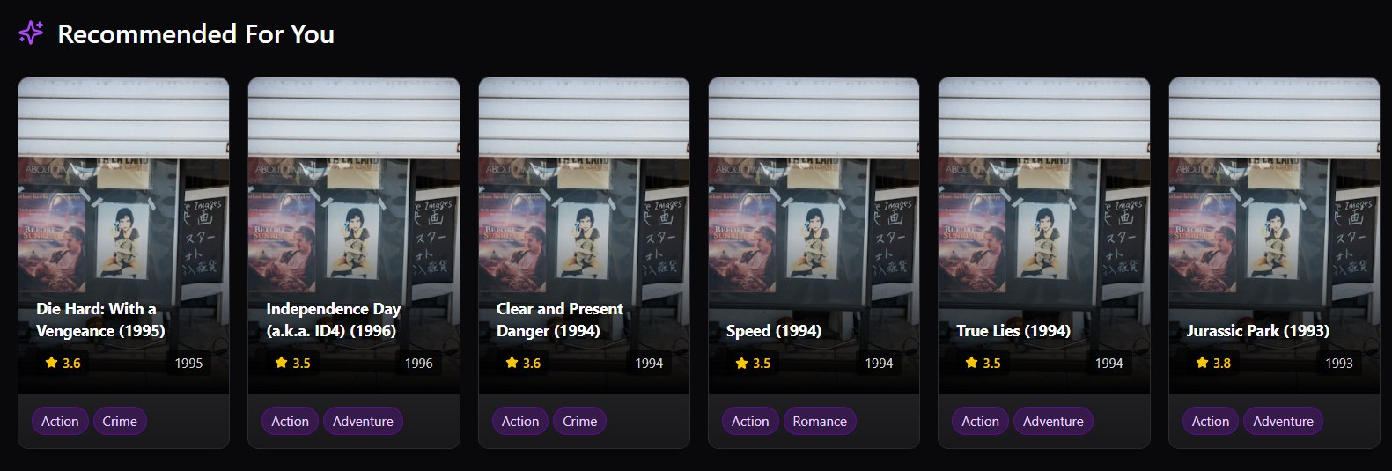

6.3.2 Similar Movies via CBF (US-10)
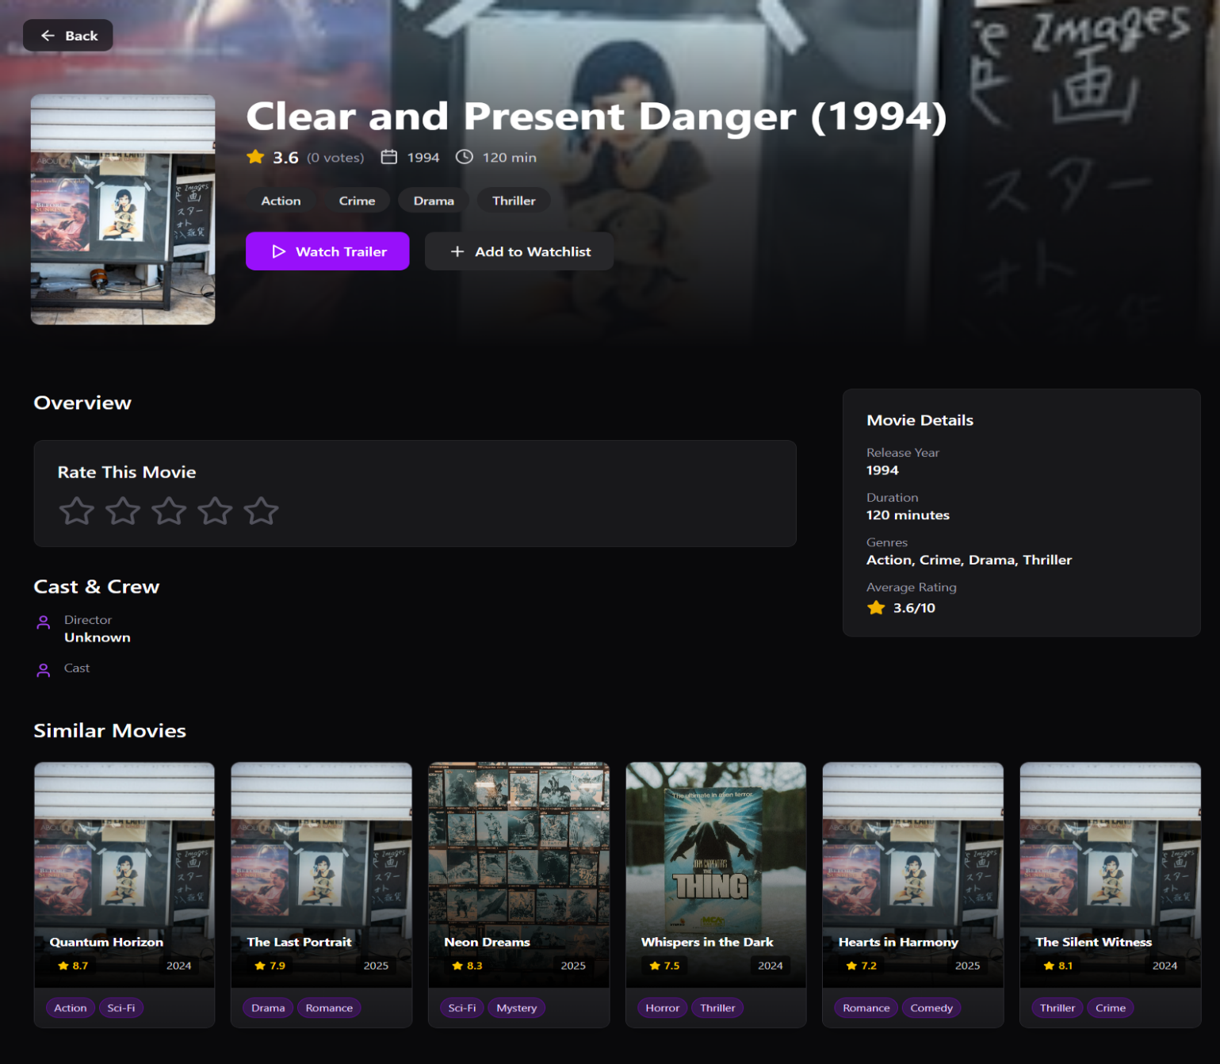

7. Product Burndown Chart
Total planned effort: 82 hours across 17 user stories over 3 sprints. All stories were completed.

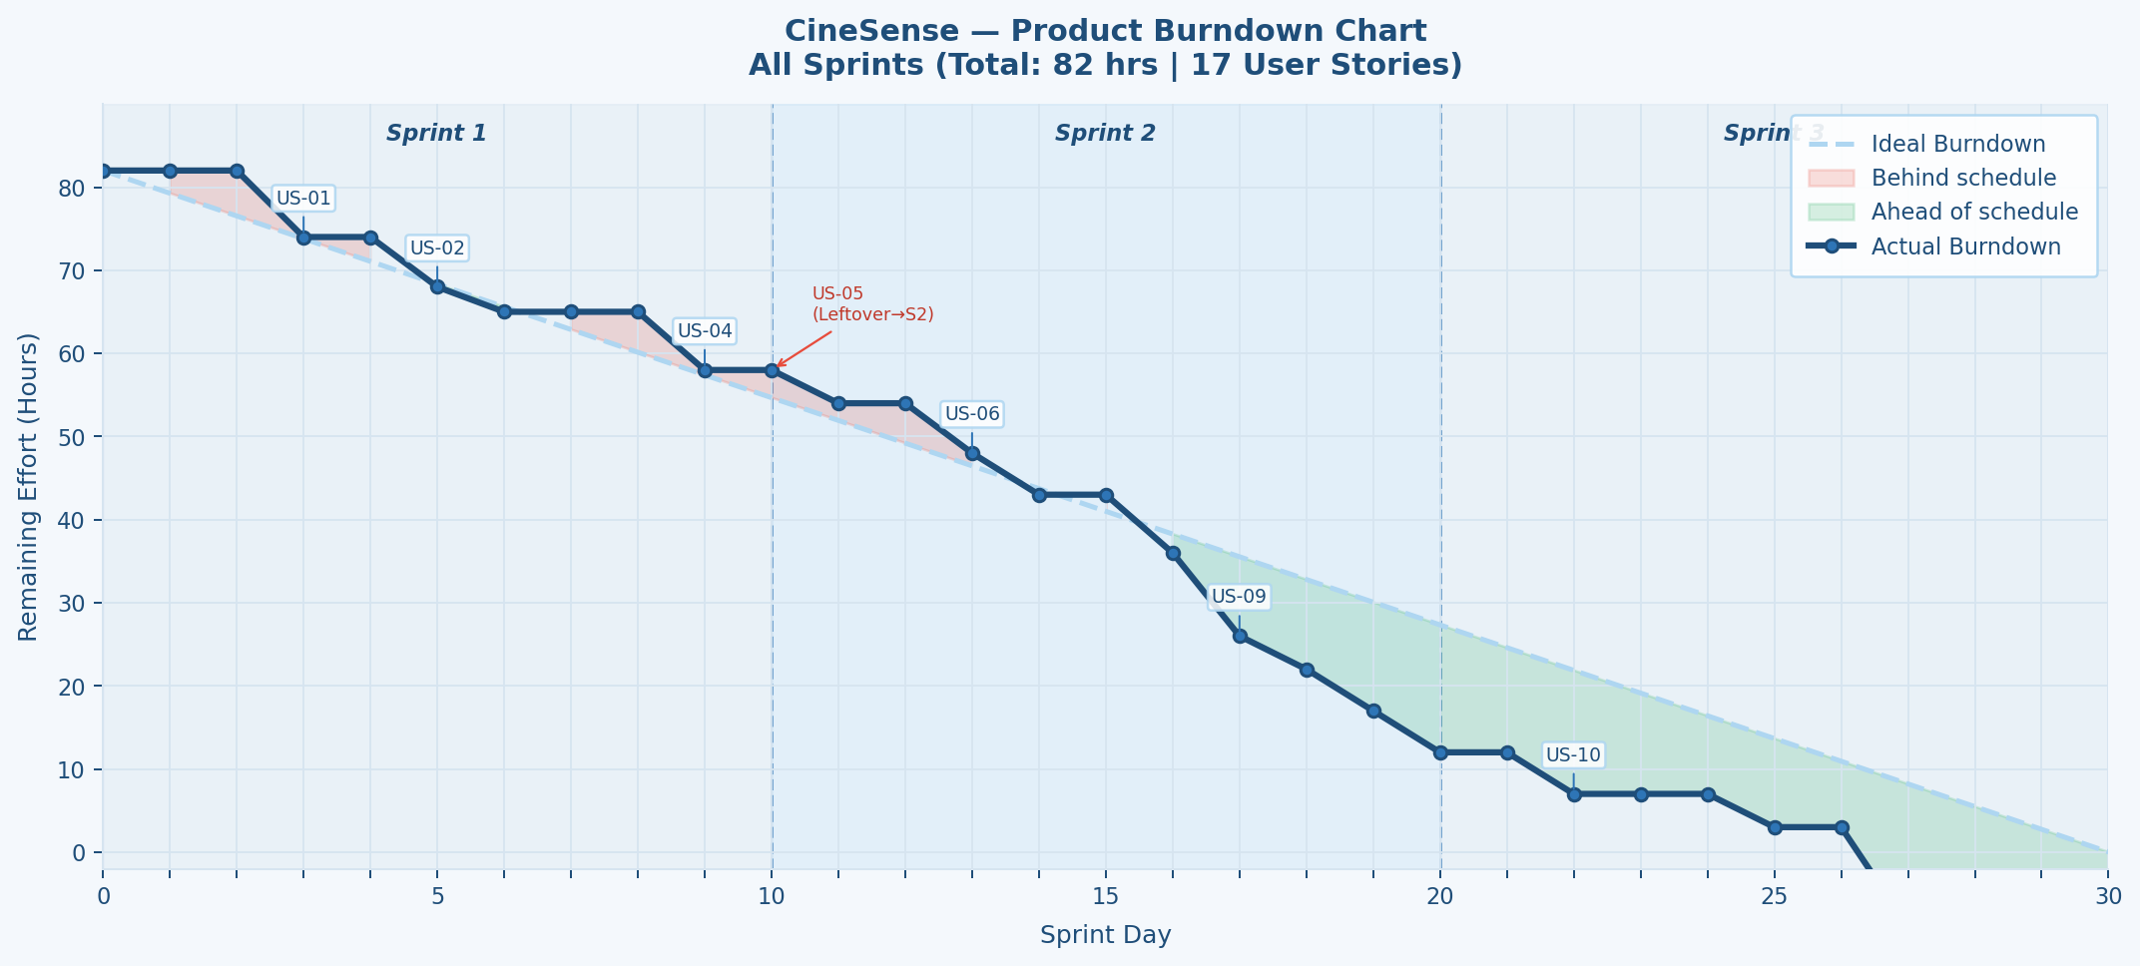
Figure 15: Product Burndown Chart — All 3 Sprints (82 hrs total)

Story ID | Story | Sprint | Est. Hours | Status
US-01 | User Registration | Sprint 1 | 8 hrs | ✓ Done
US-02 | User Login | Sprint 1 | 6 hrs | ✓ Done
US-03 | User Logout | Sprint 1 | 3 hrs | ✓ Done
US-04 | View and Edit Profile | Sprint 1 | 7 hrs | ✓ Done
US-05 | Password Reset | Sprint 1→2 | 4 hrs | ✓ Done
US-06 | Movie Search & Filtering | Sprint 2 | 6 hrs | ✓ Done
US-07 | Movie Details Page | Sprint 2 | 5 hrs | ✓ Done
US-08 | Rate a Movie | Sprint 2 | 7 hrs | ✓ Done
US-09 | Personalized Dashboard (Manual) | Sprint 2 | 10 hrs | ✓ Done
US-11 | Trending Movies Section | Sprint 2 | 4 hrs | ✓ Done
US-12 | Add Movie to Watchlist | Sprint 2 | 5 hrs | ✓ Done
US-15 | Feedback System | Sprint 2 | 5 hrs | ✓ Done
US-10 | Similar Movies (CBF) | Sprint 3 | 5 hrs | ✓ Done
US-13 | Feedback → ML Re-ranking | Sprint 3 | 4 hrs | ✓ Done
US-14 | AI Recommendations (Hybrid ML) | Sprint 3 | 12 hrs | ✓ Done
US-16 | Performance & UI Polish | Sprint 3 | 6 hrs | ✓ Done
US-17 | Integration Testing & BVA | Sprint 3 | 5 hrs | ✓ Done

8. Trello Board Screenshots

8.1 Start of Sprint 3
All Sprint 3 stories (US-10, US-13, US-14, US-16, US-17) placed in Sprint 3 Backlog. In Progress, Done, and Leftover columns empty.
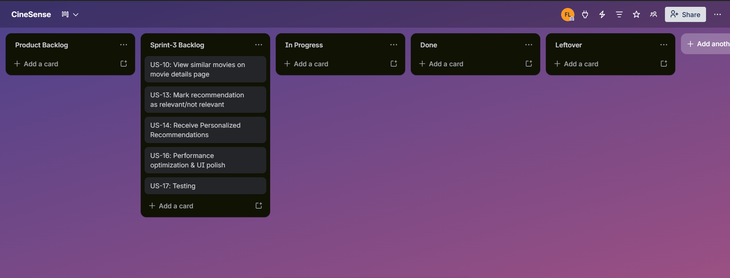
Figure 16: Sprint 3 Start — All Stories in Backlog

8.2 Midpoint of Sprint 3
US-10 (Similar Movies) and US-16 (Performance & UI Polish) completed and moved to Done. US-14 (AI Recommendations) and US-13 (Feedback ML Re-ranking) currently In Progress. US-17 (Integration Testing) in backlog.
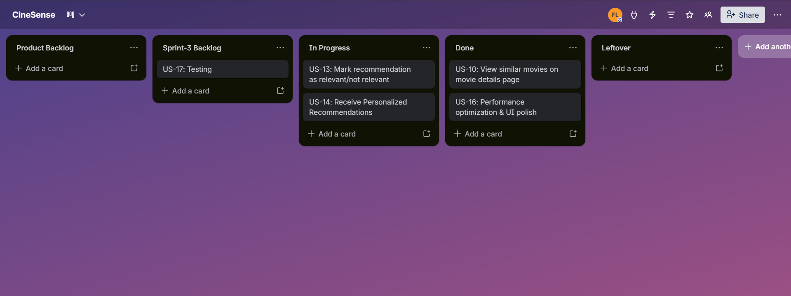
Figure 17: Sprint 3 Midpoint

8.3 End of Sprint 3
All Sprint 3 stories completed. No stories in Leftover — all sprint goals achieved.
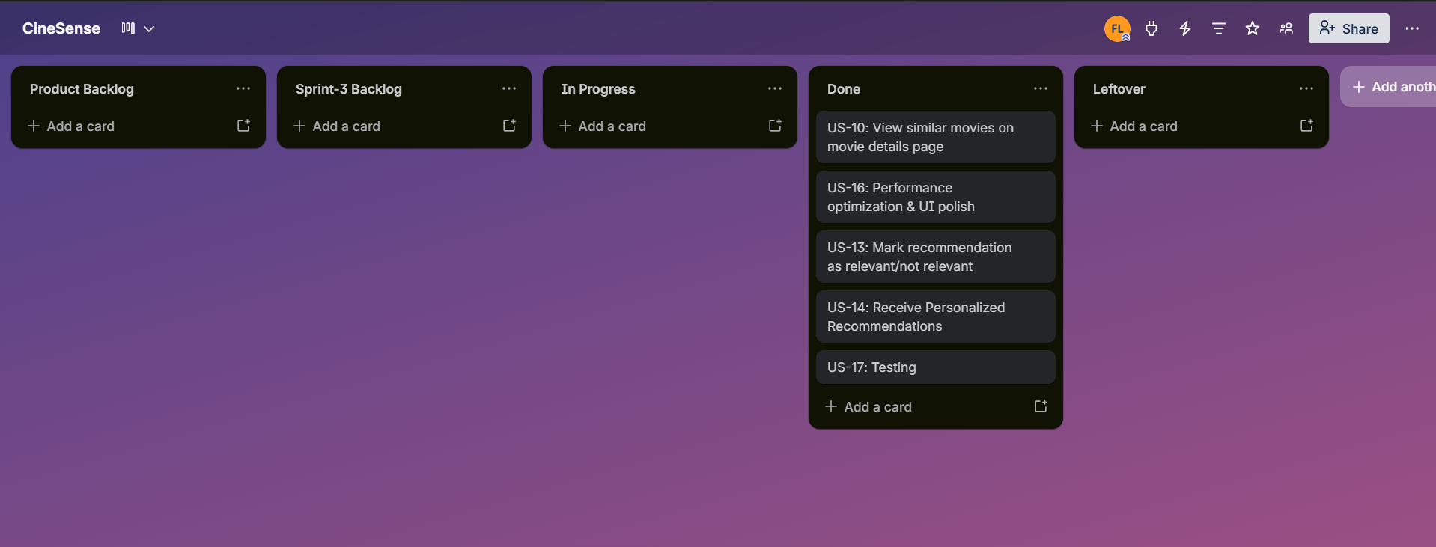
Figure 18: Sprint 3 End — All Stories Done

9. Boundary Value Analysis Testing
BVA testing is performed on the Signup and Login interfaces. Tests exercise boundaries at minimum, just-below, just-above, and maximum values.

9.1 Signup Interface

9.1.1 Full Name (Min: 2 chars, Max: 50 chars)
TC | Input Value | Chars | Expected Result | Pass/Fail
TC-S-01 | (empty) | 0 | Error: Name required | Pass
TC-S-02 | A | 1 | Error: Name too short | Pass
TC-S-03 | Ab | 2 | Valid: minimum accepted | Pass
TC-S-04 | Abc | 3 | Valid: just above minimum | Pass
TC-S-05 | A × 50 | 50 | Valid: maximum accepted | Pass
TC-S-06 | A × 49 | 49 | Valid: just below maximum | Pass
TC-S-07 | A × 51 | 51 | Error: Name too long | Pass

9.1.2 Email Field
TC | Input Value | Condition | Expected Result | Pass/Fail
TC-S-08 | (empty) | Empty | Error: Email required | Pass
TC-S-09 | abc | No @ symbol | Invalid format error | Pass
TC-S-10 | abc@ | Missing domain | Invalid format error | Pass
TC-S-11 | abc@d.c | Minimum valid format | Valid email accepted | Pass
TC-S-12 | user@example.com | Standard valid format | Valid email accepted | Pass
TC-S-13 | existing@email.com | Already registered | Error: Email in use | Pass

9.1.3 Password Field (Min: 8 chars)
TC | Input Value | Chars | Expected Result | Pass/Fail
TC-S-14 | (empty) | 0 | Error: Password required | Pass
TC-S-15 | Pass12 | 6 | Error: Too short (min 8) | Pass
TC-S-16 | Pass123 | 7 | Error: Too short (min 8) | Pass
TC-S-17 | Pass1234 | 8 | Valid: minimum accepted | Pass
TC-S-18 | Pass12345 | 9 | Valid: just above minimum | Pass
TC-S-19 | P × 100 | 100 | Valid: long password accepted | Pass

9.1.4 Confirm Password Field
TC | Input Value | Condition | Expected Result | Pass/Fail
TC-S-20 | (empty) | Empty | Error: Field required | Pass
TC-S-21 | Pass1233 | Does not match | Error: Passwords do not match | Pass
TC-S-22 | Pass1234 | Matches exactly | Valid: passwords match | Pass

9.2 Login Interface

9.2.1 Email Field
TC | Input Value | Condition | Expected Result | Pass/Fail
TC-L-01 | (empty) | Empty | Error: Email required | Pass
TC-L-02 | wrongformat | No @ symbol | Invalid format error | Pass
TC-L-03 | notregistered@email.com | Not in Firebase | Error: No account found | Pass
TC-L-04 | registered@email.com | Valid registered email | Proceed to password check | Pass

9.2.2 Password Field
TC | Input Value | Chars | Expected Result | Pass/Fail
TC-L-05 | (empty) | 0 | Error: Password required | Pass
TC-L-06 | wrongpass | 9 | Error: Incorrect password | Pass
TC-L-07 | correctpassword | correct | Login successful; redirect to dashboard | Pass
TC-L-08 | P × 100 | 100 (wrong) | Error: Incorrect password | Pass

9.3 BVA Summary
- Total test cases: 22 (Signup: 18 across 4 fields; Login: 8 across 2 fields).
- All cases passed — both forms enforce minimum character limits and format checks client-side before any Firebase call.
- Password minimum boundary (8 chars) strictly enforced; 7-character inputs are rejected.
- Firebase error messages (duplicate email, wrong password) surfaced inline, never as browser alerts.

10. Work Division
Member | Responsibilities in Sprint 3
Haris Fayyaz 23L-0767 | - ML Microservice (Python/Flask): hybrid recommendation engine (CBF + CF)  - Content-Based Filtering: TF-IDF vectorization and cosine similarity for similar movies (US-10)  - Collaborative Filtering: matrix factorization using MovieLens rating matrix  - POST /recommend endpoint: accept uid, return Top-N ranked movie list  - Feedback-to-ML loop: adjust re-ranking from feedback collection (US-13)  - Cold-start fallback: return trending movies for users with < 3 ratings  - Firestore recommendations collection: cache TTL management  - Final integration testing and BVA documentation (US-17)
Faiqa Waseem 23L-0633 | - Frontend: 'Recommended For You' section on Personalized Dashboard (US-14)  - Frontend: Similar Movies section on Movie Details Page (US-10)  - Performance: lazy loading for all movie posters (US-16)  - UI polish: visual consistency pass across all pages; fix spacing/color issues  - Pagination / infinite scroll on Search page (US-16)  - Full documentation: Sprint 3 user stories, BVA write-up, final report compilation
Moeez Ijaz 23L-0750 | - Backend: Node.js route to proxy recommendations from Flask ML service  - Firestore cache reads/writes for recommendations collection with TTL check  - Backend endpoint: GET /recommendations/:uid — check cache, call ML if stale  - Integration testing: full user journey from signup through recommendation display  - Trello Sprint 3 board management and sprint coordination  - Code review across all Sprint 3 PRs and final code merge & submission

11. Lessons Learnt

11.1 Technical Lessons
- Hybrid ML recommendation systems require more data preparation time than initially estimated. Loading and cleaning the MovieLens dataset, building the user-item matrix, and handling sparse rating data took significantly longer than planned — future projects should allocate dedicated data pipeline time before sprint work begins.
- Firestore security rules must be designed upfront alongside the data model, not retrofitted later. Several hours were lost adjusting rules in Sprints 2 and 3 after collections were already populated.
- The cold-start problem needs a concrete fallback strategy from Day 1. We planned it in Sprint 3 but should have defined the behavior in Sprint 1 when designing the data model.
- Separating the ML service (Python/Flask) from Node.js backend was the right decision — it allowed Haris to develop the recommendation engine independently while others worked concurrently on frontend and backend.
- React Context for global auth state works well but requires memoization discipline to avoid full context re-renders on the recommendation dashboard.

11.2 Process Lessons
- Starting documentation early and keeping it updated with each sprint change saved significant rework — when US-09 changed from AI-powered to manual curation in Sprint 2, the well-structured user stories made correction straightforward.
- Moving Trello cards in real time (not at end of sprint) gave an accurate progress picture and made burndown charts reflect reality.
- The Sprint 1 leftover (US-05 Password Reset) taught us to factor in integration overhead (~20-30%) when estimating story hours.
- Short 15-minute check-ins prevented blockers from sitting unresolved. The ML microservice CORS issue was resolved quickly because it was surfaced in a check-in.

11.3 Team Collaboration Lessons
- Clear role separation (frontend / backend / ML) reduced conflicts but required explicit API contract agreements before coding — contracts should be written before development begins, not during it.
- Version control discipline improved sprint over sprint. By Sprint 3, the team consistently used feature branches and PRs, significantly reducing integration bugs versus Sprint 1's direct pushes to main.
- Adopting a 30-minute rule — raise a blocker to the group after 30 minutes rather than continuing solo — improved team velocity noticeably in Sprint 3.

