SOFTWARE ENGINEERING
CineSense
Intelligent Web-Based Movie Recommendation System
DELIVERABLE 2 — Sprint 1

Module: Signup / Login / Profile Management
Group Members
M Haris Fayyaz | 23L-0767
Moeez Ijaz | 23L-0750
Faiqa Waseem | 23L-0633
Section: BCS-6C | Submitted to: Ma'am Ansa Liaqat
Date: 18 March 2026

1. Project Title and Introduction
1.1 Project Title
CineSense — Intelligent Web-Based Movie Recommendation System

1.2 Introduction
CineSense is a full-stack web-based application that delivers personalized movie recommendations to users using a hybrid machine learning approach. The system combines content-based filtering and collaborative filtering to overcome the limitations of single-method recommendation engines and the cold-start problem common in existing platforms.

Users can create accounts, log in securely, manage their profiles, rate movies, and receive ranked movie suggestions tailored to their individual preferences and rating history. The application is built using modern web technologies with Firebase as the backend-as-a-service for authentication, Firestore for data storage, and a Python-based ML model exposed via REST APIs for recommendation generation.

1.3 Sprint 1 Scope
Sprint 1 focuses on the Core User Management module, which serves as the foundation for all other features. The following functionality is being developed in this sprint:
- User Registration (Signup) with Firebase Authentication and Firestore data persistence
- User Login with session management
- User Logout
- View and Edit Profile (fetch and update data from Firestore)
- Password Reset via email

2. User Stories
The following user stories have been selected for Sprint 1. Each story follows the standard template: As a [user], I want [goal] so that [reason].

US-01: User Registration (Signup)
Story ID: US-01 Story Title: User Registration (Signup)
Priority | High | Est. Hours | 8
User Story | As a new user, I want to create an account using my email and password so that I can access CineSense and receive personalized movie recommendations.
Description | This story covers the complete user registration flow: collecting name, email, and password, validating inputs, creating a Firebase Authentication account, and saving the user profile data (name, email, join date) to Firestore under the users collection.
Sub User Stories | - As a new user, I want to fill in a registration form with my name, email, and password.  - As a new user, I want the system to validate my input before submitting.  - As a new user, I want my account to be created in Firebase Authentication.  - As a new user, I want my profile data to be saved to Firestore upon successful registration.
Acceptance Criteria | - Registration form must include name, email, password, and confirm password fields.  - Email must be validated for correct format; password must be at least 8 characters.  - On successful signup, user data (name, email, uid, joinDate) must be stored in Firestore.  - User must be automatically redirected to the home/dashboard page after successful registration.  - Appropriate error messages must be shown for duplicate email or weak password.

US-02: User Login
Story ID: US-02 Story Title: User Login
Priority | High | Est. Hours | 6
User Story | As a registered user, I want to log in using my email and password so that I can access my personalized CineSense dashboard.
Description | This story covers the login flow using Firebase Authentication. The system authenticates the user, retrieves their profile from Firestore, and redirects them to the dashboard. It also handles persistent sessions so users remain logged in across browser refreshes.
Sub User Stories | - As a registered user, I want to enter my email and password to log in.  - As a registered user, I want my session to persist across browser refreshes.  - As a registered user, I want to see an error message if my credentials are incorrect.
Acceptance Criteria | - Login form must include email and password fields with a submit button.  - Firebase Authentication must verify credentials; incorrect credentials must display a clear error.  - On successful login, the user must be redirected to their dashboard.  - Session persistence must be enabled so the user remains logged in after a page refresh.  - A Forgot Password link must be visible on the login page.

US-03: User Logout
Story ID: US-03 Story Title: User Logout
Priority | Medium | Est. Hours | 3
User Story | As a logged-in user, I want to log out of my account so that my session is terminated and my data remains secure.
Description | This story covers the logout mechanism, which calls Firebase Authentication's sign-out method, clears the local session state, and redirects the user to the login page.
Sub User Stories | - As a logged-in user, I want a visible logout button in the navigation bar.  - As a logged-in user, I want to be redirected to the login page after logout.  - As a logged-in user, I want the app to clear my session data on logout.
Acceptance Criteria | - A logout button must be accessible from the navigation bar at all times when logged in.  - Clicking logout must invoke Firebase signOut() and clear local auth state.  - User must be redirected to the login page after logout.  - Protected routes must not be accessible after logout.

US-04: View and Edit Profile
Story ID: US-04 Story Title: View and Edit Profile
Priority | High | Est. Hours | 7
User Story | As a logged-in user, I want to view and edit my profile information so that I can keep my account details up to date.
Description | This story covers fetching the user's profile from Firestore and displaying it on a Profile page. Users can update their display name and profile picture. Changes must be saved back to Firestore and reflected immediately in the UI.
Sub User Stories | - As a user, I want to view my current profile information (name, email, join date).  - As a user, I want to update my display name.  - As a user, I want to upload or change my profile picture.  - As a user, I want my updated profile to be saved to Firestore.
Acceptance Criteria | - Profile page must display the user's name, email, profile picture, and account join date fetched from Firestore.  - User must be able to edit their display name and save changes to Firestore.  - Profile picture upload must be supported via Firebase Storage; the URL must be saved to Firestore.  - Changes must be reflected in the UI immediately after saving without a full page reload.  - Email field must be read-only as it is tied to Firebase Authentication.

US-05: Password Reset
Story ID: US-05 Story Title: Password Reset
Priority | Medium | Est. Hours | 4
User Story | As a user who has forgotten their password, I want to receive a password reset email so that I can regain access to my account.
Description | This story covers the Forgot Password flow using Firebase Authentication's sendPasswordResetEmail method. The user enters their registered email and receives a reset link.
Sub User Stories | - As a user, I want to enter my email address to request a password reset.  - As a user, I want to receive a password reset email with a secure link.  - As a user, I want to see a confirmation message after submitting the reset request.
Acceptance Criteria | - A Forgot Password page or modal must be accessible from the login screen.  - User must be able to enter their registered email and submit the form.  - Firebase must send a password reset email; a success confirmation must be shown in the UI.  - If the email is not registered, an appropriate error message must be displayed.

3. Structured Specifications
Structured specifications are provided for all five user stories and their sub-user stories.

US-01: User Registration (Signup)
US-01.1: Fill in Registration Form
Type | Specification
Functional | The registration form must include fields for Full Name, Email Address, Password, and Confirm Password.
Functional | All fields must be marked as required; the form must not submit if any field is empty.
UX | A visible Sign Up button must be present at the bottom of the form.
UX | Password and Confirm Password fields must include a show/hide toggle for user convenience.
US-01.2: Input Validation
Type | Specification
Functional | Email must be validated against a standard email format; invalid formats must be rejected before submission.
Functional | Password must be at least 8 characters long and must contain at least one letter and one number.
Functional | Confirm Password must match the Password field exactly; a mismatch must display an inline error.
UX | Validation errors must be displayed inline below the respective field, not in a pop-up or alert.
US-01.3: Firebase Account Creation
Type | Specification
Functional | On valid form submission, the system must call Firebase Authentication's createUserWithEmailAndPassword method.
Functional | If the email is already registered, a user-friendly error message must be displayed.
Security | Passwords must never be stored in plaintext; Firebase Authentication handles hashing and storage.
Performance | The account creation API call must complete within 3 seconds under normal network conditions.

US-01.4: Save User Data to Firestore
Type | Specification
Functional | After successful account creation, the system must write a document to the Firestore users collection using the Firebase uid as the document ID.
Functional | The Firestore document must include: uid, displayName, email, photoURL (null by default), and joinDate (server timestamp).
Functional | If the Firestore write fails, the user must be informed and the system must attempt one automatic retry.
UX | On successful registration, the user must be automatically redirected to the home/dashboard page.

US-02: User Login
US-02.1: Login Form
Type | Specification
Functional | The login form must include Email and Password fields and a Login button.
Functional | Both fields must be required; the form must not submit if either is empty.
UX | A Forgot Password link must be visible below the password field.
UX | Password field must include a show/hide toggle.
US-02.2: Firebase Session Persistence
Type | Specification
Functional | Firebase Authentication persistence must be set to LOCAL so the user remains logged in across browser refreshes.
Functional | On page load, the app must check auth state and redirect authenticated users away from the login page.
Security | Unauthenticated users must not be able to access any protected route.
UX | On successful login, the user must be redirected to the dashboard without any additional steps.
US-02.3: Error Handling
Type | Specification
Functional | If credentials are incorrect, Firebase must return an error which the app must display as a readable message.
UX | Error messages must appear below the form, not as browser alerts.
Performance | The login operation must complete within 3 seconds under normal network conditions.
US-03: User Logout
US-03.1: Logout Button
Type | Specification
Functional | A logout button must be present in the navigation bar and visible on all authenticated pages.
UX | The logout button must be clearly labelled and distinguishable from other navigation elements.
US-03.2: Session Termination and Redirect
Type | Specification
Functional | Clicking logout must call Firebase signOut() and clear all local authentication state.
Functional | After logout, the user must be redirected to the login page immediately.
Security | All protected routes must become inaccessible immediately after logout; the back button must not restore access.
UX | No confirmation dialog is required for logout; the action must execute immediately on click.

US-04: View and Edit Profile
US-04.1: View Profile Information
Type | Specification
Functional | The Profile page must fetch and display the user's displayName, email, photoURL, and joinDate from Firestore.
Functional | If the Firestore document is missing or the fetch fails, a graceful error message must be displayed.
UX | Profile data must be rendered within 2 seconds of page load under normal network conditions.
UX | Email must be shown as a read-only field with a visible label indicating it cannot be changed.

US-04.2: Edit Display Name
Type | Specification
Functional | The user must be able to click an edit button to enable editing of the displayName field.
Functional | On saving, the system must update the displayName field in the Firestore users document and in Firebase Authentication via updateProfile().
UX | The UI must reflect the updated display name immediately after saving without requiring a page reload.
Functional | Display name must not be empty; saving an empty name must trigger a validation error.
US-04.3: Save Profile Changes to Firestore
Type | Specification
Functional | All edits must be saved to Firestore in a single batch update to prevent partial saves.
Functional | A success notification must be shown when the save operation completes successfully.
Functional | If the save fails, the user must be notified with an error message and the previous values must be preserved.
Performance | The Firestore update operation must complete within 2 seconds under standard network conditions.

US-05: Password Reset
US-05.1: Forgot Password Form
Type | Specification
Functional | A Forgot Password page or modal must be accessible from a link on the login screen.
Functional | The form must include an email input field and a Send Reset Email button.
UX | The email field must be pre-filled if the user had already entered their email on the login page.

US-05.2: Send Reset Email and Confirmation
Type | Specification
Functional | On form submission, the system must call Firebase Authentication's sendPasswordResetEmail method.
Functional | A success message must be displayed after the email is sent, informing the user to check their inbox.
Functional | If the email address is not registered, an appropriate error message must be displayed.
UX | The success or error message must appear inline on the same page without a full reload.

4. Scrum Board
The following three snapshots show the progression of the Sprint 1 Trello board across three stages: start, midpoint, and end of sprint.

Snapshot 1 — Start of Sprint
All 5 Sprint 1 user stories (US-01 to US-05) are placed in the Sprint Backlog at the start of the sprint. In Progress, Done, and Leftover columns are empty. The Product Backlog contains all Iteration 2 and 3 stories.

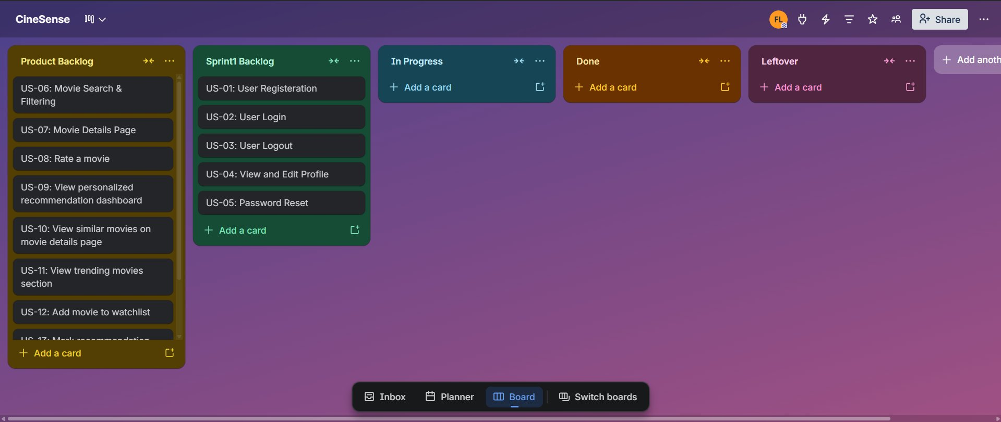
Figure 1: Snapshot 1 — Sprint Start (All 5 stories in Sprint Backlog, nothing started yet)

Snapshot 2 — Midpoint of Sprint
US-01, US-02, and US-03 have been completed and moved to Done. US-04 (View and Edit Profile) is now In Progress. US-05 (Password Reset) remains in the Sprint Backlog awaiting development.

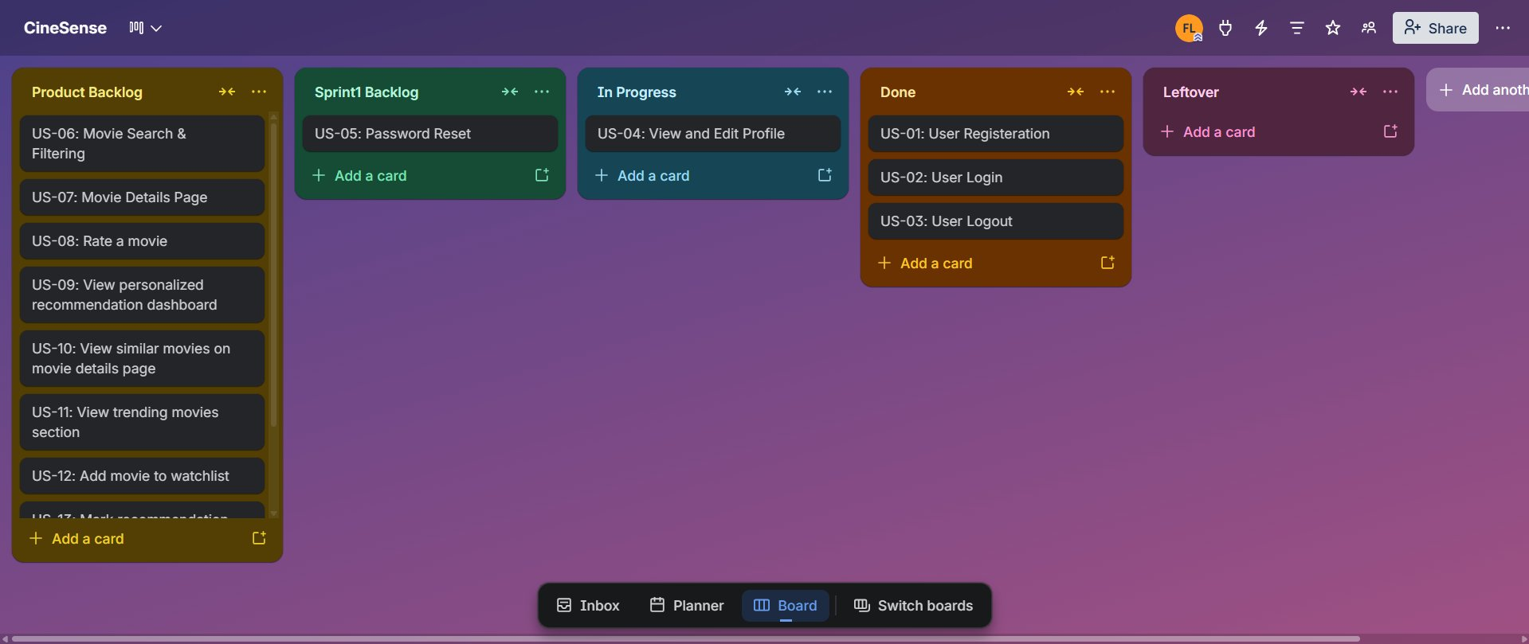
Figure 2: Snapshot 2 — Midpoint (US-01, US-02, US-03 Done; US-04 In Progress)

Snapshot 3 — End of Sprint
US-01, US-02, US-03, and US-04 have all been completed and are in the Done column. US-05 (Password Reset) could not be completed within the sprint duration and has been moved to the Leftover column. It will be carried forward to Sprint 2.

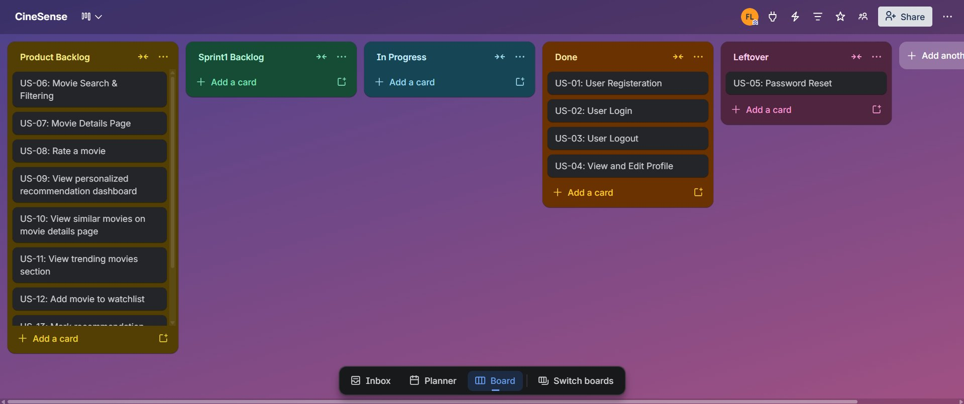
Figure 3: Snapshot 3 — Sprint End (US-04 Done; US-05 moved to Leftover)

Sprint 1 Burndown Chart
The burndown chart below shows planned effort (ideal burndown) versus actual progress across the 10-day sprint. US-01 through US-04 were completed; US-05 (Password Reset) was carried over to Sprint 2 as a leftover.

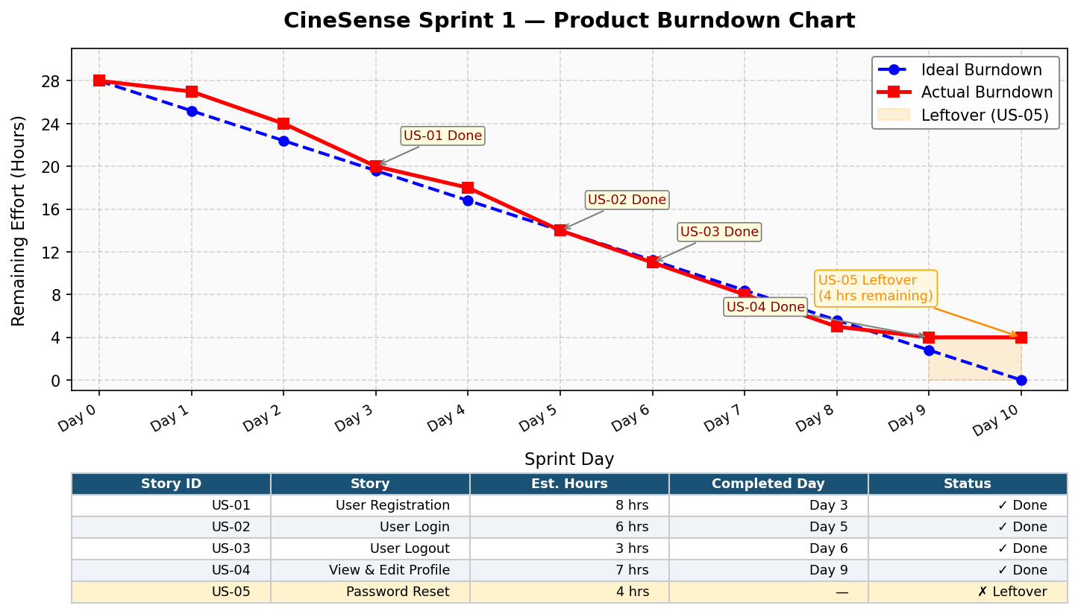
Figure 4: Sprint 1 Burndown Chart — Planned vs Actual Progress

5. Non-Functional Requirements (NFR)
The following non-functional requirements apply to the Sprint 1 module: Signup / Login / Profile Management. These are expressed using natural language specification.

# | Category | Requirement
NFR-01 | Security | All user passwords must be managed exclusively through Firebase Authentication. Passwords must never be transmitted, logged, or stored in plaintext anywhere in the system. Firebase Security Rules must restrict Firestore read/write access to authenticated users only, and users must only be able to read and write their own document in the users collection.
NFR-02 | Performance | Authentication operations (signup and login) must complete within 3 seconds under normal network conditions. Firestore reads for profile data must complete within 2 seconds on page load. These thresholds ensure the user does not experience noticeable delays during authentication flows.
NFR-03 | Reliability | The authentication module must handle Firebase service errors gracefully. If a Firestore write fails during signup, the system must attempt one automatic retry. All API calls must be wrapped in error-handling logic, and the user must never see an unhandled exception or a blank screen as a result of an authentication failure.
NFR-04 | Usability | A new user must be able to complete the full signup process within 2 minutes without any external guidance. All form validation errors must be displayed inline, in plain language, and must be visible without scrolling. The login and registration forms must be accessible on both desktop and mobile screen sizes.
NFR-05 | Scalability | The user data storage design in Firestore must follow a flat document structure (one document per user in the users collection) to support efficient querying as the user base grows. The system should remain functional and responsive for up to 10,000 registered users without architectural changes.
NFR-06 | Session Mgmt | Firebase Authentication session persistence must be set to LOCAL so the user remains authenticated across browser refreshes and new tabs without needing to log in again. A user must only be logged out when they explicitly trigger the logout action or when Firebase detects token expiry.
NFR-07 | Compatibility | The Signup, Login, and Profile pages must render correctly on the latest versions of Google Chrome, Mozilla Firefox, and Microsoft Edge. The UI must be responsive and functional on screen widths ranging from 375px (mobile) to 1920px (desktop).
NFR-08 | Data Integrity | User profile data written to Firestore must be validated on the client side before any write operation is triggered. Mandatory fields (uid, email, displayName, joinDate) must always be present in the Firestore document. Missing or malformed documents must be detected and flagged in the UI with a recovery prompt.

6. Iteration 1 Implementation Screenshots
- Signup / Registration page

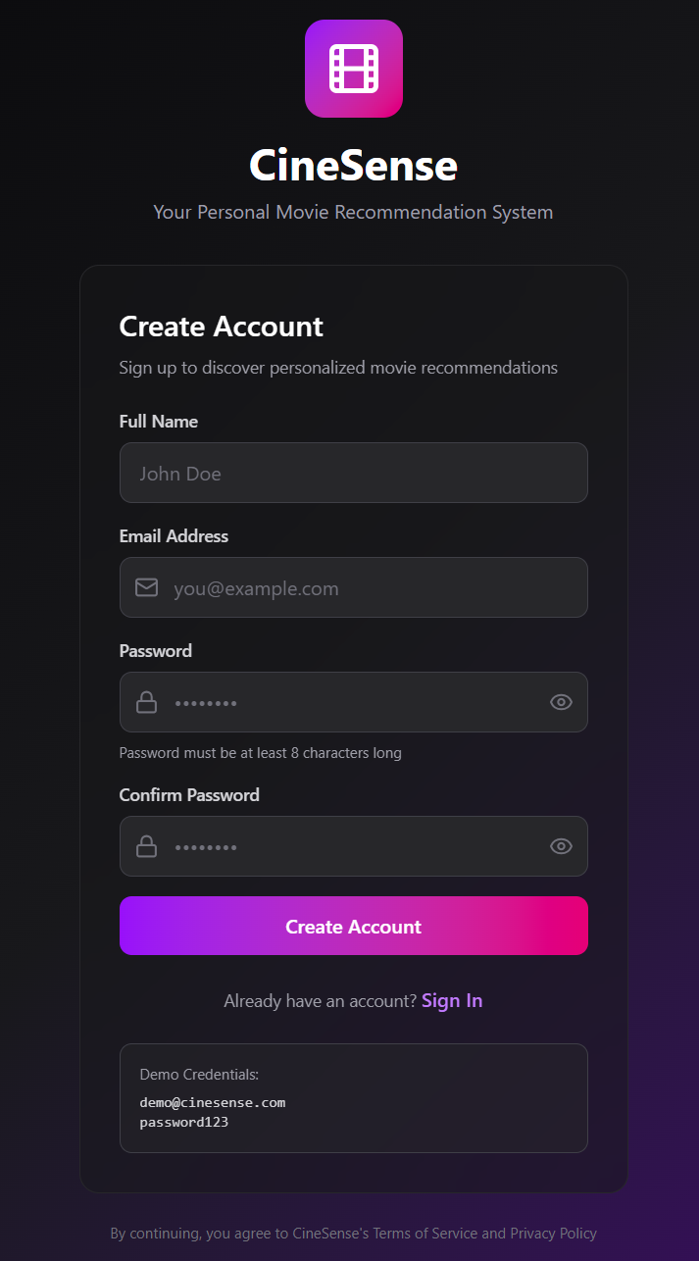
- Login page

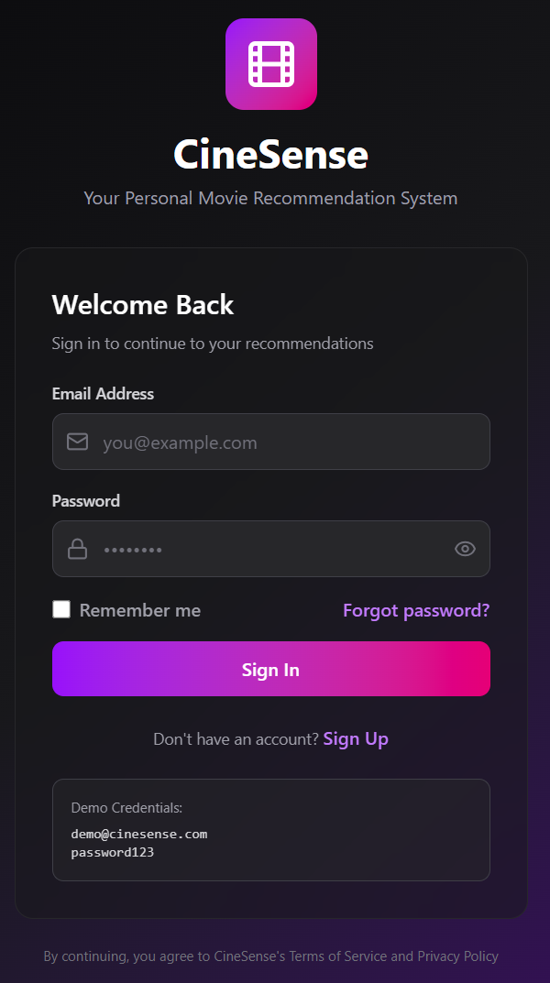
- User dashboard after login

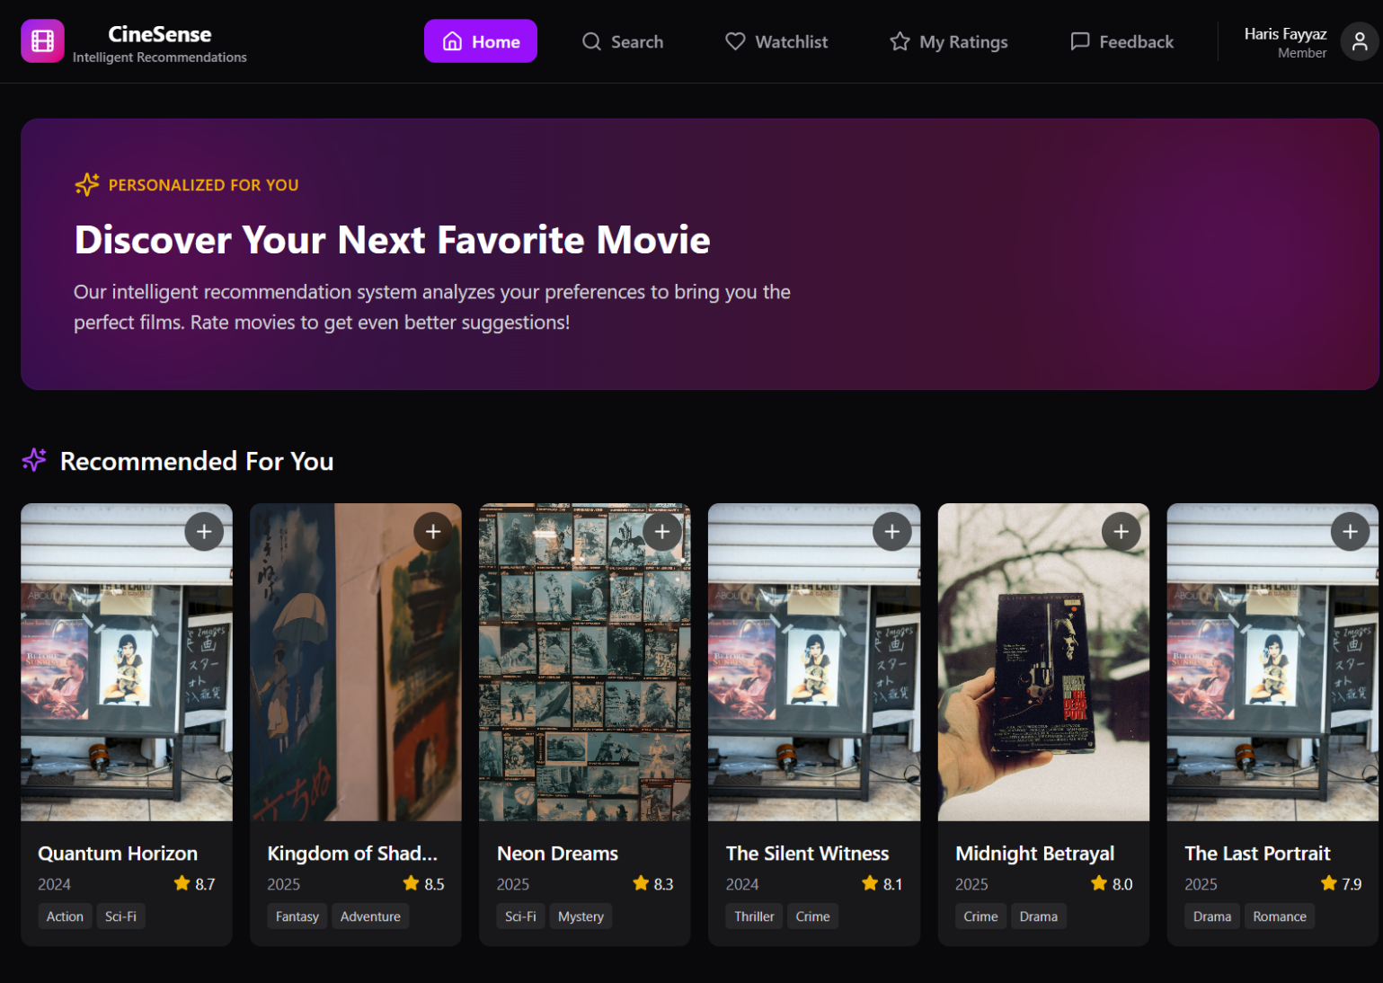
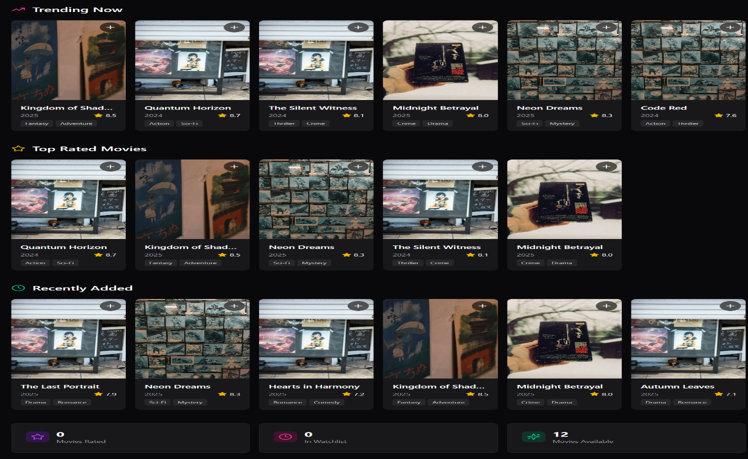
- Profile view page
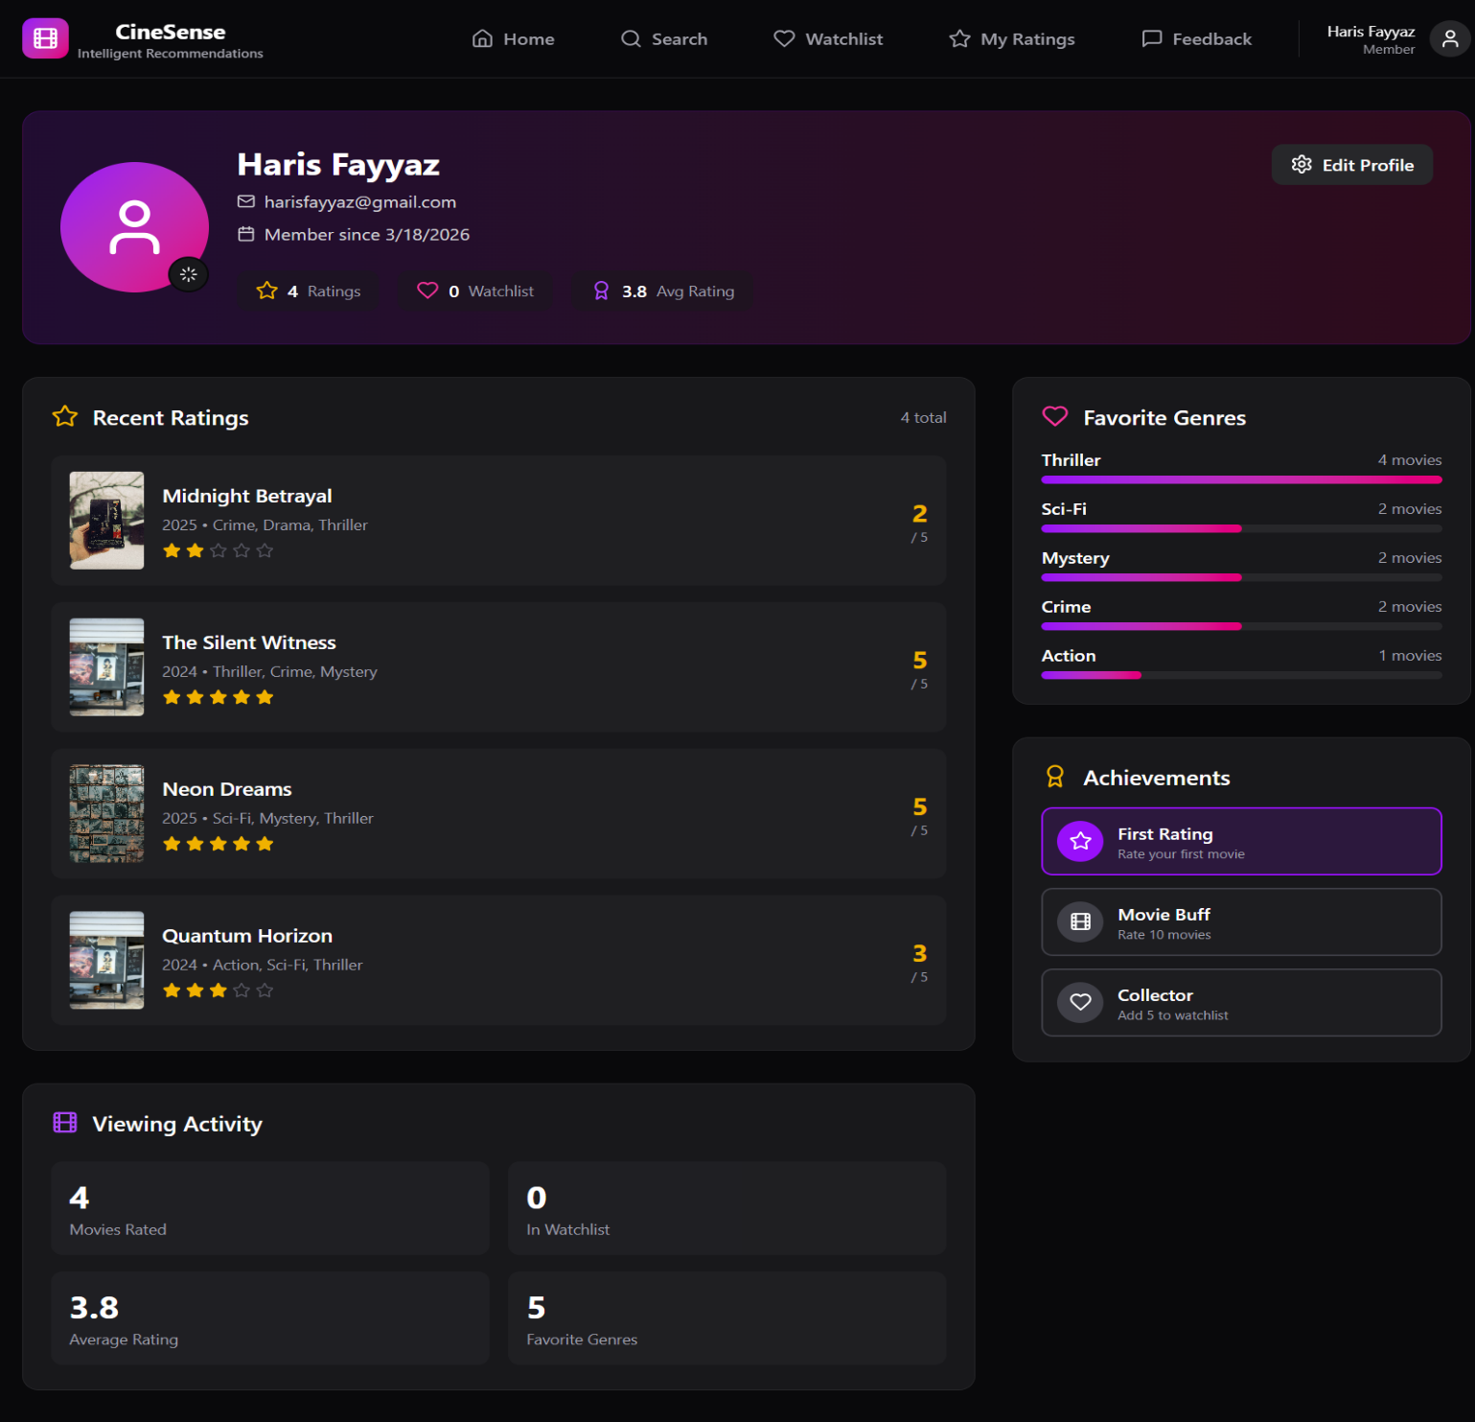

- Profile edit functionality

7. Work Division
The following table outlines the responsibilities of each team member for Sprint 1.

Member | Role | Responsibilities in Sprint 1
Haris Fayyaz 23L-0767 | Backend Developer & Team Lead | - Firebase Authentication setup and configuration  - Implement createUserWithEmailAndPassword for signup  - Firestore database structure design and rules  - Save and fetch user data from Firestore  - Firebase Storage integration for profile pictures  - sendPasswordResetEmail integration  - Session persistence configuration  - Connect frontend forms to Firebase Auth APIs
Faiqa Waseem 23L-0633 | Frontend Developer & UI/UX | - Design and implement Signup page UI  - Design and implement Login page UI  - Design and implement Profile page UI  - Forgot Password page UI  - Form validation and inline error display  - Responsive layout for mobile and desktop
Moeez Ijaz 23L-0750 | Project Manager & Architect | - Project planning and sprint coordination  - Trello board setup and maintenance  - Documentation: user stories, structured specifications, NFRs  - Code review and integration testing  - Deliverable 2 report compilation

