SOFTWARE ENGINEERING
CineSense
Intelligent Web-Based Movie Recommendation System
DELIVERABLE 3 — Sprint 2
Module: Core Movie Features & Manual Personalized Dashboard

Group Members
M Haris Fayyaz | 23L-0767
Moeez Ijaz | 23L-0750
Faiqa Waseem | 23L-0633

Section: BCS-6C
Submitted to: Ma'am Ansa Liaqat
Date: April 2026


1. Project Title and Introduction
1.1 Project Title
CineSense — Intelligent Web-Based Movie Recommendation System

1.2 Introduction
CineSense is a full-stack web-based application that delivers personalized movie experiences to users through intuitive search, rating, watchlist, and dashboard features. The system is built on a modern web stack with Firebase as the backend-as-a-service for authentication and Firestore for data storage. The AI/ML-powered recommendation engine is planned for Sprint 3; Sprint 2 focuses on delivering the core movie interaction features that will feed that engine.
Users can create accounts, log in securely, manage their profiles, search and filter movies, rate movies, build a watchlist, and manually curate a personalized dashboard of movies they are interested in. The application is built using modern web technologies with Firebase as the backend-as-a-service for authentication and Firestore for data storage. The AI/ML recommendation layer is planned for Sprint 3.

1.3 Sprint 2 Scope
Sprint 2 focuses on the Core Movie Features & Manual Personalized Dashboard module. Building on the authentication and profile management foundation delivered in Sprint 1, this sprint implements the following functionality:

- Movie Search & Filtering (US-06) — keyword search and genre/year/rating filters
- Movie Details Page (US-07) — full movie info, cast, overview, similar movies
- Rate a Movie (US-08) — 1–5 star rating system to record user preferences
- View Personalized Dashboard (US-09) — user manually curates their own dashboard by adding movies they are interested in
- View Trending Movies Section (US-11) — globally trending / highest-rated movies
- Add Movie to Watchlist (US-12) — save movies for later viewing
- Feedback System (US-15) — mark recommendations as relevant / not relevant

Note: US-05 (Password Reset), carried over as a leftover from Sprint 1, has also been completed in this sprint.

2. User Stories
The following user stories have been selected for Sprint 2. Each story follows the standard template: As a [user], I want [goal] so that [reason].

US-06: Movie Search & Filtering
Story ID: US-06 Story Title: Movie Search & Filtering
Priority | High | Est. Hours | 6
User Story | As a registered user, I want to search for movies by title and filter results by genre, year, and rating so that I can quickly find movies that match my preferences.
Description | This story covers the search and filter functionality on the Movies page. Users can type a keyword in the search bar and optionally apply filters for genre, release year, and minimum rating. Results are fetched from the Firestore movies collection and displayed as movie cards.
Sub User Stories | - As a user, I want to type a keyword in a search bar and see matching movies in real time.  - As a user, I want to filter search results by genre (e.g., Action, Drama, Comedy).  - As a user, I want to filter movies by release year range.  - As a user, I want to filter movies by minimum average rating.  - As a user, I want to clear all active filters and return to the full movie list.
Acceptance Criteria | - Search bar must accept text input and trigger results update within 1 second.  - Genre, year, and rating filter controls must be visible and functional on the search page.  - Applying multiple filters simultaneously must return correctly intersected results.  - Each result must be displayed as a movie card with title, poster, genre, and average rating.  - A 'No results found' message must be shown when no movies match the query/filters.  - Clearing filters must instantly restore the unfiltered movie list.

US-07: Movie Details Page
Story ID: US-07 Story Title: Movie Details Page
Priority | High | Est. Hours | 5
User Story | As a registered user, I want to view a dedicated details page for any movie so that I can read its full information, see similar movies, and decide whether to watch it.
Description | This story covers the Movie Details page. Clicking any movie card navigates the user to a full-page view showing the movie’s poster, title, genre(s), release year, cast, overview/synopsis, and average rating. A ‘Similar Movies’ section shows related movies based on shared genres.
Sub User Stories | - As a user, I want to see a movie's title, poster, genre, release year, and overview on a single page.  - As a user, I want to see the average community rating for the movie.  - As a user, I want to see a list of similar movies recommended based on genre and keywords.  - As a user, I want to be able to rate the movie directly from this page.  - As a user, I want to add the movie to my watchlist from the details page.
Acceptance Criteria | - Movie Details page must display: title, poster, genre(s), release year, cast, overview, and average rating.  - Similar Movies section must show at least 5 related movies based on shared genre(s).  - Page must load all data within 2 seconds under normal network conditions.  - A 'Rate this Movie' widget must be accessible directly on the page.  - An 'Add to Watchlist' button must be visible and functional on this page.

US-08: Rate a Movie
Story ID: US-08 Story Title: Rate a Movie
Priority | High | Est. Hours | 7
User Story | As a registered user, I want to rate a movie on a scale of 1 to 5 stars so that my ratings are saved and can be used to power AI/ML recommendations in Sprint 3.
Description | This story covers the movie rating flow. Users can submit a 1–5 star rating on any Movie Details page. The rating is written to the Firestore ratings collection to record user preferences for use in the future AI/ML recommendation engine (Sprint 3). Only registered, authenticated users can rate movies.
Sub User Stories | - As a user, I want to see a 1–5 star rating widget on the Movie Details page.  - As a user, I want to submit my rating with a single click and see immediate visual confirmation.  - As a user, I want to update my existing rating for a movie if I change my mind.  - As a user, I want my rating to be saved to my profile so that it can be used for future AI/ML recommendations in Sprint 3.  - As a user, I want to see the updated average community rating after I submit mine.
Acceptance Criteria | - Rating widget must display 5 interactive star icons; selected rating must be highlighted.  - Submitting a rating must write a document to the Firestore ratings collection (uid, movieId, ratingValue, timestamp).  - The submitted rating must be stored in Firestore for future use by the AI/ML recommendation engine (Sprint 3).  - If the user has already rated the movie, the existing rating must be pre-selected in the widget.  - A success toast/message must confirm the rating was saved.  - The displayed average rating for the movie must update within 2 seconds of submission.

US-09: View Personalized Dashboard
Story ID: US-09 Story Title: View Personalized Dashboard
Priority | High | Est. Hours | 10
User Story | As a registered user, I want to manually add movies to my personalized dashboard so that I can curate a collection of movies I am interested in and access them quickly from one place.
Description | This story covers the Personalized Dashboard page shown to authenticated users. In Sprint 2, the dashboard is manually curated — users can add any movie they like to their personal dashboard from the Movie Details page or search results. Added movies are stored per user in Firestore and displayed as a grid of movie cards on the dashboard. AI/ML-powered automatic recommendations will be integrated in Sprint 3.
Sub User Stories | - As a user, I want to add any movie to my personalized dashboard by clicking an ‘Add to Dashboard’ button on the Movie Details page.  - As a user, I want to see a visual confirmation when a movie is successfully added to my dashboard.  - As a user, I want to view my personalized dashboard and see all movies I have added, displayed as movie cards.  - As a user, I want to remove a movie from my personalized dashboard if I no longer want it there.  - As a user, I want the dashboard to load within 3 seconds and persist my saved movies across sessions.
Acceptance Criteria | - An ‘Add to Dashboard’ button must be present on the Movie Details page and on movie cards in search results.  - Clicking ‘Add to Dashboard’ must write a document to the Firestore dashboard collection (uid, movieId, addedAt).  - If a movie is already on the dashboard, the button must change to ‘Remove from Dashboard’ to prevent duplicates.  - The dashboard page must display all user-added movies as cards, each showing: poster, title, genre(s), and average rating.  - Dashboard must refresh immediately when a movie is added or removed, without a full page reload.  - Page load time must not exceed 3 seconds under normal network conditions.

US-11: View Trending Movies Section
Story ID: US-11 Story Title: View Trending Movies Section
Priority | Medium | Est. Hours | 4
User Story | As a registered user, I want to see a section of globally trending or highest-rated movies on my dashboard so that I can discover what is popular right now.
Description | This story covers the Trending Movies section on the Dashboard below personalized recommendations. Trending movies are retrieved from the Firestore movies collection ordered by average rating (descending). The section displays the top 10 trending movies as horizontally scrollable cards.
Sub User Stories | - As a user, I want to see a clearly labelled 'Trending Now' section on my dashboard.  - As a user, I want trending movies to be sorted by their community average rating.  - As a user, I want to click a trending movie card to navigate to its Movie Details page.
Acceptance Criteria | - The Trending section must display at least 8 movie cards sorted by average rating (descending).  - Cards must be horizontally scrollable on both desktop and mobile layouts.  - Each card must show: poster, title, and average rating.  - Clicking a trending movie card must navigate to the Movie Details page for that movie.  - Trending data must be fetched from Firestore and rendered within 2 seconds.
US-12: Add Movie to Watchlist
Story ID: US-12 Story Title: Add Movie to Watchlist
Priority | Medium | Est. Hours | 5
User Story | As a registered user, I want to add movies to a personal watchlist so that I can save movies I plan to watch later.
Description | This story covers the Watchlist feature. Users can add any movie to their watchlist by clicking an 'Add to Watchlist' button on the Movie Details page or on movie cards. Watchlist data is stored per user in the Firestore watchlist collection. Users can view and remove items from their Watchlist page.
Sub User Stories | - As a user, I want to click an 'Add to Watchlist' button on any movie card or detail page.  - As a user, I want to see a visual confirmation when a movie is successfully added to my watchlist.  - As a user, I want to navigate to a dedicated Watchlist page to view all saved movies.  - As a user, I want to remove movies from my watchlist from the Watchlist page.
Acceptance Criteria | - An 'Add to Watchlist' button must be present on both movie cards and the Movie Details page.  - Clicking the button must write a document to the Firestore watchlist collection (uid, movieId, addedAt).  - If the movie is already in the watchlist, the button must change to 'Remove from Watchlist'.  - The Watchlist page must display all saved movies with poster, title, and genre.  - Removing a movie from the watchlist must delete its document from Firestore immediately.

US-15: Recommendation Feedback System
Story ID: US-15 Story Title: Recommendation Feedback System
Priority | Medium | Est. Hours | 5
User Story | As a registered user, I want to mark a recommended movie as relevant or not relevant so that the system can learn from my feedback and improve future recommendations.
Description | This story covers the feedback mechanism on the personalized dashboard. Each movie card has a thumbs-up (like) and thumbs-down (dislike) button so users can tag their preferences. Feedback is stored in the Firestore feedback collection as a preference signal to be used by the AI/ML recommendation engine in Sprint 3.
Sub User Stories | - As a user, I want to see thumbs-up and thumbs-down icons on each recommendation card.  - As a user, I want to click thumbs-up to mark a recommendation as relevant.  - As a user, I want to click thumbs-down to mark a recommendation as not relevant.  - As a user, I want my feedback to be saved so it can improve AI/ML recommendations in a future sprint.
Acceptance Criteria | - Each recommendation card must display visible thumbs-up and thumbs-down icons.  - Clicking either icon must write a feedback document to Firestore (uid, movieId, isRelevant, timestamp).  - The selected icon must visually highlight after the user clicks it to confirm feedback was recorded.  - Feedback data must be stored in Firestore and will be passed to the AI/ML recommendation engine in Sprint 3.  - A user must be able to change their feedback (toggle from thumbs-up to thumbs-down and vice versa).

3. Design
This section presents the full system design for CineSense Sprint 2. All diagrams were created in draw.io and are embedded below.

3.1 Architecture Diagram
CineSense adopts a hybrid of two architecture styles:
- Layered (N-Tier) Architecture — separating Presentation, Business Logic, ML/AI, and Data layers for clear separation of concerns.
- Client-Server Architecture — the browser client communicates with the Node.js backend exclusively via REST APIs over HTTPS.

Rationale: The Layered style enforces separation of concerns so the ML model can be developed and scaled independently from the web frontend. The Client-Server style clearly defines communication boundaries, making the system easier to test, scale, and maintain.

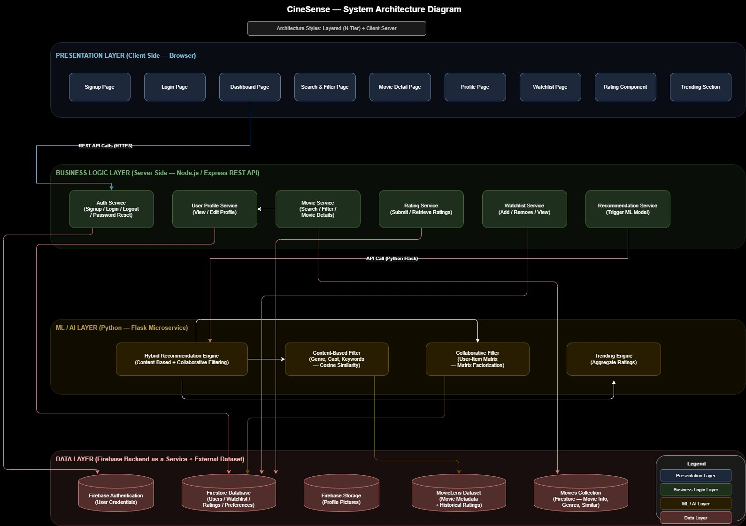
Figure 1: CineSense System Architecture Diagram (Layered N-Tier + Client-Server)
3.2 Component Diagram
The component diagram uses UML ball-and-socket (lollipop) notation. Provided interfaces (balls) represent services exposed by each component; required interfaces (sockets) represent services consumed. The four subsystems are: Frontend (React.js), Backend (Node.js/Express), ML Microservice (Python/Flask), and Firebase BaaS + Dataset.

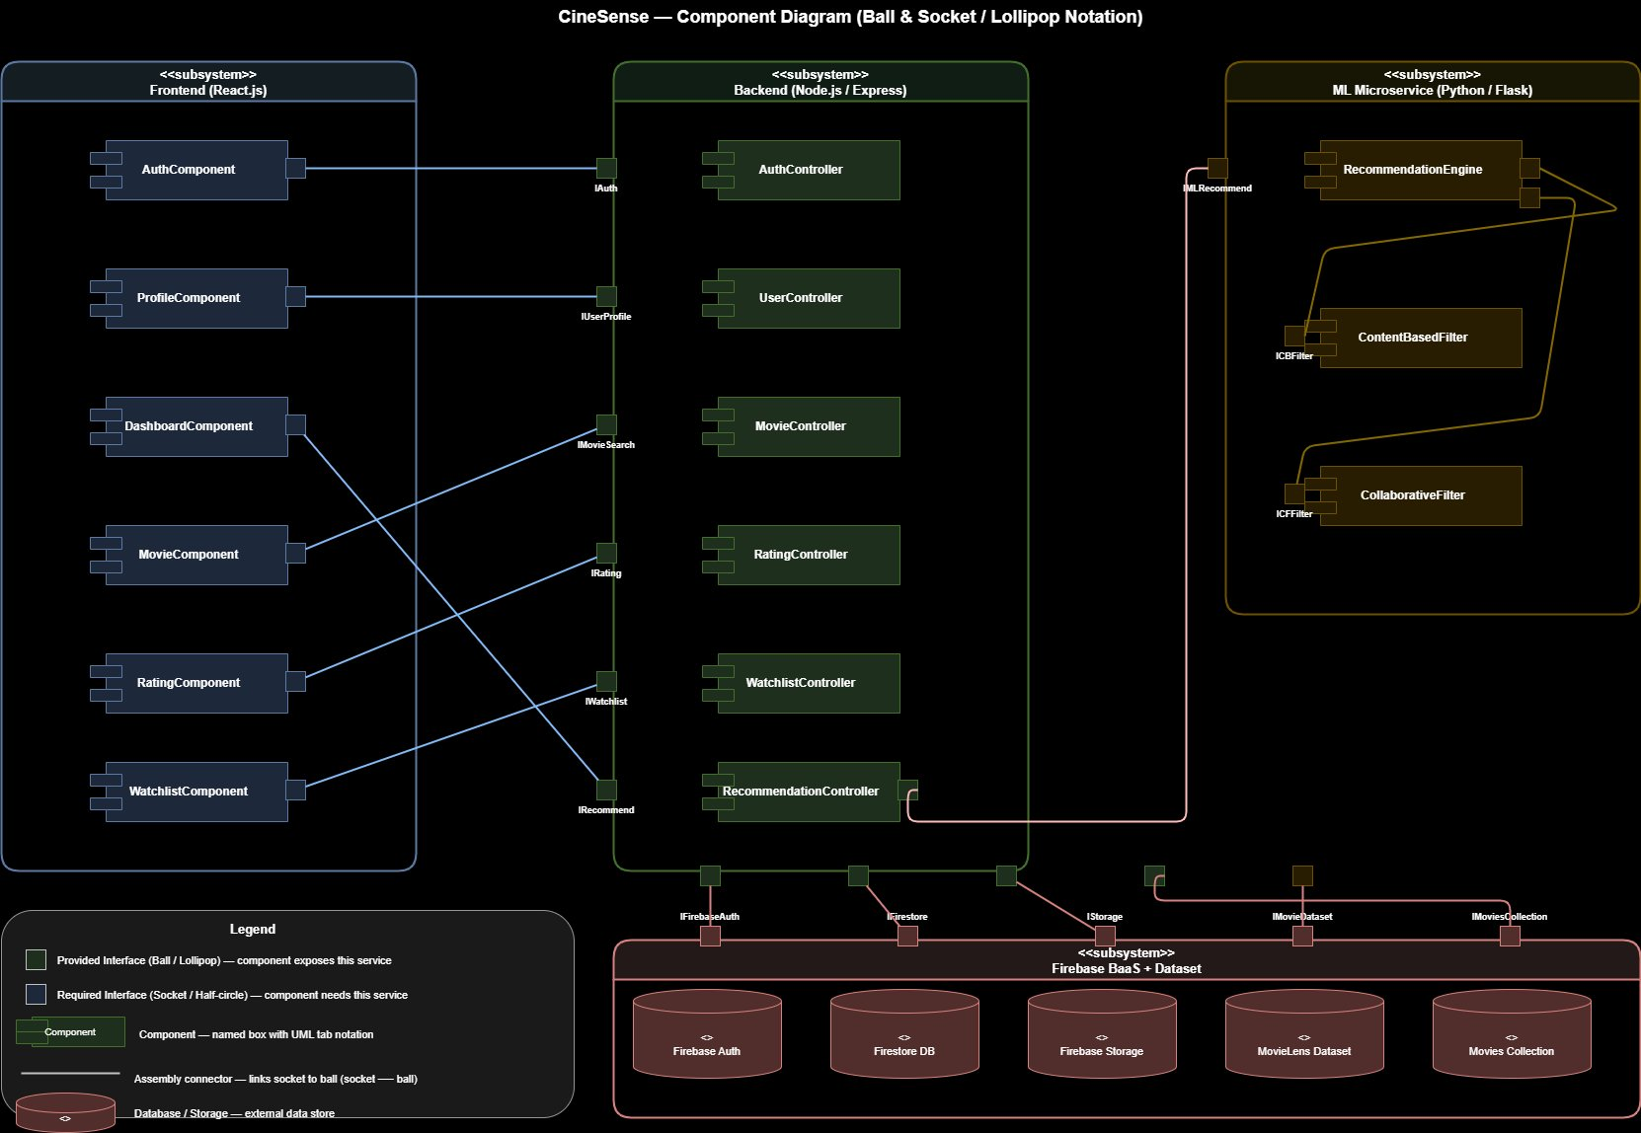
Figure 2: CineSense Component Diagram (Ball & Socket / Lollipop Notation)
3.3 Data Flow Diagrams
3.3.1 Level 0 — Context Diagram
The context diagram shows CineSense as a single process interacting with four external entities: User, Firebase BaaS, ML Microservice, and the MovieLens Dataset. All system inputs and outputs are shown at this level.

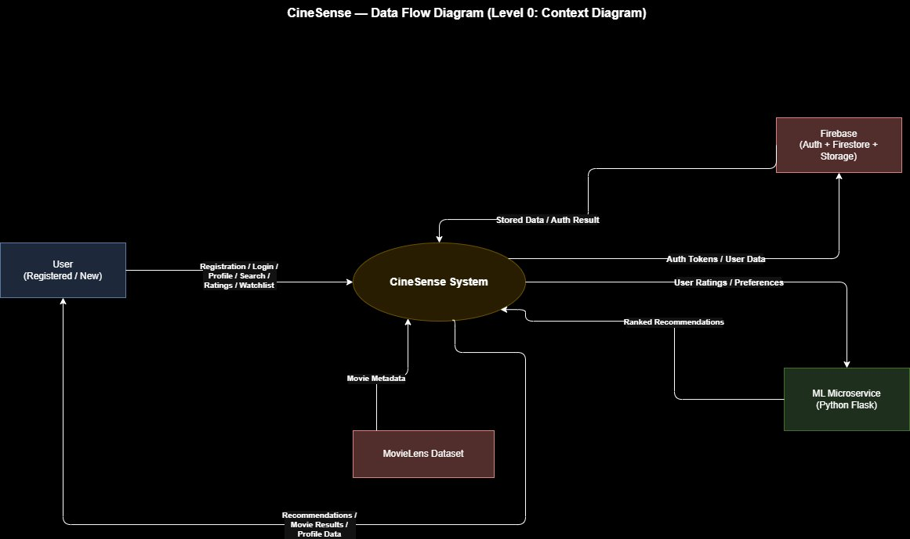
Figure 3: DFD Level 0 — Context Diagram
3.3.2 Level 1 — System Processes
Level 1 decomposes CineSense into six major processes: P1 User Authentication, P2 Profile Management, P3 Movie Search & Filter, P4 Rating & Feedback, P5 Recommendation Generation, and P6 Watchlist Management. Four Firestore data stores (D1–D4) mediate data exchange between processes and external systems.
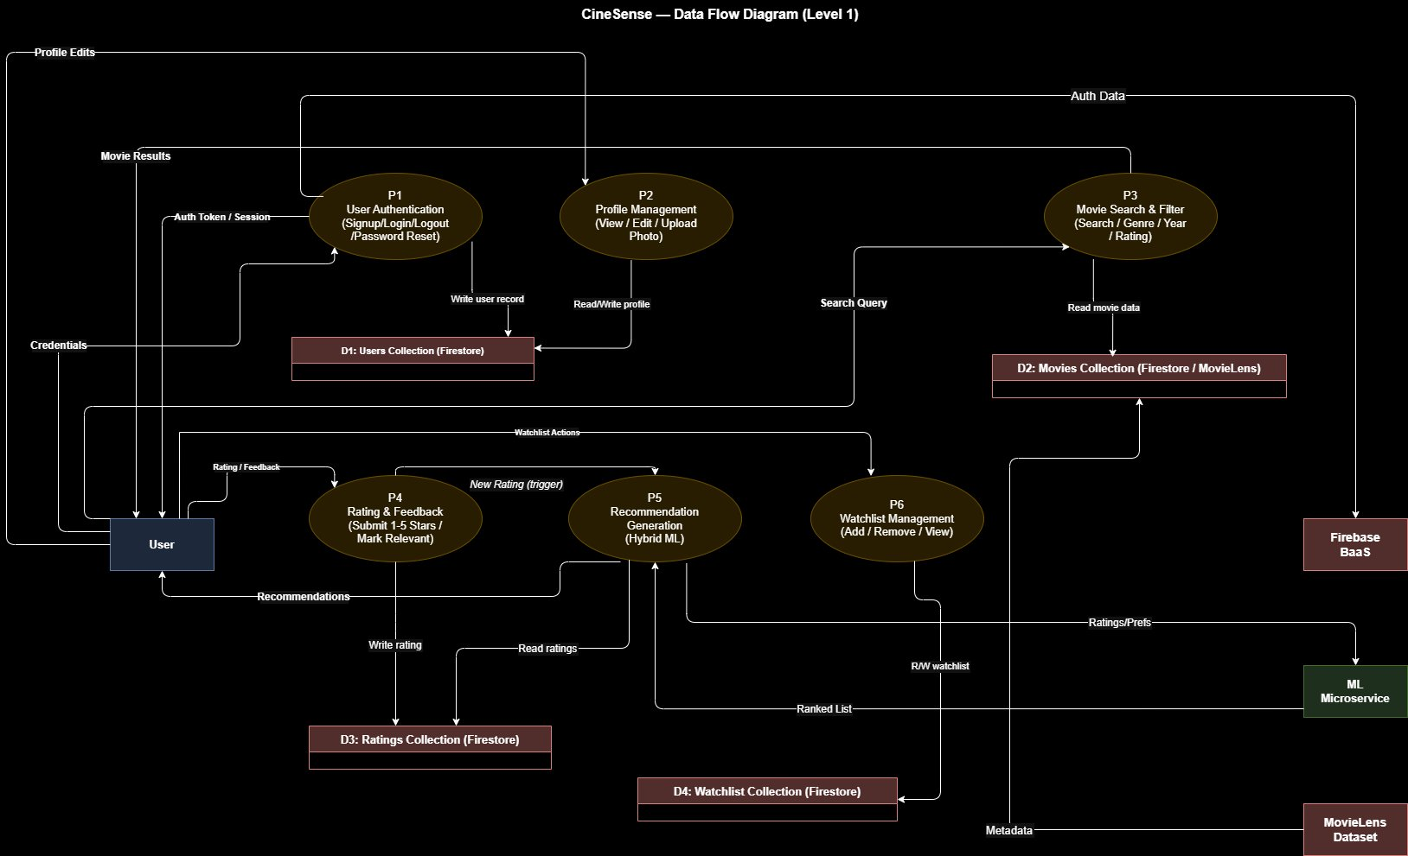
Figure 4: DFD Level 1 — System Processes
3.3.3 Level 2 — Recommendation Generation (P5)
Level 2 explodes process P5 into five sub-processes: P5.1 Fetch User Ratings & Preferences, P5.2 Content-Based Filtering (cosine similarity on TF-IDF vectors), P5.3 Collaborative Filtering (matrix factorization), P5.4 Score Aggregation (weighted hybrid combination), and P5.5 Rank & Filter Top-N Movies.
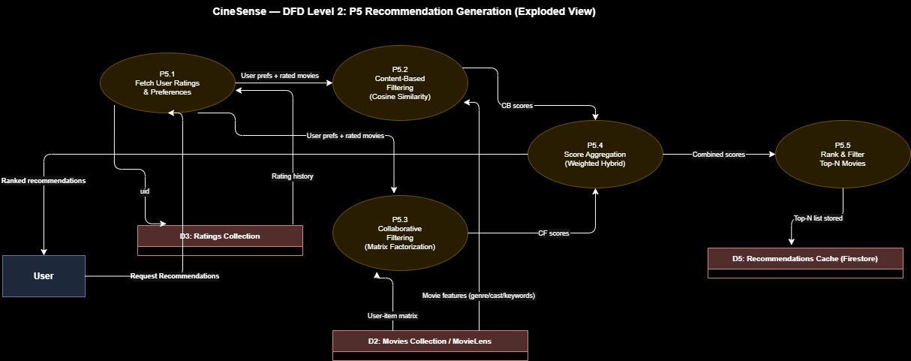
Figure 5: DFD Level 2 — P5 Recommendation Generation (Exploded View)
3.4 Activity Diagrams
Activity diagrams are provided for the three main processes in Sprint 2, illustrating control flow, decision points, and swimlane responsibilities.
3.4.1 Activity Diagram — User Registration (Signup)
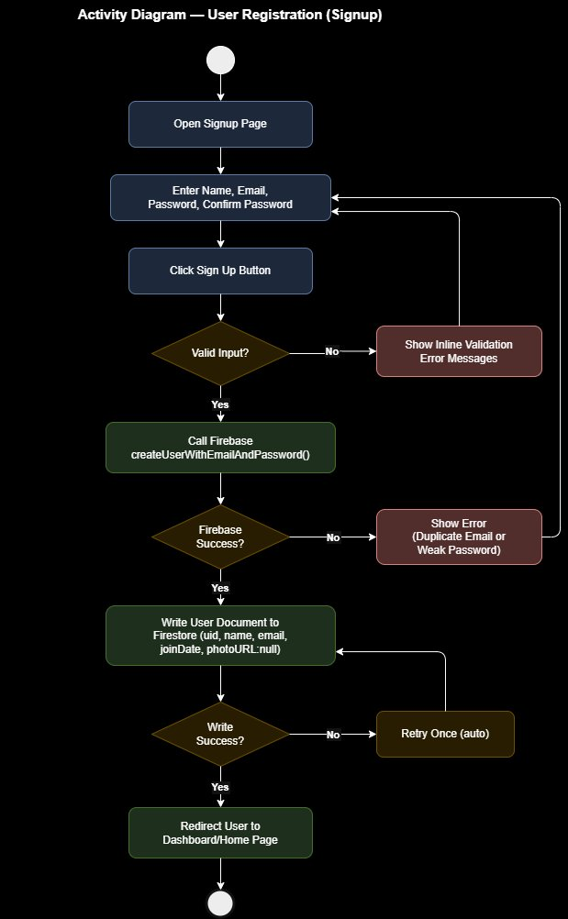
Figure 6: Activity Diagram — User Registration (Signup)
3.4.2 Activity Diagram — Rate a Movie & Recommendation Trigger

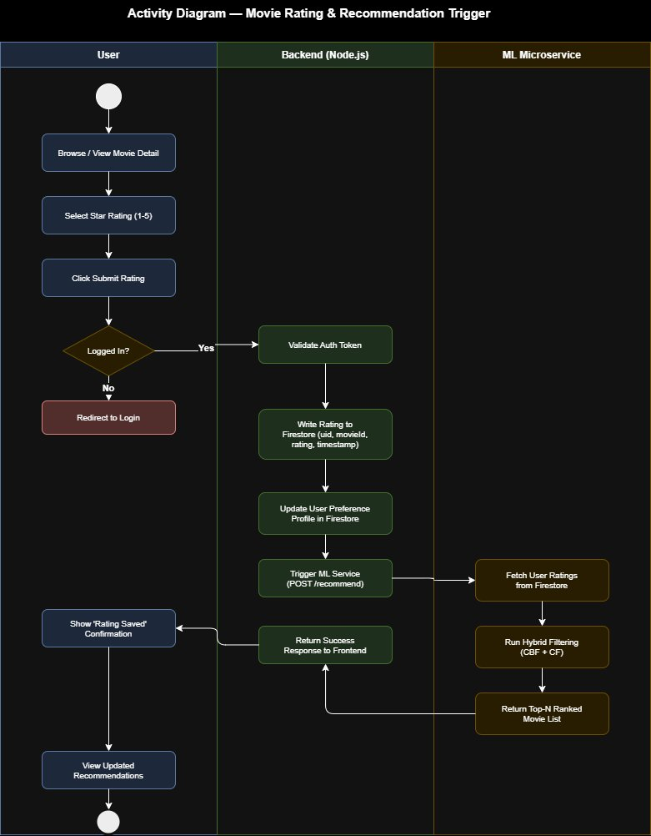
Figure 7: Activity Diagram — Movie Rating & Recommendation Trigger (Swimlane)

3.4.3 Activity Diagram — View Personalized Recommendations

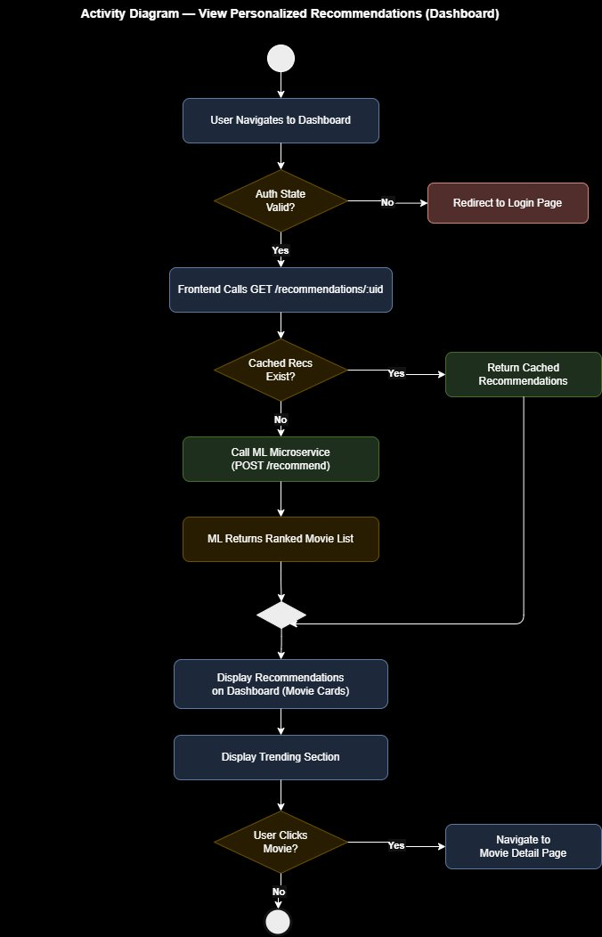
Figure 8: Activity Diagram — View Personalized Recommendations (Dashboard)
3.5 Use Case Diagram
The use case diagram identifies all actors: Guest User, Registered User (inherits Guest use cases via generalization), ML Microservice, and Firebase BaaS. Key relationships include <<include>> (e.g., View Recommendations includes Generate Recommendations) and <<extend>> (e.g., Filter Movies extends Search Movies).

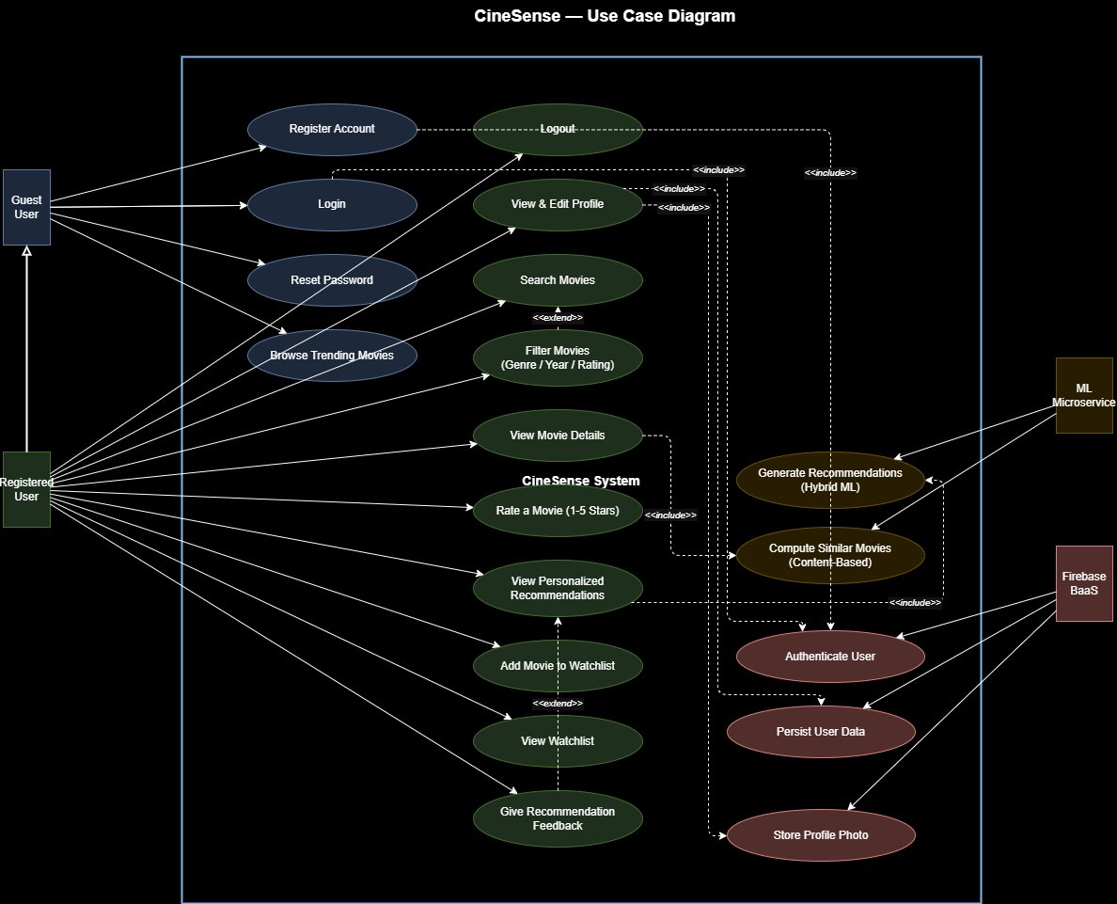
Figure 9: CineSense Use Case Diagram — All Actors and Use Cases

3.6 Sequence Diagrams
3.6.1 Sequence Diagram — User Login

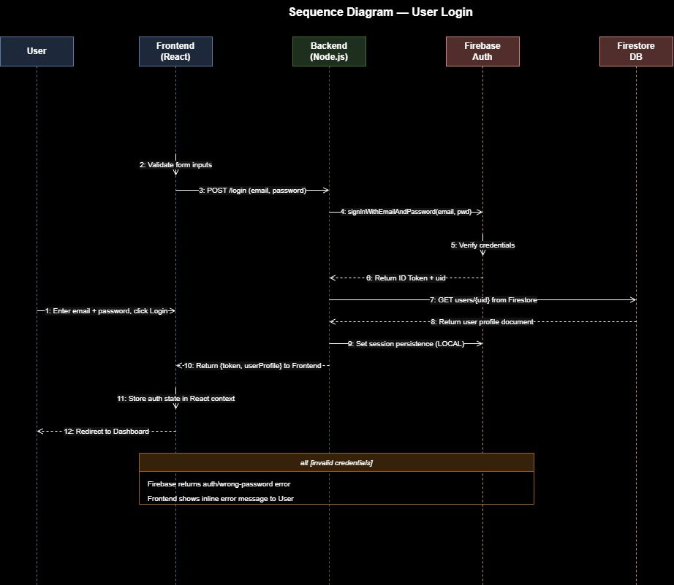
Figure 10: Sequence Diagram — User Login

3.6.2 Sequence Diagram — Rate a Movie & Trigger Recommendation Update
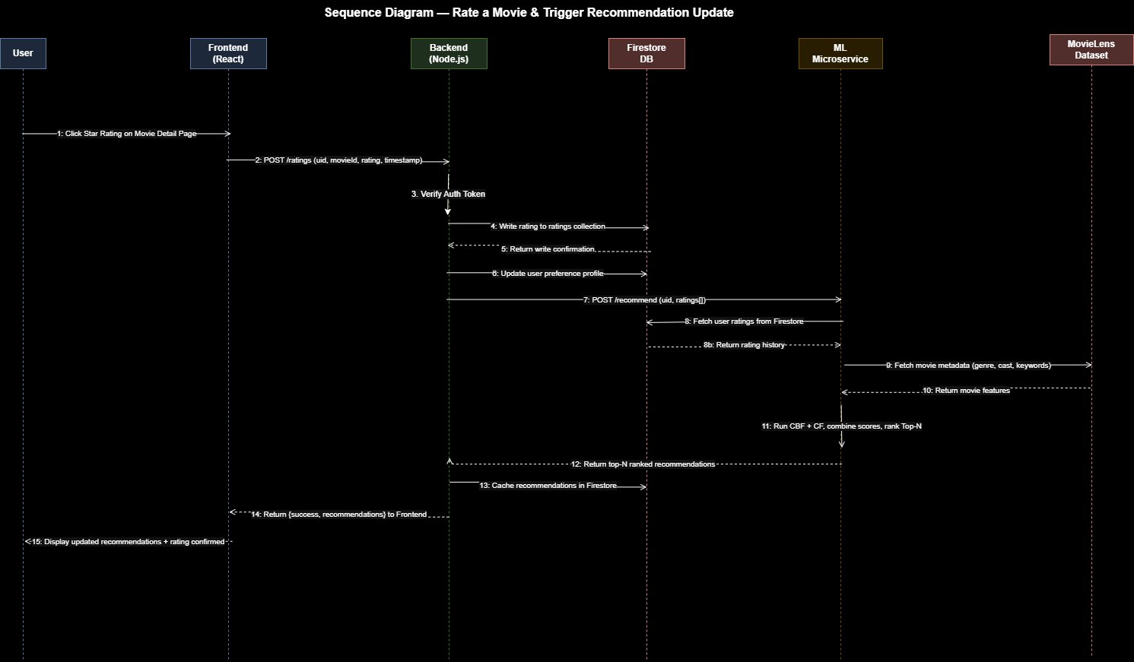
Figure 11: Sequence Diagram — Rate a Movie & Trigger Recommendation Update
3.6.3 Sequence Diagram — View Personalized Recommendations (Dashboard Load)
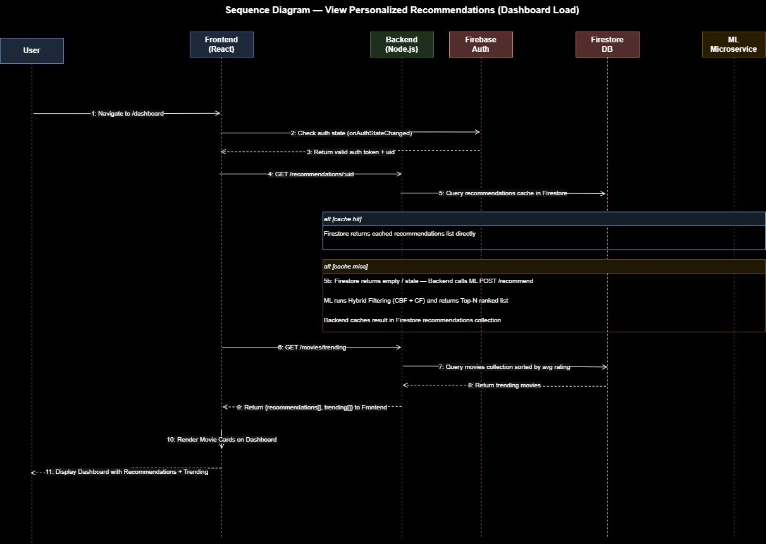
Figure 12: Sequence Diagram — View Personalized Recommendations (Dashboard Load)
3.7 Class Diagram
The class diagram identifies eight core classes: User, Movie, Rating, Watchlist, Recommendation, RecommendationEngine, Feedback, and AuthService. Relationships include association (User submits Rating), aggregation (Watchlist contains Movies), dependency (Recommendation uses RecommendationEngine), and one-to-many multiplicities throughout.

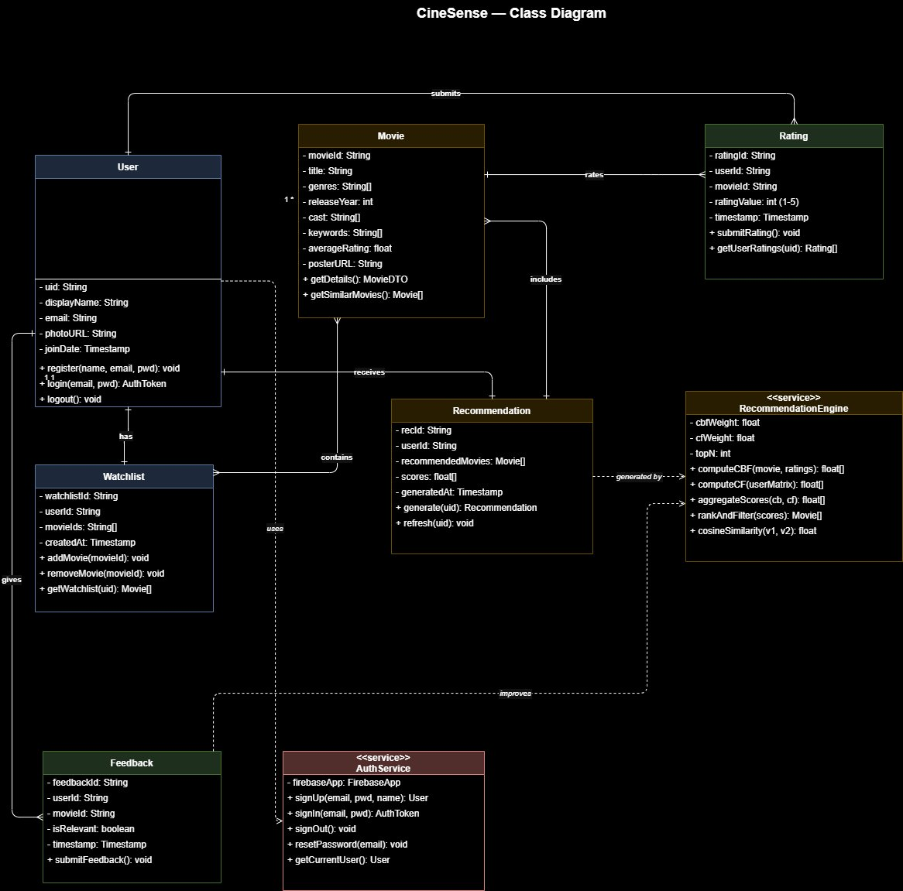
Figure 13: CineSense Class Diagram — All Classes and Relationships

4. Scrum Board
The following three snapshots show the progression of the Sprint 2 Trello board across three stages: start of sprint, midpoint, and end of sprint.

Snapshot 1 — Start of Sprint 2
All Sprint 2 user stories (US-05, US-06, US-07, US-08, US-09, US-11, US-12, US-15) are placed in the Sprint 2 Backlog. In Progress, Done, and Leftover columns are empty at the start.
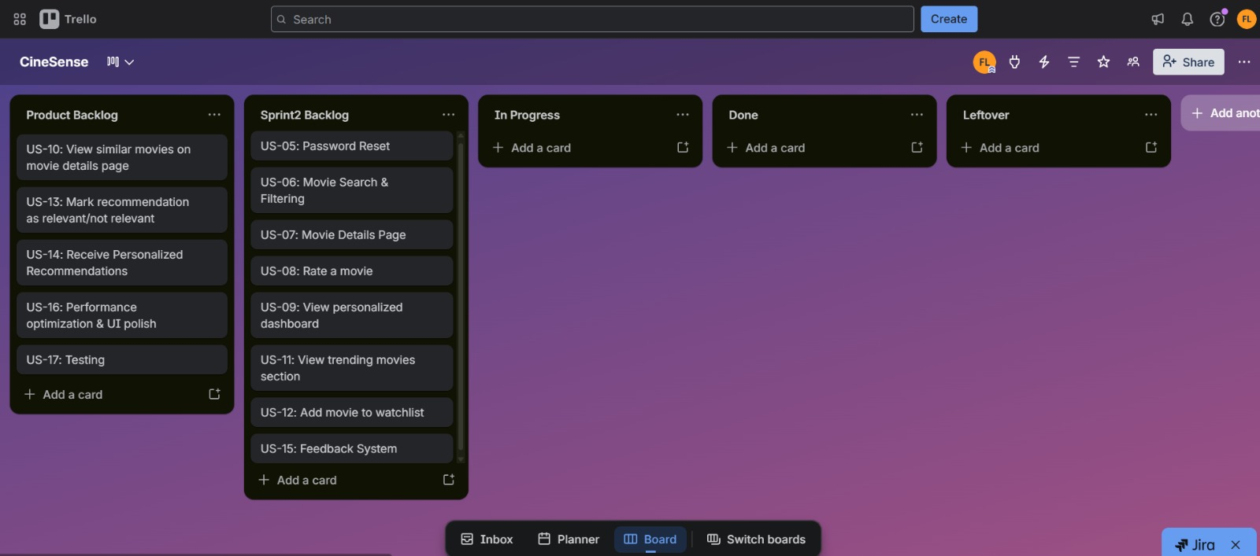
Figure 14: Snapshot 1 — Sprint 2 Start (All stories in Sprint 2 Backlog)
Snapshot 2 — Midpoint of Sprint 2
US-07 (Movie Details Page), US-06 (Movie Search & Filtering), and US-05 (Password Reset leftover) have been completed and moved to Done. US-08 (Rate a Movie) and US-09 (View Personalized Dashboard) are currently In Progress. US-11, US-12, and US-15 remain in the Sprint 2 Backlog.
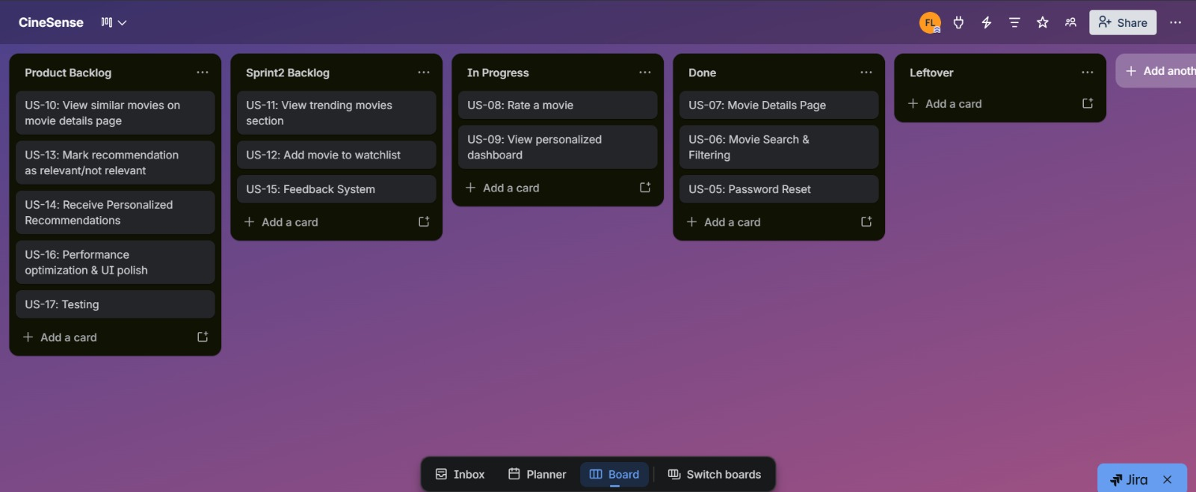
Figure 15: Snapshot 2 — Midpoint (US-07, US-06, US-05 Done; US-08, US-09 In Progress)
Snapshot 3 — End of Sprint 2
US-05, US-06, US-07, US-08, US-09, US-11, US-12, and US-15 have all been completed and moved to the Done column. No stories have been moved to Leftover for this sprint — all sprint goals were achieved.
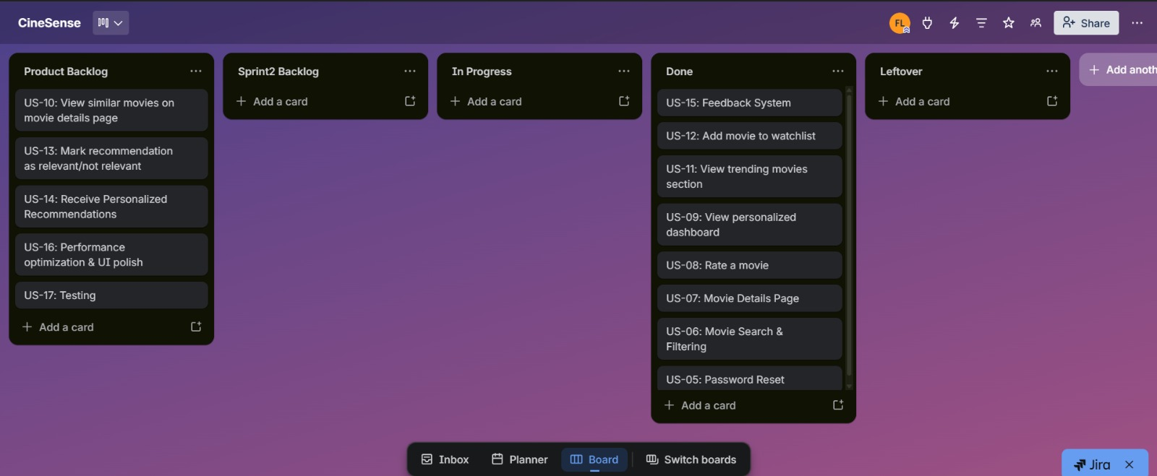
Figure 16: Snapshot 3 — Sprint End (All Sprint 2 Stories in Done)

5. Work Division
Member | Responsibilities in Sprint 2
Haris Fayyaz  23L-0767 | - Implement Rating submission API (POST /ratings) and Firestore writes for storing user ratings  - Password Reset backend: Firebase Auth password reset email trigger (sendPasswordResetEmail) and profile-based reset via re-authentication flow  - Firestore initial data setup: manually seeding movies collection with sample movie records for Sprint 2 testing  - Implement Feedback API (POST /feedback) and Firestore writes  - Firestore security rules update for new collections (ratings, watchlist, feedback, dashboard)  - Auth middleware setup: token verification for all protected API routes (ratings, watchlist, dashboard, feedback)  - Password Reset implementation (US-05): Forgot Password flow on Login page (email verification link via Firebase) and Reset Password from Edit Profile settings page  - Documentation: user stories, structured specifications, and report writing
Faiqa Waseem  23L-0633 | - Design and implement Movie Search & Filtering page UI (US-06)  - Design and implement Movie Details Page UI (US-07) with similar movies section  - Design and implement Personalized Dashboard UI (US-09) with Add/Remove from Dashboard functionality, and Trending section (US-11)  - Implement Feedback thumbs-up/thumbs-down UI on dashboard movie cards (US-15)  - Integration testing across all Sprint 2 modules  - Form validation, inline error handling, and responsive layout for all new pages  - Trello board management and sprint coordination
Moeez Ijaz  23L-0750 | - Implement Rating widget (star selector) on Movie Details Page (US-08)  - Implement Watchlist page UI and Add/Remove to Watchlist buttons (US-12)  - Backend MovieController: GET /movies/search, GET /movies/:id, GET /movies/trending, GET /movies/similar/:id using Firestore movies collection  - Backend WatchlistController: POST /watchlist, DELETE /watchlist/:id, GET /watchlist/:uid  - Backend DashboardController: GET /dashboard/:uid, POST /dashboard, DELETE /dashboard/:movieId with Firestore persistence  - Integration testing across all Sprint 2 modules  - Project planning, code review, and final report compilation

6. Implementation Screenshots
The following screenshots demonstrate the Sprint 2 implemented features. Insert actual screenshots below each caption.

6.1 Password Reset (US-05)
Forgot Password: Click Forgot Password on Login Page and you will receive a password reset link on your email. From the link update the password of you account and you are good to go.

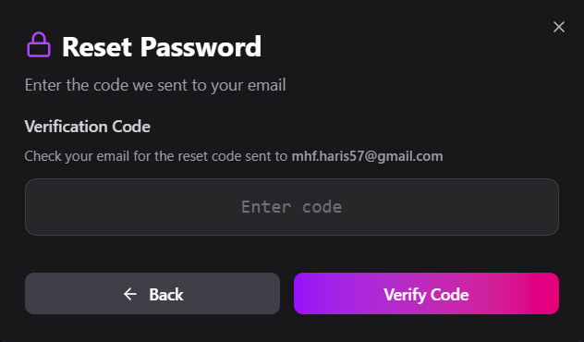

You can also reset your password from the logged in profile “edit profile” settings.

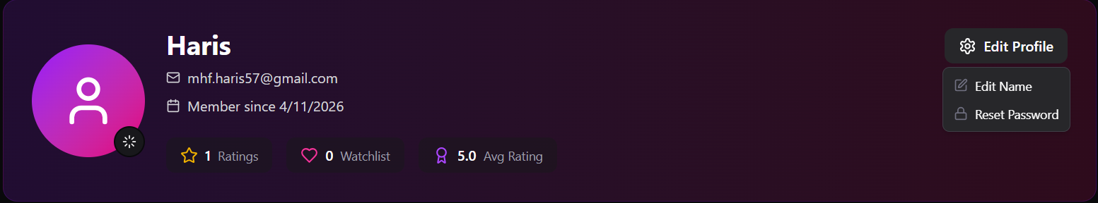
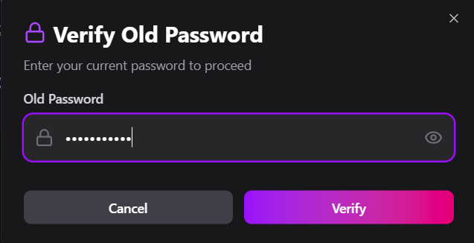
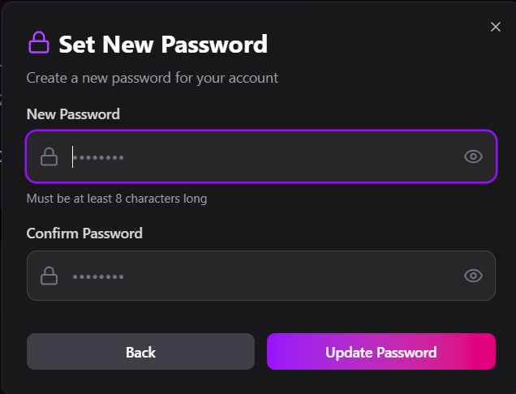
6.2 Movie Search & Filtering Page (US-06)
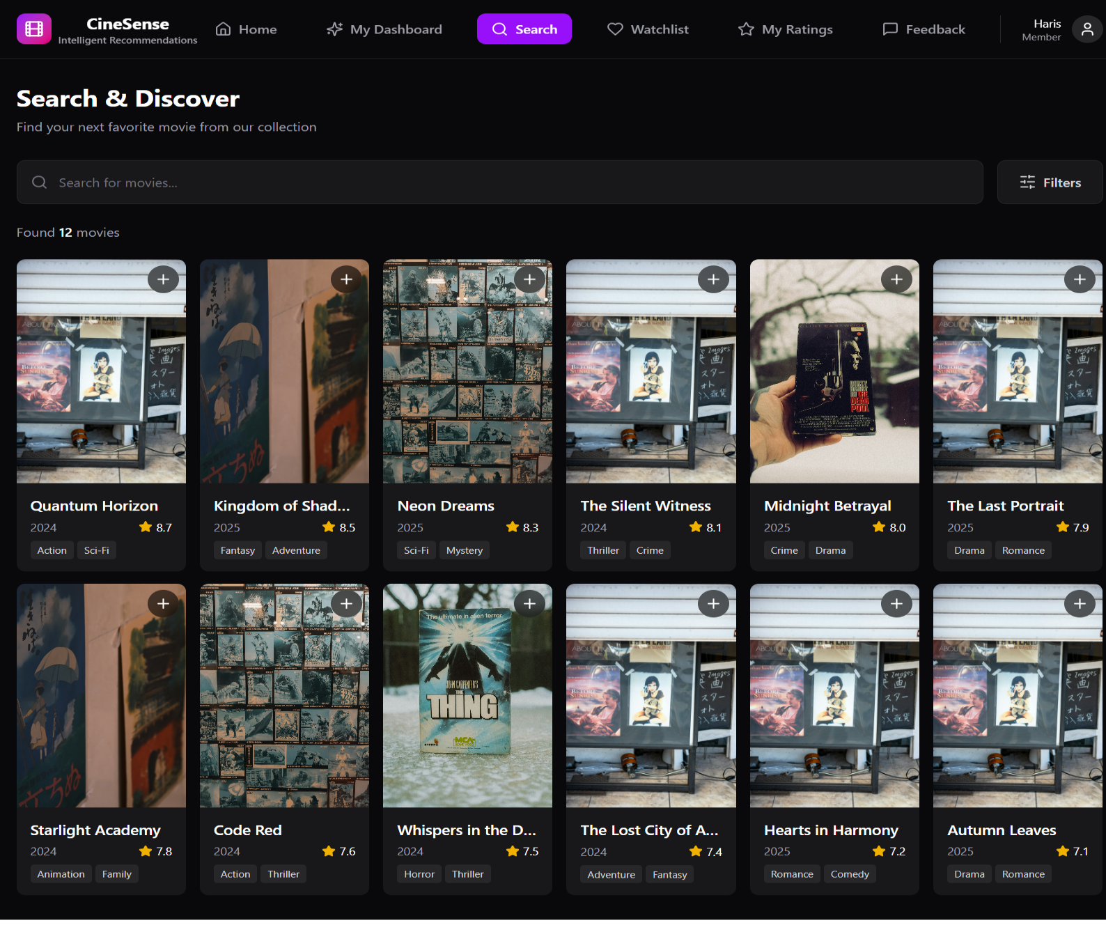
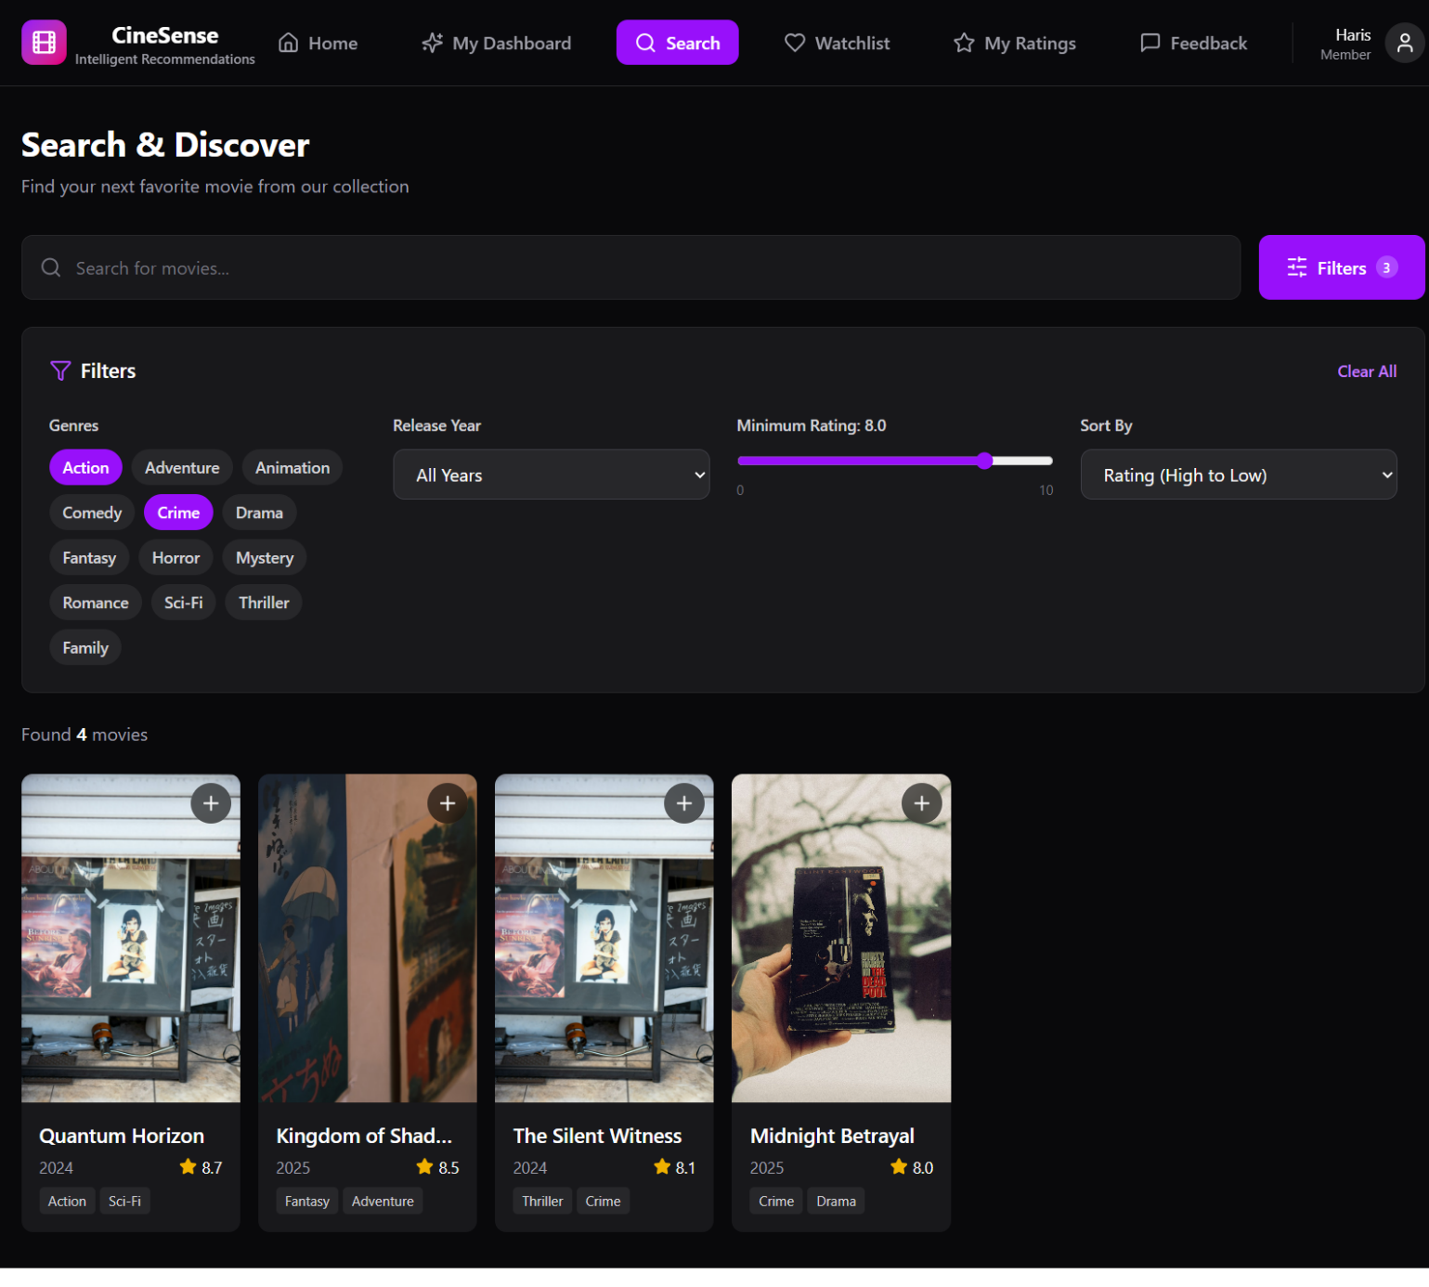

6.3 Movie Details Page (US-07)
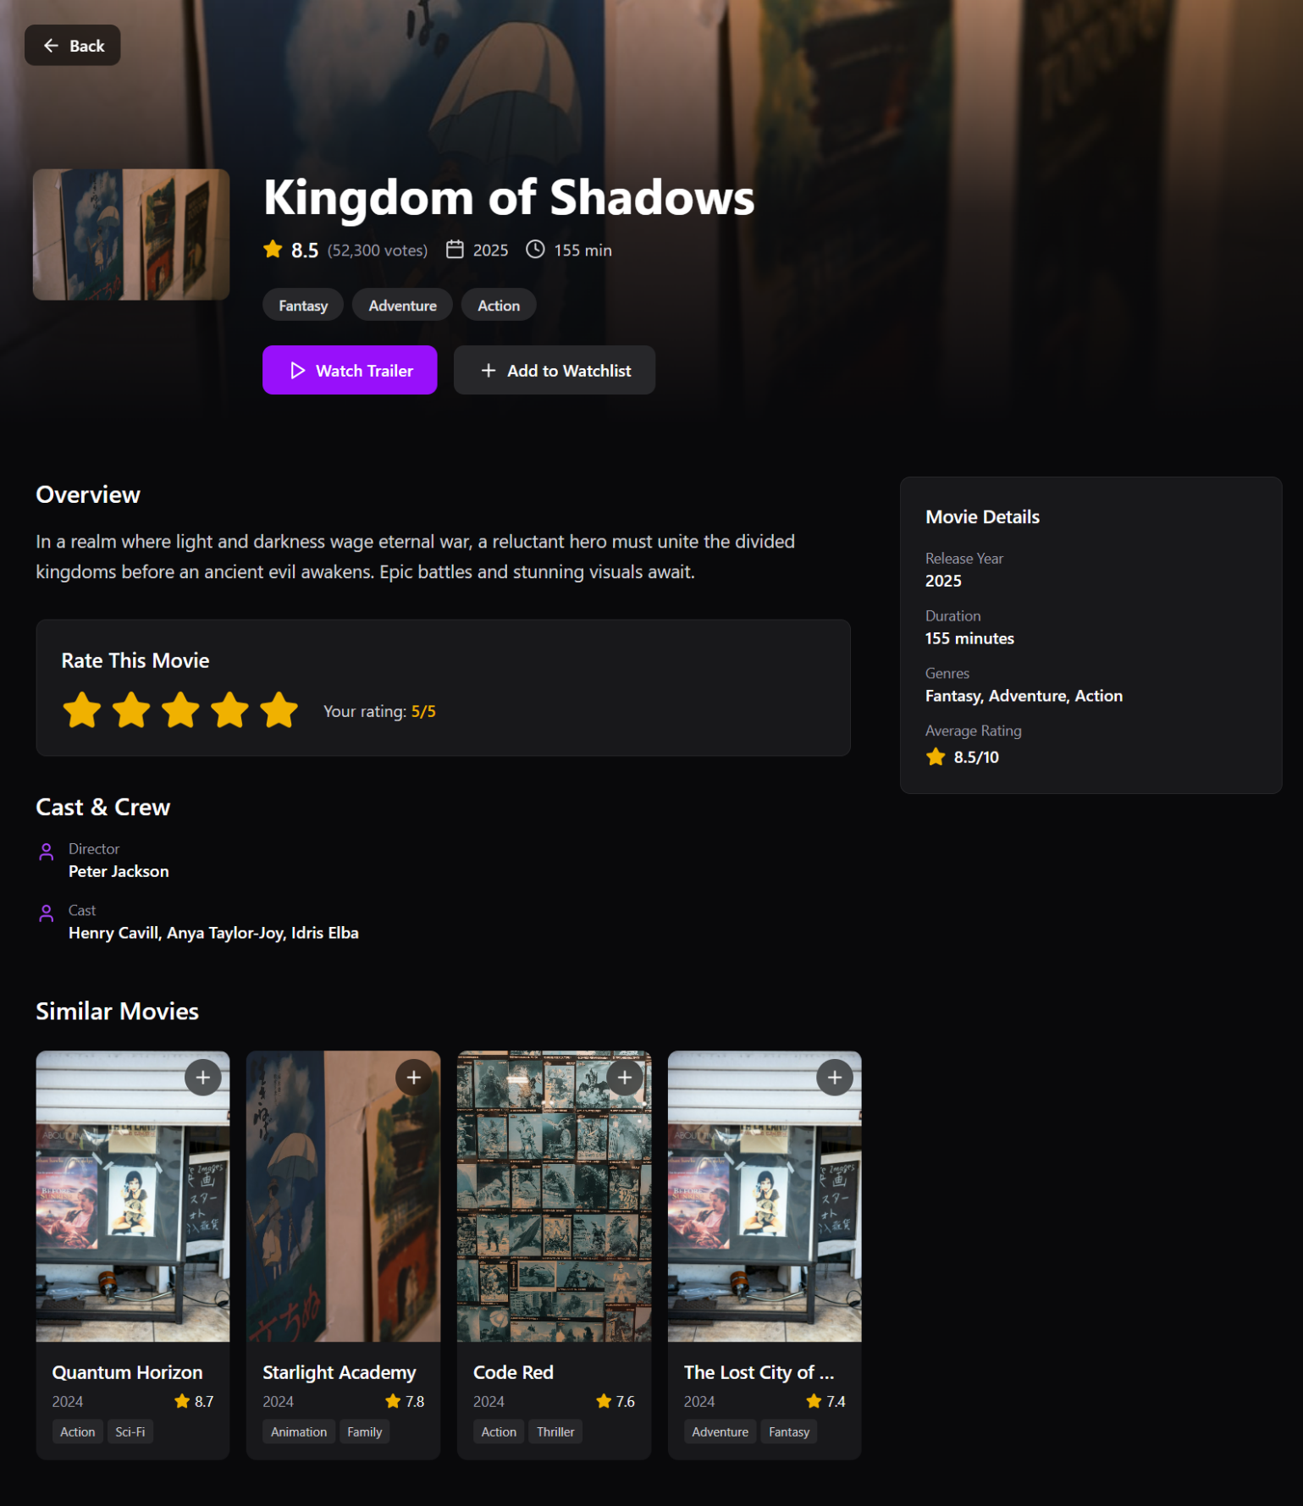

6.4 Rate a Movie Widget (US-08)
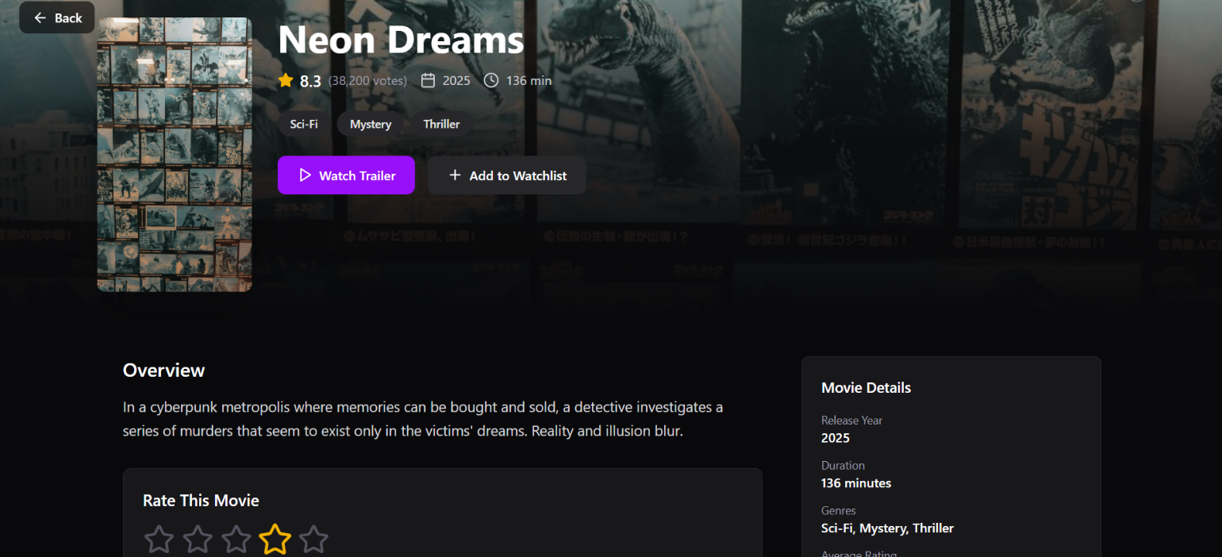
6.5 Personalized Dashboard (US-09)
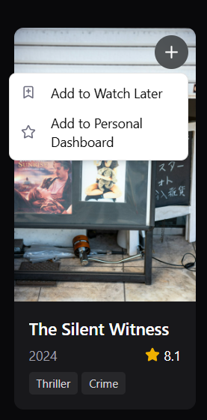

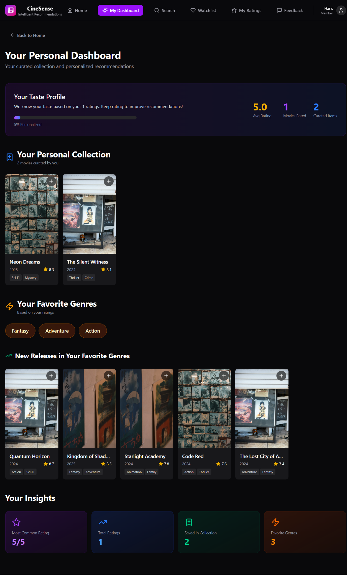
6.6 Trending Movies Section (US-11)
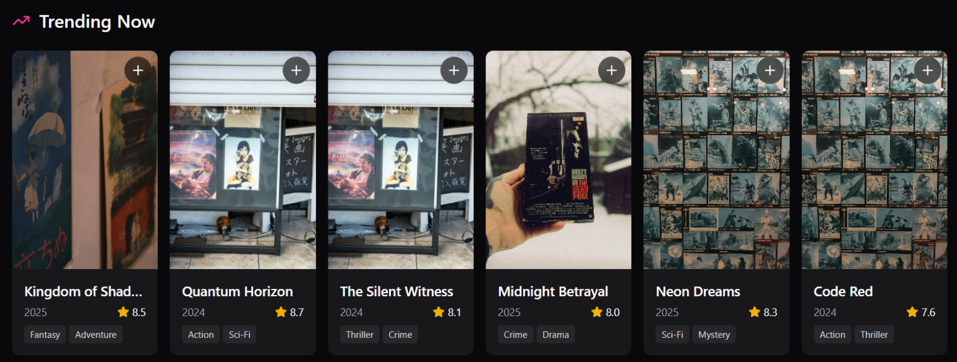
6.7 Watchlist Page (US-12)
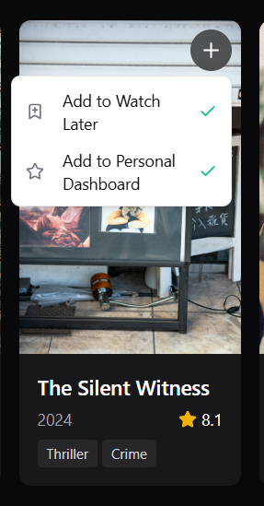
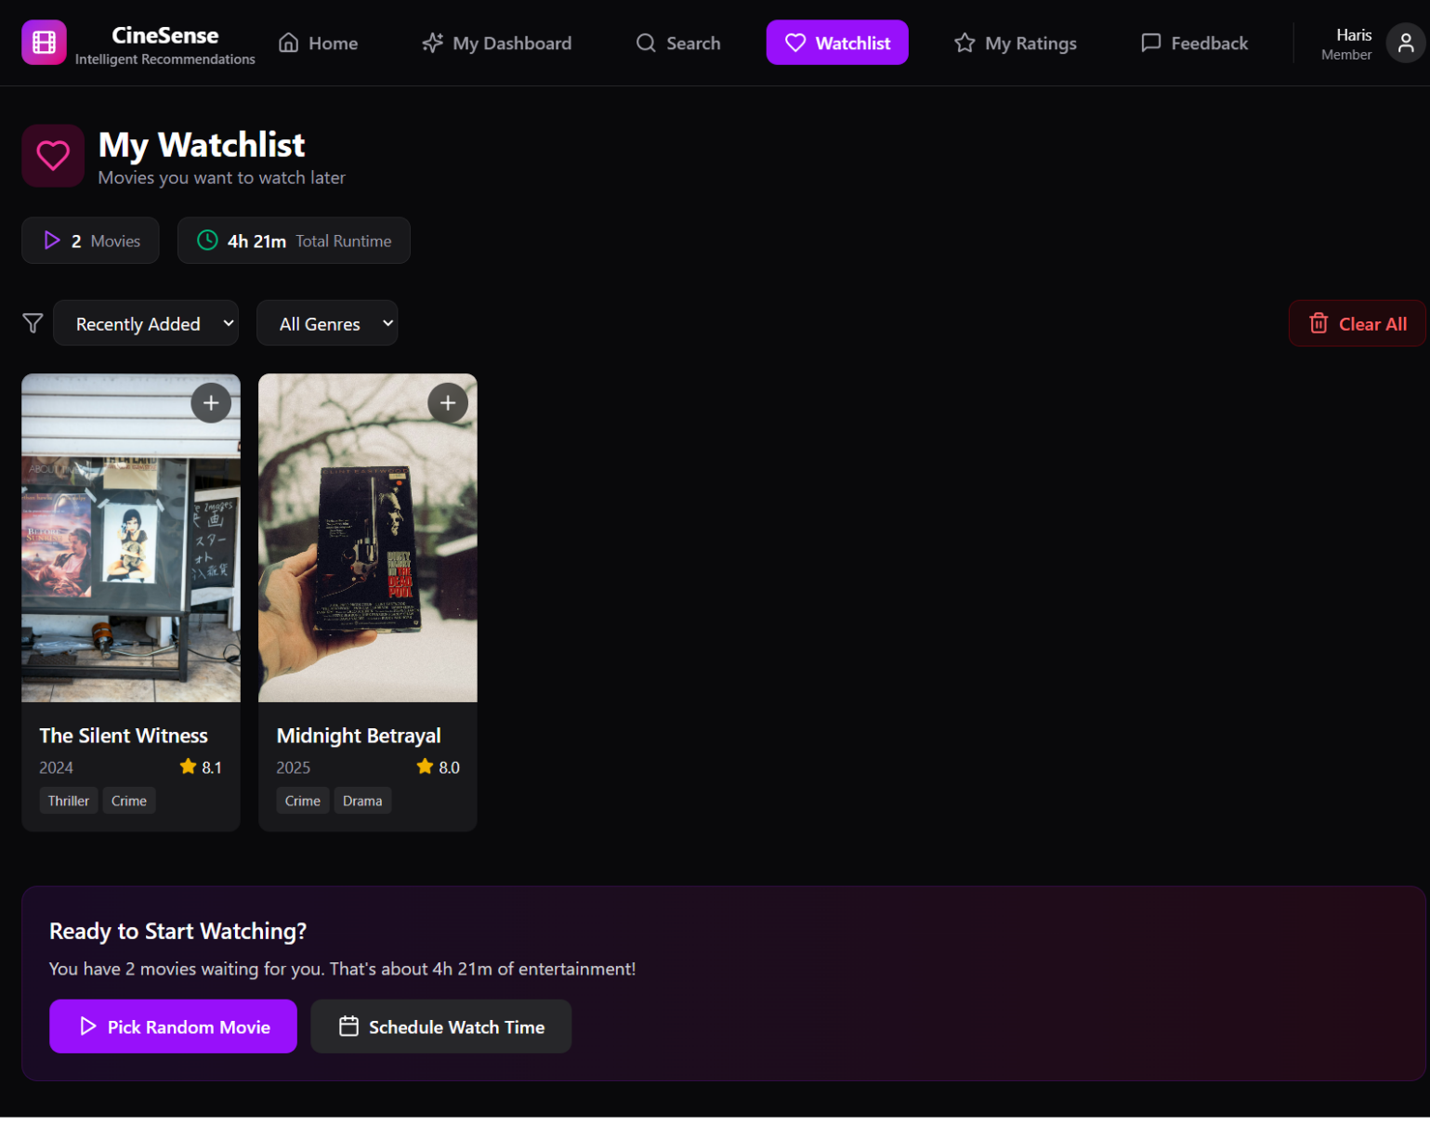
6.8 Recommendation Feedback (US-15)
