Harish K

**DevOps Engineer** |6+ years’ Experience **Mail:**

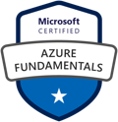

**Phone:**

# Career Objective:

Having **6+ years** of experience as a **DevOps Engineer** involved in deployment of applications which includes tools like **Git, Maven, Jenkins, Nexus, Ansible, Docker, Kubernetes, SonarQube, JFrog** in various **Linux Environment**.

# Professional Summary:

* Experience in automating build and deployment workflows using GIT, MAVEN, Jenkins, Docker and Ansible.
* Create branches and participating in merging for Java applications using GIT**.**
* Performed all necessary day-to-day GIT support for different projects.
* Experience in Continuous Integration (CI) setup, and Installing Jenkins, creating build jobs.
* Worked on set up distributed builds using Jenkins master/slave concepts, plug-in installation, and backup using Jenkins.
* Implementing **CI/CD** pipeline by using **Jenkins**, Maven, and Artifactory in Linux environment.
* Working with various teams like Dev, Test, and support automated builds, using CI/CD.
* Troubleshooting the issues daily throughout the CICD**.**
* Experience in managing the artifacts generated by Maven.
* Using Nexus repository manager for versioning artifacts and deploying it to application servers.
* Hands-on experience in provisioning, installing packages, services, configuration, and deployment using Ansible.
* Managed servers on the Amazon Web Services (AWS) platform instances using Ansible configuration management.
* Worked on Tomcat Application Server for application deployment in Ansible.
* Experience on Amazon EC2, EBS, IAM, AMI, S3, VPC, and Elastic Load Balancing services of the AWS family.
* Professional Experience on Containerization tool like Docker, writing Docker files for creating Docker images, and containers for different environments.
* Knowledge on deploying the end application using Kubernetes.
* Experience on Monitoring tools such as ELK.
* Understanding knowledge of SHELL.
* Excellent debugging and problem-solving skills.
* Knowledge of web services and micro services.

# Academic:

* B. Tech from Kakatiya University

# Technical Skills:

* + Version Control : **GIT**
  + Operating Systems : **Linux , Windows**
  + Build tools : **Maven**
  + Configuration Management Tool : **Ansible**
  + Continuous Integration Tools : **Jenkins**
  + Cloud Computing Services : **Amazon web services (Aws)**
  + Container Tools : **Docker**
  + Orchestration Tools : **Kubernetes**
  + Application Server : **Apache Tomcat**
  + Monitoring and logging **: Prometheus, Grafana, ELK, EFK**
  + Networking : **TCP/IP, DNS. Load Balancing**
  + Infrastructure as code : **Terraform, CloudFormation**
  + Artifact Management : **JFrog**

# Professional Experience:

* + Worked as a **Software Developer** at **Avya IT, Hyderabad**. Since **1st August 2017** To **5th May 2023.**

# Worked as a specialist product engineer (AWS Devops) at ABSA, Johannesburg. Since 21st September 2023 To 29th September 2024.

**Project #1: 21/09/2023 -29/09/2024**

Client**: ABSA**

Project Domain**: Financial Services**

# Designation: Specialist Product Engineer Responsibilities:

* Managed and optimized cloud infrastructure using **AWS** services such as **EC2**, **S3**, **VPC**, and **IAM**, ensuring high availability, scalability, and security.
* Automated infrastructure provisioning and management using **Terraform**, applying Infrastructure as Code (IaC) principles to streamline deployments.
* Containerized and orchestrated applications using **Docker** and **Kubernetes**, enabling efficient scaling, resource optimization, and rolling updates.
* Utilized **Rancher** to manage and monitor **Kubernetes clusters**, simplifying multi-cluster orchestration and centralized management.
* Configured and monitored application performance using **Grafana** integrated with **Prometheus**, creating custom dashboards and alerts to ensure system reliability.
* Deployed and managed log aggregation using **Elasticsearch** and **Logstash**, enabling quick access to application and system logs for troubleshooting and performance tuning.
* Automated CI/CD pipelines with **Jenkins**, integrating with Git for version control and continuous delivery of applications.
* Collaborated with cross-functional teams to enhance development workflows, improve infrastructure automation, and resolve production issues in real-time.
* Implemented **AWS CloudWatch** and **CloudTrail** for monitoring, logging, and auditing cloud resources, ensuring compliance and visibility across environments.

**Environment**: AWS, Git, Terraform, Maven, Jenkins, Docker, Kubernetes, Rancher, Grafana

# Project #2: : 01/08/2020 -05/05/2023

Client**: Health Care, Australia** Project Domain**: Healthcare Portal** Designation**: Software Developer**

# Responsibilities:

* Maintained **Git** repositories.
* Automated Weekly releases with Maven scripting for Compiling Java Code, Debugging, and Placing builds into Repository.
* Designed **CI/CD** processes in the context of a **Jenkins** orchestration, including the usage of automated build, test/QA, and deployment tools.
* Integrated Jenkins with build tool and stored war files in Artifactory.
* Created Jobs on Jenkins for building and deploying code (pulling from GIT Repository) on Tomcat Server.
* Work with Development Teams and Testing Team to establish a build schedule, execute the builds, and troubleshoot build failures.
* Integrating with DevOps tools like **Git** and **Ansible.**
* Using Configuration management tool **Ansible** for configuring multiple servers.
* Worked on Containerization tool like **Docker**, writing **Docker files,** and creating Docker **Images**

out of them.

* Created **Docker** container images by tagging and pushing the images and worked on the infrastructure using **Docker** containerization.
* Worked on **Docker** container, attaching to a running container, removing images, and managing containers.

**Environment**: Git, Maven, Jenkins, Nexus, Ansible, Docker, ELK, LINUX

# Project #3: 01/08/2019 -30/07/2020

Client**: UPMC Health Systems** Project Domain**: Insurance** Designation**: Software Developer**

# Responsibilities:

* **Git** and ensured reliability of application besides working on branching strategies for GIT.
* Configured and deployed **Git** repositories with branching tagging merge requests and notifications.
* Build scripts using **Maven** build tool plugins to generate the artifacts in Jenkins.
* Creating and maintaining the Jenkins slaves for distribution of loads.
* Automate the build process using **Jenkins jobs.**
* Used **Jenkins** to implement Continuous Integration and Continuous deployment into Ansible.
* Monitoring daily builds using the CI tool Jenkins.
* Verifying logs if a build fails.
* Integrated Jenkins with various tool such as **Artifactory.**
* Setting **Ansible** control server on AWS instances, written **Ansible** Playbooks and Managed Ansible Hosts.
* Maintaining the infrastructure (servers for different data centers) using Amazon Web Services.
* Creating servers, AMIs, storage blocks in S3 Bucket, taking snapshots, VPCs, subnets, load balancing and auto-scaling in AWS.
* Worked on Containerization tool like **Docker**, writing **Docker files,** and creating Docker **Images**

out of them.

* Created **Docker** container images by tagging and pushing the images and worked on the infrastructure using **Docker** containerization.
* Worked on **Docker** container, attaching to a running container, removing images, and managing containers.

**Environment:** Git, Maven, Jenkins, Nexus, Ansible, Docker, ELK, LINUX

# 01/08/2018 -30/07/2019



**Project #4:**

**Name :** Global Finance service

**Client :** PricewaterhouseCoopers

**Role :** Azure DevOps Engineer

# Description:

PwC is a global network of firms delivering assurance, tax and consulting services for businesses. PricewaterhouseCoopers is a multinational professional services network of firms operating as partnerships under the PwC brand.

# Roles and Responsibilities:

* Automated Continuous Integration builds, nightly builds, deployments and unit tests across multiple different environments (DEV, QA, Production).
* Created Build and Release Definition for Continuous Integration and Continuous Deployment. VM deployments using portal and PowerShell. Create web apps for developers to do development work.
* Creating/Configuring Load balancer and Traffic manager. Create storage accounts for dev & QA teams for their application development and testing purpose.
* Writing PowerShell scripts to schedule auto shutdown virtual machines during off business hours.
* Create ARM templates to reuse similar deployment with some standard configurations and naming conventions. Adding additional disks to Azure VM upon request/utilization. Create PowerShell script to manage multiple subscriptions.
* Scale up and scale down various services like VMs, SQL Servers.
* Creation of Azure VM’s, Azure NIC, Azure Virtual networks, and provide access, users and managing entire Azure infrastructure services.
* Preparing the recovery services vault and finalize the azure resources. Working with the application Owner for the Data assessment and Getting Approvals.
* Deploy and manage the Azure Services like Virtual Machines, Web Apps, Storage, Virtual Networks, & Azure Monitoring service.
* Installing and configuring IIS and FTP services, creation of FTP sites.
* Created web apps (app services) and functional apps for developers for doing development work.
* Providing solutions to the Customers based on the requirements/service requests.
* Configuring storage account access, diagnostics & monitoring.
* Performing Health Checks on server for space and memory management.

# 01/08/2017 -30/07/2018



Project #5:

**Name :** PepsiCo

**Client :** PepsiCo

**Role :** Azure DevOps Engineer

# Description:

PepsiCo is a multinational food beverage corporation with headquarters at New York. We used to manage all the windows servers hosted on Azure. We maintained and configured the windows servers on Azure platform.

# Roles and Responsibilities:

* Worked on Azure IAAS and PAAS services for automation deployments.
* Creating repositories, new users for GIT and give the permissions to users to access repository. Create branches and merging the Branches for Integration. Helping users on Day to Day activities involving Check In, Check Out, View problems.
* Manage branching & merging of releases for Parallel development. Maintaining the repositories (includes creating, deleting).
* Taking back up on time of the repository. Work with Development Teams and Testing Team to establish a build schedule, execute the builds and troubleshoot build failures.
* Good exposure of agile development methodology in designing and implementation of Continuous Integration and Delivery (CI/CD) methodology. Build and release definition configuration and enabling triggers for CI and CD.
* High level of understanding and experience of Continuous Integration, Continuous Delivery (CI/CD), Agile and other DevOps related methodologies.
* Writing PowerShell scripts for automating repetitive tasks. Providing Access Rights to users, giving support to developers and resolving trouble shooting Git issues.
* Developing the utility scripts to effectively reduce the time and manual effort. Process template modifications/customization based on the customer requirements.
* Provided administration support for IaaS and PaaS services including backups and recoveries, and first level problem determination.
* Created users and groups and good experience in managing various options of Azure Active Directory and configured RBAC (role-based access controls) roles as per client and project requirement and have strong understanding on IAM (Identity Access Management) service.
* Creating/Configuring Load balancer and Traffic manager.
* Enabled and configured the backup policies on virtual machines.
* Implemented various replication types such as LRS, GRS, RA- GRS etc., as per the project requirement
* Installing the Azure VM Agents for integrating the Azure Backup services.
* Scale up and Scale down various services like VMs, SQL Servers.
* Creation of Azure VM’s, Azure NIC, Azure Virtual networks, and provide access, users and managing entire Azure infrastructure services.
* Deployed and managed various Azure services such as virtual machines, web apps, resource groups, storage accounts, containers, blobs, file shares, azure key vaults, azure active directory, peering configurations such as VNet to VNet, Point to Site, Site to Site configurations etc.,
* Adding additional disks to Azure VM upon request/utilization
* Involved in the process of hosting and deployment of entire application into Microsoft Azure Cloud

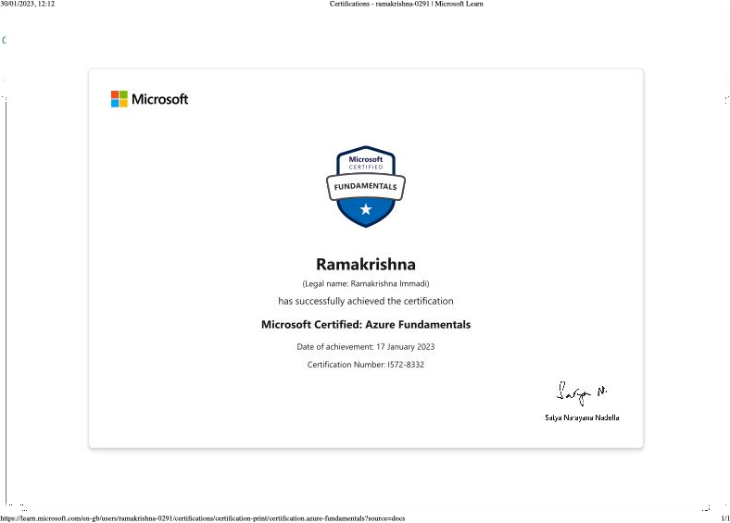 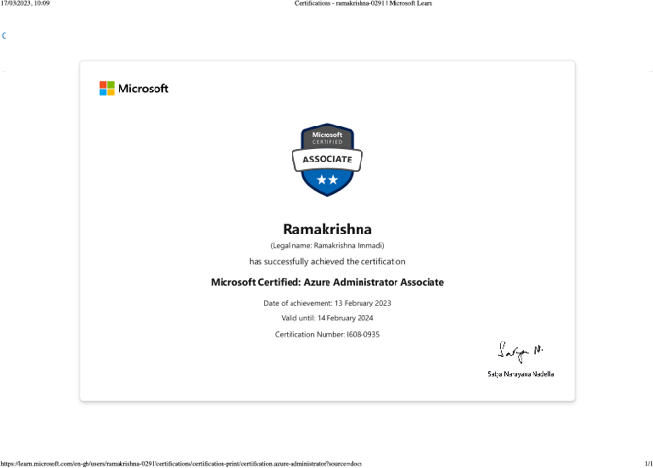

**DECLARATION:**

I do hereby declare that the information furnished above is true to the best of my Knowledge. Place: (Ramakrishna)