**TABLEAU – VISUALIZATION**

**Harish A K**

**E0121008**

1. **Create Chart between Measure Names and Measure Values. Add filter to Measure Names**

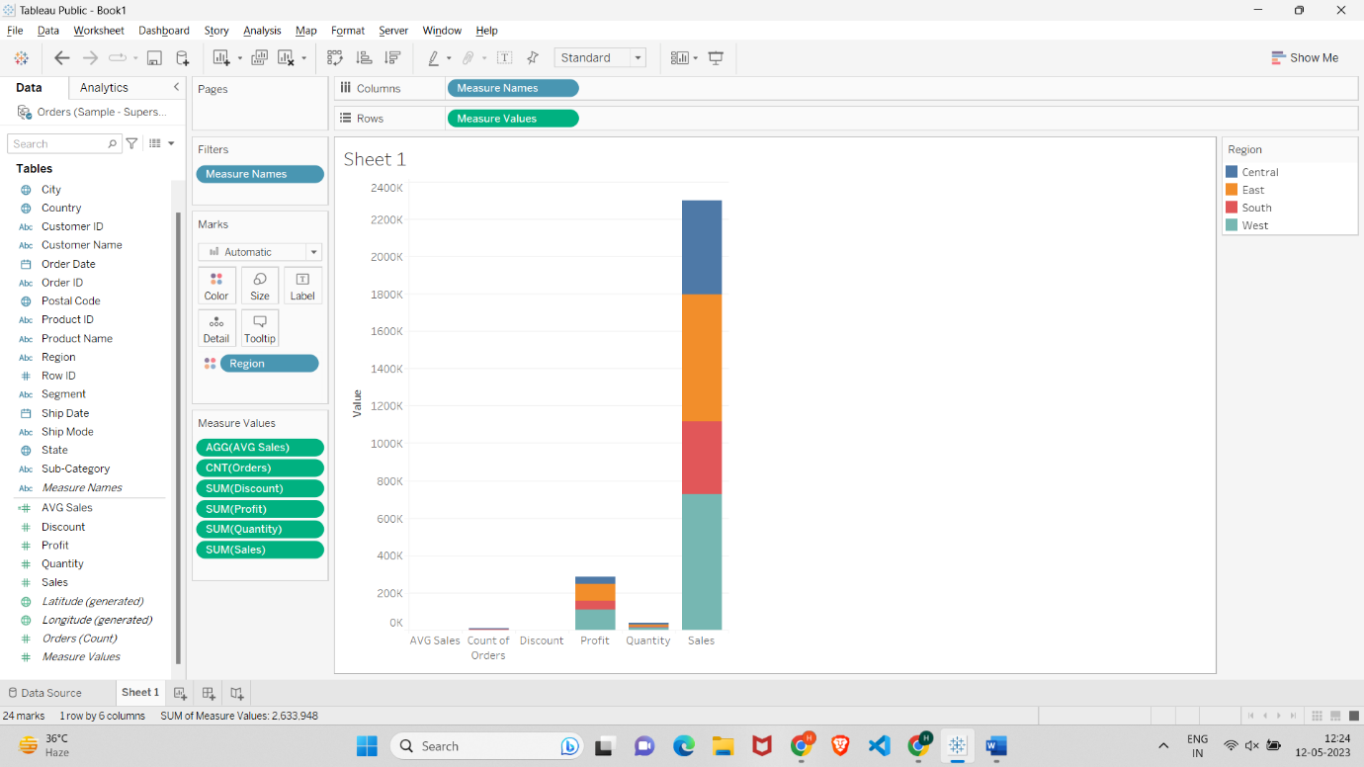

**2.** **create a chart for the total profit on different years along with the profit earned by**

**Months**

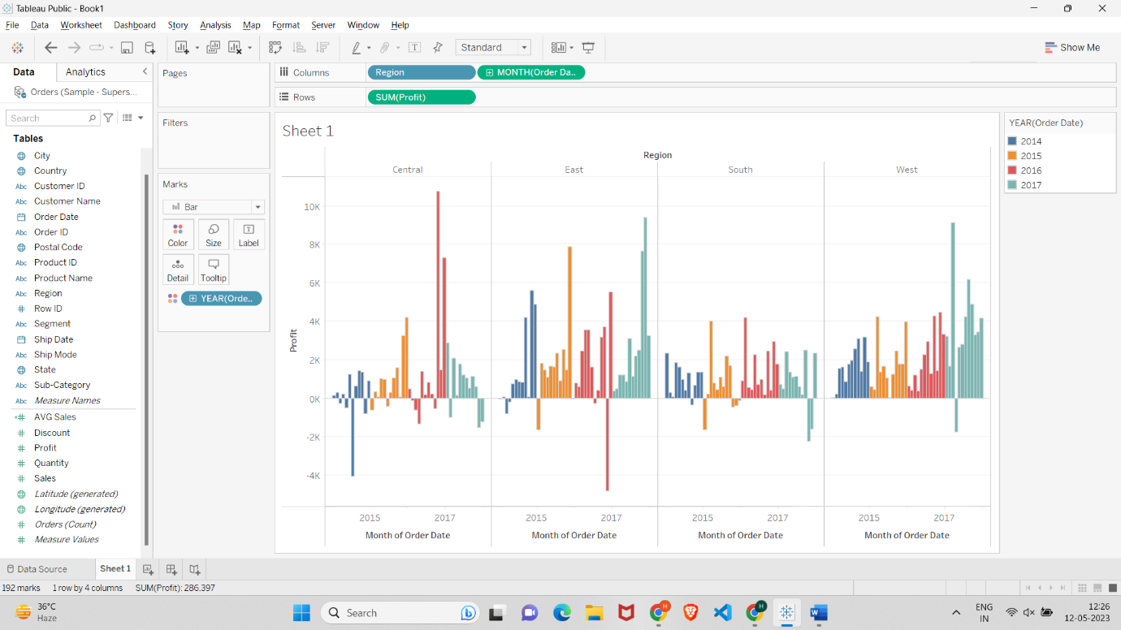

**3.** **Create chart for the total profit on different years along with the profit earned by**

**months on the x-axis.**

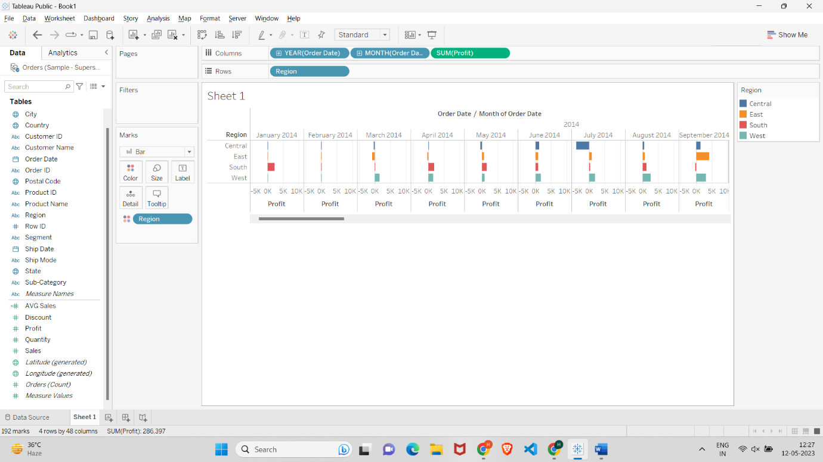

**4.** **Create a text table for the Avg (Sales) for each subcategory using Sample Superstore?**

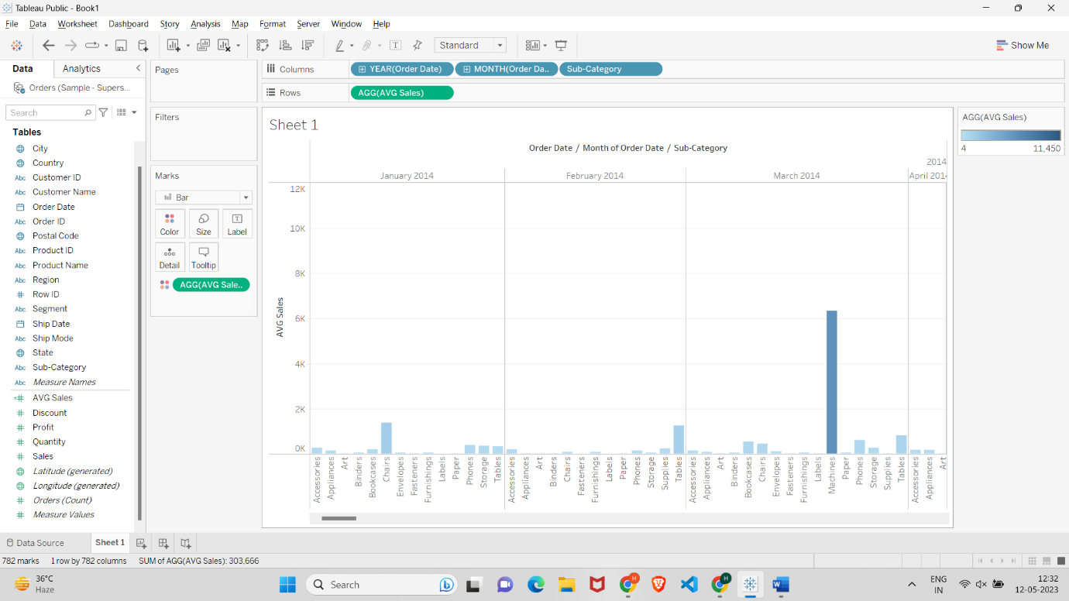

**5. List which Sub Category is got Avg (Sale) more than $1000? -Sample Superstore**

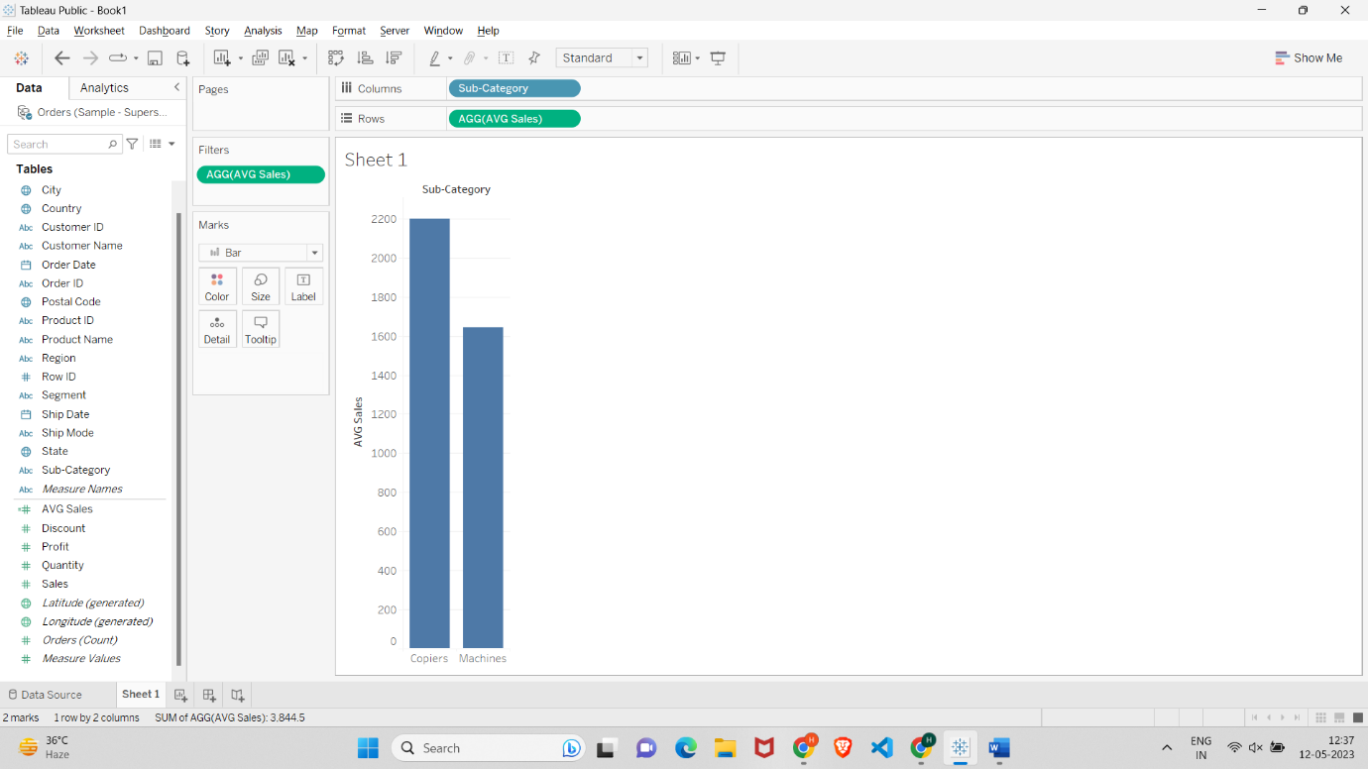

**6.** **Create a Highlight table for the States for the Order Date Year whose highlighting is**

**done based on Sum of profits -Sample Superstore**

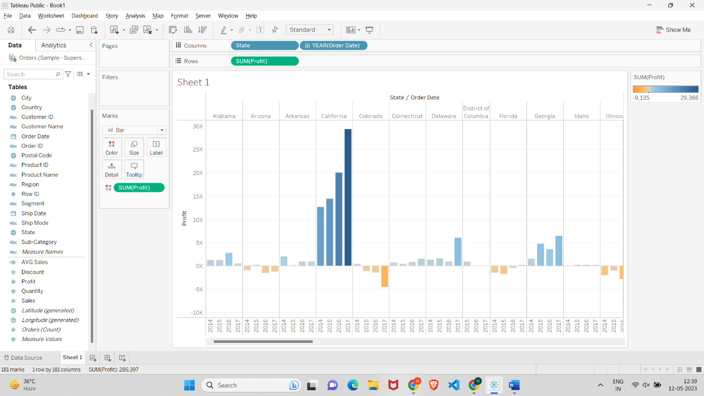

**7. Which customer is having maximum returns of sales in the year 2011? -Global**

**Superstore.**

