# This task1:1 was run in jupyter ; Other remaining tasks were run in PyCharm

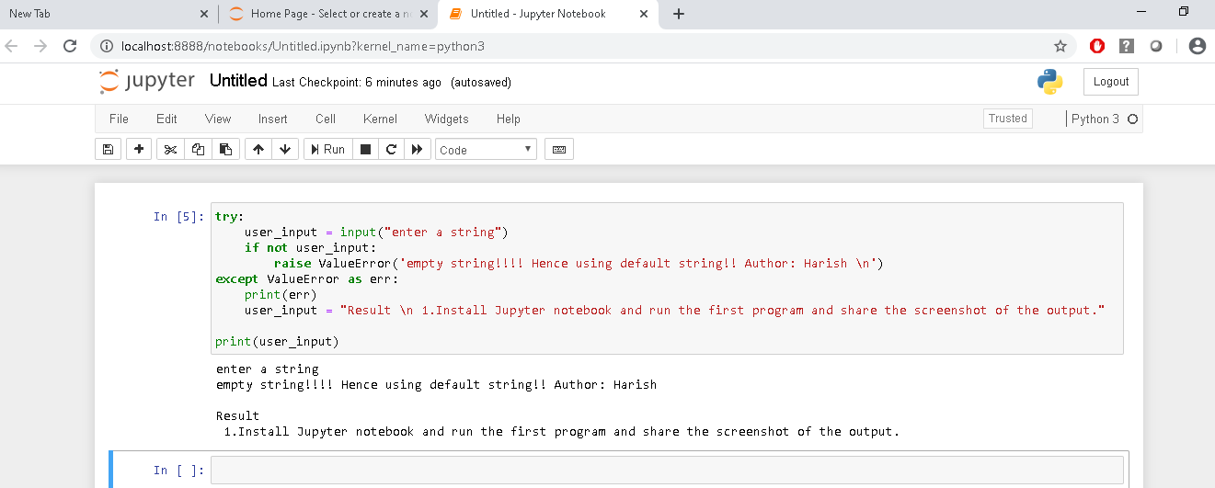

Have used two versions to solve the same . One of the answers doesn’t have the function taught in the session , so wasn’t sure if that would be acceptable for this , so have pasted both approaches

Approach 1: representing output as a list;

**Please note, all the values are printed in a single line but since so many values couldn’t be showed in this snapshot, have copied the results in separate lines with comments from the pycharm output console to the code editor**

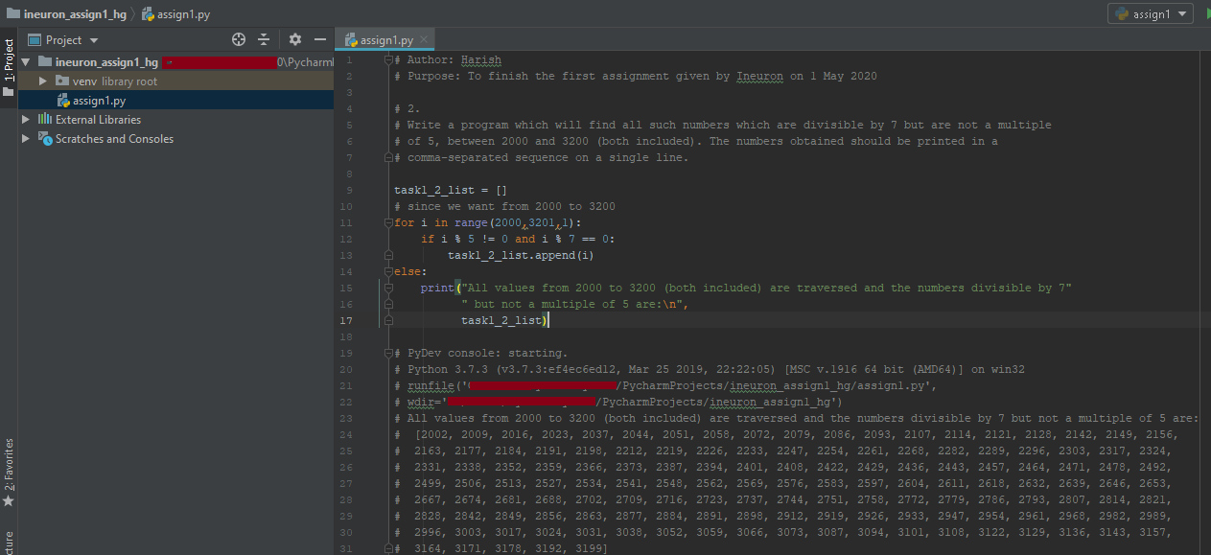

Approach 2: Using Join method and displaying output as just a string with commas

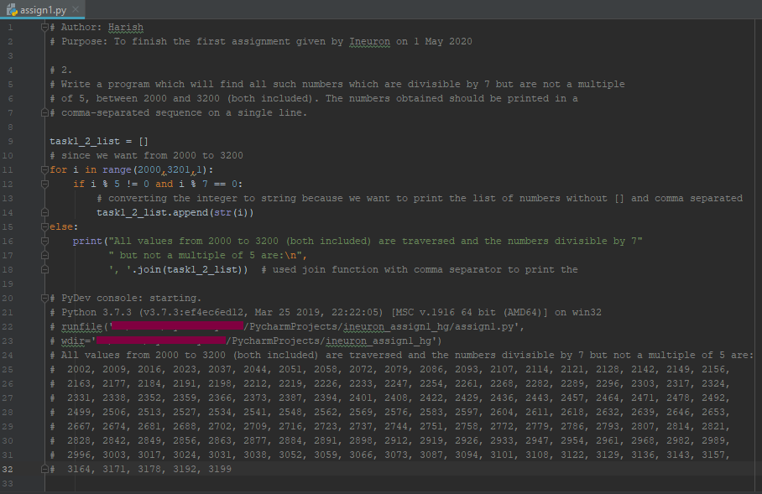

Task1 :3

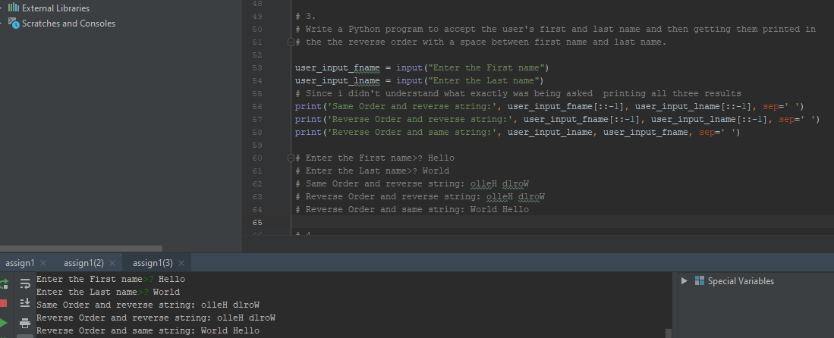

Task1:4

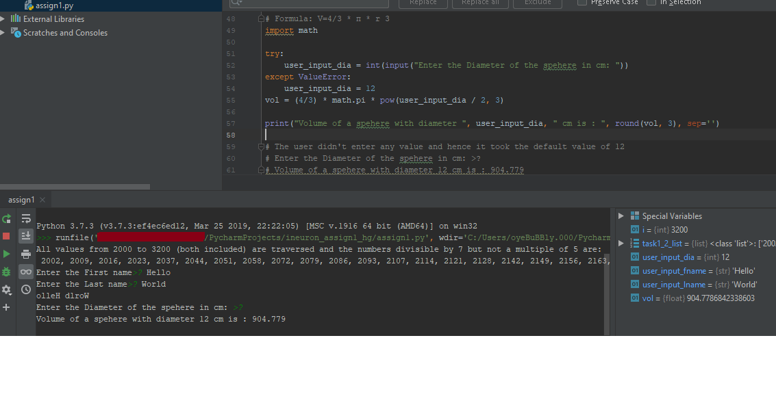

Task2:1

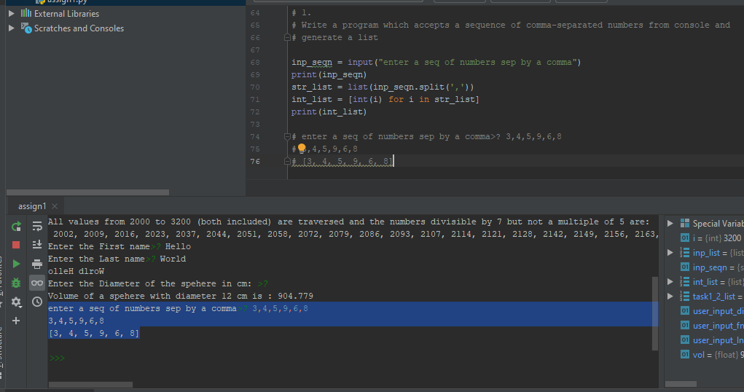

Task2:2

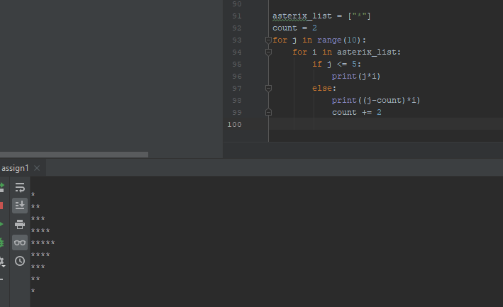

Task2:3 ; Used two test cases words were TeSt and AcadGild

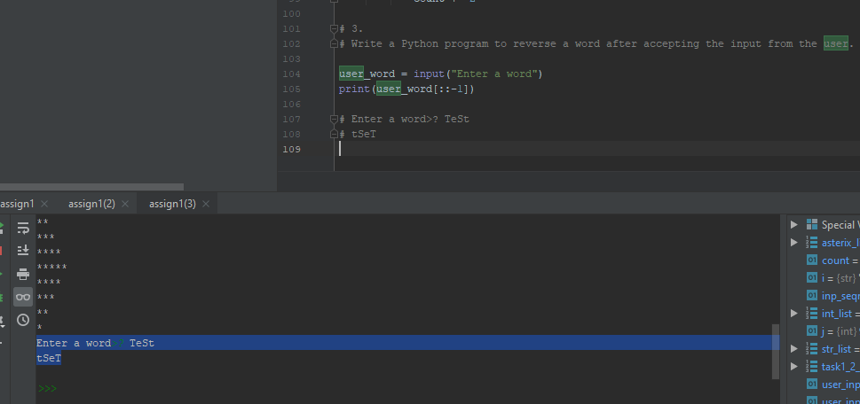

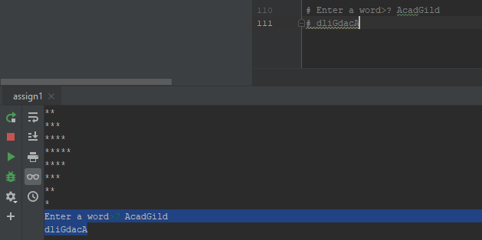

Task2:4

