Test a Perceptual Phenomenon

Project 1 of Udacity Data Analysts Nanodegree

Author: Harish Kumar Garg

Contents

1. Summary
2. Questions For Investigation
3. Resources

## Summary

In this project, we are going to investigate a Stroop Task. From the [project instructions](https://docs.google.com/document/d/1-OkpZLjG_kX9J6LIQ5IltsqMzVWjh36QpnP2RYpVdPU/pub?embedded=True),

*In a Stroop task, participants are presented with a list of words, with each word displayed in a color of ink. The participant’s task is to say out loud the color of the ink in which the word is printed. The task has two conditions: a congruent words condition, and an incongruent words condition. In the congruent words condition, the words being displayed are color words whose names match the colors in which they are printed: for example RED, BLUE. In the incongruent words condition, the words displayed are color words whose names do not match the colors in which they are printed: for example PURPLE, ORANGE. In each case, we measure the time it takes to name the ink colors in equally-sized lists. Each participant will go through and record a time from each condition.*

## Questions For Investigation

**1. What is our independent variable? What is our dependent variable?**

**Answer:**

* Our independent variable is the type of test i.e.whether the words presented were congruent or incongruent.
* Our dependent variable is the time it takes to finish the test.

**2. What is an appropriate set of hypotheses for this task? What kind of statistical test do you expect to perform? Justify your choices.**

**Answer:**

Hypotheses:

* Null hypotheses is that the average time it takes to perform the incongruent test is <= congruent test
* Alternative hypotheses is that the average time to takes to perform the incongruent test is >= congruent test

Statistical Test:We would be performing the Paired Samples T Test because our data is a matched pairs samples and we want to infer that the parameter is greater than the hypothesized parameter.

**3. Report some descriptive statistics regarding this dataset. Include at least one measure of central tendency and at least one measure of variability.**

**Answer:**

* Average
  + Congruent test: 14.051125
  + Incongruent test: 22.01591667
  + Time difference: 7.964791667
* Standard Deviation for
  + Congruent test: 3.559357958
  + Incongruent test: 4.797057122
  + Time difference: 4.86482691

**4. Provide one or two visualizations that show the distribution of the sample data. Write one or two sentences noting what you observe about the plot or plots.**

**Answer:**

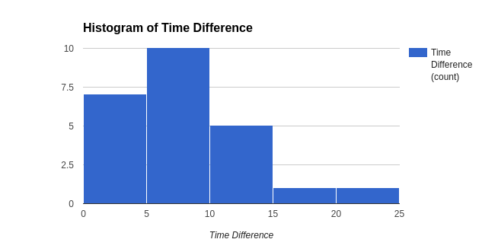

**Observations:**

* Time difference have a positively skewed distribution
* We have a couple of outliers.

**5. Now, perform the statistical test and report your results. What is your confidence level and your critical statistic value? Do you reject the null hypothesis or fail to reject it? Come to a conclusion in terms of the experiment task. Did the results match up with your expectations?**

**Answer:**

Test Stats:

* Confidence level: 95%
* Test Statistics(t): 8.0207069
* Critical statistic value: 1.7138715

Conclusions:

* Test statistic is greater than the critical statistic value, hence Null hypothesis is rejected
* Final conclusion is that the average time it takes for incongruent test is more than the congruent test.
* When I took the test, i felt i hesitated every time in the incongruent test, no matter how many times I try it. So yes, the results match with the expectations.

**6. Optional: What do you think is responsible for the effects observed? Can you think of an alternative or similar task that would result in a similar effect? Some research about the problem will be helpful for thinking about these two questions!**

**Answer:**

* There are several theories why this happens and some are explained on the [wikipedia page](https://en.wikipedia.org/wiki/Stroop_effect). The explanation which strikes to me the most if that the we read faster then we identify colors and putting them together confuses the brain as it has already read the word and trying to skip identifying the color as brain tries to overcompensate and skip the extra work of identifying the color by how it looks.
* Show 2 pair of different digits at a time. In the first test, keep the size of the digits as same. In the second test, vary the size of the digits. Measure the time person takes to identify which digit is bigger in both cases.

## Resources

1. <https://en.wikipedia.org/wiki/Stroop_effect>
2. <https://docs.google.com/document/d/1-OkpZLjG_kX9J6LIQ5IltsqMzVWjh36QpnP2RYpVdPU/pub?embedded=True>
3. <http://libguides.library.kent.edu/SPSS/PairedSamplestTest>