**Steps to create Insight68.com using Docker containers**

1. Unzip the given folder “**insight-docker-image**” and go to the location

“insight-docker-image” folder using command prompt.

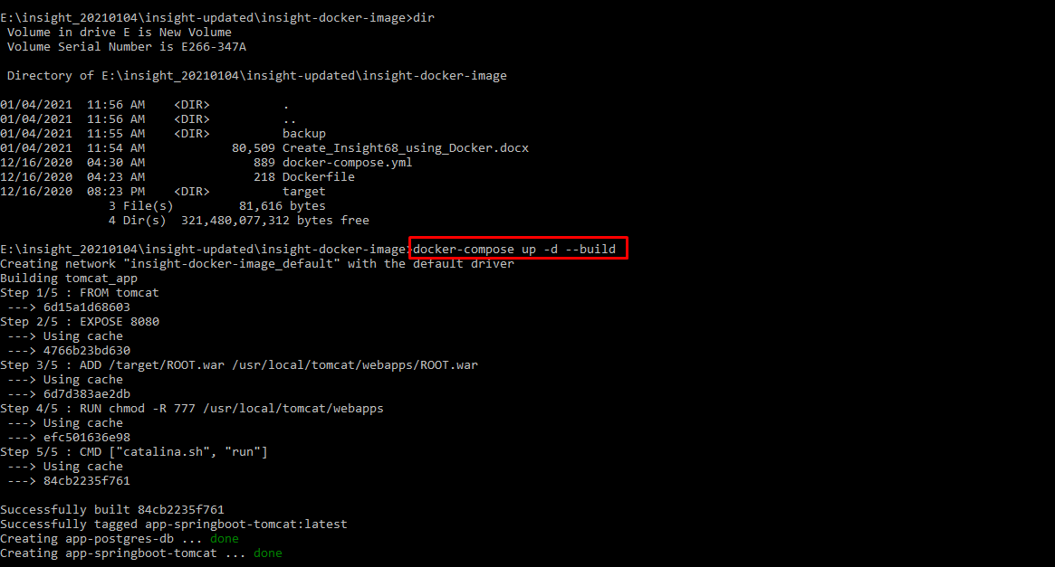

1. And execute “**docker compose up –d --build**”
2. Then open “**localhost**” in browser.
3. Login with below credentials :  
   **Username:** [admin@gmail.com](mailto:admin@gmail.com)

**Password:** Admin@123

**Note:** Please don’t edit **“POSTGRES_DB=insight”** but we can edit database Username and Password as per requirement, by editing variables “**spring.datasource.username**” and “**spring.datasource.password**” in **docker-compose.yml** file under “**tomcat_app**“service and “**postgres_server_tomcat”** service in “**environment”.**



