|  |  |
| --- | --- |
| **DESIGN PROJECT REPORT COVER SHEET** | **ANU College of Engineering and Computer Science** Australian National University Canberra ACT 0200 Australia **www.anu.edu.au**  **+61 2 6125 5254** |
| Submission and assessment is anonymous where appropriate and possible. Please do not write your name on this coversheet.  This coversheet must be attached to the front of your assessment when submitted in hard copy. If you have elected to submit in hard copy rather than Turnitin, you must provide copies of all references included in the assessment item.  All assessment items submitted in hard copy are due at 5pm unless otherwise specified in the course outline. |

|  |  |  |  |
| --- | --- | --- | --- |
| Student ID  For group assignments, list each student’s ID | U 6366102 | | |
| Course Code | ENGN 6223 | | |
| Course Name | Control Systems | | |
| Assignment number |  | | |
| Assignment Topic | Design of Controller for Cruise Control | | |
| Lecturer | Dr. Guodong Shi | | |
| Tutor |  | | |
| Tutorial (day and time) |  | | |
| Word count |  | Due Date | 17/09/2018 |
| Date Submitted | /09/18 | Extension Granted |  |

I declare that this work:

* upholds the principles of academic integrity, as defined in the ANU Policy[: Code of Practice for Student Academic Integrity](https://hkxprd0610.outlook.com/owa/redir.aspx?C=pkUS4AqeVkC0OHXUsRYzk8JcJE65y9AI4r3Mqfll_bLO9DXo_dFgmbuC6N5TOcnRwCb-AmVT460.&URL=https%3a%2f%2fpolicies.anu.edu.au%2fppl%2fdocument%2fANUP_000392);
* is original, except where collaboration (for example group work) has been authorised in writing by the course convener in the course outline and/or Wattle site;
* is produced for the purposes of this assessment task and has not been submitted for assessment in any other context, except where authorised in writing by the course convener;
* gives appropriate acknowledgement of the ideas, scholarship and intellectual property of others insofar as these have been used;
* in no part involves copying, cheating, collusion, fabrication, plagiarism or recycling

Table of Contents

Introduction 1

Systems Modelling and Simulations 1

Controller Design and Validations 2

PID/PD controller design 2

Fuzzy P controller design 3

Discussions and Conclusions 5

Appendix: Models and Graphs 6

Fuzzy P Controller design for an average car 6

Fuzzy P Controller design for an average car - Optimized (Triangular Membership functions) 7

Fuzzy P Controller design for an average car (Gaussian Membership functions) 9

Fuzzy P Controller design for BMW 520D (Gaussian Membership functions) 11

Fuzzy P Controller design for BMW 520D (Triangular Membership functions) 13

Fuzzy P Controller design for Audi A4 2.0 TDI (Triangular Membership functions) 15

Fuzzy P Controller design for Audi A4 2.0 TDI (Gaussian Membership functions) 17

PID Controller in average car 19

PID Controller design for BMW 520D 22

PID Controller design for Audi A4 2.0 TDI 24

PD Controller design for an average car 26

PD Controller design for BMW 520d 28

PD Controller design for Audi A4 2.0 TDI 30

# Introduction

The Cruise control is one of the most used control systems in automobile industry to ensure the safety of the vehicle and cruise at any desired speed that can be achieved by a given vehicle. This report discusses the design of controllers for an average car, Audi A4 2.0 TDI, and BMW 520d.

The necessity of cruise control is to improve the driving experience, reduce fatigue, and advance the overall efficiency of the car. There are various techniques to attain a desirable solution for this problem. This report focuses on PD, PID based cruise controller design and Fuzzy P based controller design. The document also analyzes the advantages and disadvantages of each of the controllers and modelling of each of the above-mentioned cars and the performance of each of the controller in various scenarios that are experienced on roads.

# Systems Modelling and Simulations

Analyzing the given equation gives us an insight that the equation has non-linearity induced by the which in turn produces uncertainty over the system responses. The system is linearized over a specific point . Here the system is linearized over the point 50 kmph (13.88 ms-1).

The first step in achieving cruise control is to linearize and compute transfer function of the plant which generates the following equation,

The parameters chosen for each of the cars are tabulated below,

|  |  |  |  |  |
| --- | --- | --- | --- | --- |
| Cars / Parameters | m2 | ms-1 |  | kg |
| Average car | 0.23 | 13.88 | 1.1839 | 1000 |
| BMW 520d | 0.52 | 13.88 | 1.1839 | 1743 |
| Audi A4 2.0 TDI | 0.51 | 13.88 | 1.1839 | 1650 |

The systems modelling involves substitution of values to the transfer function to generate the plant transfer function. This function is substituted to the transfer function block of Simulink.

When the open-loop transfer function of the plant is simulated for unit step input, the plant response keeps rising as it does not have any reference value to settle. This confirms the need of controller design for this problem. Also, analyzing the transfer function also validates this stand as poles of the system remains close to the imaginary axis (in the order of 10-3).

# Controller Design and Validations

## PID/PD controller design

The design of PID/ PD controller was one of the challenging tasks in arriving at a solution for this problem. The PID controller was manually designed using Ziegler – Nichols method [] to understand the concepts behind the tuning of PID controllers. The controllers designed was also initially designed using the integrator, differentiator, and gain blocks to understand how a PID/ PD controller works. When designing the controller, the following block diagram was followed to implement the controller,

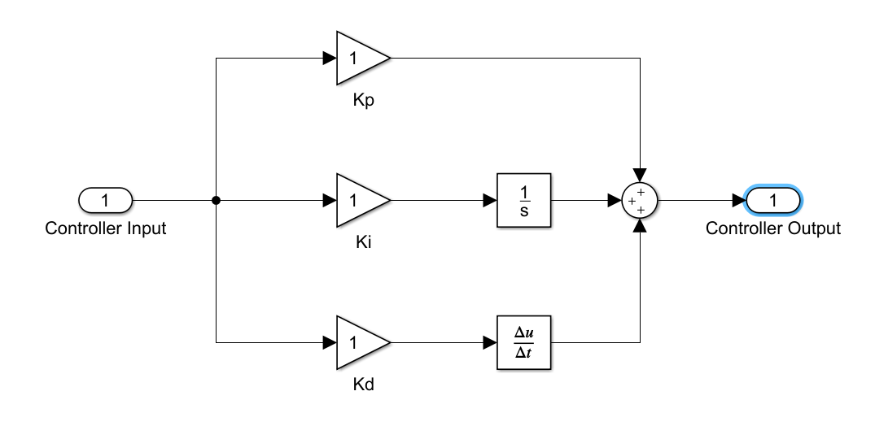

The Kp, Ki, Kd mentioned in the diagram are samples, the applied values are documented in the Appendix.

The initial open loop test conducted on the system resulted in a ramped response and the open loop was made into a closed loop using proportional control alone. The system response was satisfactory, but the steady state error was about 5-7% on various instances like difference in mass, change of road conditions.

Later, after some research [] I was able to confirm that whatever change in the gain of the proportional controller it won’t affect the steady state of the system. This lead to testing of system with PD alone. The response of the system was better than the earlier proportional controller, yet the rise time was unrealistic. To understand the rise time of the car from 0-100 kmph, I was able to find some credible documents which provided enough details on the design specifications of the cars []. When the controller was designed for a specific model, the controller was designed based on the rise time of each car from 0-100 kmph. BMW 520d and Audi A4 2.0 TDI has a rise time of 7.7s and 8.9s respectively. Updating the transfer function parameters, the controller gain was adjusted to the specified rise time. The controller was also validated using this criterion. The Simulink’s PID block was also studied and the controller tuning methods were also studied which also resulted in similar gains as obtained through Ziegler-Nichols method.

To explore more on system performance, I tested the system with “Repeating stair sequence” in Simulink with 8s time space for each transition of signal over a period of 120s. On testing the system, I was able to comprehend the reality of applying gradient or sudden transition of speeds. Though PD controller performed satisfactorily on flat road scenario, when it came to mixed field scenario, both BMW 520d and Audi A4 2.0 TDI were unable to gradually reach the speed of 110 kmph due to the restrictions on engine power within the given timeframe. When the system was given enough time, it did settle in its set point value. Adjusting the parameters of the controller is out of scope because the gains of the controller were chosen based on the rise time specified by the company for the flat road scenario. Adjusting/ optimizing them would cause undesirable response in the flat road scenario. The average car is more like a *conceptual* car with the parameters based on the general design of 4-door sedan type cars. The controller response of the average car is considered as ideal response of cruise controller in the car. The changes in ρ does not cause any major deviations in the controller response. The weight tabulated earlier is kerb weight of the cars, when the car is operated in full load conditions, the controller responses are similar as of with a minimum load with slight variations in rise time in flat road (in order of 10-2) and in mixed road, the controller reaches lower speeds with variation of about 3-5% of its value reached in minimum load conditions.

When I moved on to PID controllers in the thoughts of improving control accuracy, the integrator induced oscillations to the system response. As I moved from PD to PID for controller accuracy, it was clear that the differential term suppressed the overshoot that is induced by the integral of the controller. Increase of integral gain increased the overshoot in the system, so I intended to use the integral controller as a tool to reach the set point value with greater accuracy. When the controller was validated using the actual car parameters (BMW 520d and Audi A4 TDI), the controller response on the float road scenario had slight variation in settling value with 2 - 3% increase. A significant difference was seen in the mixed field scenario where the controller delivered a 3 - 5% increase in the settling value compared to the PD controller.

The gains of PD/ PID controller must be changed manually over every scenario to understand the performance of the controller. A car may be driven various regions in a country. So, when designing PD/ PID controller for cruise control of a car it is better to design controllers which are region specific to ensure the better satisfaction of the customers. Also, if the company management decides to design controller for various regions, it would be a wise choice to go with adaptive control where the gains of the controller can be changed on real time. Another feasible solution would be every car can have more than one controller which can be activated manually through switches for various regions of the country (like economy/ sport mode selection which stops/ kick starts turbochargers in engines). The only disadvantage of this solution is that it would shoot up the costs of the overall unit.

## Fuzzy P controller design

To overcome this disadvantage, I implemented P controller alongside Fuzzy logic controller. Fuzzy is a rule-based algorithm which covers a wide area of errors and can be implemented for unpredictable systems. As I explained earlier P controller reaches steady state value with up to 5% error from setpoint value. This can be rectified by coupling P controller with fuzzy logic controller. Fuzzy acts upon the rules to decide the output and fires it to the system. The rules of the controller are controlled using the membership functions, which ranges over a specific region. The rules are framed in the form of if-then. The controller output signals are almost similar to the PID and gives better control accuracy. Another reason for designing Fuzzy P controller is because it is easy to design and as it acts upon the rules alone, the designer just needs to frame the rules to give the output variable bounded for every bounded input which ensures that there is no unexpected behavior of the controller. The designer also needs to be extra careful while framing the rules because if one of the inputs doesn’t have any rules then the controller output will be unpredictable.

To design Fuzzy controller in MATLab, one can use fuzzy toolboxes and call the variables to Simulink through Fuzzy block. The rule viewer also helps to analyze the output for each possible value of error. I designed the controller considering a maximum error in the system as 60, so the driver of the car can go from 0-60 kmph in a single stretch and later adjust the car for higher speeds. The controller can also be modified to accept error values (say 110), when error acceptance range is higher, the number of membership functions and rules increases to improve the accuracy of the controller output which increases the complexity of the system. This controller can also be coupled to perform other tasks like cruise control and braking which are highly related to each other and ensures the safety of the driver/ passengers. This can be done adding one more variable for braking and frame rules around error, error derivatives and cruising speed of the vehicle. The above controller is designed with future scope of the controller in mind to incorporate braking and many other features.

The Fuzzy P controller was tested out for its responses for triangular and gaussian membership functions for the inputs and outputs of the controller. The rules of the fuzzy controller were framed using the following tabulation,

|  |  |  |  |  |  |
| --- | --- | --- | --- | --- | --- |
| Error/ Error derivative | HN | MN | Zero | MP | HP |
| LN | MP | HP | HP | VHP | VHP |
| MN | SP | MP | MP | HP | VHP |
| Zero | SN | SN | NO | SP | SP |
| MP | HN | HN | MN | MN | SN |
| LP | VHN | VHN | HN | HN | MN |

HN / HP – High Negative / High Positive

MN / MP – Medium Negative / Medium Positive

SN / SP – Small Negative / Small Positive

VHN / VHP – Very High Negative / Very High Positive

Each of the categories in the table has a certain range of values depending on the car and there are 5 membership functions in each of the input and inputs outputs one of the 9 membership functions based on the tabulated rules. When the system over/undershoots, the output needs to be recalibrated so that over/undershoots are under acceptable levels.

# Discussions and Conclusions

I recommend using Fuzzy based controller because of their versatility and easy implementation procedure.

# Appendix: Models and Graphs

## Fuzzy P Controller design for an average car

Uphill scenario

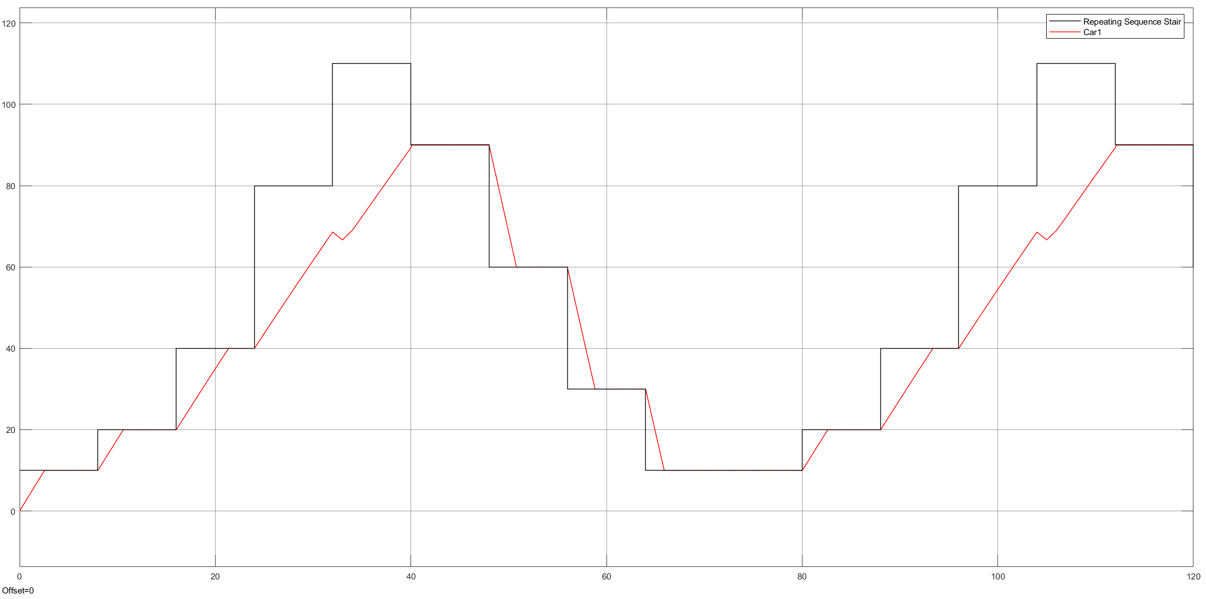

## Fuzzy P Controller design for an average car - Optimized (Triangular Membership functions)

Flat road scenario

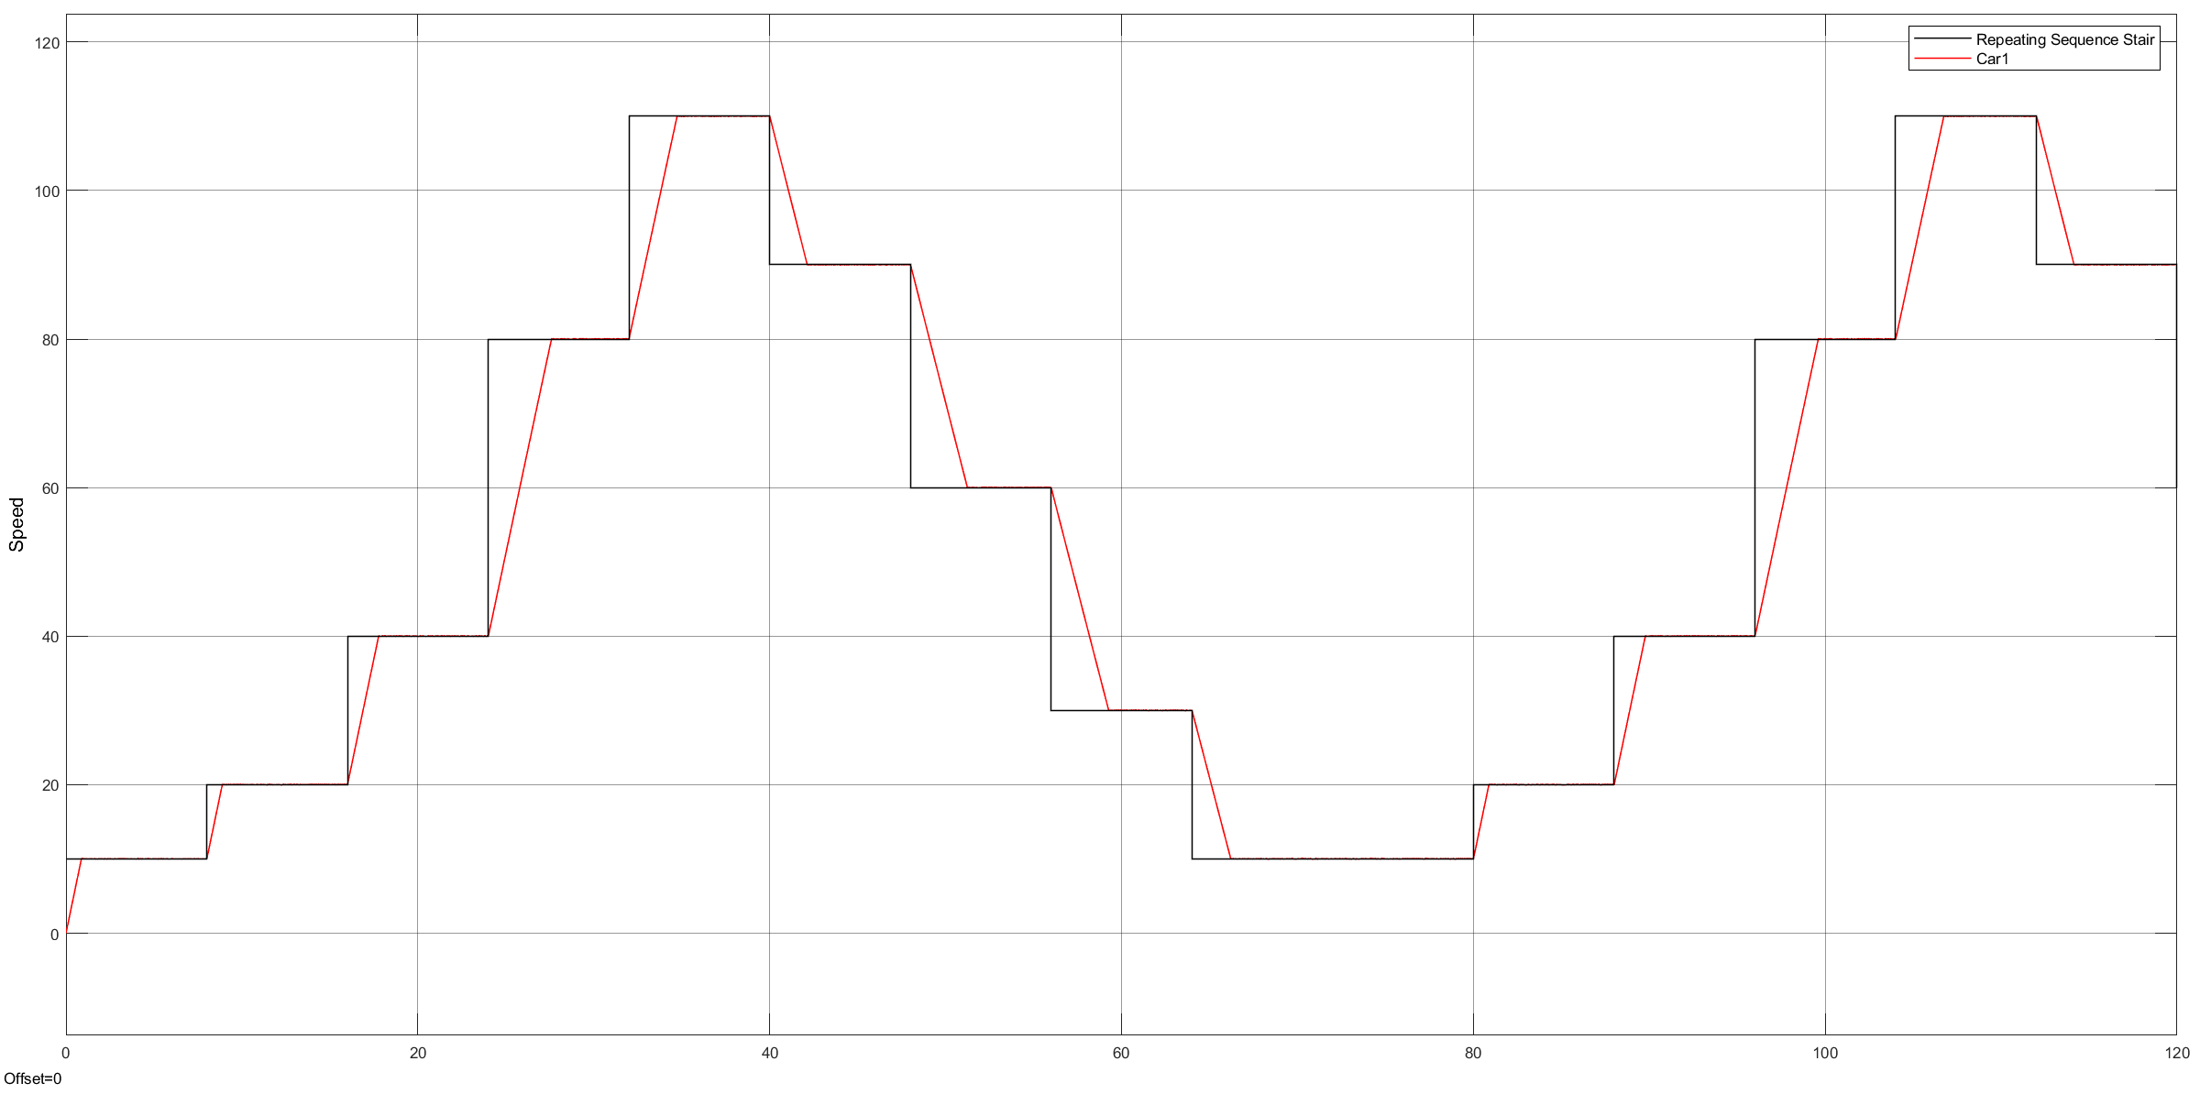

Uphill scenario

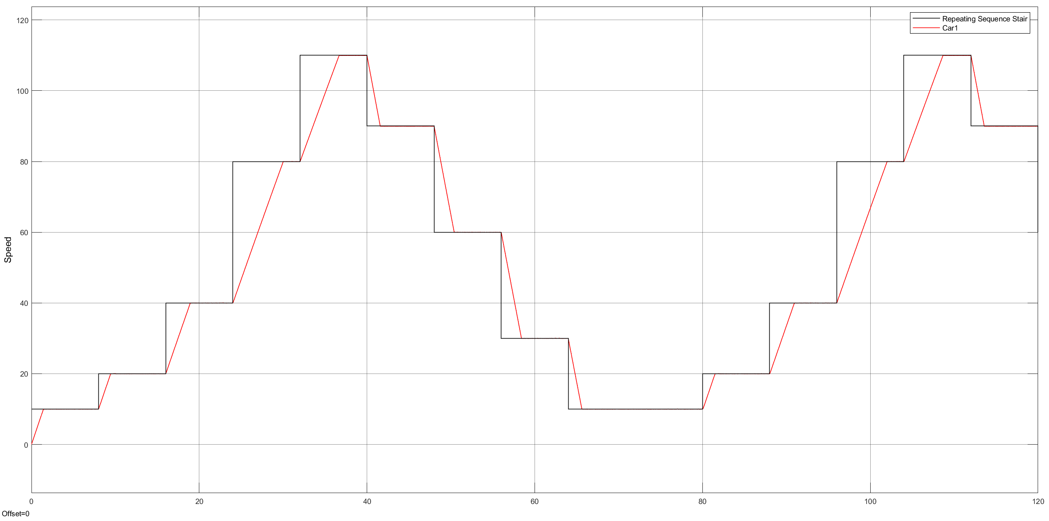

## Fuzzy P Controller design for an average car (Gaussian Membership functions)

Flat road scenario

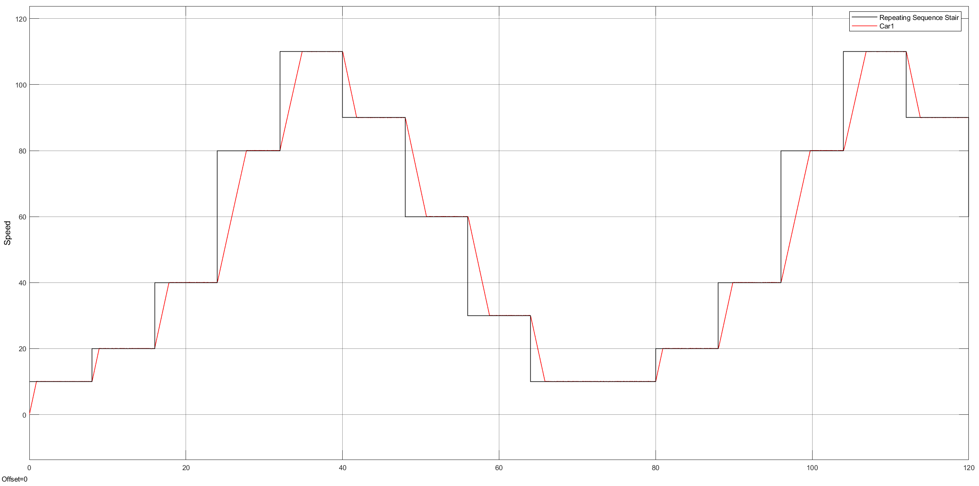

Uphill scenario

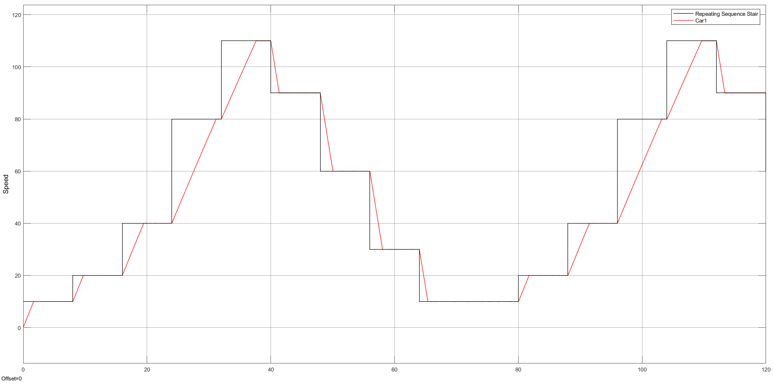

## Fuzzy P Controller design for BMW 520D (Gaussian Membership functions)

Flat road scenario

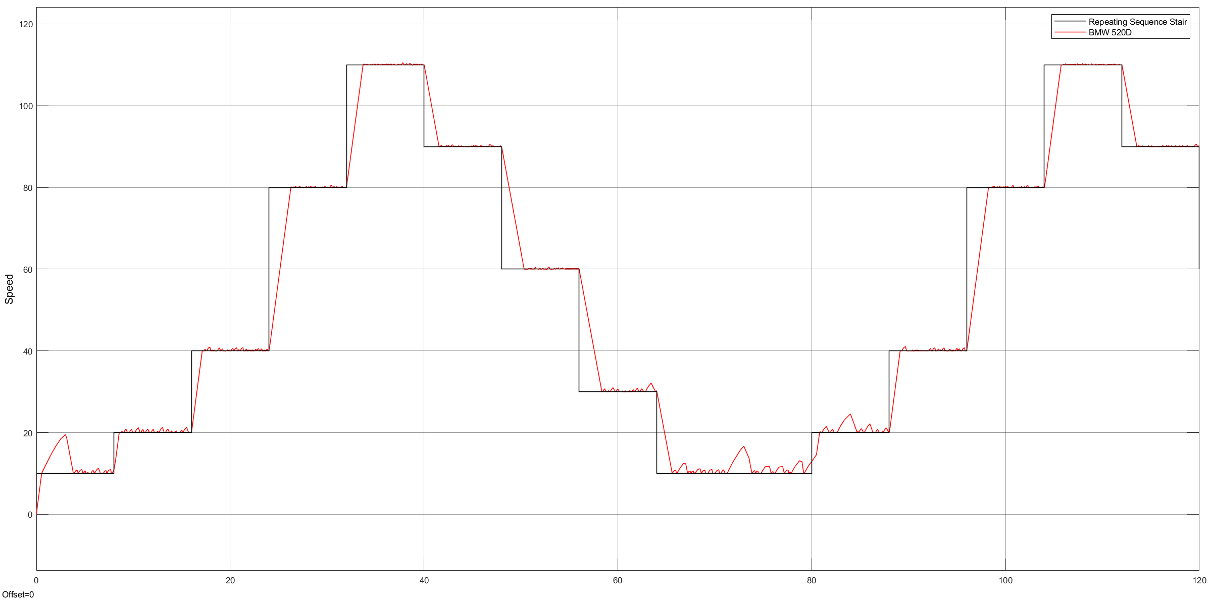

Uphill scenario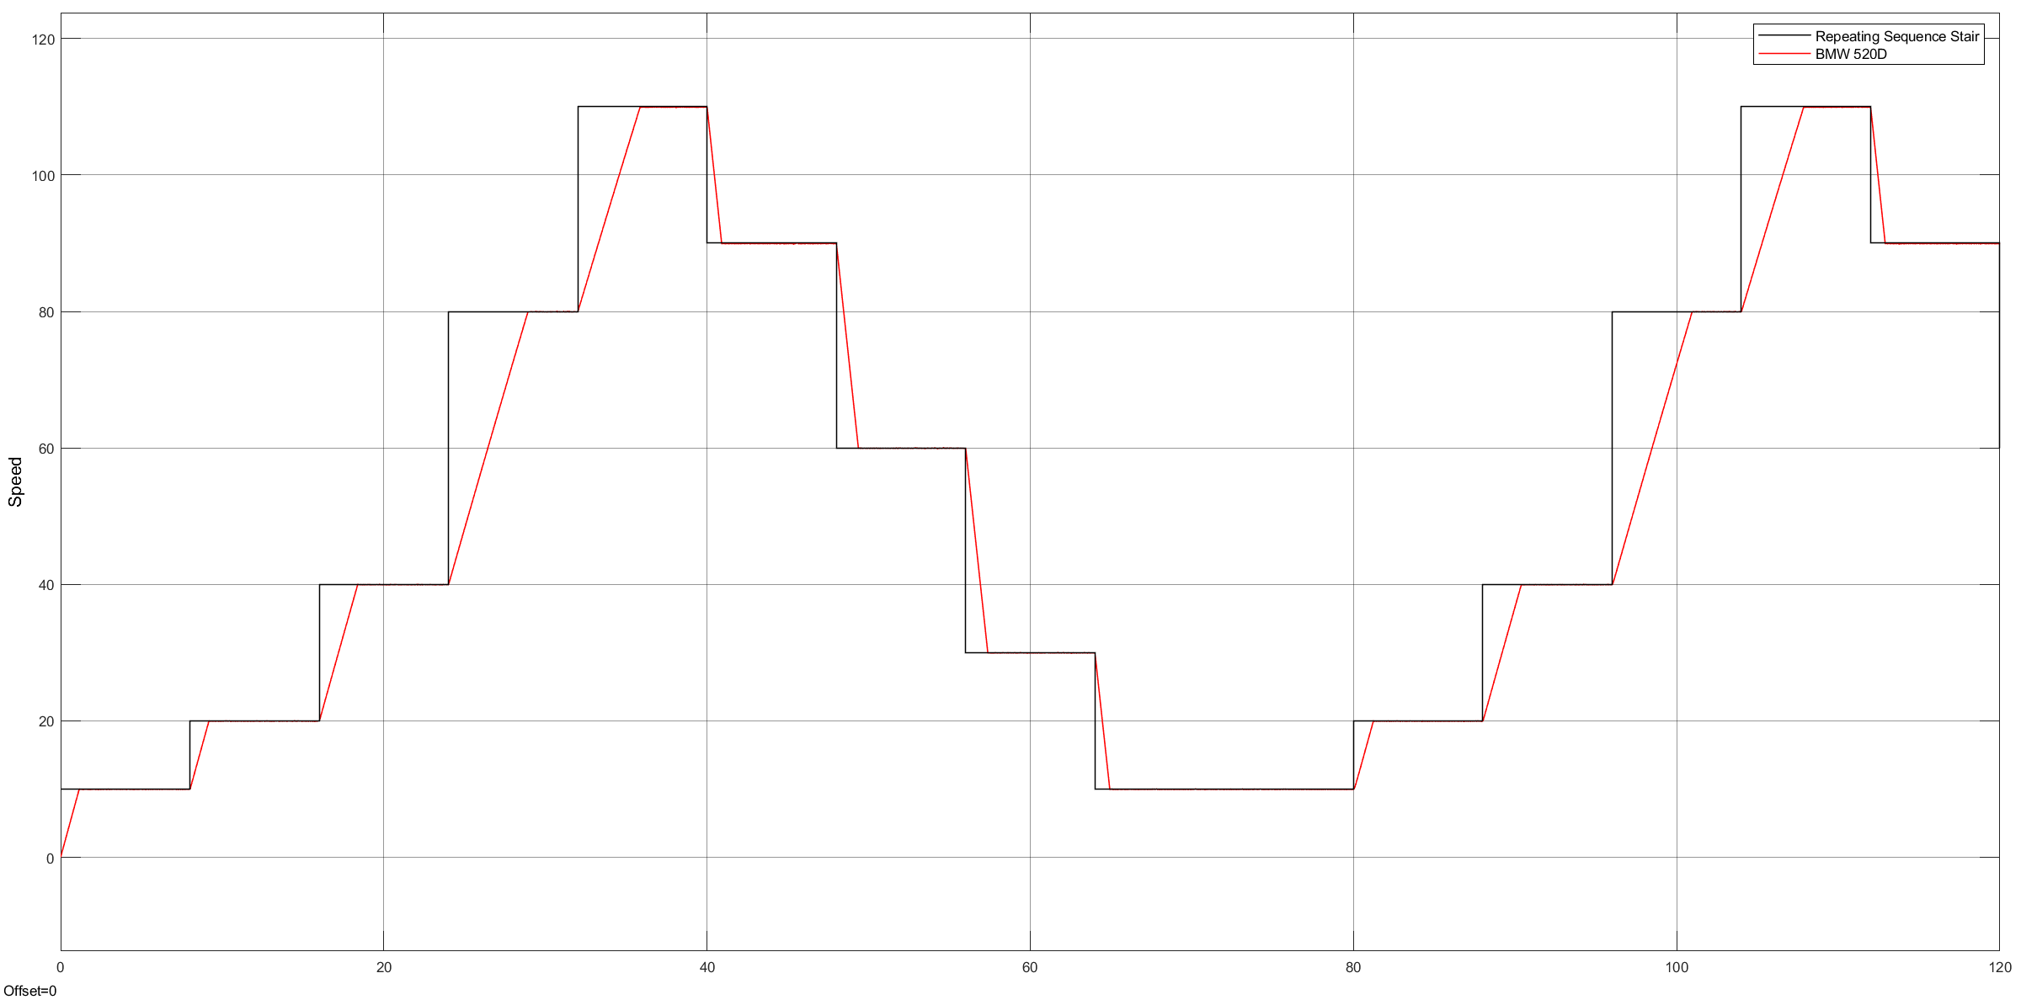

## Fuzzy P Controller design for BMW 520D (Triangular Membership functions)

Flat road scenario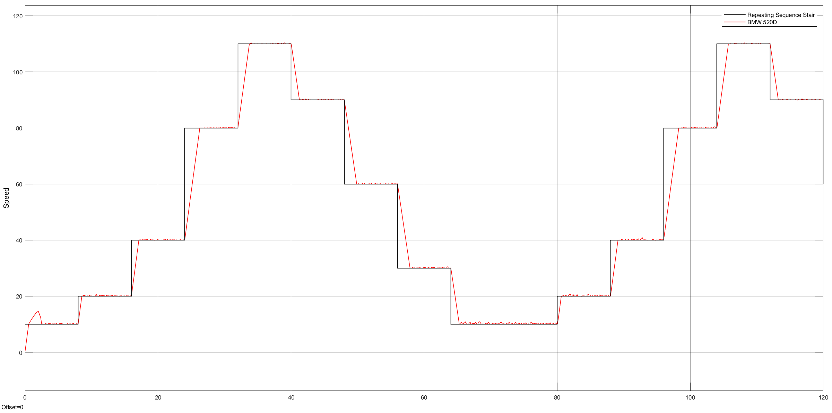

Uphill scenario

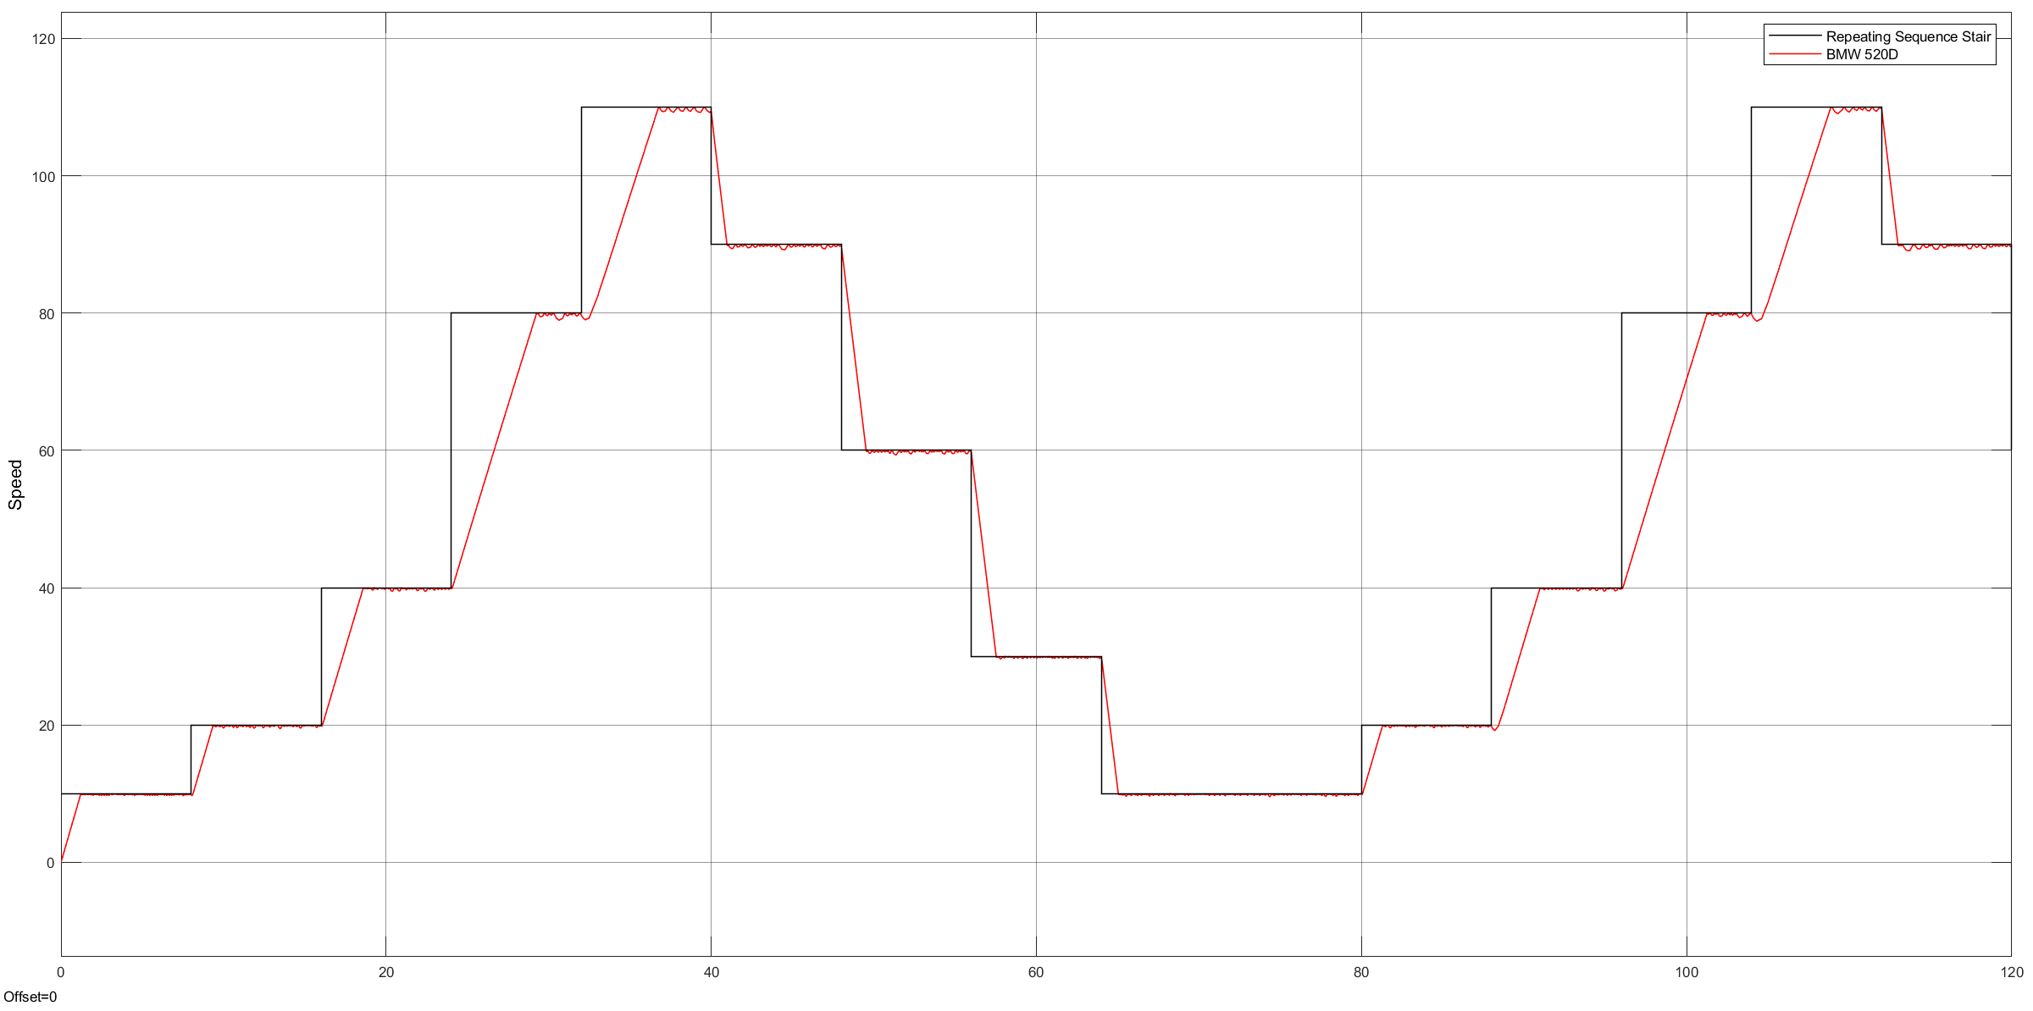

## Fuzzy P Controller design for Audi A4 2.0 TDI (Triangular Membership functions)

Flat road scenario 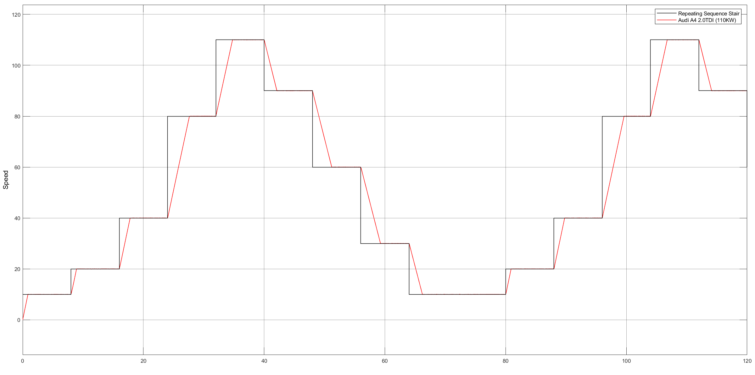

Uphill scenario

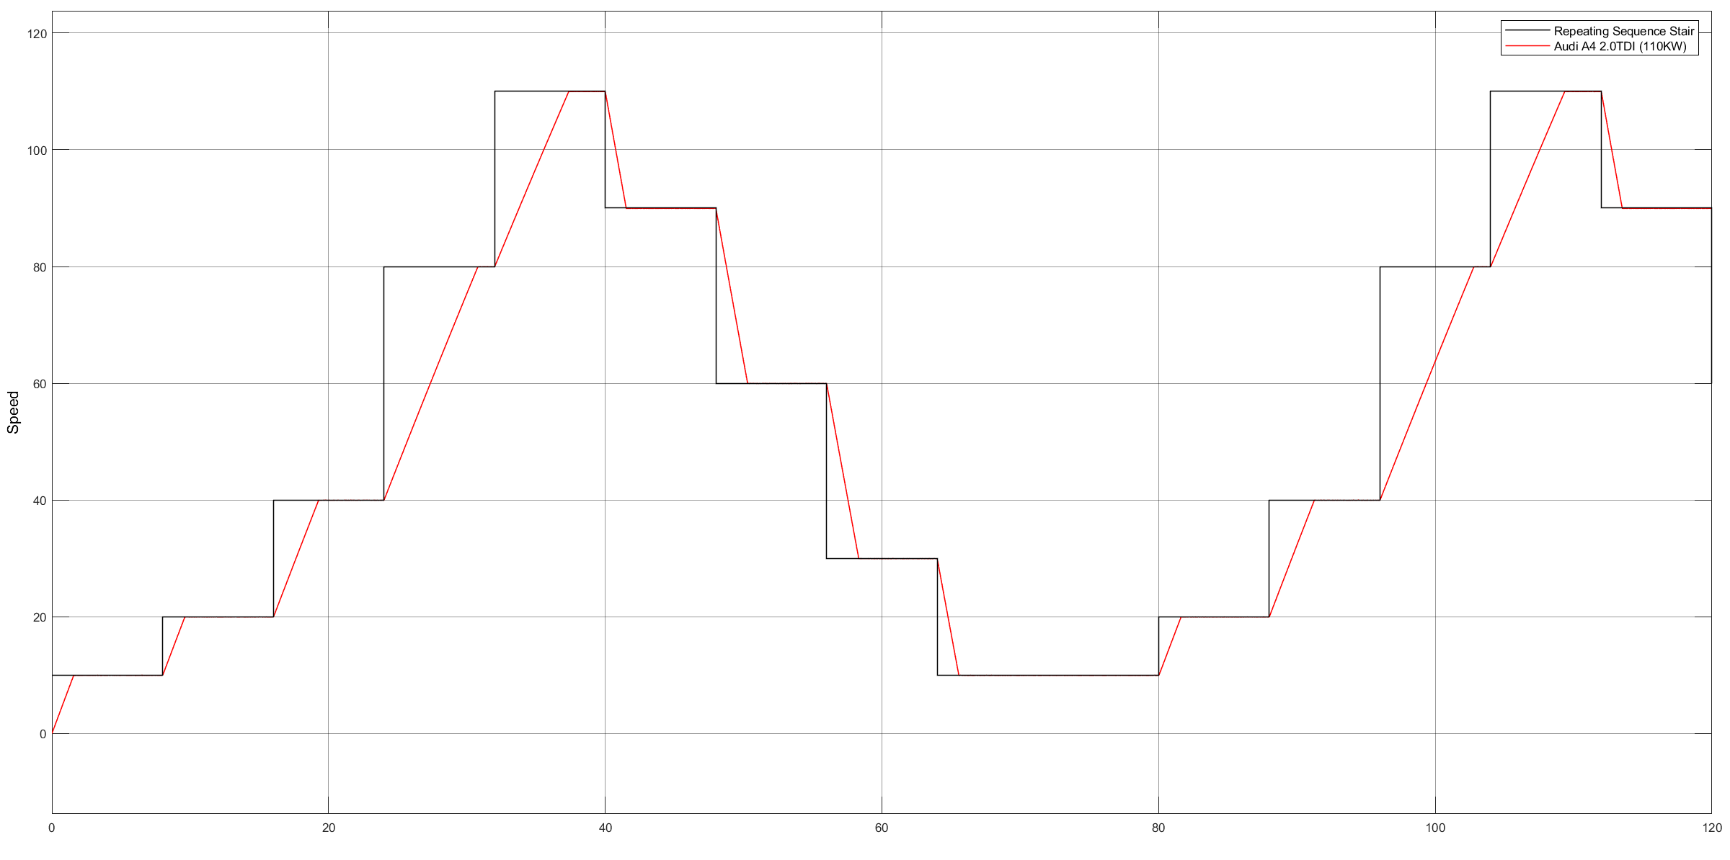

## Fuzzy P Controller design for Audi A4 2.0 TDI (Gaussian Membership functions)

Flat road scenario

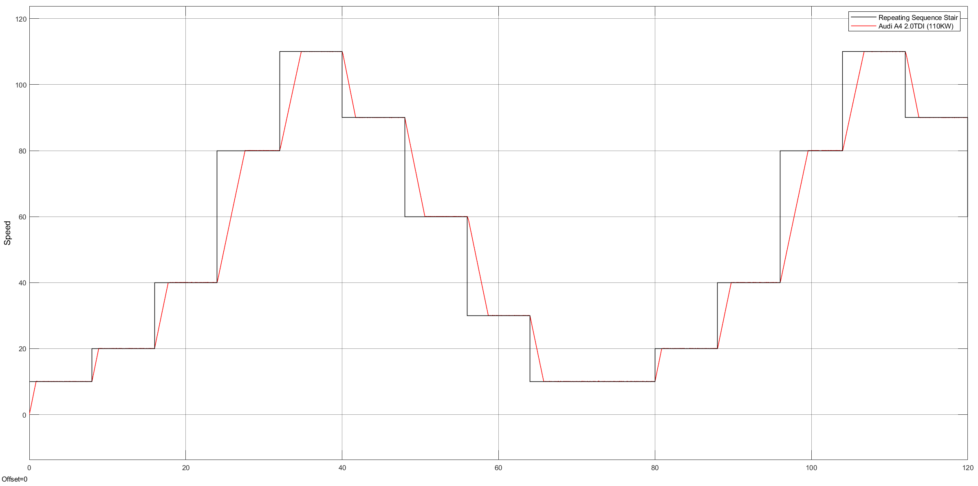

Uphill scenario

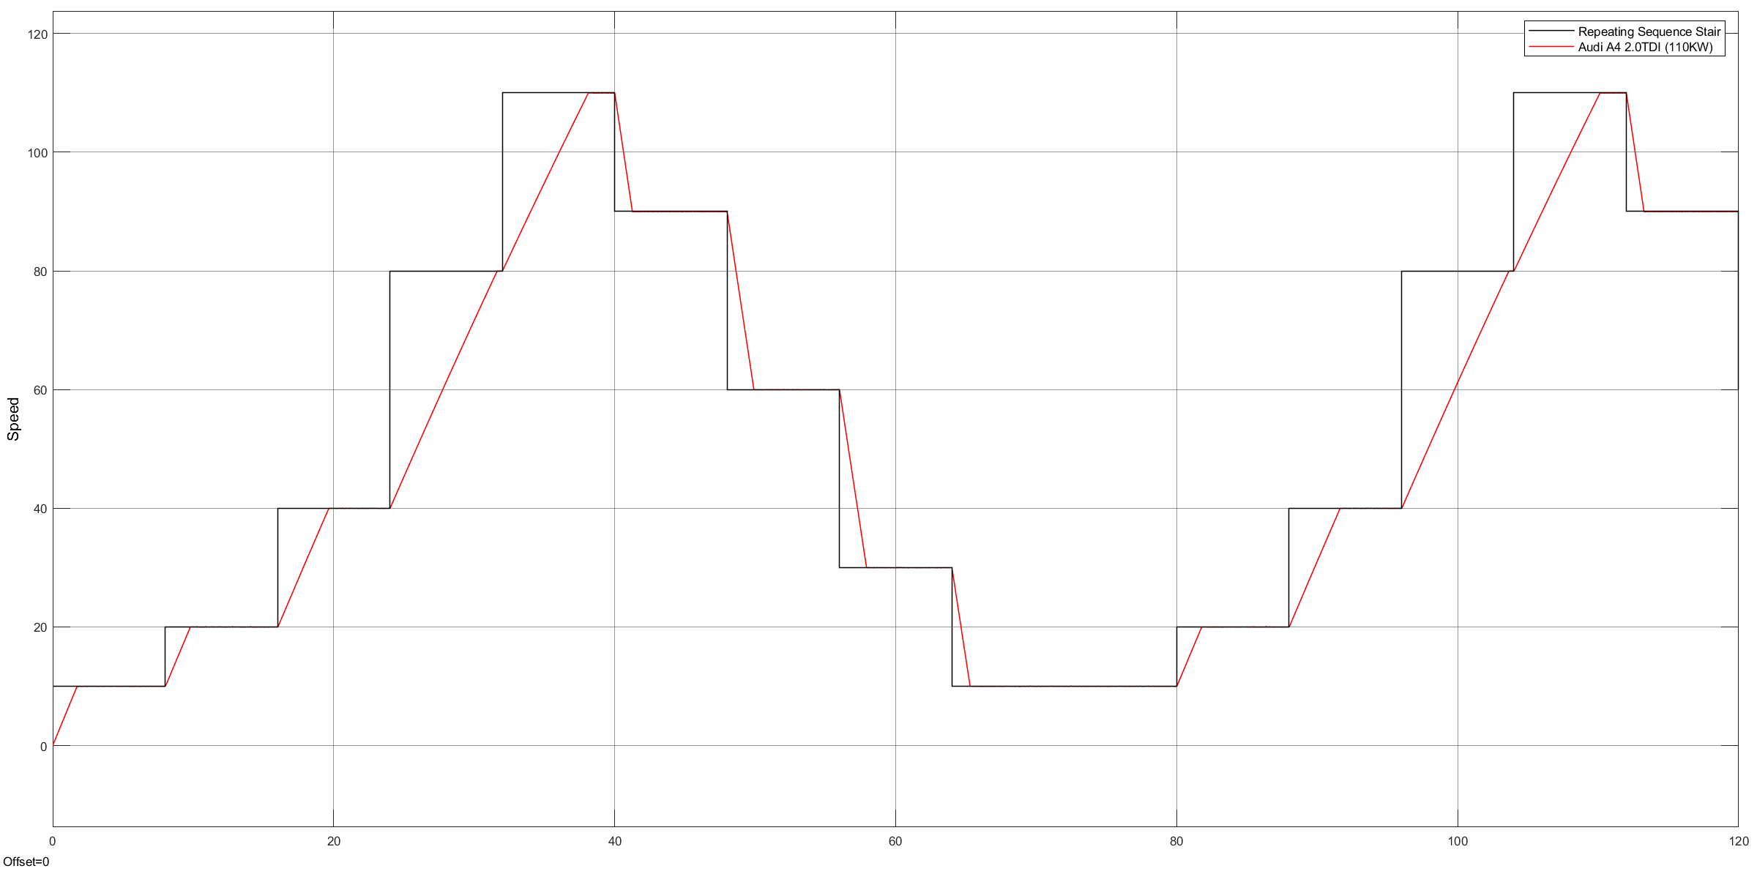

PID Controller in average car

Flat road scenario

[Kp, Ki, Kd] = [900, 1, 5]

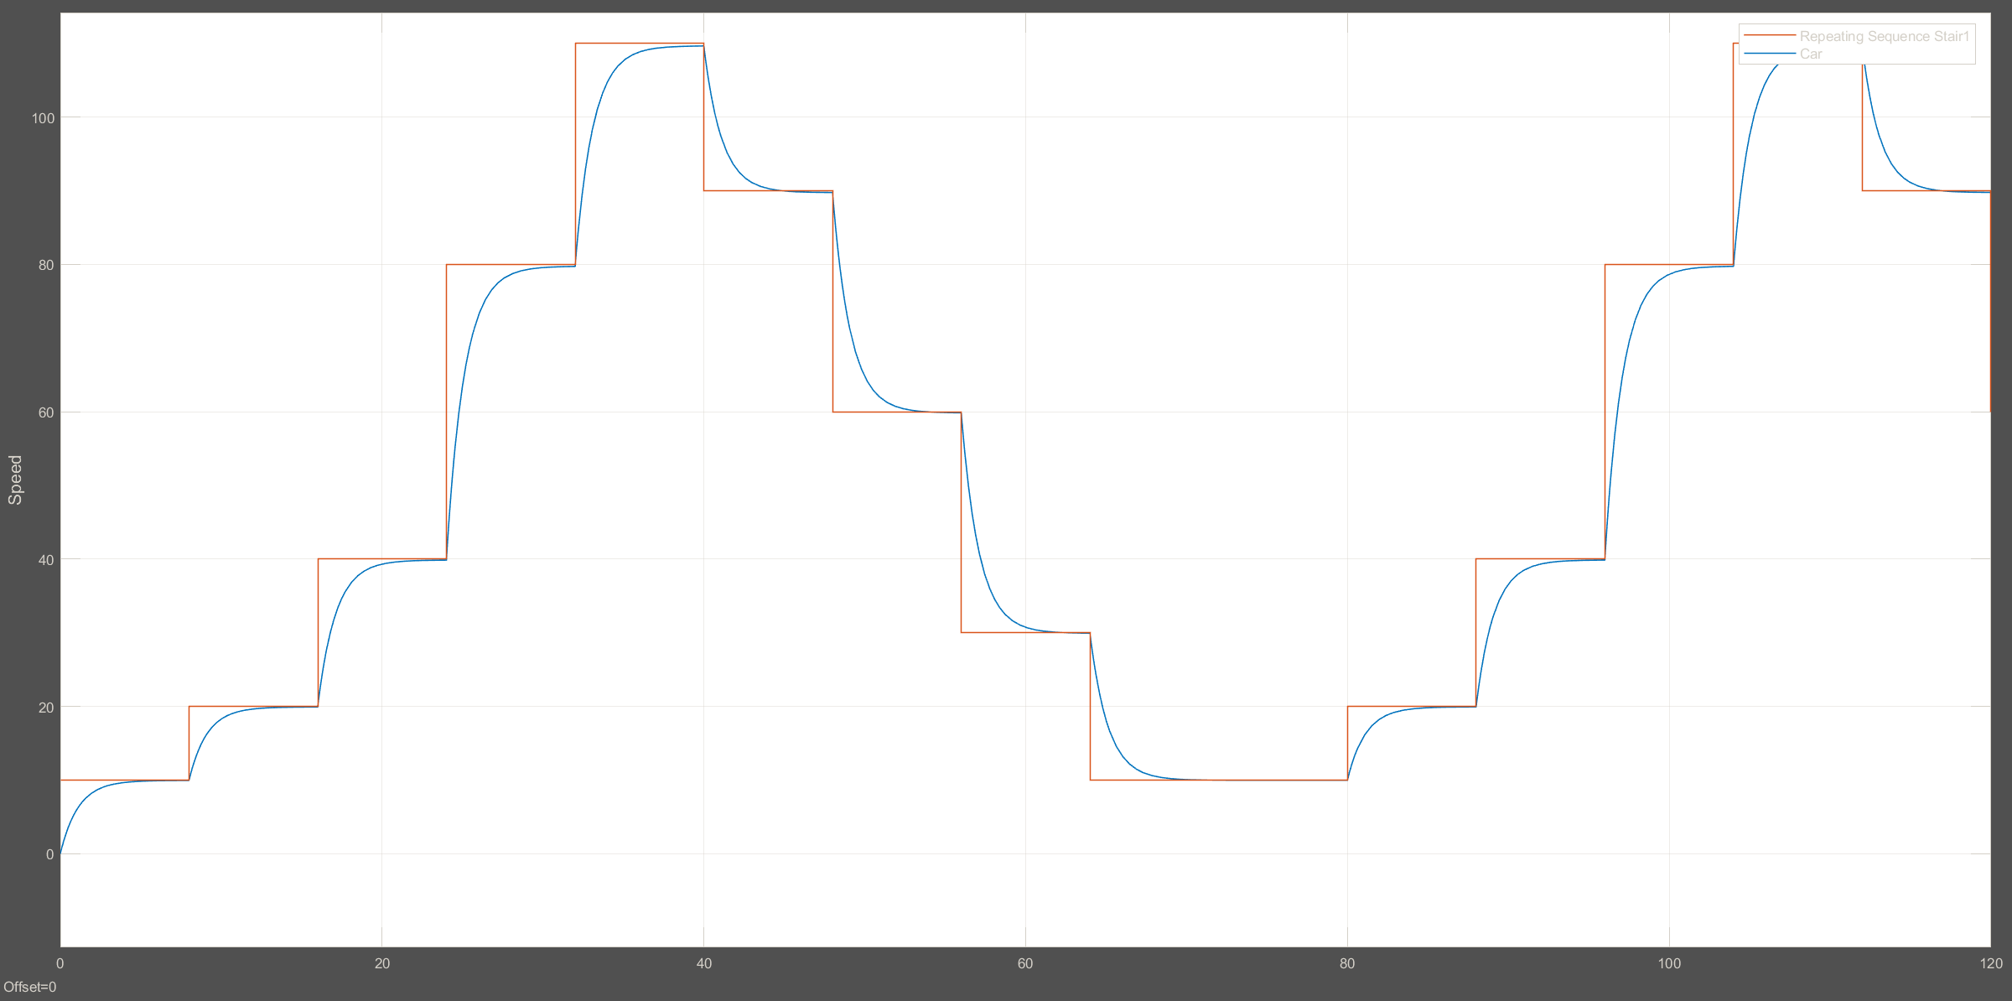

Uphill Scenario

[Kp, Ki, Kd] = [900, 1, 5]

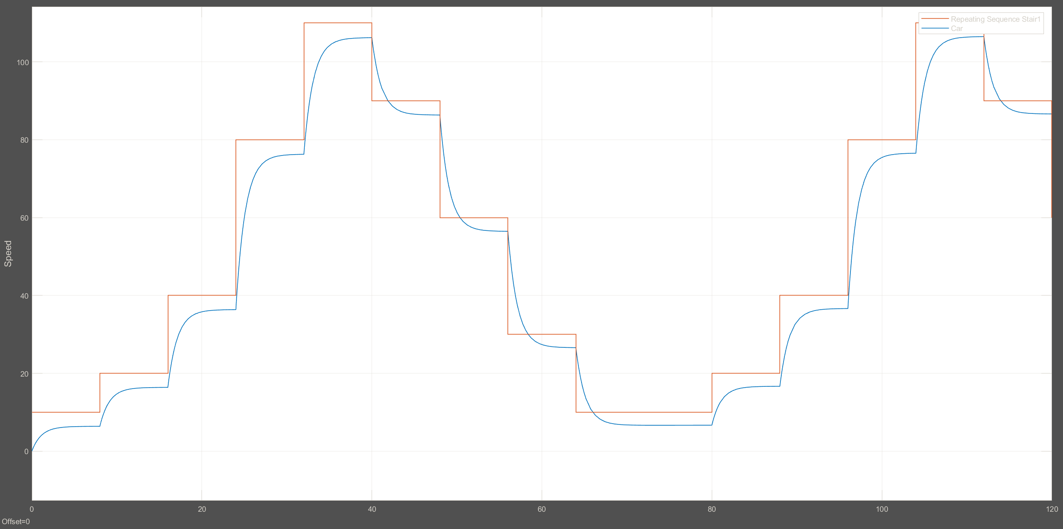

[Kp, Ki, Kd] = [900, 35, 5]

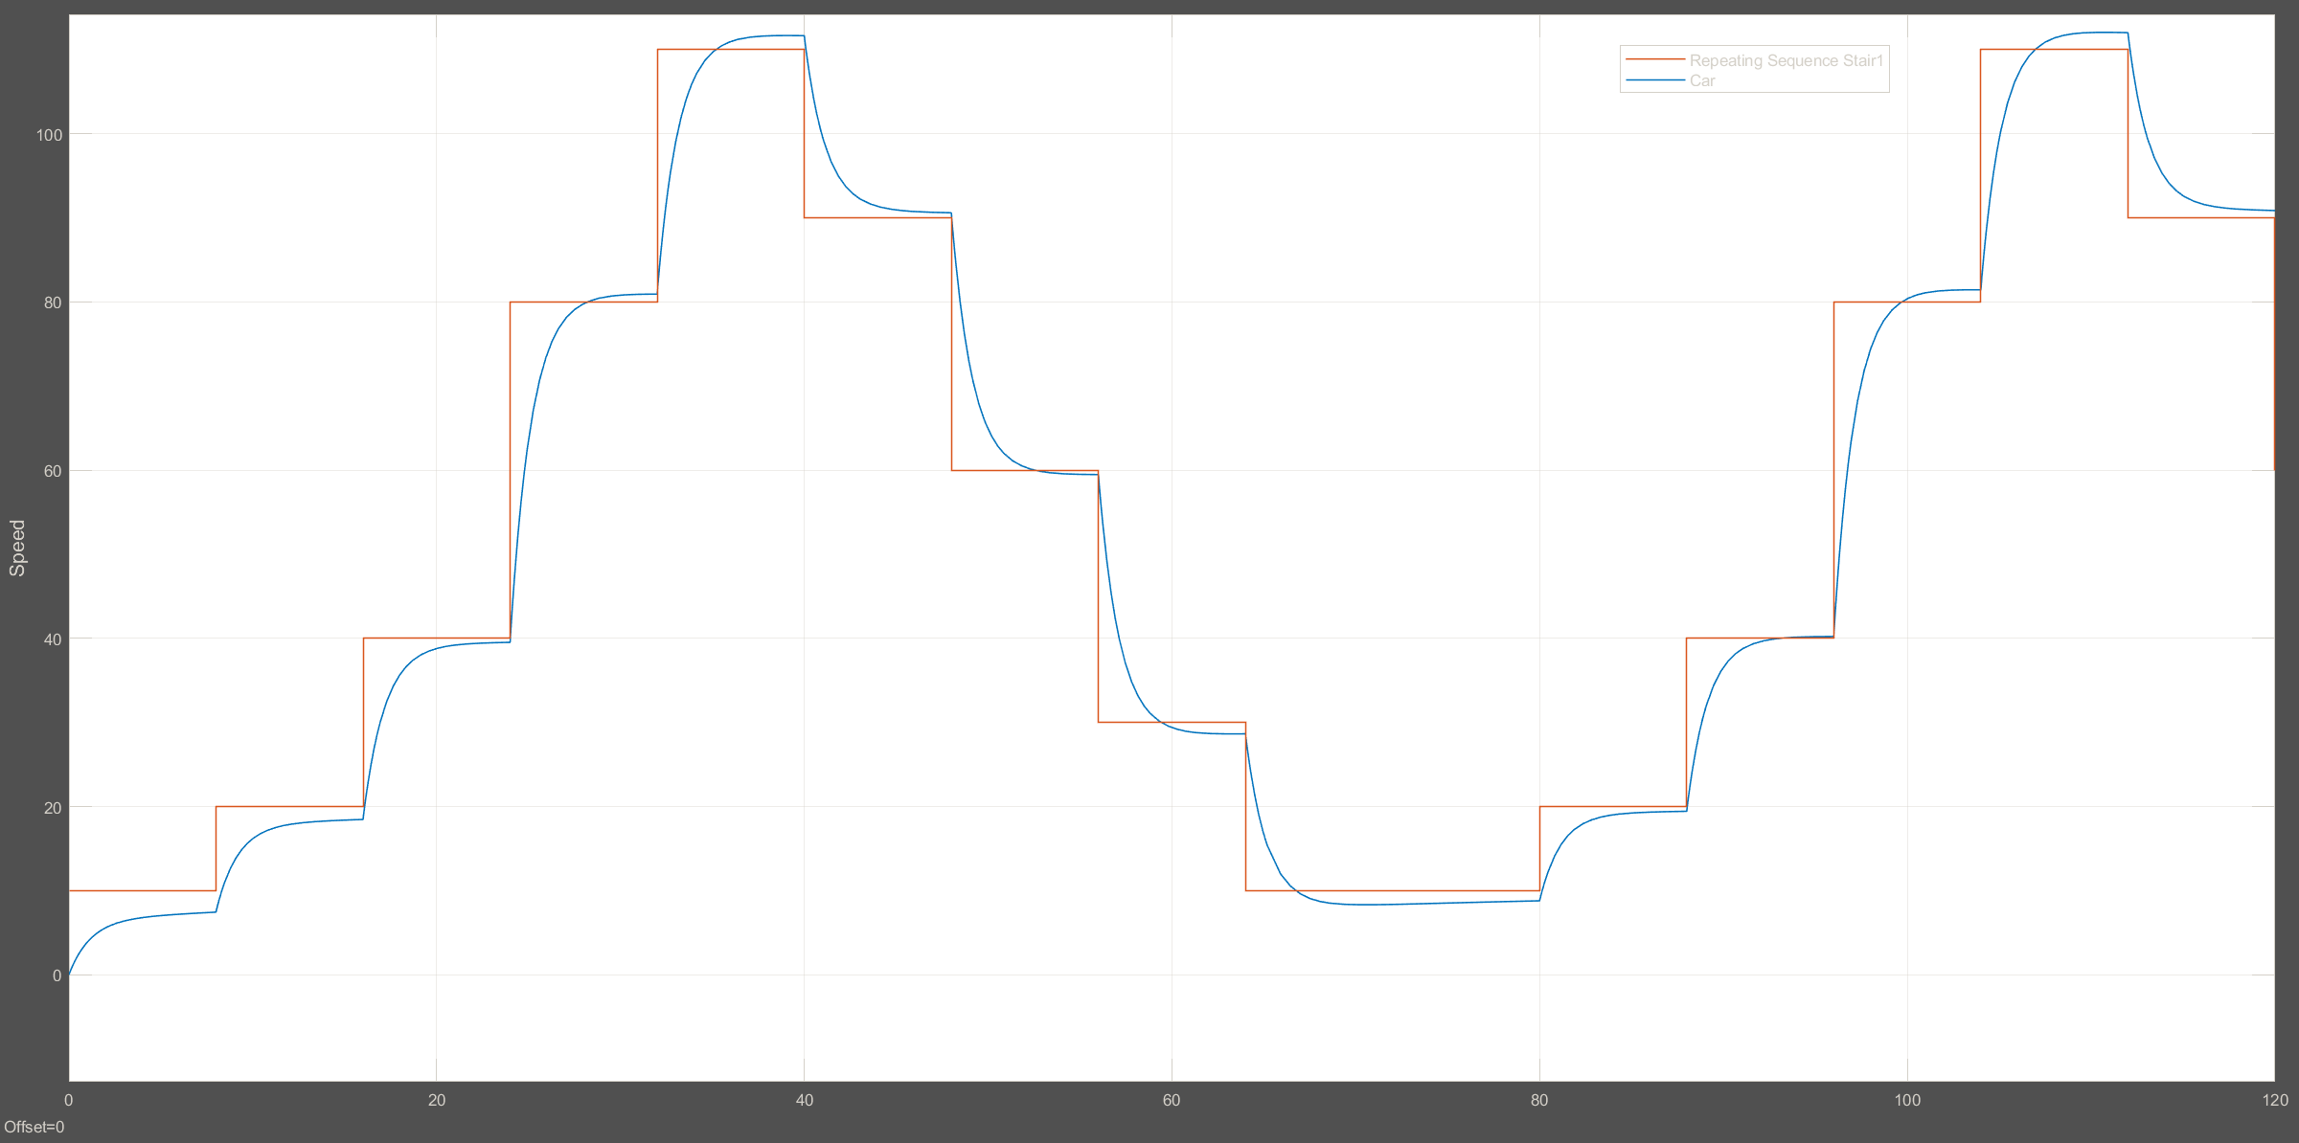

PID Controller design for BMW 520D

Flat road scenario

[Kp, Ki, Kd] = [178, 1, 50]

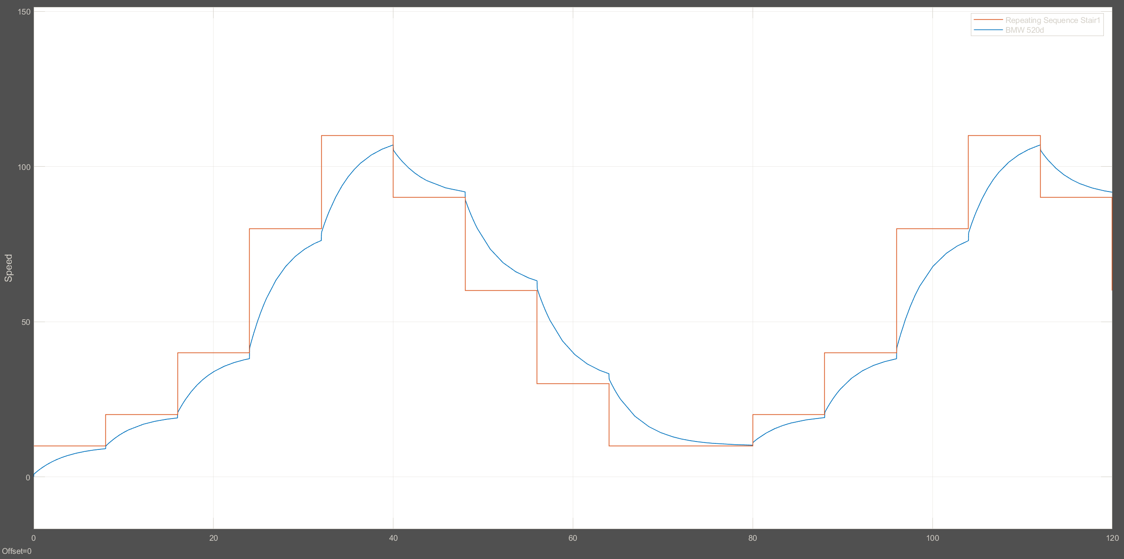

Uphill Scenario

[Kp, Ki, Kd] = [178, 1, 50]

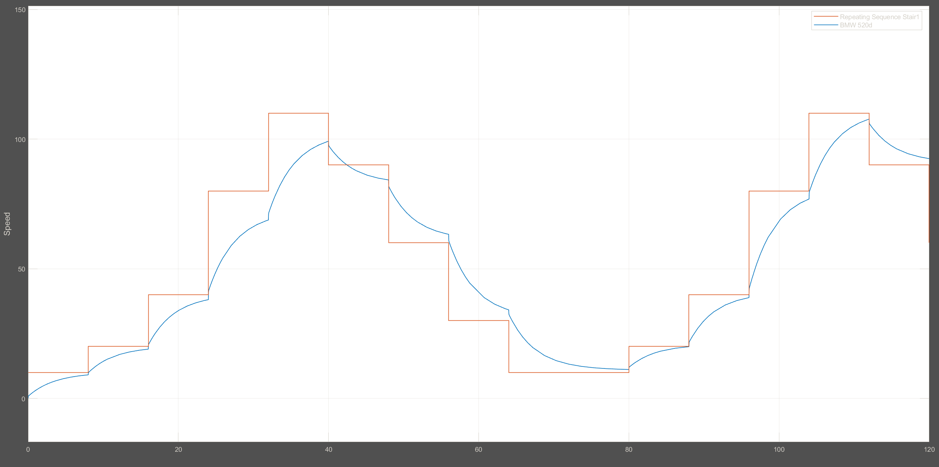

PID Controller design for Audi A4 2.0 TDI

Flat road scenario

[Kp, Ki, Kd] = [165, 1, 20]

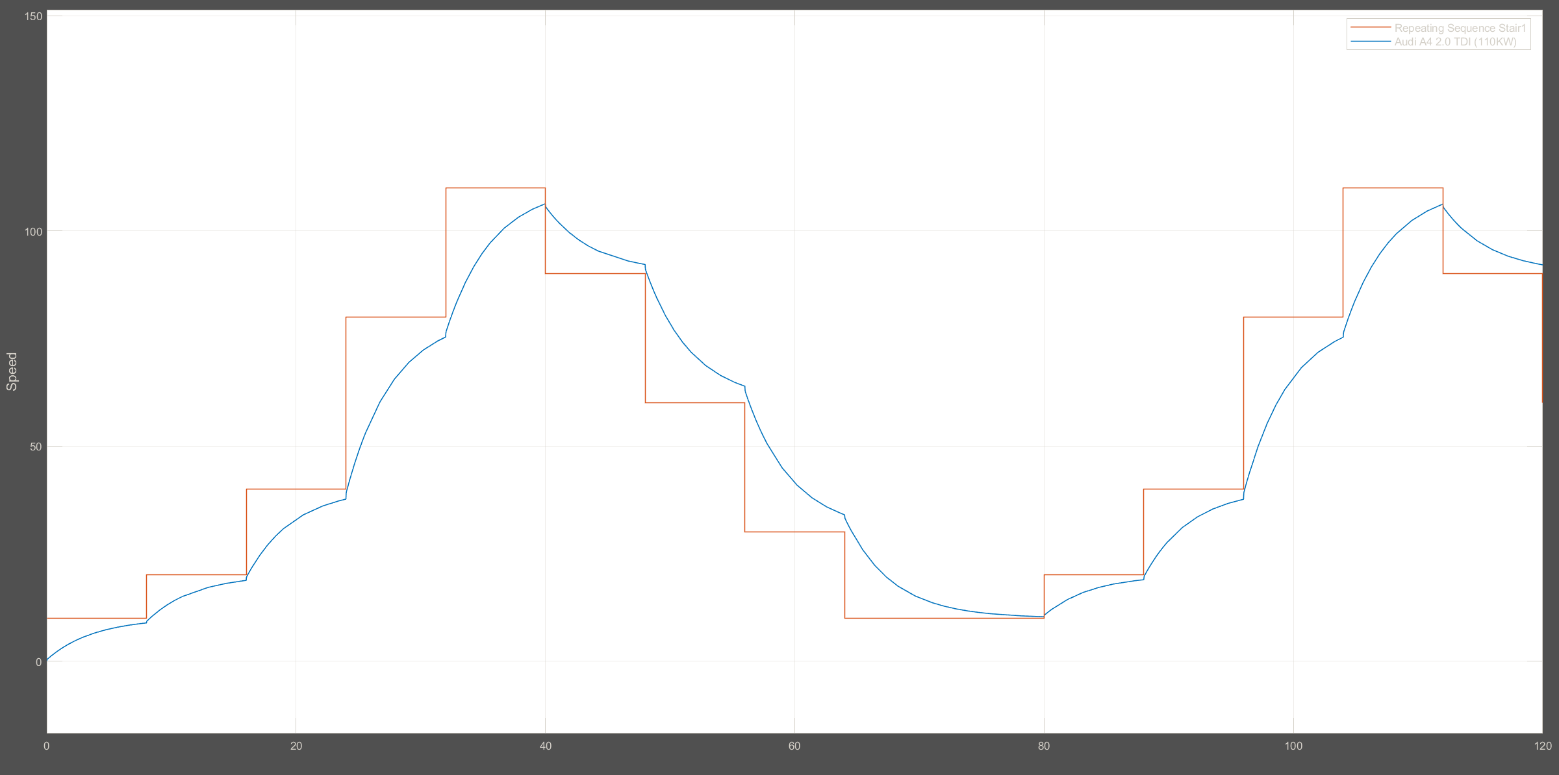

Uphill Scenario

[Kp, Ki, Kd] = [165, 1, 20]

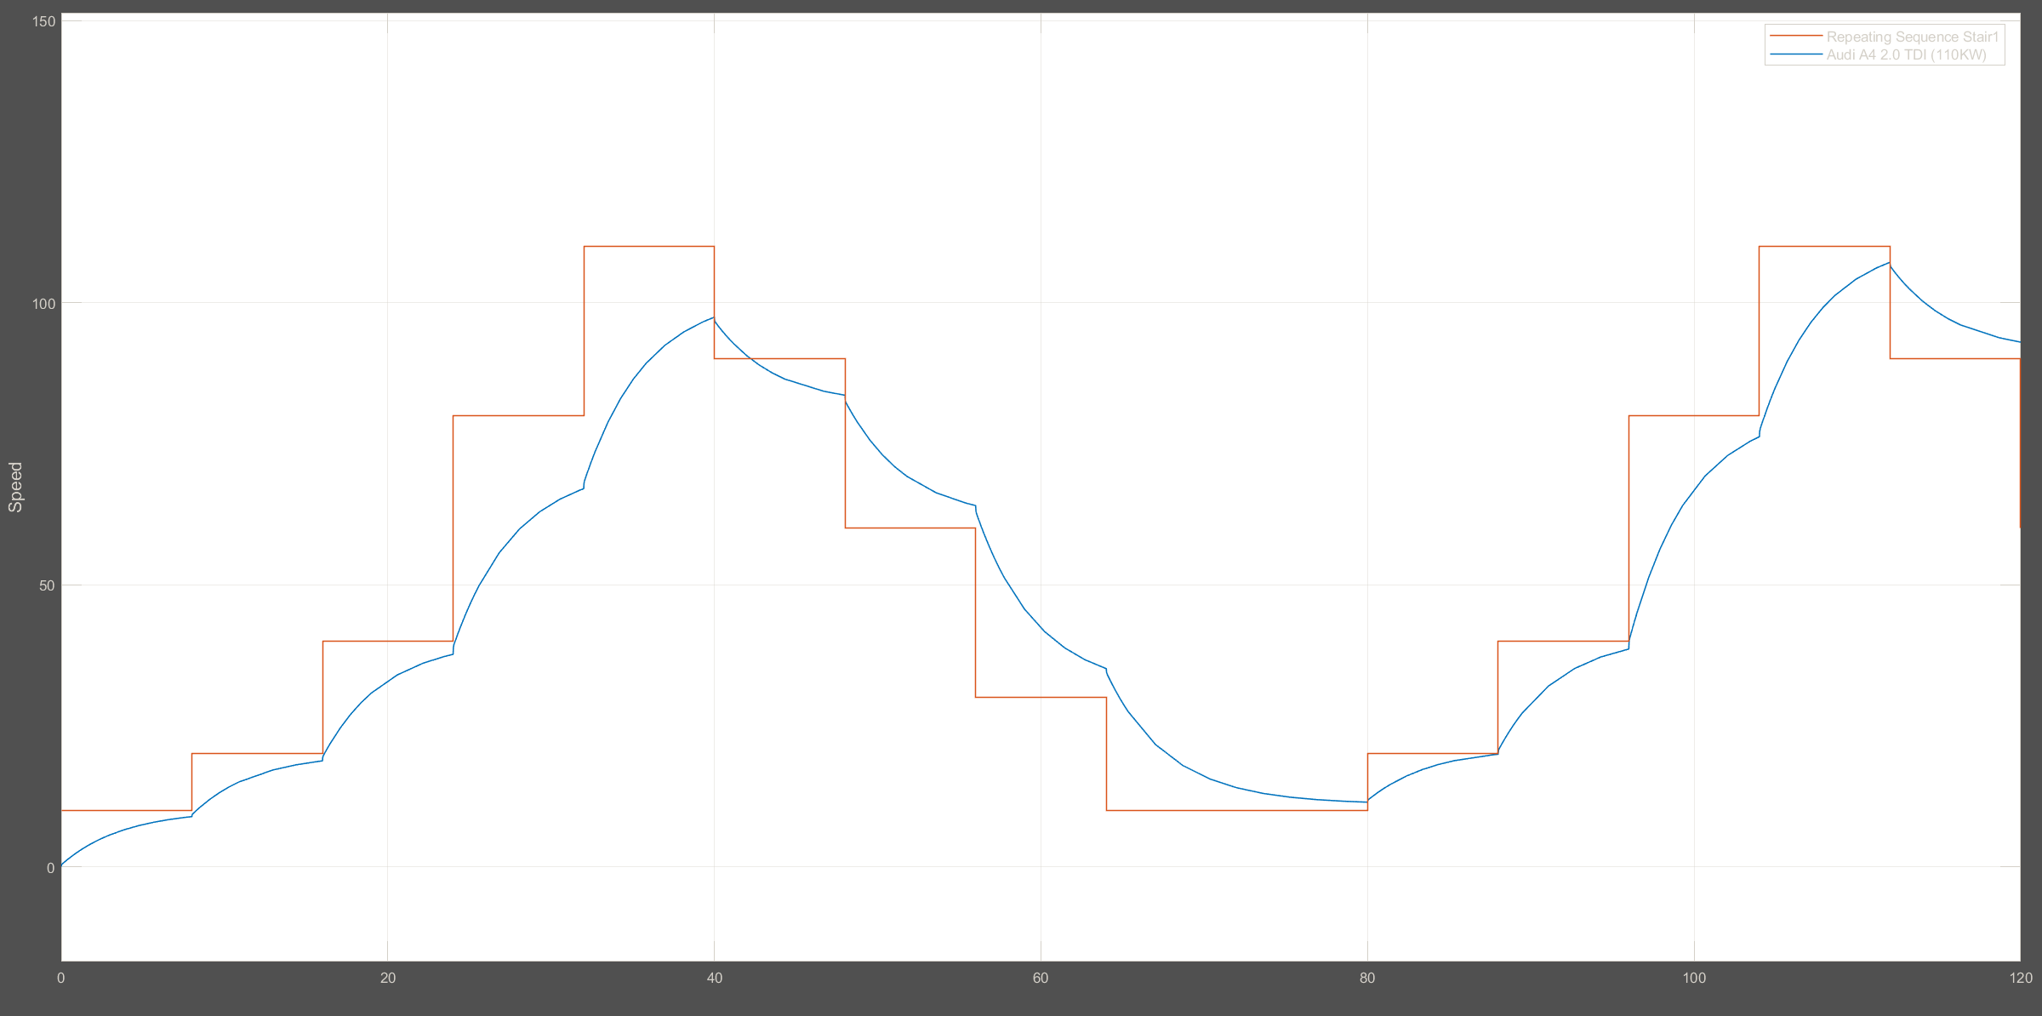

## PD Controller design for an average car

Flat road scenario

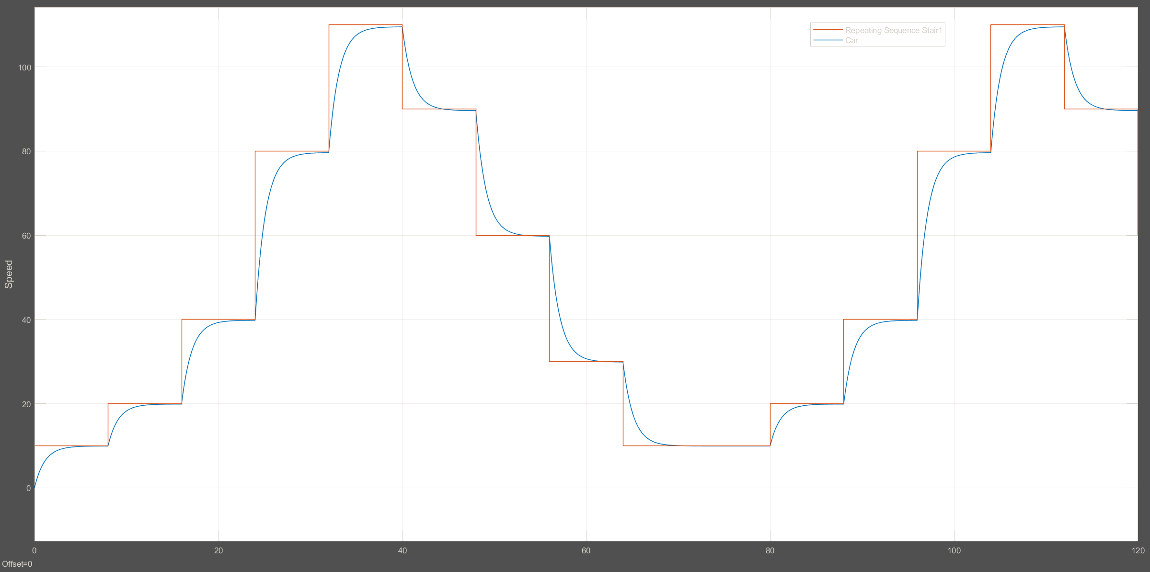

Uphill scenario

[Kp, Kd] = [900, 5]

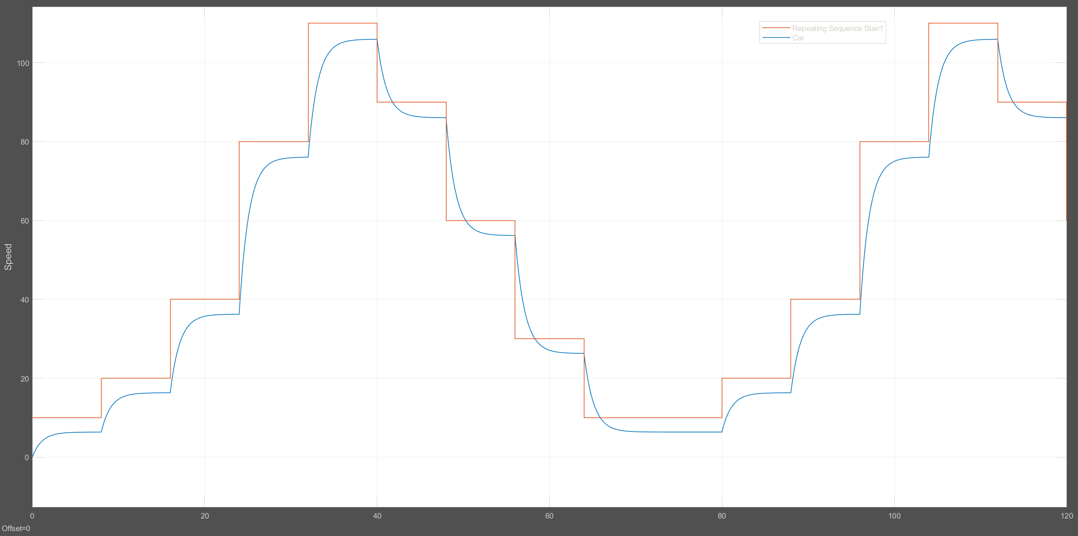

PD Controller design for BMW 520d

Flat road scenario

[Kp, Kd] = [180, 10]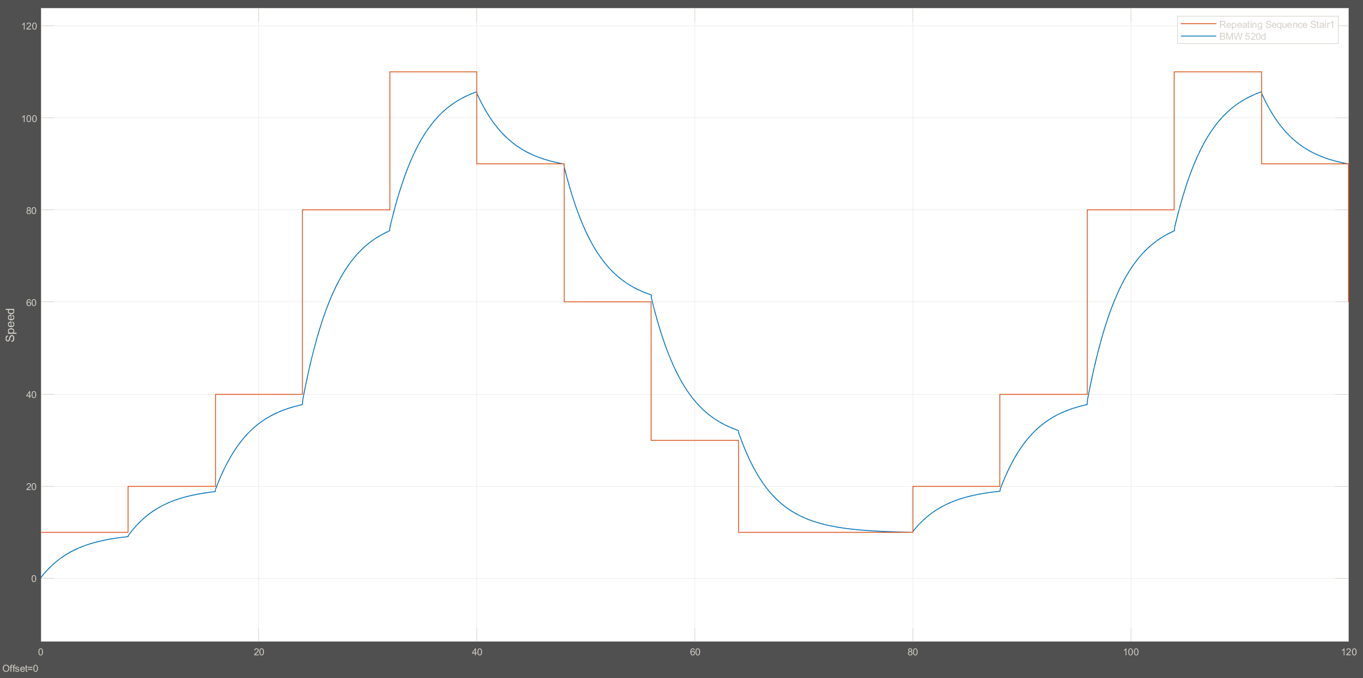

Uphill scenario

[Kp, Kd] = [180, 10]

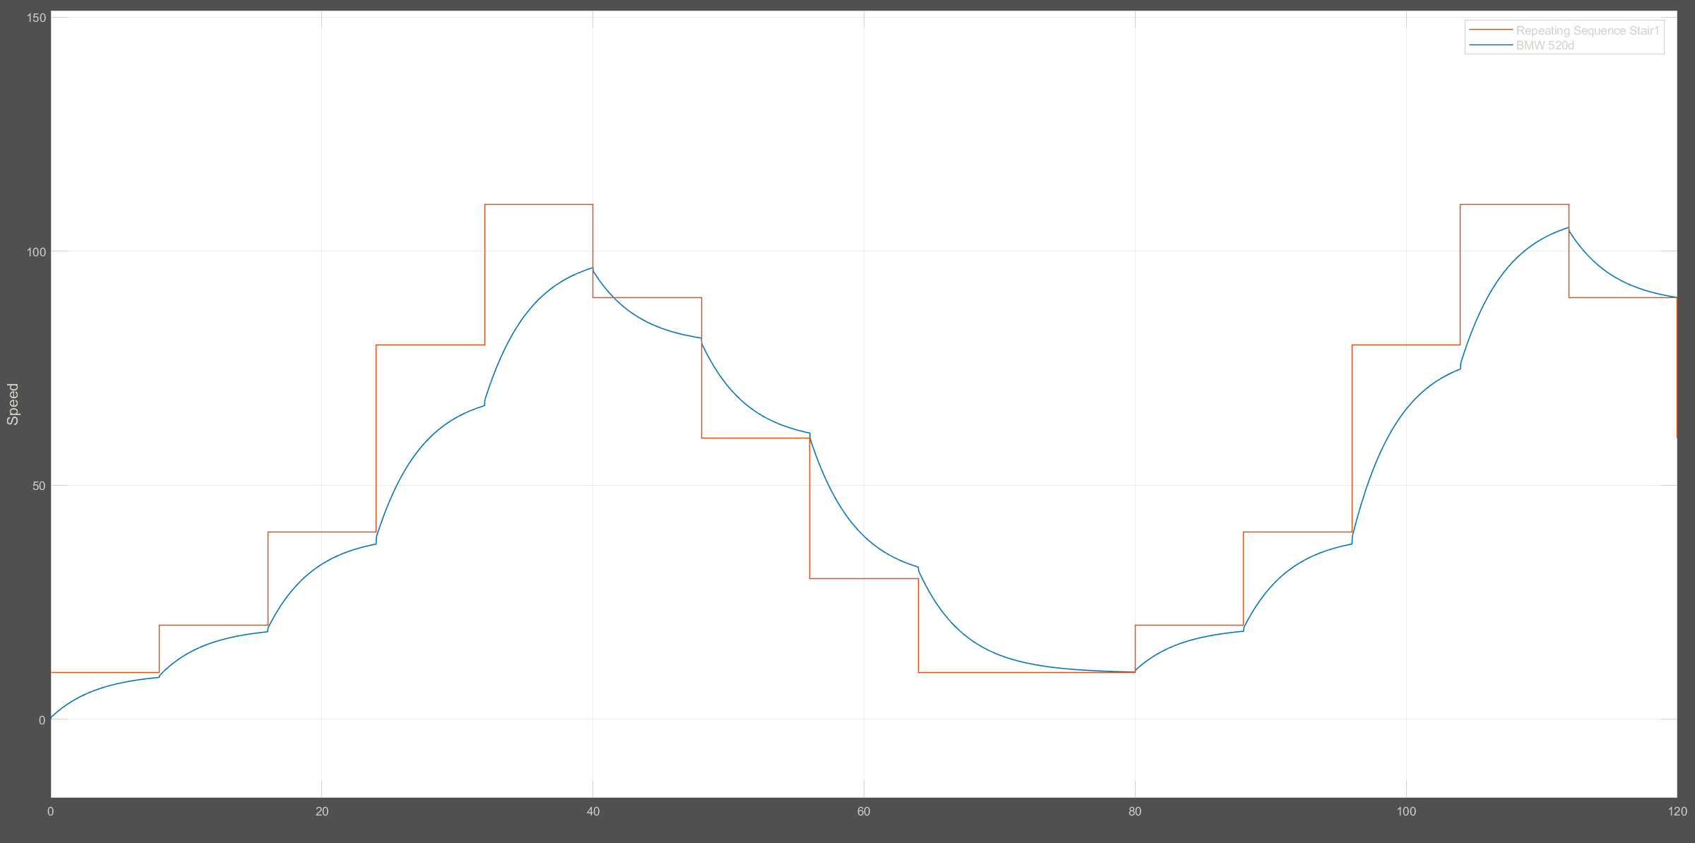

PD Controller design for Audi A4 2.0 TDI

Flat road scenario

[Kp, Kd] = [170, 20]

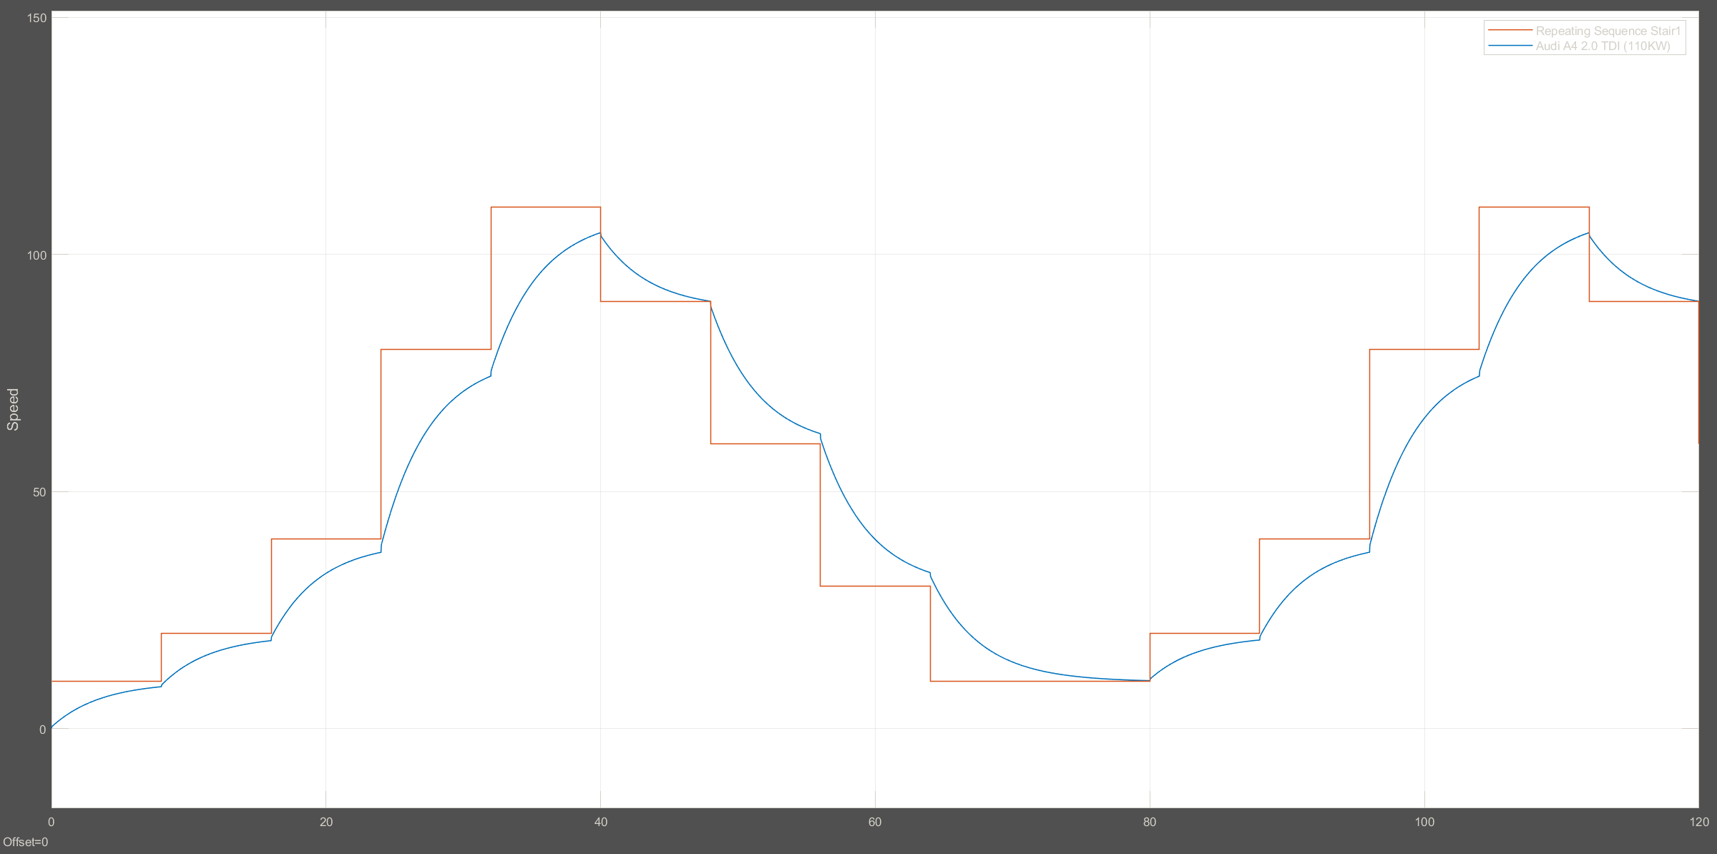

Uphill scenario

[Kp, Kd] = [170, 20]

