EXP3:MATLAB-BASED MODELLING OF VSB MODULATOR AND DEMODULATOR FOR ANALOG TELEVISION DATE: COMMUNICATION APPLICATIONS

Objectives:
- To generate and analyse the Vestigial Sideband (VSB) modulated signal by performing DSB-SC modulation and applying a suitable filter using MATLAB. ii) To implement coherent demodulation and recover the original message signal from the VSB signal, and compare the transmitted and recovered waveforms.
PROGRAM (MATLAB CODE)
clc;
clear;
close all;
% Parameters
fs = 100000; % Sampling Frequency
t = 0:1/fs:0.02; % Time Vector
fm = 500; % Message Frequency
fc = 5000; % Carrier Frequency
% Message Signal
m = cos(2*pi*fm*t);
% Carrier Signal
c = cos(2*pi*fc*t);
% DSB-SC Modulation
dsb = m .* c;
% VSB Filter (Low-pass + High-pass Approximation)
[b,a] = butter(4, fc/(fs/2));
vsb = filter(b,a,dsb);
% Coherent Demodulation
demod = vsb .* (2*cos(2*pi*fc*t));
% Recover Message
[b1,a1] = butter(4, 1000/(fs/2));
rec = filter(b1,a1,demod);
% Display Results
figure;
subplot(5,1,1)
plot(t,m)
title('Message Signal')
grid on
subplot(5,1,2)
plot(t,c)
title('Carrier Signal')
grid on
subplot(5,1,3)
plot(t,dsb)
title('DSB-SC Signal')
grid on
subplot(5,1,4)
plot(t,vsb)
title('VSB Signal')
grid on
subplot(5,1,5)
plot(t,rec,'r')
title('Recovered Message')
grid on

Procedure
1. Open MATLAB and create a new script file.
2. Define the simulation parameters such as sampling frequency, message frequency, carrier
frequency, and time vector.
3. Generate the message signal using a low-frequency cosine waveform.
4. Generate the carrier signal using a high-frequency cosine waveform.
5. Perform DSB-SC modulation by multiplying the message signal with the carrier signal.
6. Design a Butterworth filter to approximate the Vestigial Sideband (VSB) filter.
7. Apply the VSB filter to the DSB-SC signal to obtain the VSB modulated signal.
8. Perform coherent demodulation by multiplying the VSB signal with a synchronized carrier
signal.
9. Design and apply a low-pass filter to the demodulated signal to recover the original message
signal.
10. Plot the message signal, carrier signal, DSB-SC signal, VSB signal, demodulated signal,
and recovered message signal using MATLAB subplots.
11. Compare the recovered message signal with the original message signal to verify successful
modulation and demodulation.
12. Analyze the simulation results and conclude the performance of the VSB modulation and
demodulation process for analog television communication applications.

OUTPUT:
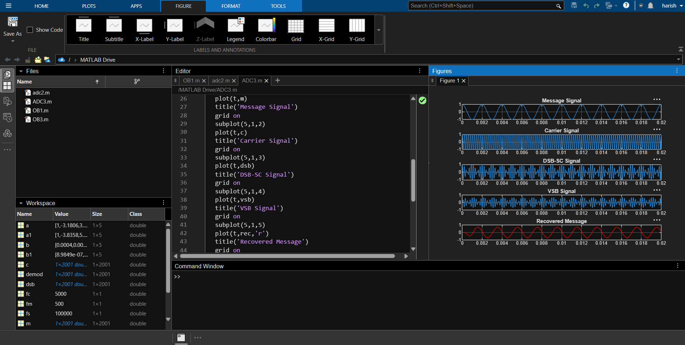

RESULT:
i) The VSB modulated signal was successfully generated from the DSB-SC signal using MATLAB and verified through the displayed waveforms. ii) The original message signal was successfully recovered through coherent demodulation and low-pass filtering, confirming the correct implementation of the VSB communication system.

