**PROJECT NAME : AIR QUALITY MONITORING**

**PHASE 3 : DEVELOPMENT PART 1**

**SENSORS:**

***DHT22 Sensor***

* The DHT22 sensor is a temperature and

humidity sensor that provides a calibrated digital output , it comes with a dedicated NTC to measure temperature and an 8-bit microcontroller to output the values of temperature and humidity as serial data.

* It uses a capacitive humidity sensor and a

thermistor to measure the surrounding air, and outputs the values of temperature and humidity as serial data.

* Here are some specifications of the DHT22 sensor:
* Operating Voltage: 3.5V to 5.5V
* Operating current: 0.3mA (measuring), 60uA
* Output: Serial data
* Temperature Range: -40°C to 80°C
* Humidity Range: 0% to 100%
* Resolution: Temperature and Humidity both are 16-bit

• In this project DHT22 Sensor is used to find air quality. By calculating the TEMPARATURE and HUMIDITY and measuring the differences air quality can be measured.

**COMPONENTS USED IN THE PROJECT**

* DHT22
* ESP32
* LED

# 1.DHT22

* DHT22 is commonly used to measure temperature and humidity. It is based on a digital sensor output and can provide high accuracy measurements with a resolution of 0.1 degree Celsius temperature and 0.1% for humidity.
* The sensor can measure temperature from -40 degree Celsius to 80 degree Celsius and humidity from 0% to 100% with an accuracy of [±1°C and ±1%.](https://components101.com/sensors/dht22-pinout-specs-datasheet)

# 2.ESP32

* [ESP32 not only has Built in WiFi but also has Bluetooth and Bluetooth Low Energy1](https://www.circuitschools.com/what-is-esp32-how-it-works-and-what-you-can-do-with-esp32/)
* The ESP32 can be used as the main microcontroller to gather data from various sensors (like the DHT22 for temperature and humidity) and send it

to a server for further processing. This can be done through WiFi on the AQM system.

## C0DE

#include "DHTesp.h"

const int DHT_PIN = 15;

const int LED_PIN = 13;

DHTesp dhtSensor;

void setup() {

Serial.begin(115200);

dhtSensor.setup(DHT_PIN, DHTesp::DHT22);

pinMode(LED_PIN, OUTPUT);

}

void loop() {

TempAndHumidity data= dhtSensor.getTempAndHumidity();

// Check temperature and humidity values

if (data.temperature > 35 || data.temperature < 12 || data.humidity > 70 || data.humidity < 40) {

digitalWrite(LED_PIN, HIGH);

} else {

digitalWrite(LED_PIN, LOW);

}

Serial.println("Temp: " + String(data.temperature, 2) + "°C");

Serial.println("Humidity: " + String(data.humidity, 1) + "%");

Serial.println("---");

if(data.temperature >30.0 && data.humidity <20.0 || data.humidity >80.0)

{

Serial.println("Air Quality might be Poor[high temperature and humidity]");

}

else if(data.temperature >15.0 && data.temperature <30.0 && data.humidity >30.0 && data.humidity <70)

{

Serial.println("Air Quality might be Moderate[Medium level of temperature and humidity]");

}

else

{

Serial.println("Air Quality might be Good[less temperature and humidity]");

}

delay(10000);

}

Stimulation:

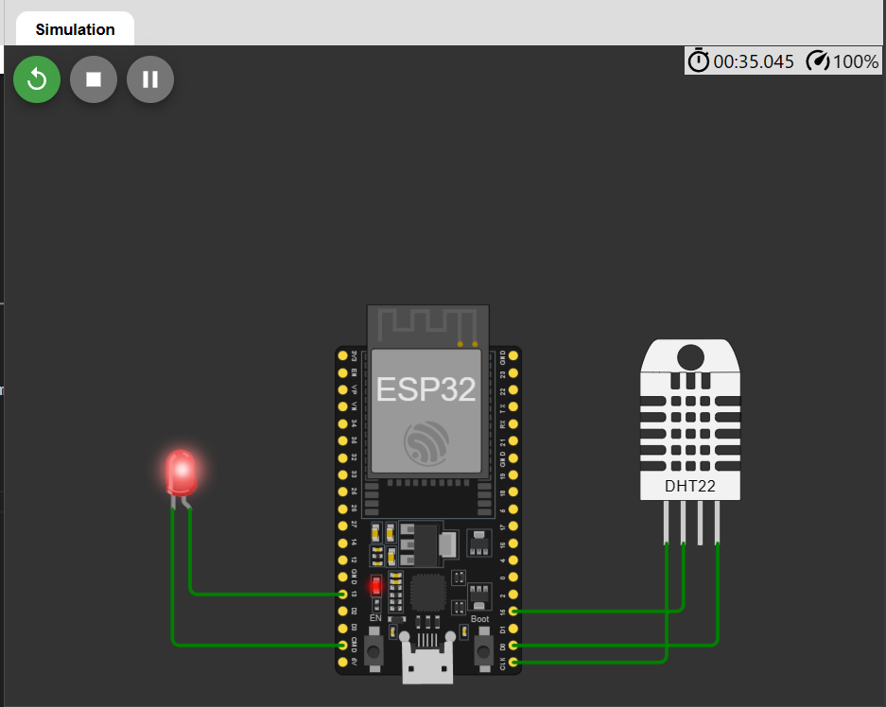

Output:

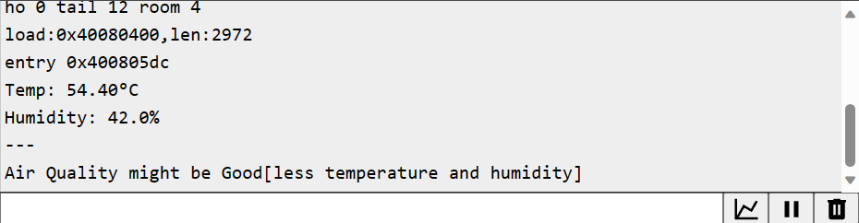

Conclusion:

Thus we conclude that this project works perfectly with the use of DHT22 Sensor. And the LED light blinks when change in temperature/humidity.