**PROJECT NAME: AIR QUALITY MONITORING**

**PHASE 4: DEVELOPMENT – PART 2**

**INTRODUCTION:**

1. Air quality monitoring refers to the systematic, long-term assessment of pollutant levels by measuring the quantity and types of certain pollutants in the surrounding, outdoor air. Pollutants tied to human and environmental health impacts include PM2.5, PM10, ground-level ozone, nitrogen dioxide and sulphur dioxide.
2. Uses of Air Quality Monitoring (AQM) are,
3. Health Protection
4. Environmental Protection
5. Regulatory Compliance
6. Research and Study
7. Public Awareness
8. In this phase, we have used web development technologies such as HTML, CSS to create a platform that displays real-time air quality data.

**CODE :**

**HTML CODE :**

index.html

<html>

<head>

<meta name="viewport" content="width=device-width, initial-scale=1.0">

<title>AQM</title>

<link rel="stylesheet" href="style.css">

</head>

<body>

<div id="hero">

<div class="navbar">

<img src="C:\Users\Lenovo\Desktop\ponraj\iot\air_pollute.jpg" width= "100px"

class="logo">

<div class="user">

<a href="https://thingspeak.com/channels/2324461/sharing" target="_blank">

<button type="button">AQM</button>

</a>

</div>

<div class="container">

<div class="info">

<h1>Air Quality Monitoring</h1>

<p> Air Quality Monitoring (AQM) is the systematic, longterm assessment of pollutant levels by measuring the quantity and types of certain pollutants in the surrounding, outdoor air.It is an integral part of an effective air quality management system.The locations for monitoring stations depend on the purpose of the monitoring. <br>

<br>

Most air quality monitoring networks are designed to support human health objectives, and monitoring stations are established in population centers. They may be near busy roads, in city centers, or at locations of particular concern (e.g., a school, hospital, particular emissions sources). particular concern (e.g., a school, hospital, particular emissions sources). Monitoring stations also may

be established to determine background pollution levels, away from urban areas and emissions sources</p>

</div>

</div>

</body>

</html>

**CSS CODE :**

style.css

*{

margin:0;

padding:0;

font-family: timesnewroman;

}

#hero{

width:100%;

height:100vh;

background-image:url(air_pollute.jpg);

background-size:cover;

background-position:center;

position:relative;

}

.navbar{

width:90%;

margin:auto;

display:flex;

align-items:center;

justify-content:space-between;

position:relative;

z-index:10;

}

.logo{

top:11%;

left:90%;

position:relative;

}

.navbar .logo{

width:60px;

margin:30px 0;

cursor:pointer;

}

.user{

display:flex;

align-items:center;

**OUTPUT :**

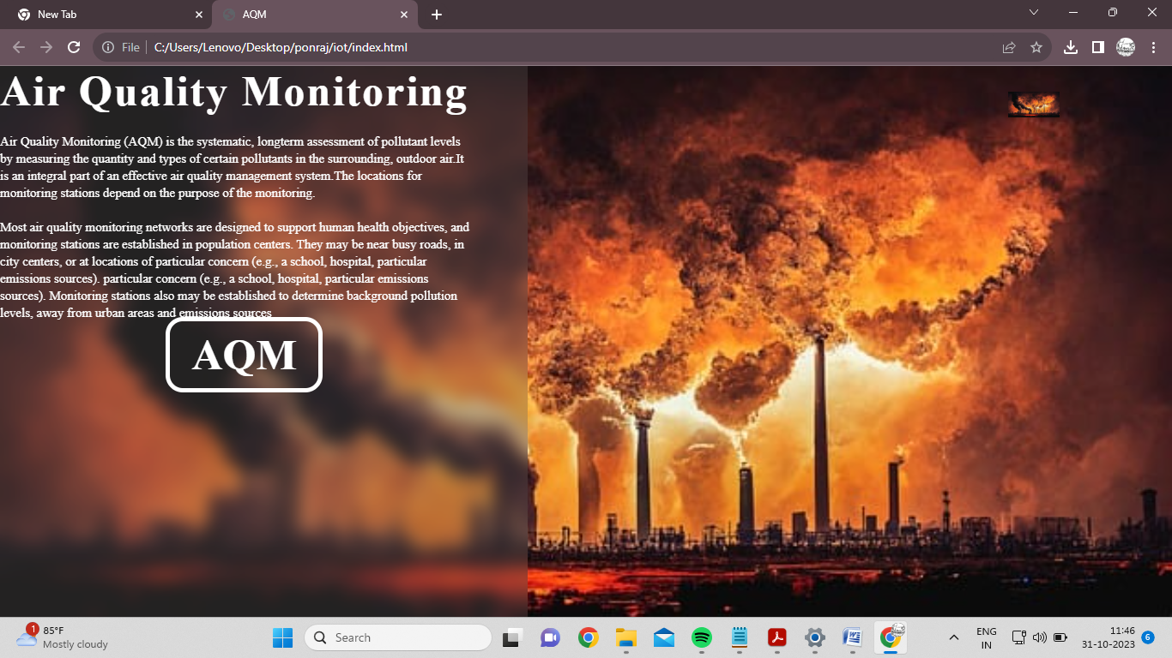

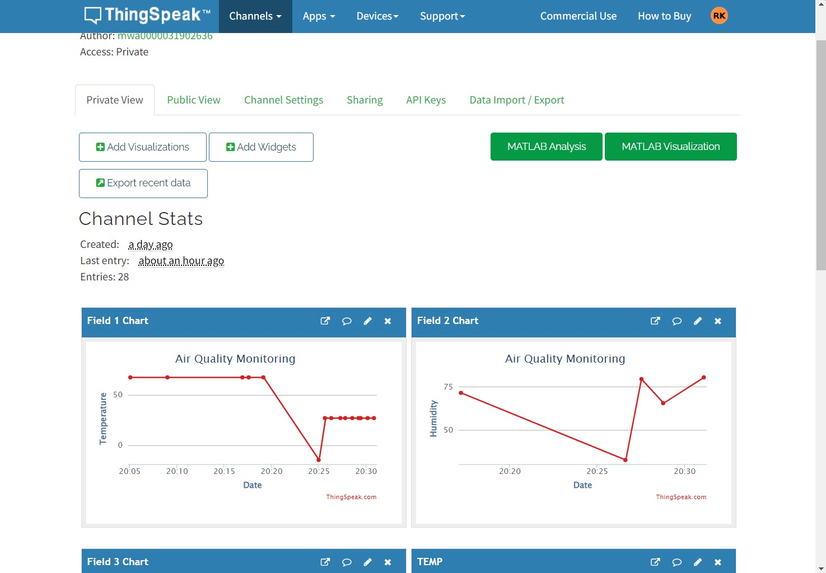

**CONCLUSION:**

➢ In conclusion, the use of web technologies in an Air Quality Monitoring (AQM) project has proven to be highly beneficial. This data includes detailed information about air quality, which is crucial for comprehensive air quality analysis.

➢ The use of web technologies has also facilitated the development of user-friendly applications that provide timely air quality updates. These applications can be customized to provide data for specific locations, making them highly relevant for users