**KLEID**E-commerce Website Using Python with FLASK

**UNDER THE GUIDANCE OF**

Dr. PACKIALATHA

IT Dept (ASSISTANT PROFESSOR)

**TEAM MEMBERS:**

HARISH.P(310818205028)

ARUN.N(310818205008)

DEEPAK KUMAR .N.G(310818205017)

**TABLE OF CONTENTS**

|  |  |  |
| --- | --- | --- |
| CHAPTER NO  1  2  3  4  5  5  6  7  8  9  10  11  12  12  13  14 | TITLE  ABSTRACT INTRODUCTION  What is E-Commerce?  WHAT DO YOU MEAN BY E-COMMERCE  DEFINATION OF E-COMMERCE  THE ELEMENTS OF E-COMMERCE  PROJECT OBJECTIVE EXISTING SYSTEM PROPOSED SYSTEM  ARCHITECTURE DIAGRAM  MODULES  FUNCTIONAL REQUIREMENT  USE CASE DIAGRAM  SYSTEM REQUIREMENTS  Hardware Requirements:  Software Requirements:  MODELS OF E-COMMERCE  BUSINESS-TO-BUSINESS  BUSINESS-TO-CONSUMERS  CONSUMER - TO – BUSINESS E-COMMERCE PAYMENT PROCESS  CREDIT CARD  DEBIT CARD  E-COMMERCE SELLING PROCESS  IMPLEMENTATION  HTML  MySQL  XAMPP server  DESIGN SPECIFACTION  LOGIN PAGE  REGISTER PAGE  HOME PAGE UI  PRODUCT CART PAGE  BEFORE CHECKOUT PAGE  CHECKOUT PAGE  ADMIN LOGIN  ADMIN DASHBOARD  ADMIN ORDERS VIEW  ADMIN PRODUCTS VIEW  ADMIN ADD PRODUCTS  ADMIN AUDIT LOGS  REFERENCE  CONCLUSION | PAGE NO |

**ABSTRACT**

* The business – to – consumer aspect of product commerce (e – commerce) is the most visible business use of the World Wide Web. The primary goal of an e – commerce site is to sell goods online.
* This project deals with developing an e – commerce website for Online Product Sale. Provides the user with a catalogue of different product available for purchase in the store. In order to facilitate online purchase a shopping cart is provided to the user. The system is implemented using a 3 – tier approach, with a backend database, a middle tier of Flask and a web browser as the front end client In order to develop an e – commerce website, a number of Technologies must be studied and understood. E-commerce helps small scale proprietor to develop their products to grow higher and faster.

**INTRODUCTION**

* The term e-commerce was coined back in the 1960s, with the rise of electronic commerce – the buying and selling of goods through the transmission of data – which was made possible by the introduction of the electronic data interchange. Fast forward fifty years and e-commerce has changed the way in which society sells goods and services.
* The main objective of the system is to make the seller and the customer satisfied with low cost and more convenience.

**What is E-Commerce?**

* Such as mobile commerce, electronic funds transfer, supply chain management, Internet marketing, online transaction processing, electronic data interchange (EDI), inventory management systems, and automated data collection systems. Modern electronic commerce typically users the World Electronic commerce, commonly known as Ecommerce or E-Shop, is trading in products or services using computer networks, such as the Internet. Electronic commerce draws on technologies Wide Web for at least one part of the transaction‘s life cycle, although it many also use other technologies such as email.
* Many retails shop are shift on E-Commerce because e-commerce is fast grow in the world.

**WHAT DO YOU MEAN BY E-COMMERCE**

E-Commerce is the exchange of goods & Services, usually for money. When you something at a store you buy something at a store you are participating in commerce. Going to work each day for a company that produces a product, is a link in the chain of the commerce. When one thinks of different ways, he/she immediately recognize several different players of the commerce such as:

* **Buyers:** These are the people or organization with money who want to purchase goods & service products.
* **Sellers:** These are the people who offer goods & service to buyers. Sellers are recognizing in different forms such as retailers who sell directly to consumers and wholesalers who sell to retailers & others. Wholesalers are also known as distributers.
* **Producers:** These are the people organization that create the product & services that seller’s offer to buyers. Producer may is classified in the category of a seller. They can sell there products to any category to customers.

**DEFINATION OF E-COMMERCE**

E-Commerce supports an entire range of activities such as product design, manufacturing, advertising, commercial transactions, settlements of accounts using a variety of computer networks.

Thus E-Commerce refers to the paperless exchange of business information using electronic data interchange, electronic mail, electronic fund transfer & other networked based technologies.

In a holistic sense electronic commerce can be summarized as:

* It is a business strategy.
* It uses technology to achieve business goals.
* It improves external business relationships.
* It is an evolution in the way companies internal.
* It provides information to facilitate delivery of goods & Services.

**THE ELEMENTS OF E-COMMERCE**

* **A Product or service:** In case of E-Commerce, it is virtual product shown on a web site. One can demonstrate multimedia presentation of the product & its entire feature on the web page itself, which may not be possible in case of physical products of commerce activity.
* **A Place to sell the products:** In the E-Commerce case, a website displays the products in all ways & act as a place for E-Commerce.
* **A way to get customers to visit your website:** In case of E-Commerce search engines and linkages with other web sites play an important role in helping the customers to reach web sites of the E-organizations.
* **A way to accept returns:** The orders are accepted on the web site itself. On the web pages of the E-commerce companies shopping carts are beings provided. One can click on the icon and fill in the shopping card to order items to be purchased and it is accepted by the E-Commerce company as order from customer.
* **A way to accept money:** In case of traditional commerce, buyers and sellers are in direct contact with each other. The payments in E-Commerce are made using Electronic fund Transfer in various form using credit cards, smart cards, e-checks etc. the information of payment is routed through Value added Networks (VANs) and Payment Gateway Systems etc.
* **A way to accept returns:** As is the case of commerce, in case of ECommerce all the trading companies have the system of accepting the returns if the goods and services are not to the satisfaction of the customer or not up to the standred and specifications mentioned in the product catalogs or brochures hosted on the web pages.
* **A way to handle warranty claims:** Sometimes if the product breaks in the way or some other problems crop up with the product. In such situation, warranty claims are to be honors as in the case of commerce.
* **A way to provide customer service:** The main tools of the customers services are E-mail, Online forms, Online Knowledge bases and frequently asked questions.

**PROJECT OBJECTIVE**

* Reduce management costs.
* Developing business relations.
* Providing a unique customer experience.
* Increasing the number of loyal customers.
* Boosting the efficiency of services.
* Developing relevant target.
* Making responsive ecommerce website.
* Increasing sales**.**

**EXISTING SYSTEM**

* Many customers go for purchasing offline so as to examine the product and hold the possession of the product just after the payment for the product.
* In this contemporary world customer’s loyalty depends upon the consistent ability to deliver quality, value and satisfaction.
* Offline shopping has a sense of immediacy.
* You get to possess the item you’ve purchased the very moment.
* If we can search and make a list of it.
* No return polices
* This way we can be more confident in our purchase and not missing out something.
* This can also help us to decide what areas to visit.
* And plan such an event with friends.

**PROPOSED SYSTEM**

* Customer Convenience
* Selection
* Immediacy
* Quality
* Saving Money
* Discounts and Offers
* Return and refund polices
* Seller Convenience
* Zero Commission
* AD free

**ARCHITECTURE DIAGRAM**

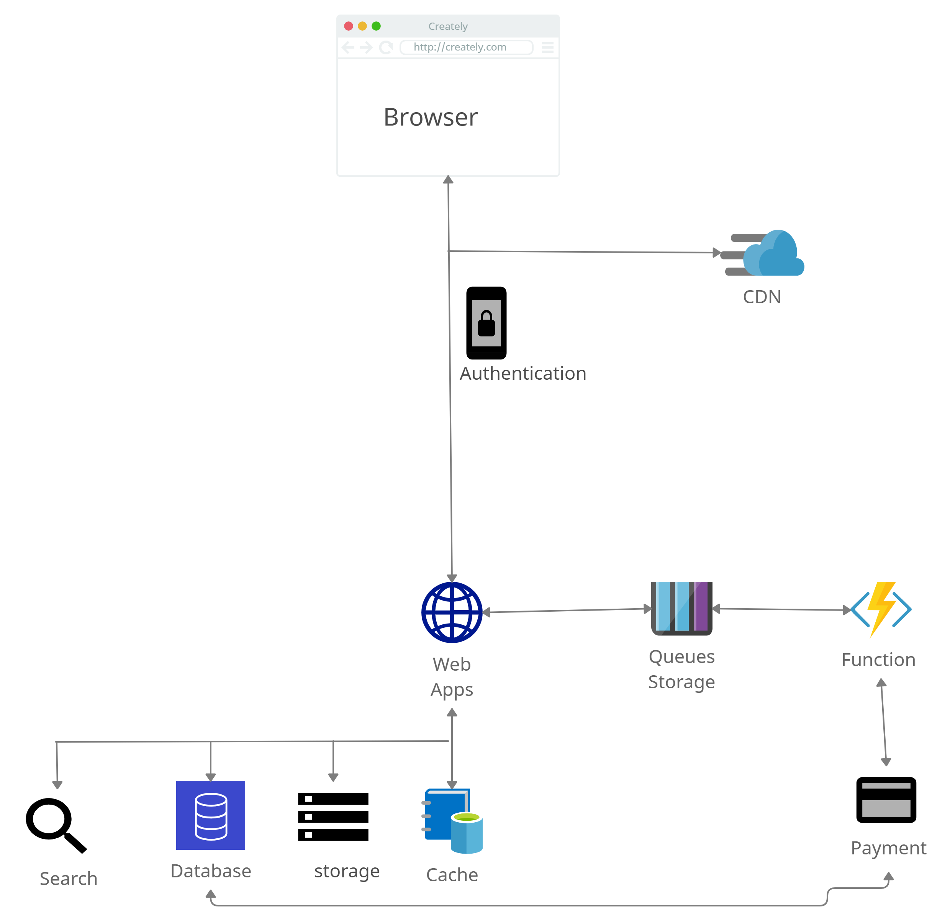

**Modules**

**FUNCTIONAL REQUIREMENT:**

* Welcome and Login Page
* Product Category Display Page
* Product Selection Screen
* Product Search Result Screen
* View Cart Screen
* Order Details Screen
* Order Confirmation Screen
* Customer Registration Products Details  
  Payment Gateway

USE CASE DIAGRAM

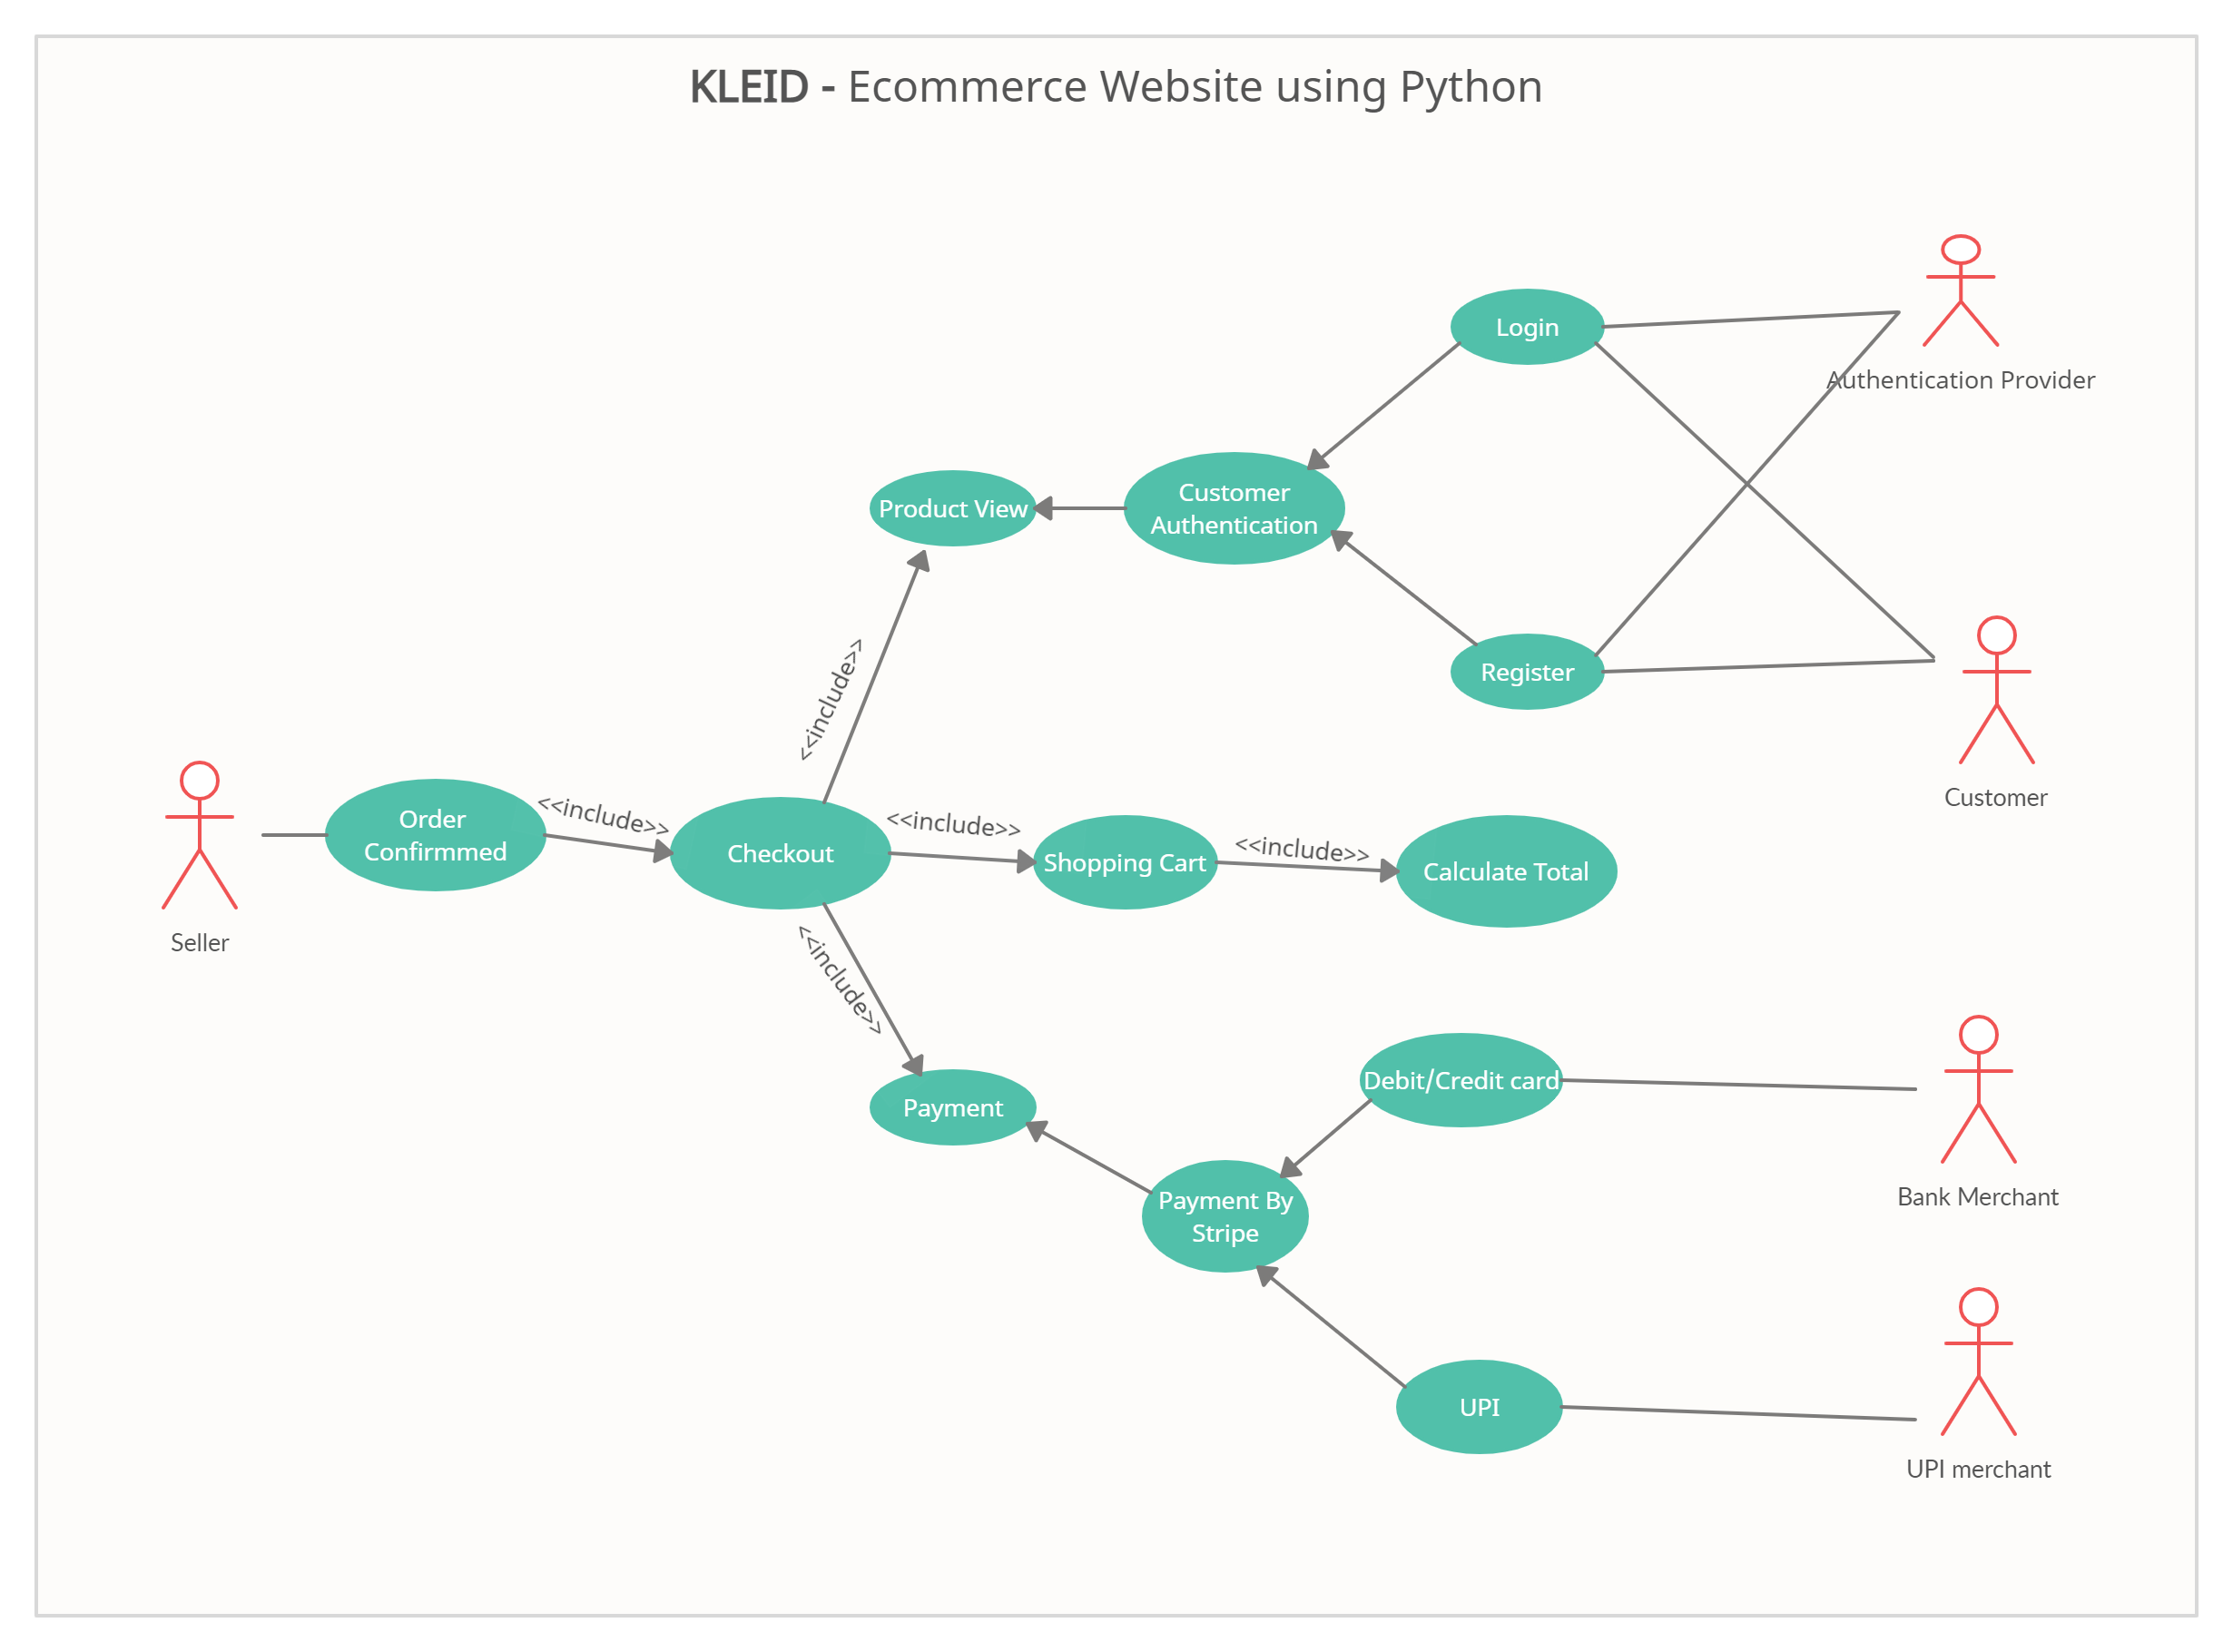

|  |  |
| --- | --- |
| **Processor** | for web 1.6 GHz , for web and database 4 x 1.6 GHz CPU |
| **Ram** | 4 GB |
| **Minimum database space** | 500 MB |

**SOFTWARE REQUIREMENT SPECIFICATION**

**Hardware Requirements:**

The selection of hardware is very important in the existence and proper working of any software. When selecting hardware, the size and requirements are also important

**Software Requirements:**

The requirement for a system is the description of what the system should do, the service or services that it provides and the constraints on its operation

|  |  |
| --- | --- |
| **Framework** | Flask and Bootstrap 5,AJAX,JQUERY |
| **Database** | MYSQL |
| **Languages** | Java script , Python , Html |
| **Server** | Apache ,XAMPSERVER |
| **IDE** | VS-Code |

**MODELS OF E-COMMERCE**

* Business - to - Business (B2B)
* Business - to - Consumer (B2C)
* Consumer - to - Business (C2B)

**BUSINESS-TO-BUSINESS**

A website following the B2B business model sells its products to an intermediate buyer who then sells the product to the final customer. As an example, a wholesaler places an order from a company's website and after receiving the consignment, sells the end product to the final customer who comes to buy the product at one of its retail outlets.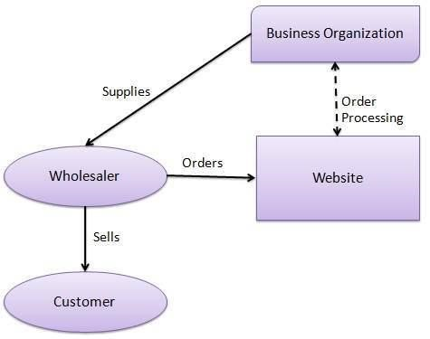

**BUSINESS-TO-CONSUMERS**

A website following the B2C business model sells its products directly to a customer. A customer can view the products shown on the website. The customer can choose a product and order the same. The website will then send a notification to the business organization via email and the organization will dispatch the product/goods to the customer.

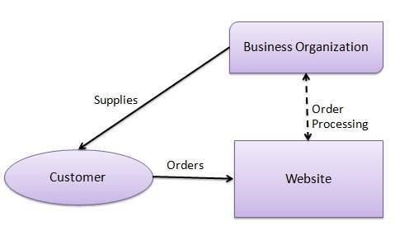

**Consumer - to – Business**

* In this model, a consumer approaches a website showing multiple business organizations for a particular product. The consumer places an estimate of amount he/she wants to spend for a particular product.
* A business organization who full fills the consumer's requirement within the specified budget, approaches the customer and provides its services.

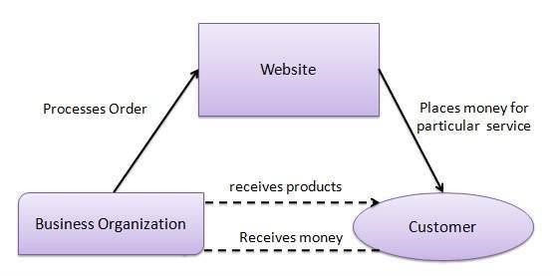

**E-COMMERCE PAYMENT PROCESS**

E-commerce sites use electronic payment, where electronic payment refers to paperless monetary transactions. Electronic payment has revolutionized the business processing by reducing the paperwork, transaction costs, and lab cost. Being user friendly and less time-consuming than manual processing, it helps business organization to expand its market reach/expansion. Listed below are some of the modes of electronic payments.

* Credit Card
* Debit Card

**CREDIT CARD**

Payment using credit card is one of most common mode of electronic payment. Credit card is small plastic card with a unique number attached with an account. It has also a magnetic strip embedded in it which is used to read credit card via card readers. When a customer purchases a product via credit card, credit card issuer bank pays on behalf of the customer and customer has a certain time period after which he/she can pay the credit card bill. It is usually credit card monthly payment cycle. Following are the actors in the credit card system.

* **The card holder** − Customer
* **The merchant** − seller of product who can accept credit card payments.
* **The card issuer bank** − card holder's bank
* **The acquirer bank** − the merchant's bank
* **The card brand** − for example, visa or Mastercard.

**DEBIT CARD**

Debit card, like credit card, is a small plastic card with a unique number mapped with the bank account number. It is required to have a bank account before getting a debit card from the bank. The major difference between a debit card and a credit card is that in case of payment through debit card, the amount gets deducted from the card's bank account immediately and there should be sufficient balance in the bank account for the transaction to get completed; whereas in case of a credit card transaction, there is no such compulsion.

Debit cards free the customer to carry cash and cheques. Even merchants accept a debit card readily. Having a restriction on the amount that can be withdrawn in a day using a debit card helps the customer to keep a check on his/her spending.

**E-COMMERCE SELLING PROCESS**

Selling online has become easily possible nowadays. In fact, it has become one the most popular platforms people prefer buying from.

If you plan to start a business of your own, and wondering how to go about it, then this post will help you learn the complete e-Commerce Selling Process.

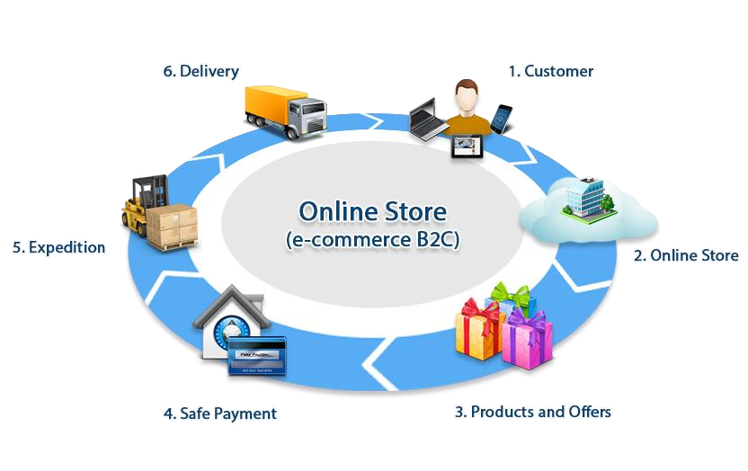

**IMPLEMENTATION**

While there are number of software tools to develop and implement the web based online shopping system, I have chosen those are open source, so that it will reduce the developing cost of the project. For designing the project HTML, CSS, Bootstraps, Apache server as web server, Python for making the system dynamic. MySQL as database server. All of the tools are open source.

**HTML**

In this project HTML used for design the structure. HTML is a markup language for describing web documents and stands for Hyper Text Markup Language, a markup language is a set of markup tags.HTML documents are described by HTML tags. Each HTML tag describes different document content. HTML used because:

* Easy to learn.
* Easy to use.
* Supported by all browser.

**MySQL**

* MySQL a database system used for the web application and it runs that runs on a server. The reason of using

MySQL are:

* MySQL is ideal for both small and large applications.
* MySQL is very fast, reliable, and easy to use.
* MySQL uses standard SQL.
* MySQL compiles on a number of platforms.
* MySQL is free to download and use.

**XAMPP server**

* XAMPP is a free and open source cross-platform web server solution stack package developed by Apache Friends, consisting mainly of the Apache HTTP Server, MariaDB database, and interpreters for scripts written in the Python programming languages. XAMPP stands for Cross-Platform (X), Apache (A), MariaDB (M), Python.
* It is a simple, lightweight Apache distribution that makes it extremely easy for developers to create a local web server for testing purposes. Everything needed to set up a web server – server application (Apache), database (MariaDB), and scripting language (Python) – is included in an extractable file. XAMPP is also cross-platform, which means it works equally well on Linux, Mac and Windows. Since most actual web server deployments use the same components as XAMPP, it makes transitioning from a local test server to a live server extremely easy as well.

Dataflow Diagram Level 0

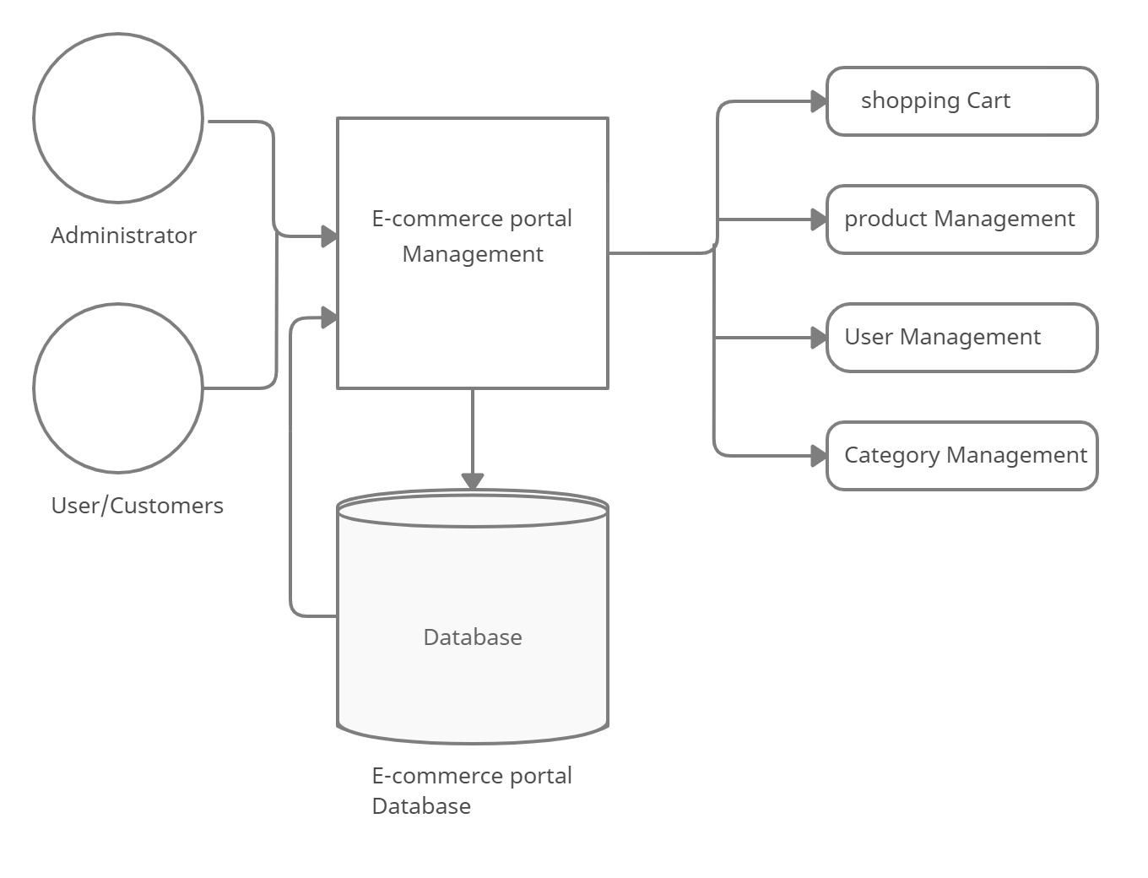

Data flow Diagram Level 1

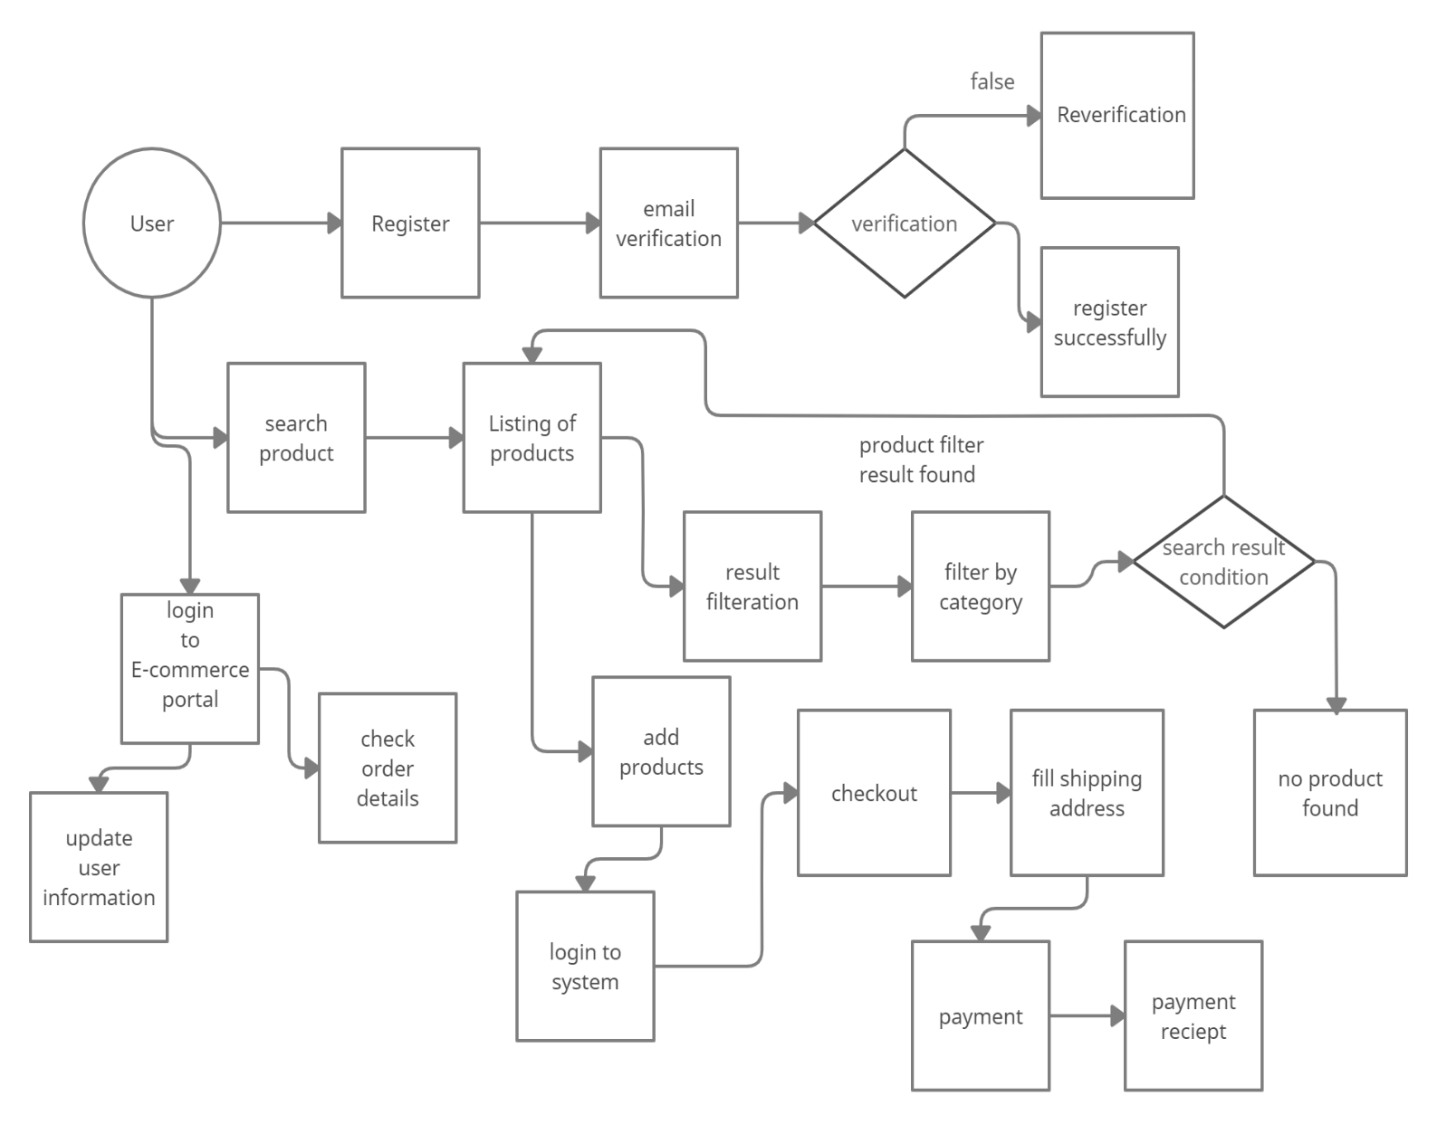

Data flow Diagram Level 2

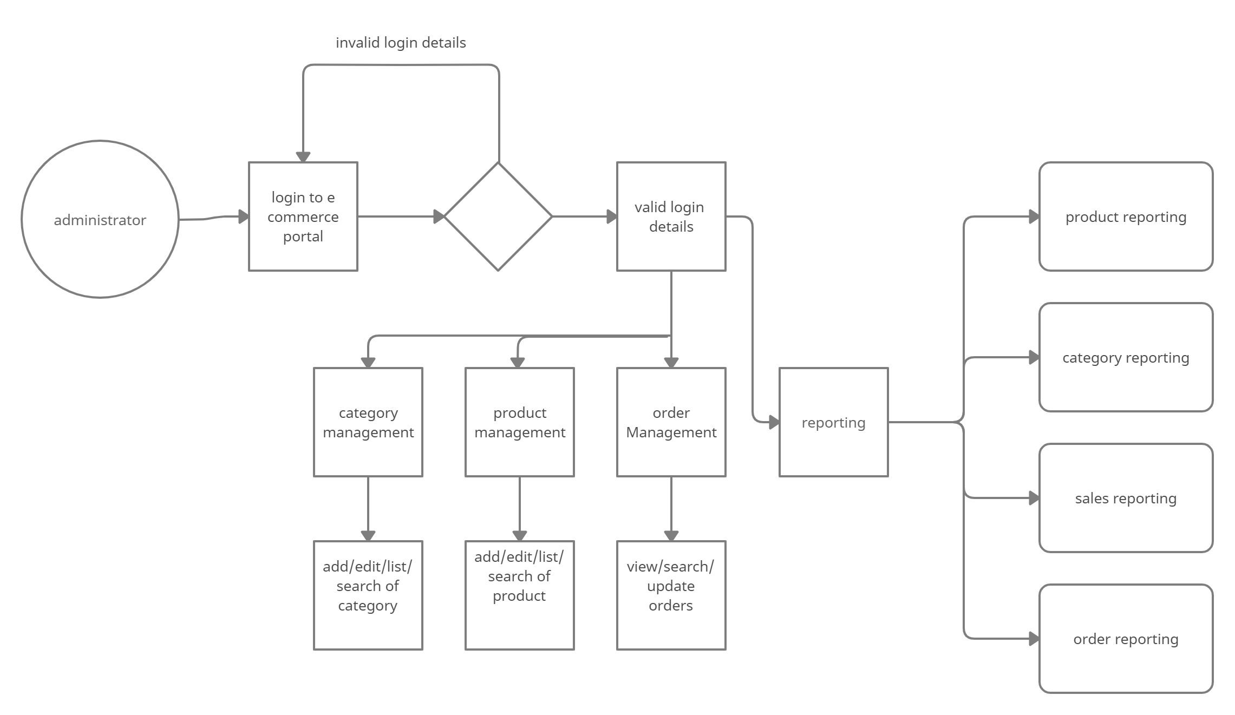

**DESIGN SPECIFACTION**

**Login Page**

Customer have to login before adding product in cart. In this page existing customer can login to buy product and new user can create an account for buying the product.

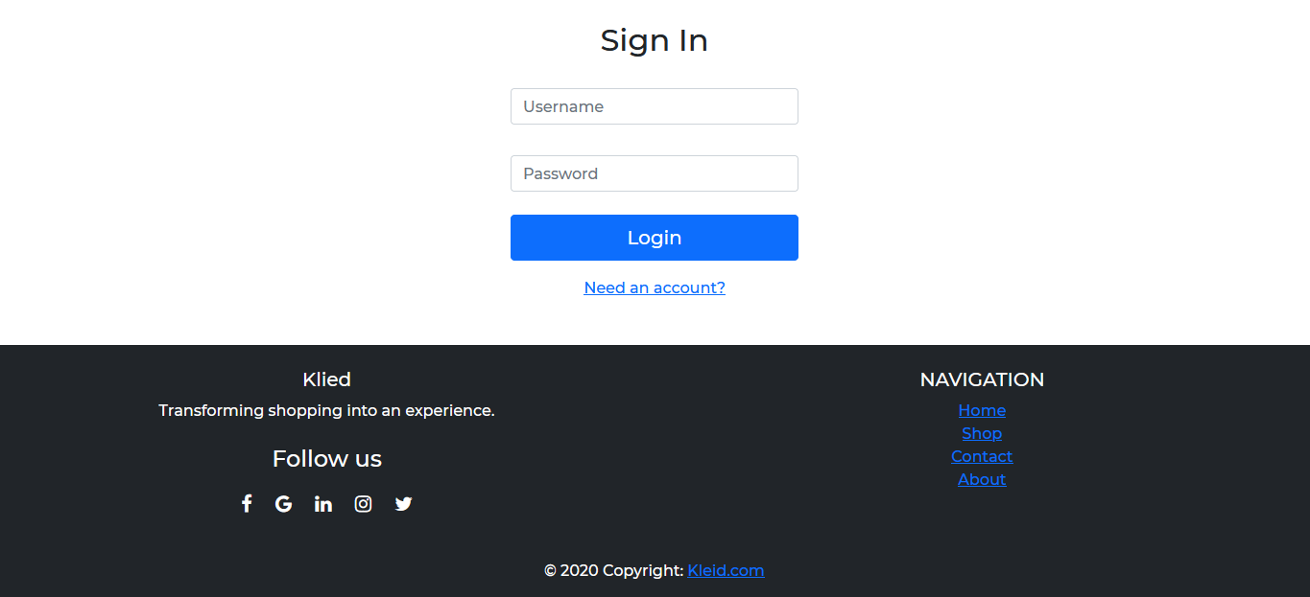

**Register Page**

Customer have to login before adding product in cart. In this page existing customer can login to buy product and new user can create an account for buying the product.

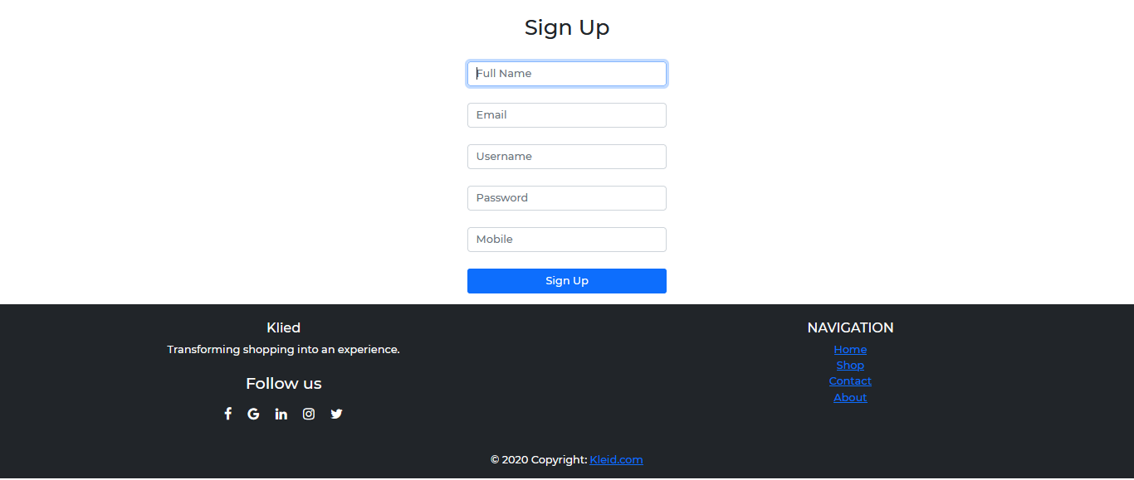

**Home Page Ui**

A home page is a webpage that serves as the starting point of website. It is the default webpage that loads when visit a web.

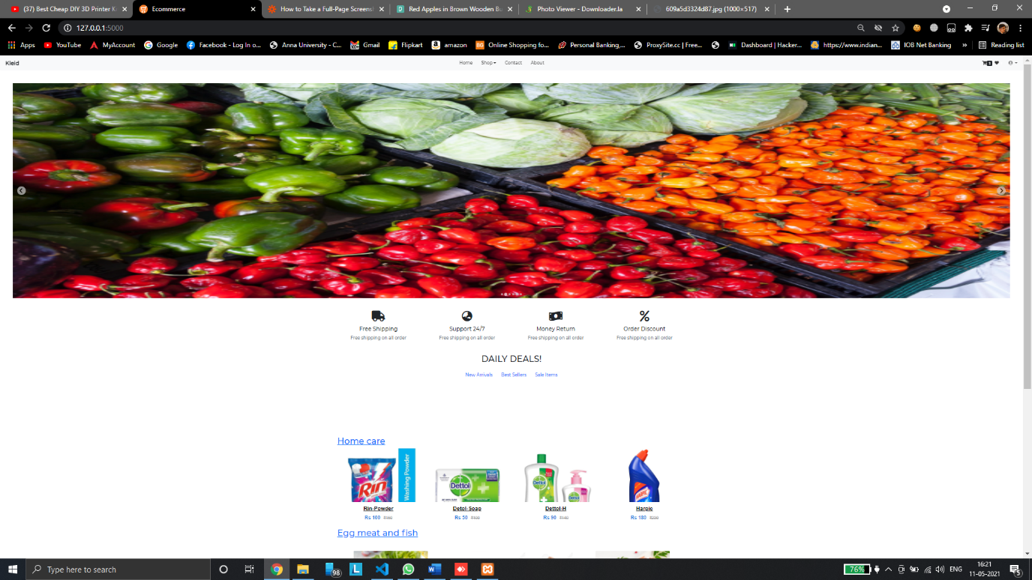

**Product View page**

To buy a product the customer have to add product to cart. Also customer can view the product details, as well as large view by putting the cursor over the product image. The figure of adding product to cart given

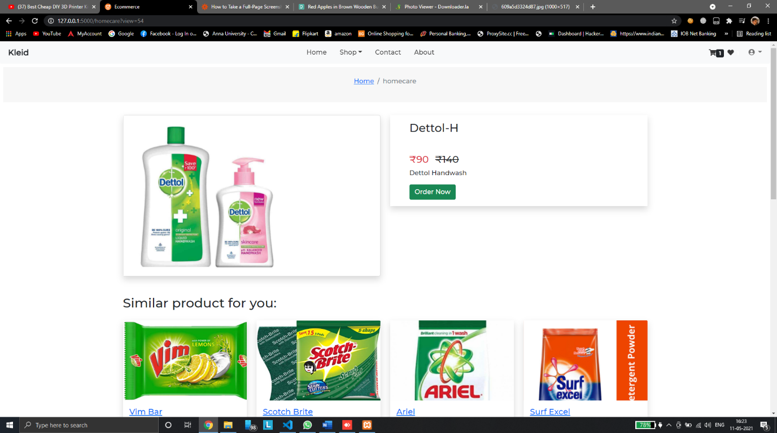

**Checkout Page**

The customer can view the product, update number of product, delete product from cart and send request to check out and given figure below

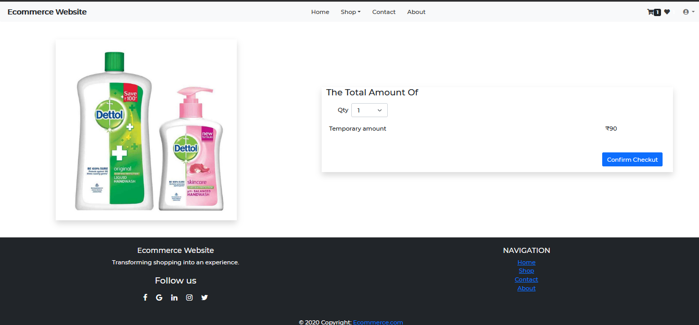

**Payment Page**

Customer checkout page using stripe integration where user can pay there money using payment gateway

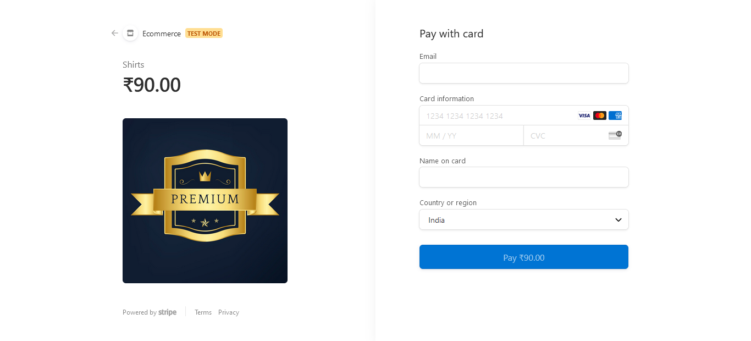

**Admin login**

Admin part in so important part of the system and he take cares all the part the shopping system. When the system developed an admin user created and using admin user email id and password 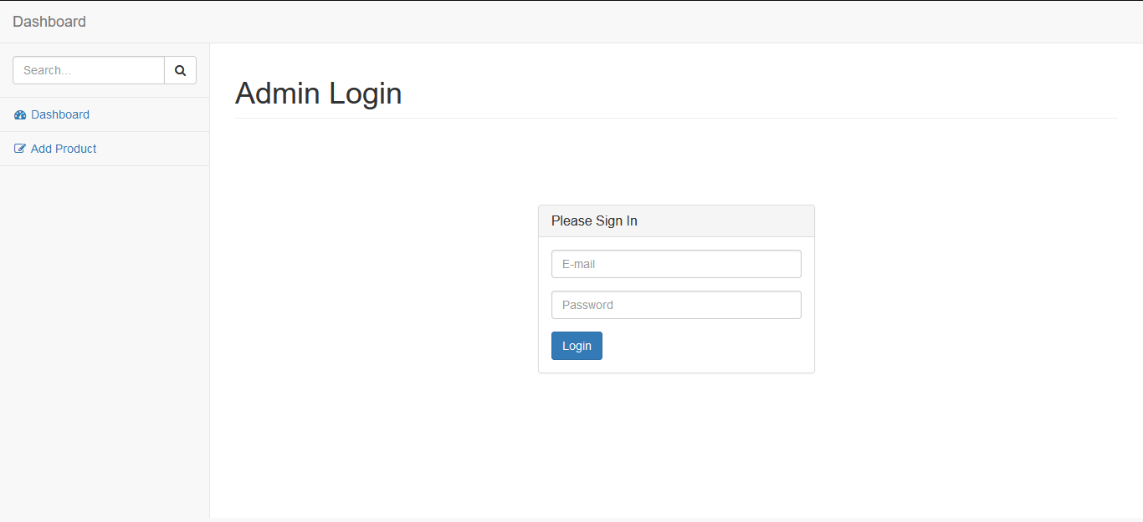

**Admin Dashboard**

Admin will get Add product, Manage Product and Archive Product submenu under product menu. The customer request for product will show on Manager Order menu

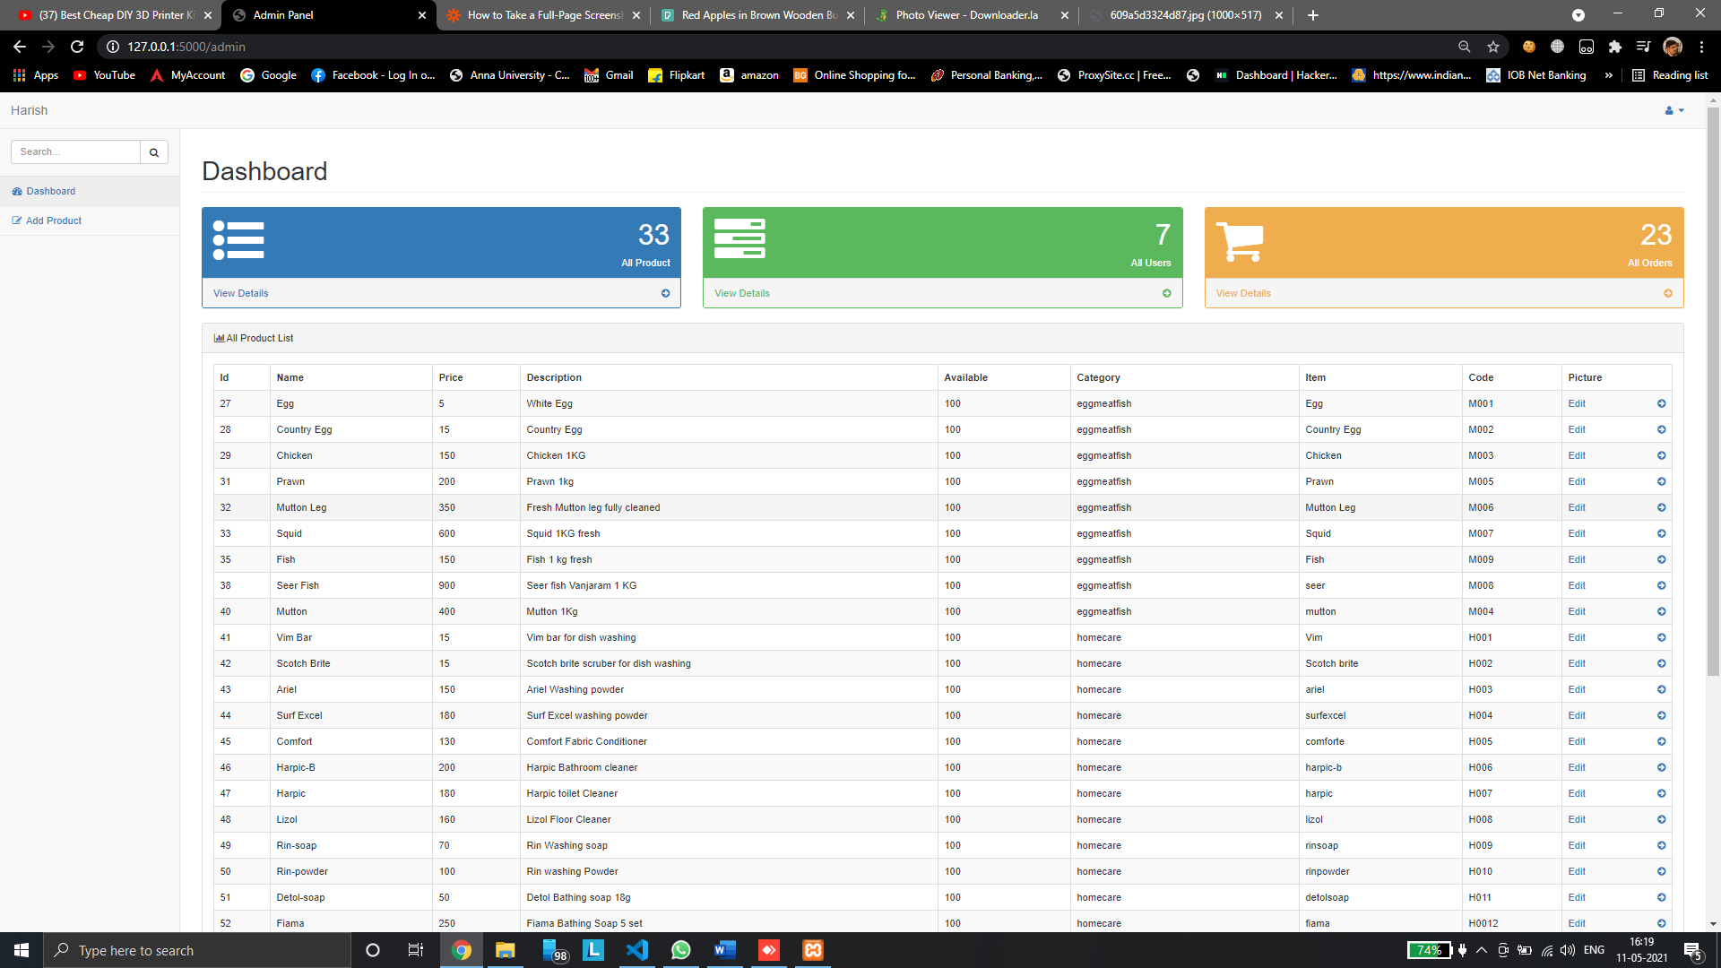

**Admin Orders view**

Admin can able to handle customer order in single page

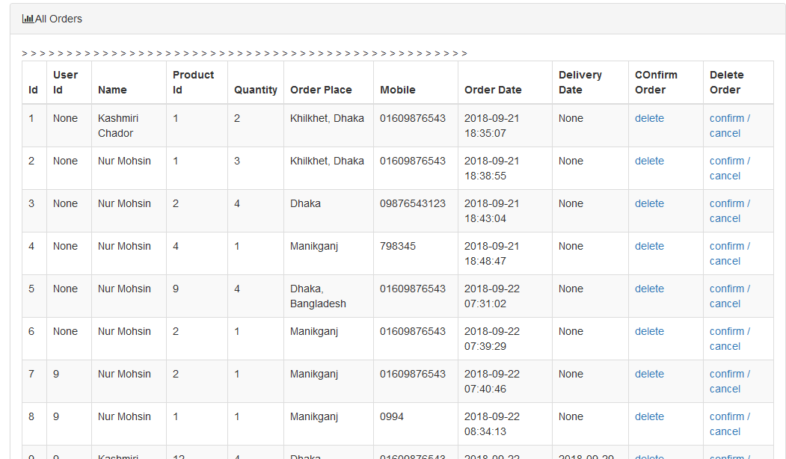

**Admin Products view**

Admin can able to handle Products in single page and can edit and manage products

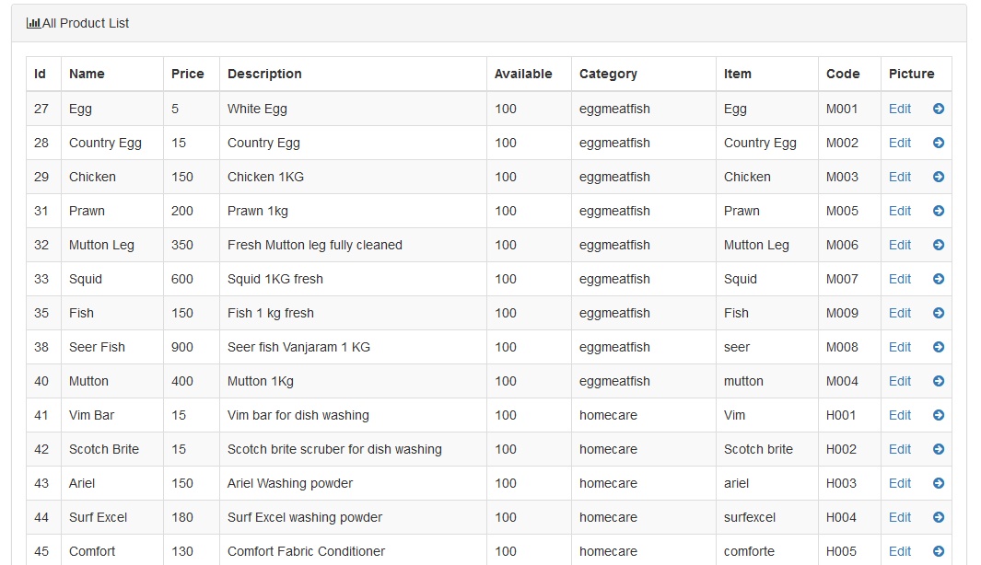

**Admin ADD Products**

Admin can able to handle Add Products with Category, price and etc.

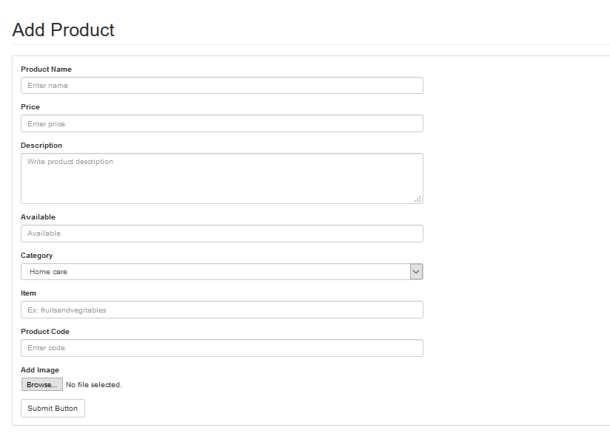

**Admin Audit Logs**

Admin can able to view and audit customer username ,online status and registration time 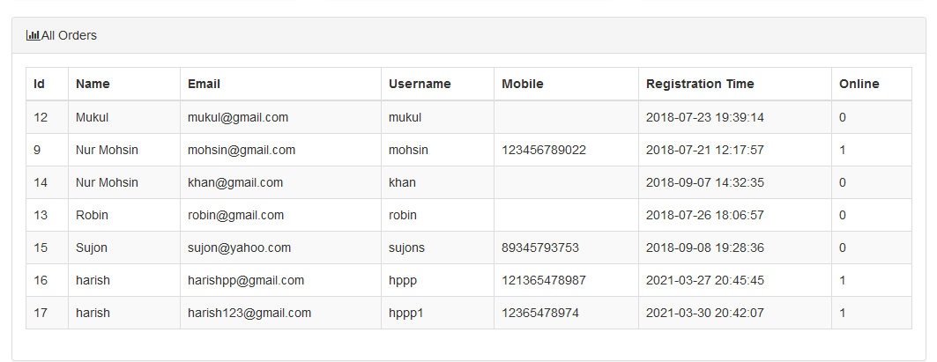

**Reference**

* en.wikipedia.org/wiki/Online_shopping_case_management
* [www.w3schols.com](http://www.w3schols.com)
* <http://www.siteground.com/tutorials/php-mysql/zend_optimizer.html>
* <https://www.mysql.com>
* <https://medium.com/@mushtaque87/flask-in-pycharm-community-edition-c0f68400d91e>
* <https://getbootstrap.com/docs/5.0/getting-started/introduction/>
* <https://css-tricks.com/>
* Database System Concept By Silberschartz, kith, Sudarshan ISBN 007-124476-

**conclusion**

From the above discussed trends in the buying experiences, the irreversible changes are already proved, It has changed the way in which people communicate, interact, search for products to buy, as well as to conduct shopping. A strong retailer and an effective business should take consideration from all the above-stated points and discussed figures as well as commercial appeals. Thus in the 21st century, it‘s a very hard battle to conduct effective business activities. Hence the business that adapts the changes and finds an appeal to new customers are doomed to commercial success and great grand revenues

Thank you