Name : S.HARISH
Reg.no: 192524413

CSA1509-Cloud computing and Big Data Analytics

EXPERIMENT – 22
Running Virtual Machines with Different Configurations

Aim:
To run virtual machines with different configurations and determine how many virtual machines can be utilized simultaneously based on the available system resources.
Short Procedure:
- Open Oracle VirtualBox and create a new virtual machine.
- Configure the VM with different RAM, CPU, and storage settings.
- Install the required operating system in each virtual machine.
- Start the virtual machines one by one and observe the system performance.
- Continue running VMs until the available RAM/CPU resources are nearly utilized.
- Record the number of VMs running simultaneously and their configurations.
- Compare the configurations and determine the maximum number of VMs that can be utilized at a particular time. Result:
The number of virtual machines that can run simultaneously depends on the host system's available RAM, CPU, and storage resources.

Step 1 : CREATING VM AND PROVIDING ISO FILE
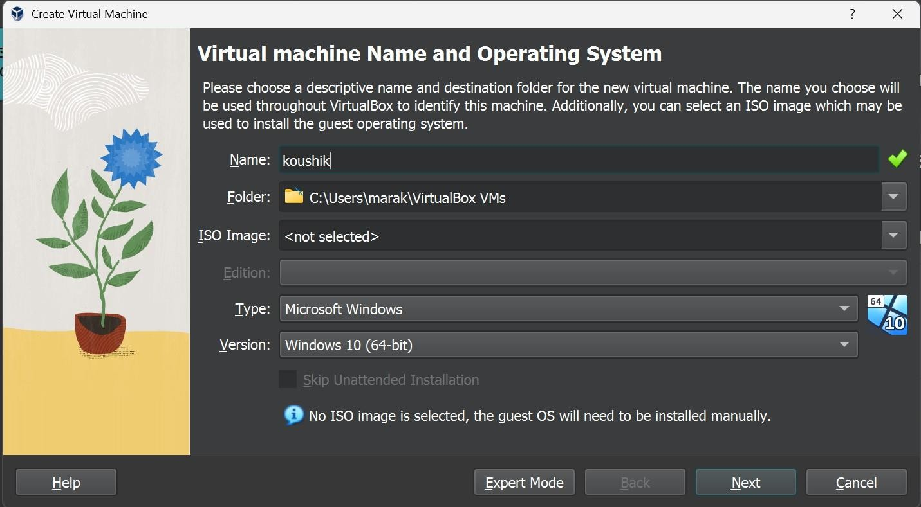

Step 2 :PROVIDING CREDENTIALS FOR THE VM
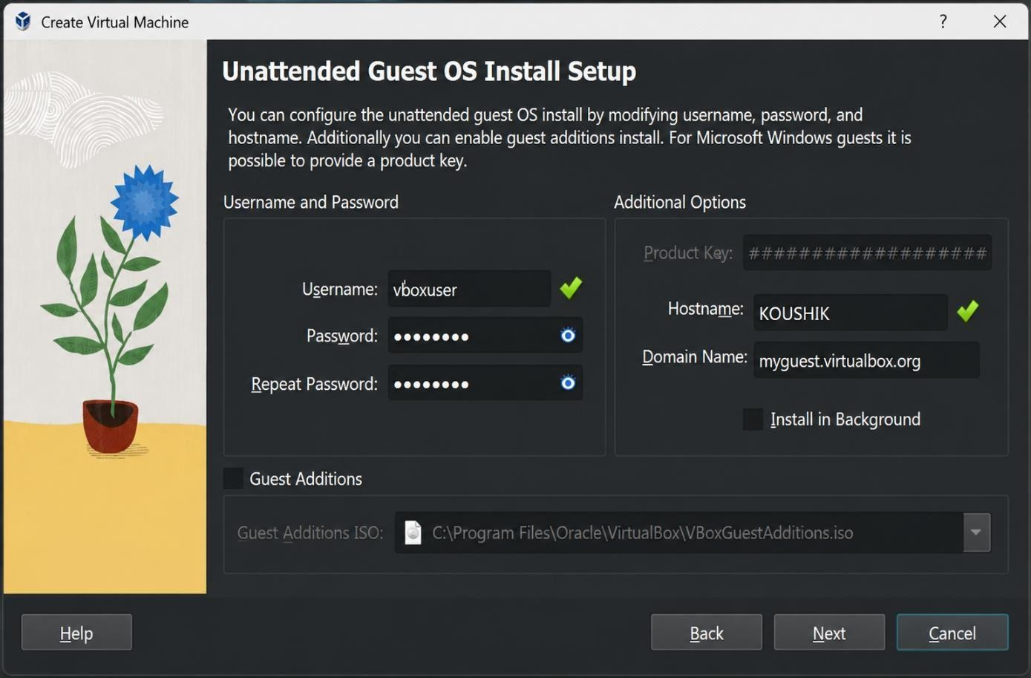
Step 3 : CREATING VIRTUAL HARD DISK WITH REQUIRED CONFIGURATION
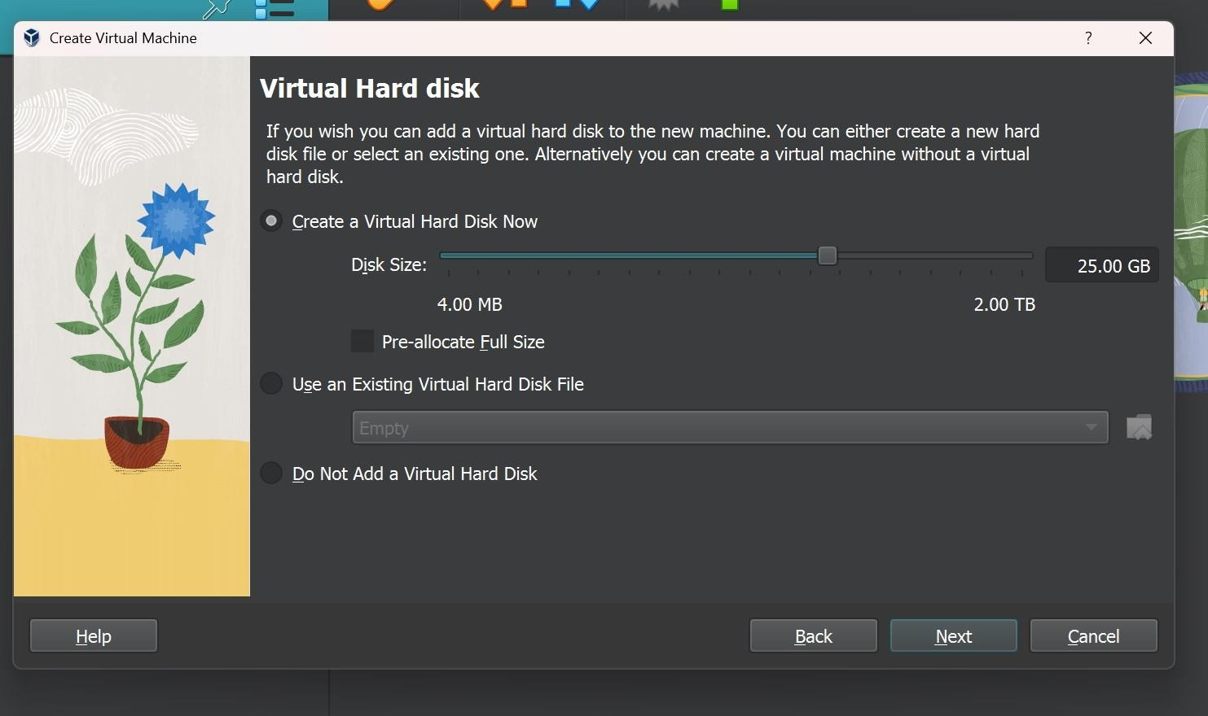

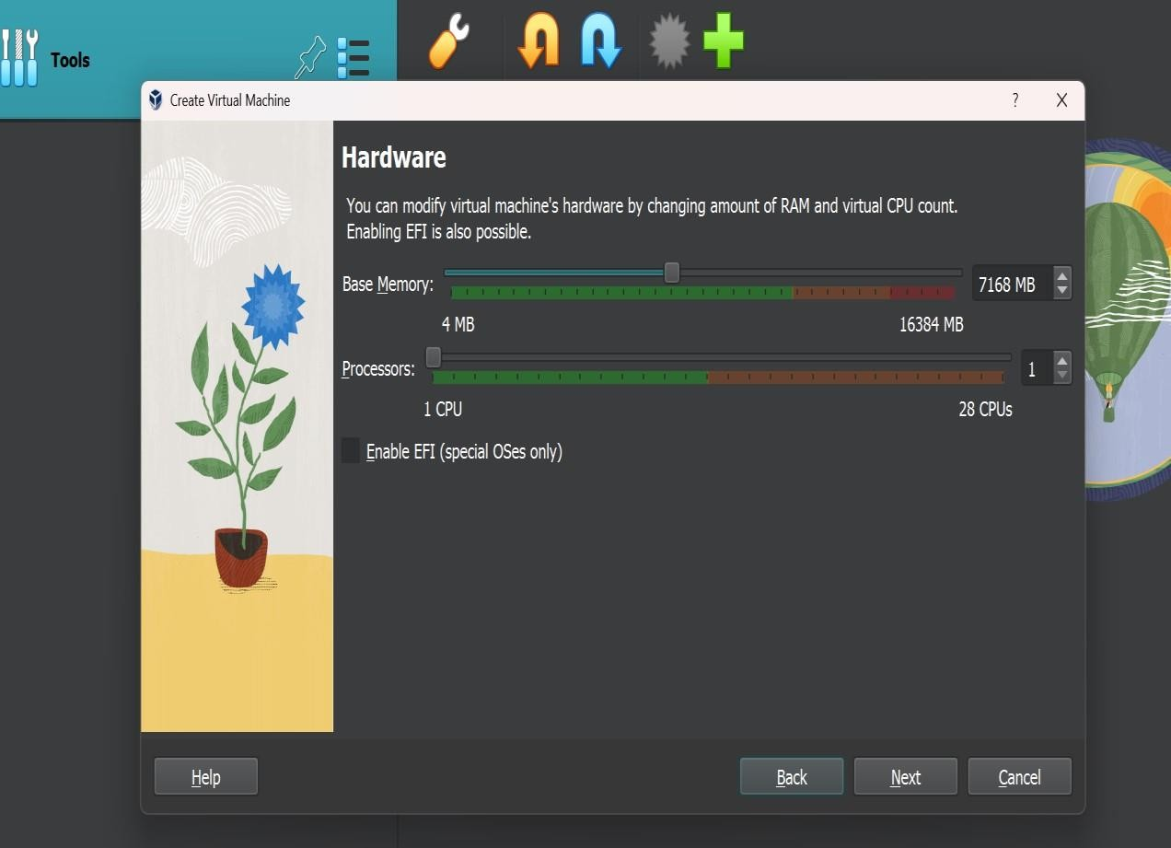
Step 4 : CONFIGURING THE VM
Step 5:- when take different configurations look like these

