**Project Milestone-01**

**Date: 05/18/2020**

**Project title:**

FCUS Mobile Banking

**Project Description:**

Main aim of the project is to build mobile applications for Client, the expansion of their business and banking operations on mobile devices. Client customers log in to their profiles in mobile application and use banking operations.

**Team name:**

FCUS Development.

**Team member names:**

Mohan Krishna Alavala

Harish Thadka

Rohith Chittimalla

Bhaskar Reddy Minupuri

Rohith Reddy Avisakula

**Client:**

Dr. Aziz Fellah

**Team Logo:**



**Project Charter**

**Date: 05/18/2020**

|  |  |  |  |
| --- | --- | --- | --- |
| **Project Title**: FCUS Mobile Banking | | | |
| **Project Start Date:** 15 May 2020  **Projected Finish Date:** 04 June 2020 | | | |
| **Budget Information:** Sponsors | | | |
| **Project Manager:** **Name:** Mohan Krishna Alavala, **Phone**:+1 660 541 5768, **E-mail**: [S538097@nwmissouri.edu](mailto:S538097@nwmissouri.edu) | | | |
| **Project Objectives:**  Building Mobile Application for client, to grow their business and banking operations on mobile devices. | | | |
| **Success Criteria:**  We will be designing our Mobile application with an interactive user interface and without any bugs before the deadline. | | | |
| **Approach:**  AGILE APPOROACH | | | |
| **Roles and Responsibilities** | | | |
| ***Name and Signature*** | ***Role*** | ***Position*** | ***Contact Information*** |
| **Mohan Krishna Alavala** | Developer | Project Manager/ Backend developer | **+1 660 541 5768** |
| **Harish Thadka** | Developer | Team Lead/ Front End developer | **+1 660 528 0687** |
| **Rohith Chittimalla** | Developer | Content & User Interface Developer | **+1 660 528 0778** |
| **Bhaskar Reddy Minupuri** | Developer | Web application Developer | **+1 660 528 0164** |
| **Rohith Reddy Avisakula** | Tester | Testing Manager | **+1 660 215 8754** |
|  | | | |
| **Comments:**  (N/A) | | | |

Stakeholder Register for FCUS Mobile Banking

**Prepared by:** Harish Thadka **Date: 05/18/2020**

|  |  |  |  |  |
| --- | --- | --- | --- | --- |
| **Name** | **Position** | **Internal/External** | **Project Role** | **Contact Information** |
| Mohan Krishna Alavala | Project manager/ Backend developer | Internal | Sr. Developer | +1 6605415768 |
| Harish Thadka | Team Lead/ Front End developer | Internal | Sr. Developer | +1 6605280687 |
| Rohith Chittimalla | Content & User Interface Developer | Internal | Sr. Developer | +1 6605280778 |
| Bhaskar Reddy Minupuri | Web application Developer | Internal | Jr. Developer | +1 6605280164 |
| Rohith Reddy Avisakula | Testing Manager | Internal | Tester | +1 6602158754 |
| Dr. Aziz Fellah | Client | External | End User | 0000000000 |

**Team meetings:**

We’re going to meet at our workplace for daily meetings and we’ll share the confidential information, project-related documents through our organization mails.

We will discuss the work in below following schedule:

**Monday –Friday**

At 6:30 PM -6:45 PM – Daily Standup Meeting.

* Team lead discuss about the work and updates about teamwork.

**Every Saturday**

At 7:00 PM -8:00 PM – Team Meeting

* Project Manager shares project information with the project support team and clarifies team lead questions and offers input on the team member's work.

**Every Monday**

At 9:00 AM -11:00 AM – Client Meeting.

* Project Manager and Team lead provides information about project work to the client and backlogs of the project.

If there is a non-participating team member working on the project, we will personally meet with the project manager to find out what difficulties encountering in work and try to solve the problem. Even if he doesn't cope with the work, we’ll give them a chance to get back on track as soon as possible.

**Roles:**

Mohan Krishna Alavala: Project manager/ Backend developer (Senior Developer and Manager)

Harish Thadka: Team Lead/ Front End developer (Senior Developer and Team Leader)

Rohith Chittimalla: Content & User Interface Developer (Senior Developer)

Bhaskar Reddy Minupuri: Web application Developer (Junior Developer)

Rohith Reddy Avisakula: Testing Manager (Tester)

**Signatures:**

Mohan Krishna Alavala:

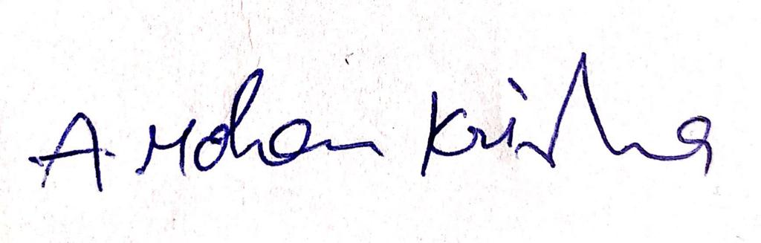

Harish Thadka:



Rohith Chittimalla:

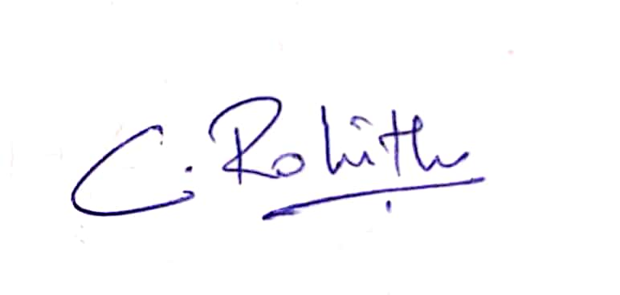

Bhaskar Reddy Minupuri:

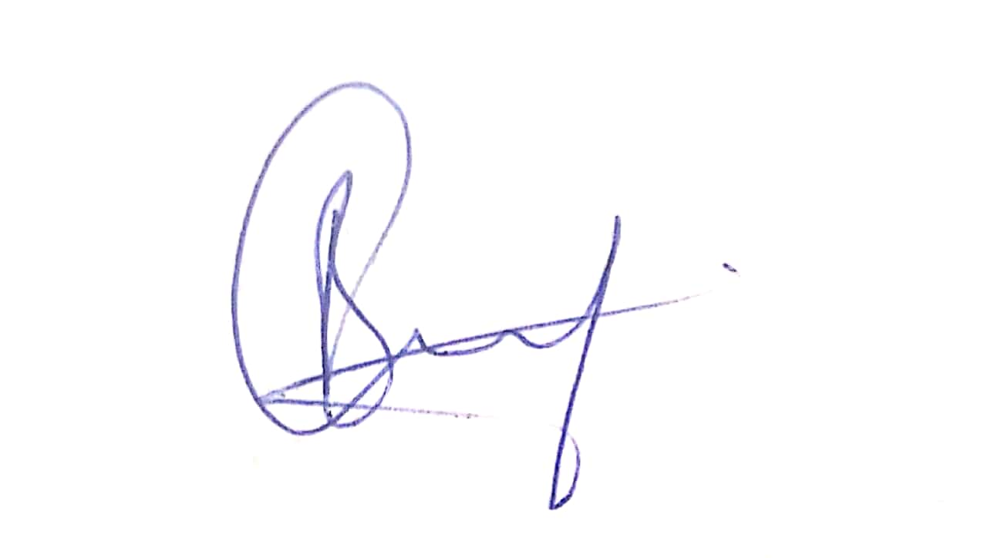

Rohith Reddy Avisakula:

