**Output:**

1. Starting of Application:

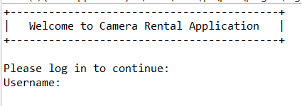

2. Entering username and password:

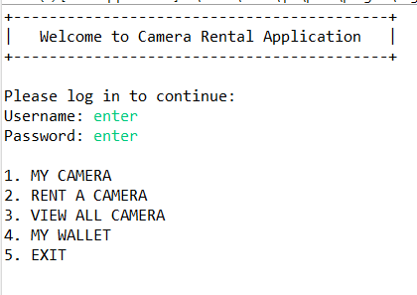

Here we can see main menu is visible after entering username and password.

3. Entering 3rd option to see all cameras available in application:

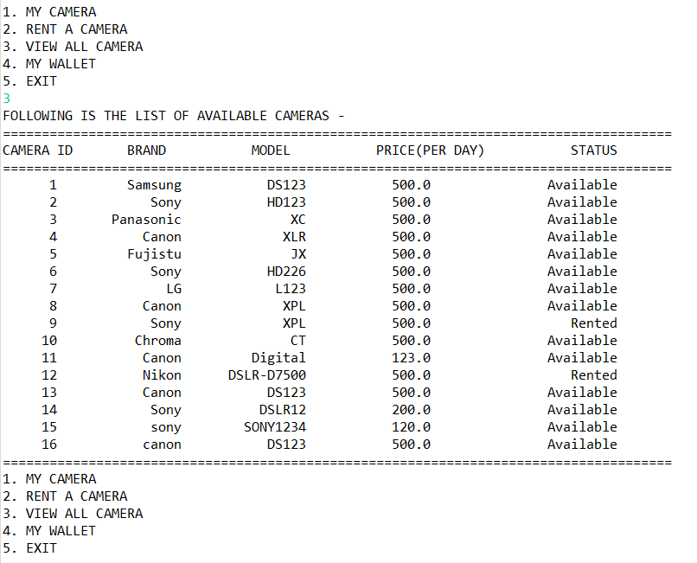 here we can see the list of cameras available with details like camera id, brand name, model , price and status.

4. Now entering 1st option that is MY CAMERA:

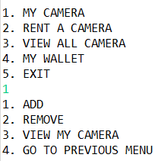

5. Here we are adding a camera so enter 1st option:

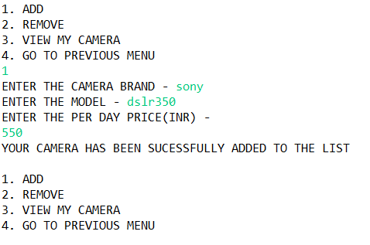

6: Now we are removing one camera from application:

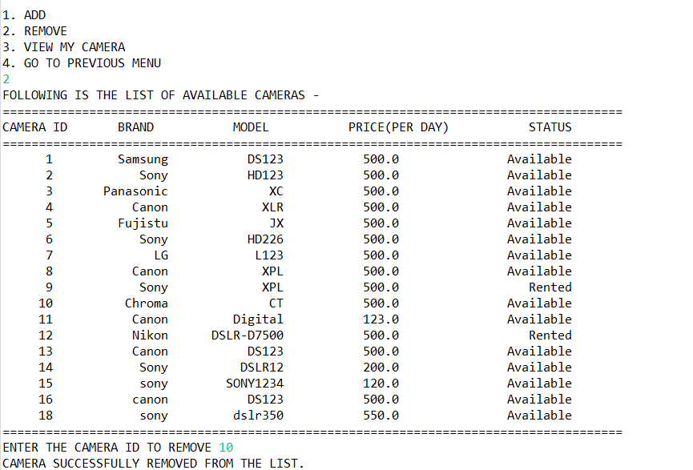

Here we are removing camera with camera id 10. In step 5 we added a camera to list, here we can see the camera id 18 is new entry the we entered.

7. Now enter 3, to see mycamera list:

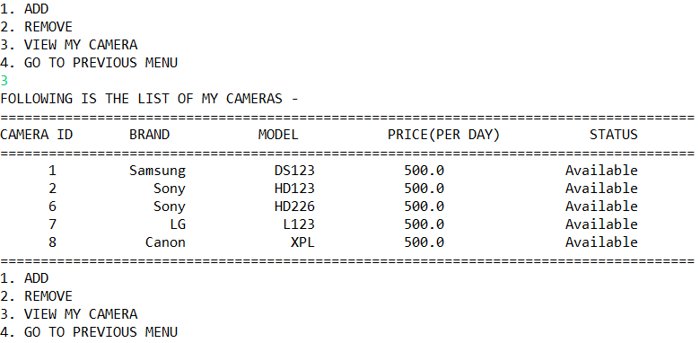

8: Enter 4th option to navigate back to main menu:

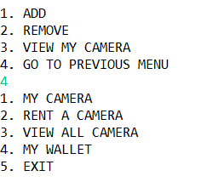

9: Now enter 3rd option to see updated camera list:

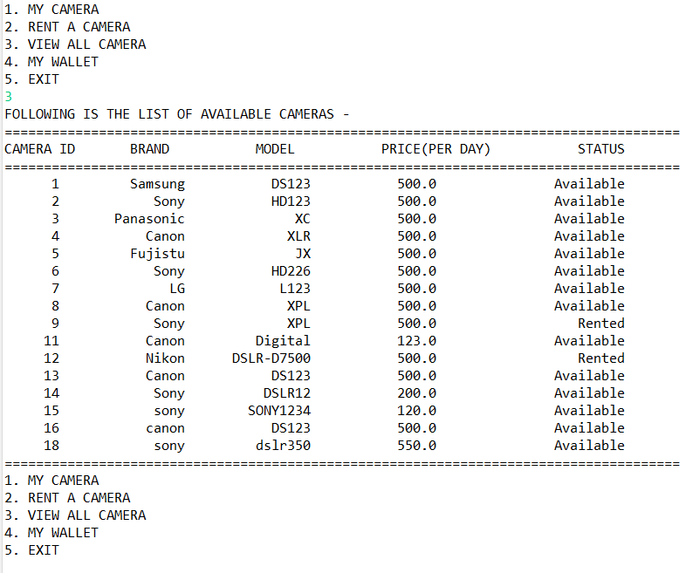

Here we can see that camera with camera id 10 was removed from list as in step 6 we removed camera id 10.

10. Enter 4 to see wallet:

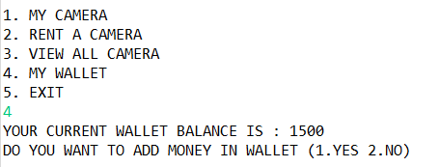

11. Enter 1 if user want to add money to wallet:

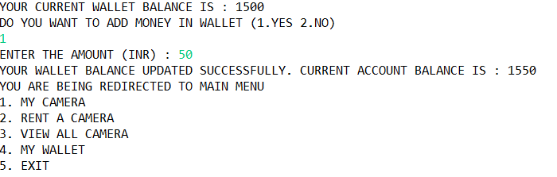

12. Enter 2 for rent a camera: All available cameras will be displayed.

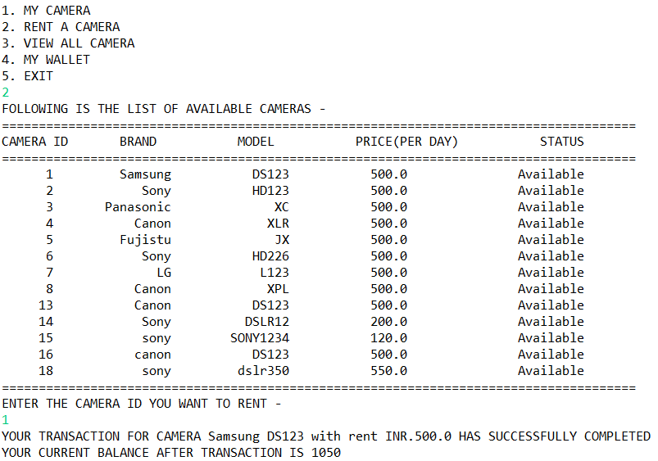

13. Above we rented camera with camera id 1, Now lets see the status of cameras:

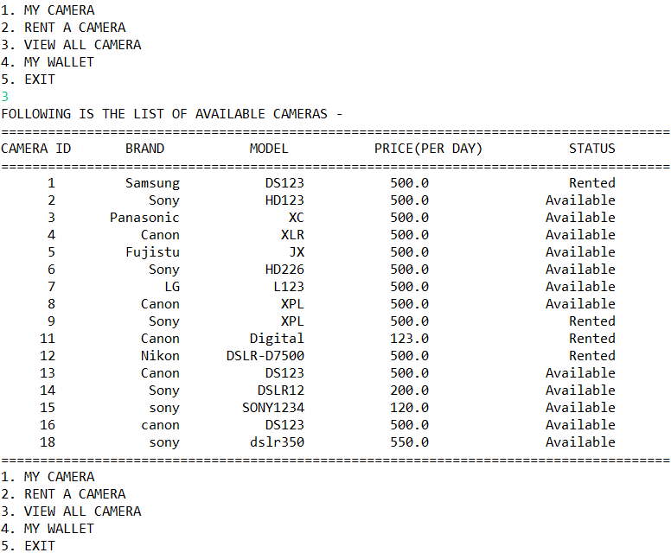

Above we can see the status for camera id 1 is changed from “Available” to “Rented”

14. Now let’s see our wallet if money deducted or not:

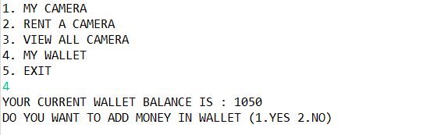

Initial our wallet amount was 1500 and then we added 50 rupee and after renting a camera worth 500, Total remaining amount is 1050.

15. Enter 5 to exit Application:

