**Output:**

**User End:**

**1. User register.**

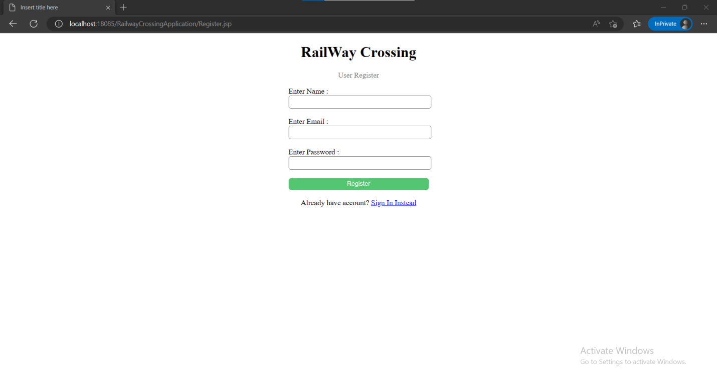

**2. Once user Enter details then he will be redirected to Log in page.**

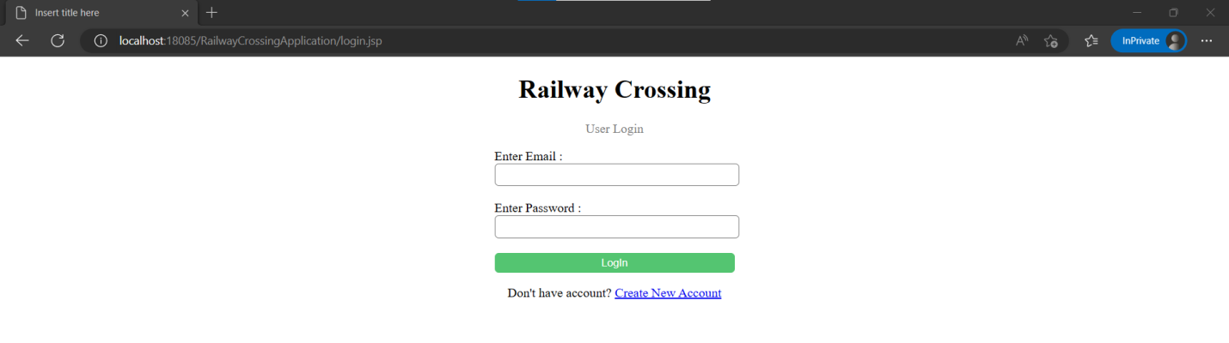

**3. If user enter invalid mail or password then out will be:**

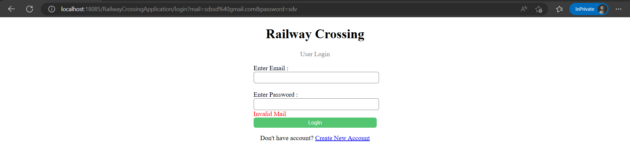

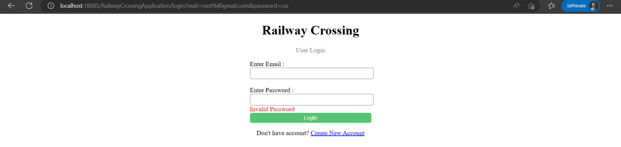

**4. After login home page :**

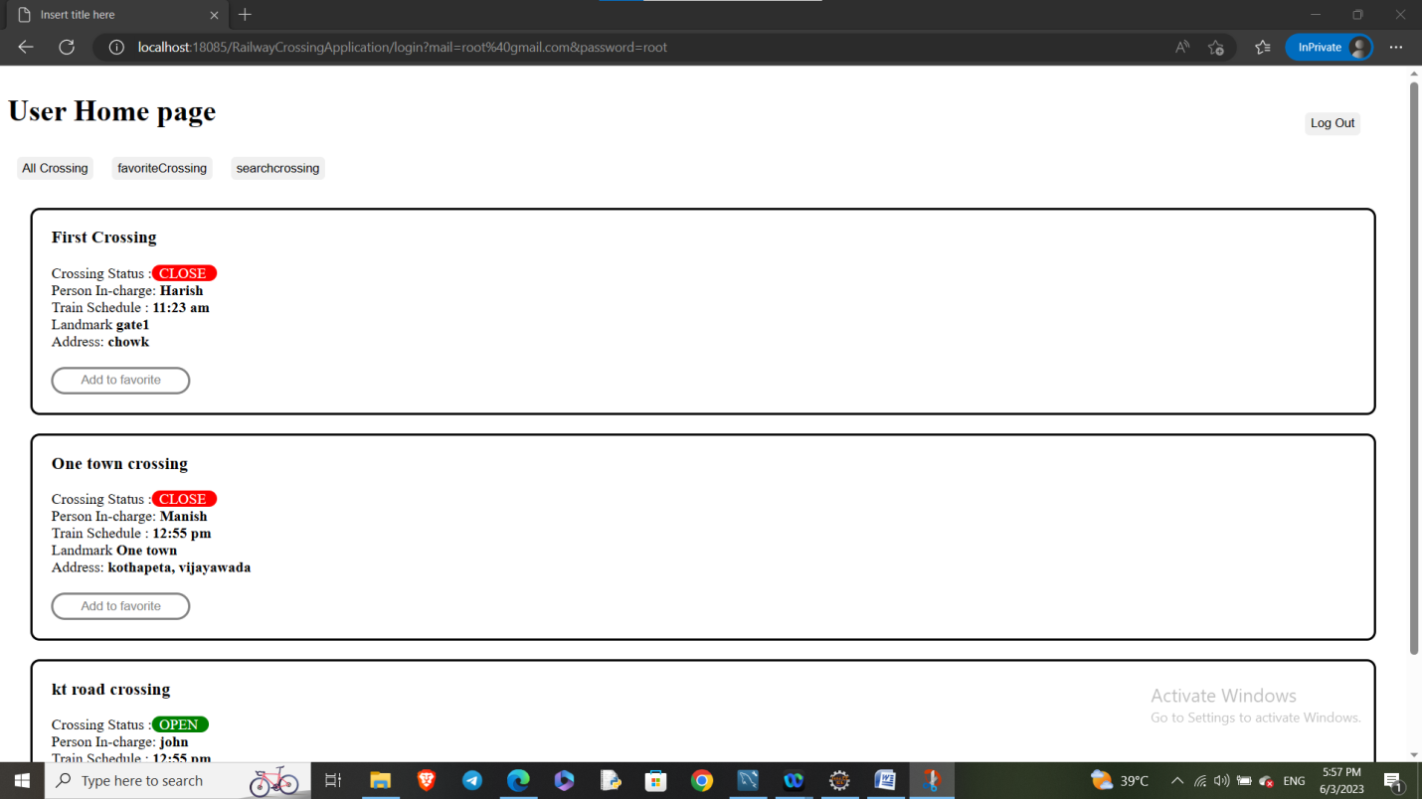

**5. If user click on favorite Crossing:**

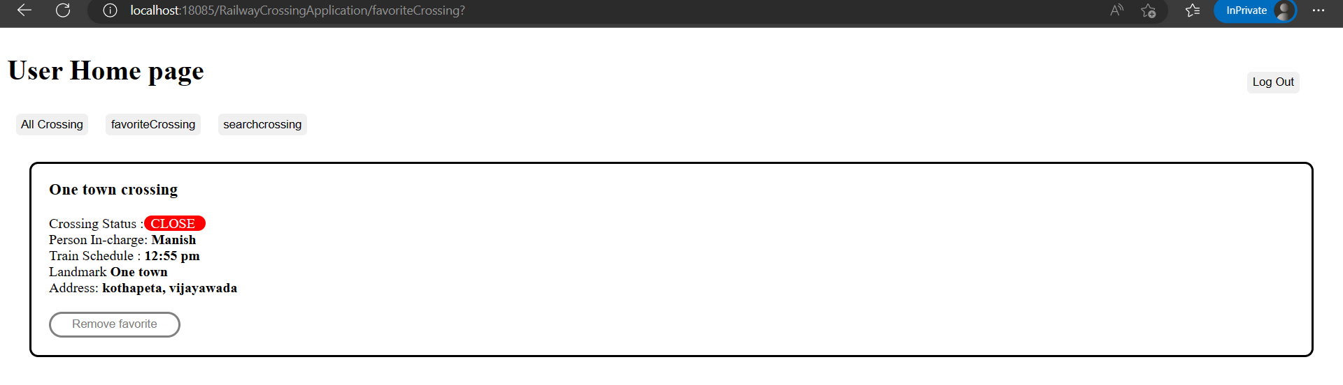

**6. Now user click on All crossing and click add to favorite the following crossing will be appear in user favorite section:**

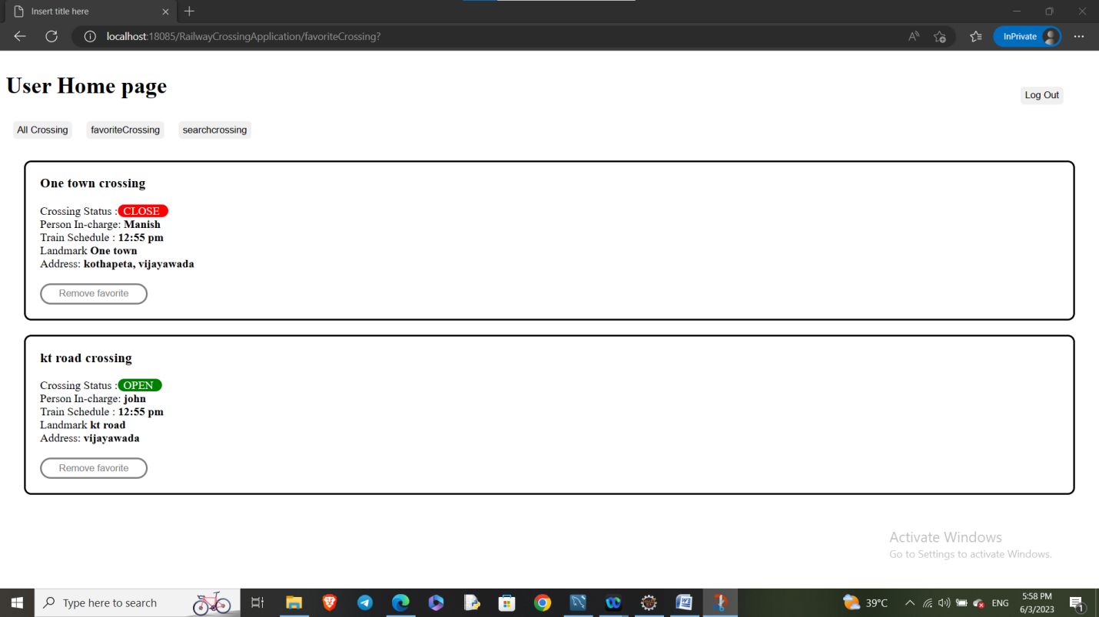

**7. If user want to remove one town crossing from his favorite, so clicks on remove favorite then favorite crossing section :**

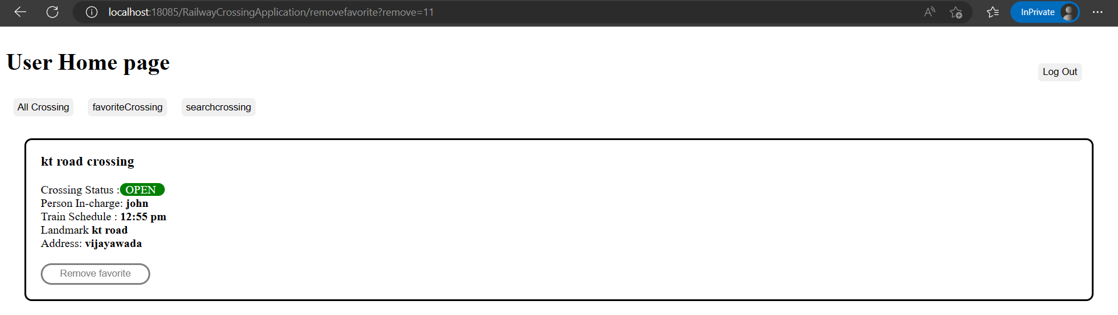

**8. If user Click searchcrossing button then output will be:**

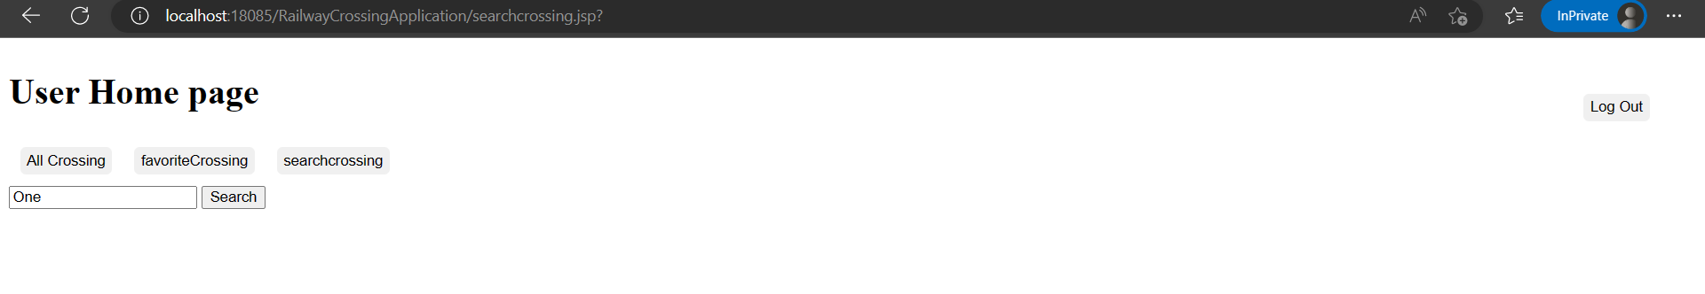

**9. User enter “One” and click on Search then output will be:**

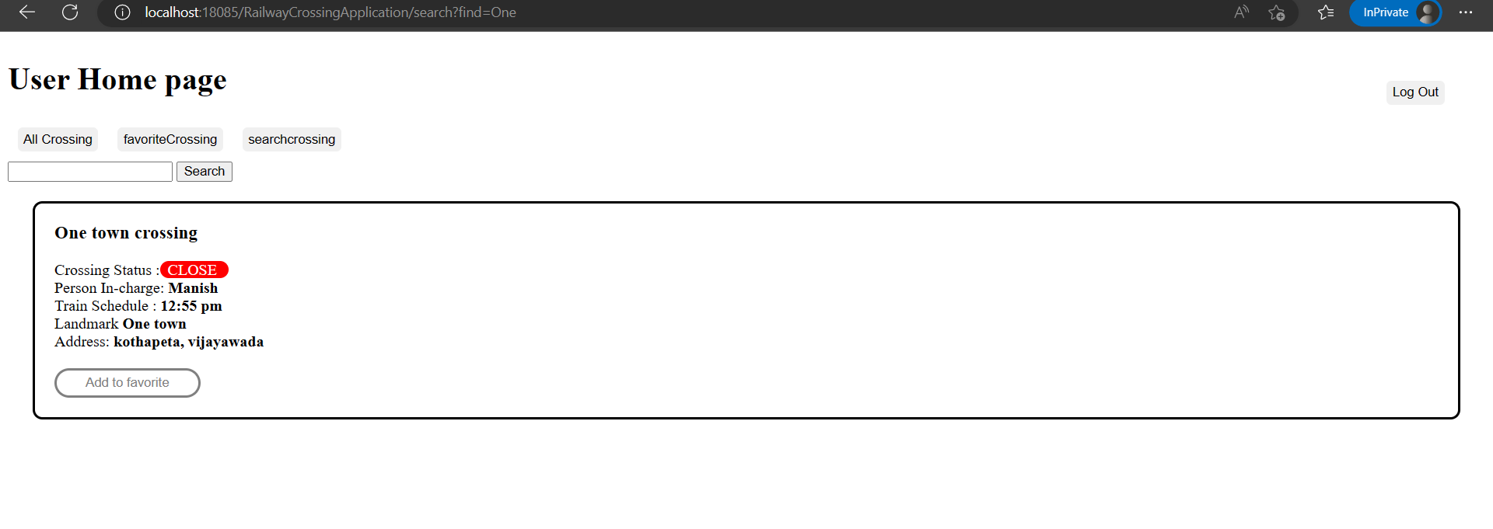

**10. When user click on logout he will be redirected to logout page and session will be terminated.**

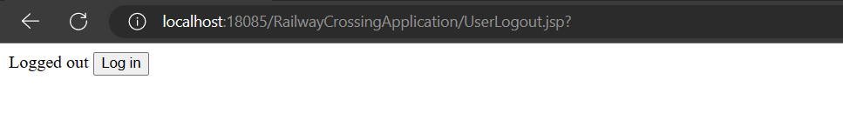

**11. If user enters favoriteCrossing link without login, then he will be redirected to login page.**

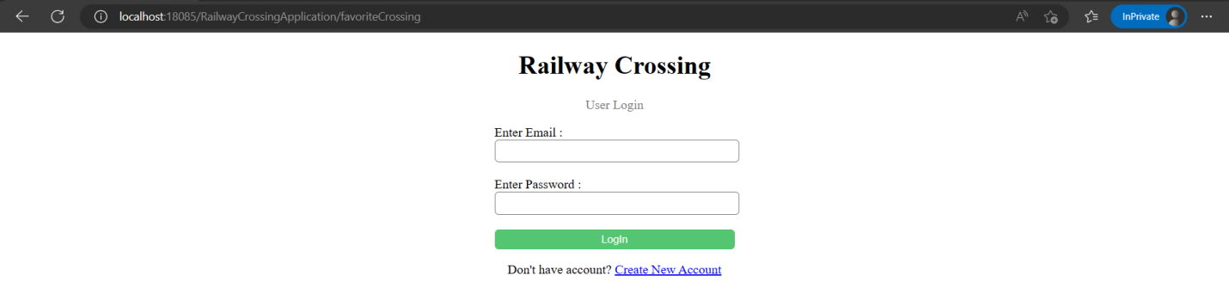

**Admin End:**

**1. Admin login:**

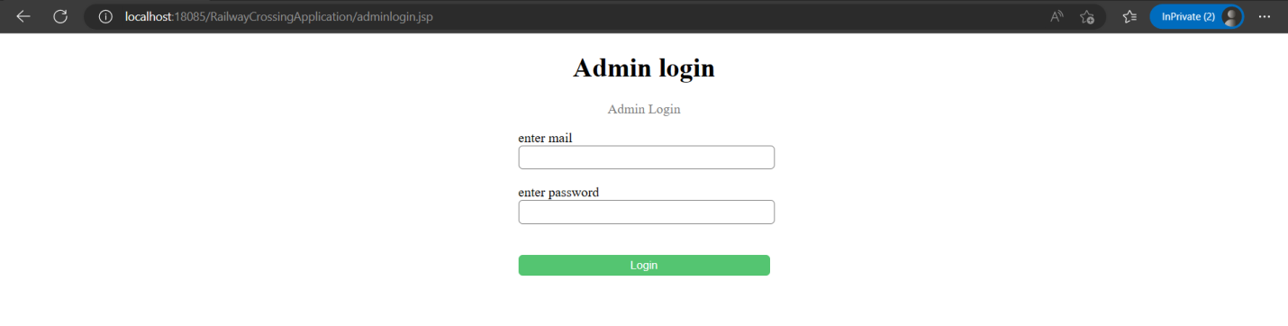

**2. After logIn dashboard will appread like this:**

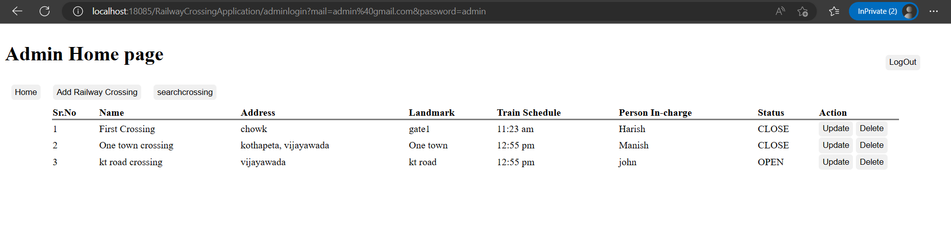

**3. If user clicks on Add Railway Crossing button:**

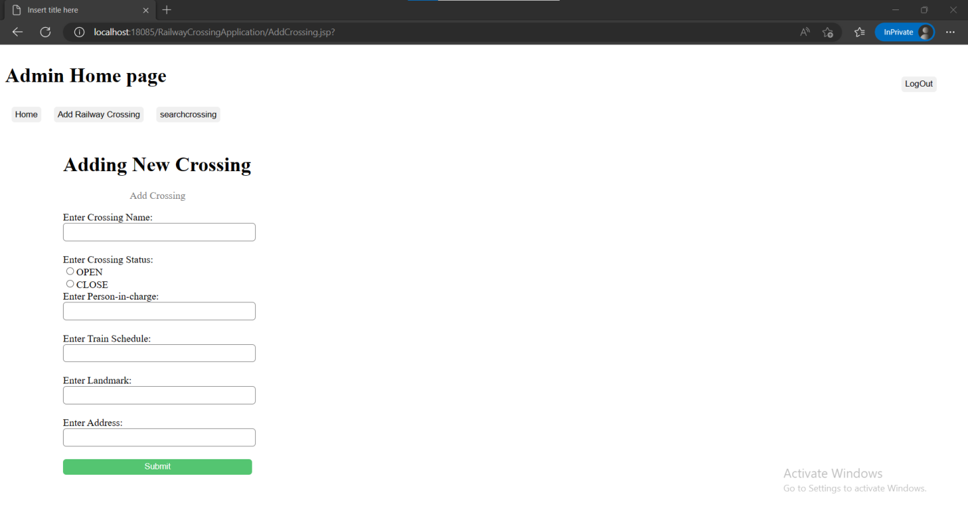

**4. Once user fills the form and submit the details then the crossing will be added and admin will be redirected to home page:**

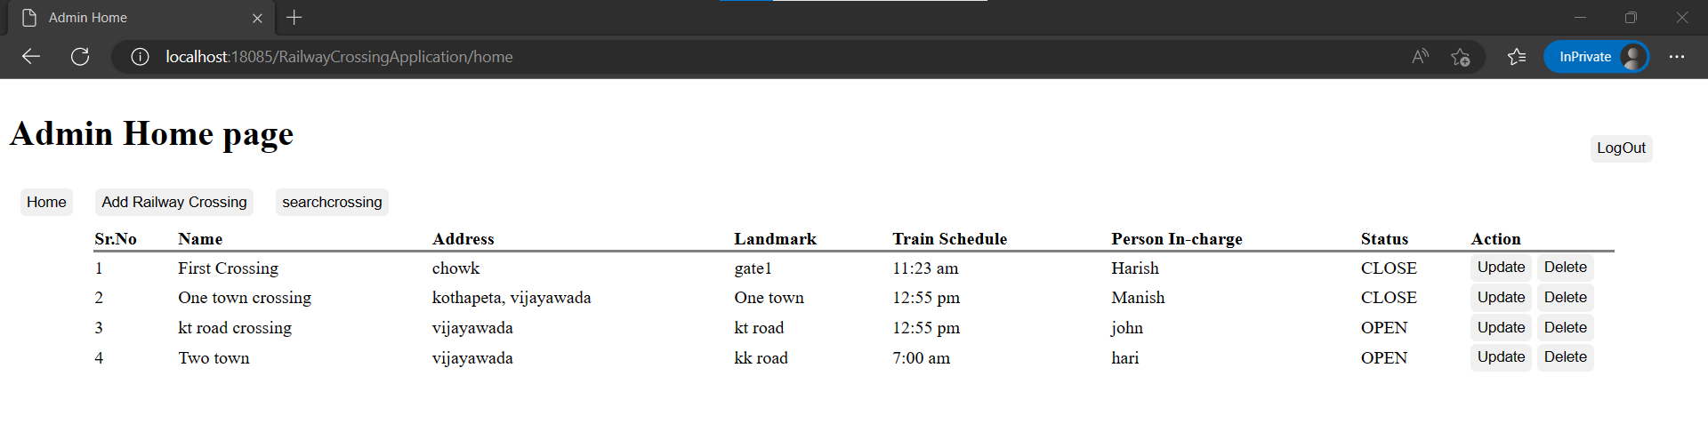

**5. If User clicks on searchcrossing:**

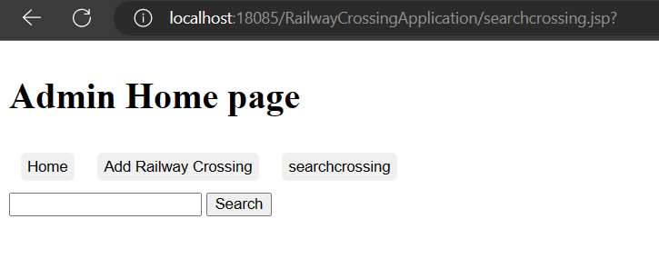

**6. User enter “town” and clicks on search then the following output will be displayed:**

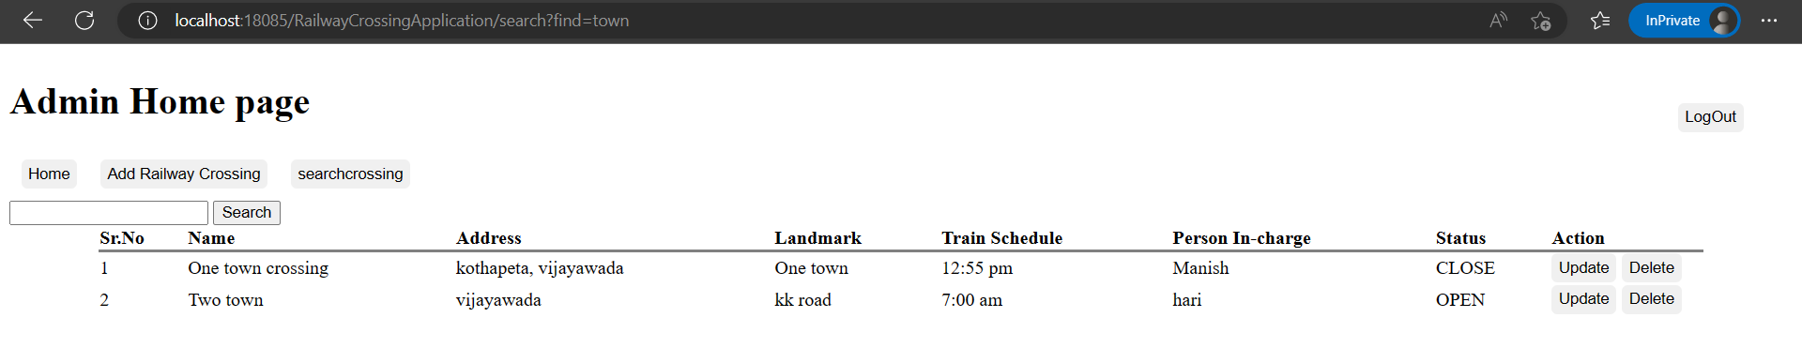

**7. If user Clicks on Update then a from will be displayed with values user can change the values:**

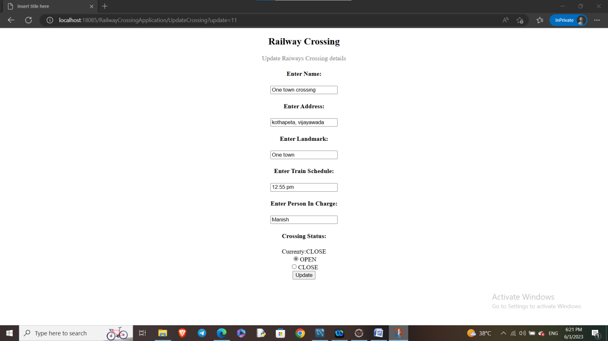

User submits the above from where the crossing status is changed from close to open.

**8. After user click on update the output displays:**

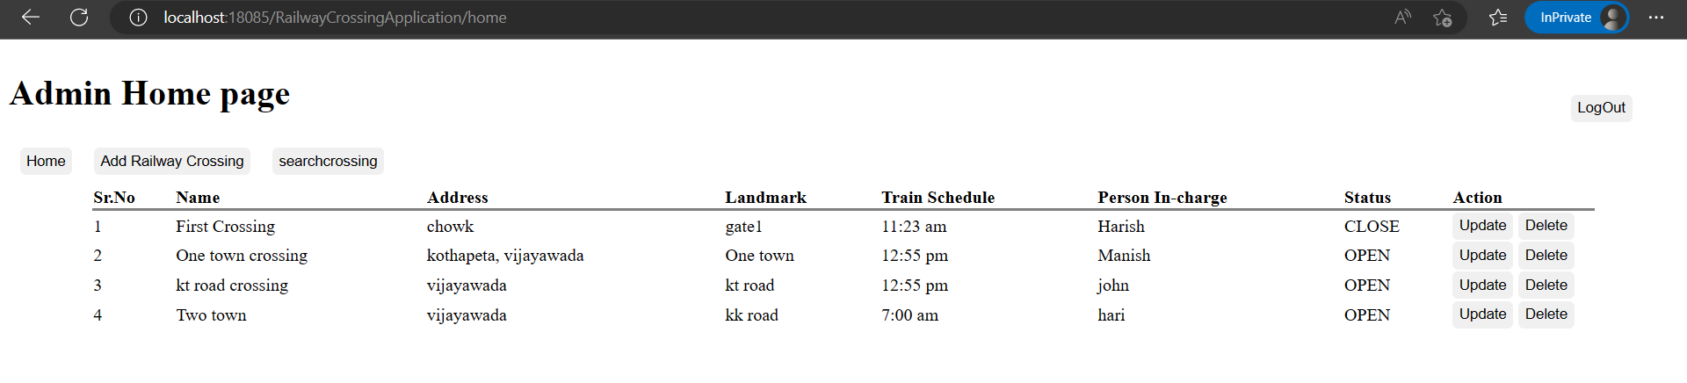

**9. User click on delete button of “first crossing” then output will be:**

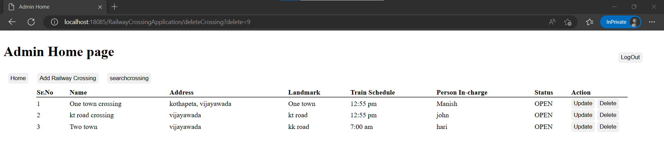

**10. user clicks on logout he will redirected to logout page and session will be terminated:**

