**Output:**

**1. Login page:**

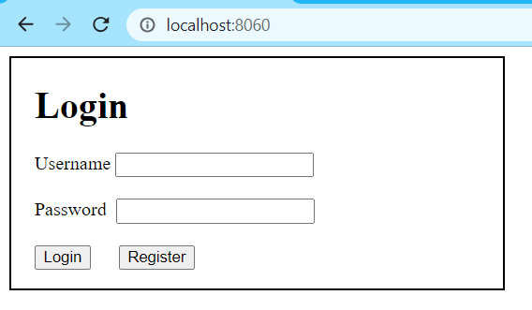

**2. Register page:**

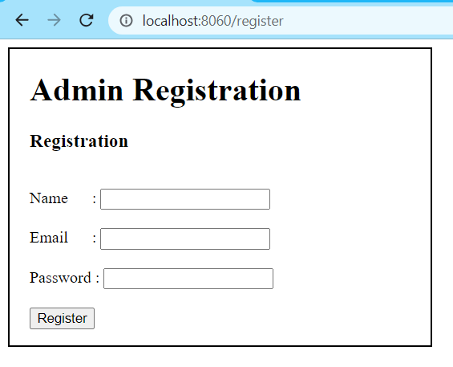

**3. After user login Home page will get displayed:**

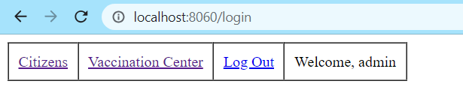

**4. If user clicks on Vaccination Center:**

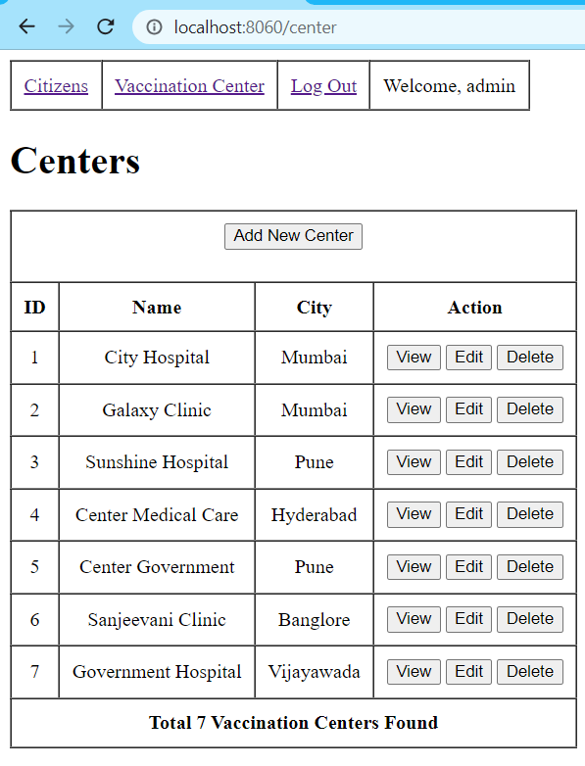

**5. User wants to add new user so clicks on Add new Center:**

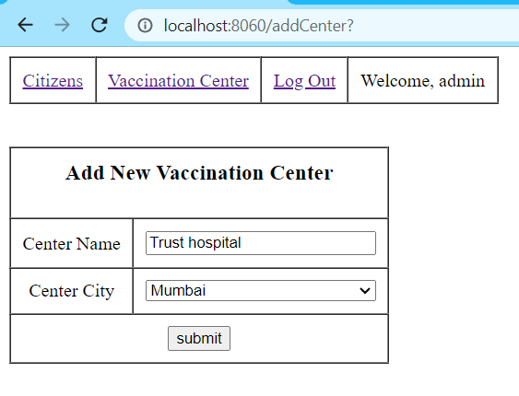

**6. User submits above form then user will redirected to vaccination center page where new center added:**

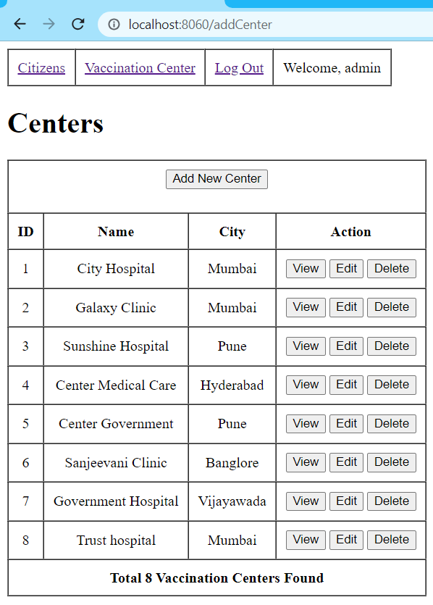

**7. Now user clicks on view of any center then citizens in that clinic will get displayed:**

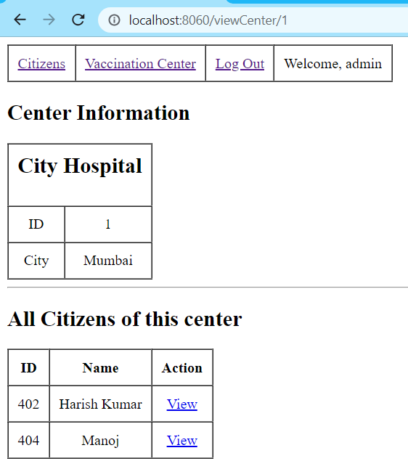

**8. Now user click on edit of any center then a edit form will get displayed:**

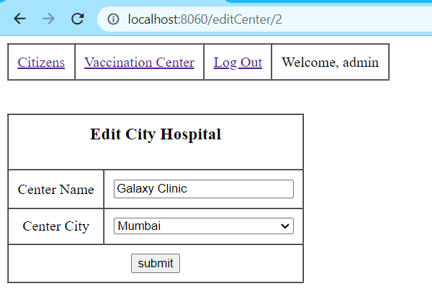

**9. If user clicks on delete center then that center will get deleted if that center does not have any citizens:**

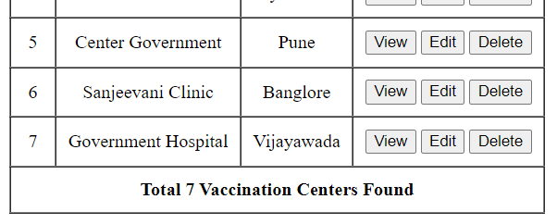

**Here we can see 8th center is deleted.**

**Citizens section**

**10. Now user clicks on citizen then citizens details will get displayed:**

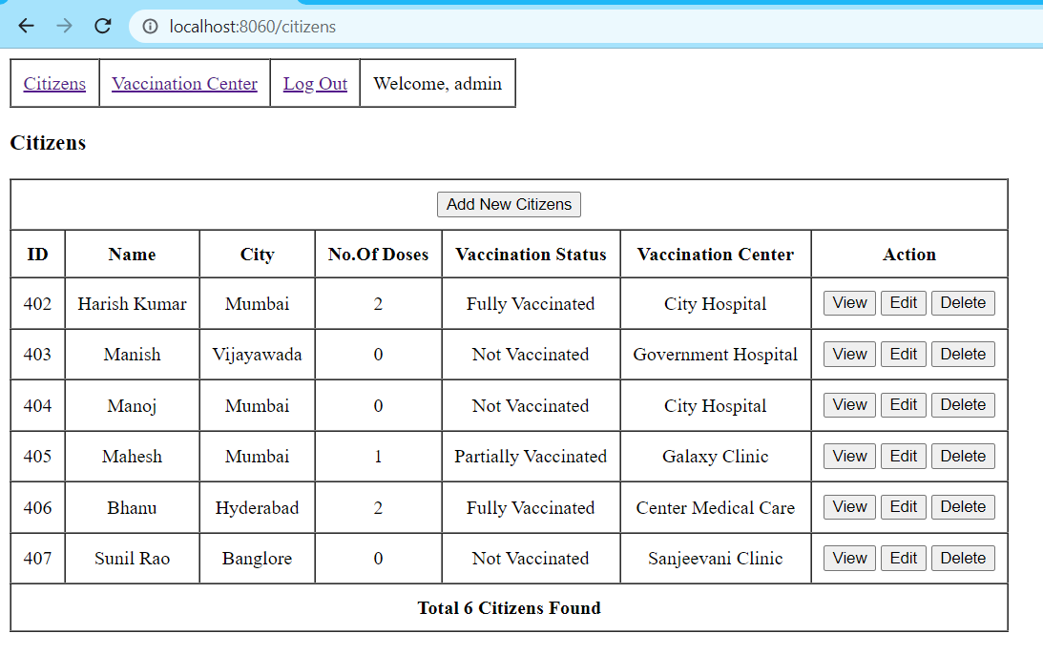

**11. If user wants to add new citizen so he clicks on add new citizens then new form will get displayed:**

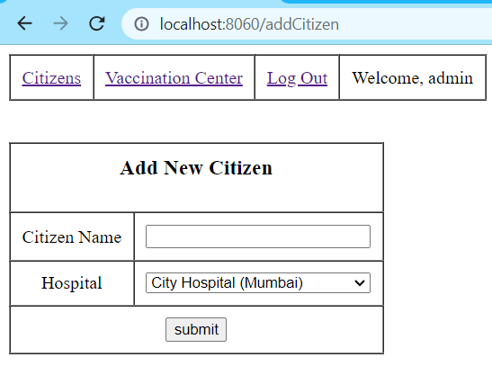

**12. After submitting that form user will redirected to citizens page where he can see new person added:**

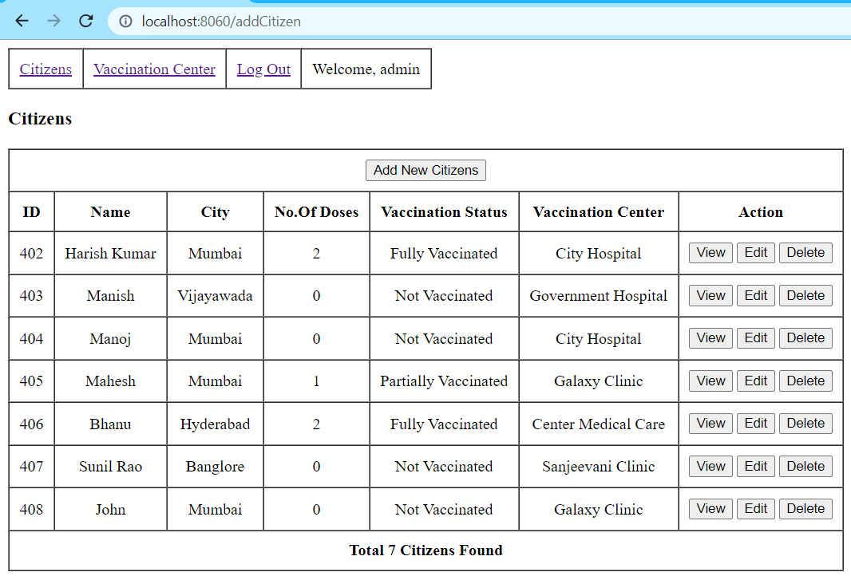

**13. Now user clicks on Edit of john to edit his details then new form will get displayed:**

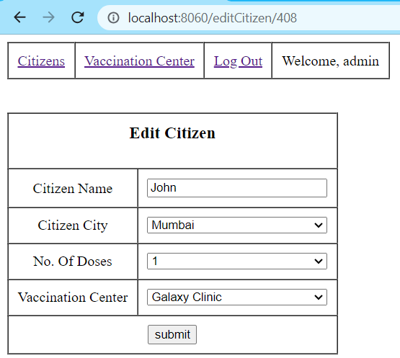

**14. Now user submit the details he can see in citizens that data get reflected:**



**15. Now user clicks on Delete citizen of id 408 then that user will be removed from database:**

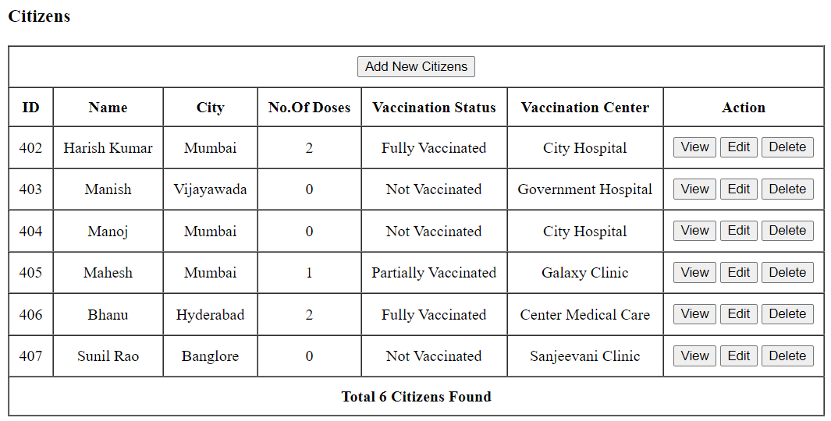

**16. User click on view then the individual details will get displayed:**

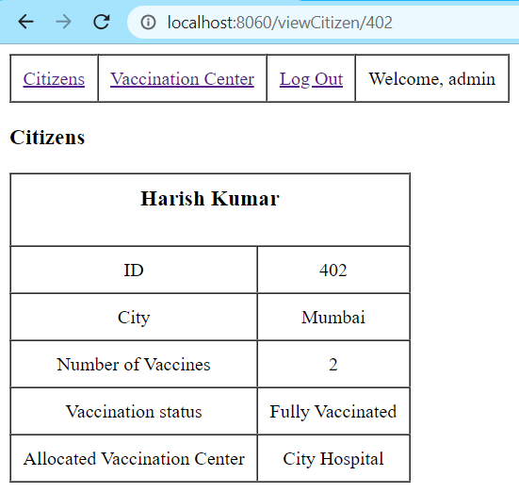

**18. This is the process of the application and In final user click on logout then he will be redirected to log in page and session will get invalidated:**

