Table of Contents

Software Stack 2

Back End 2

Flow 2

Front End 3

Movie Booking System Design

## Software Stack

### Back End

Backend is written in java using spring boot framework. No SQL mongo db was used to handle high volume of booking data with scale out architecture. Stateless Services are written in spring boot which could be deployed as micro-services in any cloud infrastructure. Runs on port 8001.

#### Installation

mvn clean install

Main Class is : com.bookings.DemoApplication.

All package names are self explanatory

Mongo DB details are mentioned in src/main/resources/application.properties

### Flow

#### Show Available Movies

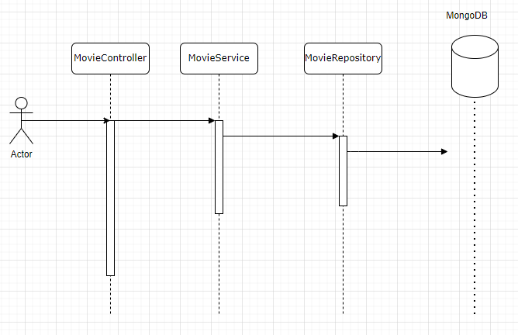

#### Book Movie Ticket

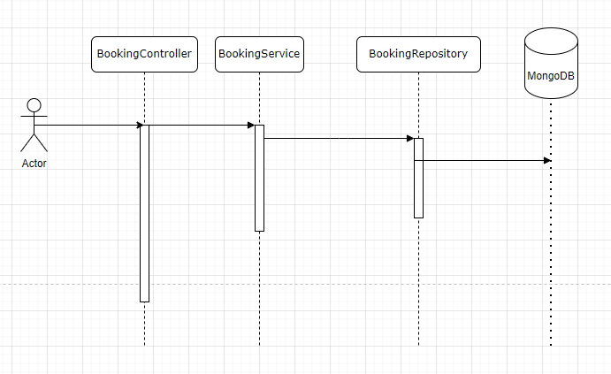

## Front End

UI is written in React Framework (which is quite a lightweight framework with small footprint) using javascript and semantui for styling. Runs on port 3000. CORS was enabled for demo only

#### Installation

npm install

App.js is the main javascript

## DataModel

1. Movie 🡪 Has the movie title and other details
2. MovieRating 🡪 Represents Rating of the Movie
3. MovieScreen 🡪 Details of Theatre Screen showing the Movie
4. MovieShowTiming 🡪 Timing of Movie being shown in MovieScreen
5. Genre 🡪 Genre of the Movie
6. Booking 🡪 Captures the Movie ID, User ID and other booking details
7. User 🡪 Models User details