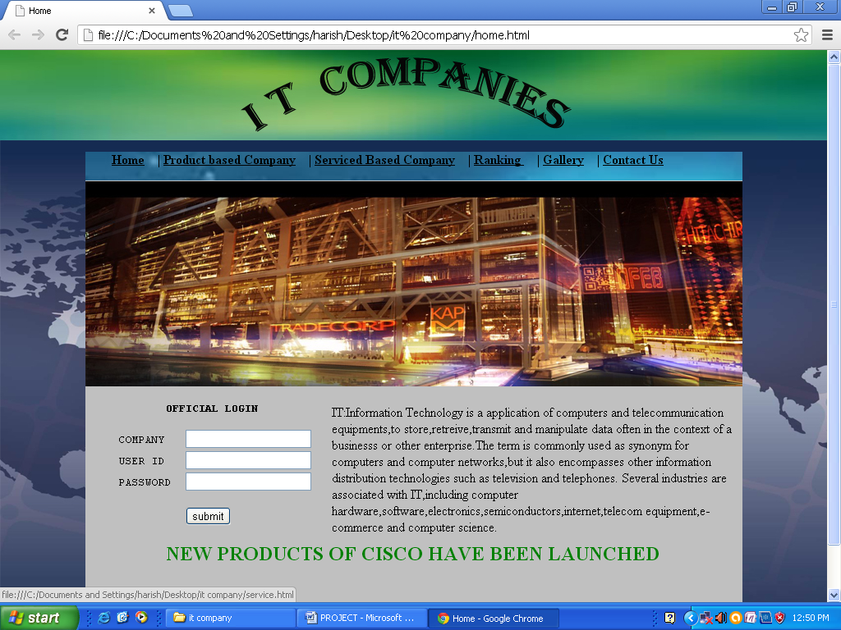

<html>

<head>

<title>Home</title>

</head>

<body background="images\bg2.jpg">

<br><br><br><br><br>

<div style="background-color:silver; width:800px; height:600;margin:0 Auto;">

<div style="background-image: url(Images/div.jpg); height: 35px; width: 800px;">

<p>&nbsp;&nbsp;&nbsp;&nbsp;&nbsp;&nbsp;&nbsp;

<a href="home.html"><font color="black" size="3"><b>Home</b></font></a>&nbsp;&nbsp;&nbsp;&nbsp;|

<a href="product.html"><font color="black" size="3"><b>Product based Company</b></font></a>&nbsp;&nbsp;&nbsp;&nbsp;|

<a href="service.html"><font color="black" size="3"><b>Serviced Based Company</b></font></a>&nbsp;&nbsp;&nbsp;&nbsp;|

<a href="ranking.html"><font color="black" size="3"><b>Ranking </b></font></a>&nbsp;&nbsp;&nbsp;&nbsp;|

<a href="gallery.html"><font color="black" size="3"><b>Gallery</b></font></a>&nbsp;&nbsp;&nbsp;&nbsp;|

<a href=""><font color="black" size="3"><b>Contact Us</b></font></a>

</p>

<div style="background-image: url(Images/bg1.jpg); height:250px; width:800px;"><br><br><br><br><br><br><br><br><br><br><br><br>

<p>

<div style="float:left;background-color:silver; width:300px; height:175;">

<form>

<pre>

<center><legend><b> <font size=3 color=black>OFFICIAL LOGIN</font></b></legend></center>

COMPANY <input type="text">

USER ID <input type="text">

PASSWORD <input type="password">

<form action="sub.html" method="get"><center><input type="button" value="submit"></center></form>

<pre>

</div>

<div style="float:right;background-color:silver; width:500px; height:185;">

<p>

IT:Information Technology is a application of computers and telecommunication equipments,to store,retreive,transmit and manipulate data

often in the context of a businesss or other enterprise.The term is commonly used as synonym

for computers and computer networks,but it also encompasses other information distribution technologies such as television and telephones.

Several industries are associated with IT,including computer hardware,software,electronics,semiconductors,internet,telecom equipment,e-commerce

and computer science.

</p>

</div>

<div style="float:right;background-color:silver; width:800px; height:100;">

<marquee><b><font color=green size=5>NEW PRODUCTS OF CISCO HAVE BEEN LAUNCHED</font></b></marquee>

</div>

</html>

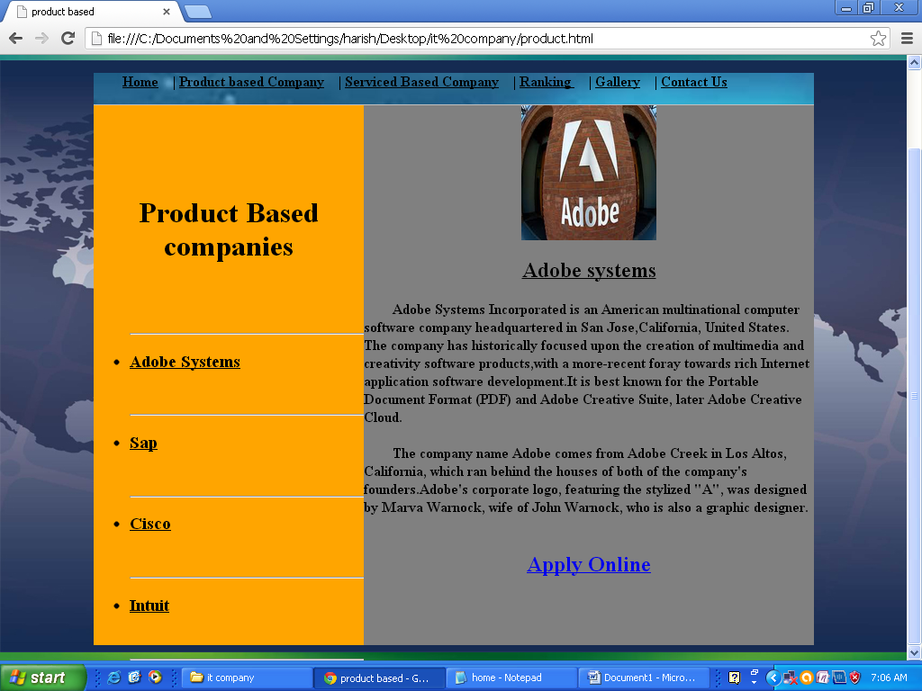

<html>

<head>

<title>product based</title>

</head>

<body background="images\bg2.jpg">

<br><br><br><br><br>

<div style="background-color:silver; width:800px; height:600px;margin:0 Auto;">

<div style="background-image: url(Images/div.jpg); height: 35px; width: 800px;">

<p>&nbsp;&nbsp;&nbsp;&nbsp;&nbsp;&nbsp;&nbsp;

<a href="home.html"><font color="black" size="3"><b>Home</b></font></a>&nbsp;&nbsp;&nbsp;&nbsp;|

<a href="product.html"><font color="black" size="3"><b>Product based Company</b></font></a>&nbsp;&nbsp;&nbsp;&nbsp;|

<a href="service.html"><font color="black" size="3"><b>Serviced Based Company</b></font></a>&nbsp;&nbsp;&nbsp;&nbsp;|

<a href="ranking.html"><font color="black" size="3"><b>Ranking </b></font></a>&nbsp;&nbsp;&nbsp;&nbsp;|

<a href="gallery.html"><font color="black" size="3"><b>Gallery</b></font></a>&nbsp;&nbsp;&nbsp;&nbsp;|

<a href=""><font color="black" size="3"><b>Contact Us</b></font></a>

</p>

<div style="float:left;background-color:orange; width:300px; height:600;">

<br><br><br><br>

<h1><center><font color="black">Product Based companies</h1></center></font>

<br><br>

<ul type="disc"><hr>

<li><a href="product.html"><h3><font color="black">Adobe Systems</font></h3></a></li><br><hr>

<li><a href="sap.html"><h3><font color="black">Sap</font></h3></a></li><br><hr>

<li><a href="cisco.html"><h3><font color="black">Cisco</font></h3></a></li><br><hr>

<li><a href="intuit.html"><h3><font color="black">Intuit</font></h3></a></li><br><hr>

</ul>

</div>

<div style="float:right;background-color:grey; width:500px; height:600;">

<center><img src="images\adobe_logo.jpg" width=150 height=150></center>

<h2><center><u>Adobe systems</u></center></h2>

<p><b>&nbsp;&nbsp;&nbsp;&nbsp;&nbsp;&nbsp;&nbsp;&nbsp;Adobe Systems

Incorporated is an American multinational computer software company

headquartered in San Jose,California, United States. The company has historically

focused upon the creation of multimedia and creativity software products,with a

more-recent foray towards rich Internet application software development.It is best known

for the Portable Document Format (PDF) and Adobe Creative Suite, later Adobe Creative Cloud.<br><br>

&nbsp;&nbsp;&nbsp;&nbsp;&nbsp;&nbsp;&nbsp;&nbsp;The company name Adobe comes from Adobe Creek in Los Altos, California, which ran behind the

houses of both of the company's founders.Adobe's corporate logo, featuring the stylized "A",

was designed by Marva Warnock, wife of John Warnock, who is also a graphic designer.<br><br>

</b></p>

<center><h2><a href="form.html">Apply Online</h2></center>

</div>

</body>

</html>

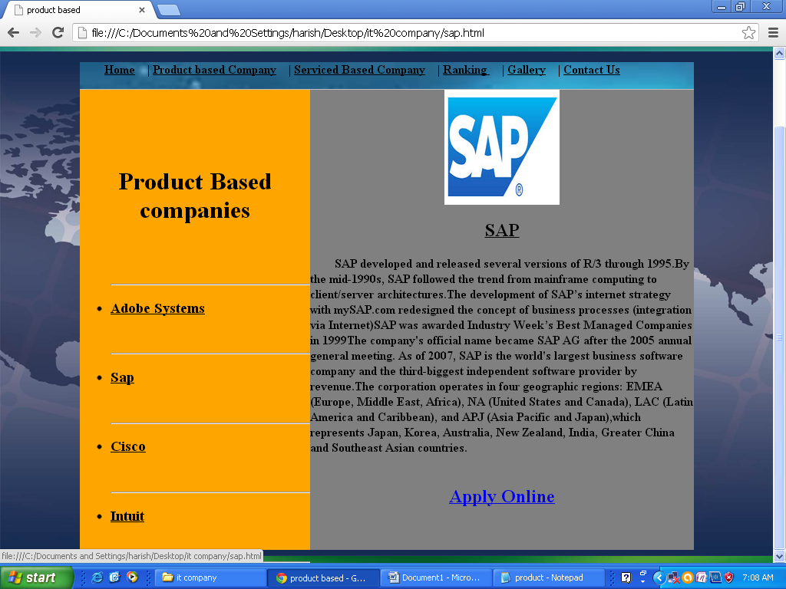

<html>

<head>

<title>product based</title>

</head>

<body background="images\bg2.jpg">

<br><br><br><br><br>

<div style="background-color:silver; width:800px; height:600px;margin:0 Auto;">

<div style="background-image: url(Images/div.jpg); height: 35px; width: 800px;">

<p>&nbsp;&nbsp;&nbsp;&nbsp;&nbsp;&nbsp;&nbsp;

<a href="home.html"><font color="black" size="3"><b>Home</b></font></a>&nbsp;&nbsp;&nbsp;&nbsp;|

<a href="product.html"><font color="black" size="3"><b>Product based Company</b></font></a>&nbsp;&nbsp;&nbsp;&nbsp;|

<a href="service.html"><font color="black" size="3"><b>Serviced Based Company</b></font></a>&nbsp;&nbsp;&nbsp;&nbsp;|

<a href="ranking.html"><font color="black" size="3"><b>Ranking </b></font></a>&nbsp;&nbsp;&nbsp;&nbsp;|

<a href="gallery.html"><font color="black" size="3"><b>Gallery</b></font></a>&nbsp;&nbsp;&nbsp;&nbsp;|

<a href=""><font color="black" size="3"><b>Contact Us</b></font></a>

</p>

<div style="float:left;background-color:orange; width:300px; height:600;">

<br><br><br><br>

<h1><center><font color="black">Product Based companies</h1></center></font>

<br><br>

<ul type="disc"><hr>

<li><a href="product.html"><h3><font color="black">Adobe Systems</font></h3></a></li><br><hr>

<li><a href="sap.html"><h3><font color="black">Sap</font></h3></a></li><br><hr>

<li><a href="cisco.html"><h3><font color="black">Cisco</font></h3></a></li><br><hr>

<li><a href="intuit.html"><h3><font color="black">Intuit</font></h3></a></li><br><hr>

</ul>

</div>

<div style="float:right;background-color:grey; width:500px; height:600;">

<center><img src="images\sap_logo.jpg" width=150 height=150></center>

<h2><center><u>SAP</u></center></h2>

<p><b>&nbsp;&nbsp;&nbsp;&nbsp;&nbsp;&nbsp;&nbsp;&nbsp;SAP developed and released several versions of R/3

through 1995.By the mid-1990s, SAP followed the trend from mainframe computing to

client/server architectures.The development of SAP’s internet strategy with mySAP.com

redesigned the concept of business processes (integration via Internet)SAP was awarded

Industry Week’s Best Managed Companies in 1999The company's official name became SAP AG

after the 2005 annual general meeting.

As of 2007, SAP is the world's largest business software company and the third-biggest

independent software provider by revenue.The corporation operates in four geographic regions:

EMEA (Europe, Middle East, Africa), NA (United States and Canada), LAC (Latin America and

Caribbean), and APJ (Asia Pacific and Japan),which represents Japan, Korea, Australia, New

Zealand, India, Greater China and Southeast Asian countries.<br><br>

</b></p>

<center><h2><a href="form.html">Apply Online</h2></center>

</div>

</body>

</html>

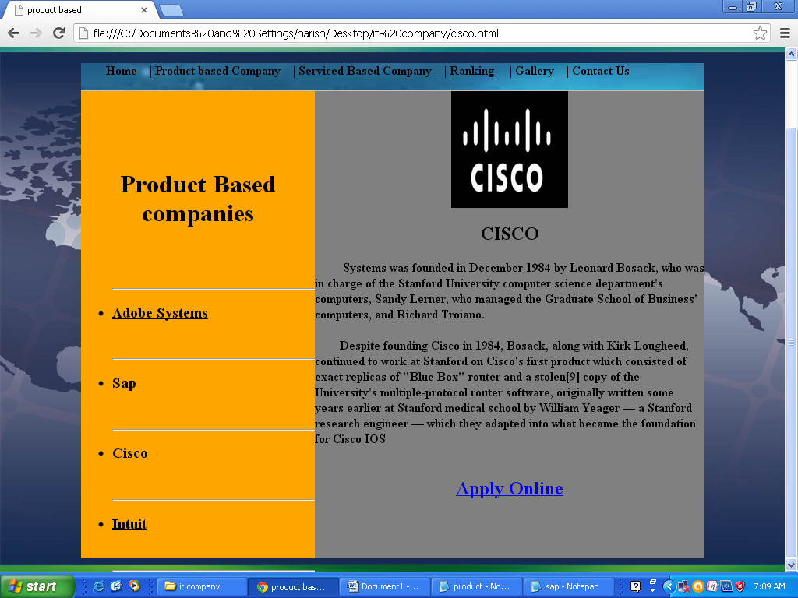

<html>

<head>

<title>product based</title>

</head>

<body background="images\bg2.jpg">

<br><br><br><br><br>

<div style="background-color:silver; width:800px; height:600px;margin:0 Auto;">

<div style="background-image: url(Images/div.jpg); height: 35px; width: 800px;">

<p>&nbsp;&nbsp;&nbsp;&nbsp;&nbsp;&nbsp;&nbsp;

<a href="home.html"><font color="black" size="3"><b>Home</b></font></a>&nbsp;&nbsp;&nbsp;&nbsp;|

<a href="product.html"><font color="black" size="3"><b>Product based Company</b></font></a>&nbsp;&nbsp;&nbsp;&nbsp;|

<a href="service.html"><font color="black" size="3"><b>Serviced Based Company</b></font></a>&nbsp;&nbsp;&nbsp;&nbsp;|

<a href="ranking.html"><font color="black" size="3"><b>Ranking </b></font></a>&nbsp;&nbsp;&nbsp;&nbsp;|

<a href="gallery.html"><font color="black" size="3"><b>Gallery</b></font></a>&nbsp;&nbsp;&nbsp;&nbsp;|

<a href=""><font color="black" size="3"><b>Contact Us</b></font></a>

</p>

<div style="float:left;background-color:orange; width:300px; height:600;">

<br><br><br><br>

<h1><center><font color="black">Product Based companies</h1></center></font>

<br><br>

<ul type="disc"><hr>

<li><a href="product.html"><h3><font color="black">Adobe Systems</font></h3></a></li><br><hr>

<li><a href="sap.html"><h3><font color="black">Sap</font></h3></a></li><br><hr>

<li><a href="cisco.html"><h3><font color="black">Cisco</font></h3></a></li><br><hr>

<li><a href="intuit.html"><h3><font color="black">Intuit</font></h3></a></li><br><hr>

</ul>

</div>

<div style="float:right;background-color:grey; width:500px; height:600;">

<center><img src="images\cisco_logo.jpg" width=150 height=150></center>

<h2><center><u>CISCO</u></center></h2>

<p><b>&nbsp;&nbsp;&nbsp;&nbsp;&nbsp;&nbsp;&nbsp;&nbsp;

Systems was founded in December 1984 by Leonard Bosack, who was in

charge of the Stanford University computer science department's

computers, Sandy Lerner, who managed the Graduate School of Business'

computers, and Richard Troiano.<br><br>

&nbsp;&nbsp;&nbsp;&nbsp;&nbsp;&nbsp;&nbsp;&nbsp;Despite founding Cisco in 1984,

Bosack, along with Kirk Lougheed, continued to work at Stanford on Cisco's first product

which consisted of exact replicas of "Blue Box" router and a stolen[9] copy of the University's

multiple-protocol router software, originally written some years earlier at Stanford medical

school by William Yeager — a Stanford research engineer — which they adapted

into what became the foundation for Cisco IOS<br><br>

</p>

<center><h2><a href="form.html">Apply Online</h2></center>

</div>

</body>

</html>

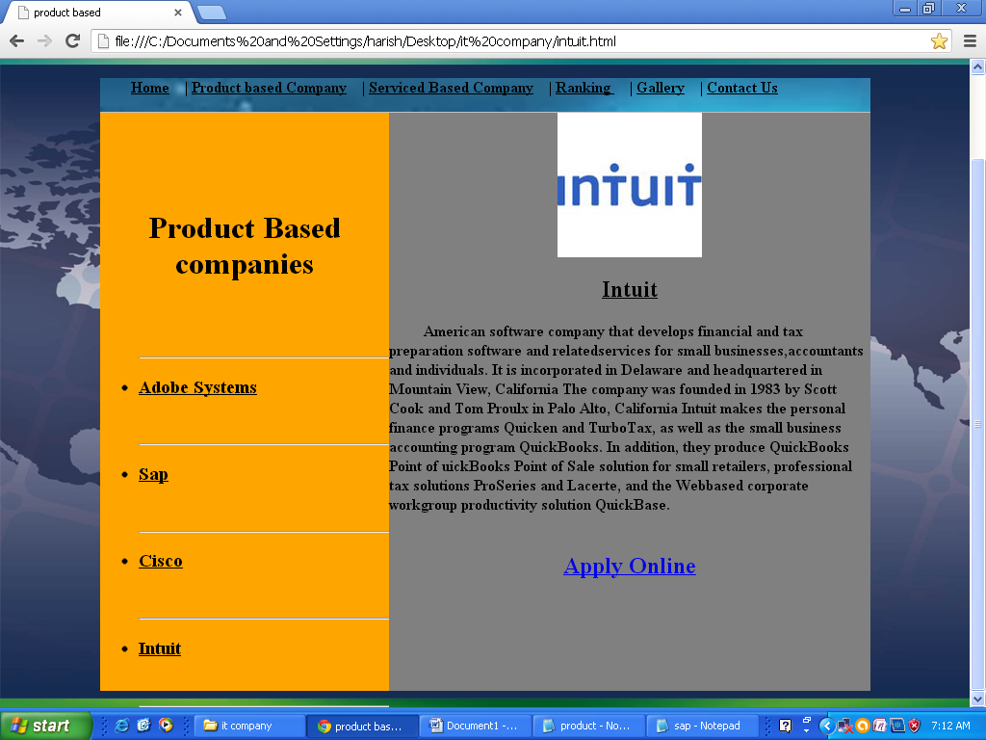

<html>

<head>

<title>product based</title>

</head>

<body background="images\bg2.jpg">

<br><br><br><br><br>

<div style="background-color:silver; width:800px; height:600px;margin:0 Auto;">

<div style="background-image: url(Images/div.jpg); height: 35px; width: 800px;">

<p>&nbsp;&nbsp;&nbsp;&nbsp;&nbsp;&nbsp;&nbsp;

<a href="home.html"><font color="black" size="3"><b>Home</b></font></a>&nbsp;&nbsp;&nbsp;&nbsp;|

<a href="product.html"><font color="black" size="3"><b>Product based Company</b></font></a>&nbsp;&nbsp;&nbsp;&nbsp;|

<a href="service.html"><font color="black" size="3"><b>Serviced Based Company</b></font></a>&nbsp;&nbsp;&nbsp;&nbsp;|

<a href="ranking.html"><font color="black" size="3"><b>Ranking </b></font></a>&nbsp;&nbsp;&nbsp;&nbsp;|

<a href="gallery.html"><font color="black" size="3"><b>Gallery</b></font></a>&nbsp;&nbsp;&nbsp;&nbsp;|

<a href=""><font color="black" size="3"><b>Contact Us</b></font></a>

</p>

<div style="float:left;background-color:orange; width:300px; height:600;">

<br><br><br><br>

<h1><center><font color="black">Product Based companies</h1></center></font>

<br><br>

<ul type="disc"><hr>

<li><a href="product.html"><h3><font color="black">Adobe Systems</font></h3></a></li><br><hr>

<li><a href="sap.html"><h3><font color="black">Sap</font></h3></a></li><br><hr>

<li><a href="cisco.html"><h3><font color="black">Cisco</font></h3></a></li><br><hr>

<li><a href="intuit.html"><h3><font color="black">Intuit</font></h3></a></li><br><hr>

</ul>

</div>

<div style="float:right;background-color:grey; width:500px; height:600;">

<center><img src="images\int_logo.jpg" width=150 height=150></center>

<h2><center><u>Intuit</u></center></h2>

<p><b>&nbsp;&nbsp;&nbsp;&nbsp;&nbsp;&nbsp;&nbsp;&nbsp;

American software company that develops financial and tax preparation

software and relatedservices for small businesses,accountants and individuals. It is incorporated

in Delaware and headquartered in Mountain View, California

The company was founded in 1983 by Scott Cook and Tom Proulx in Palo Alto, California

Intuit makes the personal finance programs Quicken and TurboTax, as well as the small

business accounting program QuickBooks. In addition, they produce QuickBooks Point of

uickBooks Point of Sale solution for small retailers, professional tax solutions ProSeries and

Lacerte, and the Webbased corporate workgroup productivity solution QuickBase.

<br><br>

</p>

<center><h2><a href="form.html">Apply Online</h2></center>

</div>

</body>

</html>

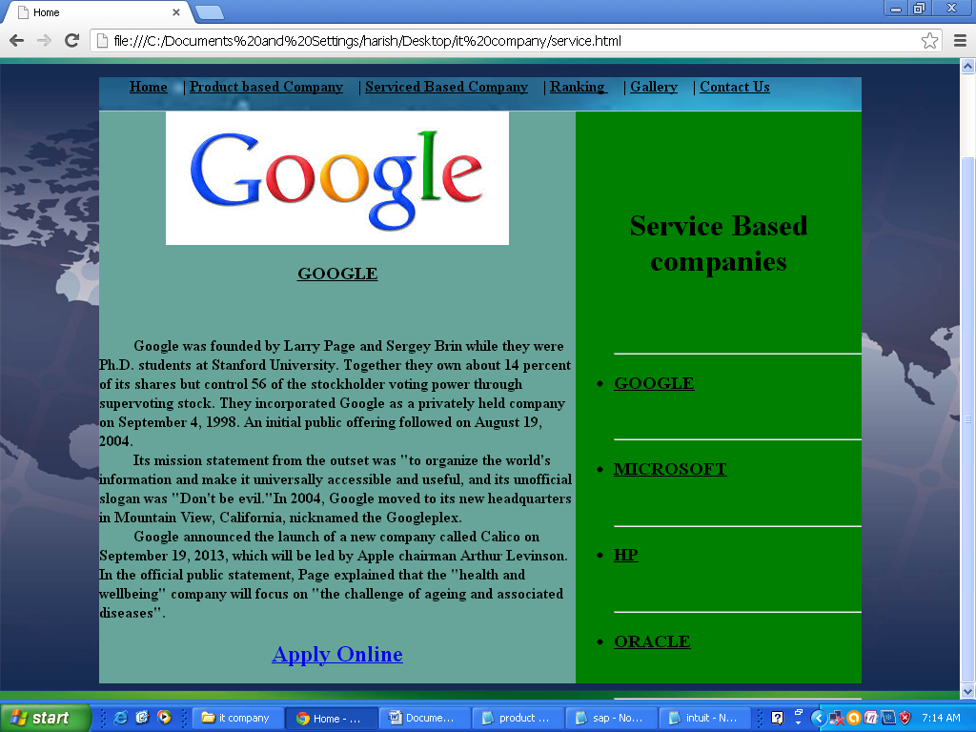

<html>

<head>

<title>Home</title>

</head>

<body background="images\bg2.jpg">

<br><br><br><br><br>

<div style="background-color:silver; width:800px; height:600px;margin:0 Auto;">

<div style="background-image: url(Images/div.jpg); height: 35px; width: 800px;">

<p>&nbsp;&nbsp;&nbsp;&nbsp;&nbsp;&nbsp;&nbsp;

<a href="home.html"><font color="black" size="3"><b>Home</b></font></a>&nbsp;&nbsp;&nbsp;&nbsp;|

<a href="product.html"><font color="black" size="3"><b>Product based Company</b></font></a>&nbsp;&nbsp;&nbsp;&nbsp;|

<a href="service.html"><font color="black" size="3"><b>Serviced Based Company</b></font></a>&nbsp;&nbsp;&nbsp;&nbsp;|

<a href="ranking.html"><font color="black" size="3"><b>Ranking </b></font></a>&nbsp;&nbsp;&nbsp;&nbsp;|

<a href="gallery.html"><font color="black" size="3"><b>Gallery</b></font></a>&nbsp;&nbsp;&nbsp;&nbsp;|

<a href=""><font color="black" size="3"><b>Contact Us</b></font></a>

</p>

<div style="float:right;background-color:green; width:300px; height:600;">

<br><br><br><br>

<h1><center><font color="black">Service Based companies</h1></center></font>

<br><br>

<ul type="disc"><hr>

<li><a href="service.html"><h3><font color="black">GOOGLE</font></h3></a></li><br><hr>

<li><a href="microsoft.html"><h3><font color="black">MICROSOFT</font></h3></a></li><br><hr>

<li><a href="hp.html"><h3><font color="black">HP</font></h3></a></li><br><hr>

<li><a href="oracle.html"><h3><font color="black">ORACLE</font></h3></a></li><br><hr>

</ul>

</div>

<div style="float:left;background-color:#67a59a; width:500px; height:600;">

<center><img src="images\google_logo.jpg"></center>

<h3><center><u>GOOGLE</u></center></h3><br>

<p>&nbsp;&nbsp;&nbsp;&nbsp;&nbsp;&nbsp;&nbsp;&nbsp;

<b> Google was founded by Larry Page and Sergey Brin

while they were Ph.D. students at Stanford University. Together they own about 14

percent of its shares but control 56 of the stockholder voting power through supervoting

stock. They incorporated Google as a privately held company on September 4, 1998.

An initial public offering followed on August 19, 2004. <br>

&nbsp;&nbsp;&nbsp;&nbsp;&nbsp;&nbsp;&nbsp;&nbsp; Its mission statement from the

outset was "to organize the world's information and make it universally accessible and

useful, and its unofficial slogan was "Don't be evil."In 2004, Google moved to its

new headquarters in Mountain View, California, nicknamed the Googleplex.<br>

&nbsp;&nbsp;&nbsp;&nbsp;&nbsp;&nbsp;&nbsp;&nbsp; Google announced the launch of a new company called Calico on September 19, 2013, which

will be led by Apple chairman Arthur Levinson. In the official public statement, Page explained

that the "health and wellbeing" company will focus on "the challenge of ageing and associated

diseases".

</b></p>

<center><h2><a href="form.html">Apply Online</h2></center>

</div>

</body>

</html>

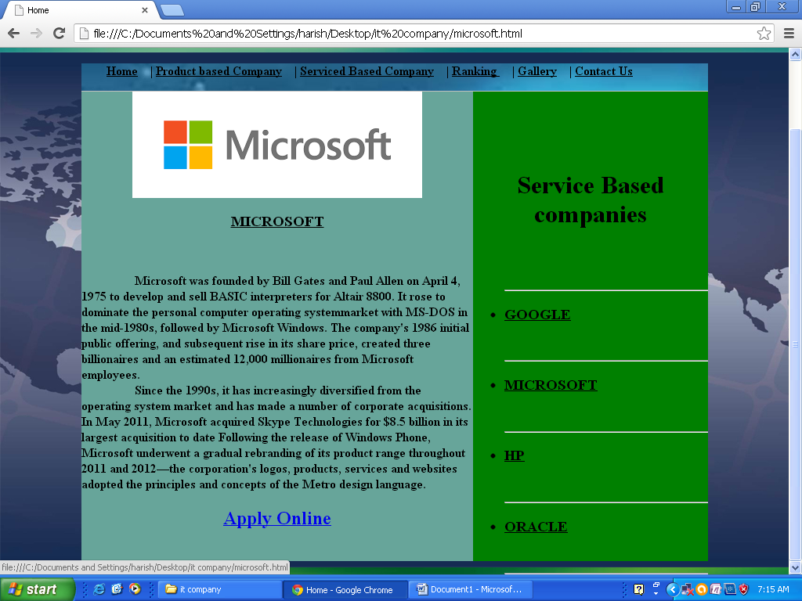

<html>

<head>

<title>Home</title>

</head>

<body background="images\bg2.jpg">

<br><br><br><br><br>

<div style="background-color:silver; width:800px; height:600px;margin:0 Auto;">

<div style="background-image: url(Images/div.jpg); height: 35px; width: 800px;">

<p>&nbsp;&nbsp;&nbsp;&nbsp;&nbsp;&nbsp;&nbsp;

<a href="home.html"><font color="black" size="3"><b>Home</b></font></a>&nbsp;&nbsp;&nbsp;&nbsp;|

<a href="product.html"><font color="black" size="3"><b>Product based Company</b></font></a>&nbsp;&nbsp;&nbsp;&nbsp;|

<a href="service.html"><font color="black" size="3"><b>Serviced Based Company</b></font></a>&nbsp;&nbsp;&nbsp;&nbsp;|

<a href="ranking.html"><font color="black" size="3"><b>Ranking </b></font></a>&nbsp;&nbsp;&nbsp;&nbsp;|

<a href="gallery.html"><font color="black" size="3"><b>Gallery</b></font></a>&nbsp;&nbsp;&nbsp;&nbsp;|

<a href=""><font color="black" size="3"><b>Contact Us</b></font></a>

</p>

<div style="float:right;background-color:green; width:300px; height:600;">

<br><br><br><br>

<h1><center><font color="black">Service Based companies</h1></center></font>

<br><br>

<ul type="disc"><hr>

<li><a href="service.html"><h3><font color="black">GOOGLE</font></h3></a></li><br><hr>

<li><a href="microsoft.html"><h3><font color="black">MICROSOFT</font></h3></a></li><br><hr>

<li><a href="hp.html"><h3><font color="black">HP</font></h3></a></li><br><hr>

<li><a href="oracle.html"><h3><font color="black">ORACLE</font></h3></a></li><br><hr>

</ul>

</div>

<div style="float:left;background-color:#67a59a; width:500px; height:600;">

<center><img src="images\microsoft_logo.jpg"></center>

<h3><center><u>MICROSOFT</u></center></h3><br>

<p>&nbsp;&nbsp;&nbsp;&nbsp;&nbsp;&nbsp;&nbsp;&nbsp;&nbsp;&nbsp;&nbsp;&nbsp;&nbsp;&nbsp;&nbsp;&nbsp;

<b> Microsoft was founded by Bill Gates and Paul Allen on April 4, 1975 to develop and

sell BASIC interpreters for Altair 8800. It rose to dominate the personal computer

operating systemmarket with MS-DOS in the mid-1980s, followed by Microsoft Windows.

The company's 1986 initial public offering, and subsequent rise in its share price, created

three billionaires and an estimated 12,000 millionaires from Microsoft employees.<br>

&nbsp;&nbsp;&nbsp;&nbsp;&nbsp;&nbsp;&nbsp;&nbsp;&nbsp;&nbsp;&nbsp;&nbsp;&nbsp;&nbsp;&nbsp;&nbsp; Since the 1990s, it has increasingly diversified from the operating system market and has

made a number of corporate acquisitions. In May 2011, Microsoft acquired Skype Technologies

for $8.5 billion in its largest acquisition to date

Following the release of Windows Phone, Microsoft underwent a gradual rebranding

of its product range throughout 2011 and 2012—the corporation's logos, products, services

and websites adopted the principles and concepts of the Metro design language.

</b></p>

<center><h2><a href="form.html">Apply Online</h2></center>

</div>

</body>

</html>

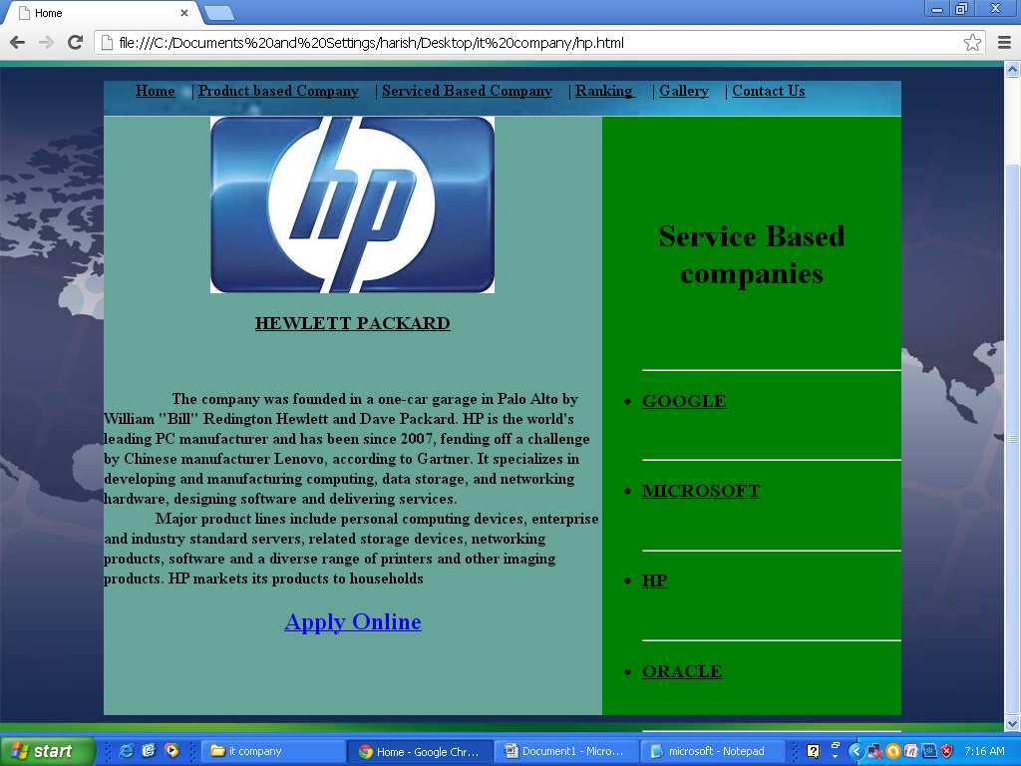

<html>

<head>

<title>Home</title>

</head>

<body background="images\bg2.jpg">

<br><br><br><br><br>

<div style="background-color:silver; width:800px; height:600px;margin:0 Auto;">

<div style="background-image: url(Images/div.jpg); height: 35px; width: 800px;">

<p>&nbsp;&nbsp;&nbsp;&nbsp;&nbsp;&nbsp;&nbsp;

<a href="home.html"><font color="black" size="3"><b>Home</b></font></a>&nbsp;&nbsp;&nbsp;&nbsp;|

<a href="product.html"><font color="black" size="3"><b>Product based Company</b></font></a>&nbsp;&nbsp;&nbsp;&nbsp;|

<a href="service.html"><font color="black" size="3"><b>Serviced Based Company</b></font></a>&nbsp;&nbsp;&nbsp;&nbsp;|

<a href="ranking.html"><font color="black" size="3"><b>Ranking </b></font></a>&nbsp;&nbsp;&nbsp;&nbsp;|

<a href="gallery.html"><font color="black" size="3"><b>Gallery</b></font></a>&nbsp;&nbsp;&nbsp;&nbsp;|

<a href=""><font color="black" size="3"><b>Contact Us</b></font></a>

</p>

<div style="float:right;background-color:green; width:300px; height:600;">

<br><br><br><br>

<h1><center><font color="black">Service Based companies</h1></center></font>

<br><br>

<ul type="disc"><hr>

<li><a href="service.html"><h3><font color="black">GOOGLE</font></h3></a></li><br><hr>

<li><a href="microsoft.html"><h3><font color="black">MICROSOFT</font></h3></a></li><br><hr>

<li><a href="hp.html"><h3><font color="black">HP</font></h3></a></li><br><hr>

<li><a href="oracle.html"><h3><font color="black">ORACLE</font></h3></a></li><br><hr>

</ul>

</div>

<div style="float:left;background-color:#67a59a; width:500px; height:600;">

<center><img src="images\hp_logo.jpg"></center>

<h3><center><u>HEWLETT PACKARD</u></center></h3><br>

<p>&nbsp;&nbsp;&nbsp;&nbsp;&nbsp;&nbsp;&nbsp;&nbsp;&nbsp;&nbsp;&nbsp;&nbsp;&nbsp;&nbsp;&nbsp;&nbsp;

<b>

The company was founded in a one-car garage in Palo Alto by

William "Bill" Redington Hewlett and Dave Packard. HP is the world's leading

PC manufacturer and has been since 2007, fending off a challenge by Chinese

manufacturer Lenovo, according to Gartner. It specializes in developing and

manufacturing computing, data storage, and networking hardware, designing

software and delivering services. <br>

&nbsp;&nbsp;&nbsp;&nbsp;&nbsp;&nbsp;&nbsp;&nbsp;&nbsp;&nbsp;&nbsp;&nbsp;&nbsp;Major product lines include personal computing

devices, enterprise and industry standard servers, related storage devices, networking

products, software and a diverse range of printers and other imaging products. HP markets

its products to households

</b></p>

<center><h2><a href="form.html">Apply Online</h2></center>

</div>

</body>

</html>

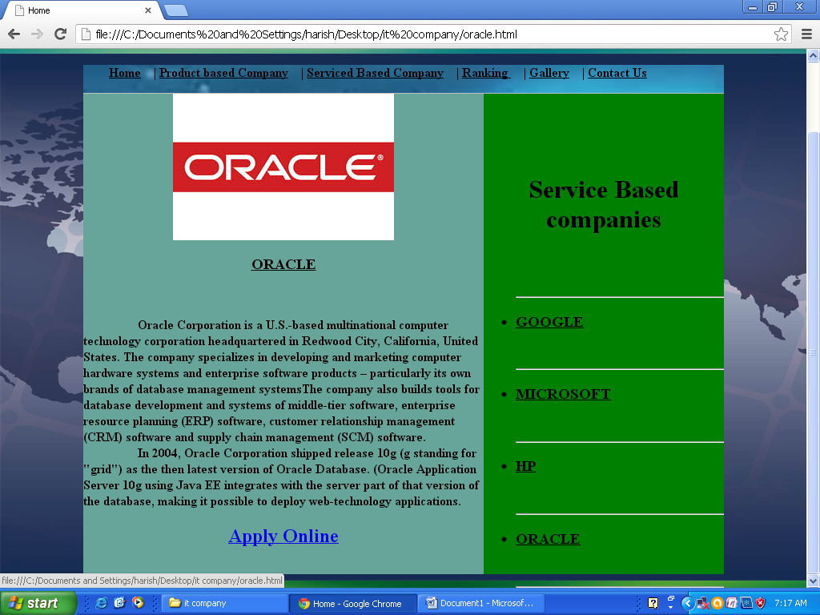

<html>

<head>

<title>Home</title>

</head>

<body background="images\bg2.jpg">

<br><br><br><br><br>

<div style="background-color:silver; width:800px; height:600px;margin:0 Auto;">

<div style="background-image: url(Images/div.jpg); height: 35px; width: 800px;">

<p>&nbsp;&nbsp;&nbsp;&nbsp;&nbsp;&nbsp;&nbsp;

<a href="home.html"><font color="black" size="3"><b>Home</b></font></a>&nbsp;&nbsp;&nbsp;&nbsp;|

<a href="product.html"><font color="black" size="3"><b>Product based Company</b></font></a>&nbsp;&nbsp;&nbsp;&nbsp;|

<a href="service.html"><font color="black" size="3"><b>Serviced Based Company</b></font></a>&nbsp;&nbsp;&nbsp;&nbsp;|

<a href="ranking.html"><font color="black" size="3"><b>Ranking </b></font></a>&nbsp;&nbsp;&nbsp;&nbsp;|

<a href="gallery.html"><font color="black" size="3"><b>Gallery</b></font></a>&nbsp;&nbsp;&nbsp;&nbsp;|

<a href=""><font color="black" size="3"><b>Contact Us</b></font></a>

</p>

<div style="float:right;background-color:green; width:300px; height:600;">

<br><br><br><br>

<h1><center><font color="black">Service Based companies</h1></center></font>

<br><br>

<ul type="disc"><hr>

<li><a href="service.html"><h3><font color="black">GOOGLE</font></h3></a></li><br><hr>

<li><a href="microsoft.html"><h3><font color="black">MICROSOFT</font></h3></a></li><br><hr>

<li><a href="hp.html"><h3><font color="black">HP</font></h3></a></li><br><hr>

<li><a href="oracle.html"><h3><font color="black">ORACLE</font></h3></a></li><br><hr>

</ul>

</div>

<div style="float:left;background-color:#67a59a; width:500px; height:600;">

<center><img src="images\oracle_logo.jpg"></center>

<h3><center><u>ORACLE</u></center></h3><br>

<p>&nbsp;&nbsp;&nbsp;&nbsp;&nbsp;&nbsp;&nbsp;&nbsp;&nbsp;&nbsp;&nbsp;&nbsp;&nbsp;&nbsp;&nbsp;&nbsp;

<b>

Oracle Corporation is a U.S.-based multinational computer technology corporation

headquartered in Redwood City, California, United States. The company specializes in developing and

marketing computer hardware systems and enterprise software products – particularly its own brands of

database management systemsThe company also builds tools for database development and systems of middle-tier

software, enterprise resource planning (ERP) software, customer relationship management (CRM) software and

supply chain management (SCM) software.<br>

&nbsp;&nbsp;&nbsp;&nbsp;&nbsp;&nbsp;&nbsp;&nbsp;&nbsp;&nbsp;&nbsp;&nbsp;&nbsp;&nbsp;&nbsp;&nbsp; In 2004, Oracle Corporation shipped release 10g (g standing for "grid") as the then latest version of Oracle Database.

(Oracle Application Server 10g using Java EE integrates with the server part of that version of the database, making it

possible to deploy web-technology applications.

</b></p>

<center><h2><a href="form.html">Apply Online</h2></center>

</div>

</body>

</html>

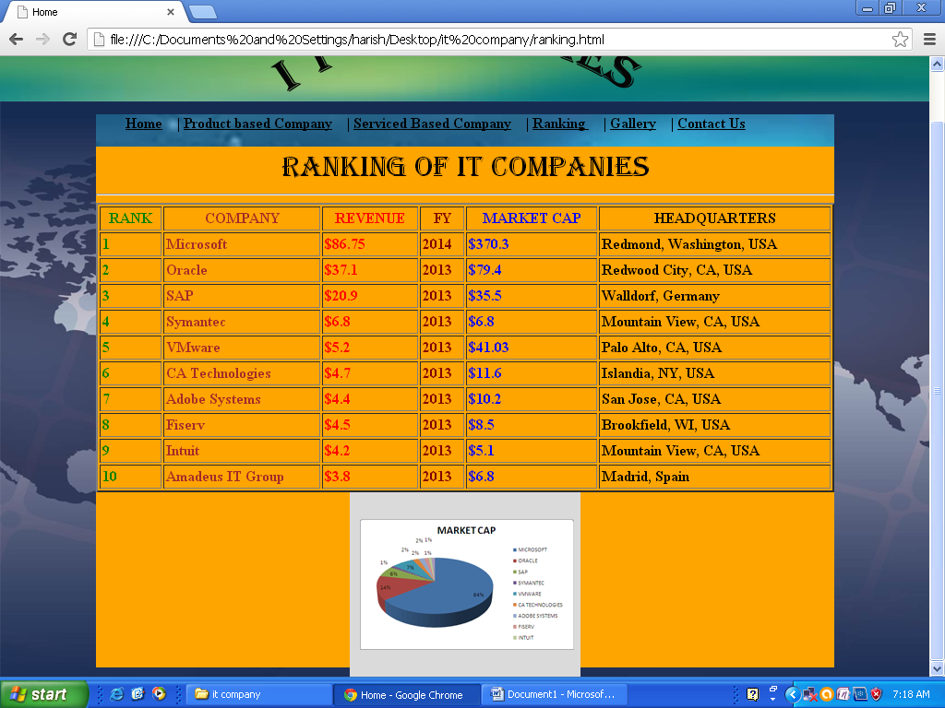

<html>

<head>

<title>Home</title>

</head>

<body background="images\bg2.jpg">

<br><br><br><br><br>

<div style="background-color:orange; width:800px; height:600;margin:0 Auto;">

<div style="background-image: url(Images/div.jpg); height: 35px; width: 800px;">

<p>&nbsp;&nbsp;&nbsp;&nbsp;&nbsp;&nbsp;&nbsp;

<a href="home.html"><font color="black" size="3"><b>Home</b></font></a>&nbsp;&nbsp;&nbsp;&nbsp;|

<a href="product.html"><font color="black" size="3"><b>Product based Company</b></font></a>&nbsp;&nbsp;&nbsp;&nbsp;|

<a href="service.html"><font color="black" size="3"><b>Serviced Based Company</b></font></a>&nbsp;&nbsp;&nbsp;&nbsp;|

<a href="ranking.html"><font color="black" size="3"><b>Ranking </b></font></a>&nbsp;&nbsp;&nbsp;&nbsp;|

<a href="gallery.html"><font color="black" size="3"><b>Gallery</b></font></a>&nbsp;&nbsp;&nbsp;&nbsp;|

<a href=""><font color="black" size="3"><b>Contact Us</b></font></a>

</p>

<caption><font face="Algerian" color="black" size="6" ><center>RANKING OF IT COMPANIES</center></font></caption>

<hr>

<table border="2" align="center" width="100%" cellpadding=2px>

<tr>

<th ><b><font color=green size=3><b>RANK</b></font></th>

<th><b><font color=brown size=3>COMPANY</b></font></th>

<th><b><font color=red size=3>REVENUE</b></font></th>

<th><b><font color=maroon size=3>FY</b></font></th>

<th><b><font color=blue size=3>MARKET CAP</b></font></th>

<th><b><font color=black size=3>HEADQUARTERS</b></font></th>

</tr>

<tr>

<td><b><font color=green size=3><b>1</b></font></td>

<td><b><b><font color=brown size=3>Microsoft</b></font></td>

<td><b><b><font color=red size=3>$86.75</b></font></td>

<td><b><b><font color=maroon size=3>2014</b></font></td>

<td><b><b><font color=blue size=3>$370.3</td>

<td><b><b><font color=black size=3>Redmond, Washington, USA</b></font></td>

</tr>

<tr>

<td><b><font color=green size=3><b>2</b></font></td>

<td><b><font color=brown size=3>Oracle</b></font></td>

<td><b><font color=red size=3>$37.1</b></font></td>

<td><b><font color=maroon size=3>2013</b></font></td>

<td><b><font color=blue size=3>$79.4</b></font></td>

<td><b><font color=black size=3>Redwood City, CA, USA</b></font></td>

</tr>

<tr>

<td><b><font color=green size=3><b>3</b></font></td>

<td><b><font color=brown size=3>SAP</b></font></td>

<td><b><font color=red size=3>$20.9</b></font></td>

<td><b><font color=maroon size=3>2013</b></font></td>

<td><b><font color=blue size=3>$35.5</b></font></td>

<td><b><font color=black size=3>Walldorf, Germany</b></font></td>

</tr>

<tr>

<td><b><font color=green size=3><b>4</b></font></td>

<td><b><font color=brown size=3>Symantec</b></font></td>

<td><b><font color=red size=3>$6.8</b></font></td>

<td><b><font color=maroon size=3>2013</b></font></td>

<td><b><font color=blue size=3>$6.8</b></font></td>

<td><b><font color=black size=3>Mountain View, CA, USA</b></font></td>

</tr>

<tr>

<td><b><font color=green size=3><b>5</b></font></td>

<td><b><font color=brown size=3>VMware</b></font></td>

<td><b><font color=red size=3>$5.2</b></font></td>

<td><b><font color=maroon size=3>2013</b></font></td>

<td><b><font color=blue size=3>$41.03</b></font></td>

<td><b><font color=black size=3>Palo Alto, CA, USA</b></font></td>

</tr>

<tr>

<td><b><font color=green size=3><b>6</b></font></td>

<td><b><font color=brown size=3>CA Technologies</b></font></td>

<td><b><font color=red size=3>$4.7</b></font></td>

<td><b><font color=maroon size=3>2013</b></font></td>

<td><b><font color=blue size=3>$11.6</b></font></td>

<td><b><font color=black size=3>Islandia, NY, USA</b></font></td>

</tr>

<tr>

<td><b><font color=green size=3><b>7</b></font></td>

<td><b><font color=brown size=3>Adobe Systems</b></font></td>

<td><b><font color=red size=3>$4.4</b></font></td>

<td><b><font color=maroon size=3>2013</b></font></td>

<td><b><font color=blue size=3>$10.2</b></font></td>

<td><b><font color=black size=3>San Jose, CA, USA</b></font></td>

</tr>

<tr>

<td><b><font color=green size=3><b>8</b></font></td>

<td><b><font color=brown size=3>Fiserv</b></font></td>

<td><b><font color=red size=3>$4.5</b></font></td>

<td><b><font color=maroon size=3>2013</b></font></td>

<td><b><font color=blue size=3>$8.5</b></font></td>

<td><b><font color=black size=3>Brookfield, WI, USA</b></font></td>

</tr>

<tr>

<td><b><font color=green size=3><b>9</b></font></td>

<td><b><font color=brown size=3>Intuit</b></font></td>

<td><b><font color=red size=3>$4.2</b></font></td>

<td><b><font color=maroon size=3>2013</b></font></td>

<td><b><font color=blue size=3>$5.1</b></font></td>

<td><b><font color=black size=3>Mountain View, CA, USA</b></font></td>

</tr>

<tr>

<td><b><font color=green size=3><b>10</td>

<td><b><font color=brown size=3>Amadeus IT Group</b></font></td>

<td><b><font color=red size=3>$3.8</b></font></td>

<td><b><font color=maroon size=3>2013</b></font></td>

<td><b><font color=blue size=3>$6.8</b></font></td>

<td><b><font color=black size=3>Madrid, Spain</b></font></td>

</tr>

</table>

<center><img src="images\graph.gif"></center>

</body>

</html>

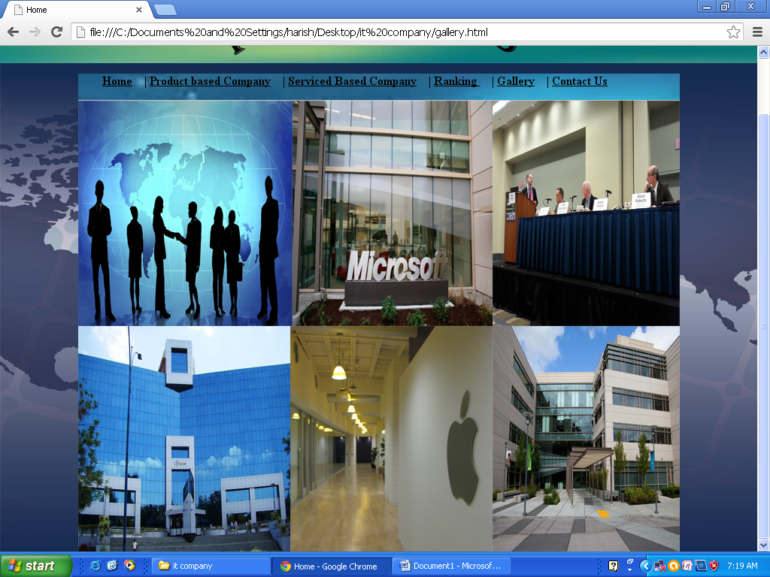

<html>

<head>

<title>Home</title>

</head>

<body background="images\bg2.jpg">

<br><br><br><br><br>

<div style="background-color:silver; width:800px; height:600;margin:0 Auto;">

<div style="background-image: url(Images/div.jpg); height: 35px; width: 800px;">

<p>&nbsp;&nbsp;&nbsp;&nbsp;&nbsp;&nbsp;&nbsp;

<a href="home.html"><font color="black" size="3"><b>Home</b></font></a>&nbsp;&nbsp;&nbsp;&nbsp;|

<a href="product.html"><font color="black" size="3"><b>Product based Company</b></font></a>&nbsp;&nbsp;&nbsp;&nbsp;|

<a href="service.html"><font color="black" size="3"><b>Serviced Based Company</b></font></a>&nbsp;&nbsp;&nbsp;&nbsp;|

<a href="ranking.html"><font color="black" size="3"><b>Ranking </b></font></a>&nbsp;&nbsp;&nbsp;&nbsp;|

<a href=""><font color="black" size="3"><b>Gallery</b></font></a>&nbsp;&nbsp;&nbsp;&nbsp;|

<a href=""><font color="black" size="3"><b>Contact Us</b></font></a>

</p>

<img src="images\gallery.jpg">

</html>

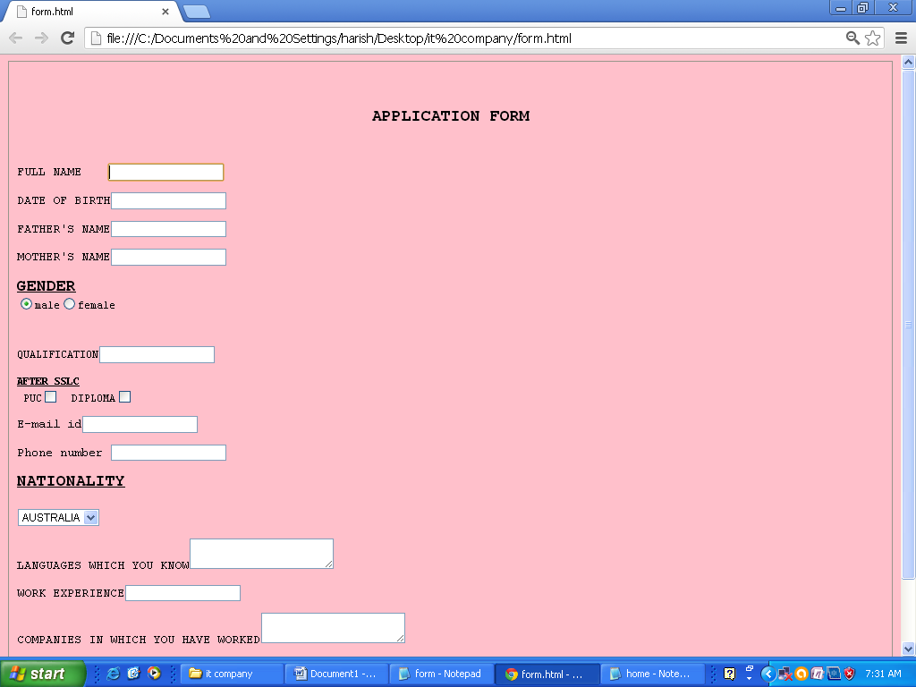

<html>

<pre>

<fieldset>

<body bgcolor=pink>

<h1><center><legend><font size=5>APPLICATION FORM</font></legend></center></h2>

<p><font size=4>FULL NAME </font> <input type="text">

<p><font size=4>DATE OF BIRTH</font><input type="text">

<p><font size=4>FATHER'S NAME</font><input type="text">

<p><font size=4>MOTHER'S NAME</font><input type="text">

<p><b><u><font size=5>GENDER</font></u></b><br><input type="radio" name=sex value="male">male<input type="radio" name=sex value="female">female</p>

<p>QUALIFICATION<input type="text"><p><b><u>AFTER SSLC</u></b><br> PUC<input type="checkbox"> DIPLOMA<input type="checkbox">

</p><p><font size=4>E-mail id</font><input type="text">

<p><font size=4>Phone number </font><input type="text">

<p><b><u><font size=5>NATIONALITY</u></b><br>

<select name="NATIONALITY">

<option value="AUSTRALIA">AUSTRALIA</option>

<option value="USA">USA</option>

<option value="INDIA">INDIA</option>

<option value="UK">UK</option></select></p><p><font size=4>LANGUAGES WHICH YOU KNOW</font><textarea></textarea>

<p><font size=4>WORK EXPERIENCE</font><input type="text"><p><font size=4>COMPANIES IN WHICH YOU HAVE WORKED</font><textarea></textarea>

<center><input type="button" value="submit"></center>

</fieldset>

</pre>

</body></html>