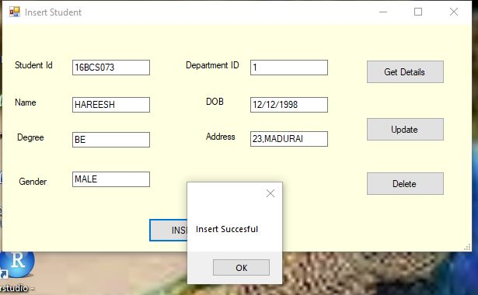

**Fig 1.** A form which inserts student details into the student database

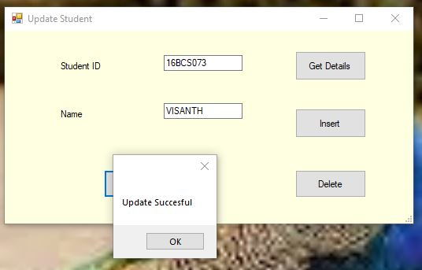

**Fig2**. A form which updates the student details into the student database

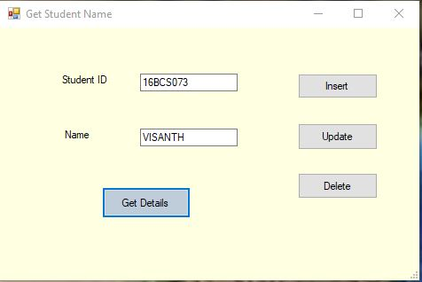

**Fig3.** A form which is used to view the student details into the student database

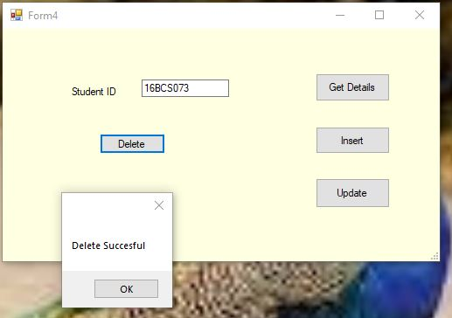

**Fig4.** A form which is used to delete the student details from the student database