<ShopTV>
High-Level Design Document
v1.00

Confidential

Robosoft Technologies Pvt. Ltd.
Registered & Corporate Office
217, N.H.66, Santhekatte
New Udupi – 576 105
Karnataka, India
Tel: +91 820 2593930
Fax: +91 820 2593900

Document Revision History

Date | Version | Authors | Reviewed By | Approved By | Brief Description
<dd-Mmm-yy> | 0.01 | <Author> | <Reviewer>  (One person/ Group Review - PQAL) | - | Initial draft
<dd-Mmm-yy> | 0.02 | <Author> | Verified by | - | List the changes incorporated as per review
<dd-Mmm-yy> | 0.03 | <Author> | <Customer> | <Customer> | List the changes incorporated as per Customer feedback and sent to Customer for approval
<dd-Mmm-yy> | 1.00 |  |  |  | Approved by Customer and baselined

Contents

1. High-Level Design 3
1.1 Introduction 3
1.1.1 Purpose 3
1.1.2 Scope 3
1.1.3 Audience 3
1.1.4 References 3
1.1.5 Terms and Abbreviations 3
1.2 Software Product Overview 3
1.3 Design Considerations 3
1.3.1 Assumptions and dependencies 3
1.3.2 Development methods 3
1.3.3 General constraints 3
1.4 Architectural Strategies 3
1.5 Software Product Architecture 3
1.6 Component Architecture 3
1.7 Bibliography 3
2. Reference 3

Figures

High-Level Design

Introduction

Purpose

To give the use the TV watching and shopiing experience in single platform.

Scope
Scope is not just limited to entertainment / infotainment rather for e-commerce

Audience\
People who are looking and entertainment and exploring new things

References
Roku documentation

Terms and Abbreviations

Software Product Overview

Design Considerations

Assumptions and dependencies
All the data are static

Development methods
Since Bright script is functional programming language development is limited to procedures .

General constraints
Roku does not support social media integration so sharing the products has been part of this implimentarion.

Architectural Strategies
Have used the re usablilty to best it could be since its functional programming.
Have defined global objects to reuse for singleton pattern.
Have used extends feature for components to carry its parent properties for compoent.
Eg: Like base screen for all the screens.

Software Product Architecture
There is a main scene under which the screens are created

Flow Diagram

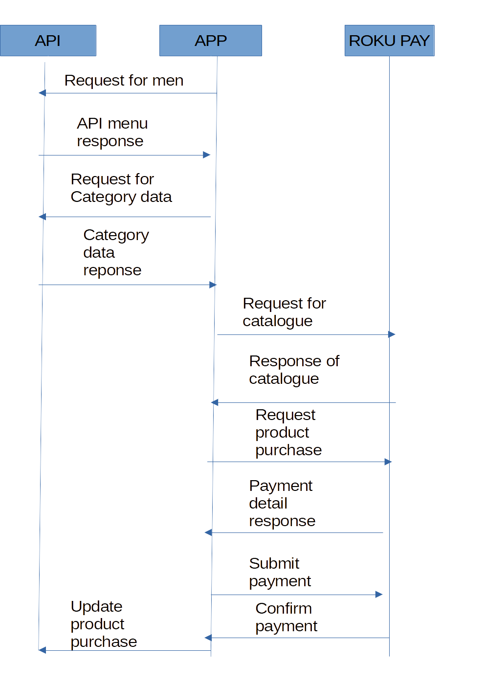

Component Architecture

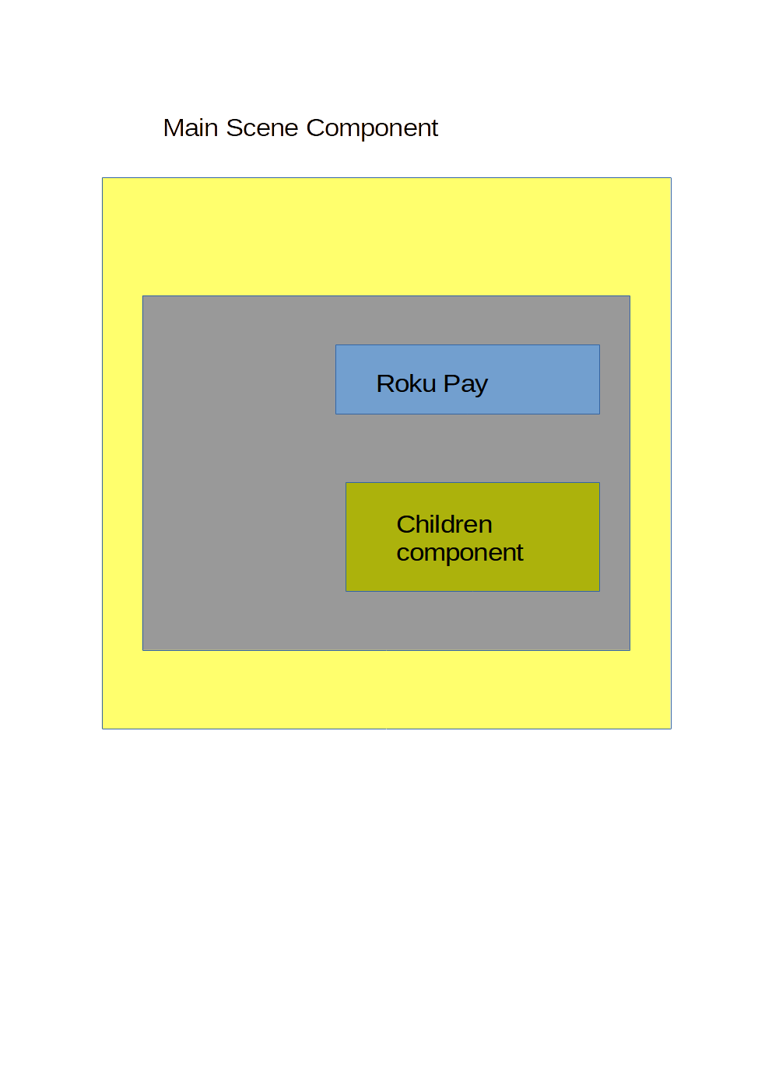

Bibliography

Reference

- High-Level
1.1
TV platform to give the user the experience of shopping.

  - Scope
The scope is limited to

