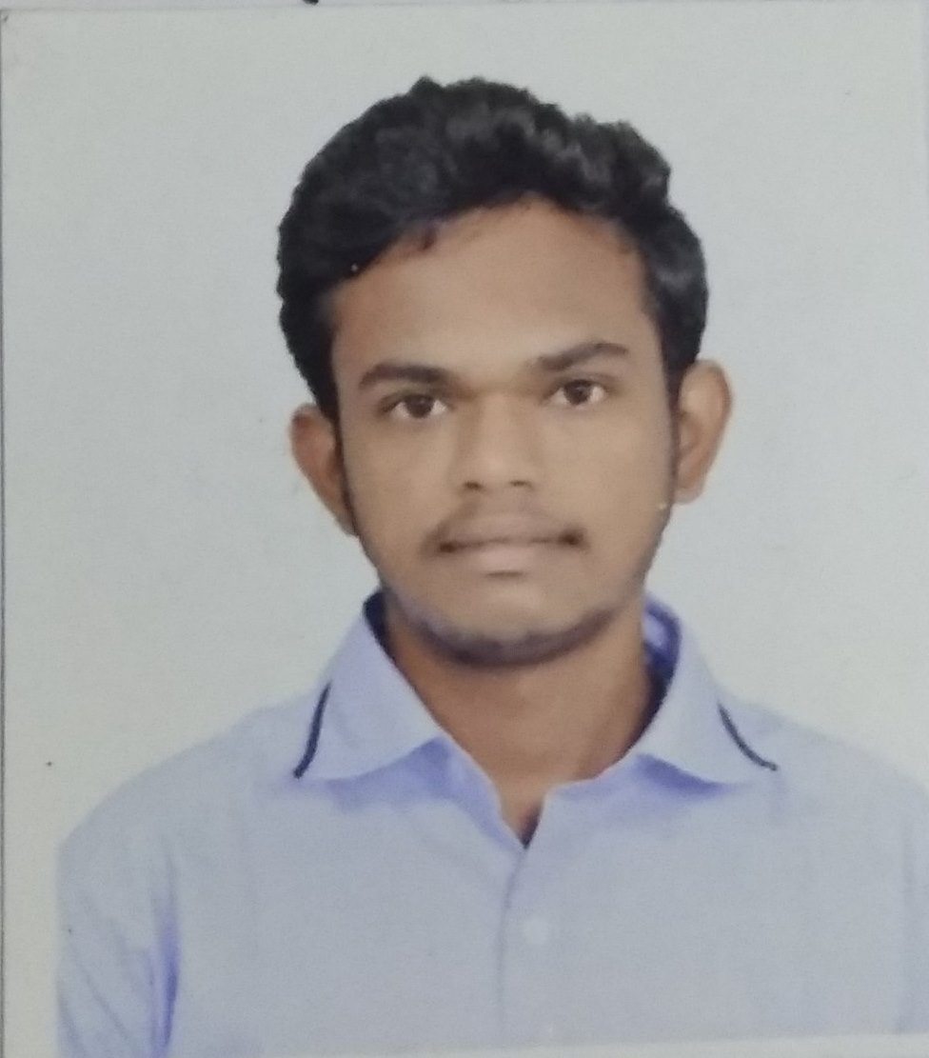

HARISH AJANKAR

27-3-2018