AWS · DEVOPS · FLASK E-COMMERCE
E-COM-1
Complete Project Documentation
A Flask e-commerce platform deployed on AWS with a Jenkins CI/CD pipeline, Docker, Nginx, Amazon RDS MySQL, Route 53 and Prometheus/Grafana monitoring.
Repository | github.com/harishankaraj04/e-com-1
Branch | main
Cloud | AWS: EC2, RDS MySQL, Route 53
CI/CD | Jenkins pipeline, 9 stages (job e-commerce-CI-CD)
Runtime | Docker, Nginx, Flask (Python 3.12)
Monitoring | Node Exporter, Prometheus, Grafana
Domain | eshanth.shop
Prepared by | Hari
Date | October 2026

Contents
1 | Project Overview
2 | Technology Stack
3 | System Architecture
4 | Repository and Project Structure
5 | Environment Setup
6 | Flask Application Logic
7 | Amazon RDS MySQL
8 | Product Catalog
9 | Admin Orders Dashboard
10 | Docker
11 | Jenkins CI/CD Pipeline
12 | Nginx Reverse Proxy
13 | Route 53 and Domain
14 | Monitoring: Prometheus, Grafana and Node Exporter
15 | Network and Security Group Design
16 | Troubleshooting Commands
17 | Problems Encountered and Lessons Learned
18 | Git Commands
19 | End-to-End Deployment Runbook
20 | Current Project Status
21 | Recommended Improvements
22 | Interview Explanation
23 | Security Notes
24 | Final Command Checklist
A | Appendix: Accuracy and Trademark Notes

1. Project Overview
E-COM-1 is a Flask e-commerce application deployed as a practical AWS and DevOps project. The source code lives in GitHub, Jenkins performs continuous integration and deployment, Docker packages and runs the application, Nginx acts as the public reverse proxy, Amazon RDS MySQL stores customer and order data, and Route 53 provides DNS for the domain eshanth.shop.

Objectives
- Run the Flask e-commerce website on AWS EC2.
- Use GitHub as the source-control system.
- Automate validation, testing, Docker build and deployment with Jenkins.
- Run the Flask application inside Docker.
- Use RDS MySQL for customers, orders and order items.
- Provide an admin orders dashboard.
- Use Nginx for public HTTP/HTTPS traffic.
- Connect the application to eshanth.shop through Route 53.
- Monitor the host and application with Node Exporter, Prometheus and Grafana.
- Deliver a project that can be explained as a real CI/CD DevOps implementation.

Scope note. Customer and order data is stored in Amazon RDS MySQL. The 25-product catalog is still served from the existing SQLite database and is planned for migration to RDS.

2. Technology Stack
The table below lists every tool used in the project, with the role each one plays.
 | Tool | Category | Role in this project
 | GitHub | Source control | Hosts the repository harishankaraj04/e-com-1 (branch main); Jenkins checks out code from here.
 | Git | Version control | Command-line workflow: status, add, commit, push, log.
 | Jenkins | CI/CD | Job e-commerce-CI-CD runs the Jenkinsfile: test, build, deploy, smoke test.
 | Docker | Containers | Image e-commerce-app built from python:3.12-slim; container exposes port 5000.
 | Flask | Web framework | Application routes, cart, checkout, order success and admin orders page.
 | Python 3 | Runtime | Application runtime; virtual environments (venv, jenkins-venv) for tests.
 | Nginx | Reverse proxy | Public entry point on ports 80/443, forwarding to Flask on 127.0.0.1:5000.
 | AWS EC2 | Compute | Amazon Linux host running Jenkins, Docker, Nginx and the monitoring stack.
 | Amazon RDS | Managed database | Hosts the ecommerce database with customers, orders and order_items tables.
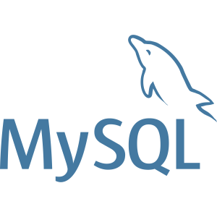 | MySQL / PyMySQL | Database engine and driver | MySQL engine on RDS; PyMySQL connects from rds_database.py.
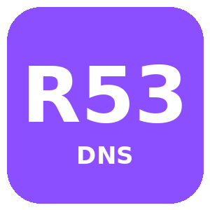 | Amazon Route 53 | DNS | Hosted zone for eshanth.shop; A record points to the EC2 public/Elastic IP.
 | Security Groups | Network security | Controls access to ports 22, 80, 443, 5000, 3306 and 8080.
 | SQLite | Local database | boom_store.db holds the 25-product catalog (to be migrated to RDS).
 | Prometheus | Metrics collection | Scrapes Flask /metrics and Node Exporter; UI on port 9090.
 | Grafana | Dashboards | Visualises Prometheus data; UI on port 3000.
 | Node Exporter | Host metrics | Exposes EC2 CPU, memory, disk and network metrics on port 9100.
Logos are trademarks of their respective owners. AWS service tiles are stylised labels, not official AWS icons.

3. System Architecture
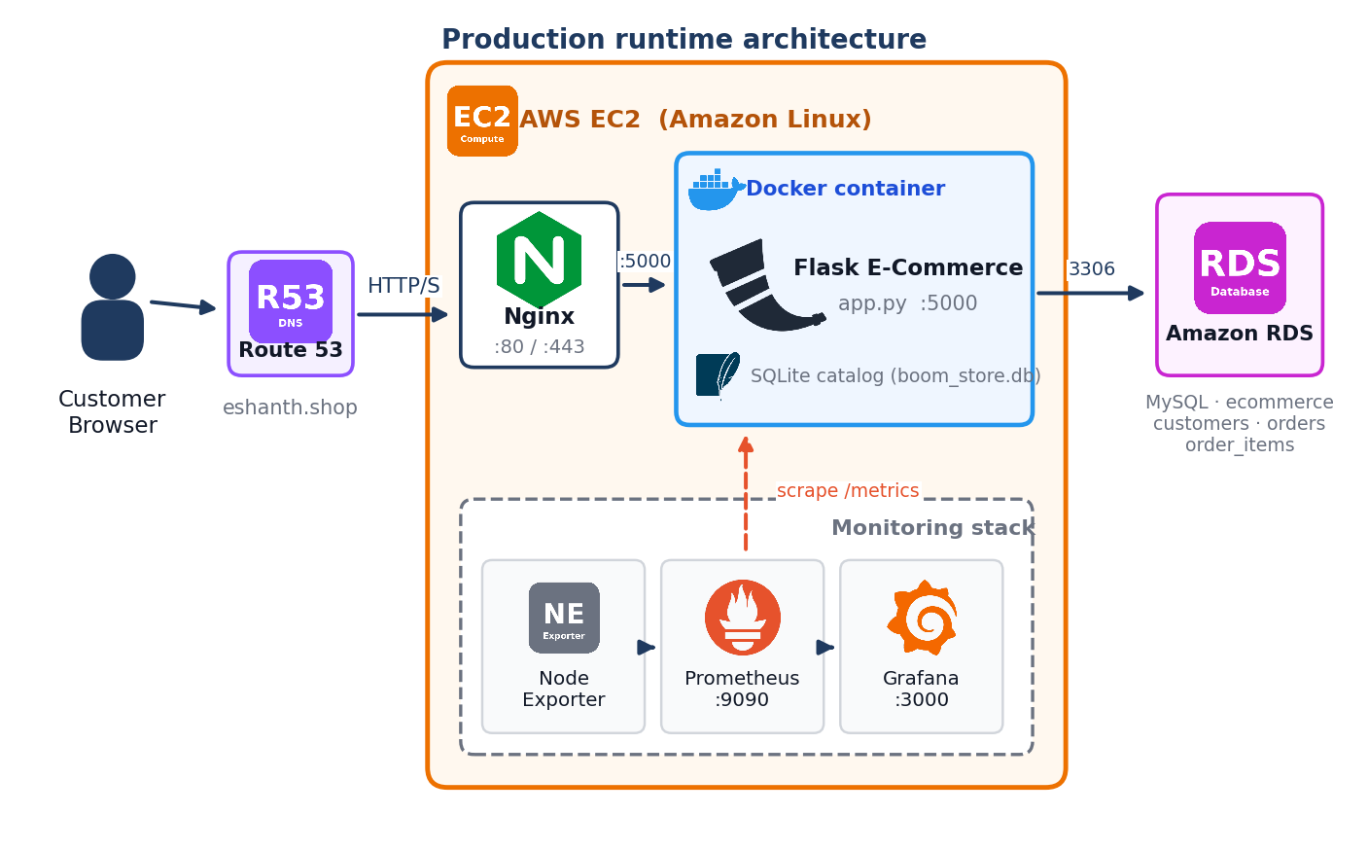
Figure 1. Production runtime architecture

Request flow
- The customer opens eshanth.shop in a browser.
- Route 53 resolves the domain to the EC2 public IP.
- Nginx receives the request on port 80/443 and proxies it to 127.0.0.1:5000.
- The Flask container serves product pages from the SQLite catalog.
- At checkout, Flask writes the customer, order and order items to Amazon RDS MySQL.
- Prometheus scrapes application and host metrics; Grafana displays them.

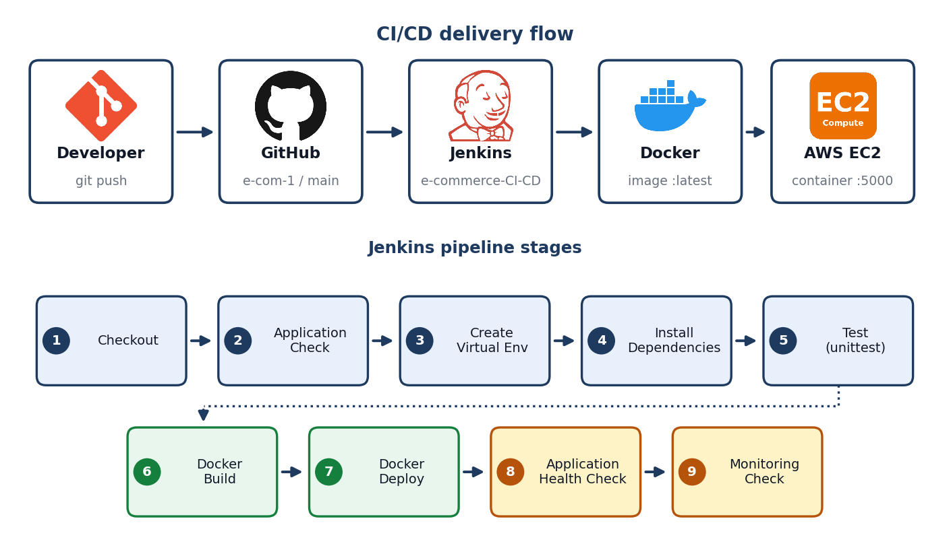
Figure 2. CI/CD delivery flow and Jenkins pipeline stages

4. Repository and Project Structure
Item | Value
Correct repository | https://github.com/harishankaraj04/e-com-1.git
Branch | main
Jenkins job | e-commerce-CI-CD
Jenkins workspace | /var/lib/jenkins/workspace/e-commerce-CI-CD
Pipeline file | Jenkinsfile
Known commit | d28e27c - Add Docker CI CD deployment
Old repository to avoid | https://github.com/harishankaraj04/e-com.git

Directory layout
e-com-1/
├── app.py
├── database.py
├── rds_database.py
├── requirements.txt
├── Dockerfile
├── Jenkinsfile
├── test_app.py
├── boom_store.db
├── templates/
│ └── admin_orders.html
├── static/
│ ├── css/style.css
│ └── js/main.js
└── monitoring/
├── prometheus/
│ └── prometheus.yml
└── grafana/
└── dashboards/

Files and purpose
File / directory | Purpose | Status
app.py | Main Flask application and routes | Confirmed
requirements.txt | Python dependencies | Confirmed
Jenkinsfile | Declarative CI/CD pipeline | Confirmed
Dockerfile | Container image definition | Used
database.py | SQLite database helper | Confirmed
database.py.backup | Backup of database.py | Created
rds_database.py | PyMySQL RDS connection helper | Confirmed
boom_store.db | SQLite product catalog | Referenced
templates/ | Flask HTML templates | Confirmed
templates/admin_orders.html | RDS-backed admin order page | Created
static/css/style.css | Frontend CSS | Confirmed
static/js/main.js | Frontend JavaScript | Confirmed
monitoring/ | Prometheus configuration and Grafana dashboards | Created
venv/ | Manual EC2 Python environment | Created
jenkins-venv/ | Jenkins pipeline virtual environment | Created by pipeline
test_app.py | Unit-test target used by Jenkins | Referenced by Jenkinsfile

5. Environment Setup

EC2 / Linux project commands
cd ~/e-com-1

git remote -v
git branch
git branch --show-current
git status

python3 --version
python3 -m py_compile app.py

python3 -m venv venv
./venv/bin/python -m pip install --upgrade pip
./venv/bin/python -m pip install Flask PyMySQL
./venv/bin/python -c "import flask, pymysql; print('Flask OK'); print('PyMySQL OK')"
./venv/bin/python -m py_compile app.py

Running Flask manually
./venv/bin/python app.py

# Alternative manual launch used during testing
./venv/bin/python -c "from app import app; app.run(host='0.0.0.0', port=5000, debug=False)"

6. Flask Application Logic
app.py contains the main Flask application. The flow covers product browsing, product detail pages, cart management, checkout and an order-success page. The checkout route was extended to save customer, order and order-item data into RDS.

Checkout flow
- Read cart data from the Flask session.
- Load selected products from the SQLite catalog.
- Calculate item subtotals, discount, delivery fee and final amount.
- Read and validate customer delivery information.
- Generate a unique order number.
- Build the order_items list from the cart.
- Open an RDS MySQL connection.
- Insert the customer.
- Insert the order and obtain the RDS order_id.
- Insert each order item.
- Commit the transaction.
- Close the RDS connection.
- Clear the shopping cart and redirect to order-success.

RDS insertion code
from rds_database import get_connection

rds = get_connection()

try:
with rds.cursor() as cursor:
cursor.execute("""
INSERT INTO customers
(name, email, phone, address, city, state, pincode)
VALUES (%s, %s, %s, %s, %s, %s, %s)
""", (
full_name, None, phone, address, city, state, pincode
))

customer_id = cursor.lastrowid

cursor.execute("""
INSERT INTO orders
(order_number, customer_id, total_amount, status)
VALUES (%s, %s, %s, %s)
""", (
order_id, customer_id, final_amount, 'Confirmed'
))

rds_order_id = cursor.lastrowid

for item in order_items:
cursor.execute("""
INSERT INTO order_items
(order_id, product_name, quantity, price)
VALUES (%s, %s, %s, %s)
""", (
rds_order_id,
item["title"],
item["quantity"],
item["price"]
))

rds.commit()

except Exception:
rds.rollback()
raise

finally:
rds.close()

7. Amazon RDS MySQL
Property | Value
Engine | Amazon RDS MySQL
Database | ecommerce
Endpoint | database-2.cv0qmagc4wz2.us-east-2.rds.amazonaws.com
Port | 3306
Application driver | PyMySQL
Tables | customers, orders, order_items

Connection helper: rds_database.py
import pymysql
import os

def get_connection():
return pymysql.connect(
host=os.getenv(
"DB_HOST",
"database-2.cv0qmagc4wz2.us-east-2.rds.amazonaws.com"
),
user=os.getenv("DB_USER", "admin"),
password=os.getenv("DB_PASSWORD"),
database=os.getenv("DB_NAME", "ecommerce"),
port=3306,
cursorclass=pymysql.cursors.DictCursor,
autocommit=False
)

Environment variables
export DB_HOST='database-2.cv0qmagc4wz2.us-east-2.rds.amazonaws.com'
export DB_USER='admin'
export DB_NAME='ecommerce'
export DB_PASSWORD='YOUR_RDS_PASSWORD'

Security. Never commit the database password. The password was exposed during troubleshooting and must be rotated.

Create the database
mysql -h database-2.cv0qmagc4wz2.us-east-2.rds.amazonaws.com -P 3306 -u admin -p

CREATE DATABASE ecommerce;
USE ecommerce;

Table: customers
CREATE TABLE customers (
customer_id INT AUTO_INCREMENT PRIMARY KEY,
name VARCHAR(100) NOT NULL,
email VARCHAR(150),
phone VARCHAR(30),
address TEXT,
city VARCHAR(100),
state VARCHAR(100),
pincode VARCHAR(20),
created_at TIMESTAMP DEFAULT CURRENT_TIMESTAMP
);

Table: orders
CREATE TABLE orders (
order_id INT AUTO_INCREMENT PRIMARY KEY,
order_number VARCHAR(50) UNIQUE NOT NULL,
customer_id INT NOT NULL,
total_amount DECIMAL(10,2) NOT NULL,
status VARCHAR(30) DEFAULT 'Confirmed',
order_date TIMESTAMP DEFAULT CURRENT_TIMESTAMP,
FOREIGN KEY (customer_id) REFERENCES customers(customer_id)
);

Table: order_items
CREATE TABLE order_items (
item_id INT AUTO_INCREMENT PRIMARY KEY,
order_id INT NOT NULL,
product_name VARCHAR(255) NOT NULL,
quantity INT NOT NULL,
price DECIMAL(10,2) NOT NULL,
FOREIGN KEY (order_id) REFERENCES orders(order_id)
);

Verification queries
USE ecommerce;
SHOW TABLES;
DESCRIBE customers;
DESCRIBE orders;
DESCRIBE order_items;

SELECT * FROM customers ORDER BY customer_id DESC LIMIT 5;
SELECT * FROM orders ORDER BY order_id DESC LIMIT 5;
SELECT * FROM order_items ORDER BY item_id DESC LIMIT 10;

Complete order report query
SELECT
o.order_number,
c.name AS customer_name,
c.email,
c.phone,
c.address,
c.city,
c.state,
c.pincode,
oi.product_name,
oi.quantity,
oi.price,
o.total_amount,
o.status,
o.order_date
FROM orders o
JOIN customers c ON o.customer_id = c.customer_id
JOIN order_items oi ON o.order_id = oi.order_id
ORDER BY o.order_id DESC;

8. Product Catalog
The product catalog is still backed by the existing SQLite database. Application logs showed initialisation with 25 products. Product records include id, title, price, original_price and images_json.
sqlite3 boom_store.db
.tables
SELECT * FROM products;

.headers on
.mode column
SELECT id, title, price, original_price FROM products;

.exit

Future target: create a products table in RDS and migrate the 25-product catalog so the application uses a single database.

9. Admin Orders Dashboard
The route /admin/orders queries RDS and renders templates/admin_orders.html.
@app.route('/admin/orders')
def admin_orders():
from rds_database import get_connection

rds = get_connection()

try:
with rds.cursor() as cursor:
cursor.execute("""
SELECT
o.order_id,
o.order_number,
c.name AS customer_name,
c.email,
c.phone,
c.address,
c.city,
c.state,
c.pincode,
oi.product_name,
oi.quantity,
oi.price,
o.total_amount,
o.status,
o.order_date
FROM orders o
JOIN customers c ON o.customer_id = c.customer_id
LEFT JOIN order_items oi ON o.order_id = oi.order_id
ORDER BY o.order_id DESC
""")
orders = cursor.fetchall()
finally:
rds.close()

return render_template('admin_orders.html', orders=orders)

Security warning. This endpoint has no authentication yet and must not be exposed publicly in production.

10. Docker
Docker packages the Flask application into the e-commerce-app image and exposes Flask on port 5000.

Dockerfile
FROM python:3.12-slim

WORKDIR /app

COPY requirements.txt .

RUN pip install --no-cache-dir -r requirements.txt

COPY . .

EXPOSE 5000

CMD ["python", "app.py"]

Build and run
docker build --no-cache -t e-commerce-app:latest .

docker run -d \
--name e-commerce-app \
-p 5000:5000 \
--restart unless-stopped \
e-commerce-app:latest

docker ps
docker images
docker logs e-commerce-app
curl http://localhost:5000

Docker cleanup used during reset
docker ps -aq
docker stop $(docker ps -aq) 2>/dev/null || true
docker rm $(docker ps -aq) 2>/dev/null || true
docker rmi -f $(docker images -aq) 2>/dev/null || true
docker system prune -a -f

Caution. The cleanup commands remove all containers and images on the host, including unrelated ones. Use only on a dedicated project server.

11. Jenkins CI/CD Pipeline
Jenkins is configured as Pipeline script from SCM. The repository is e-com-1, the branch is */main and the script path is Jenkinsfile.
# | Stage | Action
1 | Checkout | checkout scm
2 | Application Check | pwd, Git remote, branch, file list, Python version
3 | Create Virtual Environment | Create a clean jenkins-venv
4 | Install Dependencies | Upgrade pip and install requirements
5 | Test | py_compile app.py and unittest test_app.py
6 | Docker Build | Build e-commerce-app:latest
7 | Docker Deploy | Replace the running e-commerce-app container
8 | Application Health Check | Retry curl http://localhost:5000 until the app responds
9 | Monitoring Check | Verify Prometheus, Grafana and the app /metrics endpoint are healthy

Jenkinsfile
pipeline {
agent any

stages {
stage('Checkout') {
steps { checkout scm }
}

stage('Application Check') {
steps {
sh '''
echo "===== e-com-1 ====="
pwd
git remote -v
git branch --show-current
ls -la
python3 --version
'''
}
}

stage('Create Virtual Environment') {
steps {
sh '''
rm -rf jenkins-venv
python3 -m venv jenkins-venv
./jenkins-venv/bin/python --version
'''
}
}

stage('Install Dependencies') {
steps {
sh '''
./jenkins-venv/bin/pip install --upgrade pip
./jenkins-venv/bin/pip install -r requirements.txt
'''
}
}

stage('Test') {
steps {
sh '''
./jenkins-venv/bin/python -m py_compile app.py
./jenkins-venv/bin/python -m unittest test_app.py
'''
}
}

stage('Docker Build') {
steps {
sh '''
docker build --no-cache -t e-commerce-app:latest .
docker images e-commerce-app
'''
}
}

stage('Docker Deploy') {
steps {
sh '''
docker stop e-commerce-app || true
docker rm e-commerce-app || true
docker run -d --name e-commerce-app -p 5000:5000 --restart unless-stopped e-commerce-app:latest
docker ps
'''
}
}

stage('Application Health Check') {
steps {
sh '''
for i in $(seq 1 10); do
curl -fs http://localhost:5000/ > /dev/null && exit 0
sleep 5
done
echo "Application failed health check"
exit 1
'''
}
}

stage('Monitoring Check') {
steps {
sh '''
curl -fs http://localhost:9090/-/healthy
curl -fs http://localhost:3000/api/health
curl -fs http://localhost:5000/metrics > /dev/null
'''
}
}
}

post {
success { echo 'e-com-1 CI/CD SUCCESS' }
failure { echo 'e-com-1 CI/CD FAILED' }
}
}

Monitoring Check requirement. Stage 9 fails if Prometheus (9090), Grafana (3000) or the Flask /metrics endpoint is not running. Start the monitoring containers and add a metrics library to the app (for example prometheus-flask-exporter) before enabling this stage.

Jenkins Docker permission
sudo usermod -aG docker jenkins
sudo systemctl restart jenkins
sudo -u jenkins docker ps

12. Nginx Reverse Proxy
sudo dnf install nginx -y
sudo systemctl enable --now nginx
sudo systemctl status nginx

Site configuration
server {
listen 80;
server_name _;

location / {
proxy_pass http://127.0.0.1:5000;

proxy_set_header Host $host;
proxy_set_header X-Real-IP $remote_addr;
proxy_set_header X-Forwarded-For $proxy_add_x_forwarded_for;
proxy_set_header X-Forwarded-Proto $scheme;
}
}

sudo nginx -t
sudo systemctl restart nginx

Target traffic path: Internet → Nginx :80/:443 → Flask container :5000. Port 5000 should eventually be closed to the public.

13. Route 53 and Domain
Domain: eshanth.shop. Route 53 hosted-zone nameservers recorded during setup:
- ns-1784.awsdns-31.co.uk
- ns-145.awsdns-18.com
- ns-985.awsdns-59.net
- ns-1209.awsdns-23.org

During troubleshooting, nslookup still returned the Hostinger nameservers athena.dns-parking.com and apollo.dns-parking.com. Delegation to Route 53 must be verified before DNS is considered complete.

nslookup -type=NS eshanth.shop
nslookup eshanth.shop
nslookup www.eshanth.shop

Always confirm the current EC2 public or Elastic IP before setting the final A record.

14. Monitoring: Prometheus, Grafana and Node Exporter
Monitoring runs as separate containers beside the application. Node Exporter reports host metrics, Prometheus scrapes and stores metrics, and Grafana visualises them.
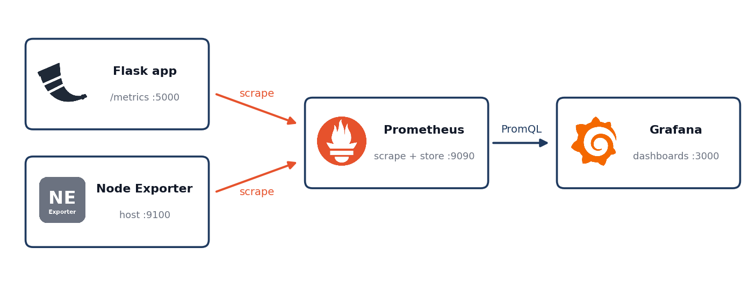
Figure 3. Monitoring data flow
Component | Port | Purpose
Flask app | 5000 | Application; exposes /metrics for Prometheus
Node Exporter | 9100 | EC2 CPU, memory, disk and network metrics
Prometheus | 9090 | Scrapes targets and stores time-series data
Grafana | 3000 | Dashboards and visualisation

Node Exporter service (docker-compose)
node-exporter:
image: prom/node-exporter:latest
container_name: node-exporter
ports:
- "9100:9100"
pid: host
volumes:
- /proc:/host/proc:ro
- /sys:/host/sys:ro
- /:/rootfs:ro
command:
- '--path.procfs=/host/proc'
- '--path.sysfs=/host/sys'
- '--path.rootfs=/rootfs'
restart: unless-stopped

Prometheus scrape configuration
File: monitoring/prometheus/prometheus.yml
scrape_configs:
- job_name: 'flask-app'
static_configs:
- targets: ['e-commerce-app:5000']

- job_name: 'node'
static_configs:
- targets: ['node-exporter:9100']

Verification steps
- Start the stack: docker compose up -d.
- Open http://<server-ip>:9090/targets and confirm both targets show UP.
- Open Grafana on port 3000 and add Prometheus as a data source.
- Import dashboard ID 1860 (Node Exporter Full) and select the Prometheus data source.

Requirements. The Flask app needs a metrics library (for example prometheus-flask-exporter) to expose /metrics, and Prometheus must share a Docker network with the app container to resolve e-commerce-app:5000.

15. Network and Security Group Design
Port | Use | Recommended access
22 | SSH | Your IP only
80 | Nginx HTTP | Public
443 | Nginx HTTPS | Public
5000 | Flask direct test | Temporary only
3306 | RDS MySQL | EC2 security group only
8080 | Jenkins | Trusted/admin IP only
9090 / 3000 / 9100 | Prometheus / Grafana / Node Exporter | Admin IP only, or Docker network only

16. Troubleshooting Commands
# Flask syntax
python3 -m py_compile app.py
./venv/bin/python -m py_compile app.py

# Port / process
sudo ss -ltnp | grep :5000
ps -ef | grep '[p]ython'

# Application
curl http://localhost:5000

# Docker
docker ps
docker logs e-commerce-app

# Nginx
sudo nginx -t
sudo systemctl status nginx

# Jenkins
sudo systemctl status jenkins
sudo journalctl -u jenkins --no-pager -n 50

# Git
git remote -v
git branch --show-current
git status

17. Problems Encountered and Lessons Learned
Problem | Cause | Fix / lesson
Jenkins: Jenkinsfile not found | Wrong repo, branch or path | Use e-com-1 / main / Jenkinsfile
Groovy: expecting EOF | Extra closing brace | Keep declarative braces balanced
Groovy: unexpected token | Shell command outside an sh block | Put shell commands inside sh
Jenkins: pip missing | System Python lacked pip | Use jenkins-venv
Docker: permission denied | jenkins user not in docker group | Add jenkins to the docker group
Flask: json NameError | json import missing | Add import json
RDS: access denied | Credential mismatch | Verify environment variables and RDS credentials
Unknown column c.city | Schema missing location columns | Add city, state and pincode
email cannot be null | RDS email was NOT NULL but code passed None | Make nullable or collect the email
Port 5000 already in use | Existing Flask process | Check ss and ps before starting another
Debug mode restart failure | Flask reloader cannot restart a python -c launch | Use app.py for debug mode
requirements install failure | aws-cfn-bootstrap==2.0 unavailable | Clean requirements.txt for deployment

18. Git Commands
git status
git branch
git branch --show-current
git remote -v

git add .
git commit -m "Update e-commerce application"
git push origin main
git log --oneline -5

19. End-to-End Deployment Runbook
- Developer updates code.
- Run syntax and unit tests.
- Commit and push to main.
- Jenkins checks out e-com-1.
- Jenkins creates a clean virtual environment.
- Jenkins installs dependencies.
- Jenkins runs tests.
- Jenkins builds the Docker image.
- Jenkins replaces the old container.
- Jenkins runs the application health check.
- Jenkins runs the monitoring check (Prometheus, Grafana, /metrics).
- Nginx exposes the application publicly.
- Flask serves products and checkout.
- Checkout writes customer, order and order_items to RDS.
- Admin dashboard reads joined RDS data.
- Prometheus and Grafana show application and host health.

20. Current Project Status
Component | Status
GitHub e-com-1 / main | Configured
Jenkins checkout | Working
Jenkins CI/CD (stages 1-8) | Successful after fixes
Monitoring Check stage (9) | Pending; needs monitoring containers and /metrics
Docker access for Jenkins | Configured
Flask on EC2 | Working on port 5000
RDS connection | Verified
RDS schema | customers, orders and order_items created
Admin orders route | Reached HTTP 200 during testing
Checkout RDS write | Email-null schema issue identified; final order test pending
Product catalog | Still SQLite
Nginx | Documented; next deployment layer
Route 53 | Delegation needs final verification
Monitoring stack | Designed; verify targets are UP
HTTPS | Not completed
Admin authentication | Not completed

21. Recommended Improvements
- Create an RDS products table and migrate the existing 25 products.
- Update checkout to collect customer email or intentionally allow NULL.
- Add admin authentication and authorisation.
- Move database credentials into AWS Secrets Manager.
- Rotate the exposed RDS password.
- Use Gunicorn instead of the Flask development server.
- Expose only ports 80 and 443 through Nginx.
- Enable HTTPS (Let's Encrypt or ACM).
- Restrict RDS to the application security group.
- Tag Docker images with the Git commit SHA.
- Add automatic rollback to the previous image when a health check fails.
- Add a docker-compose.yml for the app and the monitoring stack.
- Clean requirements.txt so Jenkins and Docker builds are reproducible.
- Add integration tests for checkout and RDS transactions.

22. Interview Explanation
I built a Flask e-commerce application and deployed it on AWS EC2. The source code is stored in GitHub and Jenkins checks out the main branch. The CI/CD pipeline creates a Python environment, installs dependencies, runs tests, builds a Docker image and deploys the container, then runs an application health check and a monitoring check. Nginx is used as a reverse proxy in front of Flask. Customer and order information is stored in Amazon RDS MySQL using PyMySQL. The product catalog is still in SQLite and is planned for migration to RDS. I also created an admin orders dashboard that reads customer, order and order-item data from RDS, and designed a Prometheus, Grafana and Node Exporter monitoring stack for the host and application.

23. Security Notes
- Never commit the RDS password.
- Rotate credentials that were exposed during troubleshooting.
- Never publish GitHub personal access tokens.
- Do not expose RDS port 3306 publicly.
- Do not expose /admin/orders without authentication.
- Use HTTPS for customer traffic.
- Use least-privilege IAM roles.
- Keep Jenkins restricted to trusted administrators.
- Do not expose Prometheus, Grafana or Node Exporter to the internet.

24. Final Command Checklist
# Git
git remote -v
git branch --show-current
git status

# Python
./venv/bin/python -m py_compile app.py

# RDS
mysql -h database-2.cv0qmagc4wz2.us-east-2.rds.amazonaws.com -P 3306 -u admin -p

# Application
./venv/bin/python app.py

# Port
sudo ss -ltnp | grep :5000

# Docker
docker ps
docker images
docker logs e-commerce-app

# Nginx
sudo nginx -t
sudo systemctl status nginx

# DNS
nslookup -type=NS eshanth.shop
nslookup eshanth.shop
nslookup www.eshanth.shop

# Jenkins
sudo systemctl status jenkins
sudo -u jenkins docker ps

# Monitoring
curl http://localhost:9090/-/healthy
curl http://localhost:3000/api/health
curl http://localhost:9100/metrics | head

Appendix: Accuracy and Trademark Notes
This document is a project record based on the commands, logs, schemas and code snippets established during implementation. It does not invent the complete contents of source files that were not supplied in full. The exact code sections recorded are the RDS connection helper, the RDS checkout insertion logic, the admin-orders route, the Jenkinsfile and the Dockerfile. The monitoring configuration is a reference design and should be verified on the server.
Tool logos are trademarks of their respective owners and are used for identification only. AWS service tiles in this document are stylised labels, not official AWS architecture icons.
END OF E-COM-1 PROJECT DOCUMENTATION

