**BASH SCRIPTING**

### **1. Script to print the count of files and subdirectories in the specified directory.**

#!/bin/bash

if [ -d "$@" ]; then

echo "Files found: $(find "$@" -type f | wc -l)"

echo "Folders found: $(find "$@" -type d | wc -l)"

else

echo "[ERROR] Please retry with a folder."

exit 1

fi

**Output:**

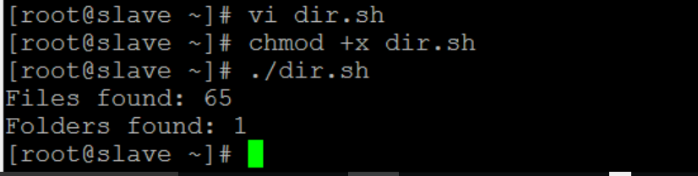

**2. Script reading user input**

#!/bin/bash

echo -e "Hi, please type the word: \c "

read word

echo "The word you entered is: $word"

echo -e "Can you please enter two words? "

read word1 word2

echo "Here is your input: \"$word1\" \"$word2\""

echo -e "How do you feel about bash scripting? "

# read command now stores a reply into the default build-in variable $REPLY

read

echo "You said $REPLY, I'm glad to hear that! "

echo -e "What are your favorite colours ? "

# -a makes read command to read into an array

read -a colours

echo "My favorite colours are also ${colours[0]}, ${colours[1]} and ${colours[2]}:-)"

**Output:**

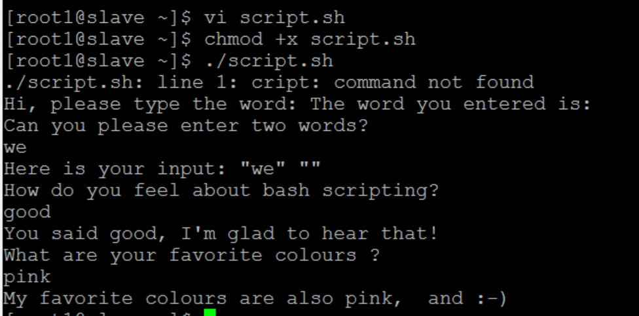

**3. Script to select the particular case statement**

#!/bin/bash

echo "What is your preferred programming / scripting language"

echo "1) bash"

echo "2) perl"

echo "3) phyton"

echo "4) c++"

echo "5) I do not know !"

read case;

#simple case bash structure

# note in this case $case is variable and does not have to

# be named case this is just an example

case $case in

1) echo "You selected bash";;

2) echo "You selected perl";;

3) echo "You selected phyton";;

4) echo "You selected c++";;

5) exit

esac

~

**Output:**

**Option 1:**

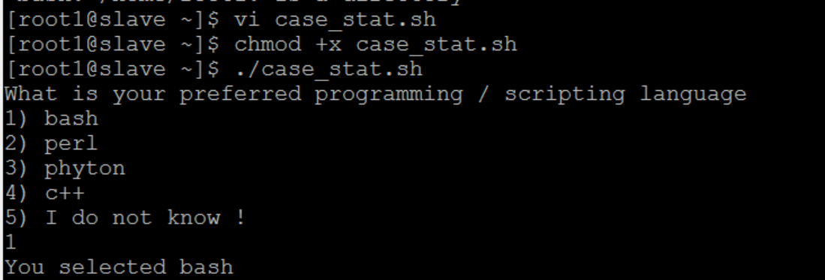

**Option 2:**

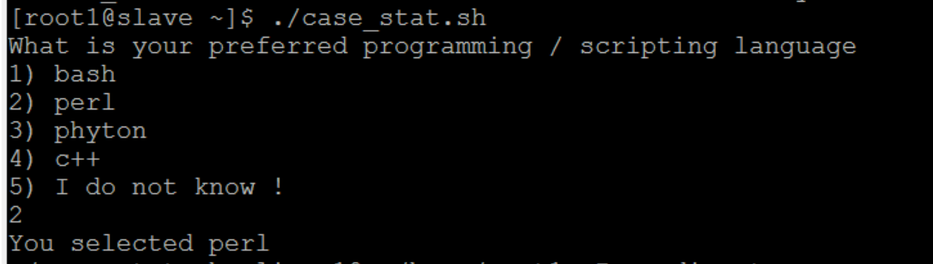

**Option 3:**

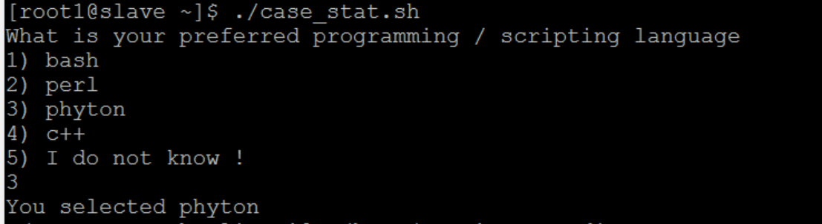

**4. Script to create simple menus and take action according to that selected**

## #!/bin/bash

while :

do

clear

echo "-------------------------------------"

echo " Main Menu "

echo "-------------------------------------"

echo "[1] Show Todays date/time"

echo "[2] Show files in current directory"

echo "[3] Show calendar"

echo "[4] Start editor to write letters"

echo "[5] Exit/Stop"

echo "======================="

echo -n "Enter your menu choice [1-5]: "

read yourch

case $yourch in

1) echo "Today is `date` , press a key. . ." ; read ;;

2) echo "Files in `pwd`" ; ls -l ; echo "Press a key. . ." ; read ;;

3) cal ; echo "Press a key. . ." ; read ;;

4) vi ;;

5) exit 0 ;;

*) echo "Opps!!! Please select choice 1,2,3,4, or 5";

echo "Press a key. . ." ; read ;;

esac

done

**Output:**

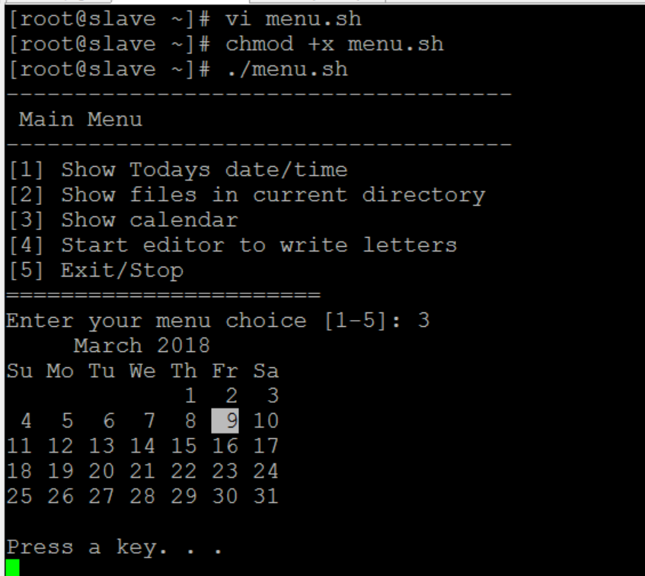

**5. Script to validate Password strength**

#Password Validation Script

echo "Enter your password"

read password

len="${#password}"

if test $len -ge 8 ; then

echo "$password" | grep -q [0-9]

if test $? -eq 0 ; then

echo "$password" | grep -q [A-Z]

if test $? -eq 0 ; then

echo "$password" | grep -q [a-z]

if test $? -eq 0 ; then

echo "Strong Password"

else

echo "Weak Password -> Should include a lower case letter."

fi

else

echo "Weak Password -> Should include a capital case letter."

fi

else

echo "Weak Password -> Should use numbers in your password."

fi

else

echo "Weak Password -> Password length should have at least 8 characters."

fi

**Output:**