Name: Om Balasaheb Shinde
PRN No: 202402040015
Roll No: 282

GRP Members:
Hari Sharma 202402040014
Pawan Shinde 202402040012
Pawan Rathod 202402040021

LSTM-Based Sequence Prediction System with FastAPI Deployment

1. Introduction
Sequence prediction is an important problem in artificial intelligence and natural language processing. It involves predicting the next element in a sequence based on previously observed elements. In natural language processing, this often refers to predicting the next word in a sentence.
In this project, we developed an AI-based sequence prediction system using Long Short-Term Memory (LSTM) networks. LSTM is a type of recurrent neural network (RNN) capable of learning long-term dependencies in sequential data.
The system was trained on a text dataset and deployed using FastAPI to provide real-time prediction capabilities through an API. The project demonstrates the complete pipeline of dataset collection, preprocessing, model training, evaluation, and deployment.

2. Objective
The main objectives of this assignment are:
• To develop an LSTM-based sequence prediction model
• To preprocess and prepare text data for machine learning
• To train a deep learning model capable of predicting the next word
• To deploy the trained model using FastAPI for real-time inference
• To build an end-to-end AI system combining machine learning and API deployment

3. Dataset Used
Dataset Name: Tiny Shakespeare Dataset
Dataset Source:
https://raw.githubusercontent.com/karpathy/char-rnn/master/data/tinyshakespeare/input.txt
Dataset Description:
The Tiny Shakespeare dataset contains dialogues from Shakespeare’s plays. It provides thousands of lines of natural language text that allow deep learning models to learn sequential language patterns.
Example:
First Citizen:
Before we proceed any further, hear me speak.
All:
Speak, speak.

4. Data Preprocessing
Text preprocessing was performed before training the model.
Steps included:
Text Cleaning – Converting text to lowercase and removing punctuation.
Sentence Extraction – Splitting the dataset into individual sentences.
Tokenization – Converting words into numerical indices.
Sequence Generation – Creating input-output training sequences.
Padding – Making all sequences equal length so they can be processed by the neural network.

5. LSTM Model Architecture
The deep learning model consists of the following layers:
Embedding Layer – Converts word indices into dense vectors.
LSTM Layer – Learns sequential dependencies in the text.
Dropout Layer – Prevents overfitting.
Second LSTM Layer – Improves sequence learning.
Dense Layer – Predicts the probability of the next word.
Architecture:
Embedding → LSTM → Dropout → LSTM → Dense

6. Mathematical Model of LSTM
LSTM networks use gates to control information flow.
Forget Gate:
ft = σ(Wf[ht−1, xt] + bf)
Input Gate:
it = σ(Wi[ht−1, xt] + bi)
Candidate Memory:
C̃t = tanh(Wc[ht−1, xt] + bc)
Cell State Update:
Ct = ft * Ct−1 + it * C̃t
Output Gate:
ot = σ(Wo[ht−1, xt] + bo)
Hidden State:
ht = ot * tanh(Ct)

7. Model Training
Training configuration:
Loss Function: Sparse Categorical Crossentropy
Optimizer: Adam Optimizer
Batch Size: 64
Epochs: 40
Sparse categorical crossentropy was used because labels were integer encoded rather than one-hot encoded.

8. Model Performance
Training Accuracy: Approximately 0.4
Accuracy increased gradually over epochs, demonstrating effective learning of language patterns.
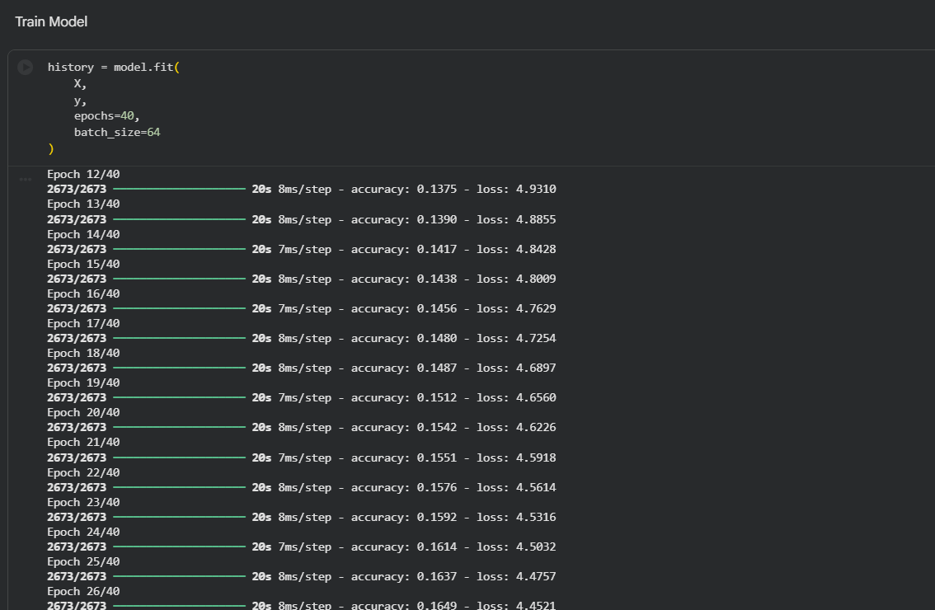
Loss decreased steadily during training, indicating improved model performance.

9. Prediction Results
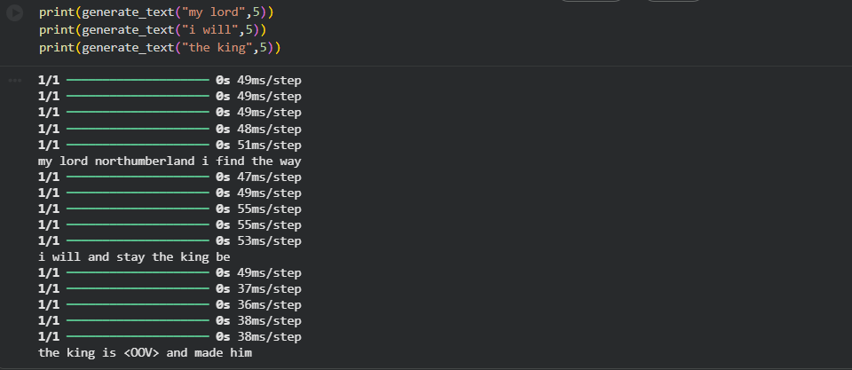
These predictions demonstrate that the LSTM model successfully learned sequence patterns.

10. Accuracy and Loss

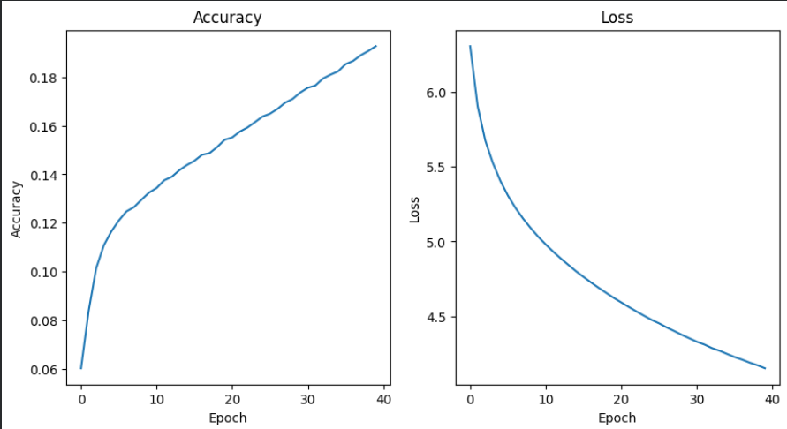

10. API Deployment Using FastAPI
The trained model was deployed using FastAPI.
API Endpoints:
/predict – Predict the next word
/generate – Generate multiple words
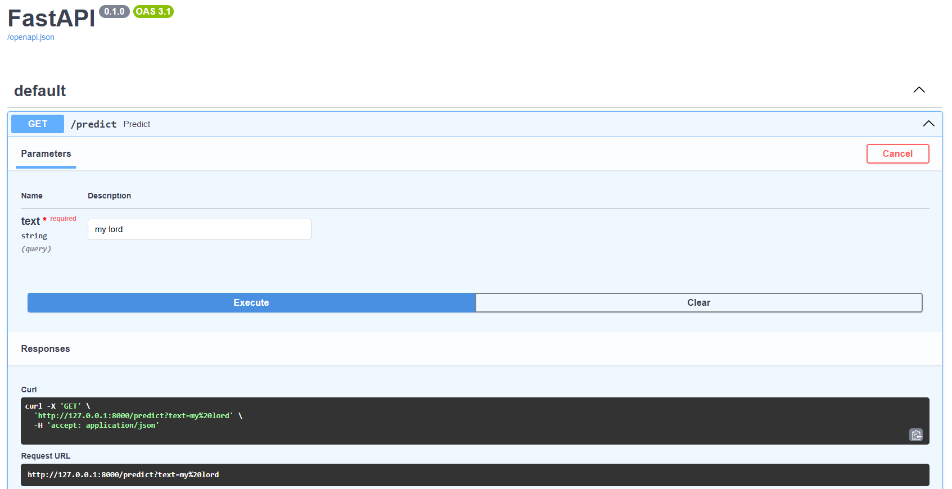
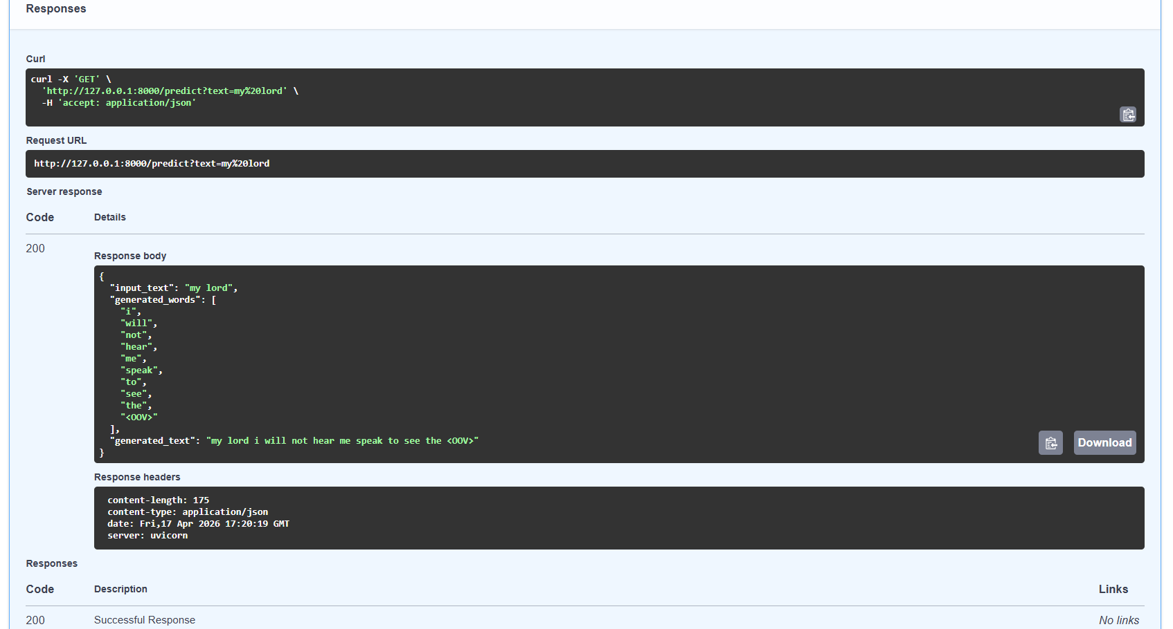
The API was tested using the Swagger interface at:
http://127.0.0.1:8000/docs

11. System Architecture
Dataset
↓
Data Preprocessing
↓
Tokenization
↓
Sequence Generation
↓
LSTM Model Training
↓
Prediction
↓
FastAPI Deployment
↓
Real-Time API Response

12. Applications
Sequence prediction systems are used in:
• Chatbots
• Text autocomplete systems
• Language translation
• AI assistants
• Text generation systems

13. Conclusion
This project successfully implemented an LSTM-based sequence prediction system. The model was trained on text data to learn language patterns and predict the next word in a sequence.
The trained model was deployed using FastAPI, enabling real-time predictions through an API. This project demonstrates the integration of deep learning and web technologies to build an industry-relevant AI application.

